Supplementary I
DNA Extraction Protocol for Human Serum, Plasma and VTM
  - Pipette 50μl Proteinase K into the bottom of a 1.5 ml microcentrifuge tube.
  - Add 200μl sample to the microcentrifuge tube and mix.
  - Add 215μl Lysis Buffer SSVL-carrier RNA mix to the sample. Pulse-vortex for 15 sec.
  - Incubate at 65°C for 10 min.
  - Briefly centrifuge the 1.5 ml microcentrifuge tube.
  - Add 280μl absolute ethanol to the sample and pulse-vortex for 15 sec.
  - Transfer all mixture from Step 6 (approx. 745μl) to a SpinStar™ column without wetting the rim. Close the cap and centrifuge at 6200 x g (8000 rpm) for 1 min. Place the SpinStar™ column in a clean Collection tube and discard the tube containing the filtrate.
  - Carefully open the SpinStar™ column and add 500μl Wash Buffer 1, SSW1 without wetting the rim. Close the cap and centrifuge at 6200 x g (8000 rpm) for 1 min. Place the SpinStar™ column in a clean Collection tube, and discard the tube containing the filtrate.
  - Carefully open the SpinStar™ column and add 500μl Wash Buffer 2, SSW2 without wetting the rim. Close the cap and centrifuge at 6200 x g (8000 rpm) for 1 min.
  - Discard filtrate and reuse Collection tube. Carefully open the SpinStar™ column and add 500ul absolute ethanol without wetting the rim. Close the cap and centrifuge at 6200 x g (8000 rpm) for 1 min.
  - Discard filtrate and reuse Collection tube. Centrifuge at 17,000 x g (13,300 rpm) for 10 min.
  - Transfer the SpinStar™ column to a clean 1.5 ml microcentrifuge tube and discard the Collection tube containing trace ethanol.
  - Carefully open the SpinStar™ column and add 30 - 60μl Elution Buffer SSE on to the center of the membrane. Incubate at room temperature (15-30°C) for 5 min, and then centrifuge at 6200 x g (8000 rpm) for 1 min. Proceed to downstream (e.g. real-time PCR) reaction setup or store eluate at -20°C if not used immediately.

Supplementary II
Viral Load Estimation
Viral load estimation on each blood samples was done using RealStar® HBV PCR kit.
Table 3: Master Mix setup.
Number of reactions | 1
Master A | 2.5µl
Master B | 10µl
Volume Master Mix | 12.5µl

Table 4: Temperature profile and dye acquisition.
 | Stage | Cycle  Repeats | Acquisition | Temperature | Time
Denaturation | Hold | 1 | - | 95°C | 2:00 min
Amplification | Cycling | 45 | - | 95°C | 0:15 min
Amplification | Cycling | 45 | ✓ | 58°C | 0:28 min
Amplification | Cycling | 45 | - | 72°C | 0:30 min

Supplementary III
HBV Genotyping using PCR

Primer sequences used for HBV genotyping by nested PCR Primer Sequenceª (position, specificity, and polarity)
First PCR
P1^{b}…………..5’-TCA CCA TAT TCT TGG GAA CAA GA-3’(nt 2823-2845, universal, sense) S1-2. 5’-CGA ACC ACT GAA CAA ATG GC-3’(nt 685-704, universal, antisense)
Second PCR Mix A
B2. 5’-GGC TCM AGT TCM GGA ACA GT-3’(nt 67-86, types A to E specific, sense)
BA1R..………5’-CTC GCG GAG ATT GAC GAG ATG T-3’(nt 113-134, type A specific, antisense)
BB1R..………5’-CAG GTT GGT GAG TGA CTG GAG A-3’(nt 324-345, type B specific, antisense)
BC1R 5’-GGT CCT AGG CCT GAT GTT G-3’(nt 165-186, type C specific, antisense)

Mix B
BD1….………5’-GCC AAC AAG GTA GGA GCT-3’(nt 2979-2996, type D specific, sense) BE1… 5’-CAC CAG AAA TCC AGA TTG GGA CCA-3’(nt 2955-2978, type E specific, sense)
BF1… 5’-GYT ACG GTC CAG GGT TAC CA-3’(nt 3032-3051, type F specific, sense)
B2R….………5’-GGA GGC GGA TYT GCT GGC AA-3’(nt 3078-3097,types D to F specific, sense)
ªAn “M” represents a nucleotide that could be either an A or a C; a “Y” represents a nucleotide that could be either a C or a T. nt, nucleotide.
^{b}The sequence for primer P1 was determined by Lindh et al. (1998).

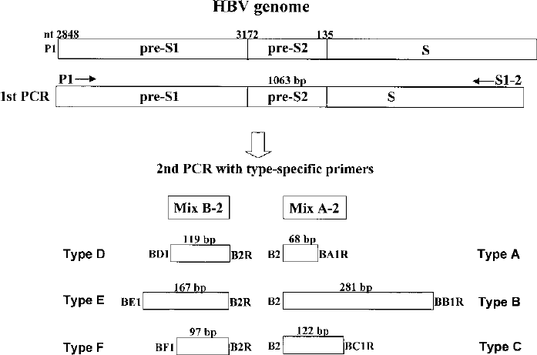
Figure 4: Strategy for genotyping of HBV by PCR using type-specific primers. nt, nucleotide (Naito et al., 2001).

Conditions for 1st PCR cycle Time and Temperature relation for 1st PCR
95°C→ 10 minutes
95°C→ 20 seconds
55°C→ 20 seconds
72°C→ 60 seconds 4°C → ∞ hold
Master Mix : 6µl
P1: 1µl
S1-2: 1 µl
Distilled water: 14 µl
DNA: 3µl

Conditions for 2nd PCR cycle
Master A Time and Temperature relation for 2nd PCR
Master Mix: 6µl
B2: 0.5µl
BA1R: 0.5µl
BB1R: 0.5µl
BC1R: 0.5µl
95°C→ 10 minutes
95°C→ 20 seconds
55°C→ 20 seconds
72°C→ 60 seconds 4°C → ∞ hold
BF1: : 0.5µl
Distilled Water: 16.5µl
DNA: 0.5µl
Master B Time and Temperature relation for 1st PCR
95°C→ 10 minutes
95°C→ 20 seconds
55°C→ 20 seconds
72°C→ 60 seconds 4°C → ∞ hold
Master Mix: 6µl
B2R: 0.5µl
BA1R: 0.5µl
BD1: 0.5µl
BE1: 0.5µl
Distilled Water: 16.5µl
DNA: 0.5µl

