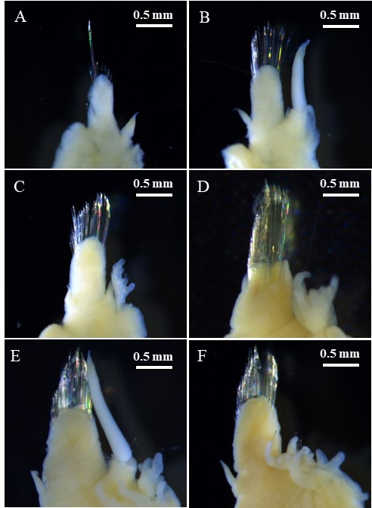
Fig. S2 Branchipolynoe onnuriensis n. sp. paratype5, female. A, left parapodium from segment 2, posterior view. B, left parapodium from segment 3, posterior view. C, left parapodium from segment 4, posterior view. D, left parapodium from segment 5, posterior view. E, left parapodium from segment 7, posterior view. F, left parapodium from segment 8, posterior view

