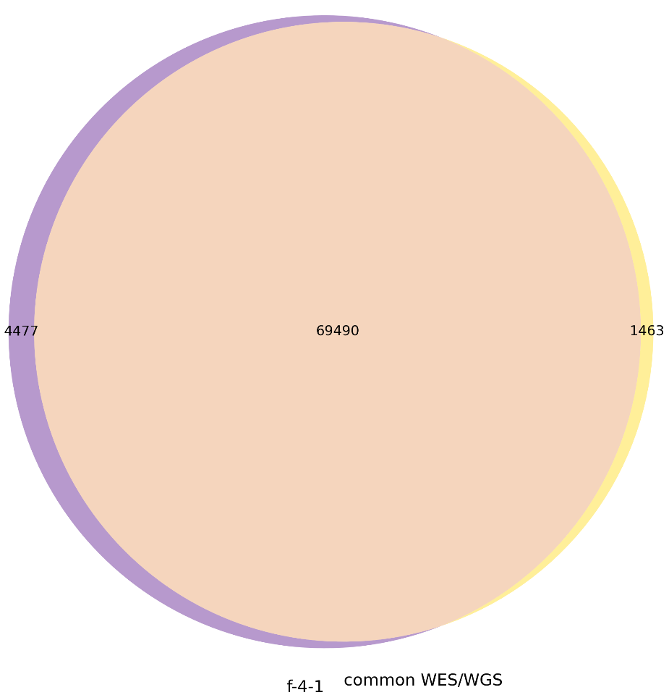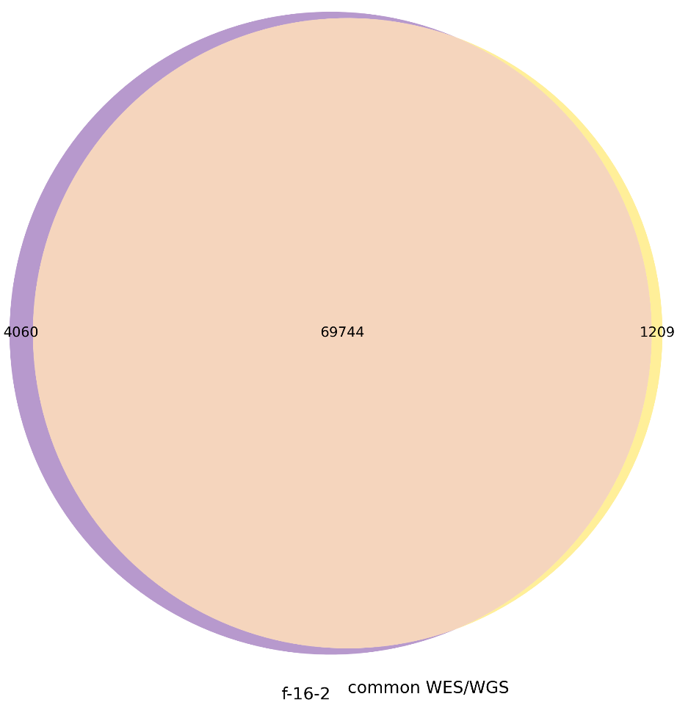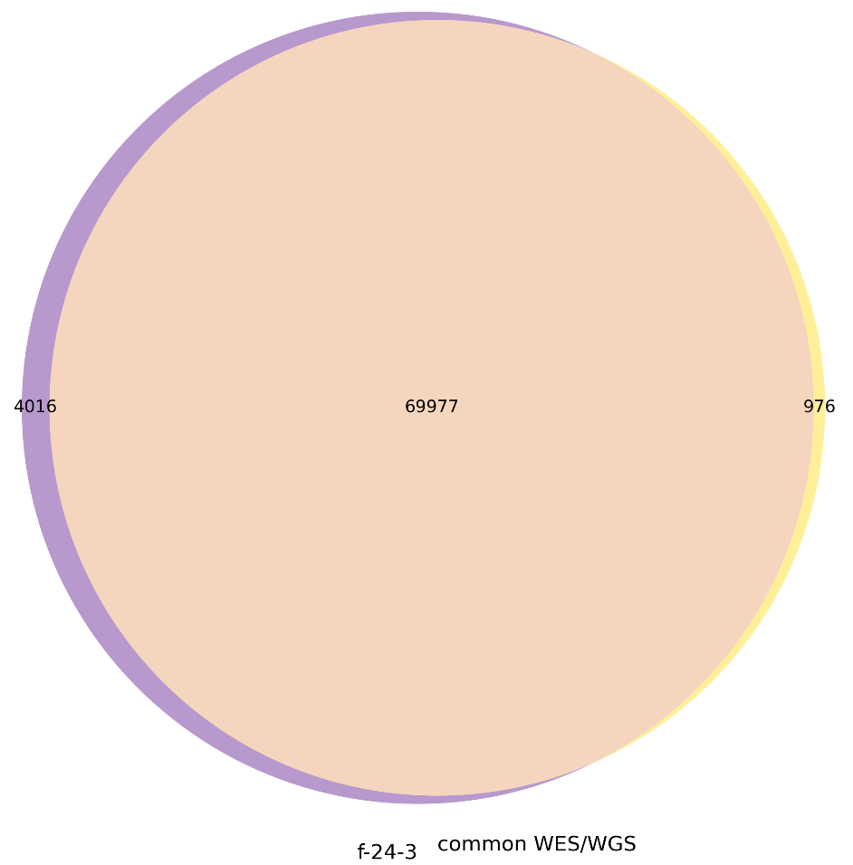

Figure 9. Venn diagrams illustrating the overlap between PTA-WES and common WES/WGS variants across samples with different initial cell numbers (4, 16, and 25 cells).

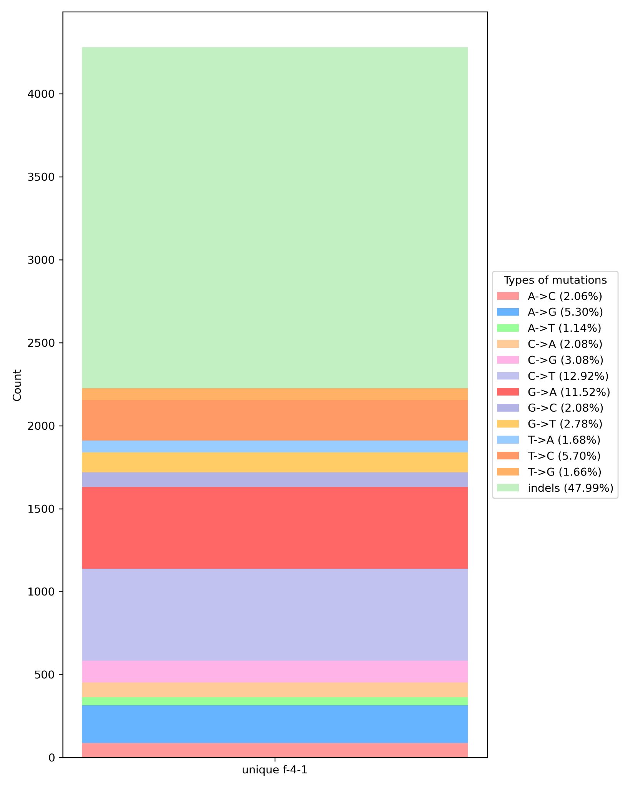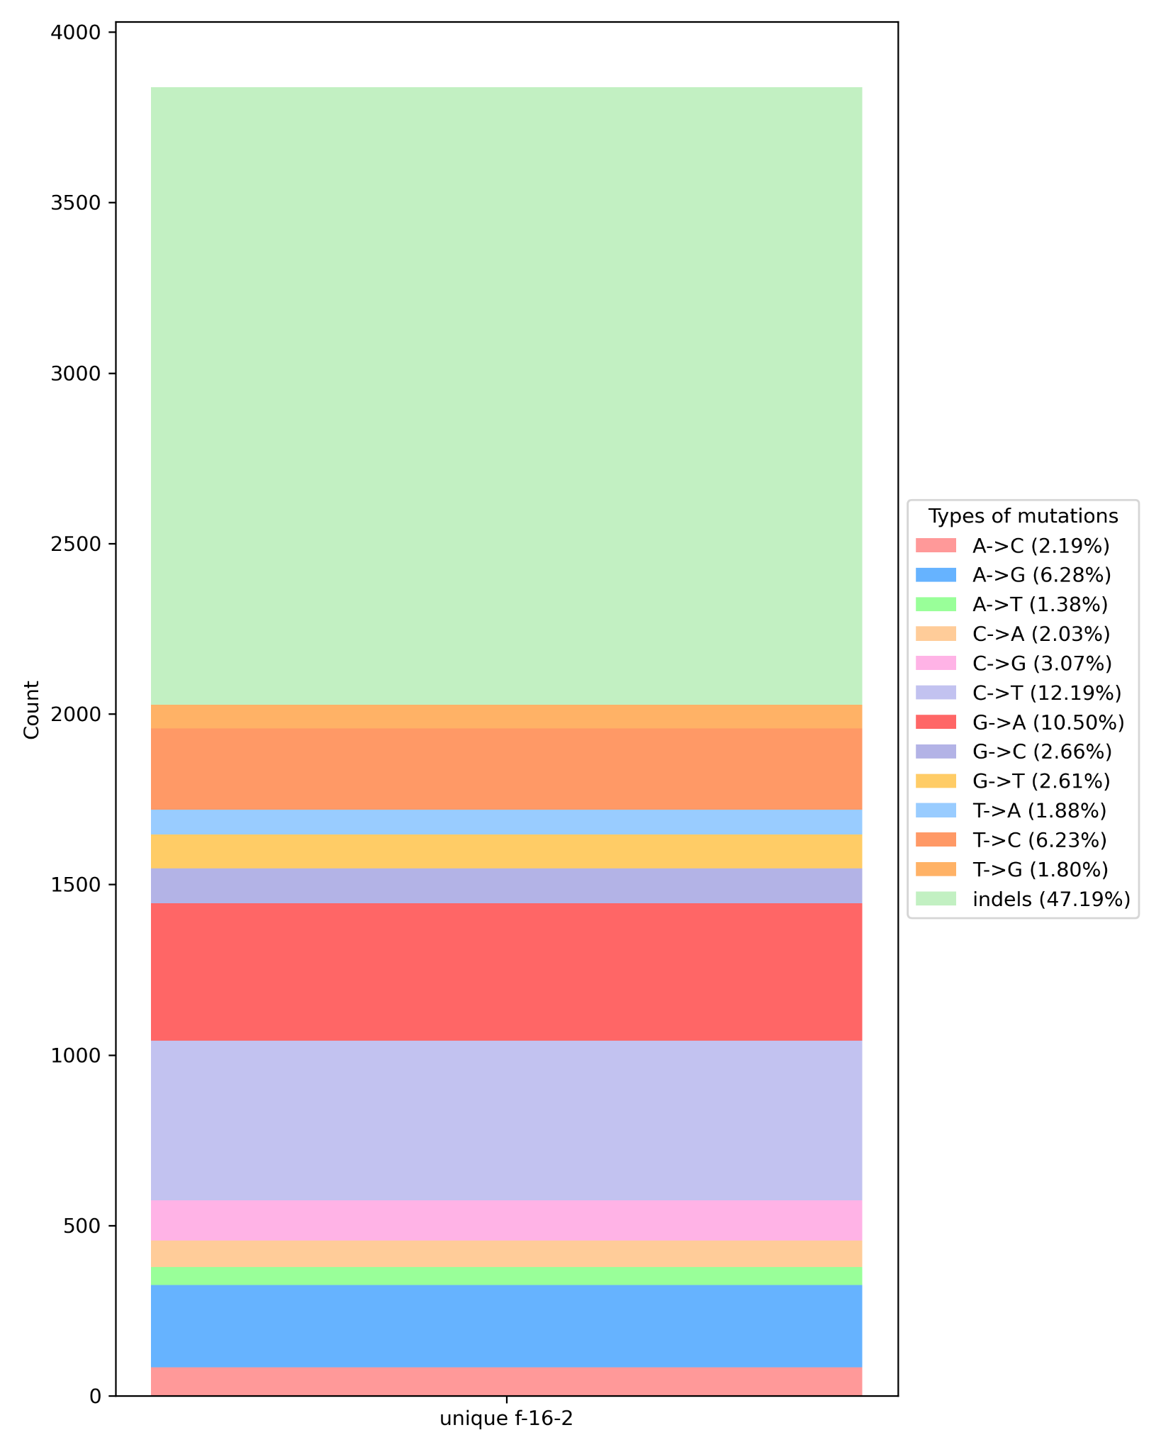

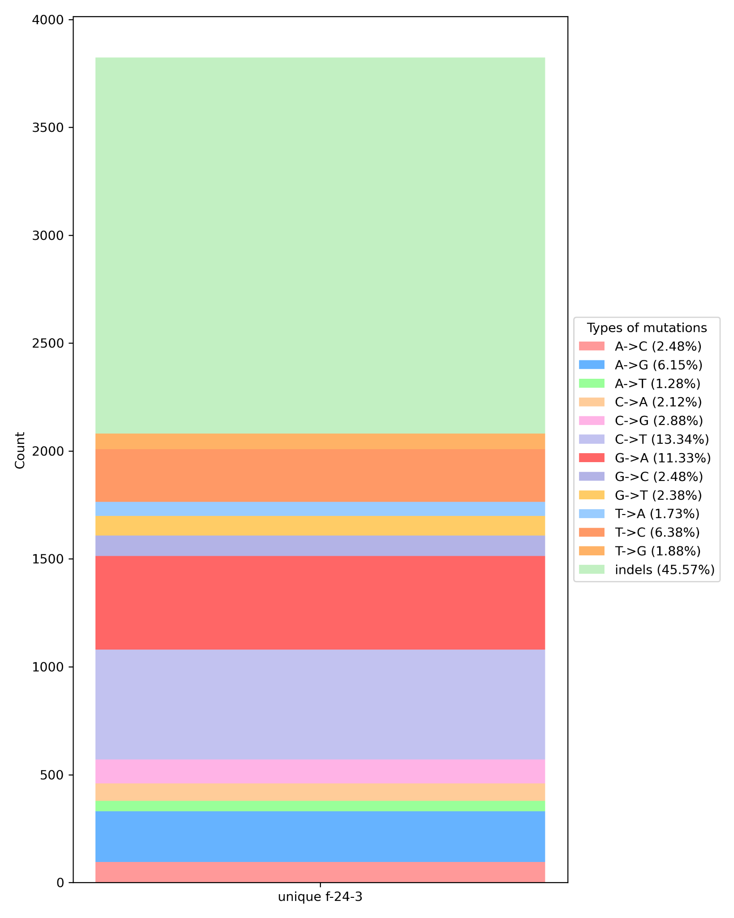
Figure 11. Percentage distribution of mutation types among unique PTA-WES and common WES/WGS variants, highlighting differences in relative mutation frequencies.

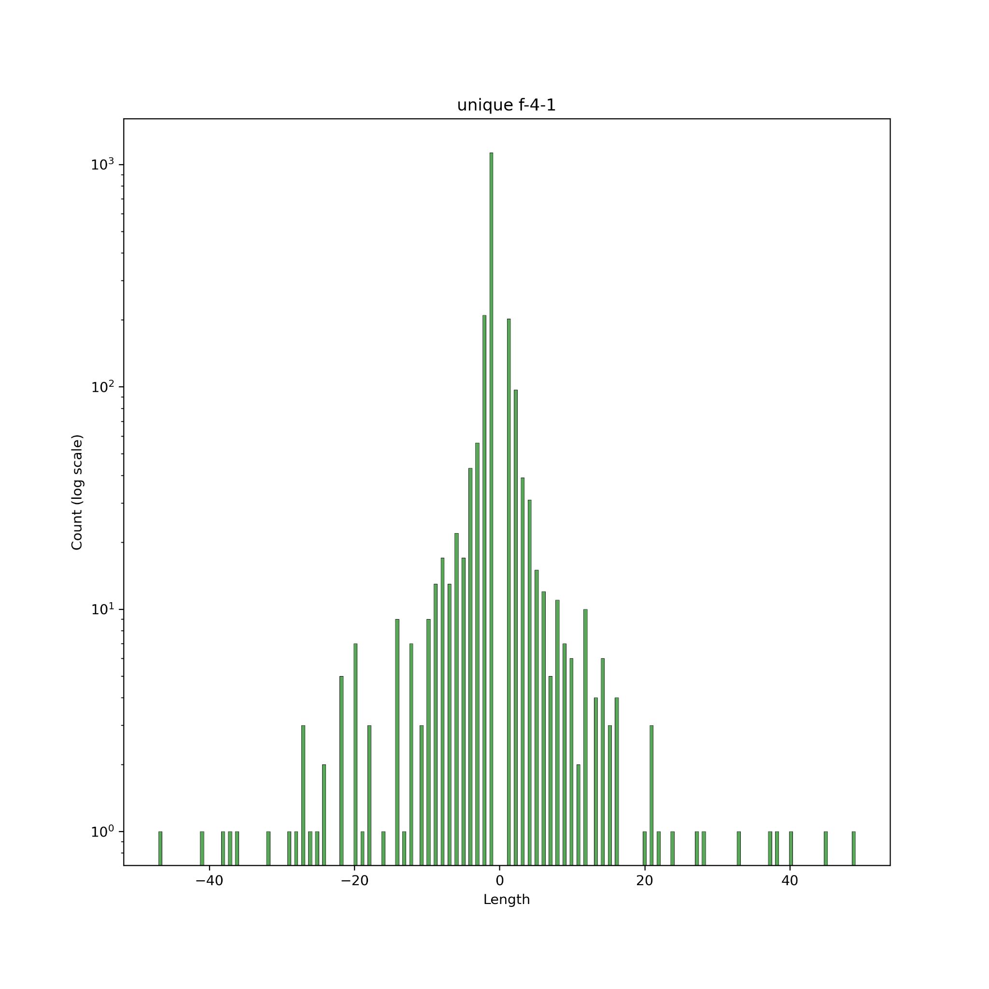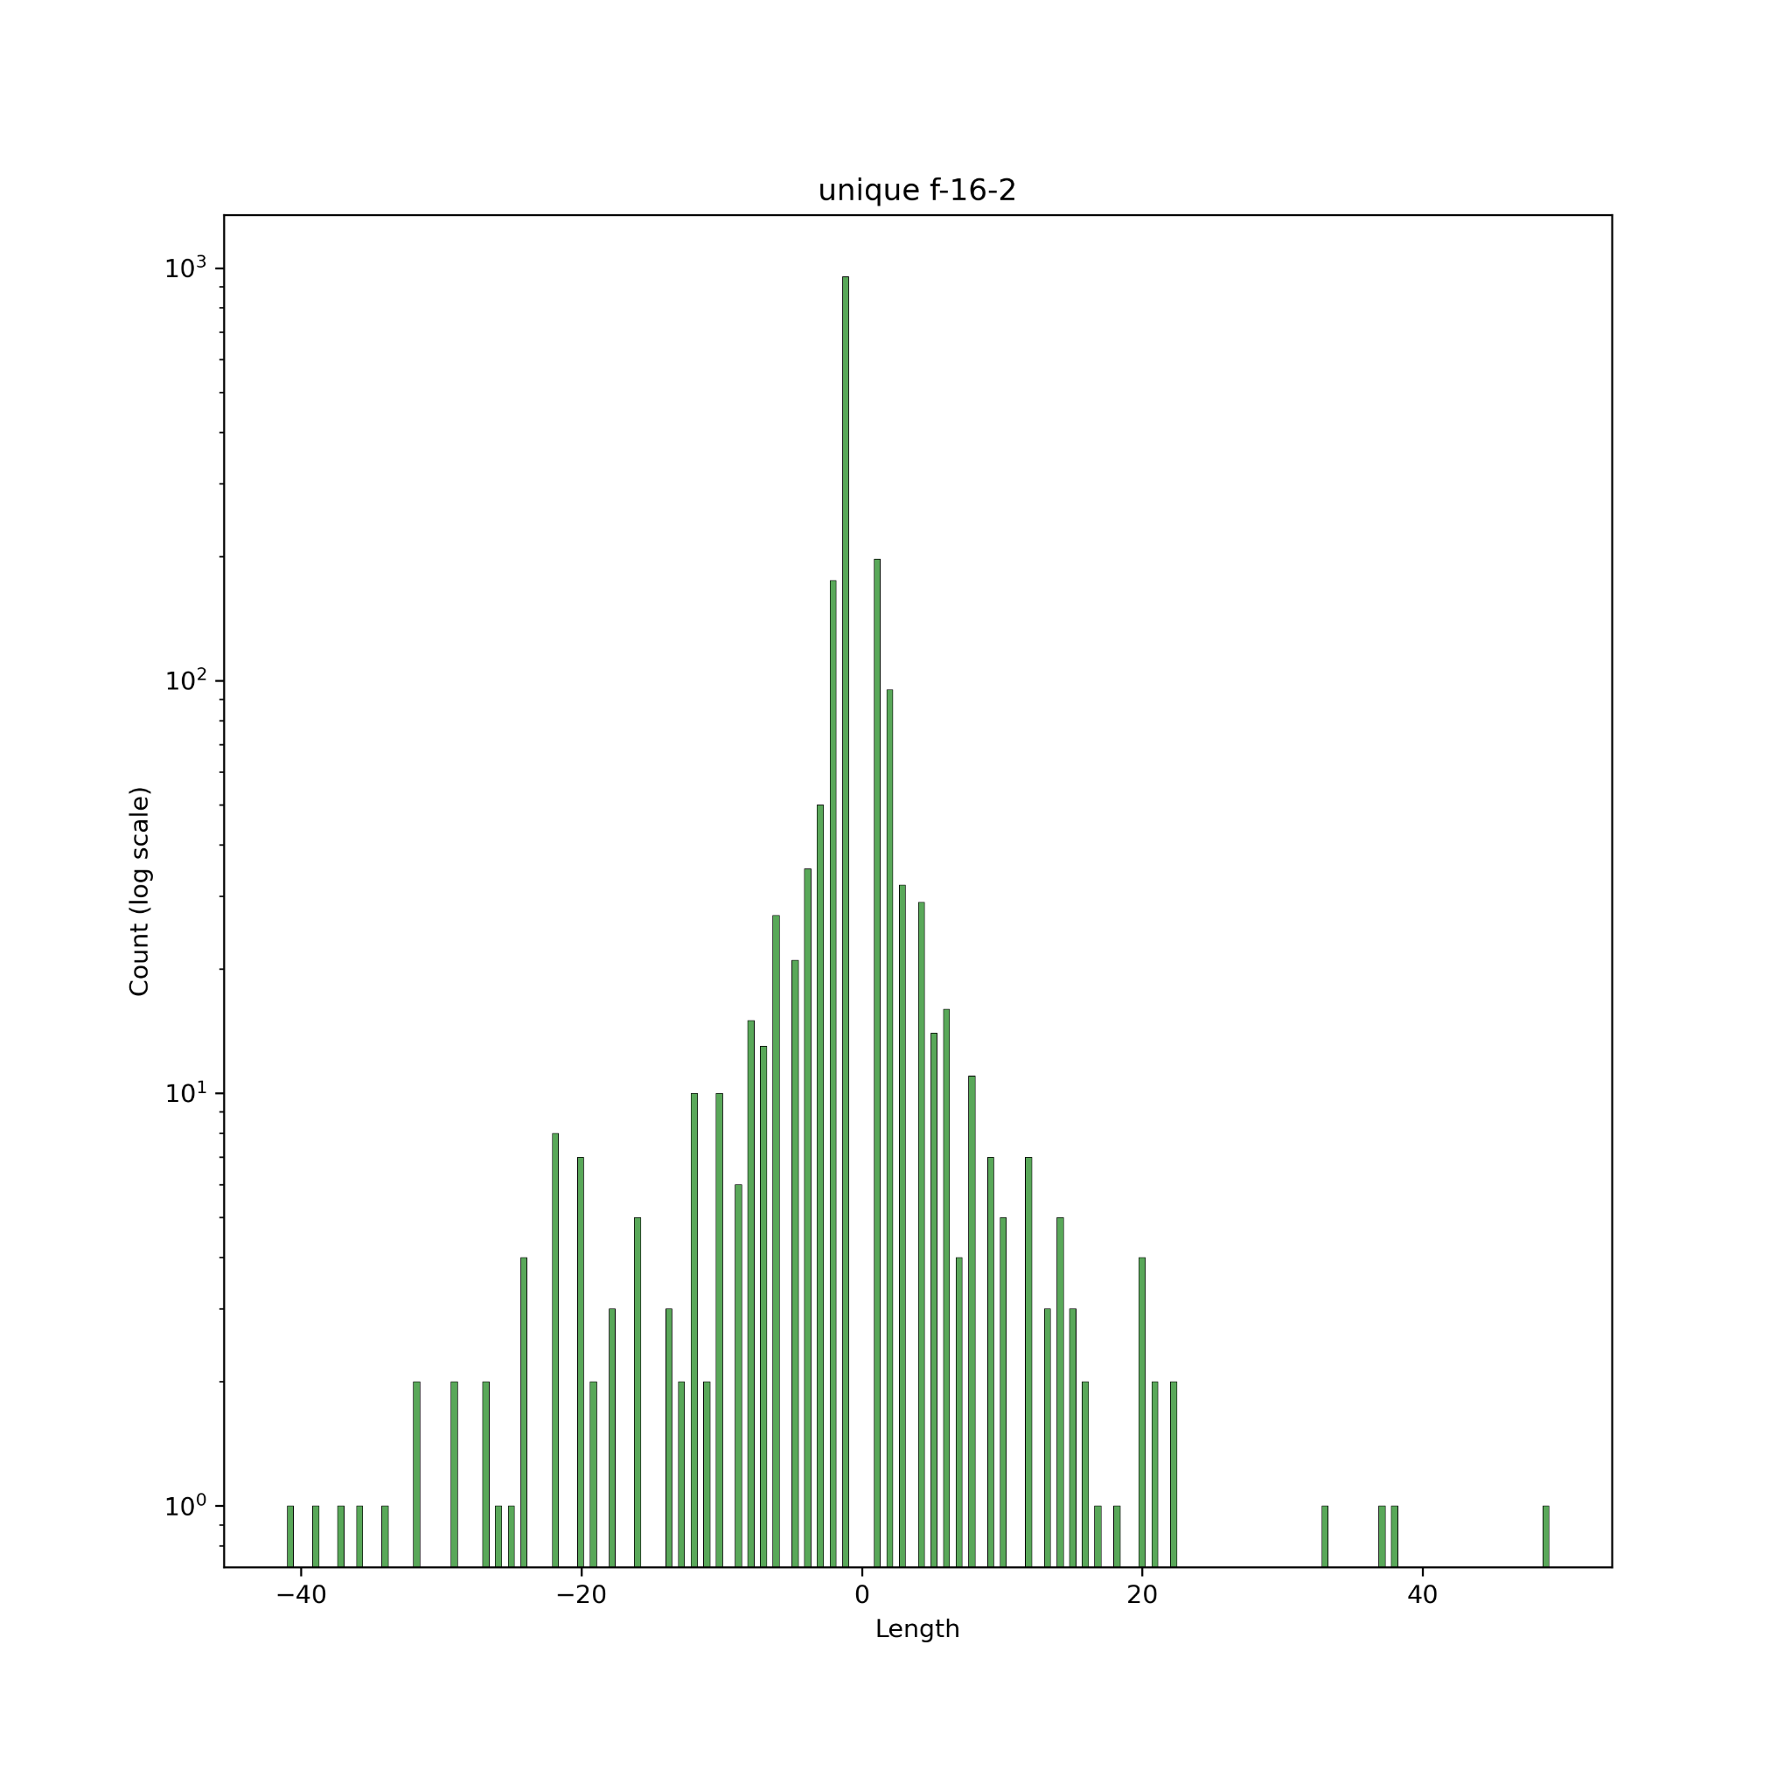
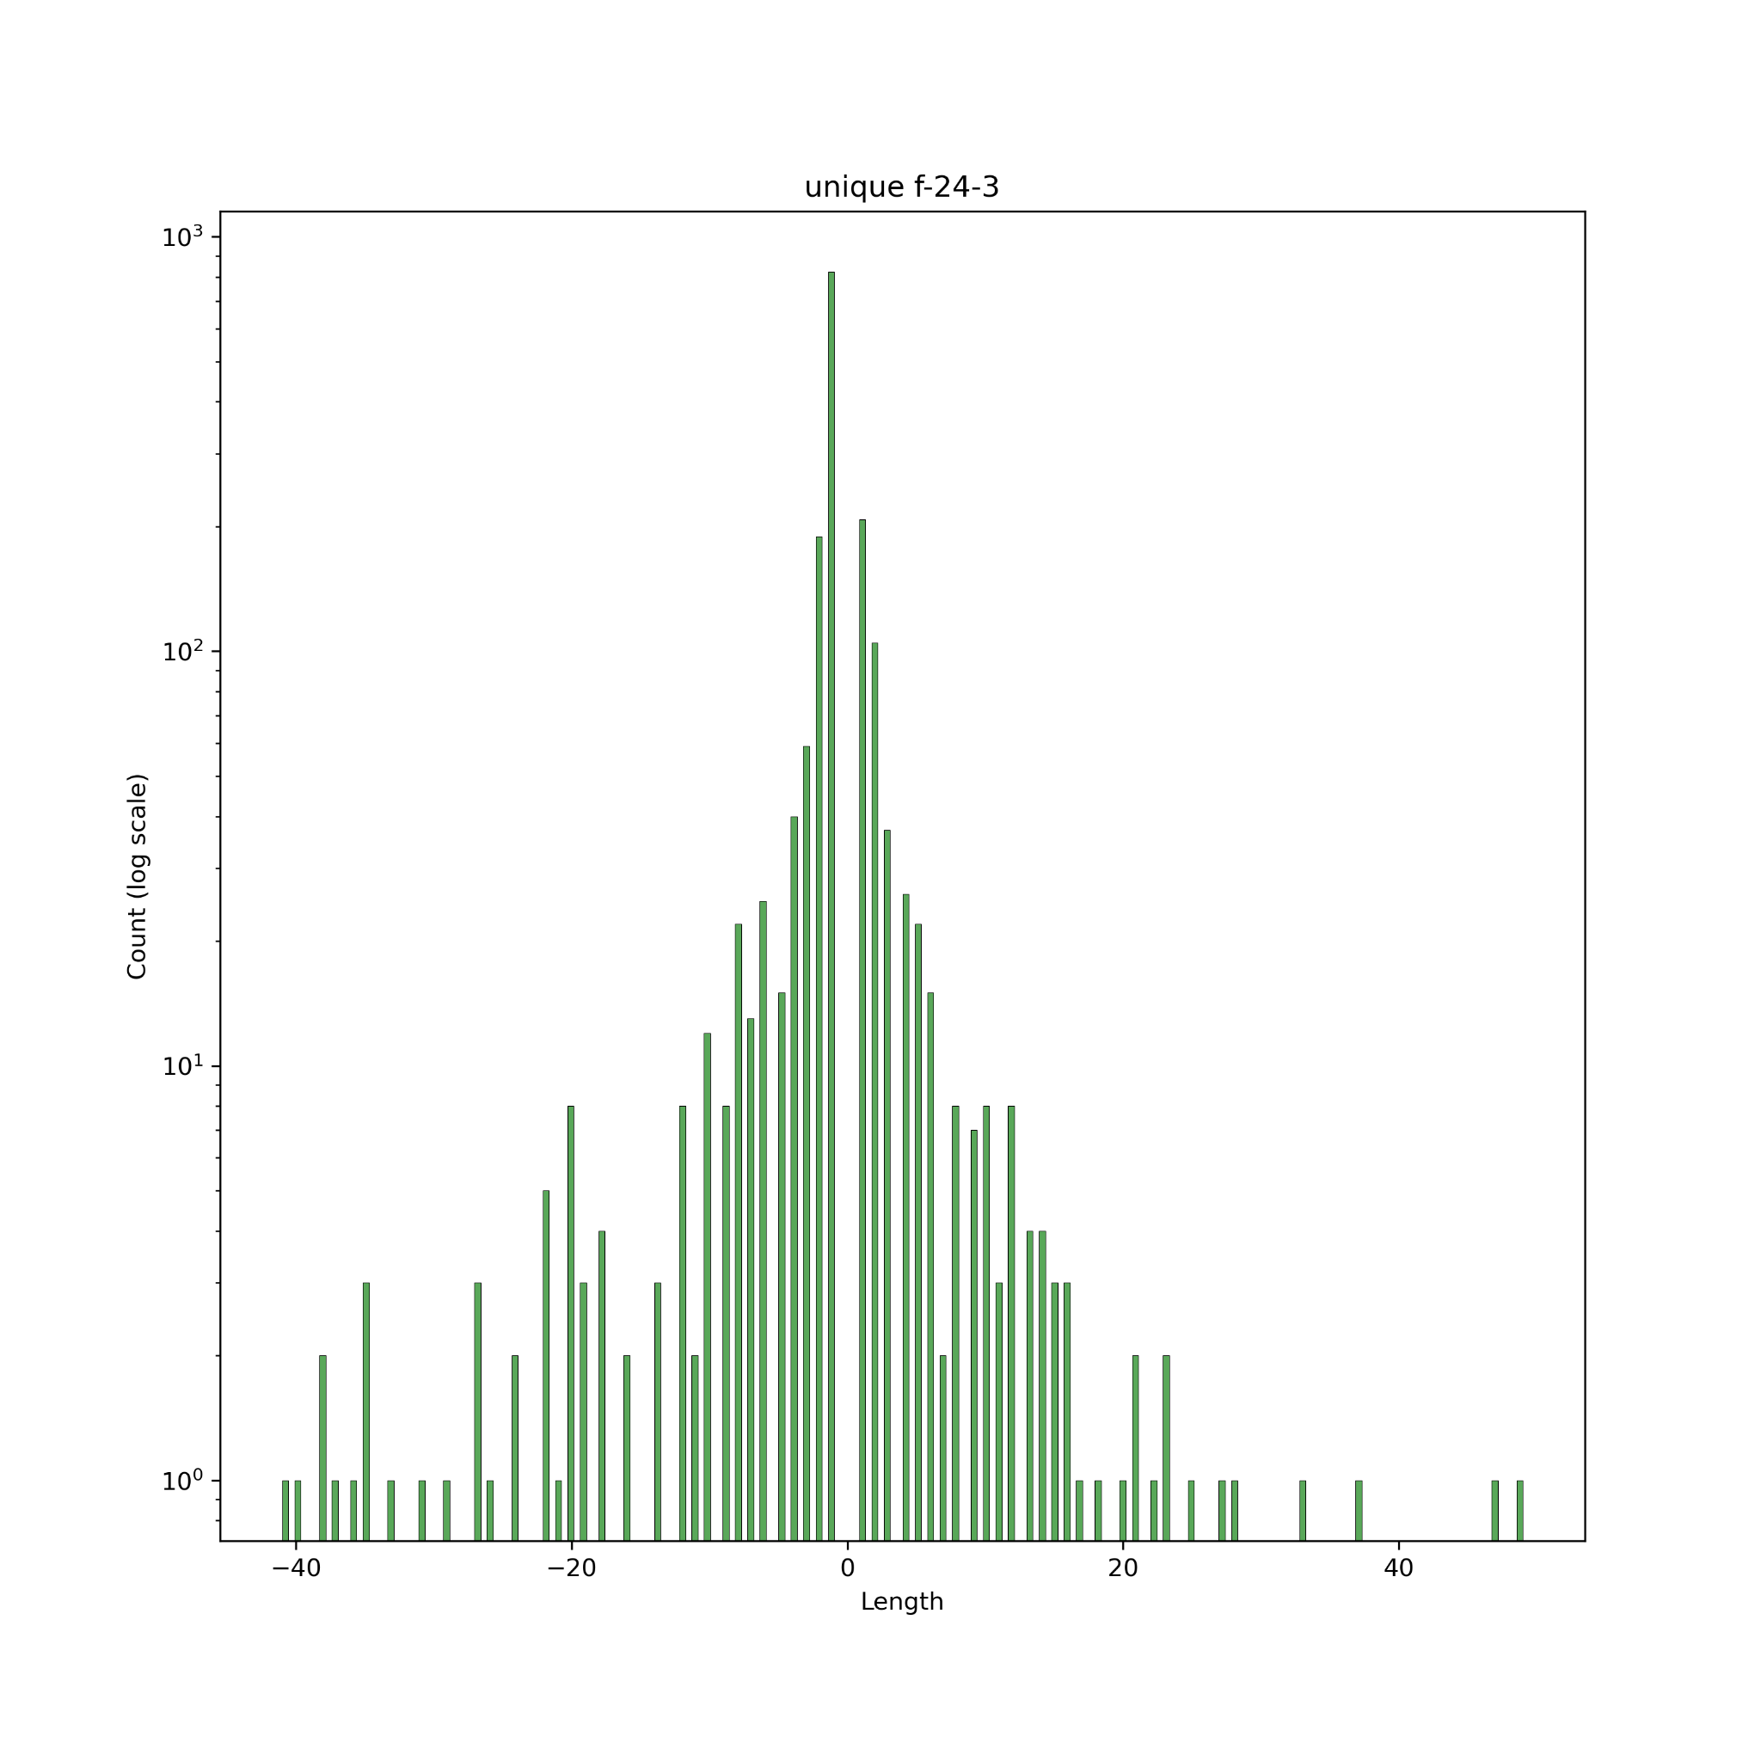
Figure 13. Indel length distributions among unique PTA-WES variants. Indels with a length more than 50 were excluded.

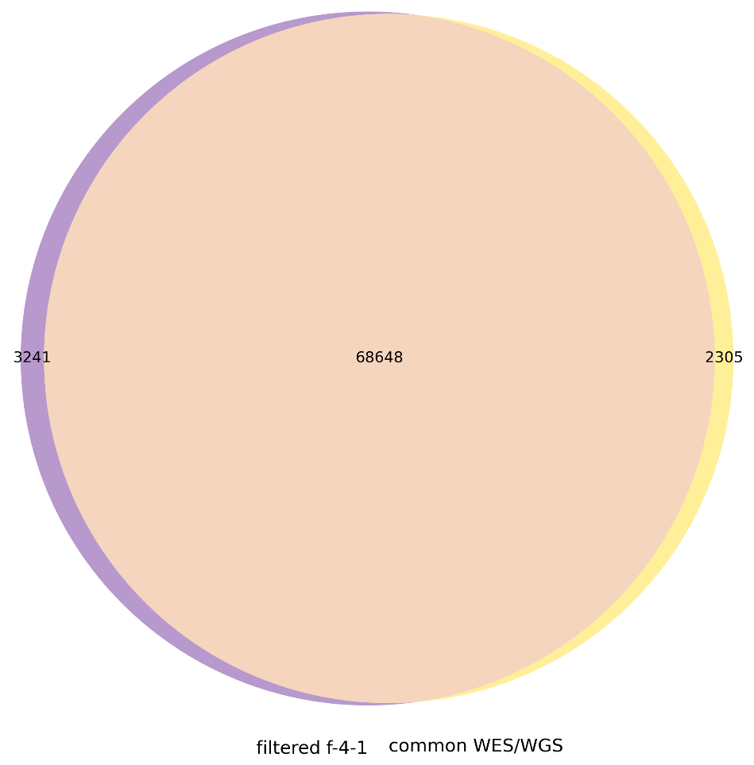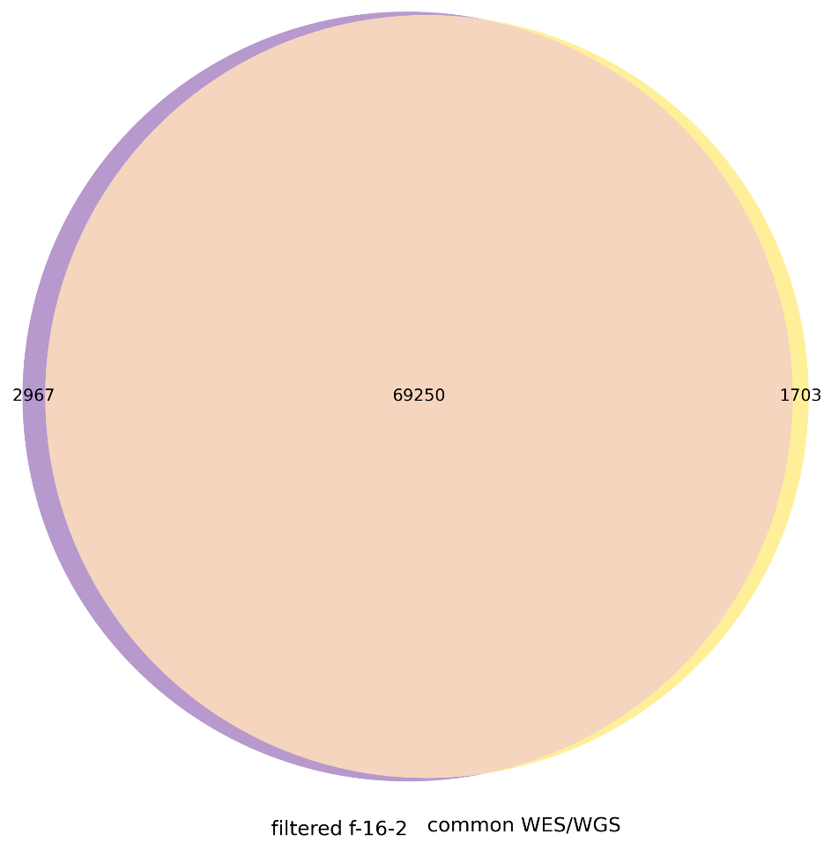

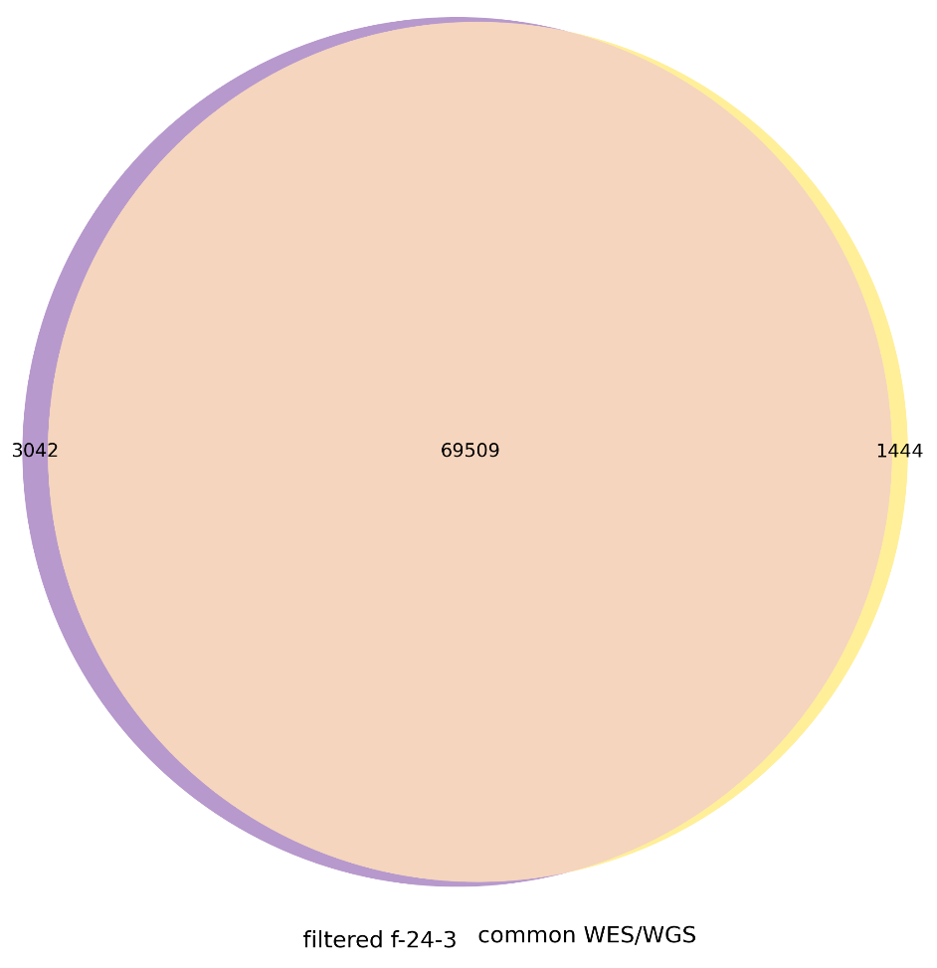

Figure 15. Venn diagram showing the intersection of filtered PTA-WES
and common WES/WGS variants

