Supplementary figures
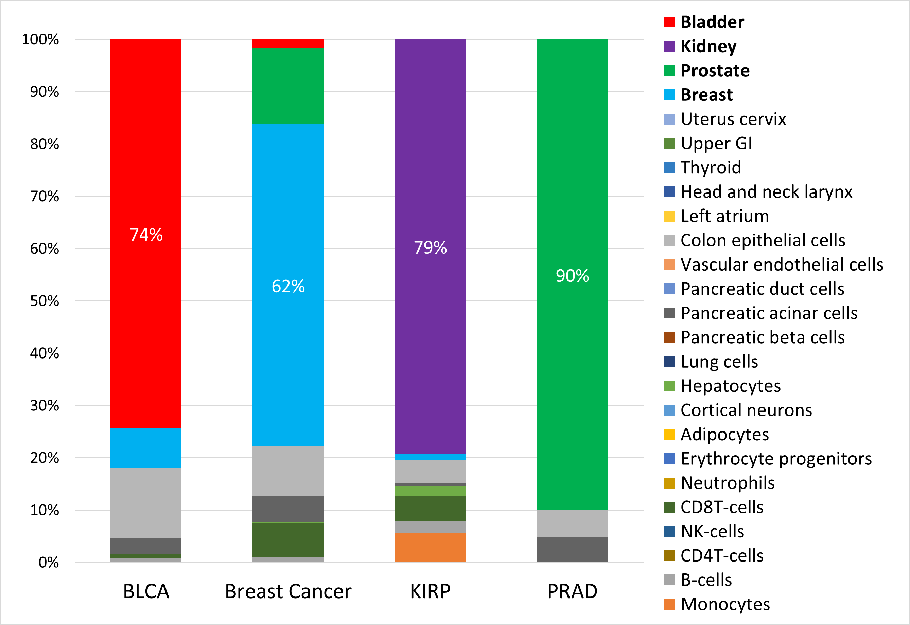

Figure S1. Methylation-based deconvolution of non-glial tumors
Bar plots comparing the average proportions of normal cell types derived from the deconvolution of methylation profiles from four different non-glial tumors. Deconvolution was performed using a 25-cell-type reference atlas from Moss et al [18]. The specified percentage represents the proportion of the most abundant cell type for each tumor. BLCA, bladder urothelial carcinoma; KIRP, kidney renal papillary cell carcinoma; PRAD, prostate adenocarcinoma

Figure S2: Methylation-based deconvolution of normal cell type samples
(A) The reference atlas used for deconvolution includes 11 tissue-specific cell types (columns) across 3,274 CpG sites (rows). (B) Proportions of normal cell types derived from the deconvolution of the methylation profiles of various normal cell types (n = 1 per sample), using a reference atlas derived from other normal samples. OPs, oligodendrocyte-lineage precursor cells; Mesenchymal SCs, mesenchymal stem cells

Figure S3. Reference atlas for glioblastoma deconvolution and cell-type identification using methylation signatures
The methylation atlas comprises 16 tissues/cell types (columns) across 4712 CpG sites (rows) that are located in 2817 genomic blocks of 500 bp each. Feature selection was carried out as described in a previous study [18]. Specifically, the top 100 uniquely hypermethylated CpGs and hypomethylated CpGs for each cell type, yielding a total of 3200 tissue-specific CpGs, with neighboring CpGs within 50 bp were also included. Mesenchymal SCs, mesenchymal stem cells; OLIG2, OLIG2-positive progenitor cells

Figure S4. Cell-type proportions derived from deconvolution analysis of glioblastoma and their proportions across glioblastoma subtypes based on the reference atlas of 16 cell types
Bar plots comparing the average proportions of normal cell types derived from the deconvolution of 263 glioblastoma samples (leftmost bar), subdivided into RTK1 (n = 64), RTK2 (n = 143), and MES (n = 56), based on the atlas of 16 cell types. For each cell type, the bar displays the average percentage along with its standard deviation. The immune cell proportion represents the combined total percentage of all five immune cell components (B cells, CD4 T cells, NK cells, CD8 T cells, and neutrophils), which are boxed and represented in different shades of purple. The average percentage and standard deviation for each cell type are displayed within its respective bar. NPs, neural progenitors; OLIG2, OLIG2-positive progenitor cells; OPCs, oligodendrocyte progenitor cells; pre-oligodendrocytes, O4+ pre-oligodendrocytes; RTK1, receptor tyrosine kinase I; RTK2, receptor tyrosine kinase II (RTK2); MES, mesenchymal

Figure S5: Comparison of methylation-based deconvolution of glioma-initiating cell samples and glioblastoma bulk tumors
Bar plots comparing the average proportions of normal cell types derived from the deconvolution of methylation profiles of glioblastoma, glioblastoma-derived glioma-initiating cell samples (n = 20, left), and glioblastoma bulk tumors (n = 263, right). The average percentage and standard deviation for each cell type are displayed within its respective bar. OPs: oligodendrocyte-lineage precursor cells, TAMs, tumor-associated macrophages

Figure S6: Comparison of methylation-based deconvolution results for a survival analysis dataset and glioblastoma bulk tumors
Bar plots comparing the average proportions of normal cell types derived from the deconvolution of methylation profiles in a glioblastoma dataset (n = 199, left) collected from the TCGA and GEO datasets for Kaplan-Meier (KM Set) survival analysis, and bulk GBM tumors (n = 263, right). The comparison of the fractions of each cell type showed no significant difference (chi-square goodness-of-fit test, p = 0.96). The average percentage of each cell type is displayed within the respective bars. GBM, glioblastoma; OPs: oligodendrocyte-lineage precursor cells; TAMs, tumor-associated macrophages

Figure S7: Survival analysis based on cell type proportions and glioblastoma subclasses
(A–F) Kaplan-Meier survival analysis of the 199 cases derived from the TCGA and GEO datasets showing differences in overall survival probability based on cell type proportions. The MSTD between the groups is indicated in months. The groups are stratified into high and low groups based on the median proportion of each cell type (High > median, Low < median): (A) OP cells, (B) microglia, (C) mesenchymal SCs, (D) TAMs (comprising monocytes and microglia), (E) immune cells (comprising B cells, CD4+ T cells, NK cells, CD8+ T cells, and neutrophils), and (F) vascular endothelial cells. (G) Kaplan-Meier survival analysis of 199 glioblastoma samples classified as RTK1 (n = 39), RTK2 (n = 97), and MES (n = 63). MTSD, median survival time difference; OPs, oligodendrocyte precursors; mesenchymal SCs, mesenchymal stem cells; TAMs, tumor-associated macrophages; RTK1, receptor tyrosine kinase I; RTK2, receptor tyrosine kinase II (RTK2); MES, mesenchymal

Figure S8: Distribution of glioblastoma subclasses according to the astrocyte-to-oligodendrocyte ratio in relation to survival
Histogram showing the distribution of the three glioblastoma subclasses, RTK1 (n = 39), RTK2 (n = 97), and MES (n = 63), across the two survival groups, LTS and STS, determined by the astrocyte-to-oligodendrocyte ratio cutoff (chi-square test, p < 2.1E-11). The table below the bar graph provides the number of patients in each group. RTK1, receptor tyrosine kinase I; RTK2, receptor tyrosine kinase II (RTK2); MES, mesenchymal; LTS, long-term survival; STS, short-term survival

