Supplementary Materials

- Table S1. Nonparametric Spearman rho correlation matrix of the items in Olson quality of marriage questionnaire
- Figure S1. Bootstrapped difference test for edge weights
- Figure S2. Bootstrapped difference test for node strengths

Table S1. Nonparametric Spearman rho correlation matrix of the items in Olson quality of marriage questionnaire
 | MS1 | MS2 | MS3 | MS4 | MS5 | MS6 | MS7 | MS8 | MS9 | MS10
MS1 | 1.00
MS2 | 0.24** | 1.00
MS3 | 0.51** | 0.34** | 1.00
MS4 | 0.31** | 0.43** | 0.35** | 1.00
MS5 | 0.30** | 0.43** | 0.43** | 0.40** | 1.00
MS6 | 0.32** | 0.38** | 0.45** | 0.46** | 0.35** | 1.00
MS7 | 0.40** | 0.49** | 0.50** | 0.55** | 0.47** | 0.61** | 1.00
MS8 | 0.33** | 0.34** | 0.42** | 0.33** | 0.40** | 0.35** | 0.37** | 1.00
MS9 | 0.24** | 0.37** | 0.37** | 0.36** | 0.46** | 0.29** | 0.33** | 0.41** | 1.00
MS10 | 0.41** | 0.41** | 0.46** | 0.50** | 0.37** | 0.51** | 0.53** | 0.33** | 0.34** | 1.00
**p < 0.01

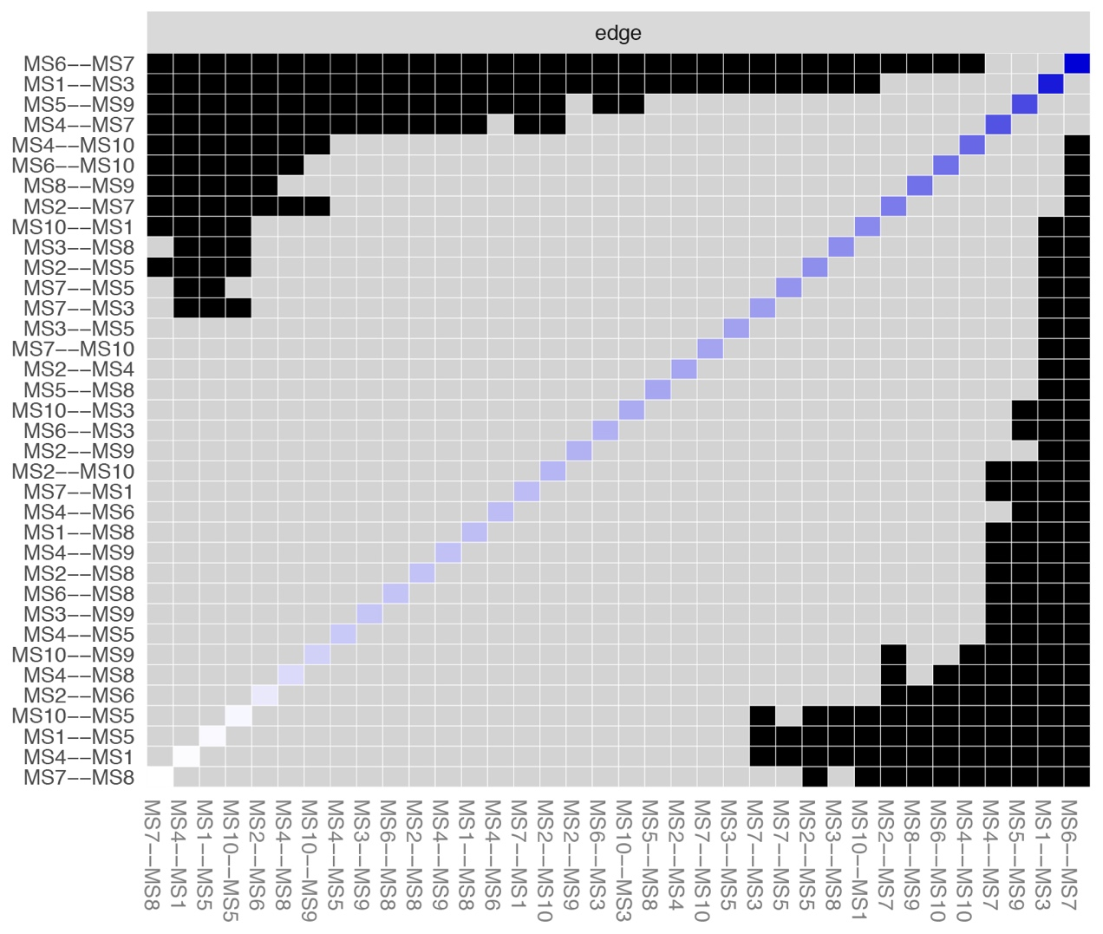
Fig. S1. Bootstrapped difference test for edge weights. Black boxes represent edges that are significantly different from one another (p < 0.05, uncorrected) and gray boxes represent edges that are not significantly different from one another. The colored boxes on the diagonal correspond to the color of the edge weights in the present network (Fig. 1). Blue boxes represent positive edge weights, red boxes represent negative edge weights.

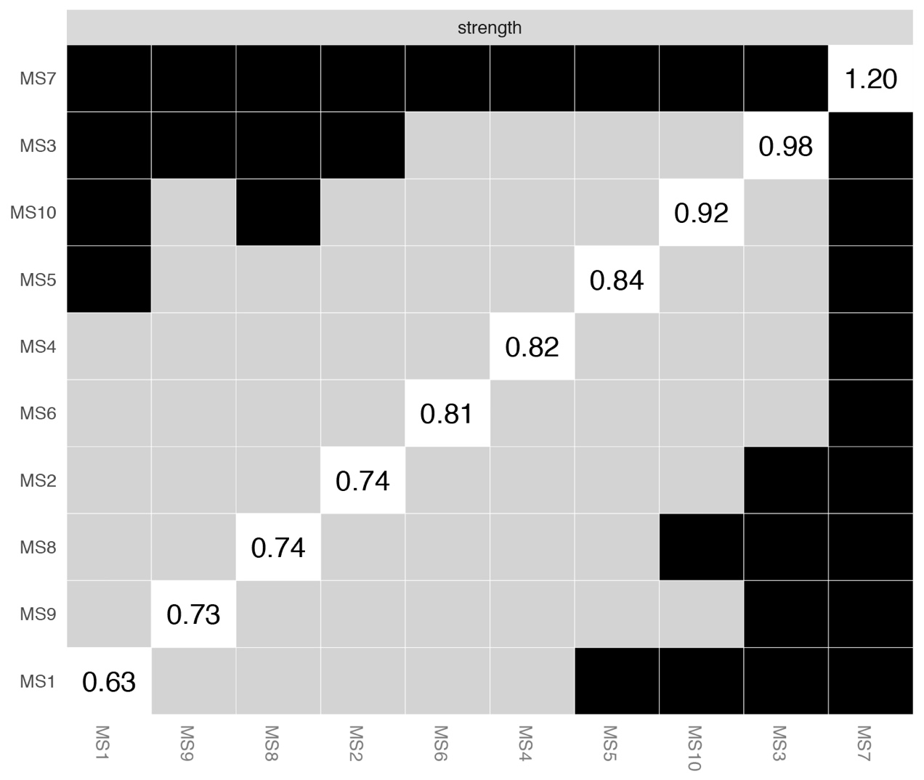
Fig. S2. Bootstrapped difference test for node strengths. Black boxes represent nodes that are significantly different from one another (p < 0.05, uncorrected) and gray boxes represent nodes that are not significantly different from one another. White boxes on the diagonal depict node strengths (raw values).

