Electronic Supplementary Information for
A selective pyridinedicarbohydrazide-based “naked-eye” fluorescent probe for detecting Cu²⁺ ions in aqueous solutions

Ali Zamani, Mahmood Tajbakhsh*, Yaghoub Sarrafi
Department of Organic Chemistry, Faculty of Chemistry, University of Mazandaran, Babolsar, Iran
*E-mail: tajbaksh@umz.ac.ir, ysarrafi@umz.ac.ir
Fig. S1 ¹H NMR Spectrum of L1
Fig. S2 ¹³C NMR Spectrum of L1
Fig. S3 FT-IR Spectrum of L1
Fig. S4 ¹H NMR Spectrum of L2
Fig. S5 ¹³C NMR Spectrum of L2
Fig. S6 FT-IR Spectrum of L2
Fig. S7 ¹H NMR Spectrum of L3
Fig. S8 ¹H NMR Spectrum of L3
Fig. S9 ¹³C NMR Spectrum of L3
Fig. S10 FT-IR Spectrum of L3
Fig. S11 Mass Spectrum of L3
Fig. S12 Benesi–Hildebrand plot
Fig. S13 Mass Spectrum of L3-Cu²⁺
Fig. S14 Job plot analysis
Fig. S15 IR spectral changes L3 and Cu²⁺ complexation
Fig. S16 Reversibility cycle

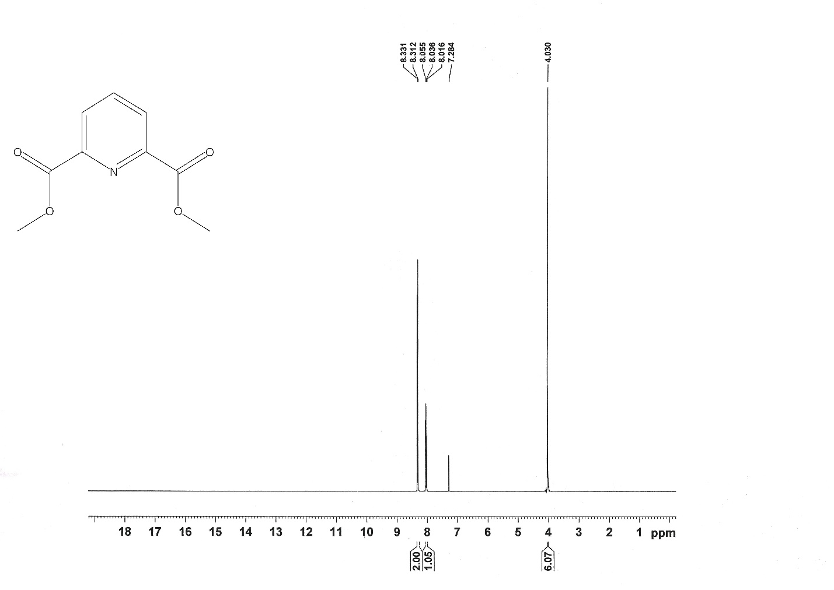
Fig. S1 ¹H NMR (400MHz in CDCl3) of L1

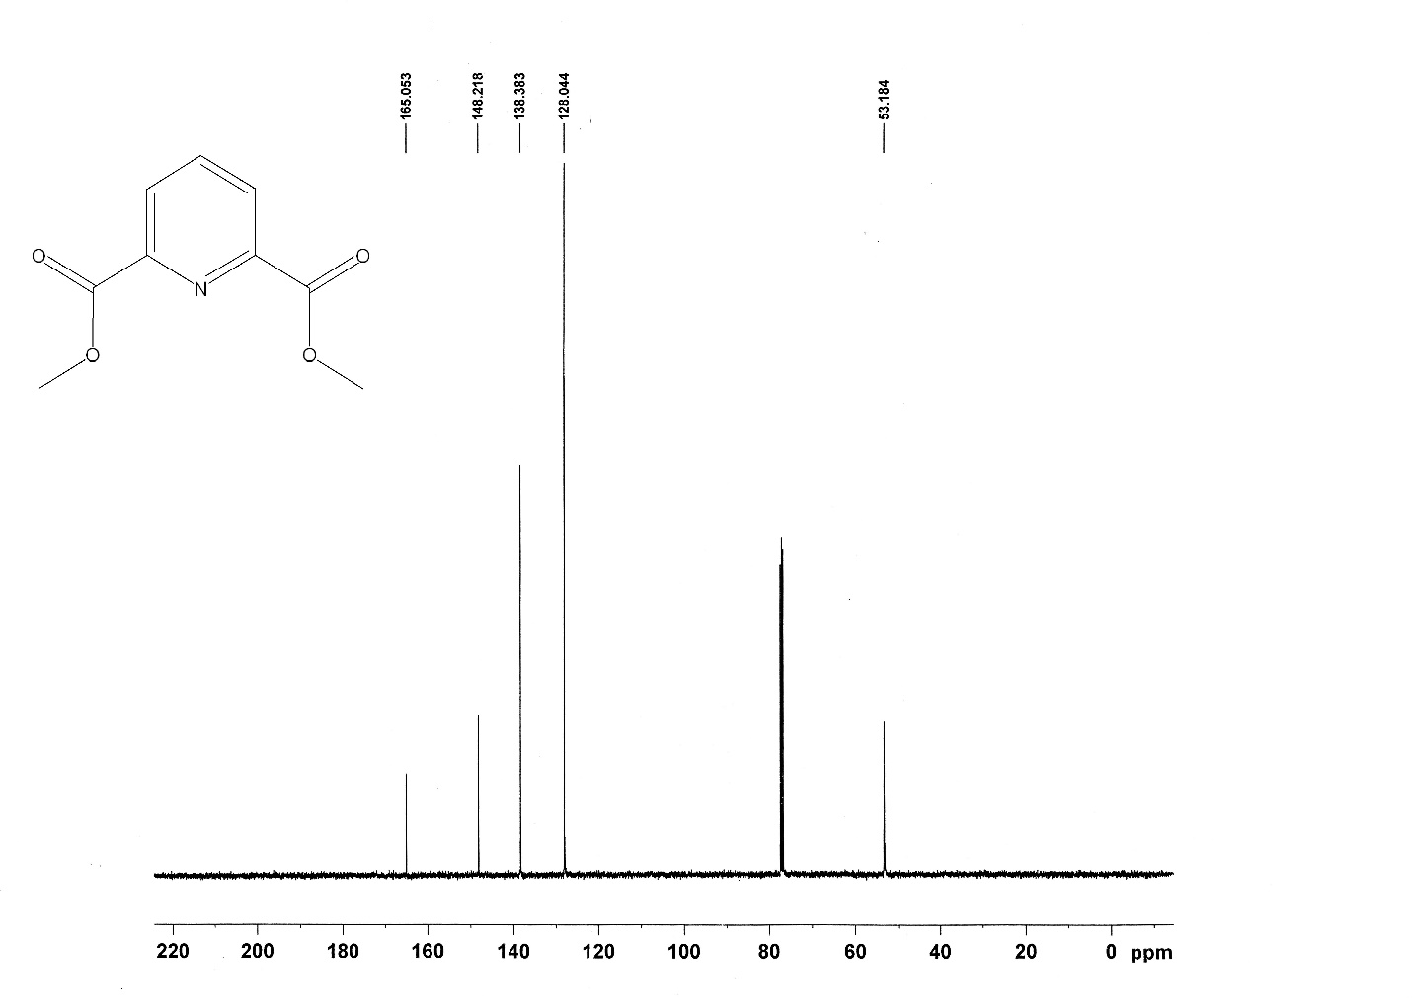
Fig. S2 ¹³C NMR (100 MHz in CDCl3) of L1

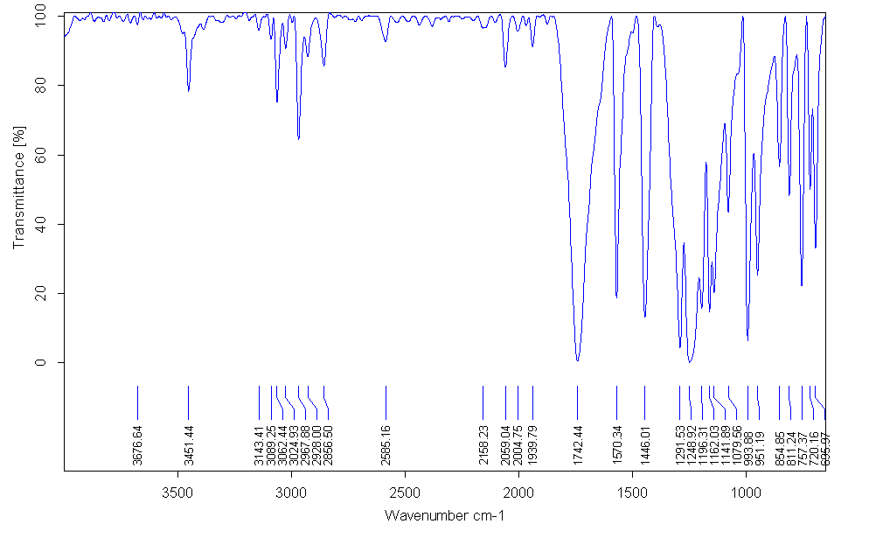
Fig. S3 FT-IR spectrum of L1

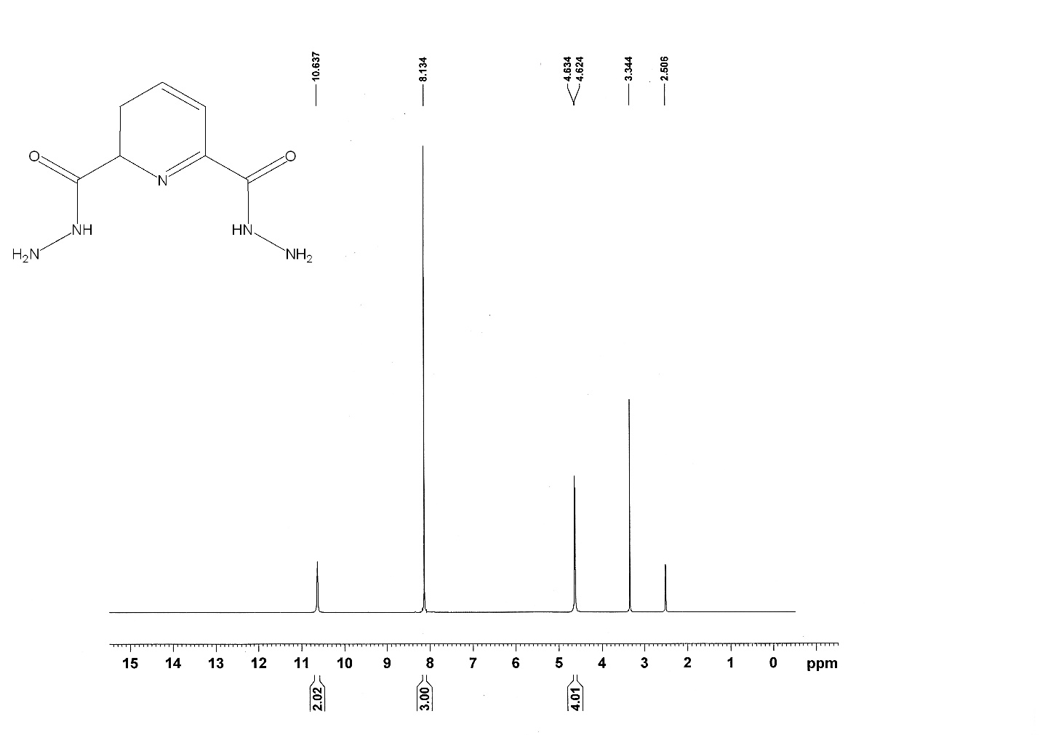
Fig. S4 ¹H NMR (400 MHz in DMSO-d6) of L2

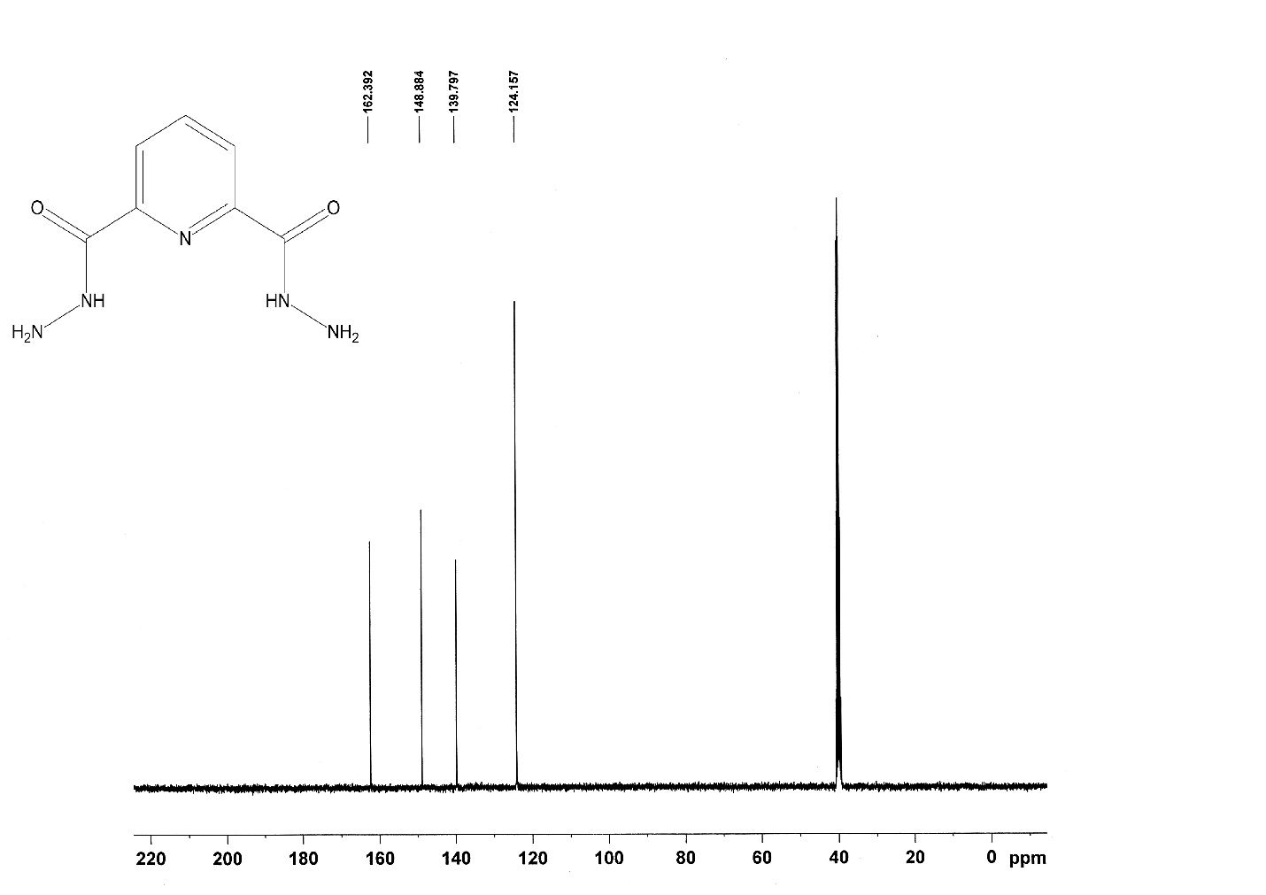
Fig. S5 ¹³C NMR Spectrum of L2
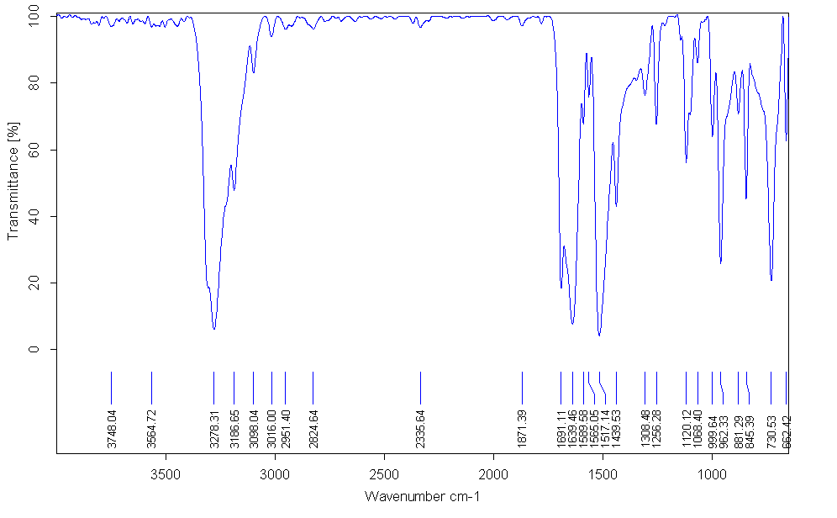
Fig. S6 FT-IR Spectrum of L2

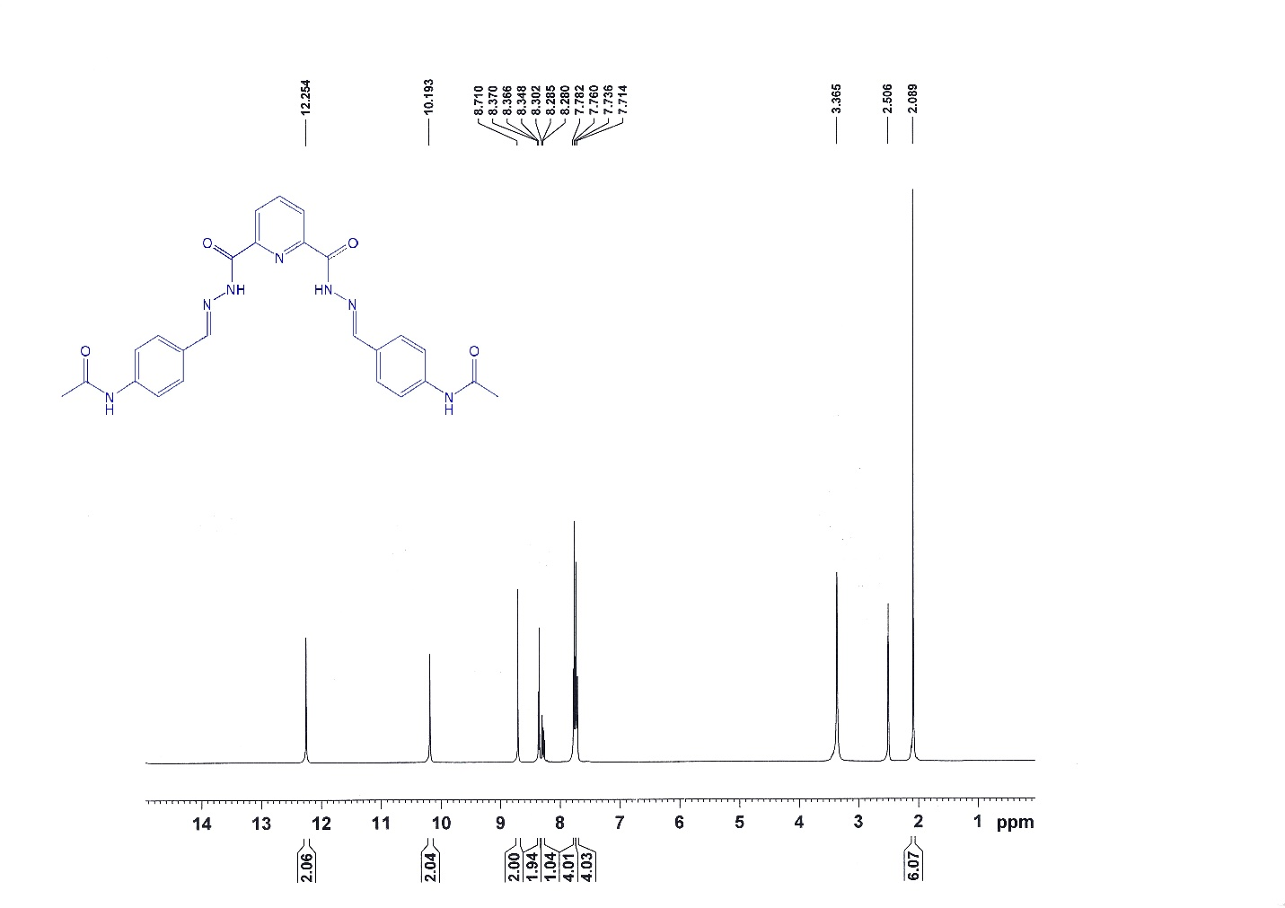
Fig. S7 ¹H NMR (400 MHz in DMSO-d6) of L3

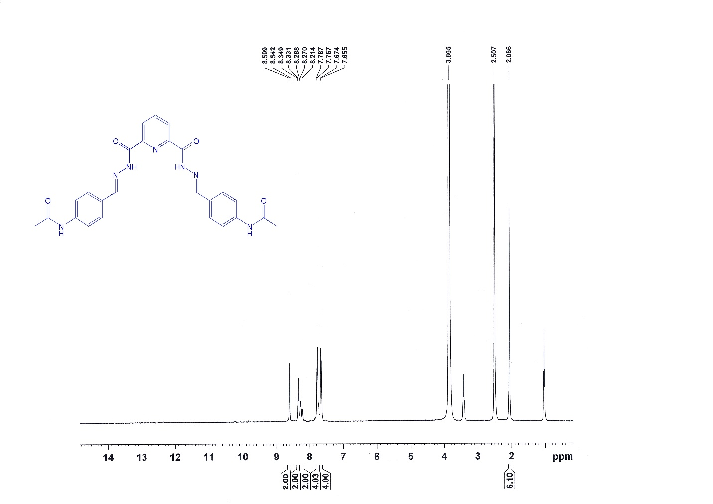
Fig. S8 ¹H NMR (400 MHz in DMSO-d6 (exchange with D₂O)) of L3
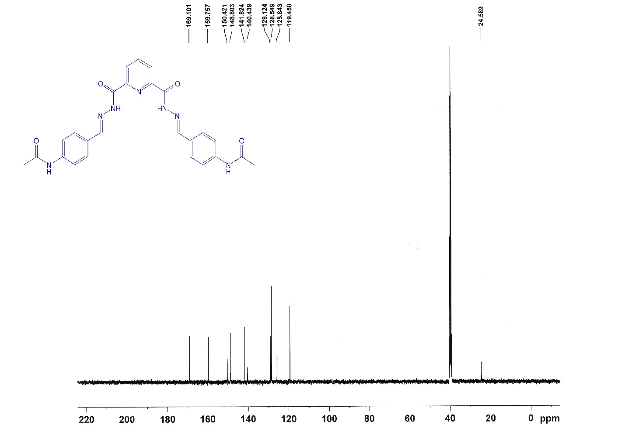
Fig. S9 ¹³C NMR (100 MHz in DMSO-d6) of L3

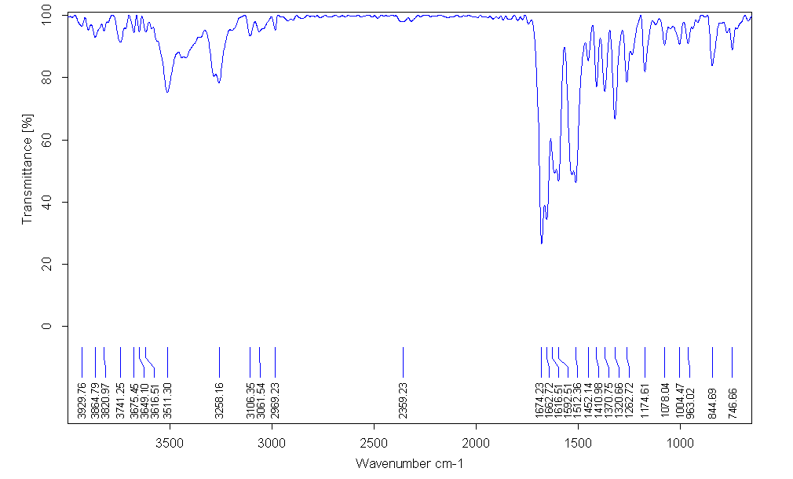
Fig.S10 FT-IR spectrum of L3
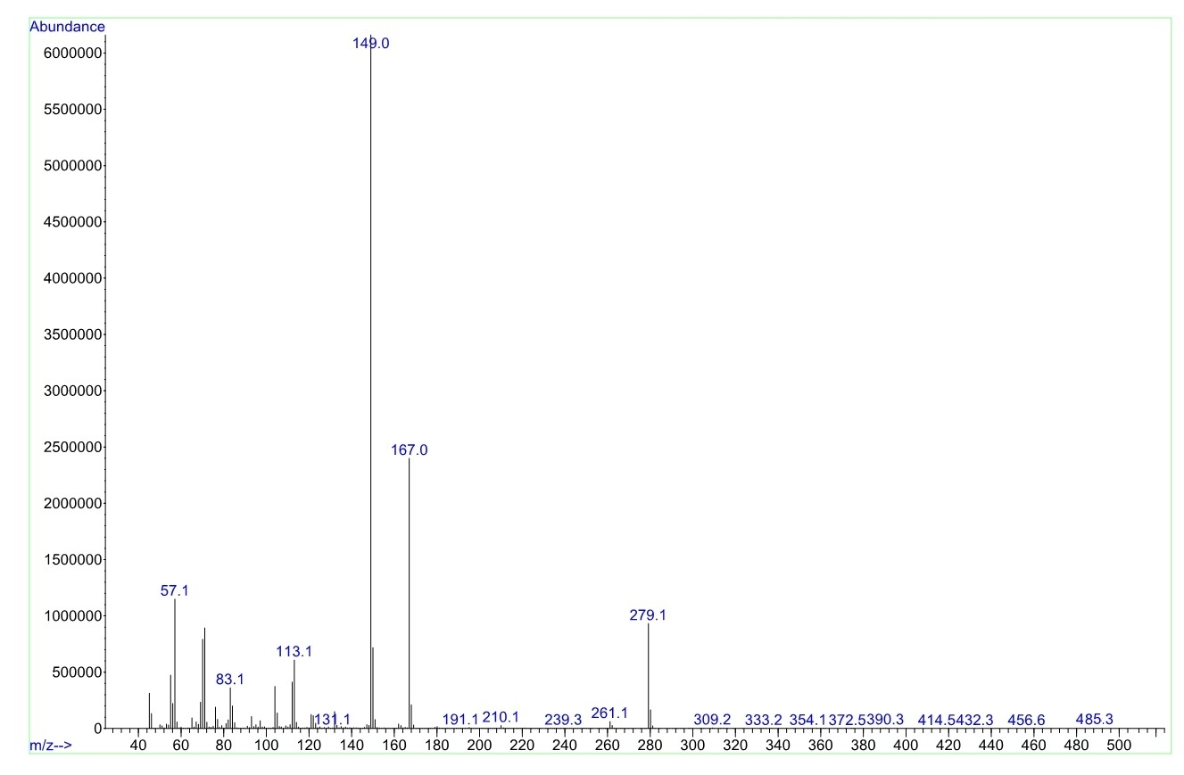
Fig. S11 Mass Spectrum of L3

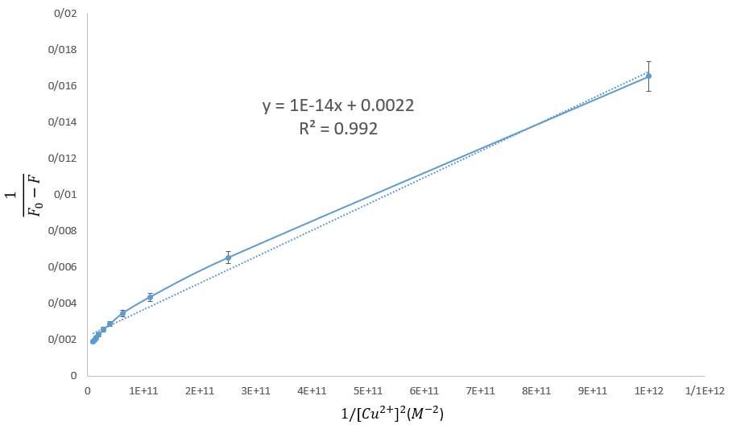
Fig. 12 Benesi–Hildebrand plot based on 1:2 association stoichiometry for receptor L3– Cu²⁺ complex (ex = 330 nm, em = 472 nm)

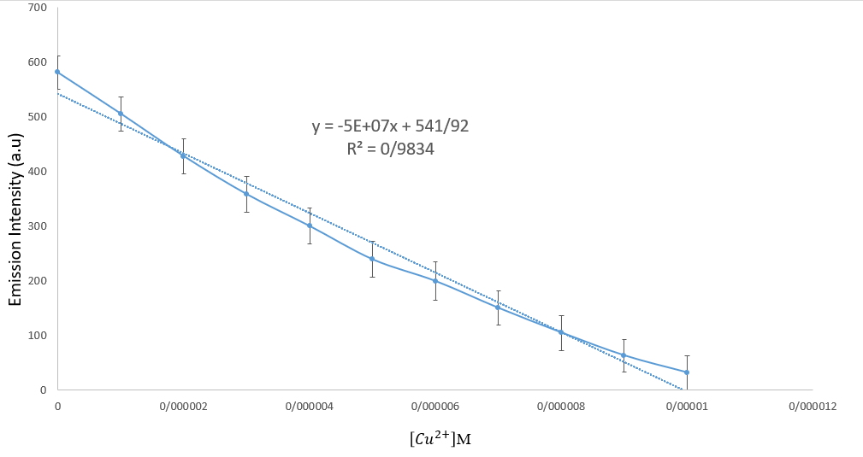
Fig. S13 Calibration curve of fluorescence intensity of receptor L3 ($5.0 × {10}^{-6 }M)$ with Cu²⁺ ion concentrations
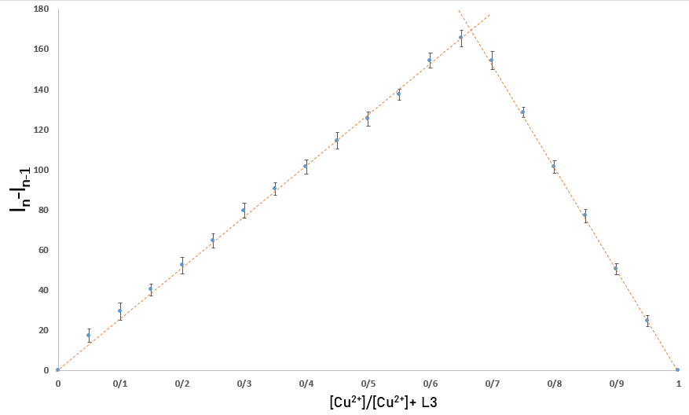
Fig. S14 Job plot analysis for L3-Cu²⁺ complex (ex = 330 nm, em = 472 nm)

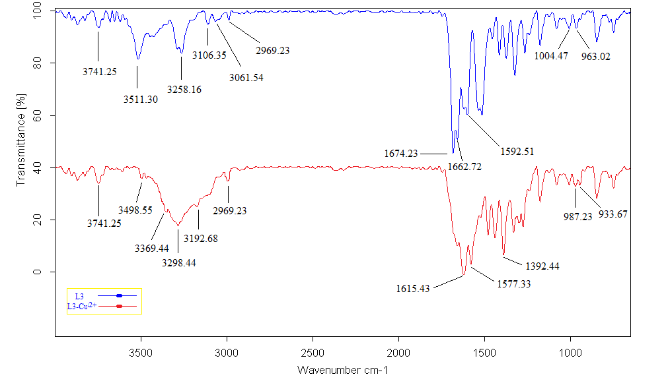
Fig. S15 IR spectral changes of L3 after the Cu²⁺ complexation
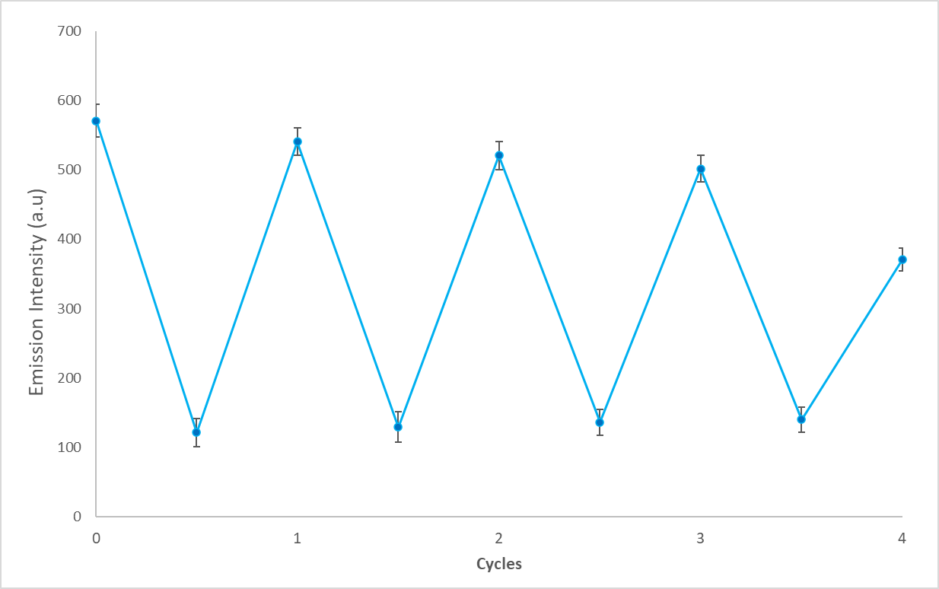
Fig. S16 Fluorescence emission intensity at 480 nm of compound L3 (5.0 μM) upon the alternate addition of Cu²⁺ and Na₂EDTA in several cycles in DMSO/H₂O (7/3, v/v) solution (ex = 330 nm, em = 472 nm)

