Supplementary Material for:

Study the Performance of Bi₂S₃‑Based Solar Cells with various Electron Transport Layers: A Numerical Investigation using DFT and SCAPS-1D
Vishvas Kumar
Department of Electronics and communication Engineering, SRM Institute of Science and Technology, Kattankulathur - 603203,Tamil Nadu, India

*Corresponding author: Vishvas Kumar
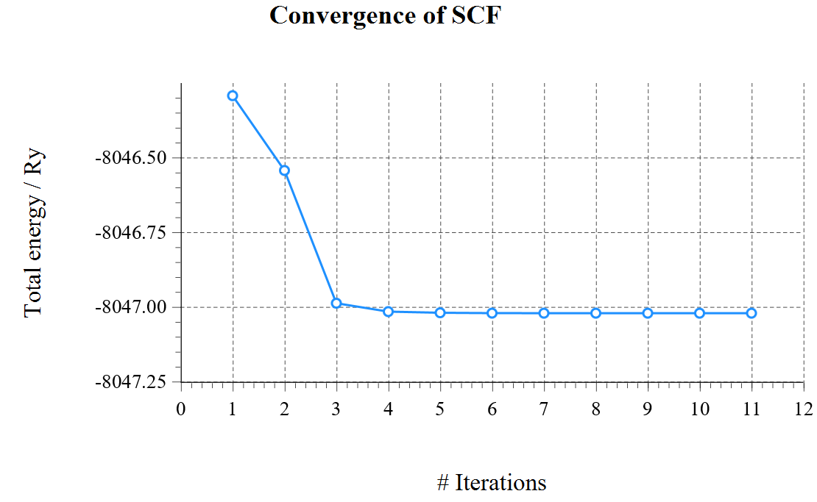
Fig. S1 SCF convergence of Bi₂S₃

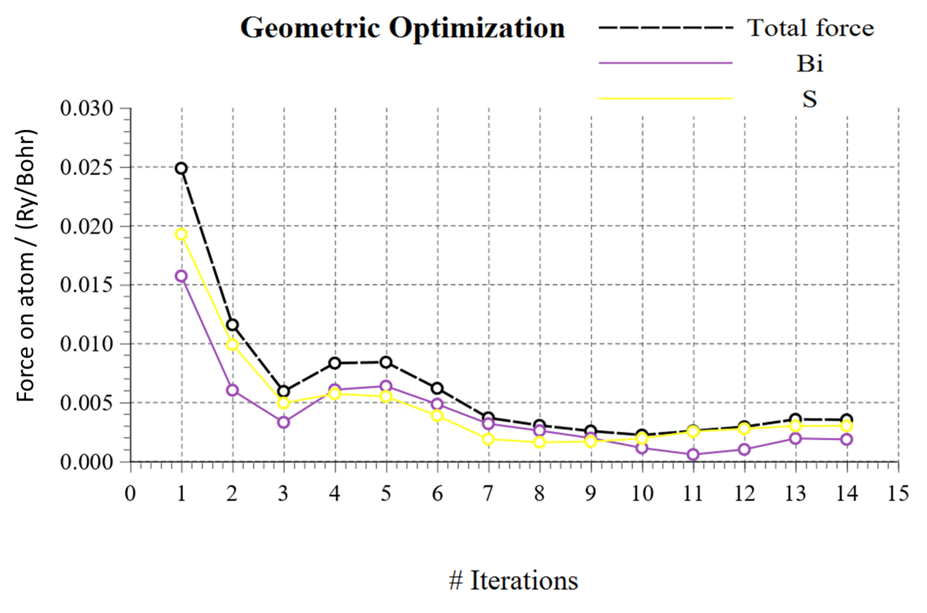
Fig. S2 Force on atom / (Ry/Bohr) convergence of Bi₂S₃

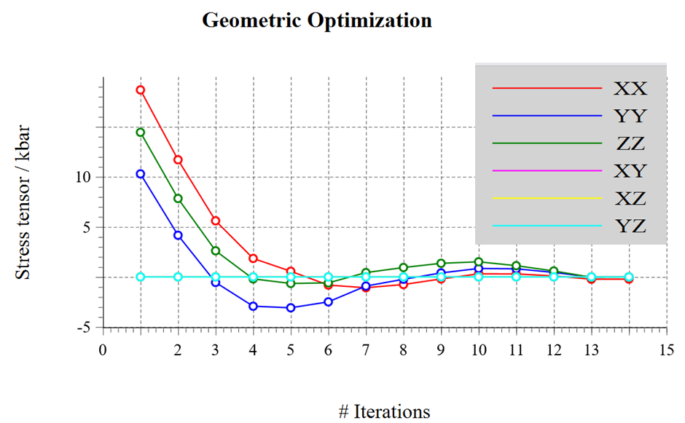
Fig. S3 Stress tensor / kbar convergence of Bi₂S₃

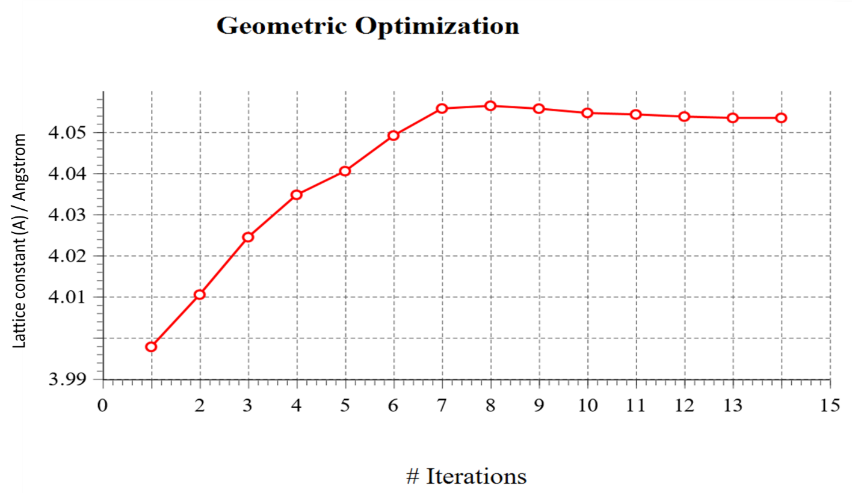
Fig. S4 Lattice constant (A) / Angstrom convergence of Bi2S3
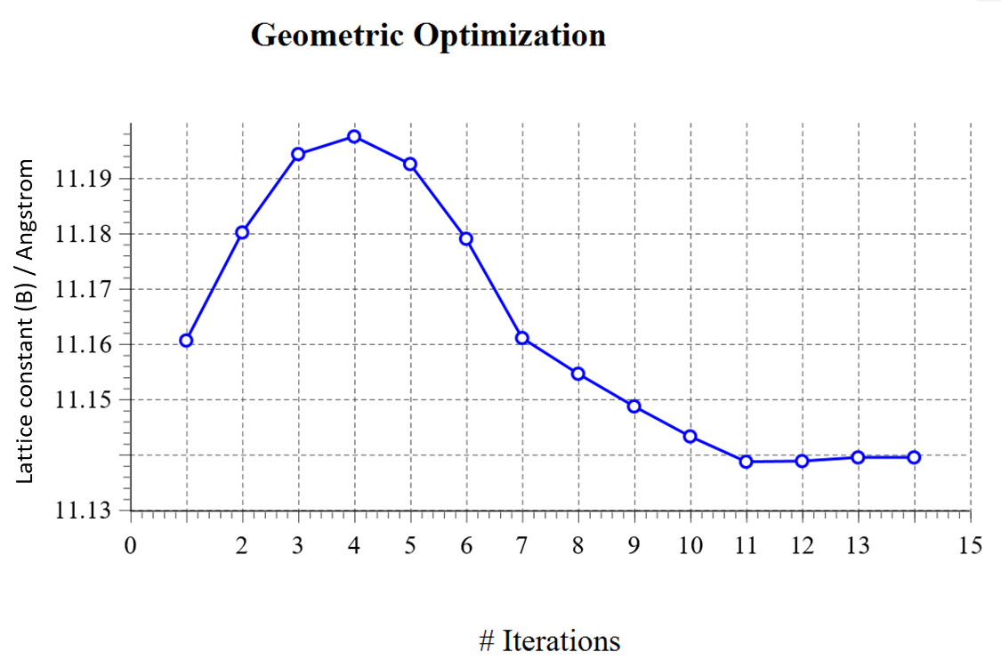
Fig. S5 Lattice constant (B) / Angstrom convergence of Bi₂S₃
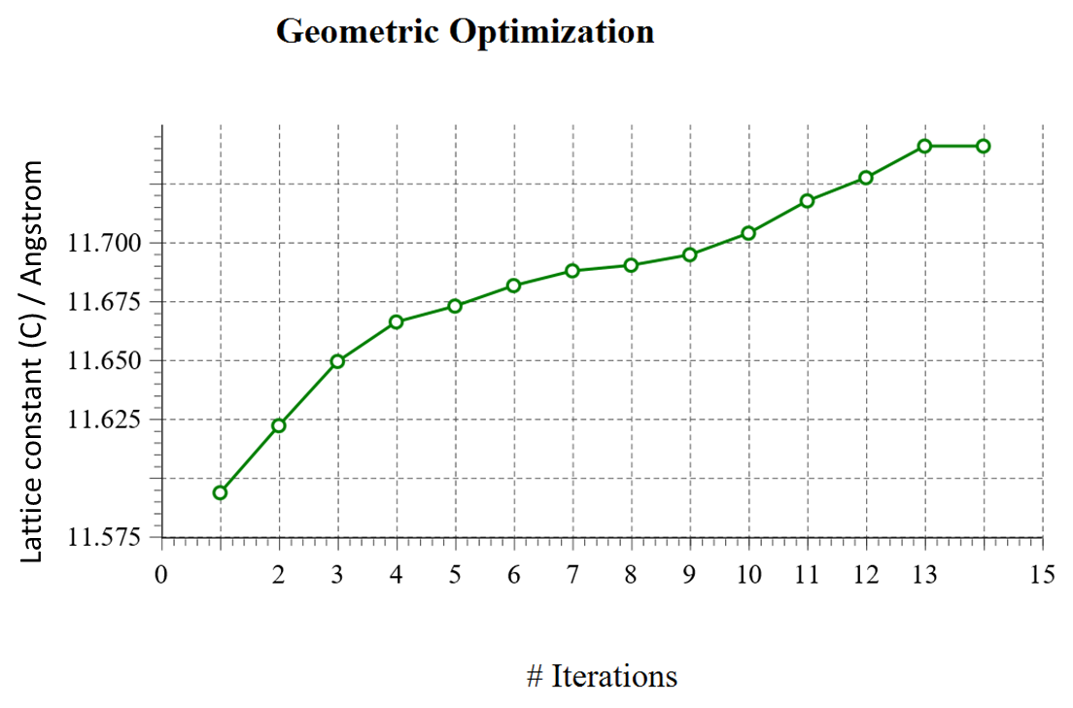
Fig. S6 Lattice constant (C) / Angstrom convergence of Bi₂S₃

