Supplementary Information
Cosolvent-induced Spontaneous Refolding of Lipase
Cheng Cheng¹*, Yongqin Su³, Lupeng Cui², Yumeng Qiu², Jialing Wang², Tianyue Jiang¹*, Bingfang He¹
¹School of Pharmaceutical Sciences, Nanjing Tech University, No. 30 Puzhu South Road, Nanjing, 211816, China
²College of Biotechnology and Pharmaceutical Engineering, Nanjing Tech University, No. 30 Puzhu South Road, Nanjing, 211816, China
³2011 College, Nanjing Tech University, No. 30 Puzhu South Road, Nanjing, 211816, China
*Corresponding author.
Cheng Cheng
E-mail address: Cheng2@njtech.edu.cn
Tianyue Jiang
E-mail address: tjiang@njtech.edu.cn

Table S1 Primers used in this study
Primers | Sequences
F1 | CATGCCATGGGCAACAAAGAAATTTTGGCTGTAGTTG
R1 | ATAAAGCTTCGCTTCGTCACCGAACCAGCAAATA
F2 | ATAAAGCTTCTGGTGCCACGCGGTTCTGCAACCGCGCCGGCGGACG
R2 | GCCTCGAGCACGCCCGCGAGTTTCAG
Ffu-lipaseF | GGAATTCCATATGCAACCGCGCCGGCGGA
Ffu-lipaseR | CCGCTCGAGCACGCCCGCGAGTTTCAGC
MBP-lipaseF | ATAGGATCCGGCAACCGCGCCGGCGGAC
MBP-lipaseR | GCAAGCTTCACGCCCGCGAGTTTCAGCCG
GST-lipaseF | ATAGGATCCGGCAACCGCGCCGGCGGAC
GST-lipaseR | ATAGCGGCCGCCACGCCCGCGAGTTTCAGCCG

Table S2 The detailed system parameters
system | Solvent molecules | Box size | Simulation time
Pure water | Water: 20062 | 8.67*8.67*8.67nm³ | 100ns
20% glycerol | Water: 14114 glycerol: 1344 | 8.67*8.67*8.67nm³ | 100ns
15% DMSO | Water: 17381 DMSO: 830 | 8.67*8.67*8.67nm3 | 100ns
4M TMAO | Water: 15927 TMAO: 800 | 8.67*8.67*8.67nm3 | 100ns

Formulas for calculating the number of solvent molecules in different systems:
1. For 20% Glycerol and 15% DMSO Systems:
·Number of solute molecules:
$N_{solute}=\frac{f_{solute}×V_{total}×ρ_{solute}}{M_{molar_solute}}×N_{A}$ (1)
- For 4M TMAO System:
·Number of solute molecules:
$N_{solute}=C_{solute}×V_{total}×{10}^{3}×\frac{ρ_{solute}}{M_{molar_solute}}×N_{A}$ (2)

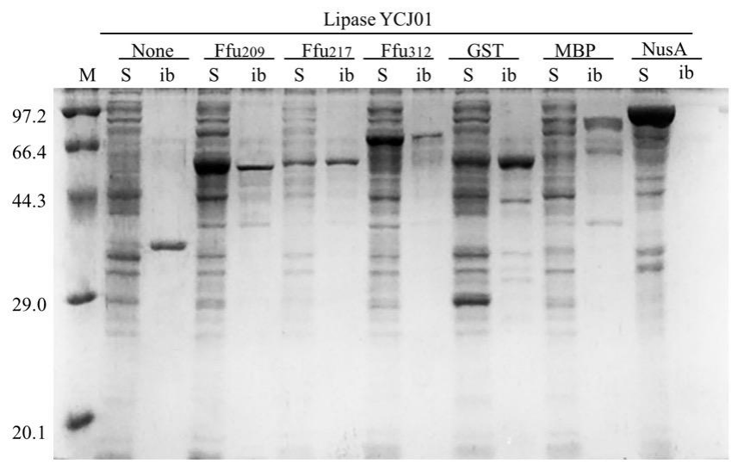
Fig. S1 Solubility enhancing effects of fusion tags (Ffu209, Ffu217, Ffu312, GST, MBP, and NusA) on lipase YCJ01

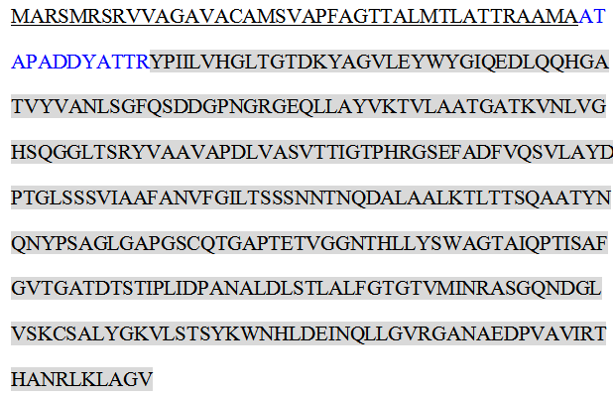
Fig. S2. The amino acid sequence of lipase YCJ01 is presented below. The signal peptide is underlined, the propeptide is highlighted in blue, and the mature lipase YCJ01 is shaded

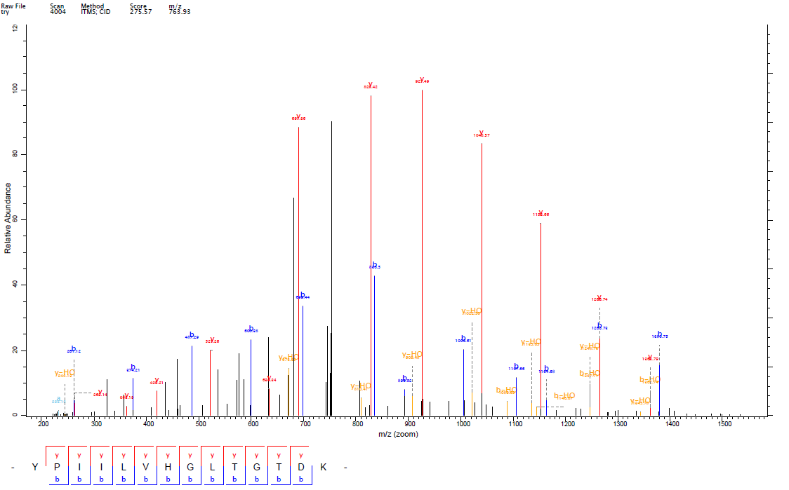
Fig. S3 NanoLC-MS/MS analysis of lipase YCJ01 after self-cleaving by chymotrypsin digestion

