Fig. 1
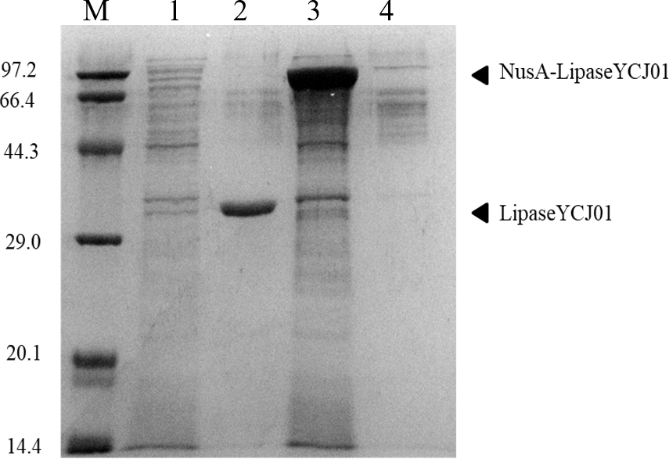

Fig. 2
LipaseYCJ01
NusA
NusA-LipaseYCJ01

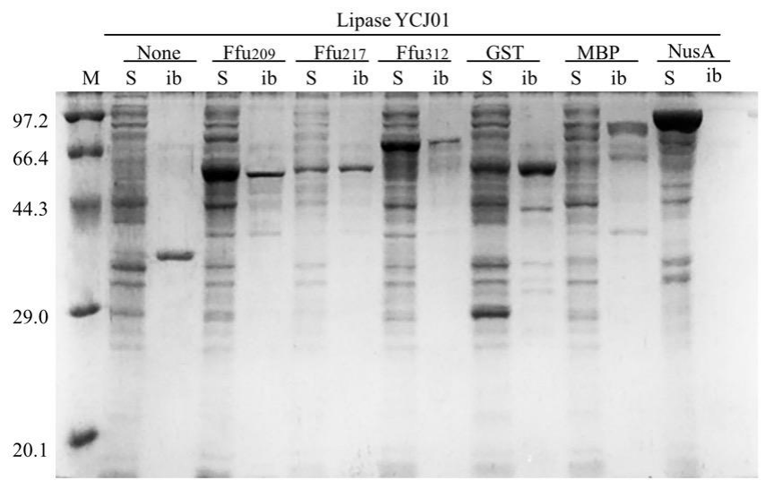

We ensure the authenticity (reproducibility) and reliability of the images, and all provided SDS-PAGE images are original.
All the author

