Hand-drawn Causal Loop Diagrams in the workshop by 4 working groups
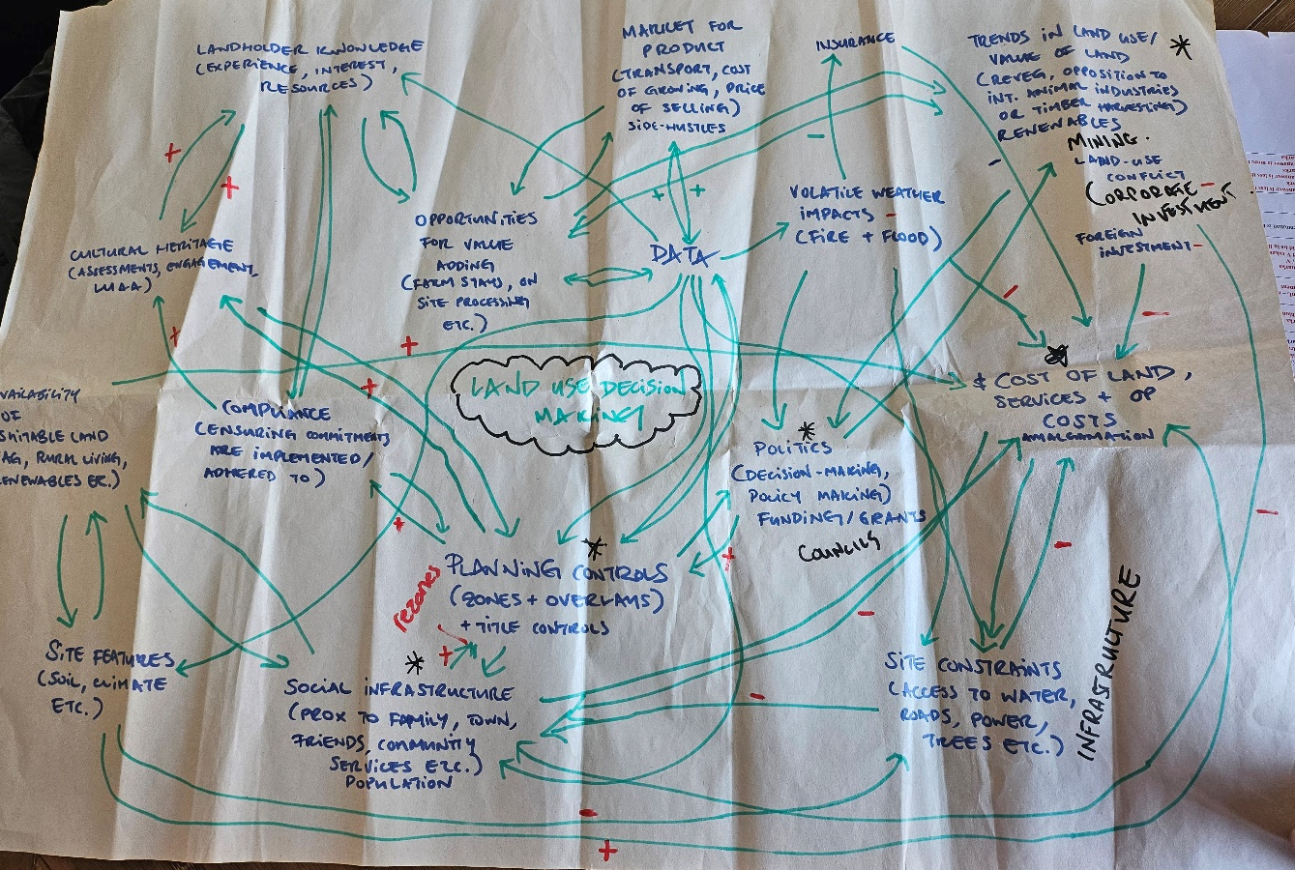
Figure 1: CLD 1- Workgroup 1
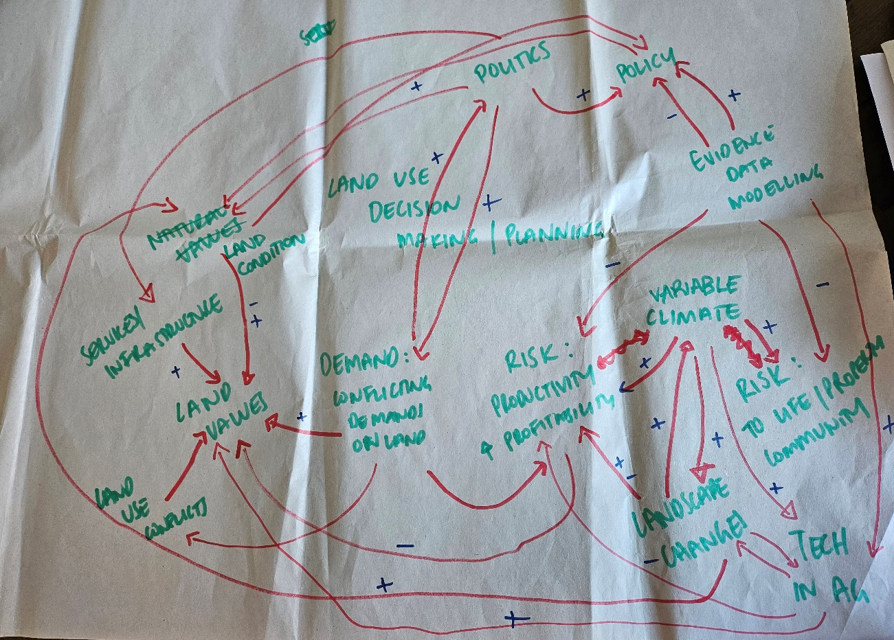
Figure 2: CLD 2 Workgroup 2
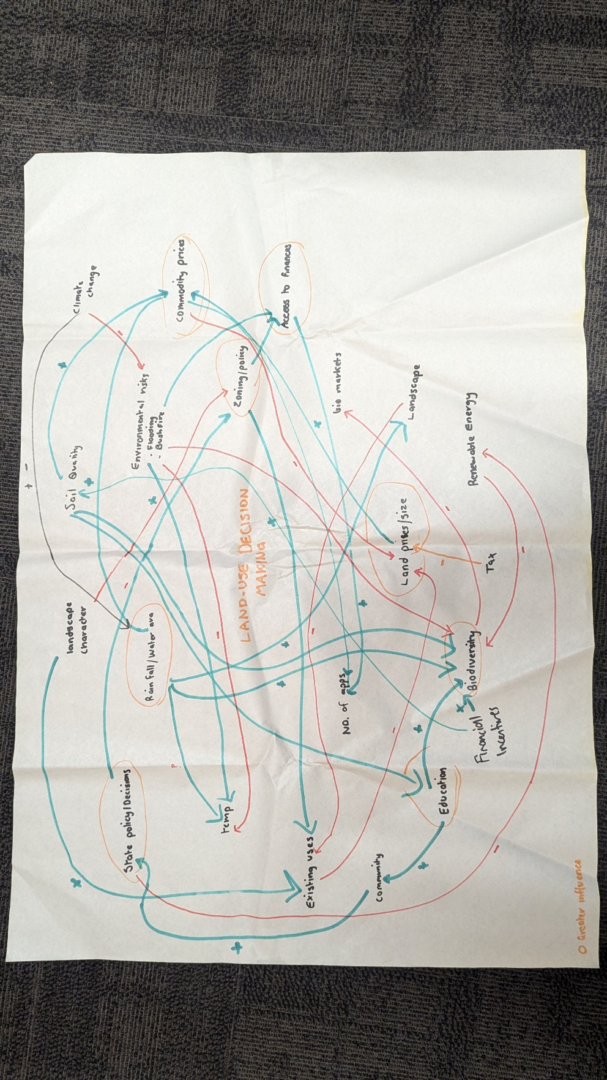
Figure 3: CLD 3 -Workgroup 3
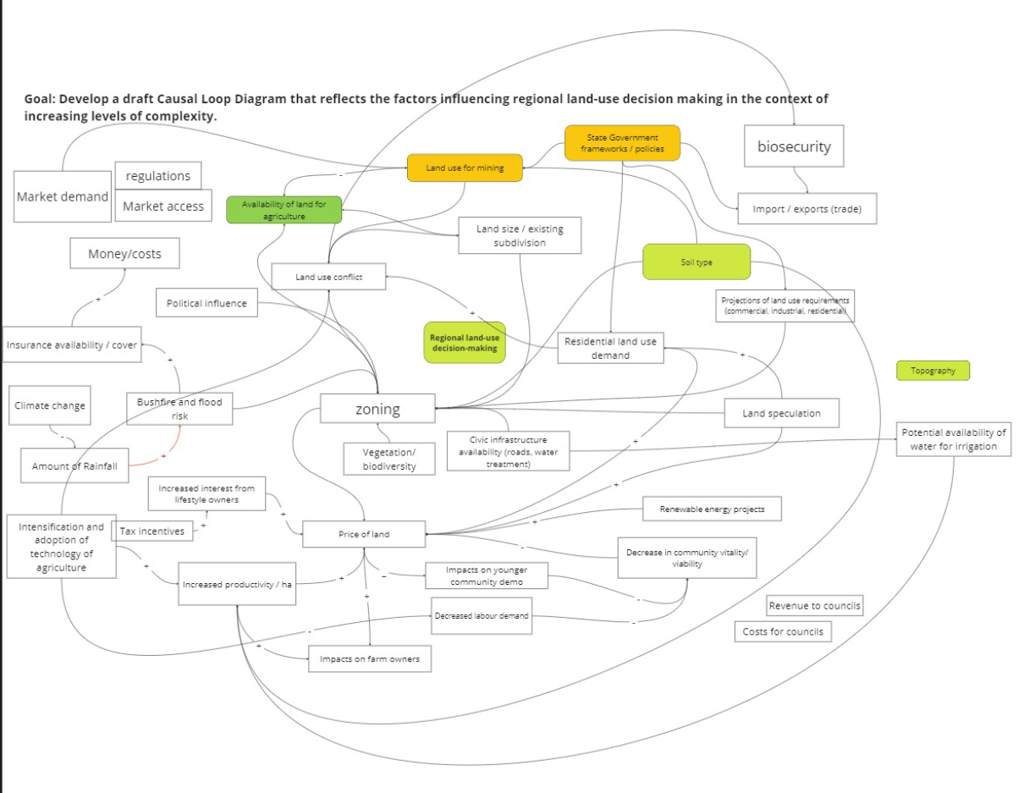
Figure 4: CLD 4 Workgroup 4 (Online)

Digitised CLD identifying relevant loops
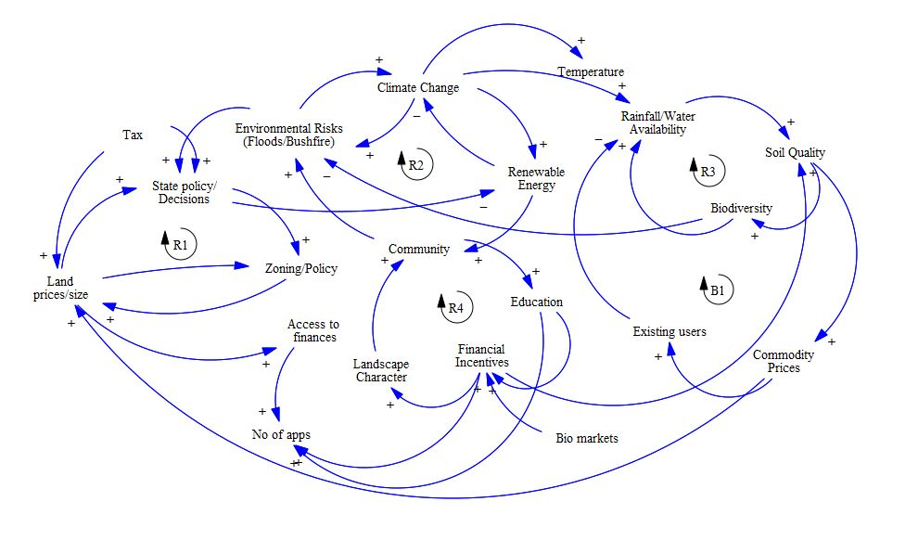
Figure 5: Digitised CLD 1
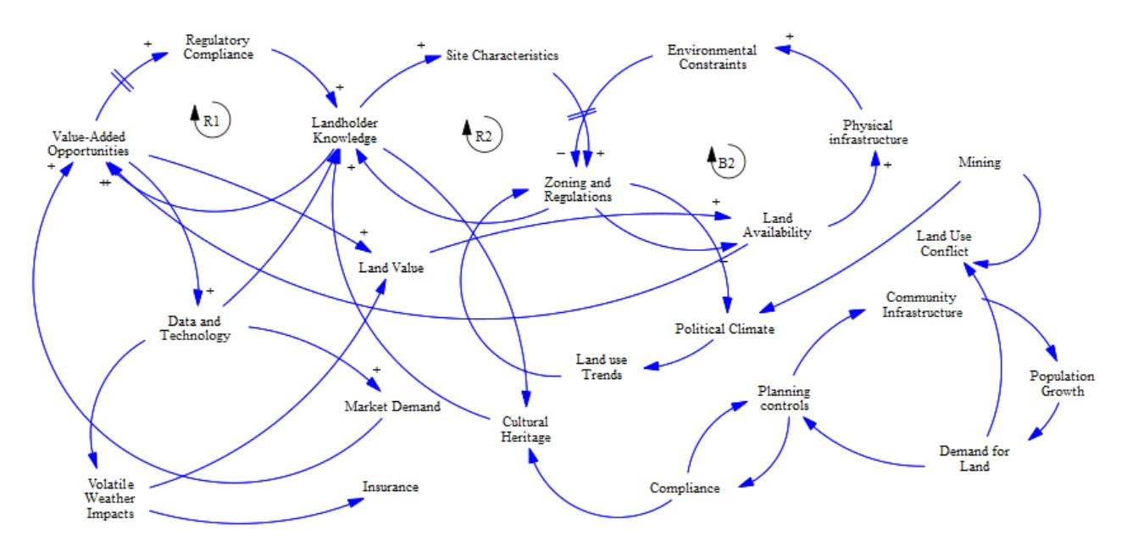
Figure 6: Digitised CLD 2
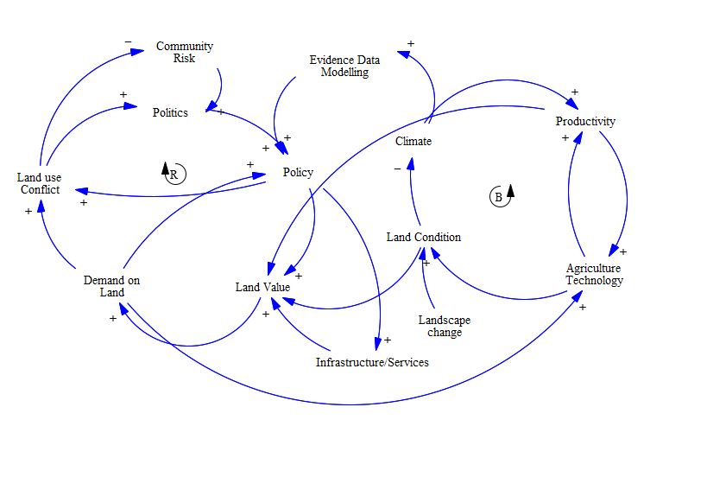
Figure 7: Digitised CLD 3
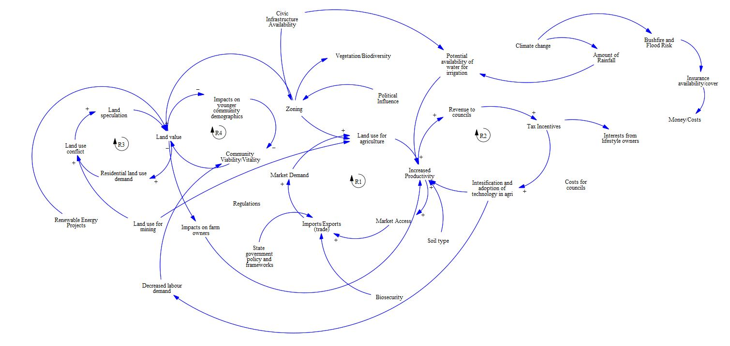
Figure 8: Digitised CLD 4

