SUPPLEMENTAL MATERIAL

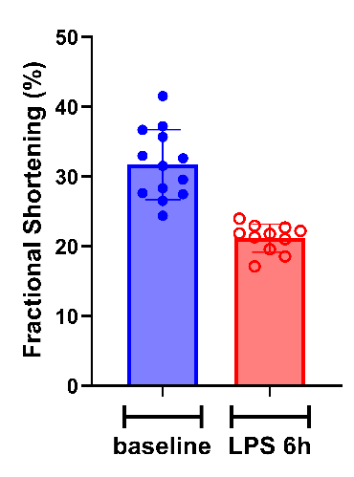
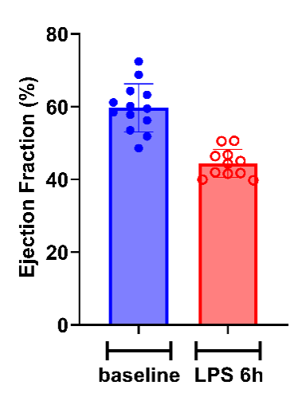
1. Intraperitoneal injection of LPS leads to a decline in cardiac function in WT (wild-type) mice.
Fig. S1. Echocardiographic measurement of LVEF and FS pre- and post-intraperitoneal injection of LPS

2. Intraperitoneal injection of LPS leads to Piezo1 protein increased in cardiac tissue from WT (wild-type) mice.
Fig. S2. Western blot results for cardiac tissue pre- and post-intraperitoneal injection of LPS.

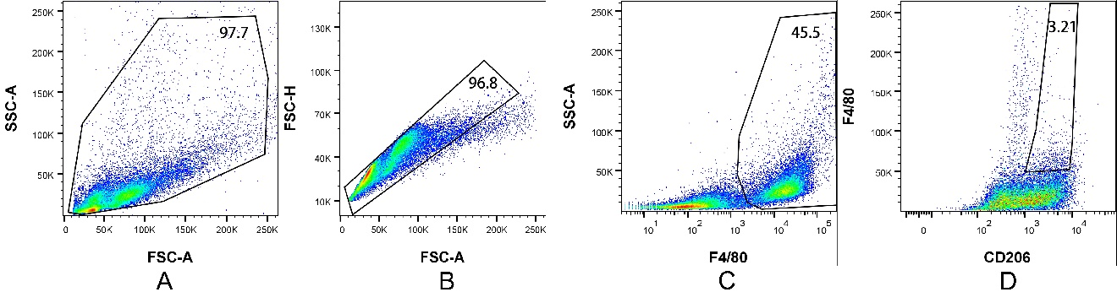
3. Flow cytometric gating strategy.
Fig. S3. The flow cytometry gating strategy. A. Exclude cell debris. B. Select singlet cells to eliminate cell aggregates. C. Identify F4/80 positive cells (macrophages). D. Select CD206 positive cells (M2-type macrophages).

4. Primer sequences for genotyping gene knockout mice.
Table S1. Primer sequences for gene identification
Gene | Sequence | Sequence (5' -> 3') | Length | Tm
Piezo1^{fl/fl} | Forward Primer | CCT TGC CCT TGT ACC TGT GC | 20 | 59.48
Piezo1^{fl/fl} | Reverse Primer | CCT GGC TGG AAA ATG GAA GAT | 21 | 55.11
Lyz2-Cre | Forward Primer | CCC AGA AAT GCC AGA TTA CG | 20 | 53.6
Lyz2-Cre | Reverse Primer | CTT GGG CTG CCA GAA TTT CTC | 21 | 56.68

- Main Reagents and Antibodies.
Table S2. Main Reagents and Antibodies
Product name | Brand | Catalog Number
TransDirect Mouse Genotyping Kit | Transgenbiotech |  |  | AD501-02
Tris Acetate-EDTA buffer (50x) | Beyotime |  |  | ST716
Agarose | Transgenbiotech |  |  | GS201-01
RIPA Lysis Buffer | Beyotime |  |  | P0012K
NuPAGE™ LDS Sample Buffer (4×) | Invitrogen |  |  | NP0007
NuPAGE™ Sample Reducing Agent (10×) | Invitrogen |  |  | NP0009
NuPAGE™ MOPS SDS Running Buffer (20×) | Invitrogen |  |  | NP0001
NuPAGE™ 4-12% Bis-Tris Gel 1.0mm x 12 well | Invitrogen |  |  | NP0322BOX
Omni-Flash™Western Blot Rapid Transfer Buffer (10×) | Omni-Flash |  |  | PS201S
Thermo Scientific PageRuler Prestained Protein Ladder | Thermo scientific |  |  | 26616
Thermo Scientific Spectra Multicolor High Range Protein Ladder | Thermo scientific |  |  | 26625
TBST (10×) | Applygen |  |  | B1009-TBST
BD Difco Skim Milk | Difco |  |  | 232100
Primary Antibody Dilution Buffer | Beyotime |  |  | P0023A-500ml
Immobilon Western | Millipore |  | WBKLS0100
Peroxidase-Conjugated Goat anti-Rabbit IgG (H+L) | ORIGENE |  |  | 2B-2301
Peroxidase-Conjugated Goat anti-Mouse IgG (H+L） | ORIGENE |  |  | 2B-2305
β-Actin Monoclonal antibody | Proteintech |  |  | 66009-1-Ig
α-Tubulin Polyclonal antibody | Proteintech |  |  | 11224-1-AP
Piezo1 (extracellular domain) Polyclonal antibody | Proteintech |  |  | 15939-1-AP
IL-1β Polyclonal antibody | Proteintech |  |  | 26048-1-AP
IL-6 Polyclonal antibody | Proteintech |  |  | 26404-1-AP
IL-6 (D3K2N) Rabbit mAb | Cell Signaling Technology |  |  | 12153
IL-10RA Polyclonal antibody | Proteintech |  |  | 13356-1-AP
Phospho-Akt (Ser473) (D9E) XP® Rabbit mAb (Biotinylated) | Cell Signaling Technology |  |  | 5012S
Akt (pan) (11E7) Rabbit mAb | Cell Signaling Technology |  |  | 4685S
Phospho-S6 Ribosomal Protein (Ser240/244) (D68F8) XP® Rabbit mAb | Cell Signaling Technology |  |  | 5364S
Anti-Osteopontin antibody [RM1018] | Abcam |  |  | AB283656
Amersham Protran | Cytiva |  |  | 10600007
Lipopolysaccharides from Escherichia coli O111:B4 | Sigma-Aldrich |  |  | L2630
Phosphate Buffered Saline (1×) | Servicebio |  |  | G4202-500ML
Corning® 500 mL RPMI 1640 | CORNING |  |  | 10-040-CV
Gibco DMEM basic (1X) | Gibco |  |  | C11885500BT
Macrophage colony-stimulating factor (M-CSF) | Merck |  |  | HY-P70553
TransSerum® RQ Fetal Bovine Serum | Transgenbiotech |  |  | FS401-02
Penicillin-Streptomycin Solution, 100X | Solarbio |  |  | P1400
Thioglycollate Broth Medium | Solarbio |  |  | LA8740
FIX&PERM Cell Permeabilization Kit | Invitrogen |  |  | GAS003
Purified anti-mouse CD16/32 Antibody | Biolegend |  |  | 101302
Alexa Fluor® 647 anti-mouse F4/80 Antibody | Biolegend |  |  | 123122
CD86 (B7-2) Monoclonal Antibody (GL1), PE, eBioscience™ | Invitrogen |  |  | 12-0862-82
CD206 (MMR) Monoclonal Antibody (MR6F3), Alexa Fluor™ 488, eBioscience™ | Invitrogen |  |  | 53-2061-82

Full Unedited Gel Figures

Full uncropped gels for Figure 1D. The red rectangle indicates the portion of the blot displayed in the manuscript.

Full uncropped immunoblots for Figure 1E. The red rectangle indicates the portion of the blot displayed in the manuscript.
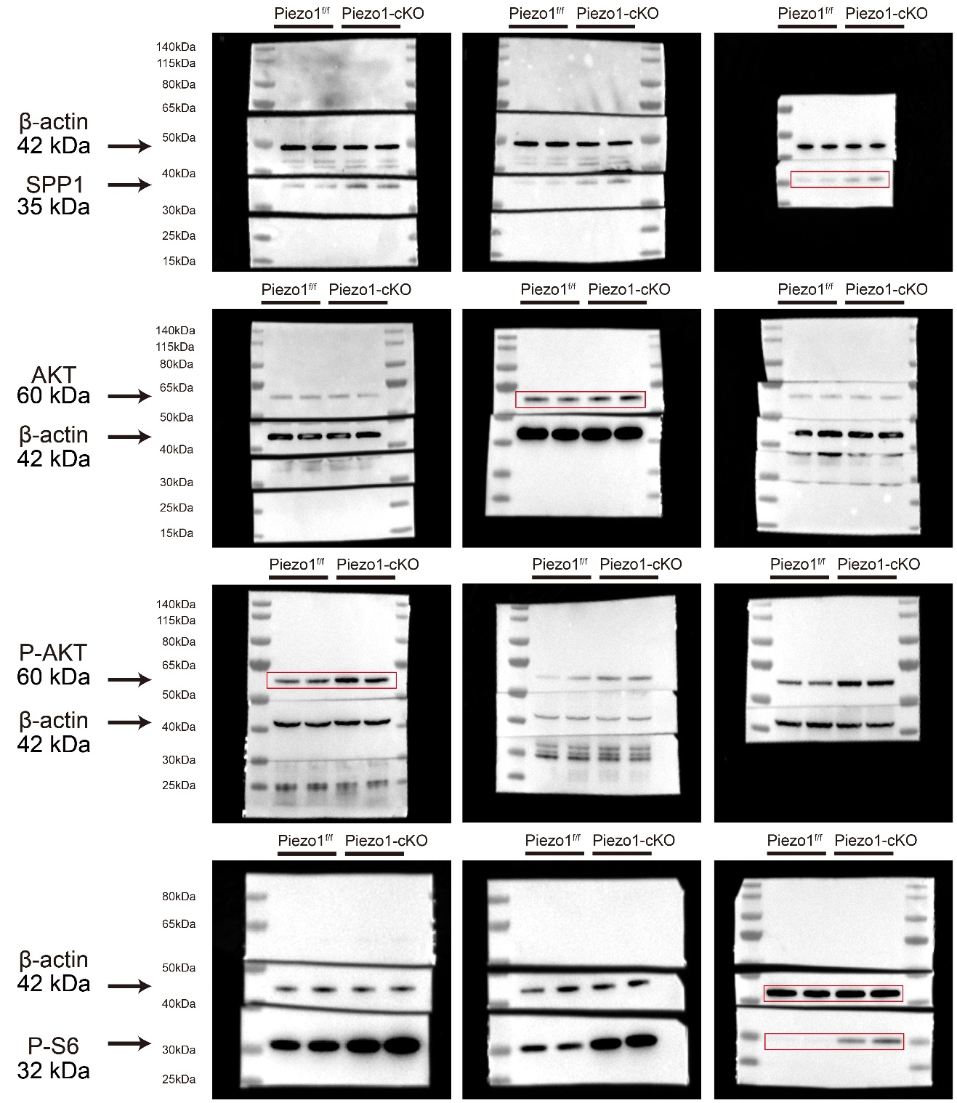

Full uncropped immunoblots for Figure 3E. The red rectangle indicates the portion of the blot displayed in the manuscript.

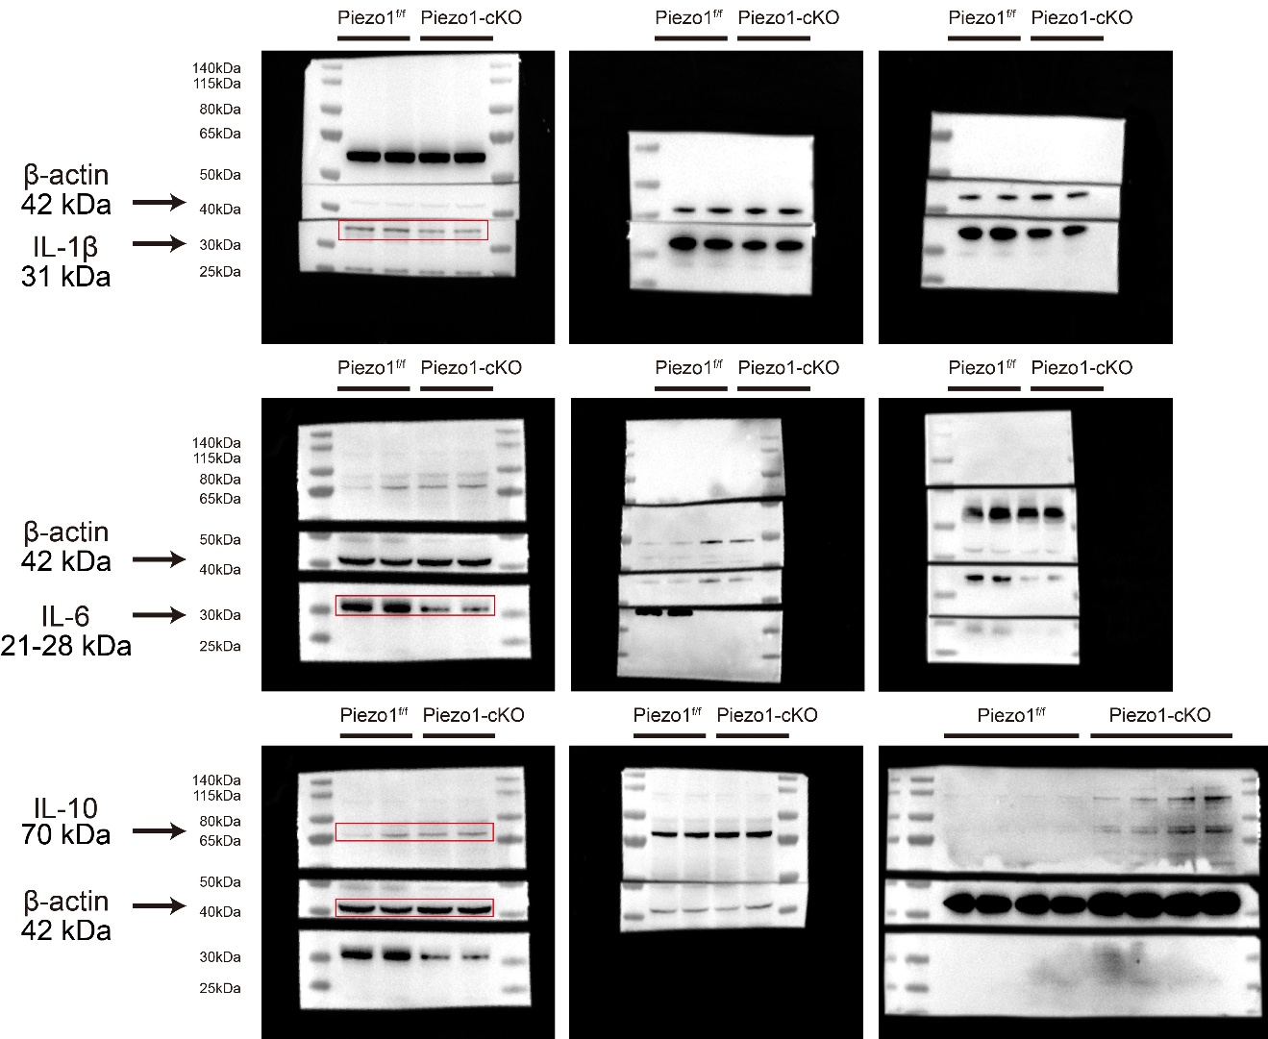

Full uncropped immunoblots for Figure 3F. The red rectangle indicates the portion of the blot displayed in the manuscript.

Full uncropped immunoblots for Figure S2. The red rectangle indicates the portion of the blot displayed in the manuscript.

