Screening of multidrug-resistant coliforms from fruit juice and their significant correlations with the developmental deformities of Artemia salina (Brine shrimp)
Md. Nazmul Haque¹, Afrin Priya Talukder², Shaila Shaimun Diba³, Md. Salah Uddin¹, Md. Abu Saleh*¹, Shahriar Zaman¹, Md. Akhtar-E-Ekram¹*,
¹Department of Genetic Engineering and Biotechnology, University of Rajshahi, Rajshahi-6205, Bangladesh;
²Department of Applied Biosciences, Macquarie University, NSW-2109, Sydney, Australia; afrinpriya.talukder@students.mq.edu.au (A.P.T.)
³Department of Oceanography, Faculty of Marine Sciences and Fisheries, University of Chittagong-4331, Bangladesh; shaimunshaila.97@gmail.com (S.S.D.)

*Correspondence: saleh@ru.ac.bd (M.A.S.); ekram_2012@ru.ac.bd (M.A.E.E);

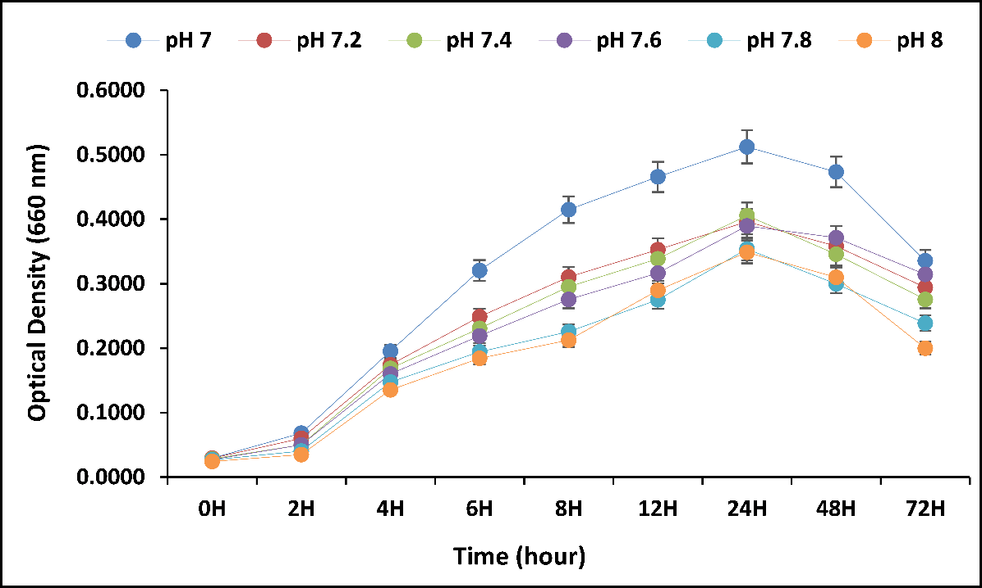
Fig. S1. Effect of optimum pH level on the growth of Acinetobacter sp. up to 72 hours of incubation period

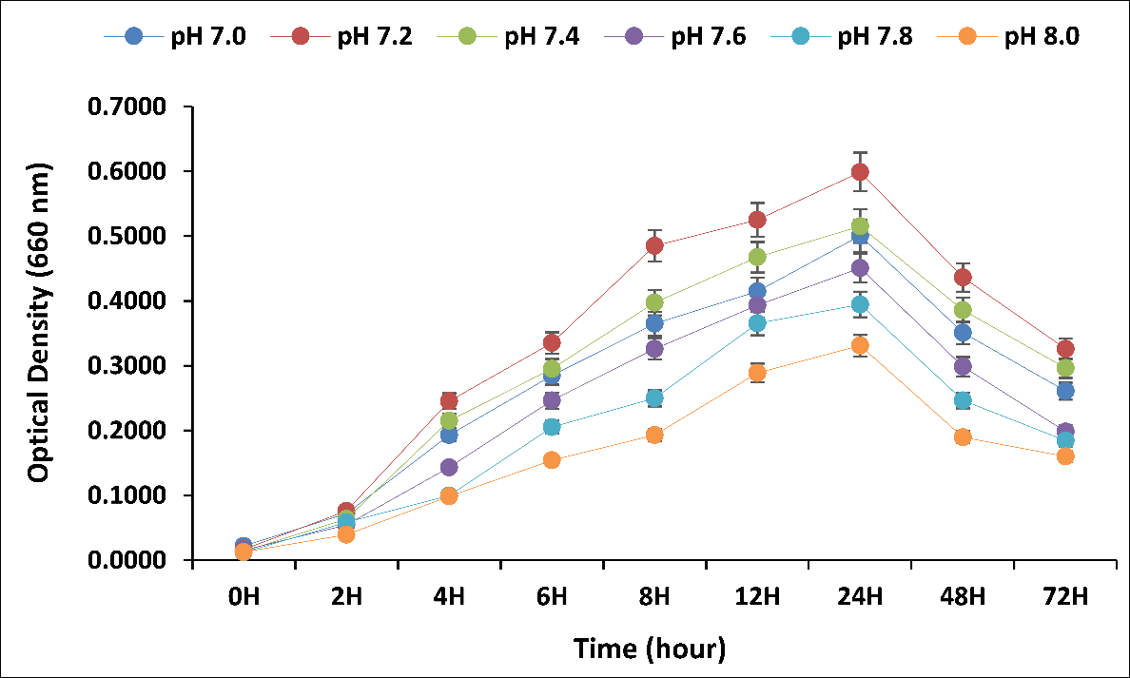
Fig. S2. Effect of optimum pH level on the growth of Klebsiella sp. up to 72 hours of incubation period

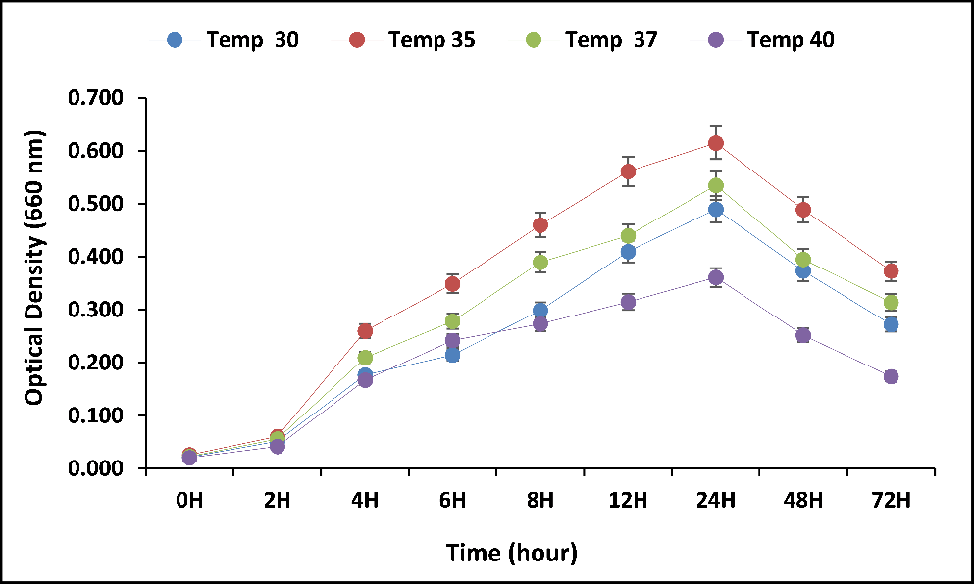
Fig. S3. Effect of temperature variations on the growth of Acinetobacter sp. up to 72 hours of incubation period

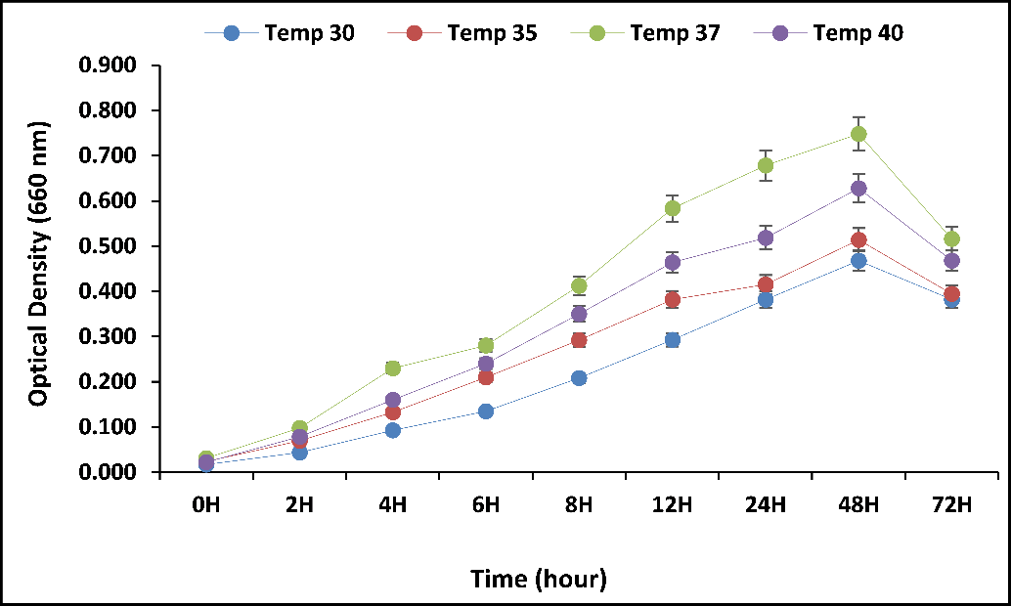
Fig. S4. Effect of temperature variations on the growth of Klebsiella sp. up to 72 hours of incubation period

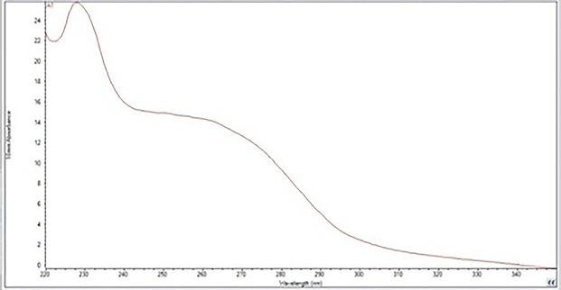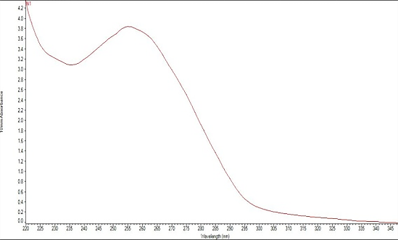

Fig. S5. DNA quantification analysis of Acinetobacter sp. Fig. S6. DNA quantification analysis of Klebsiella sp.

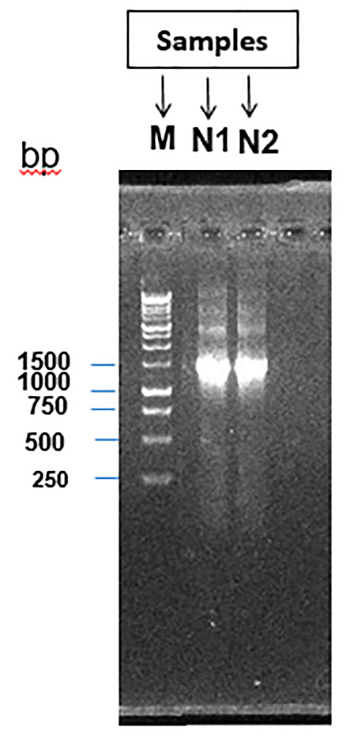
M= DNA ladder (Marker)
N1=Acinetobacter sp.
N2= Klebsiella sp.
Fig. S7. 16s rDNA gene profiles of 27F & 1492R primers generated from two different bacterial species N1 (Acinetobacter sp.) and N2 (Klebsiella sp.). M denotes 1kb DNA ladder (marker)

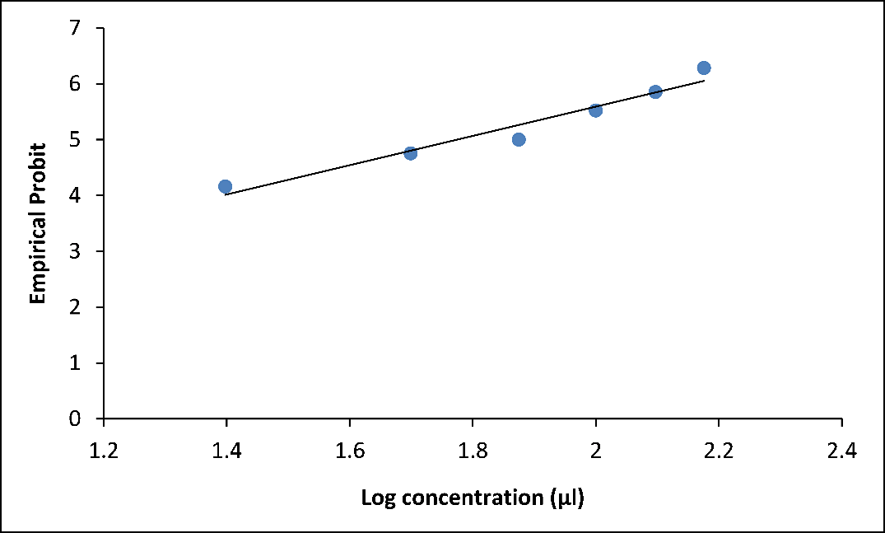
Fig. S8. Regression line of log dose of Acinetobacter sp. against brine-shrimp nauplii after 24 hours of exposure

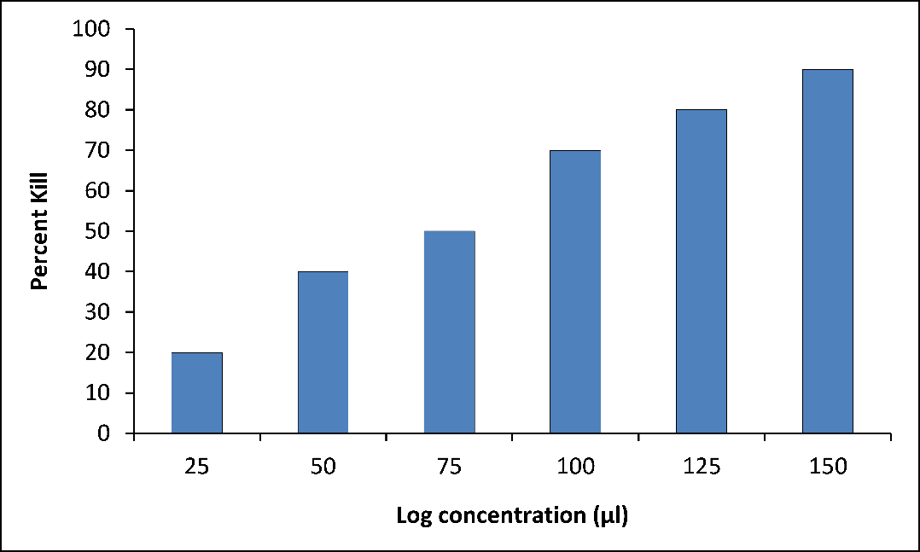
Fig. S9. Percent mortality of brine shrimp by Acinetobacter sp. after 24 hours of exposure

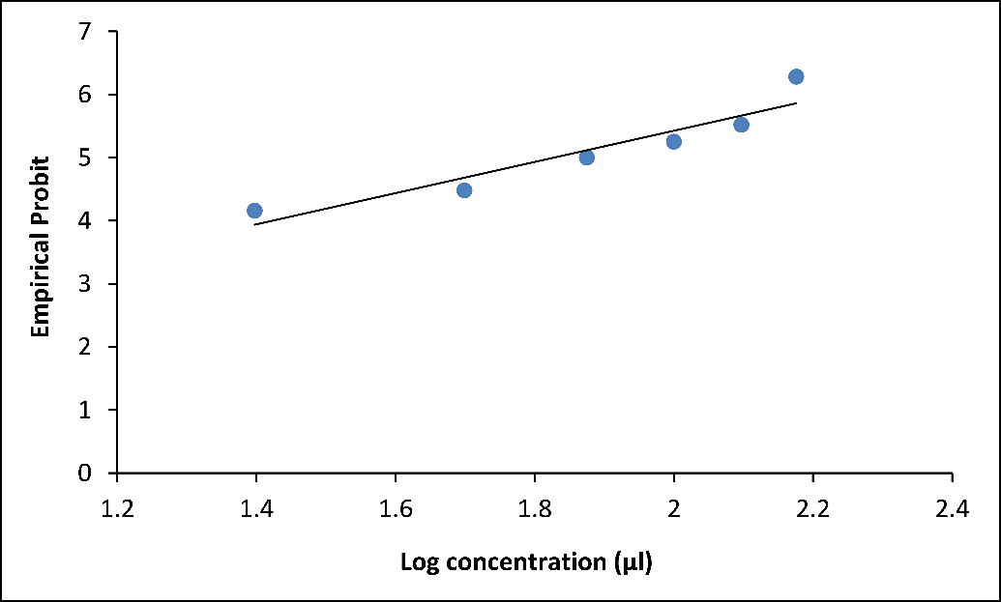
Fig. S10. Regression line of log dose of Klebsiella sp. against brine-shrimp nauplii after 24 hours of exposure

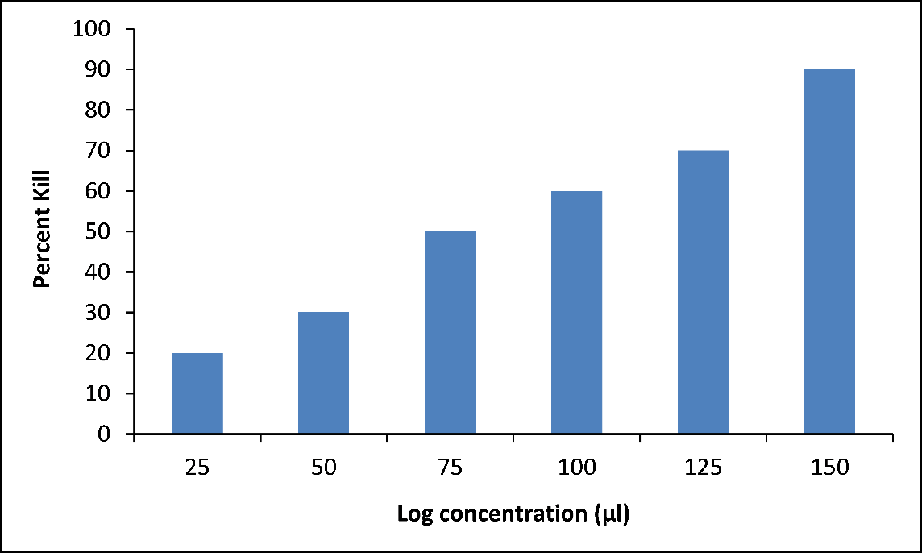
Fig. S11. Percent mortality of brine shrimp by Klebsiella sp. after 24 hours of exposure

Table S1 Global and pairwise analysis of similarities (ANOSIM) showing significant dissimilarities in the Isolate A and Isolate B treated Artemia at different time intervals compared to controls. P< 0.05 indicates significantly different global ANOSIM tests. Significance levels: 0 ‘***’ 0.001 ‘**’ 0.01 ‘*’ 0.05, ‘.’ 0.1.
Categories | ANOSIM Test
Categories | SQRT+Bray-Curtis
Bacterial Treatment | R | P | Sign. Level
Global test for Stationary Phase | 0.646 | 0.001 | ***
Global Test for Exponential Phase | 0.52 | 0.002 | **

