Supplementary Table S1. Physiological ranges of prehospital and emergency department measurements

Variable | Definition
Heart rate | Greater than 0 beats per minute (bpm) but less than or equal to 300 bpm
Systolic blood pressure | Greater than 0 mmHg but less than or equal to 300 mmHg
Diastolic blood pressure | Greater than 0 mmHg but less than or equal to 200 mmHg
Respiratory rate | Greater than 0 breaths per minute
SpO₂ (%) | Greater than 0% but less than or equal to 100%
Temperature | Between 80.0º F and 110º F
Glucose | Greater than 0 mg/dL but less than or equal to 1,500 mg/dL

Supplementary Table S2. Comparisons of stroke vs. non-stroke patients and encounters.

Demographics | Stroke patients  (N=151) | Non-stroke patients  (N=4,603) | p-value | Stroke encounters  (N=192) | Non-stroke encounters  (N=8,796) | p-value
Age | 70 [61, 79] | 63 [49, 76] | <0.01* | 72 [62, 80] | 64 [52, 78] | <0.01*
Gender, N (%) |  |  | 0.95 |  |  | 0.78
Female | 78 (51.7%) | 2,405 (52.2%) |  | 104 (54.2%) | 4,772 (54.3%)
Male | 73 (48.3%) | 2,198 (47.8%) |  | 88 (45.8%) | 3,832 (43.6%)
Race/Ethnicity, N (%) |  |  | <0.01* |  |  | <0.01*
Non-Hispanic White | 65 (43.0%) | 1,890 (41.1%) |  | 81 (42.2%) | 3,244 (36.9%)
Non-Hispanic Black | 67 (44.4%) | 2,381 (51.7%) |  | 88 (45.8%) | 4,883 (55.5%)
Non-Hispanic Other | 4 (2.6%) | 87 (1.9%) |  | 7 (3.6%) | 133 (1.5%)
Hispanic | 9 (6.0%) | 200 (4.3%) |  | 10 (5.2%) | 292 (3.3%)
Height (in) | 66 [63, 70] | 66 [63, 70] | 0.64 | 66 [63, 70] | 66 [63, 70] | 0.65
Weight (lb) | 194.9 [164.1, 232.5] | 175.7 [145.0, 213.8] | <0.01* | 190.0 [155.2, 230.0] | 172.0 [141.0, 210.0] | <0.01*
BMI (kg/m²) | 30.1 [27.1, 37.5] | 27.6 [23.8, 33.3] | <0.01* | 29.9 [26.0, 35.7] | 27.4 [23.2, 33.0] | <0.01*
Prehospital measurements | 2 [1, 3] | 1 [1, 2] | 0.01* | - | - | -
BMI, body mass index; Q1, first quartile; Q3, third quartile. Race/ethnicity was missing for 51 patients (59 visits), height for 2,733 patients (5,544 visits), weight for 1,862 patients (3,735 visits), BMI for 2,800 patients (5,661 visits). Data shown as median (IQR) for age, vitals, and prehospital measurement count.

Supplementary Table S3. Spearman’s correlation coefficients between initial prehospital vital signs and emergency department vital signs.

 | Prehospital vs. ED measures  (All encounters) |  |  | Prehospital vs. ED measures  (Any Stroke)
 | N | $ρ$ (95% CI) | p-value | N | $ρ$ (95% CI) | p-value
Heart rate | 8,043 | 0.72 (0.71, 0.73) | <0.0001 | 173 | 0.68 (0.60, 0.76) | <0.0001
Systolic blood pressure | 7,988 | 0.62 (0.61, 0.63) | <0.0001 | 185 | 0.65 (0.55, 0.72) | <0.0001
Diastolic blood pressure | 7,732 | 0.48 (0.46, 0.50) | <0.0001 | 182 | 0.52 (0.41, 0.62) | <0.0001
Respiratory rate | 8,161 | 0.21 (0.19, 0.23) | <0.0001 | 187 | 0.07 (-0.08, 0.21) | 0.38
Oxygen saturation | 7,796 | 0.30 (0.28, 0.32) | <0.0001 | 183 | 0.22 (0.08, 0.36) | 0.003
Temperature | 598 | 0.44 (0.37, 0.50) | <0.0001 | 16 | 0.57 (0.12, 0.83) | 0.02
Glucose | 3,678 | 0.73 (0.72, 0.75) | <0.0001 | 83 | 0.73 (0.60, 0.81) | <0.0001
Glasgow Coma Scale | 6,607 | 0.53 (0.51, 0.54) | <0.0001 | 129 | 0.71 (0.62, 0.79) | <0.0001
ED, emergency department.

Supplementary Table S4. Emergency department measurements regressed on prehospital measurements for full cohort, adjusting for time between measurements (per 10-minute increase in transit time).
 | N | Intercept estimate  (95% CI) | p-value | Change in ED estimate per increase in prehospital measurement  (95% CI) | p-value | Change in ED estimate per 10-minute increase in transit time  (95% CI) | p-value
Heart rate | 172 | 19.3 (4.5, 34.0) | 0.01 | 0.8 (0.6, 0.9) | <0.01 | -0.1 (-0.6, 0.8) | 0.86
Systolic blood pressure | 184 | 64.9 (47.0, 82.8) | <0.01 | 0.6 (0.5, 0.7) | <0.01 | -0.4 (-2.0, 1.1) | 0.58
Diastolic blood pressure | 182 | 46.9 (34.5, 59.3) | <0.01 | 0.5 (0.4, 0.6) | <0.01 | -0.8 (-1.6, -0.1) | 0.04
Respiratory rate | 186 | 15.1 (9.1, 21.2) | <0.01 | 0.2 (-0.1, 0.6) | 0.18 | -0.2 (-0.4, 0.1) | 0.12
Oxygen saturation | 182 | 86.6 (71.2, 102.2) | <0.01 | 0.1 (-0.1, 0.3) | 0.15 | -0.1 (-0.2, 0.1) | 0.43
Temperature | 16 | 39.7 (-23.3, 102.6) | 0.22 | 0.6 (-0.1, 1.2) | 0.07 | -0.1 (-0.1, 0.0) | 0.01
Glucose | 82 | 44.1 (10.9, 77.3) | 0.01 | 0.8 (0.6, 1.0) | <0.01 | -1.8 (-3.8, 0.3) | 0.09
Glasgow Coma Scale | 127 | 3.1 (-0.1, 6.2) | 0.06 | 0.8 (0.6, 1.0) | <0.01 | -0.1 (-0.2, 0.1) | 0.36

Supplementary Table S5. Comparison of prehospital stroke scale assessment results with true labels.
 | Stroke Scale Screening Assessment
 | Normal | Abnormal | Non-Conclusive | Not Applicable/Known/Available | NaN
Non-Stroke | 1,066 | 91 | 66 | 176 | 7,205
Non-Severe Stroke | 16 | 17 | 5 | 0 | 23
Severe Stroke | 15 | 34 | 1 | 3 | 78
Categorizes stroke scale results across all 8,796 encounters, including cases where CPSS was not performed (NaN values).

Supplementary Table S6. Confusion matrices of EMS and CPSS performance in stroke identification.
True Label | Predicted Non-Stroke (All Encounters) | Predicted Stroke  (All Encounters) | Predicted Non-Stroke (CPSS Subset) | Predicted Stroke  (CPSS Subset)
True Non-Stroke | 8,447 | 157 | 1,242 | 157
True Stroke | 135 | 57 | 34 | 57
‘All Encounters’ includes all patient transports (n=8,796), while the ‘CPSS Subset’ is limited to trips where CPSS was performed (n=1,490). In both, non-severe and severe strokes are grouped as ‘True Stroke’, and ‘Abnormal’ or ‘Non-Conclusive’ CPSS results are grouped as ‘Predicted Stroke’. For all encounters, ‘Predicted Non-Stroke’ includes ‘Normal’, ‘Not Applicable/Known/Available’, and missing CPSS values, while the missing values are excluded for the CPSS subset.

Supplementary Table S7. Threshold-based performance of the random forest model for stroke and the XGBoost model for severe stroke among EMS encounters where stroke was suspected (n=1,490).
Stroke (random forest) |  |  | Severe Stroke (XGBoost)
Threshold | Sensitivity | Specificity | Threshold | Sensitivity | Specificity
0.030 | 0.963 | 0.488 | 0.010 | 0.938 | 0.241
0.035 | 0.889 | 0.607 | 0.015 | 0.875 | 0.462
0.040 | 0.667 | 0.85 | 0.020 | 0.750 | 0.673
0.045 | 0.556 | 0.886 | 0.025 | 0.625 | 0.742
0.050 | 0.481 | 0.893 | 0.030 | 0.563 | 0.777
0.055 | 0.481 | 0.900 | 0.035 | 0.563 | 0.805
0.100 | 0.481 | 0.933 | 0.100 | 0.500 | 0.926
0.200 | 0.444 | 0.950 | 0.200 | 0.188 | 0.974
EMS (Data) | 0.569 | 0.876 | EMS (Literature) | 0.810 | 0.380
EMS (Literature) | 0.811 | 0.517 | — | — | —
Thresholds are tailored to the range of meaningful tradeoffs observed in Fig. 4 (panels c and d). EMS (Data) and EMS (Literature) rows include CPSS sensitivity and specificity calculated from our dataset and from published literature, as well as VAN benchmarks reported in literature for severe stroke.

Supplementary Figure S1. ROC and precision-recall curves comparing random forest, XGBoost, and sequential neural network models for stroke (top) and severe stroke (bottom) prediction on the EMS stroke-suspected subset (n=1,490). Dashed lines indicate chance (ROC) and baseline precision (PR)
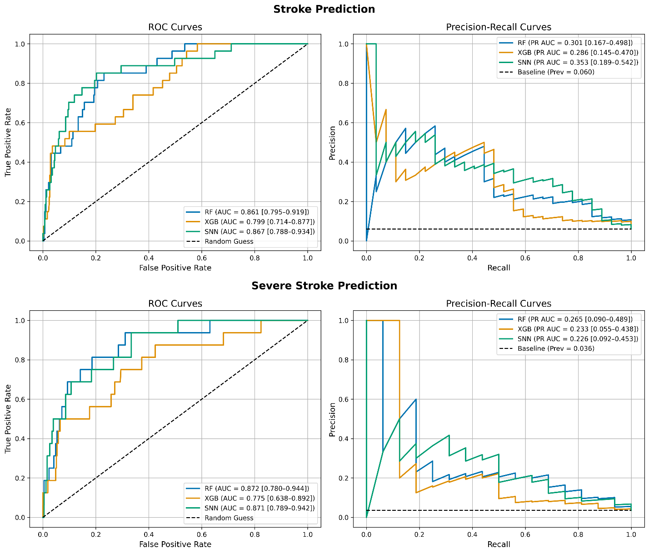

Supplementary Figure S2. Reliability diagrams comparing uncalibrated (left) and calibrated (right) Random Forest and XGBoost models for stroke and severe stroke classification, respectively.
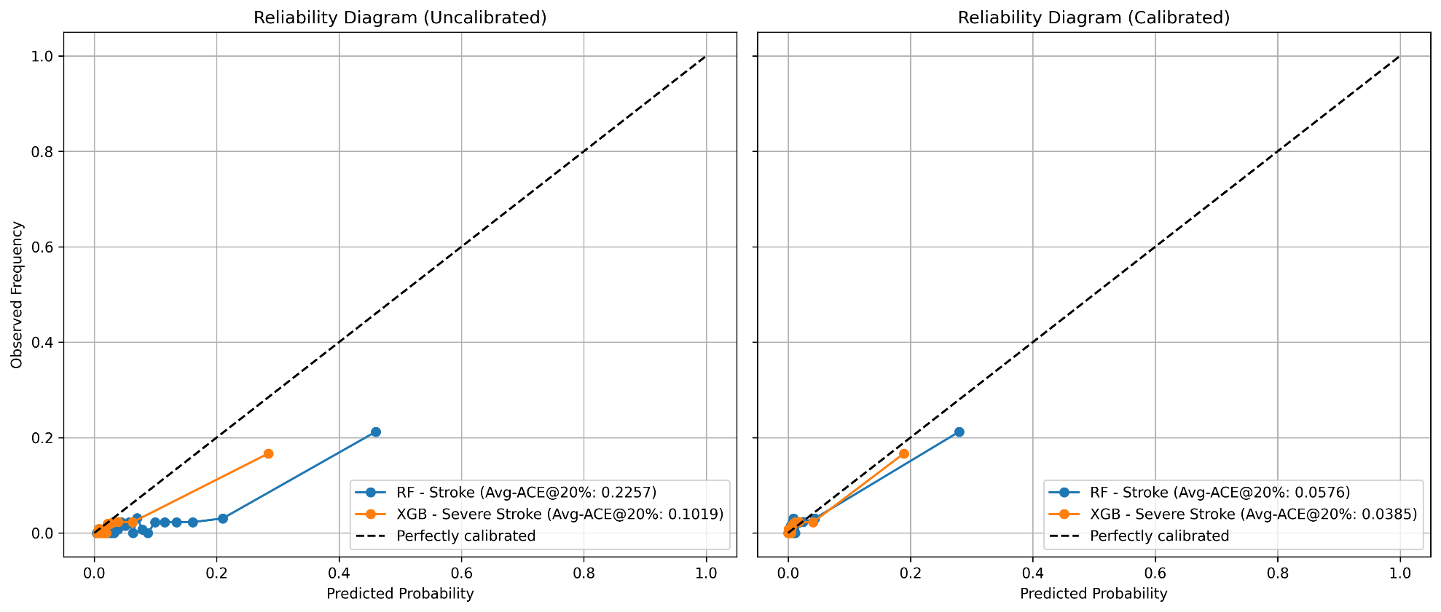
Solid lines represent model reliability, while the dashed line indicates perfect calibration. Avg-ACE@20% (Average Adaptive Calibration Error in the top 20% of predicted probabilities) quantifies miscalibration, with lower values indicating better calibration.

