Supplementary Material
The fate of wood wastes: from the gasification and its application as adsorbent of textile pollutants
Luiz Martins Pereira Neto¹, Tiago José Marques Fraga²*, Maryne Patrícia da Silva^{2,3}, Fernando Cartaxo Rolim Neto¹, Maurício Alves da Motta Sobrinho²
¹ Post-graduation Program in Environmental Engineering, Federal Rural University of Pernambuco, Campus Recife, Dom Manoel de Medeiros Street, w/n, Dois Irmãos, zip code: 52171-900 - Recife/PE
² Department of Chemical Engineering, Federal University of Pernambuco, Prof. Arthur de Sá Street, w/n, Cidade Universitária, zip code: 50.740-521 - Recife/PE, Brazil
³ Department of Chemical Engineering, Faculty of Engineering, University of Porto, Dr. Roberto Frias St., w/n, zip code: 4200-465, Porto, Portugal.

S1 Factorial design 2²
The variables of factorial design experiments were established as the Table S1:

Table S1 Variables of 2² factorial design and their levels
Variable level | -1 | 0 | +1
Agitation (rpm) | 100 | 150 | 200
Granulometry (Mesh) | 100 | 115 | 200

S2 Isotherm models for equilibrium studies
For the equilibrium study, Langmuir and Freundlich adsorption isotherms were adjusted to the experimental data. Langmuir model is associated to the monolayer adsorption which takes place in a homogeneous interface (da Rosa et al. 2019). On the other hand, Freundlich isotherm fits to systems in which the adsorption occurs with the formation of multiple layers in a heterogeneous interface. Langmuir and Freundlich isotherms are given in their non-linear form by the Eq. S4 and S5.
$\frac{q_{e}}{q_{m}}=\frac{{K_{L}C}_{e}}{(1+K_{L}C_{e})}$ (S4)
$q_{e}=K_{F}C_{e}^{1/n}$ (S5)
where q_{m} is the maximum adsorptive capacity in the monolayer (mg∙g⁻¹), and K_{L} is the equilibrium constant for Langmuir isotherm (L∙mg⁻¹); K_{F} is the Freundlich’s equilibrium constant [(mg∙g⁻¹)∙(mg∙L⁻¹)^{n}]; n (dimensionless) is the heterogeneity factor.

S3 Kinetic models - theory
From kinetic experiments, it was analyzed how the pseudo-first-order (PFO) (Lagergren 1898), pseudo-second-order (PSO) (Ho and McKay 1999) and intraparticle diffusion (IPD) (Weber and Morris 1963) kinetic models fitted experimental data. These models are respectively given in their non-linear form by the Eq. S1, S2 and S3.
$q_{t}=q_{e}(1-e^{-k_{1}t})$ (S1)
$q_{t}=\frac{k_{2}q_{e}^{2}t}{(1+k_{2}q_{e}t)}$ (S2)
$q_{t}=k_{ID}t^{1/2}+k_{0}$ (S3)
where q_{t} is the adsorption capacity in the time t (mg∙g⁻¹); q_{e} is the adsorption capacity at the equilibrium state (mg∙g⁻¹); k₁ is the the PFO rate constant (min⁻¹); k₂ is the PSO rate constant (g∙mg⁻¹∙min⁻¹); k_{ID} is the intraparticle diffusion rate coefficient (L∙mol⁻¹); while k₀ is a constant related to the resistance to the diffusion (mg∙g⁻¹).
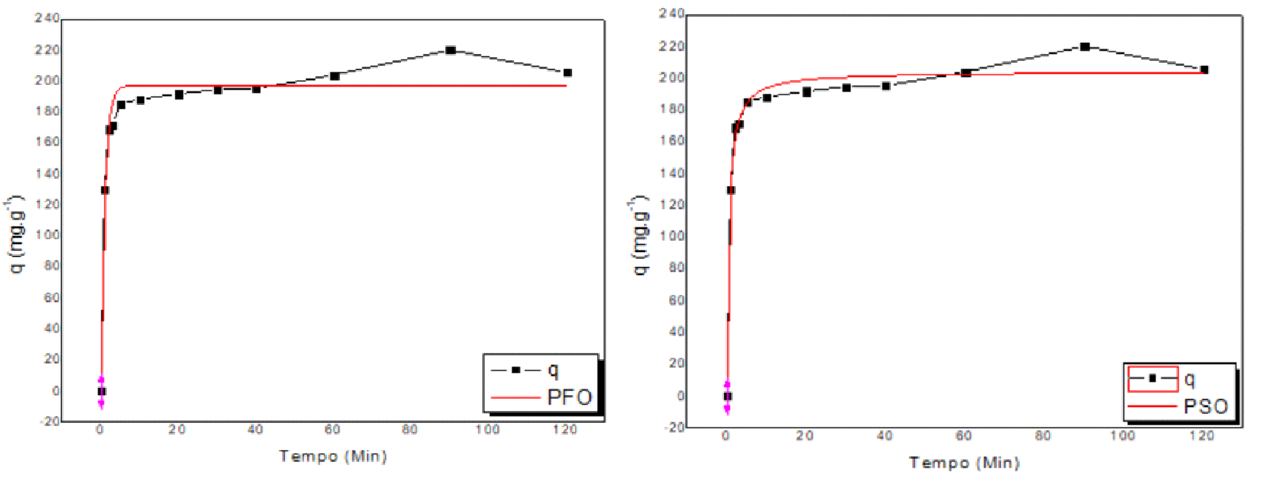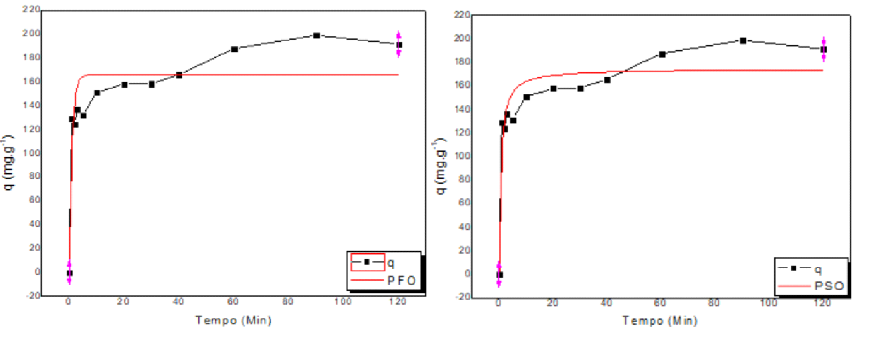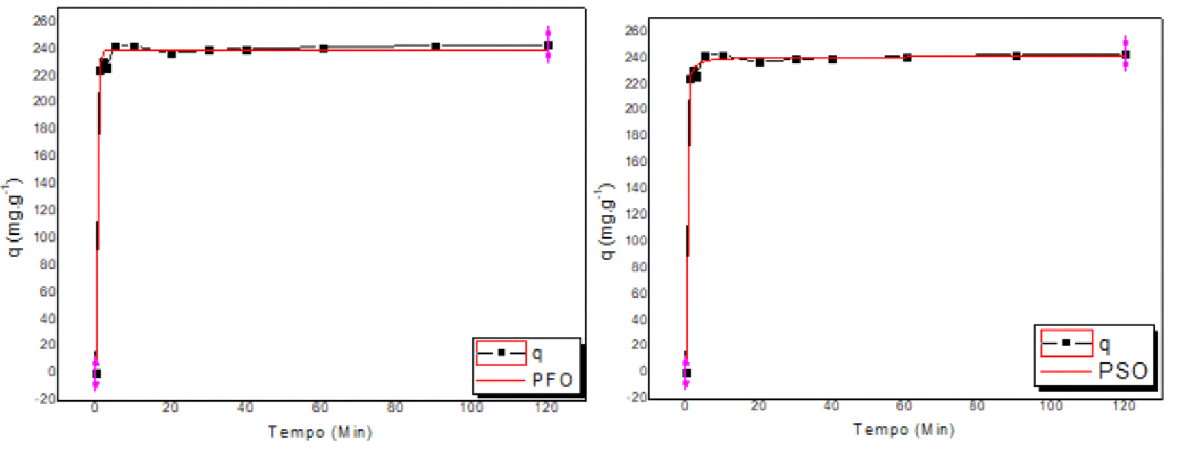
(b)
(a)
(d)
(f)
(e)
(c)
Fig. S1 kinetic curves and applied model for the adsorption of Methylene Blue onto: Bc1 – PFO (a), PSO (b); Bc2 – PFO (c), PSO (d); Bc3 – PFO (d), PSO (f)

References
da Rosa, M.P., Igansi, A.V., Lütke, S.F., Cadaval Junior, T.R.S., Santos, A.C.R., Lopes Inacio, A.P.O., Almeida Pinto, L.A., Beck, P.H. A new approach to convert rice husk waste in a quick and efficient adsorbent to remove cationic dye from water. Journal of Environmental Chemical Engineering 7 (2019) 103504.
Ho, Y.S., McKay, G. Pseudo-second order model for sorption processes. Process Biochemistry 34 (5) (1999) 451-465.
Lagergren, S. About the theory of so-called adsorption of soluble substances. Kungliga Svenska Vetenskapsakademiens Handlingar, 1898.
Weber, W.J., Morris, J.C. Kinetics of Adsorption on Carbon from Solution. Journal of the Sanitary Engineering Division 89 (2) (1963) 31–60.

