Supplementary Information

Nickel Ferrocyanide as High-Performance Next Generation Electrocatalyst for Urea Oxidation
Shi-Kui Geng,^{1,†} Yao Zheng,^{2,†} Shan-Qing Li,^{3,†} Xu Zhao,⁴ Jun Hu,¹ Hai-Bo Shu,¹ Mietek Jaroniec,⁵ Ping Chen,^{1,*} Qing-Hua Liu,^{4,*} Shi-Zhang Qiao^{2,*}
¹ School of Chemistry and Chemical Engineering, Anhui University, Hefei, Anhui, 230601, P. R. China
² School of Chemical Engineering and Advanced Materials, The University of Adelaide, Adelaide, SA 5005, Australia
³ School of Materials and Environmental Engineering, Chizhou University, Chizhou, Anhui, 247000, P. R. China
⁴ National Synchrotron Radiation Laboratory, University of Science and Technology, Hefei, P. R. China
⁵ Department of Chemistry and Biochemistry, Kent State University, Kent, OH, 44242, USA

† These authors have the equal contribution to this work.
* Email: chenping@ahu.edu.cn, qhliu@ustc.edu.cn, s.qiao@adelaide.edu.au

Synthesis of other electrocatalysts
Other Ni₂Fe(CN)₆: Besides the typical Ni₂Fe(CN)₆ sample (noted as Ni₂Fe(CN)₆-24-1 here), the products aged for 24 and 72 hours are denoted as Ni₂Fe(CN)₆-24-1 and Ni₂Fe(CN)₆-72-1. When 0.75 mmol of NiCl₂·6H₂O and 0.25 mmol of K₃[Fe(CN)₆] were used, the product is denoted as Ni₂Fe(CN)₆-48-0.5. When 3.0 mmol of NiCl₂·6H₂O and 1.0 of mmol K₃[Fe(CN)₆] were used, the product is denoted as Ni₂Fe(CN)₆-48-2.
NiC₂O₄: NiC₂O₄ was prepared using a slightly modified method reported elsewehre.¹ 2 mmol of NiCl₂·6H₂O was dissolved into 50 mL of deionized water and 20 mL of ethanol under stirring. The mixed solution was transferred into a 250 mL three-necked flask and heated at 80 ℃ for 2 hours. At the same time, 1.58 g of oxalic acid was dissolved in 50 mL of deionized water. The prepared oxalic acid solution was slowly added to the three-necked flask over ~5 min. Then the cleaned Ni foam was placed into the mixed solution, which was heated 80 ℃ in oil bath for 2 hours without stirring. After cooling down to room temperature, the Ni foam was washed with distilled water and ethanol and then vacuum-dried.
Fe₄[Fe(CN)₆]₃ and Ni₃[Co(CN)₆]₂: Fe₄[Fe(CN)₆]₃ and Ni₃[Co(CN)₆]₂ were prepared by employing the slightly modified methods reported elsewehere.^{2, 3} In the preparation of Fe₄[Fe(CN)₆]₃, 27 mg of FeCl₃·6H₂O and 1.1 g of PVP were added in 80 mL of deionized water and stirred until the solution became clear. Then the cleaned Ni foam was placed in mixed solution. Afterwards, 20 mL of deionized water containing 33 mg of K₄[Fe(CN)₆] was dropped slowly into the mixed solution under vigorous stirring at 60 ℃. The product was obtained during 30 min followed by cleaning in ethanol and deionized water for three times, respectively. In the preparation of Ni₃[Co(CN)₆]₂, 265 mg of sodium citrate and 143 mg NiCl₂·6H₂O were dissolved in 20 mL of deionized water. Next, 133 mg of K₃[Co(CN)₆] was dissolved in 20 mL of deionized water. Then the cleaned Ni foam was placed in two mixed solutions under magnetic stirring and aged for 24 hours. The product was cleaned in ethanol and deionized water for three times, respectively.
Characterization
The SEM images were obtained using a scanning electron microscope (HITACHI Regulus 8230, Japan) with a 15kV accelerating voltage. TEM images were acquired using a field emission transmission electron microscope (JEOL JEM 2100, Japan). XPS data were obtained using a Thermo ESCALAB 250Xi X-ray photoelectron spectrometer (Thermo ESCALAB 250Xi, USA). XRD patterns were obtained by a diffractometer (Rigaku SmartLab 9KW with Cu-kα radiation, λ=0.15406 nm) from 10 to 80° with a rate of 10° min⁻¹.
Measurement of urea elimination
Amount of urea elimination was detected by transforming urea into ammonia by urease. Ammonia concentration was tested by an ion ammonia-selective electrode (Orion™ High-Performance Ammonia Electrode 9512HPBNWP). The detection of ammonia obtained from urea was conducted as follows.: (a) Preparation of ammonia standards: a series of standard solutions were prepared with the concentrations of 1, 2, 5, 7 and 10 ppm (as NH₄⁺) in KOH solution. (b) Electrometer calibration: the following steps were performed during the electrometer calibration. (b1) The electrode was soaked in ammonia electrode storage solution (1 ppm standard in KOH) for at least 15 min. (b2) 100 mL of each standard was measured. (b3) The mV value and lg (ppm) were used to prepare the standard curve with a Tafel slope of 54-60 mV/dec. (c) 100 mL of the sample in KOH was measured.
Measurement of H₂O₂ production
Amount of H₂O₂ production was measured based on the reduced Ce⁴⁺ amount, which was tested by ultraviolet-visible (UV-Vis) spectrophotometry using a UV-3600 UV-Vis spectrophotometer (Shimadzu Scientific Instruments Inc., Kyoto, Japan).⁴
Details on the DFT calculations
The k-point grid was generated at the sampling density: 0.04 Å⁻¹. All electron relativistic core treatment was chosen to involve the relativistic effects, and numerical orbitals for the basis functions were treated with the double numerical plus polarization (DNP) basis. The tolerance thresholds of self-consistent field (SCF), maximum energy change, maximum force and maximum displacement were set to 10⁻⁶ hartree, 10⁻⁵ hartree, 0.002 hartree Å⁻¹ and 0.005 Å respectively. The conductor-like screening model (COSMO) was used to simulate the solvent environment.^{5, 6} The initial crystal structure of the nickel ferrocyanide (Ni₂Fe(CN)₆) was extracted from the inorganic crystal structure database, No. 28668. The space group of Ni₂Fe(CN)₆ was F-43m, and the lattice parameters of the optimized cell were a = b = c = 10.5273 Å, α = β = γ =90. The 10.53 Å × 14.89 Å (110) face of Ni₂Fe(CN)₆ was cleaved, which contained 6 Ni₂Fe(CN)₆ molecules. The (110) face was chosen as the active site for electrocatalytic UOR, considering the considerable adsorption energies as well as the higher proportion of superficial area among the nano-crystals. ⁷
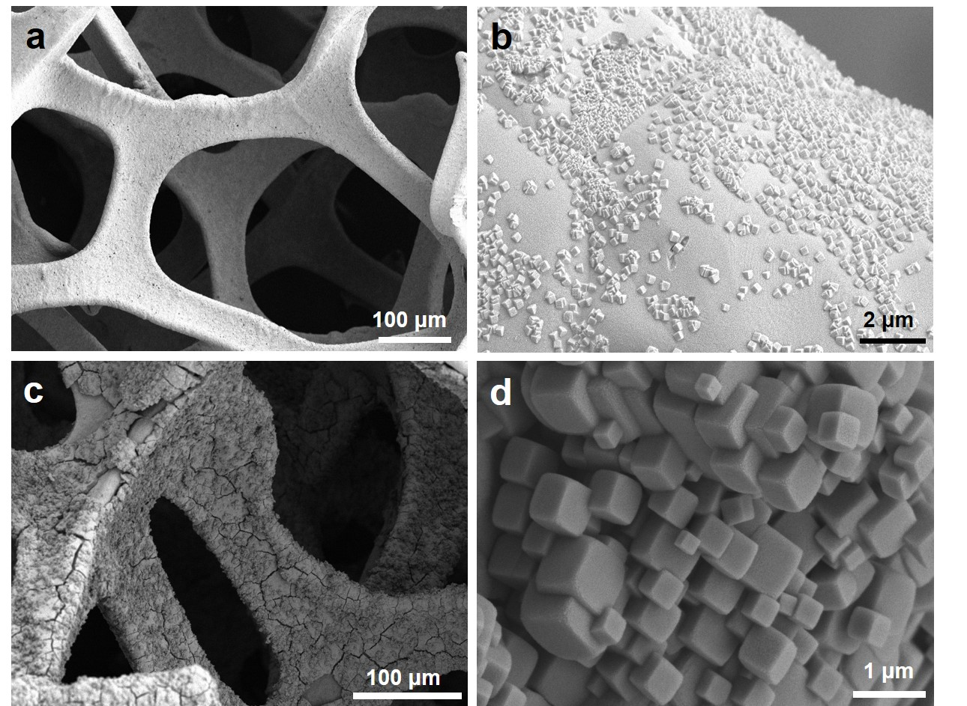
Supplementary Figure 1. SEM images of (a, b) Ni₂Fe(CN)₆-48-0.5 and (c, d) Ni₂Fe(CN)₆-48-2.

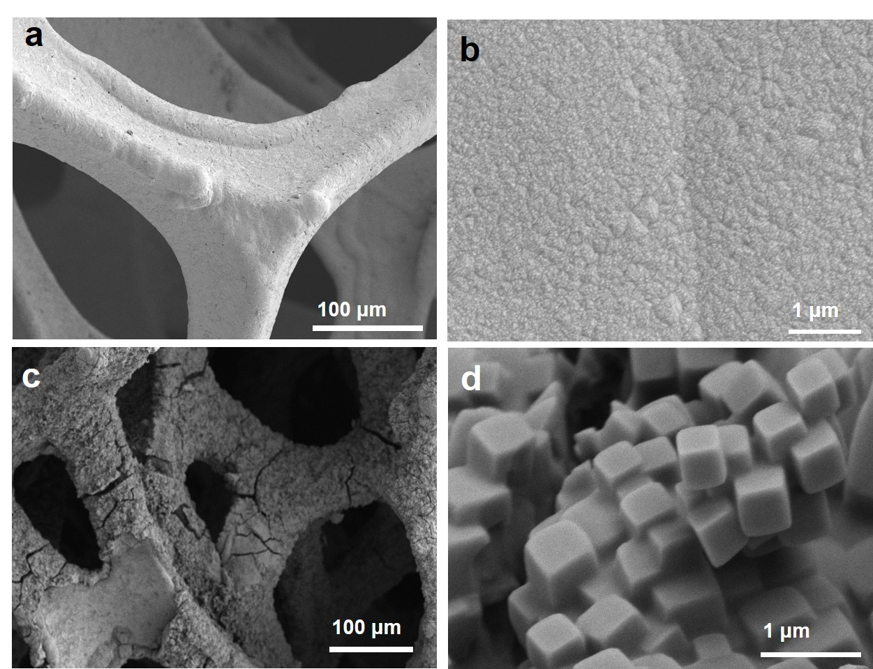
Supplementary Figure 2. SEM images of (a, b) Ni₂Fe(CN)₆-24-1 and (c, d) Ni₂Fe(CN)₆-72-1.

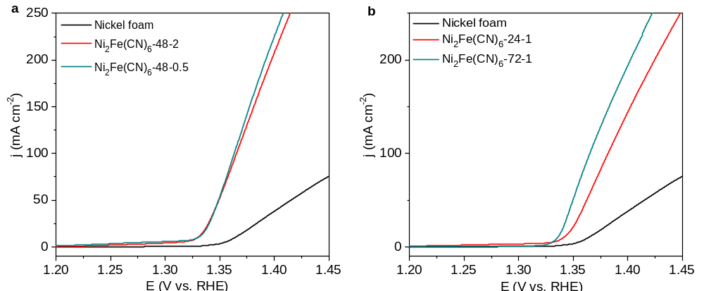
Supplementary Figure 3. (a) LSV curves of different electrocatalysts in 1.0 M KOH containing 0.33 M urea.

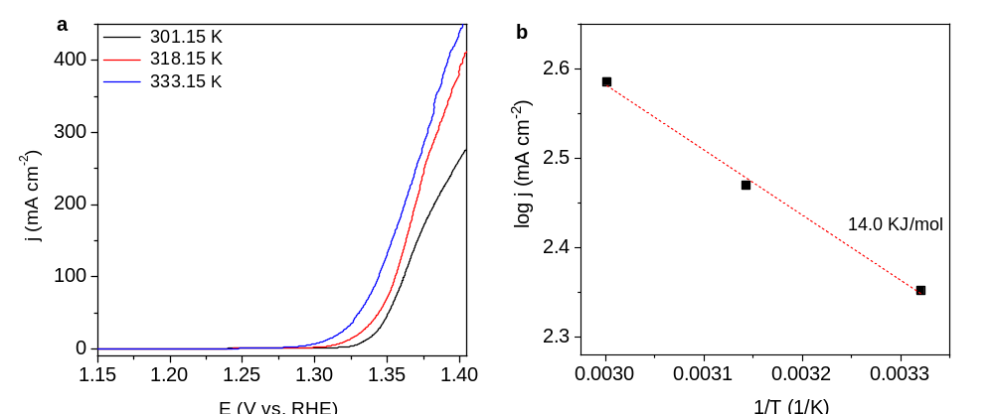
Supplementary Figure 4. (a) LSV curves of typical Ni₂Fe(CN)₆ in 1.0 M KOH containing 0.33 M urea at different temperatures. (b) The corresponding Arrhenius plot and calculated activation energy at 1.39 V vs RHE.

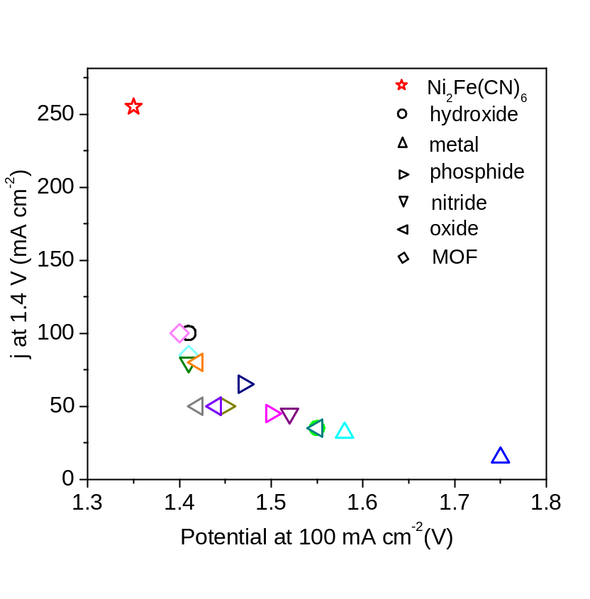
Supplementary Figure 5. Comparison of activities of different UOR electrocatalysts. The details on the current density at 1.4 V (mA cm⁻²) can be found in Supplementary Table 2.

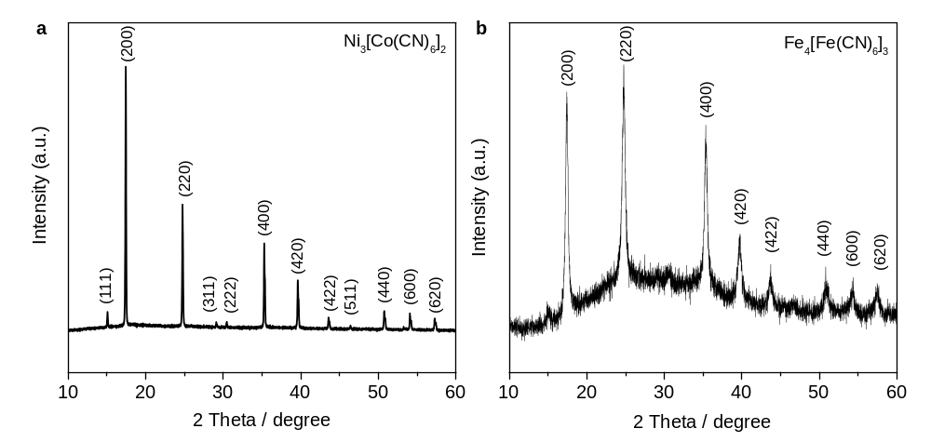
Supplementary Figure 6. XRD patterns of Ni₃[Co(CN)₆]₂ and Fe₄[Fe(CN)₆]₃ electrocatalysts.

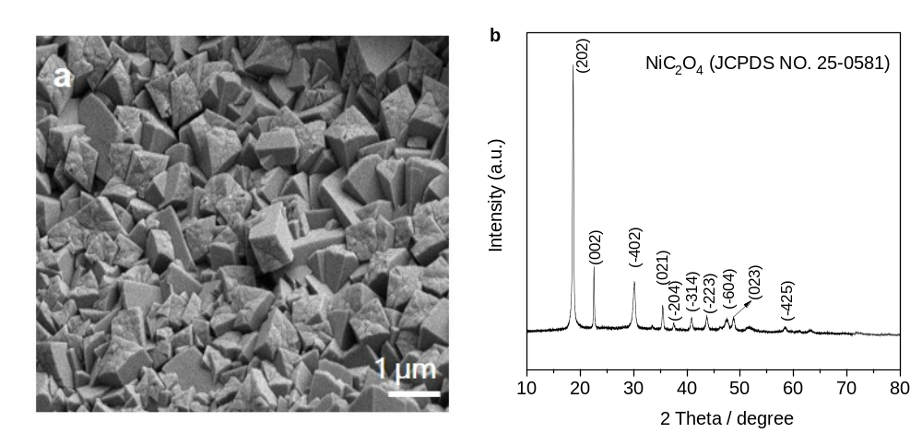
Supplementary Figure 7. SEM image and XRD pattern of NiC₂O₄ electrocatalyst.

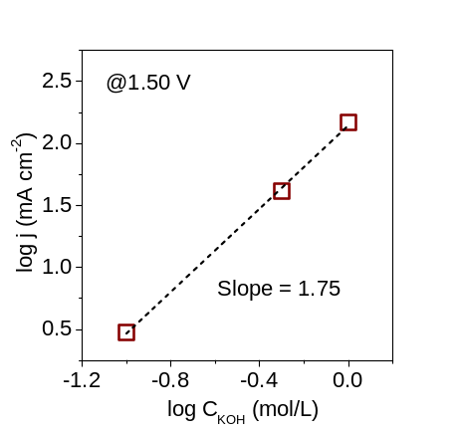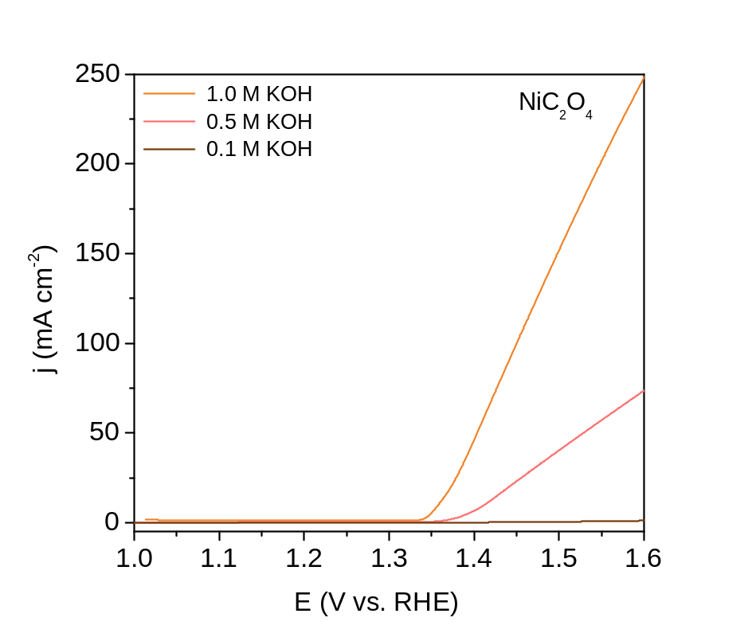
Supplementary Figure 8. LSV curves of NiC₂O₄ at different concentrations of KOH with 0.33 M urea. Inset shows the dependence of current density on the KOH concentration at 1.50 V vs RHE.

Supplementary Figure 9. The photographs of the in-situ Raman system and electrochemical cell.

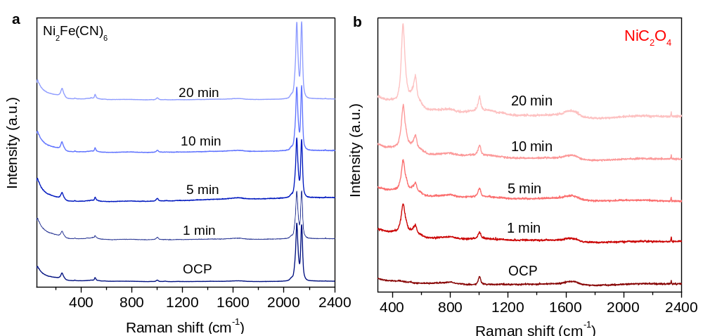
Supplementary Figure 10. In-situ Raman spectra of Ni₂Fe(CN)₆ and NiC₂O₄ electrocatalysts at a potential of 1.50 V (vs. RHE) for different reaction times.

Supplementary Figure 11. (a) Schematic diagram for the detection of trace ammonia. (b) Calibration plot of NH₄⁺ from 0.01 ppm to 0.1 ppm in 1.0 M KOH solutions.

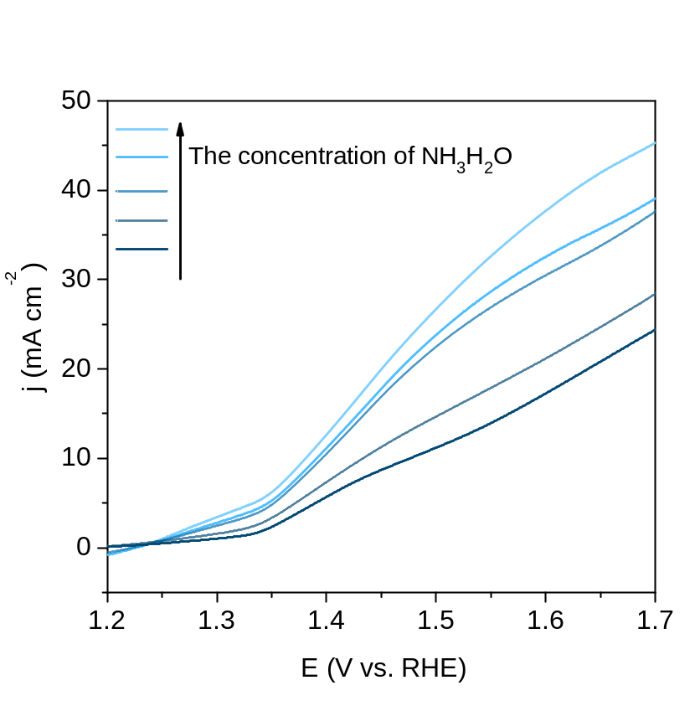
Supplementary Figure 12. LSV curves of typical Ni₂Fe(CN)₆ electrocatalyst in 1.0 M KOH containing 50, 200, 500, 750 and 1000 ppm of NH₃H₂O, respectively.

Supplementary Figure 13. Ni₂Fe(CN)₆ (001) and (011) crystal planes, top view and side view.

Supplementary Figure 14. (a) H₂O adsorbing on the Fe site of (001) crystal plane and the Ni site of (001) crystal plane, top view and side view. (b) Urea adsorbing on the Fe site of (001) crystal plane and the Ni site of (001) crystal plane, top view and side view.
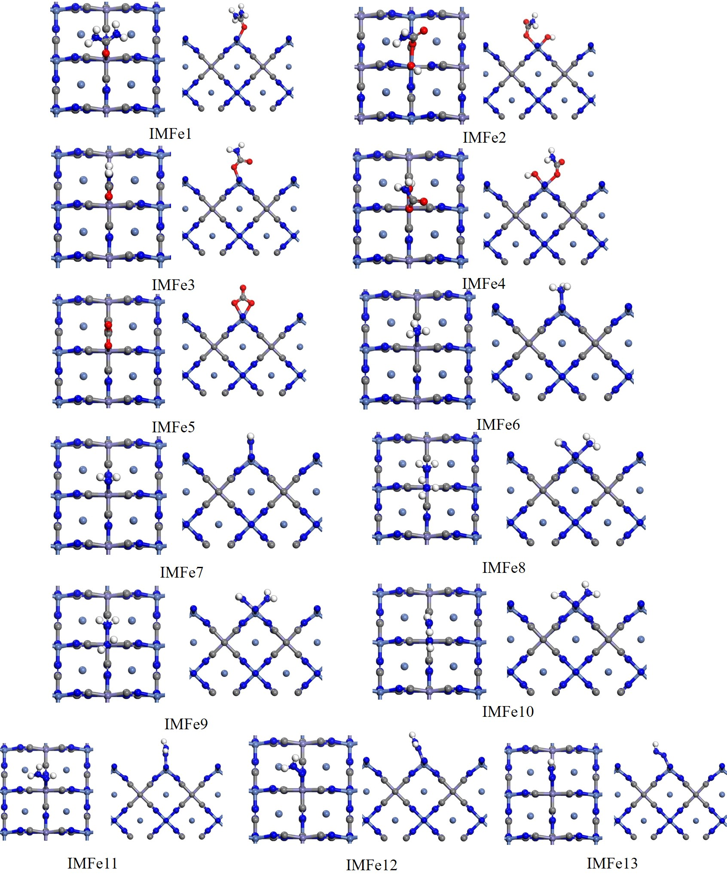
Supplementary Figure 15. Intermediate IMFe1, IMFe2, IMFe3, IMFe4, IMFe5, IMFe6, IMFe7, IMFe8, IMFe9, IMFe10, IMFe11, IMFe12 and IMFe13, top view and side view. Color code is the same as Supplementary Figure 14.

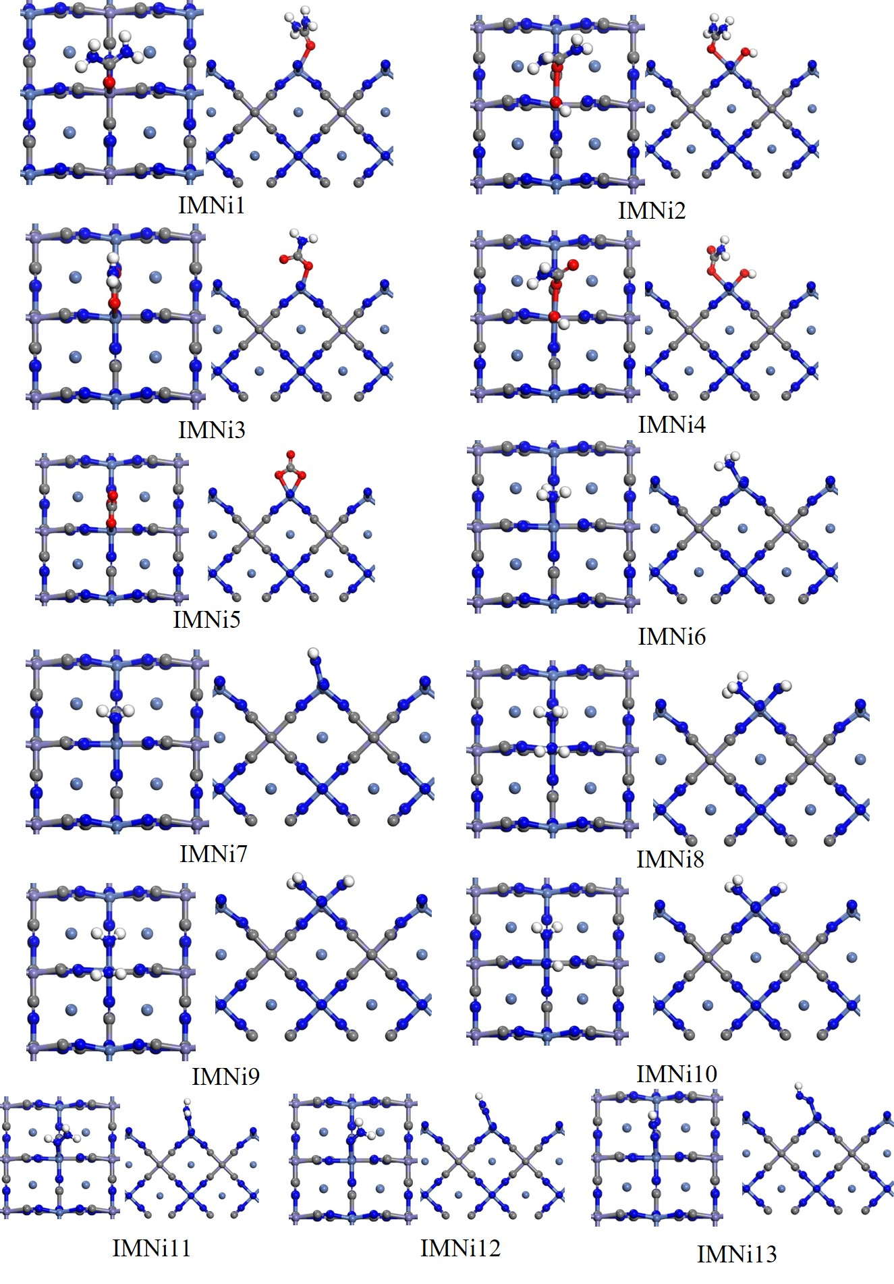
Supplementary Figure 16. Intermediate IMNi1, IMNi2, IMNi3, IMNi4, IMNi5, IMNi6, IMNi7, IMNi8, IMNi9, IMNi10, IMNi11, IMNi12 and IMNi13, top view and side view. Color code is the same as Supplementary Figure 14.
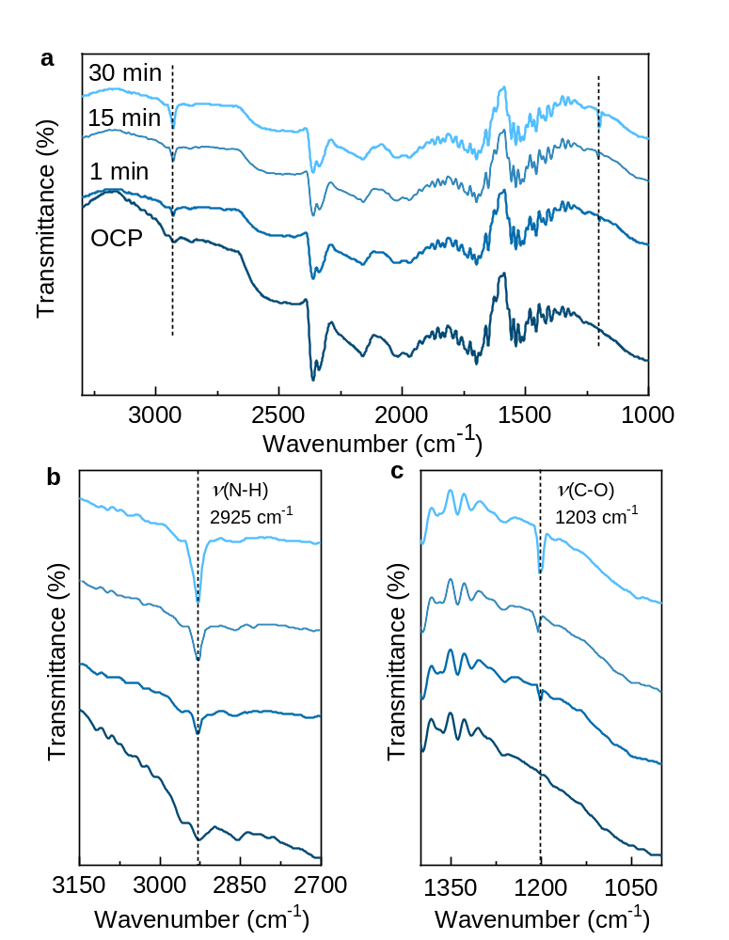
Supplementary Figure 17. In situ FTIR spectra at different reaction time with 1.65 V applied potential for Ni₂Fe(CN)₆ electrocatalyst.
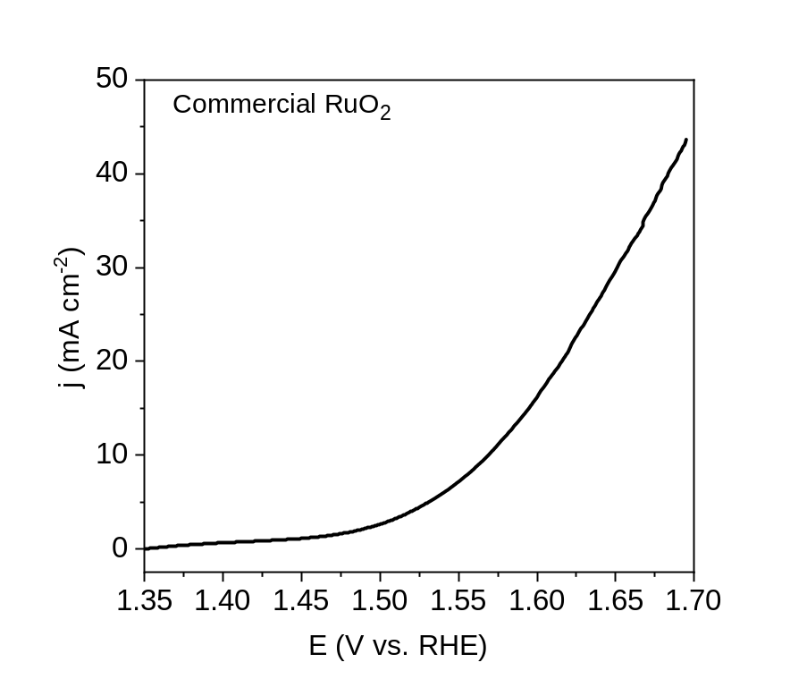
Supplementary Figure 18. LSV curve of commercial RuO₂ catalyst for OER in 1.0 M KOH.

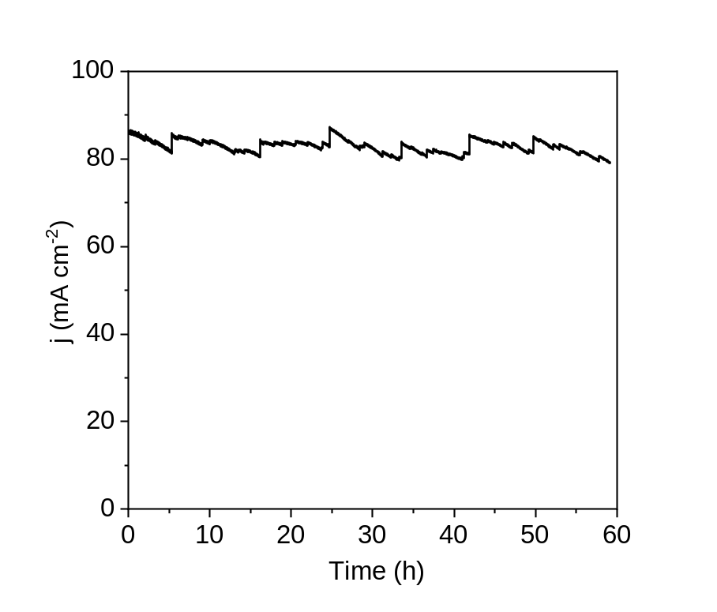
Supplementary Figure 19. Amperometric i-t curve of UOR//HER cell performed at a cell voltage of 1.50 V.

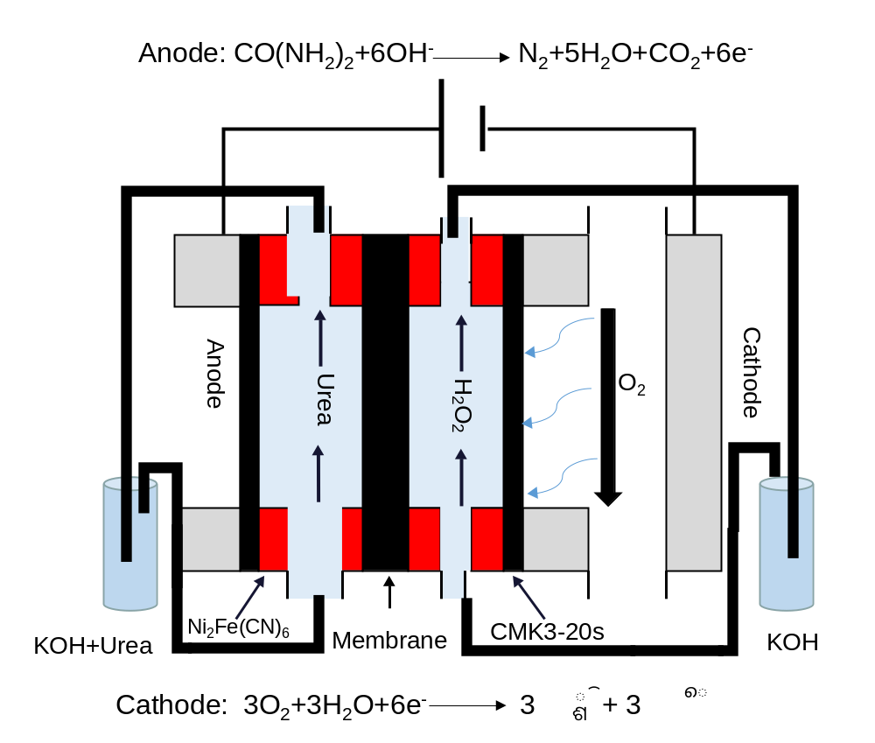
Supplementary Figure 20. Schematic diagram of the flow-cell device of UOR//2e-ORR.

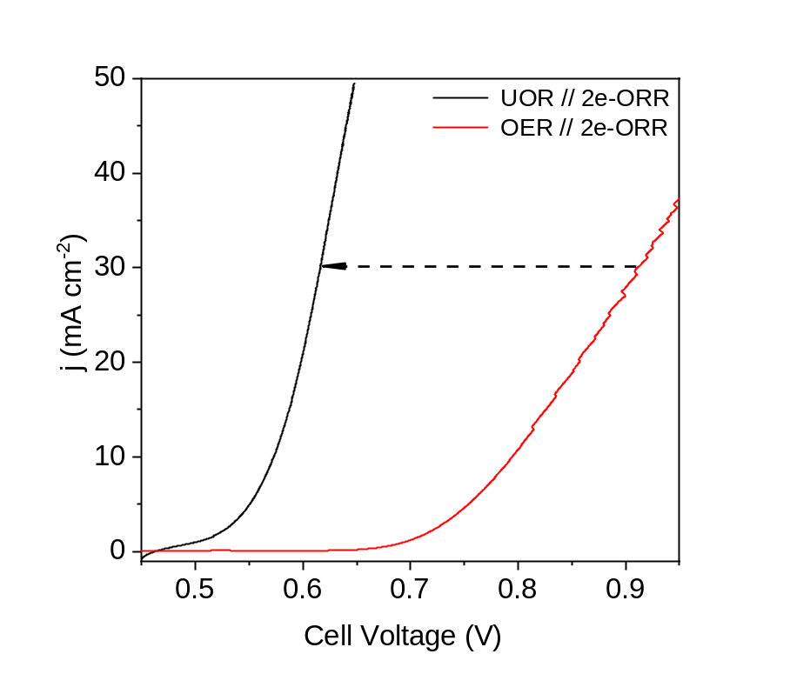
Supplementary Figure 21. Comparison of polarization curves of UOR//2e-ORR and OER//2e-ORR for H₂O₂ production.

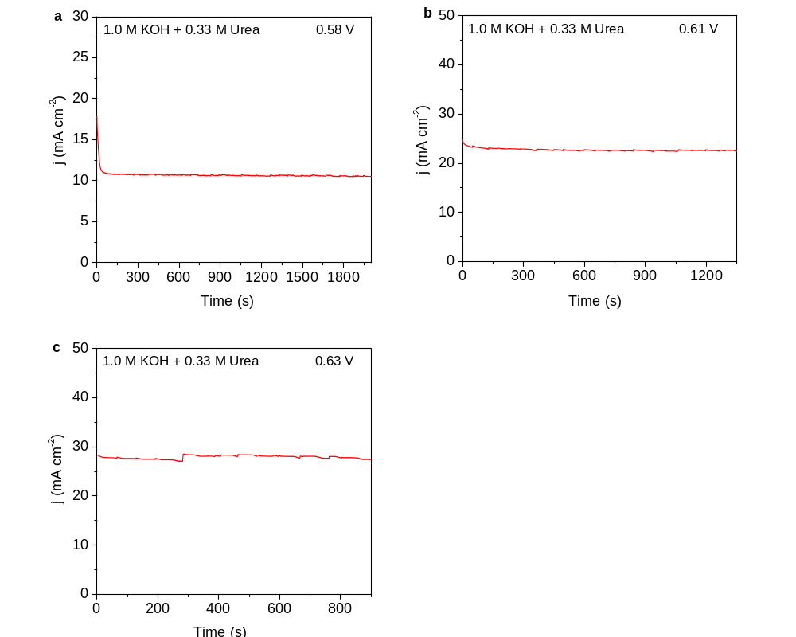
Supplementary Figure 22. The cell current in 1.0 M KOH with 0.33 M urea at different cell voltages.

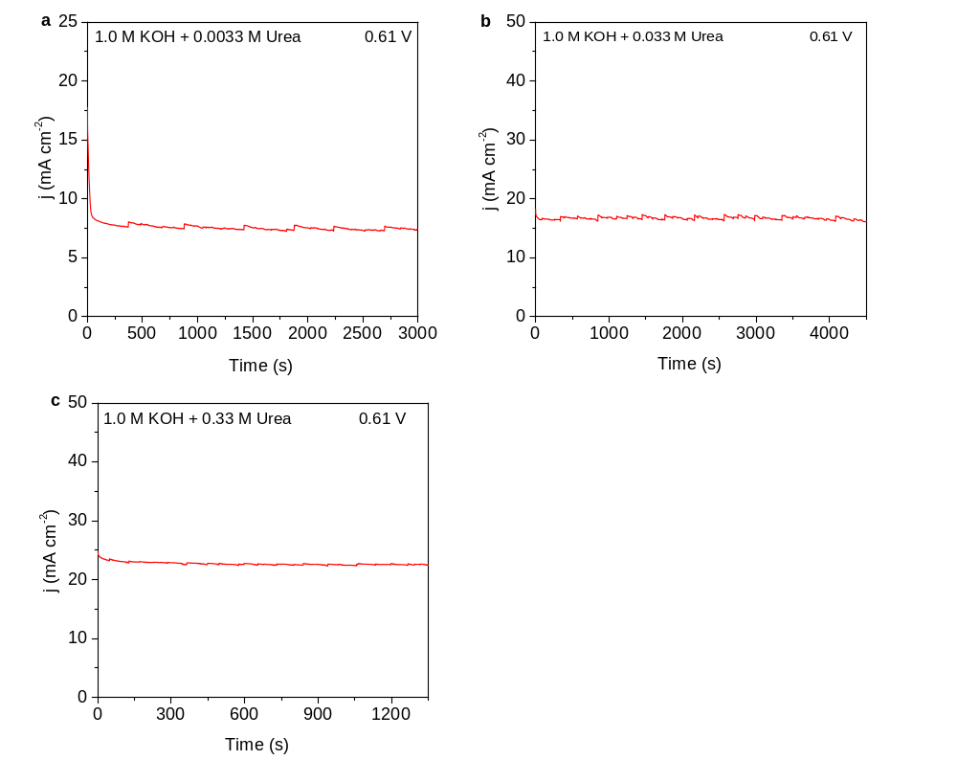
Supplementary Figure 23. The cell current at the cell voltage of 0.61V in 1.0 M KOH with different urea concentrations.

Supplementary Table 1. Gibbs free energies of adsorbates bonding on the (001) plane of Ni₂Fe(CN)₆.
adsorption site | adsorbate | ΔG /eV
001 Fe site | urea | -0.18
 | H₂O | -0.41
001 Ni site | urea | -0.20
 | H₂O | -0.25

Supplementary Table 2. Comparison of the activities on different UOR electrocatalysts
Catalyst | Electrolyte | Potential  (V vs. RHE)  for 100 mA cm⁻² | Current density  (mA cm-2) @ 1.4V | Catalyst support | Reference
Ni₂Fe(CN)₆ | 1M KOH+  0.33 M Urea | 1.35 | 255 | Nickel foam | This work
Ni(OH)₂@NF | 1M KOH+  0.3 M Urea | 1.44 | ~85 | Nickel foam | ACS Appl. Energy Mater. 2020, 3, 2996.
CoFeCr LDH | 1M KOH+  0.3 M Urea | 1.41 | ~85 | Nickel foam | Appl. Catal B- Environ.2020, 272, 118959
NiClO-D | 1M KOH+  0.3 M Urea | 1.44 | ~60 | Glassy carbon electrode | Angew. Chem. Int. Edit. 2019,58, 16820
Ni_{0.9}Fe_{0.1}O_{x} | 1M KOH+  0.33M Urea | 1.40 | ~101 | Carbon fiber paper | Chem. Commun. 2019, 55, 6555.
Ni-Mo | 1M KOH+  0.1M Urea | 1.42 | ~65 | Nickel foam | Nano Energy 2019, 60, 894.
Mo-Co-S-Se | 1M KOH+  0.5M Urea | 1.42 | ~75 | Carbon cloth | ACS Sustain. Chem. Eng. 2019, 7, 16577
NF-Ni₂P-Fe₂P | 1M KOH+  0.5M Urea | 1.46 | ~55 | Nickel foam | J. Colloid Interface Sci.  2019, 541, 279.
CuCo₂O₄ | 1M KOH+  0.33M Urea | 1.44 | ~50 | Nickel foam | Appl. Sci. 2019, 9, 793.
1%Cu: Ni(OH)₂ | 1M KOH+  0.33M Urea | 1.41 | ~85 | Nickel foam | J. Mater. Chem. A, 2019,7, 13577.
NF- Ni₃N | 1M KOH+  0.5M Urea | 1.41 | ~90 | Nickel foam | ACS Appl. Mater. Inter. 2019, 11, 13168.
NF-p-Ni | 1M KOH+  0.33M Urea | 1.42 | ~80 | Nickel foam | Electrochim. Acta. 2019, 304, 131.
Mo-doped p-NiS/Ti | 1M KOH+  0.3M Urea | ~1.55 | <5 | Ti mesh | Appl. Sur. Sci. 2019, 484, 1052.
Ni(OH)₂/MnO₂ | 1M KOH+  0.5M Urea | 1.43 | ~5 | Carbon fiber paper | Electrochim. Acta. 2019, 318, 32.
NiCoP | 1M KOH+  0.5M Urea | 1.55 | ~30 | Carbon cloth | J. Mater. Chem. A, 2019, 7, 9078.
NiFe(OH)₂-SD | 1M KOH+  0.5M Urea | 1.40 | ~101 | Nickel foam | J. Colloid Interface Sci.2019, 557,10
Ni(OH)₂ nanomeshes | 1M KOH+  0.33M Urea | More than 1.70 | ~6 | Glassy carbon electrode | Nanoscale, 2019, 11, 1058.
NF/MiMoO-Ar | 1M KOH+  0.5M Urea | 1.42 | ~65 | Nickel foam | Energy Environ. Sci., 2018, 11, 1890.
Fe-O-P/NF | 1M KOH+  0.5M Urea | 1.39 | ~140 | Nickel foam | Mater. Res. Bull.  2018, 100, 72.
1% Fe: α-Ni(OH)₂ | 1M KOH+  0.33M Urea | ~1.41 | ~85 | Nickel foam | Chem. Eur. J. 2018, 24, 18408.
Ni/C-MOF | 1M KOH+  0.33M Urea | ~2.00 | ~18 | Glassy carbon electrode | ACS Appl. Mater. Interfaces 2018, 10, 4750.
Ni₂P | 1M KOH+  0.5M Urea | 1.47 | ~62 | Carbon cloth | J. Mater. Chem. A, 2017, 5, 3208.
MnO₂/MnCo₂O₄ | 1M KOH+  0.5M Urea | 1.65 | ~48 | Nickel foam | J. Mater. Chem. A, 2017, 5, 7825.
NiO-Fe₂O₃/rGO/PVA aerogel | 1M KOH+  0.33M Urea | 1.65 | ~7.2 | No support | Electrochem. Acta, 2017, 237, 171.
Ni-Cr | 1M KOH+  0.33M Urea | >1.50 | ~70 | Carbon matrix | ChemCatChem., 2017, 9, 3374.
Carbon/Ni-Fe | 1M KOH+  0.33M Urea | >1.50 | ~55 | Nickel foam | Electrochem. Acta, 2017, 227, 210.
Ni-MOF | 1M KOH+  0.33M Urea | 1.56 | ~35 | Glassy carbon electrode | Chem. Commun., 2017,53, 10906.
Ni₃N | 1M KOH+  0.33M Urea | 1.52 | ~45 | Carbon cloth | Inorg. Chem. Front., 2017, 4, 1120.
M-Ni(OH)₂ nanosheets | 1M KOH+  0.33M Urea | >1.70 | ~35 | Glassy carbon electrode | Angew .Chem. 2016, 128,12653.
S-MnO₂ | 1M KOH+  0.5M Urea | 1.46 | ~65 | Graphene-nickel foam | Angew. Chem. Int. Ed., 2016, 55, 3804.

Supplementary References:
1. Garcia-Clavel, M. E., Martinez-Lope, M. J., Casais-Alvarez, M. T., Thermal study of NiC₂O₄•2H₂O obtained by a solid state reaction at room temperature and normal pressure. Thermochim. Acta 118, 123-134 (1987).
2. Hu, M., Ishihara, S., Ariga, K., Imura, M., Yamauchi, Y., Kinetically controlled crystallization for synthesis of monodispersed coordination polymer nanocubes and their self-assembly to periodic arrangements. Chem. Eur. J. 19, 1882-1885 (2013).
3. Zhang, W., et al., Prussian blue nanoparticles as multienzyme mimetics and reactive oxygen species scavengers. J. Am. Chem. Soc. 138, 5860-5865 (2016).
4. Wang, Y. L., et al., One minute from pristine carbon to an electrocatalyst for hydrogen peroxide production. J. Mater. Chem. A 7, 21329-21337 (2019).
5. Klamt, A., Schüürmann, G., COSMO: a new approach to dielectric screening in solvents with explicit expressions for the screening energy and its gradient. J. Chem. Soc., Perkin Transactions 2, 799-805 (1993).
6. Delley, B., The conductor-like screening model for polymers and surfaces. Mol. Simulat. 32, 117-123 (2006).
7. Nikolic, N. D., Maksimovic, V. M., Brankovic, G., Morphological and crystallographic characteristics of electrodeposited lead from a concentrated electrolyte. Rsc Adv. 3, 7466-7471 (2013).

