Table 1. Defining characteristics of models discussed in this review as per their documentation
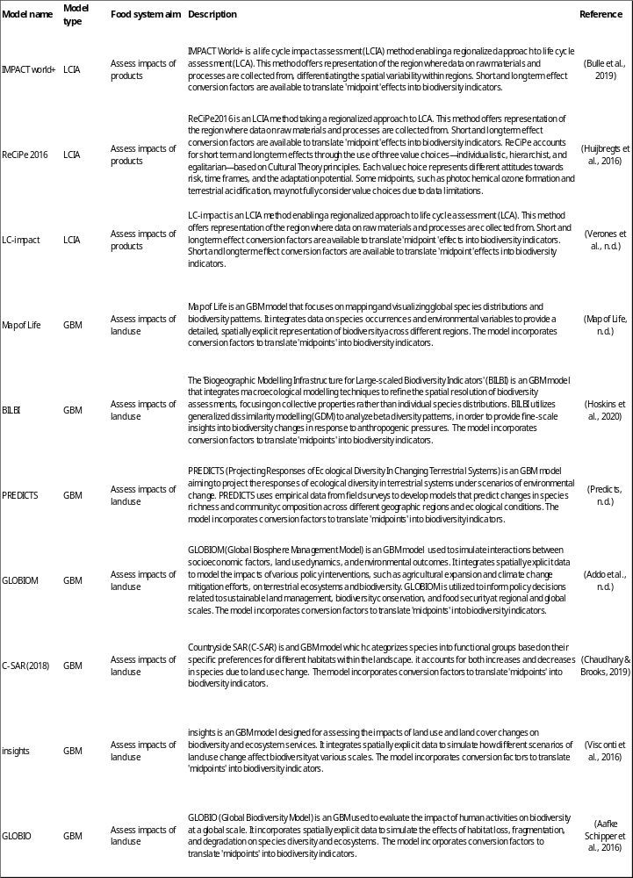
Table 2. Overview of strengths and blind spots of LCIA and GBM models in accounting for biodiversity loss
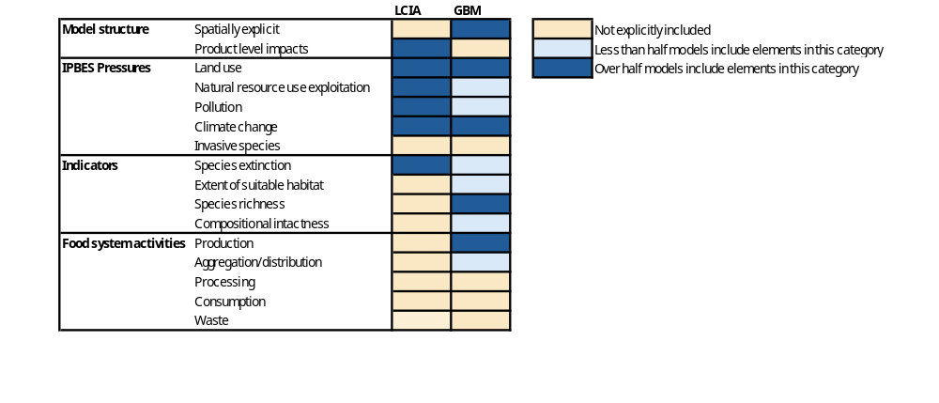

Table 3. Models and associated biodiversity impacts, indicators and metrics. Structure and definitions adapted from Pereira et al.²³.
Biodiversity impact | Biodiversity indicator | Metric* | Definition of biodiversity indicator | Model (s)
Species extinction | RLI (Red List Index) | score 0-1 | Regional species extinction risk, measures improvements and deteriorations of species groups in relation to their risk of extinction. Looks at the extent of suitable habitat relative to a baseline year, with values geometrically averaged across species | inSIGHTS
Species extinction | PDF (Potentially Disappearing Fraction) | Score (0-1) | Measure of the potential proportion of species estimated to go extinct in a region as the result of environmental pressures | LC-impact ReCiPe 2016  IMPACT World +  C-SAR (2018)
Extent of suitable habitat | SHI (Species Habitat Index) | Score (1-100) | Reduced ecosystem diversity and quality, measures the changes in the estimated size and quality of ecologically intact areas through remote sensing data relating this to species loss. The SHI is expressed relative to a  baseline of SHI = 100 | Map of Life
Extent of suitable habitat | ESH (Extent of Suitable Habitat) | score (0-1) | Measures the extent of suitable habitat to a pool of species compared to a baseline, taking a geometric average | inSIGHTS
Species Richness | Richness | Number of species/taxa present | Counts the number of species or taxa present in a given region/system. Usually either a mid-stop for other indicators calculated (e.g. species extinction) or retrieved from the indicator (e.g. SHI) | PREDICTS BILBI  GLOBIOM  C-SAR (2018)  Map of Life
Compositional intactness | MSA (Mean Species Abundance) | score (0-1) | Measures arithmetic mean of the relative abundance of species in order to estimate the intactness of local species composition. This estimate is made across all species that were originally present in comparison to an undisturbed state, potentially going beyond 1 when biodiversity is increased | GLOBIO
*Although not often observed, metric values can technically exceed the maximum score for some indicators if an increase in the measure of biodiversity is observed.

Table 4. ‘Midpoints’ found in models clustered into ‘IPBES pressures’. Pressures color coded and ordered in terms of degree of severity for the impacts on biodiversity loss using global terrestrial estimates from Jaureguiberry et al.⁴⁹. Dark red at the top being the highest impact and light red at the bottom having the smallest impact. Based on an average, estimates vary based on region and indicator.
