Figures S1
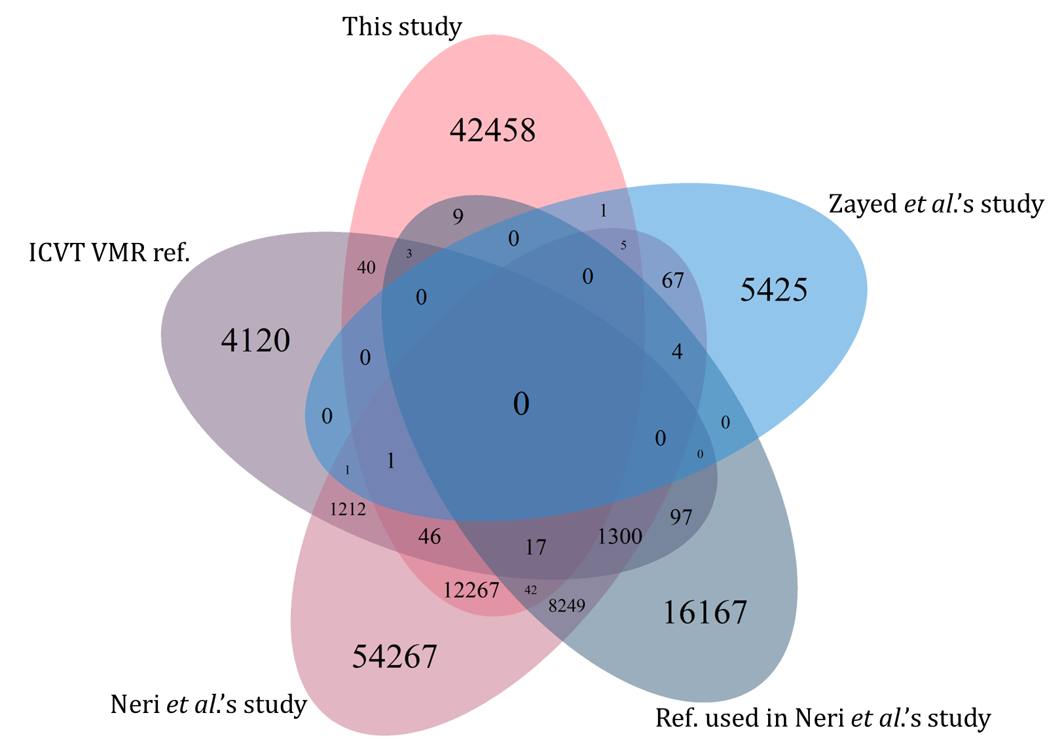
Figure S1. A Venn diagram illustrating the novelty of the urban RNA virome and its overlap with four previously published RNA virome datasets.

Figures S2
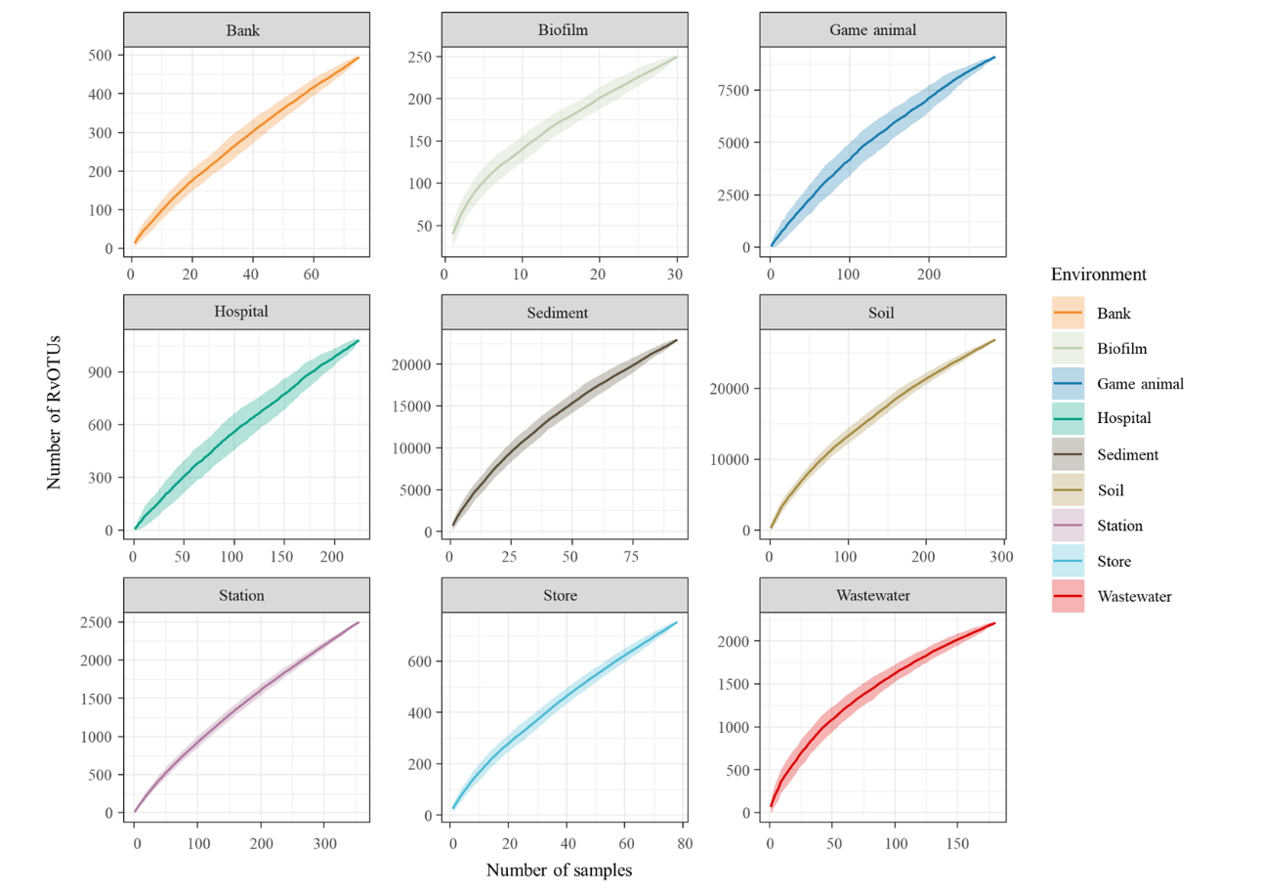
Figure S2. Urban-RvOTU rarefaction curves of samples collected from different environments. The values were obtained via bootstrapping.

Figure S3
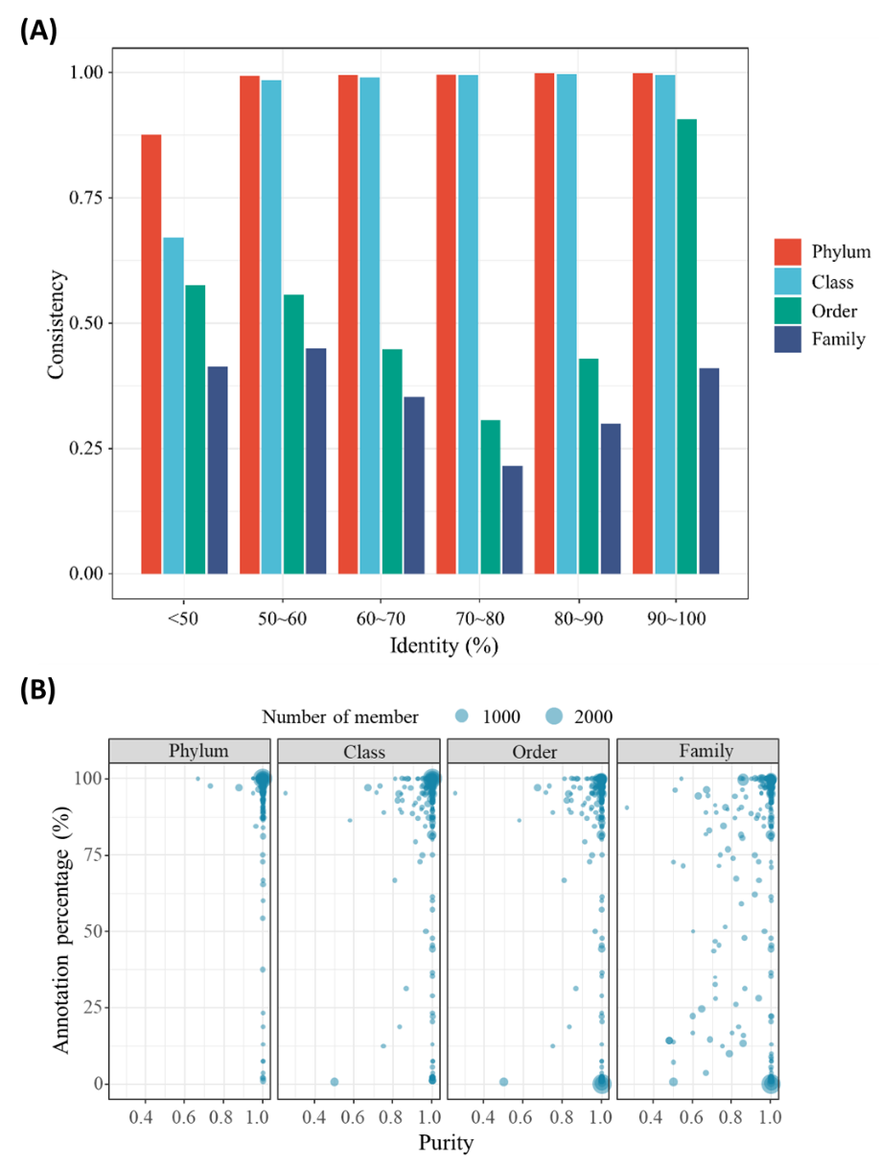
Figure S3. (A) Consistency of taxonomic classification results between geNomad and the best-hit approach across various taxonomic levels. (B) Annotation purity of the RCR95 representatives in the clusters, which were formed using a sequence identity threshold of 0.3, across different taxonomic levels. The size of the points indicated the number of RCR95 representatives in the related cluster.

Figure S4
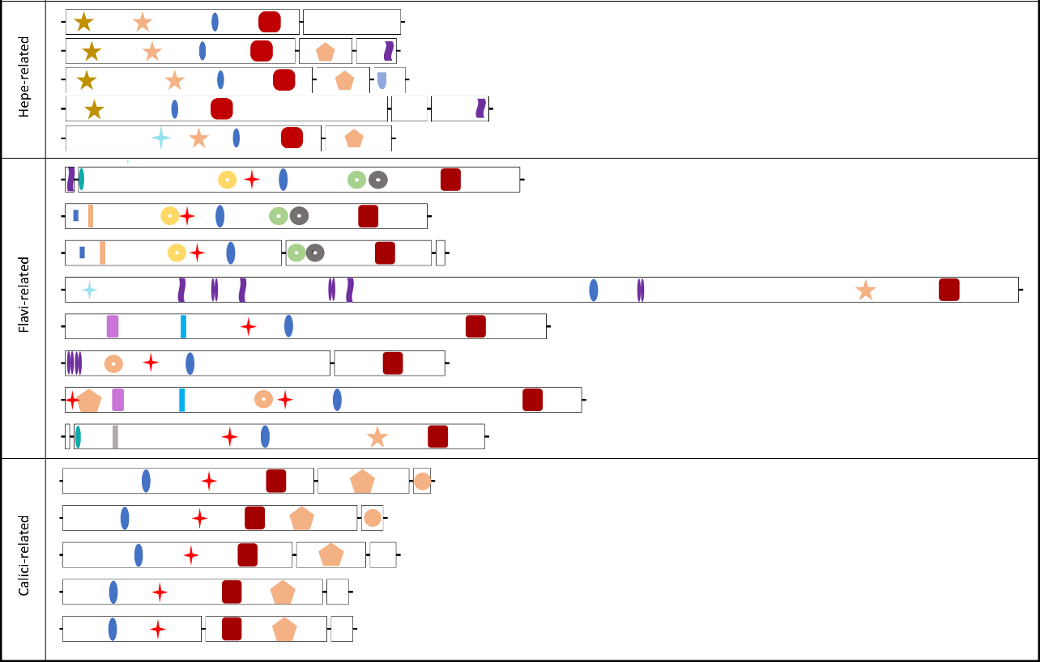
Figure S4. Diversity of protein domains in RNA viruses. Homologous domains are shown as the same shape and color, which were illustrated on the bottom.

Figure S5
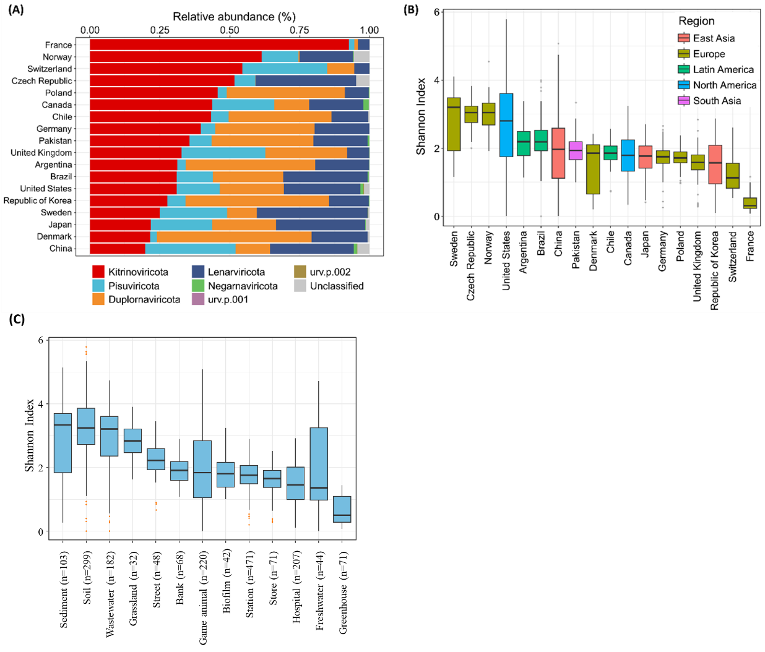
Figure S5. (A) Composition and diversity of the RNA viral community across different countries. (B) The alpha diversity of the viral community was measured using the Shannon index. (C) Shannon diversity index (SDI) of samples collected from different environments. The SDI was calculated using the “diversity” function in the Vegan package. The numbers in parentheses indicate the sample size.

Figure S6
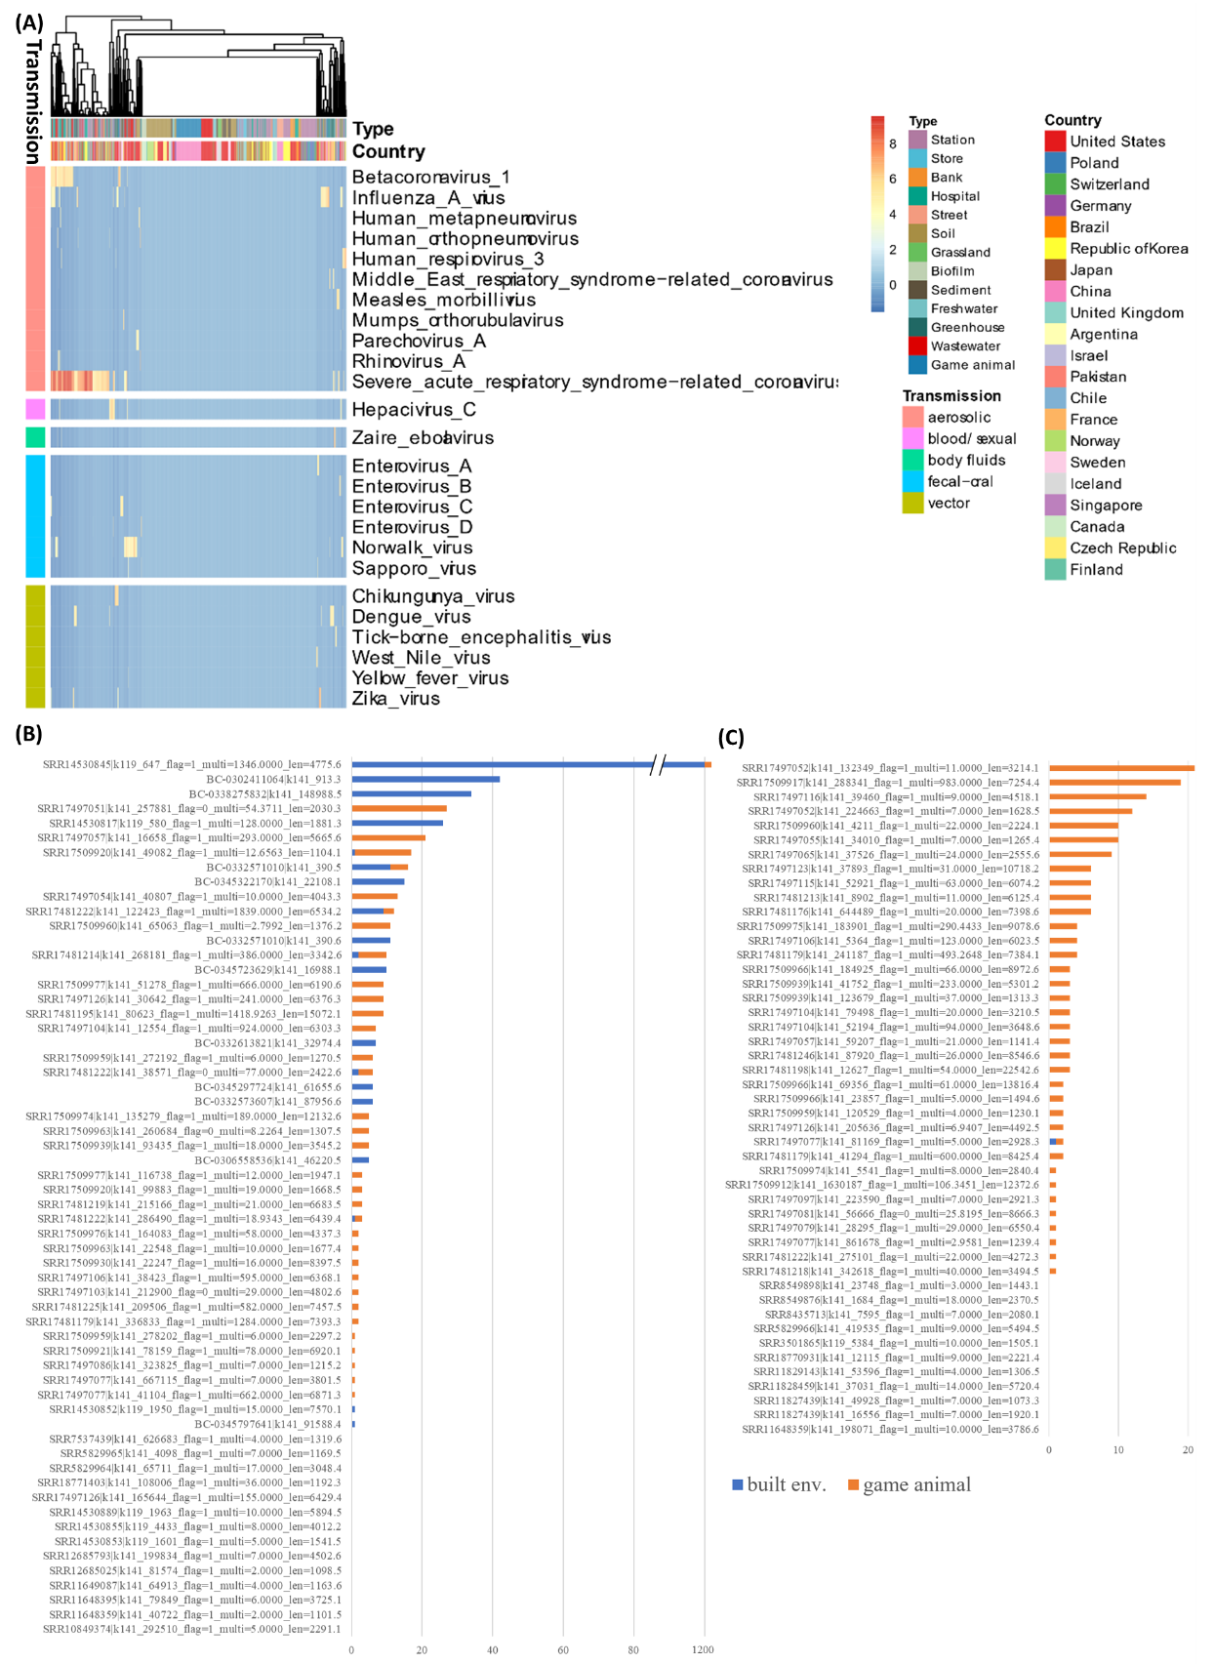
Figure S6. (A) Heatmap of Z-scored mean abundance of various human pathogenic RNA viruses in each sample. Samples are color-coded by country and environment, and clustered based on abundance patterns. Viruses are grouped and color-coded according to their transmission type. (B) Numbers of samples in which 60 human-associated RCR95s were detected. (C) Numbers of samples in which 47 mammalian-associated RCR95s were detected.

Figure S7
Figure S7. Distribution of reads from six samples collected from different body parts of game animals, mapped back to the SARS-CoV-2 reference genome.

Figure S8
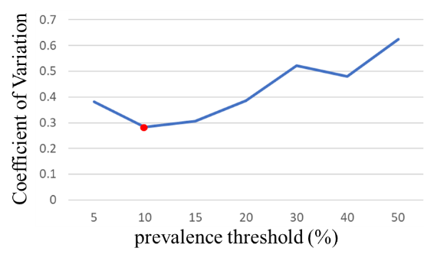
Figure S8. Calculating the coefficient of variation of the sizes of core-viromes from different environment sets. A relatively balanced number of core-viromes was obtained across all environment set under the prevalence threshold of 10%.

