Supplementary Information
A Nuclear Chemical Descriptor Based on NMR Databases for Molecular Information: Characterization of π-Conjugated Oligomers
João P. C. Oliveira*,†, Murillo. H. Queiroz §, Patricio F. Provasi¶, Roberto Rivelino*‡
† Centro de Ciência e Tecnologia em Energia e Sustentabilidade, Universidade Federal do Recôncavo da Bahia, 44085-132 Feira de Santana, Bahia, Brazil
§ Departamento de Físico-Química, Instituto de Química, Universidade Federal da Bahia, Rua Barão de Jeremoabo 147, 40170-115 Salvador, Bahia, Brazil
¶ Department of Physics, University of Northeastern, IMIT-CONICET. Av. Libertad 5500, W 3404 AAS Corrientes, Argentina
‡ Instituto de Física, Universidade Federal da Bahia, 40210-340 Salvador, Bahia, Brazil

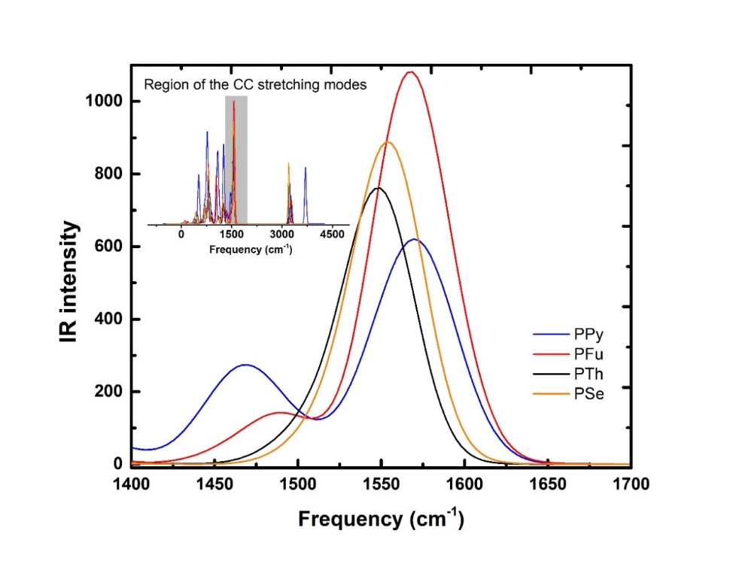
Fig S1. PBE0/6-311+G(d,p) calculated IR spectra as a function of the heteroatom and oligomer size.
Table S1. Calculated JCA for oligomers as a function of n.
n | JCA (Hz)
n | PPy | PFu | PTh | PSe
2 | 5.72 | 5.42 | 3.33 | 4.30
3 | 3.34 | 1.94 | 1.73 | 2.73
5 | 1.65 | -0.68 | 0.44 | 1.65
7 | 1.02 | -1.71 | 0.00 | 1.19
9 | 0.67 | -2.25 | -0.33 | 0.91
11 | 0.43 | -2.57 | -0.52 | 0.79

Table S2. CAM-B3LYP//PBE0, 6-311+G(d,p) calculated optical gaps and absorption wavelengths as a function of n.
n
n | PPy |  | PFu |  | PTh |  | PSe
 | Opt. Gap | Abs. | Opt. Gap | Abs. | Opt. Gap | Abs. | Opt. Gap | Abs.
2 | 5.10 | 243.1 | 4.75 | 261.0 | 4.42 | 280.7 | 4.15 | 298.4
3 | 4.41 | 280.9 | 3.99 | 311.0 | 3.74 | 331.4 | 3.51 | 352.9
5 | 3.84 | 323.3 | 3.33 | 371.9 | 3.15 | 393.3 | 2.93 | 422.8
7 | 3.62 | 342.6 | 3.06 | 404.8 | 2.91 | 426.8 | 2.68 | 461.9
9 | 3.51 | 353.0 | 2.92 | 424.1 | 2.73 | 453.4 | 2.56 | 485.1
11 | 3.44 | 360.7 | 2.84 | 436.2 | 2.70 | 458.6 | 2.48 | 499.8

