Supplementary Information of
2p interlayer exciton revealed by hybridization in bilayer MoS₂

Soonyoung Cha^{1,†}, Zhaoran Xu^{1,†}, Tianyi Ouyang^{1,†}, Hongyu Yao¹, Raj Kumar Paudel^{2,3}, Takashi Taniguchi⁴, Kenji Watanabe⁵, Andrew Y. Joe¹, Yia-Chung Chang^{2,3*}, Nathaniel M. Gabor^{1*} & Chun Hung Lui^{1*}

¹ Department of Physics and Astronomy, University of California, Riverside, CA, USA.
² Research Center for Applied Sciences, Academia Sinica, Taipei, Taiwan
³ Department of Physics, National Cheng-Kung University, Tainan, Taiwan
⁴ International Center for Materials Nanoarchitectonics, National Institute for Materials Science, Tsukuba, Japan.
⁵ Research Center for Functional Materials, National Institute for Materials Science, Tsukuba, Japan.

†These authors contributed equally to this work
*Corresponding author. Email: yiachang@gate.sinica.edu.tw; nathaniel.gabor@ucr.edu; joshua.lui@ucr.edu
Table of Contents

Section I. Experimental Methods and Analysis
1. Device fabrication
2. Field-dependent reflectance contrast measurements
3. Results on Devices 1, 2 and 3
4. Modeling differential reflectance contrast

Section II. Selection Rules and g-factors of Excitons in Bilayer MoS₂
1. Symmetry of electronic states in monolayer MoS₂
2. Symmetry of electronic states in 2H-stacked bilayer MoS₂
3. Symmetry of exciton states in 2H-stacked bilayer MoS₂
4. Hybridized excitons in bilayer MoS₂
4.1. Hybridization between $A_{1s,↓}^{0}$ and $A_{2p+,↓}^{I}$
4.2. Hybridization between $A_{1s,↑}^{0}$, $A_{2s,↑}^{0}$, and $B_{1s,↑}^{I}$
4.3. Hybridization between $A_{1s,↑}^{I}$ and $A_{2p_{+},↑}^{0}$
4.4. Hybridization between $A_{2s,↑}^{I}$, $A_{3s,↑}^{I}$, and $B_{1s,↑}^{0}$
5. Estimation of exciton g-factors

Section III. Theoretical Simulations for Excitons in Bilayer MoS₂
1. Bloch states in bilayer MoS₂
1.1. Bloch states in the K valley
1.2. Density distribution of the valence bands
1.3. Expressing bilayer valence-band states in terms of monolayer-like states
1.4. Bloch states of the conduction bands
2. Excitons and their Coulomb-interaction matrix elements
2.1. Constructing excitons from the Bloch states
2.2. Direct electron-hole Coulomb interaction
2.3. Electron-hole exchange Coulomb interaction
2.4. Field-dependent matrix elements of direct Coulomb interaction
3. Calculations of the exciton eigenstates and eigen energies in bilayer MoS₂
3.1. The exciton Hamiltonian
3.2. The zeroth-order approximation
3.3. Results in the zeroth-order approximation at zero electric field
4. Zeroth-order exciton states at finite electric fields
4.1. Band energies at finite electric fields
4.2. Hole distribution at finite electric fields
4.3. Exciton energies at finite electric fields
5. Hybridization between same-spin excitons
5.1. Six coupling terms for hybridization effect between same-spin excitons
5.2. The $A_{↑}^{I}-B_{↑}^{0}$ coupling term
5.3. The $A_{↑}^{0}-B_{↑}^{I}$ coupling term
5.4. The $A_{↑}^{0}-A_{↑}^{I}$ coupling term
5.5. Coupling terms between spin-down excitons
5.6. Calculated coupling strengths between same-spin excitons
5.7. Hybridization between same-spin excitons.
5.7.1. Hybridization between $A_{↑}^{0}$, $A_{↑}^{I}$, and $B_{↑}^{0}$ excitons
5.7.2. Hybridization between $A_{↑}^{0}$, $A_{↑}^{I}$, and $B_{↑}^{I}$ excitons
5.7.3. Hybridization between spin-down excitons
6. Hybridization between opposite-spin excitons
6.1. Calculated coupling strengths between opposite-spin excitons
6.2. Hybridization between opposite-spin excitons
6.3. Effective coupling strengths between opposite-spin excitons
7. Simulation of the reflectance contrast maps
8. Summary of theory

Section I. Experimental Methods and Analysis
1. Device fabrication
We fabricate dual-gated bilayer MoS₂ devices encapsulated by hexagonal boron nitride (BN), using thin graphite flakes as both contact and gate electrodes. The device structure is illustrated in Fig. S1a. The fabrication process proceeds as follows. First, graphite, BN, and bilayer MoS₂ flakes are mechanically exfoliated using the conventional scotch-tape method. Bulk graphite and MoS₂ crystals are purchased from HQ Graphene Inc., while BN crystals are provided by our collaborators T. Taniguchi and K. Watanabe. Following exfoliation, a dry transfer technique is used assemble the heterostructure, employing a polycarbonate (PC) stamp mounted on a polymethyl methacrylate (PMMA) film. The stacking sequence is as follows: (1) a graphite flake as the top-gate electrode, (2) a top BN dielectric layer, (3) the bilayer MoS₂ sample, (4) a graphite flake serving as the contact electrode. (5) a bottom BN dielectric layer, and (6) a graphite flake as the bottom-gate electrode. The assembled stack is then transferred onto a Si/SiO₂ substrate with 285 nm oxide layer.
Three devices are used in this study. For Devices 1 and 3, the heterostructures are transferred onto unpatterned Si/SiO₂ substrate, followed by standard electron-beam lithography and evaporation to deposit Ti/Au (5 nm/50 nm) metal contacts. For Device 2, the heterostructure is transferred onto a Si/SiO₂ substrate with pre-patterned Ti/Au contacts fabricated using the same process. Figs. S1b-S1d show the optical images of Devices 1 – 3.
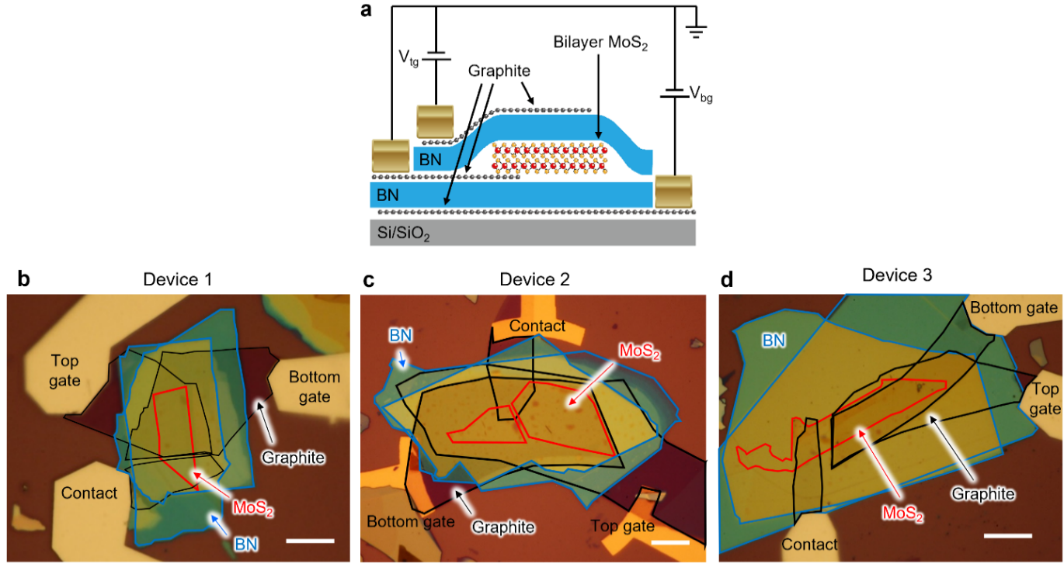
Figure S1 | a, Schematic illustration of a dual-gated bilayer MoS₂ device. b-d, Optical images of Device 1 (b), Device 2 (c) and Device 3 (d). Graphite, BN, and bilayer MoS₂ flakes are outlined by black, blue, and red lines, respectively. Scale bars represent 10 $μ$m.
2. Field-dependent reflectance contrast measurements
We perform electric-field-dependent reflection contrast measurements at a temperature of approximately 6 K using a cryostat (Montana Instruments). A tungsten-halogen lamp (SLS201L, Thorlabs) serves as the broadband white light source. The light is focused onto the sample through an objective lens with a numerical aperture (NA) of 0.6 and 50× magnification. A lens pair and a pinhole are positioned before the sample to confine the beam at the confocal plane, resulting in a spot size of approximately 2 $μ$m on the sample surface.
The reflected light is collected through the same objective lens and directed to a spectrometer (HRS-500-MS, Princeton Instruments) coupled to a CCD detector (PIXIS-400, Princeton Instruments). Reflection spectra are acquired from the sample region ($R_{s}$), while a reference spectrum ($R_{r}$) is taken from a nearby BN-encapsulated area without bilayer MoS₂. The reflectance contrast is defined as $∆R/R =(R_{s}/R_{r})-1$. To enhance the weak spectral features, we perform second-order derivative with respect to photon energy ($E_{ph}^{ }$), yielding $d^{2}(∆R/R)/dE_{ph}^{2}$. A smoothing process is then applied to the resulting spectra.
A vertical electric field is applied across bilayer MoS₂ by independently biasing the top and bottom gate electrodes using two voltage sourcemeters (Keithley 2400). The interlayer electric field, denoted as F to avoid confusion with energy, is estimated using the following expression¹:
$F≈\frac{ε_{BN}}{2ε_{MoS_{2}}}\left(\frac{V_{tg}}{d_{t}}-\frac{V_{bg}}{d_{b}}\right)$ (1)
Here, $V_{tg}$ and $V_{bg}$ are voltage applied on top and bottom gate electrodes, respectively; $d_{t}$ and $d_{b}$ are the thicknesses of the top and bottom BN layers; and the relative dielectric constants^{2,3} are $ε_{BN}=3$ and $ε_{{MoS}_{2}}=6.8$.
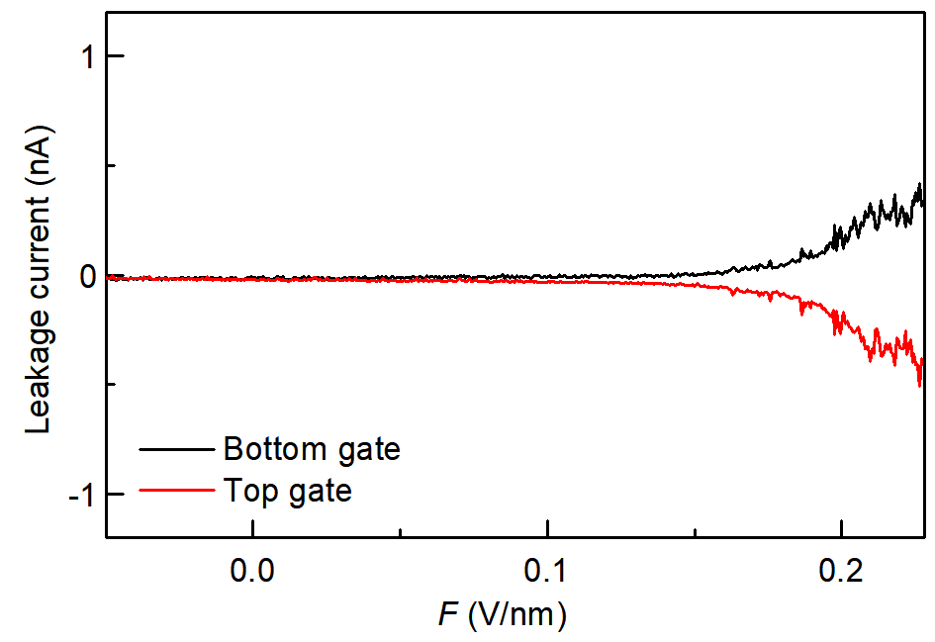
Figure S2 | Leakage currents at the top and bottom gate electrodes of Device 1

To ensure that our measurements were not influenced by unintentional charge injection or tunneling currents, we continuously monitored the gate leakage current during data acquisition for all figures in the main text. Fig. S2 shows the leakage currents at the top and bottom gates during the measurement corresponding to Fig. 2a. Throughout the entire range of applied electric fields (0 – 0.227 V/nm), the leakage current remained below 1 nA.
We also perform helicity-resolved reflection measurements under magnetic fields using a magneto-cryostat system (Attodry 2100). In this setup, a supercontinuum laser (SC-pro, YSL Photonics) is used as the broadband light source. The circular polarization of the incident light is achieved using a linear polarizer followed by a quarter-wave plate.

3. Results on Devices 1, 2 and 3
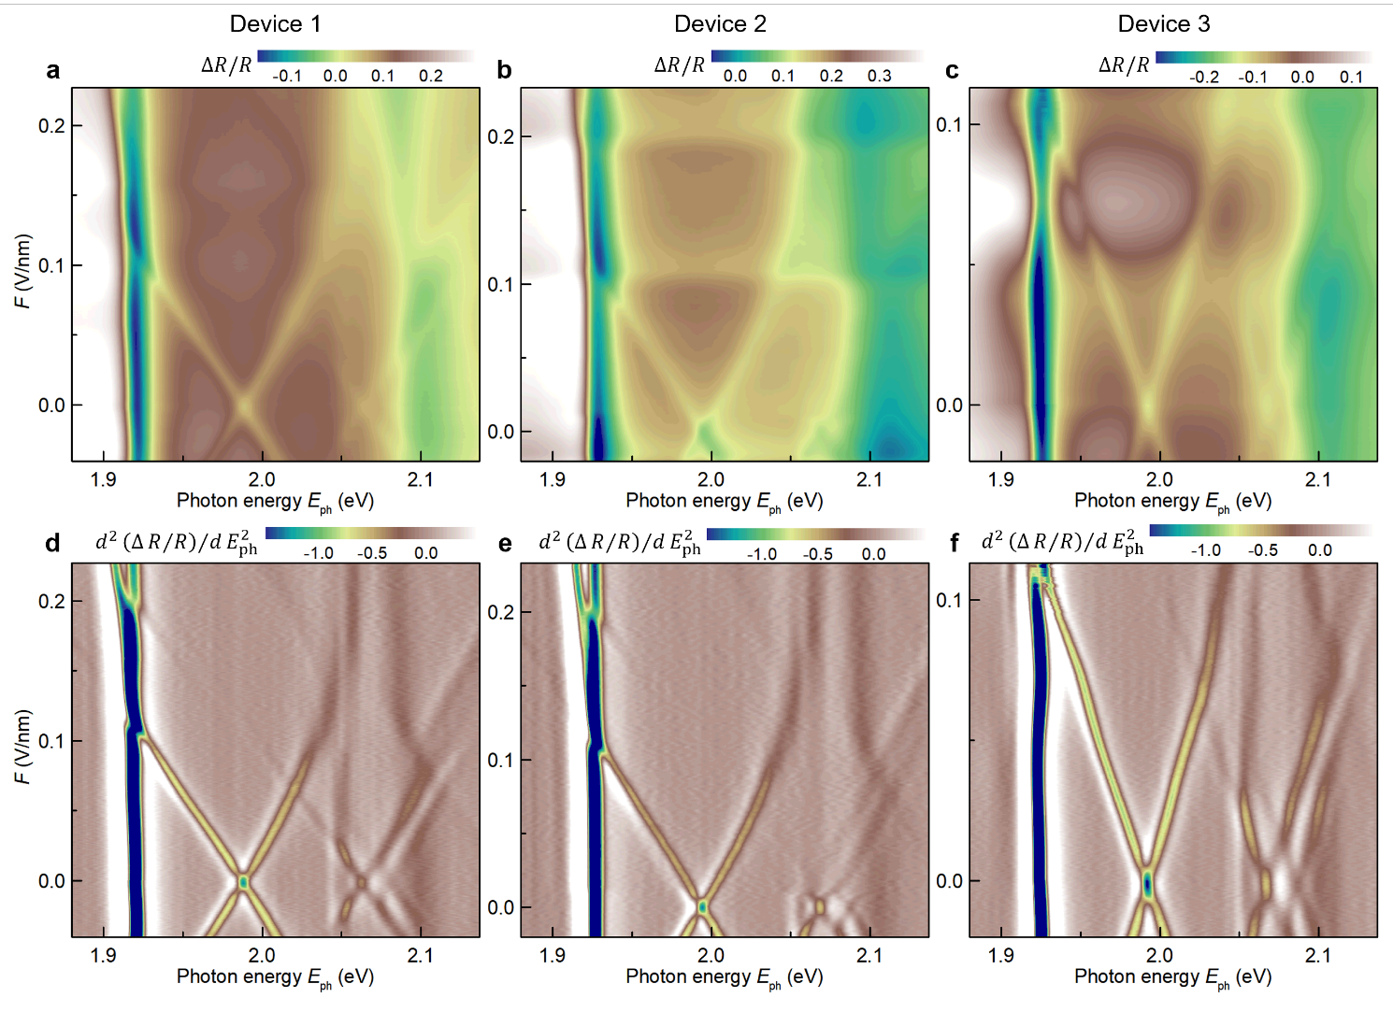
Figure S3 | a-c, Field-dependent reflectance contrast ($∆R/R$) maps for Devices 1-3. d-f, Corresponding second-order derivative of the reflectance contrast maps with respect to photon energy. The field-dependent fluctuations observed in the $∆R/R$ maps are artifacts arising from light source instability. These artifacts are largely suppressed in the second-order derivative maps.

We have presented the differential reflectance contrast maps of Devices 1-2 in the main text. In Fig. S3, we further show the field-dependent reflectance contrast ($∆R/R$) maps (top row) and their second-order energy derivatives (bottom row) for all three devices. The consistent results across devices confirm the reproducibility of our measurements.

4. Modeling differential reflectance contrast
We model the optical spectrum of excitons using a Lorentzian oscillator approach, which treats each exciton as a damped harmonic oscillator driven by a sinusoidal time-dependent force. This simple yet powerful model yields an analytical expression of the complex dielectric function:
$ε\left(ℏω\right)=ε_{0}+\sum_{j}{\frac{S_{j}ω_{0,j}}{ω_{0,j}^{2}-ω^{2}-iωΓ_{j}}}$ (2)
Here, $ε_{0}$ is the permittivity of free space; the index $j$ labels the exciton states (e.g. intralayer or interlayer exciton); $S_{j}$ represents the amplitude or strength of the j-th resonance, determining its contribution to the total permittivity; $ω_{0,j}^{ }$ and $Γ_{j}$ are the resonance frequency and damping constant, respectively, and serve as fitting parameters.
From the dielectric function in Eq. (2), the complex index of refraction $N=n-ik$ can be derived as:
$n=\frac{1}{\sqrt{2ε_{0}}}\sqrt{\sqrt{{Re(ε)}^{2}+{Im(ε)}^{2}}+Re(ε)}$ (3)
$k=\frac{1}{\sqrt{2ε_{0}}}\sqrt{\sqrt{{Re(ε)}^{2}+{Im(ε)}^{2}}-Re(ε)}$ (4)
Here, $Re(ε)$ and $Im(ε)$ denote the real and imaginary parts of the dielectric function.
Each of our devices contains a multilayer stack: Gr/BN/MoS₂/BN/Gr/SiO₂/Si (top graphite, top BN, bilayer MoS₂, bottom BN, bottom graphite, SiO₂, and silicon). For each layer (denoted by a layer index $m$), the electric and magnetic fields on the two boundaries of the layer are related through a transfer matrix⁴
$M_{m}=\left(\begin{matrix}\cos{δ_{m}} & \frac{i\sin{δ_{m}}}{η_{m}} \\ iη_{m}\sin{δ_{m}} & \cos{δ_{m}}\end{matrix}\right)$ (5)
The complex phase $δ_{m}$ and optical admittance $η_{m}$ are defined as
$δ_{m}=\frac{2π\left(n_{m}-ik_{m}\right)d_{m}}{λ}$ (6)
$η_{m}=\left(n_{m}-ik_{m}\right)\sqrt{\frac{ε_{0}}{μ_{0}}}$ (7)
Here, $n_{m}-ik_{m}$ is the complex refractive index; $d_{m}$ is the thickness of the m-th layer; $ε_{0}$ and $μ_{0}$ are the permittivity and permeability of vacuum, respectively; $λ$ is the free-space wavelength of light.
The electric and magnetic fields in the vacuum/top-graphite interface ($E_{v}$, $H_{v}$) and in the SiO₂/Si interface ($E_{Si}$, $H_{Si}$) of the stack are related by the total transfer matrix:
$\left({E_{v} \atop H_{v}}\right)=M\left({E_{Si} \atop H_{Si}}\right)$ (8)
Here, $M=M_{1}M_{2}M_{3}M_{4}M_{5}M_{6}$ is the product of transfer matrices for each layer. Defining $B=E_{v}/E_{Si}$, $C=H_{v}/E_{Si}$, $η_{Si}=H_{Si}/E_{Si}$, we rewrite Eq. (8) as:
$\left({B \atop C}\right)=M\left({1 \atop η_{Si}}\right)$ (9)
The reflectance $R_{s}$ from the area containing the MoS₂ layer is then:
$R_{s}={\left|\frac{η_{0}B-C}{η_{0}B+C}\right|}^{2}$ (10)
where $η_{0}=ε_{0}/μ_{0}$.
For a reference region without MoS₂ (i.e. the Gr/BN/BN/Gr/SiO₂/Si), a similar expression applies:
$\left({B_{r} \atop C_{r}}\right)=M_{r}\left({1 \atop η_{Si}}\right)$ (11)
with $M_{r}$, $B_{r}$ and $C_{r}$ defined similarly but excluding the MoS₂ layer. The corresponding reflectance is:
$R_{r}={\left|\frac{η_{0}B_{r}-C_{r}}{η_{0}B_{r}+C_{r}}\right|}^{2}$ (12)
The reflection contrast is then given by:
$\frac{ΔR}{R}=\frac{R_{s}-R_{r}}{R_{r}}$ (13)
We then compute the second-order derivative with respect to photon energy to obtain $d^{2}(ΔR/R)/dE_{ph}^{2}$. After establishing the connection between $ε\left(ℏω\right)$ and $d^{2}(ΔR/R)/dE_{ph}^{2}$, we fit our data using a sum of complex Lorentzian functions in $ε\left(ℏω\right)$, where $S_{j}$, $ω_{0,j}^{ }$ and $Γ_{j}$ serve fitting parameters.
Figs. S4a-S4c displays the measured $ΔR/R$ spectrum, $d^{2}(ΔR/R)/dE_{ph}^{2}$ spectrum at zero electric field for Device 1, the corresponding best-fit curve, and the extracted imaginary part of the dielectric function. Our fit includes six complex Lorentzian components corresponding to the $A_{1s}^{0}$, $A_{2s}^{0}$, $A_{1s}^{I}$, $A_{2s}^{I}$, $A_{3s}^{I}$, and $B_{1s}^{0}$ excitons. Similarly, Figs. S4d-S4f and S4g-S4i present the fits for the zero-field spectra of Devices 2 and 3, respectively. The multi-Lorentzian model captures the observed excitonic features and enables the extraction of key fitting parameters—amplitude, resonance energy, and linewidth—for each exciton state, as summarized in Table S1.
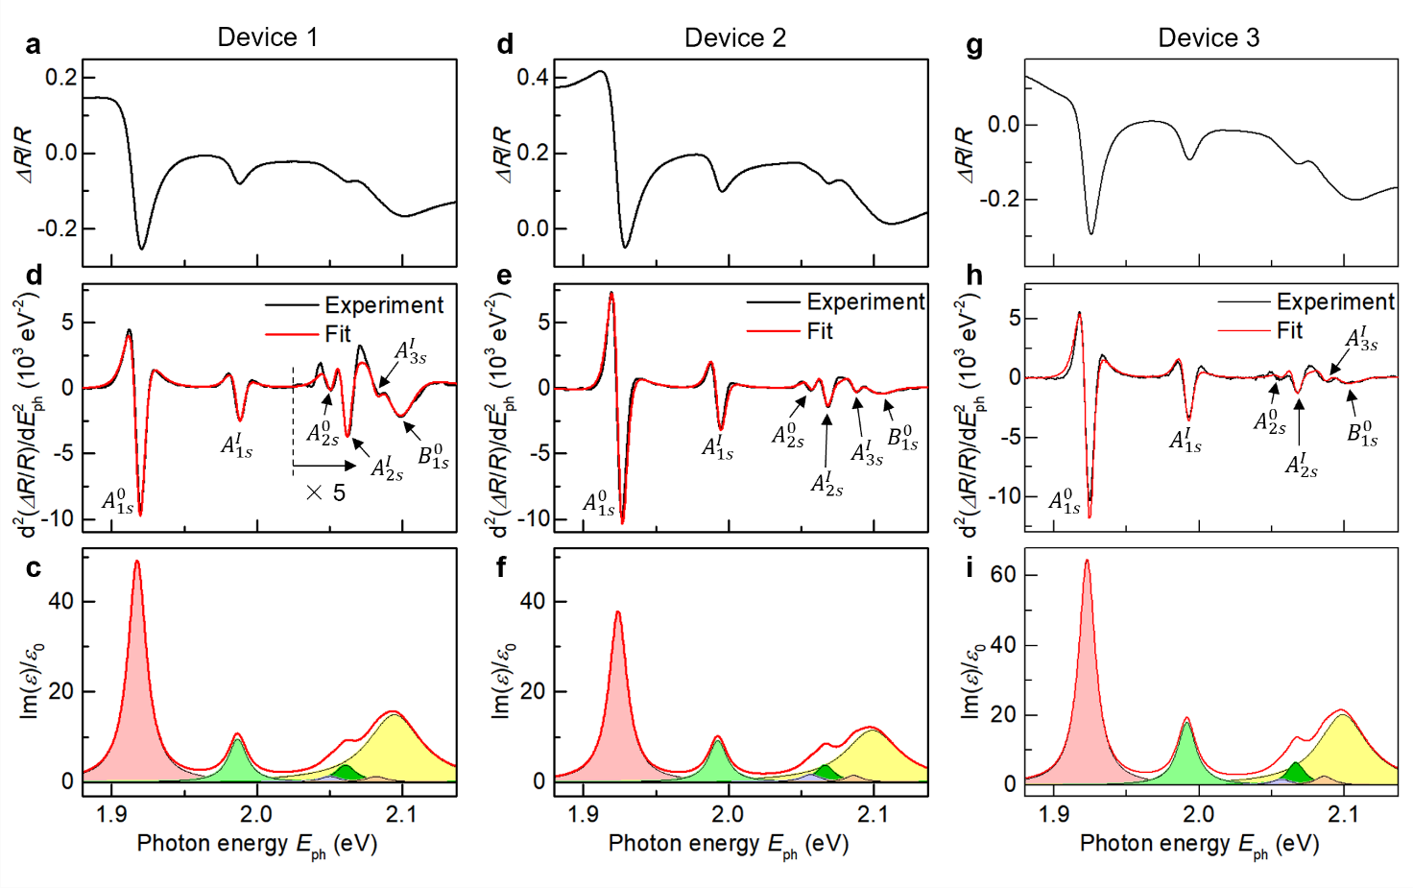
Figure S4 | a, Measured second-order derivative spectrum $d^{2}(ΔR/R)/dE_{ph}^{2}$ for Device 1 at zero electric field. b, Best-fit curve (red line) for the spectrum in panel a. c, Imaginary part of the dielectric function (red line) extracted from the fit, with individual exciton contributions shown as shaded components. d-f, Same as panels a-c, but for Device 2. g-i, Same as panels a-c, but for Device 3.
 |  | $$A_{1s}^{0}$$ | $$A_{2s}^{0}$$ | $$A_{1s}^{I}$$ | $$A_{2s}^{I}$$ | $$A_{3s}^{I}$$ | $$B_{1s}$$
Device 1 | $S$ (μeV²) | 12.67 | 0.372 | 2.592 | 1.145 | 0.384 | 12.46
Device 1 | $ω_{0}$ (eV) | 1.918 | 2.05 | 1.987 | 2.061 | 2.082 | 2.095
Device 1 | $Γ$ (meV) | 15.3 | 15.9 | 15.5 | 16.8 | 16.7 | 45
Device 2 | $S$ (μeV²) | 9.61 | 0.49 | 2.496 | 1.01 | 0.384 | 9.61
Device 2 | $ω_{0}$ (eV) | 1.924 | 2.0565 | 1.9925 | 2.0665 | 2.086 | 2.099
Device 2 | $Γ$ (meV) | 15 | 16 | 15.4 | 14.5 | 14 | 45
Device 3 | $S$ (μeV²) | 15.28 | 0.504 | 4.884 | 1.716 | 0.723 | 15.44
Device 3 | $ω_{0}$ (eV) | 1.9228 | 2.0565 | 1.9915 | 2.0665 | 2.086 | 2.099
Device 3 | $Γ$ (meV) | 14 | 16 | 15.4 | 14.5 | 15 | 41
Table S1 | Best-fit parameters for the spectra of Devices 1-3 at zero electric field, corresponding to the measured data and fitted curves shown in Fig. S4.
Section II. Selection Rules and g-factors of Excitons in Bilayer MoS₂
Our experiment reveals the coupling between intralayer and interlayer Rydberg excitons. In this section, we will derive the selection rules of such exciton coupling by symmetry analysis. We will first analyze the symmetry properties of electronic states in the K valley in monolayer and bilayer MoS₂ and then extend to the analysis to the Rydberg exciton states in the bilayer system. Based on these symmetry considerations, we further estimate the g-factors of the relevant excitons.

1. Symmetry of electronic states in monolayer MoS₂
Monolayer MoS₂ has the D_{3h} symmetry point group. The K/K’ points have the C_{3h} symmetry subgroup, which consists of the in-plane C₃ rotational symmetry and out-of-plane mirror symmetry $σ_{h}$. We define ${\hat{C}}_{3}$ as an operator that actively rotates the state counter-clockwise by $120°$ and ${\hat{σ}}_{h}$ as the mirror reflecting operator. An eigen state transforms as:
${\hat{C}}_{3}ψ=e^{-i\frac{2π}{3}C_{3}(ψ)}ψ$and ${\hat{σ}}_{h}ψ=σ_{h}\left(ψ\right)ψ$ (14)
Here, $e^{-i\frac{2π}{3}C_{3}(ψ)}$ and $σ_{h}(ψ)$ are the eigenvalues of the operators; $C_{3}\left(ψ\right)=0, ±1$ and $σ_{h}\left(ψ\right)=±1$ are the symmetry quantum numbers for the state $ψ$. If the eigen state is an electronic spin, the corresponding quantum numbers are $C_{3}=±1/2$ and $σ_{h}=±i$, where the positive (negative) signs are for the spin-up (spin-down) state.
The ${\hat{C}}_{3}$ operation can be performed with respect to the Mo atom, S atom, or the center of the hexagon (h), denoted as $C_{3}(Mo)$, $C_{3}(S)$, and $C_{3}(h)$, respectively (Fig. S5).
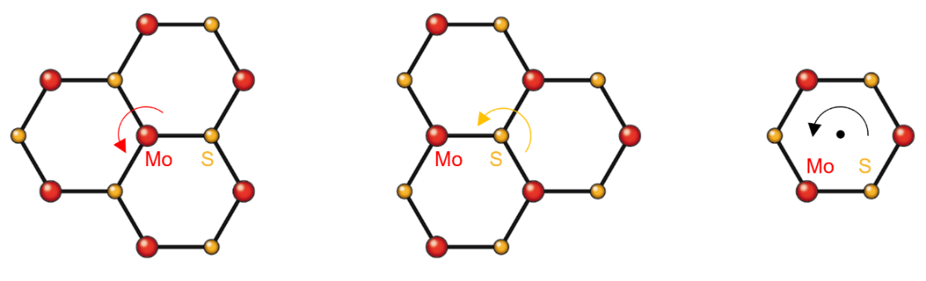
Figure S5 | Illustration of the ${\hat{C}}_{3}$ operation with respect to the Mo atom, S atom, ant the hexagon center (h), respectively.

The electronic states in the K valley in monolayer MoS₂ are dominantly contributed by the $d_{0}$ and $d_{+2}$ orbits of the Mo atom. These orbits transform in monolayer MoS₂ with the quantum numbers shown in Table S2.
Bands | Mo orbits | $$σ_{h}$$ | $$C_{3}(Mo)$$ | $$C_{3}(S)$$ | $$C_{3}(h)$$
$$C$$ | $$d_{0}$$ | +1 | 0 | -1 | +1
$$V$$ | $$d_{+2}$$ | +1 | -1 | +1 | 0
Table S2 | Symmetry quantum numbers of the $d_{0}$ and $d_{+2}$ orbits in the Mo atom of monolayer MoS₂. $C_{3}(Mo)$, $C_{3}\left(S\right)$ and $C_{3}(h)$ correspond to the $C_{3}$ rotation around the Mo atom, S atom, and the hexagon center, respectively.

In monolayer MoS₂, the conduction bands ($C_{↑}$, $C_{↓}$) are dominated by the $d_{0}$ orbit, and the valence bands ($V_{↑}$, $V_{↓}$) are dominated by the $d_{+2}$ orbit in the K valley (and $d_{-2}$ orbit in the K’ valley). The subscripts “$↑$” and “$↓$” denote their dominant spin. Table S3 displays the symmetry quantum number of these states in the K valley (those in the K’ valley are connected straightforwardly by time-reversal symmetry).
Bands | Mo orbits | $$σ_{h}$$ | $$C_{3}(Mo)$$ | $$C_{3}(S)$$ | $$C_{3}(h)$$
$$C_{↓}$$ | $$d_{0}$$ | -i | -1/2 | +3/2 | +1/2
$$C_{↑}$$ | $$d_{0}$$ | +i | +1/2 | -1/2 | +3/2
$$V_{↑}$$ | $$d_{+2}$$ | +i | -1/2 | +3/2 | +1/2
$$V_{↓}$$ | $$d_{+2}$$ | -i | +3/2 | +1/2 | -1/2
Table S3 | Symmetry quantum numbers of the K-point states in the conduction bands ($C_{↑}$, $C_{↓}$) and valence bands ($V_{↑}$, $V_{↓}$) of monolayer MoS₂. $C_{3}(Mo)$, $C_{3}\left(S\right)$ and $C_{3}(h)$ correspond to the $C_{3}$ rotation with respect to the Mo atom, S atom, and the hexagon center, respectively.

2. Symmetry of electronic states in 2H-stacked bilayer MoS₂
The K-point states in bilayer MoS₂ are primarily localized within individual layers. As our studies focus on K-valley excitons, we can treat bilayer MoS₂ as two monolayers that weakly couple to each other. In this scheme, the bilayer K-point states can be separated into two sets of monolayer states, namely the Layer 1 (L1) and Layer 2 (L2) states, as schematically shown in Fig. S6. In the 2H stacking order, the two monolayers are connected by inversion symmetry; they rotate by $180°$ so that the Mo atoms in L1 with the S atoms in L2 and the hexagon centers of the two layers align with each other. Consequently, the L1 and L2 states at the K point have different symmetry properties, as shown in Table S4.
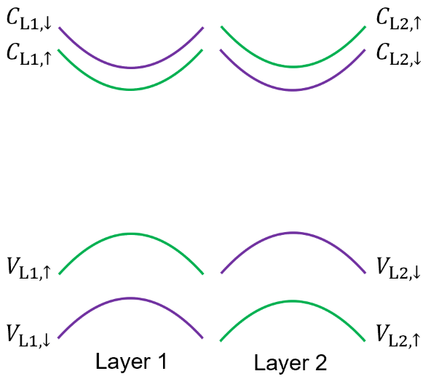
Figure S6 | Schematic band structure of bilayer MoS₂ at the K valley. Green and purple color denote bands with spin up and spin down configuration.
Bands | Mo orbits | $$σ_{h}$$ | $$C_{3}(Mo)$$ | $$C_{3}(S)$$ | $$C_{3}(h)$$ |  | Bands | Mo orbits | $$σ_{h}$$ | $$C_{3}(Mo)$$ | $$C_{3}(S)$$ | $$C_{3}(h)$$
$$C_{L1,↓}$$ | $$d_{0}$$ | -i | -1/2 | +3/2 | +1/2 |  | $$C_{L2,↑}$$ | $$d_{0}$$ | +i | +3/2 | +1/2 | -1/2
$$C_{L1,↑}$$ | $$d_{0}$$ | +i | +1/2 | -1/2 | +3/2 |  | $$C_{L2,↓}$$ | $$d_{0}$$ | -i | +1/2 | -1/2 | +3/2
$$V_{L1,↑}$$ | $$d_{+2}$$ | +i | -1/2 | +3/2 | +1/2 |  | $$V_{L2,↓}$$ | $$d_{-2}$$ | -i | +3/2 | +1/2 | -1/2
$$V_{L1,↓}$$ | $$d_{+2}$$ | -i | +3/2 | +1/2 | -1/2 |  | $$V_{L2,↑}$$ | $$d_{-2}$$ | +i | -1/2 | +3/2 | +1/2
Table S4 | The symmetry quantum numbers of the L1 states (left) and the L2 states (right) in 2H-stacked bilayer MoS₂. States with identical symmetry properties are highlighted in green or purple.

3. Symmetry of exciton states in 2H-stacked bilayer MoS₂
From the symmetry of the electron bands at the K point, we can deduce the symmetry properties of various exciton states. For an exciton ($X$) consisting of an electron in the conduction band $C$ and a hole in the valence band $V$, if its ${\hat{L}}_{z}$ quantum number is $m$, then the symmetry quantum number of the exciton is given by:
$C_{3}\left(X\right)=C_{3}\left(C\right)-C_{3}\left(V\right)+m$ (15)
For an s-like exciton $m=0$, this reduces to $C_{3}\left(X\right)=C_{3}\left(C\right)-C_{3}\left(V\right)$, which is the same as that of the corresponding band-to-band transition. For p-like excitons with $m=±1$, the symmetry quantum numbers are $C_{3}\left(X\right)=C_{3}\left(C\right)-C_{3}\left(V\right)±1$, corresponding to the $p_{+}$ and $p_{-}$ states, respectively.
Table S5 summarizes the C₃ symmetry quantum numbers of various exciton Rydberg states in bilayer MoS₂. Exciton-exciton hybridization in this system follows two selection rules: (1) only excitons with the same C₃ quantum numbers can hybridize due to the preserved three-fold rotation symmetry of bilayer MoS₂; and (2) only excitons with the same spin configuration can couple. Based on these selection rules, the excitons can be categorized into four mutually coupled sets:
(1) $A_{s,↑}^{0}$, $A_{p_{-},↑}^{I}$, $B_{p_{-},↑}^{0}$, and $B_{s,↑}^{I}$, all with $C_{3}=+1$ and spin-up;
(2) $A_{p_{+},↑}^{0}$, $A_{s,↑}^{I}$, $B_{s,↑}^{0}$, and $B_{p_{+},↑}^{I}$, all with $C_{3}=-1$ and spin-up;
(3) $A_{p_{-},↓}^{0}$, $A_{s,↓}^{I}$, $B_{s,↓}^{0}$, and $B_{p_{-},↓}^{I}$, all with $C_{3}=+1$ and spin-down;
(4) $A_{s,↓}^{0}$, $A_{p_{+},↓}^{I}$, $B_{p_{+},↓}^{0}$, and $B_{s,↓}^{I}$, all with $C_{3}=-1$ and spin-down.
If we restrict our attention to the s-like excitons, these four sets simplify into four coupled pairs:$A_{s,↑}^{0}-B_{s,↑}^{I}$, $A_{s,↑}^{I}-B_{s,↑}^{0}$, $A_{s,↓}^{0}-B_{s,↓}^{I}$, and $A_{s,↓}^{I}-B_{s,↓}^{0}$, as illustrated in Fig. S7.
Excitons | C₃ |  | Excitons | C₃ |  | Excitons | C₃ |  | Excitons | C₃
$$A_{s,↑}^{0}$$ | +1 |  | $$A_{s,↑}^{I}$$ | -1 |  | $$B_{s,↑}^{0}$$ | -1 |  | $$B_{s,↑}^{I}$$ | +1
$$A_{p_{+},↑}^{0}$$ | -1 |  | $$A_{p_{+},↑}^{I}$$ | 0 |  | $$B_{p_{+},↑}^{0}$$ | 0 |  | $$B_{p_{+},↑}^{I}$$ | -1
$$A_{p_{-},↑}^{0}$$ | 0 |  | $$A_{p_{-},↑}^{I}$$ | +1 |  | $$B_{p_{-},↑}^{0}$$ | +1 |  | $$B_{p_{-},↑}^{I}$$ | 0
$$A_{s,↓}^{0}$$ | -1 |  | $$A_{s,↓}^{I}$$ | +1 |  | $$B_{s,↓}^{0}$$ | +1 |  | $$B_{s,↓}^{I}$$ | -1
$$A_{p_{+},↓}^{0}$$ | 0 |  | $$A_{p_{+},↓}^{I}$$ | -1 |  | $$B_{p_{+},↓}^{0}$$ | -1 |  | $$B_{p_{+},↓}^{I}$$ | 0
$$A_{p_{-},↓}^{0}$$ | +1 |  | $$A_{p_{-},↓}^{I}$$ | 0 |  | $$B_{p_{-},↓}^{0}$$ | 0 |  | $$B_{p_{-},↓}^{I}$$ | +1
Table S5 | C₃ symmetry quantum numbers for various exciton Rydberg states in bilayer MoS₂. The quantum numbers remain unchanged for rotation centers at the Mo, S atom, or the center of the hexagon.
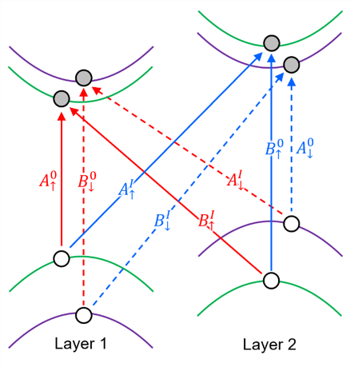
Figure S7 | s-like excitons with different C₃ symmetry in bilayer MoS₂. Red (blue) lines represent excitons with quantum number $C_{3}=+1 (-1)$.

4. Hybridized excitons in bilayer MoS₂
The selection rules discussed above are based solely on the three-fold rotational symmetry and spin configurations. However, even when two excitons satisfy these symmetry and spin conditions, their actual coupling strength is strongly influenced by their energy detuning. Significant hybridization occurs only when the exciton energies are closely aligned. In our experiment, we identify several exciton groups that simultaneously satisfy the symmetry conditions, have matching spins, and exhibit near-degenerate energies, thereby enabling strong hybridization.

4.1. Hybridization between $A_{1s,↓}^{0}$ and $A_{{2p}_{+},↓}^{I}$
This pair involves the $A_{1s,↓}^{0}$ and $A_{{2p}_{+},↓}^{I}$ excitons, both with $C_{3}=-1$ and spin-down configurations. As shown in Fig. S8, these two states are well separated by 127 meV at zero field, where the coupling is negligible and the $A_{{2p}_{+},↓}^{I}$ exciton remains optically dark. However, as the electric field increases, $A_{{2p}_{+},↓}^{I}$ crosses the $A_{1s,↓}^{0}$ state, resulting in strong hybridization and optical brightening of the initially dark $A_{{2p}_{+},↓}^{I}$ exciton.
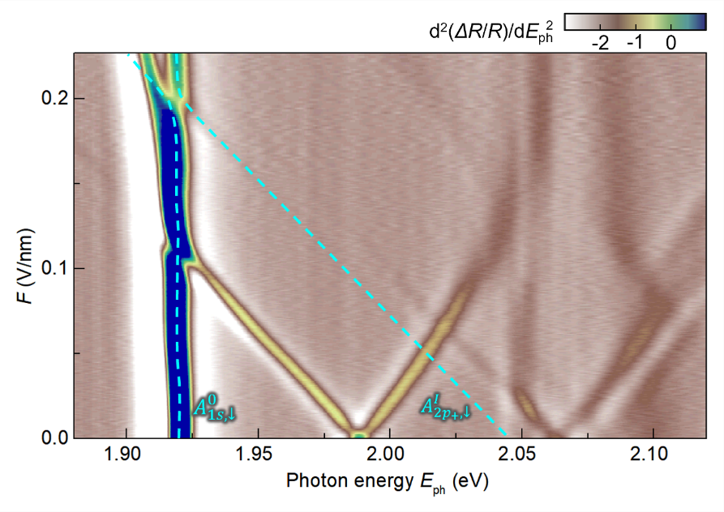
Figure S8 | Hybridization between the $A_{1s,↓}^{0}$ and $A_{{2p}_{+},↓}^{I}$ in the measured field-dependent $d^{2}(ΔR/R)/dE_{ph}^{2}$ map. Dashed lines serve as guides to the eye, highlighting the relevant excitonic features.

4.2. Hybridization between $A_{1s,↑}^{0}$, $A_{2s,↑}^{0}$, and $B_{1s,↑}^{I}$
The second group consists of the $A_{1s,↑}^{0}$, $A_{2s,↑}^{0}$ and $B_{1s,↑}^{I}$ excitons, all with $C_{3}=+1$ and spin-up configurations. These states exhibit weak coupling at zero field due to their energy separation. As the electric field increases, the $B_{1s,↑}^{I}$ exciton approaches the $A_{2s,↑}^{0}$ state, resulting in strong hybridization and pronounced level repulsion (Fig. S9). Although the $A_{1s,↑}^{0}$ state lies further in energy, it still shows weaker but noticeable repulsion with $B_{1s,↑}^{I}$ , indicating finite coupling between them. Notably, since the $A_{1s,↑}^{0}$ is degenerate with $A_{1s,↓}^{0}$ at zero field, the redshift of $A_{1s,↑}^{0}$ leads to a splitting of the $A_{1s}^{ 0}$ exciton into spin-resolved components $A_{1s,↑}^{0}$ and $A_{1s,↓}^{0}$ at higher fields, as evident in Fig. S9.
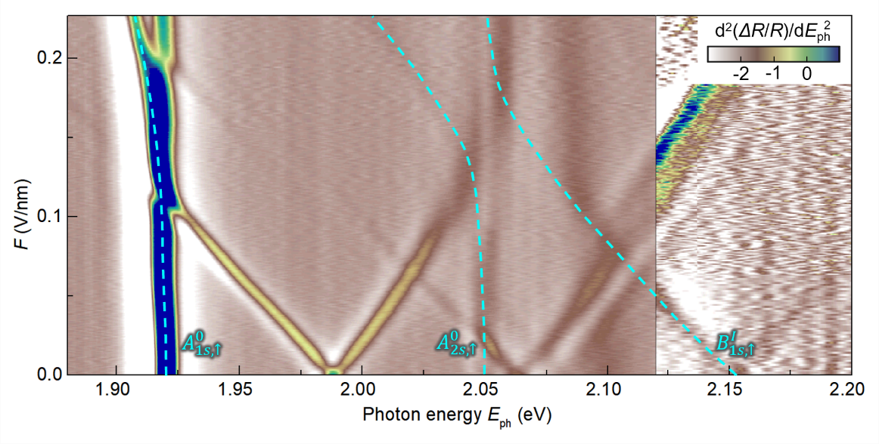
Figure S9 | Hybridization between $A_{1s,↑}^{0}$, $A_{2s,↑}^{0}$, and $B_{1s,↑}^{I}$ in the measured field-dependent $d^{2}(ΔR/R)/dE_{ph}^{2}$ map. Dashed lines serve as guides to the eye, highlighting the relevant excitonic features.

4.3. Hybridization between $A_{1s,↑}^{I}$ and $A_{{2p}_{+},↑}^{0}$
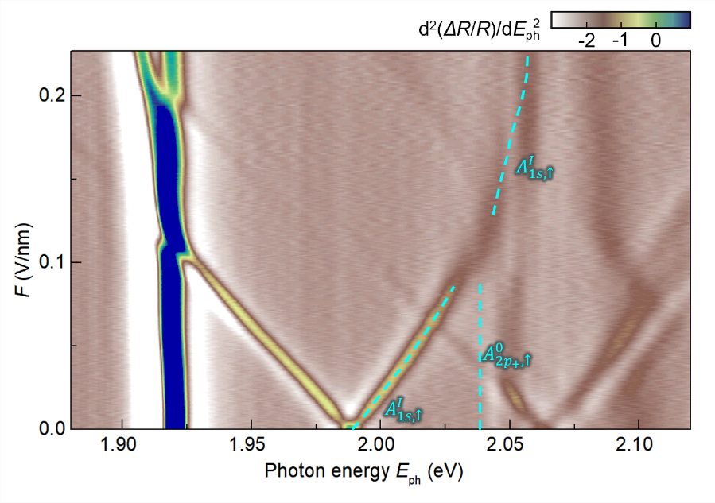
Figure S10 | Hybridization signature between $A_{1s,↑}^{I}$ and $A_{{2p}_{+},↑}^{0}$ in our field-dependent map. Dashed lines are provided as visual guides to highlight the coupling feature between $A_{1s,↑}^{I}$ and $A_{{2p}_{+},↑}^{0}$.

The third group comprises the $A_{1s,↑}^{I}$ and $A_{{2p}_{+},↑}^{0}$ excitons, which characterized by $C_{3}=-1$ and spin-up configurations. As shown in Fig. S10, the $A_{1s,↑}^{I}$ line displays a clear interruption at 2.03 eV near $F=0.1 V/nm$. Although the $A_{{2p}_{+},↑}^{0}$ line is not directly resolved in our experiment due to its weak signal, the disruption in the $A_{1s,↑}^{I}$ line provides indirect evidence for the hybridization between $A_{1s,↑}^{I}$ and $A_{{2p}_{+},↑}^{0}$.

4.4. Hybridization between $A_{2s,↑}^{I}$, $A_{3s,↑}^{I}$, and $B_{1s,↑}^{0}$
The final group involves hybridization between the Rydberg states $A_{2s,↑}^{I}$, $A_{3s,↑}^{I}$, and the $B_{1s,↑}^{0}$ exciton. All these states share the same symmetry quantum number $C_{3}=-1$ and have spin-up configurations. The coupling between $A_{2s,↑}^{I}$, $A_{3s,↑}^{I}$, and $B_{1s,↑}^{0}$ is already significant at zero electric field, resulting in notable oscillator strength transfer from $B_{1s,↑}^{0}$ to the $A_{s,↑}^{I}$ Rydberg states. As the electric field increases, the energies of the $A_{2s,↑}^{I}$, $A_{3s,↑}^{I}$ states shift toward that of $B_{1s,↑}^{0}$, leading to strong level repulsion and enhanced mixing (Fig. S11).
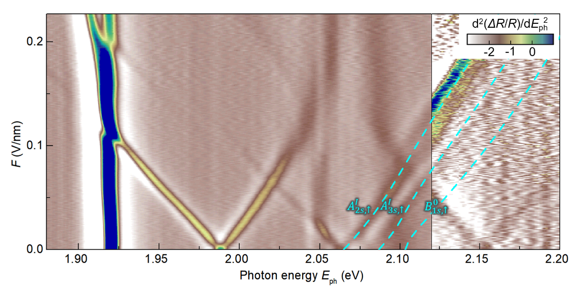
Figure S11 | Hybridization between $A_{2s,↑}^{I}$, $A_{3s,↑}^{I}$, and $B_{1s,↑}^{0}$ in our field-dependent $d^{2}(ΔR/R)/dE_{ph}^{2}$ map. Dashed lines were provided as visual guides to highlight the relevant excitonic features. The$B_{1s,↑}^{0}$ resonance is not directly visible due to its broad linewidth and overlap with nearby features.

5. Estimation of exciton g-factors
In the previous sections, we consider only excitons in the K valley. When excitons in the K’ valley are also included, the total number of excitons effectively doubles, because each exciton in the K valley has a time-reversal counterpart in the K’ valley. These time-reversal exciton pairs in opposite valleys exhibit opposite spin, opposite azimuthal quantum number, and opposite C₃ quantum number.
Table S6 summarize the intralayer and interlayer A excitons in the K valley alongside their time-reversal counterparts in K’ valley, with corresponding C₃ quantum number, all listed in the same row. For example, the $A_{p_{+},↑}^{0}(K)$ exciton in the K valley is related to the $A_{p_{-},↓}^{0}(K^{'})$ in the K’ valley; while the former has $C_{3}=-1$, the latter has $C_{3}=+1$.
Right-handed ($σ^{+}$) and left-handed ($σ^{-}$) photons have $C_{3}=+1$ and $C_{3}=-1$. By conservation of angular momentum, excitons with $C_{3}=+1$ ($-1$) couple to photons with right-handed (left-handed) polarization, and excitons with $C_{3}=0$ are optical dark. Consequently, helicity-resolved optical excitations allow for valley-selective access to excitons in the K and K’ valley.
Excitons | C₃ | Excitons | C₃ | g-factor |  | Excitons | C₃ | Excitons | C₃ | g-factor
$$A_{s,↑}^{0}(K)$$ | +1 | $$A_{s,↓}^{0}(K')$$ | -1 | -4.16 |  | $$A_{s,↑}^{I}(K)$$ | -1 | $$A_{s,↑}^{I}(K')$$ | +1 | +10.4
$$A_{p_{+},↑}^{0}(K)$$ | -1 | $$A_{p_{-},↓}^{0}(K^{'})$$ | +1 | +2.16 |  | $$A_{p_{+},↑}^{I}(K)$$ | 0 | $$A_{p_{-},↑}^{I}(K')$$ | 0
$$A_{p_{-},↑}^{0}(K)$$ | 0 | $$A_{p_{+},↓}^{0}(K^{'})$$ | 0 |  |  | $$A_{p_{-},↑}^{I}(K)$$ | +1 | $$A_{p_{+},↑}^{I}(K')$$ | -1 | -12.4
$$A_{s,↓}^{0}(K)$$ | -1 | $$A_{s,↑}^{0}(K^{'})$$ | +1 | -4.16 |  | $$A_{s,↓}^{I}(K)$$ | +1 | $$A_{s,↓}^{I}(K')$$ | -1 | +10.4
$$A_{p_{+},↓}^{0}(K)$$ | 0 | $$A_{p_{-},↑}^{0}(K^{'})$$ | 0 |  |  | $$A_{p_{+},↓}^{I}(K)$$ | -1 | $$A_{p_{-},↓}^{I}(K')$$ | +1 | -12.4
$$A_{p_{-},↓}^{0}(K)$$ | +1 | $$A_{p_{+},↑}^{0}(K^{'})$$ | -1 | +2.16 |  | $$A_{p_{-},↓}^{I}(K)$$ | 0 | $$A_{p_{+},↓}^{I}(K')$$ | 0
Table S6 | C₃ symmetry quantum numbers and g-factors for various intralayer $A_{ }^{0}$ and $A_{ }^{I}$ exciton states in bilayer MoS₂. Exciton pairs in the same row are related by time-reversal symmetry. The g-factors are not well-defined for excitons with C₃ = 0 because they are optically dark.

In the absence of magnetic field, the K and K’ valleys are degenerate, and each exciton is energetically degenerate with its time-reversal counterpart. When a magnetic field ($B$) is applied, this valley degeneracy is lifted through the Zeeman effect, and excitons in opposite valleys undergo energy shifts of opposite sign, resulting in a measurable energy splitting:
$ΔE=E\left(σ^{+}\right)-E\left(σ^{-}\right)=gμ_{B}B$ (16)
Here, $E\left(σ^{+}\right)$ and $E\left(σ^{-}\right)$ are exciton energies probed using right- and left-handed circularly polarized light, $μ_{B}$ is Bohr magneton, and $g$ is the effective g-factor of the exciton.
Within a single-particle framework, the Zeeman shift of a band can be estimated as:
$ΔE_{band}=\left(2s+mτ+\frac{m_{0}}{m^{*}}τ\right)μ_{B}B$ (17)
In this expression, $s=±1/2$ is spin quantum number of spin-up and spin-down bands; $m$ is the azimuthal quantum number of the band, with $m=0$ ($m=2$) for conduction (valence) bands (originating from the Mo d-orbitals); $τ=+1$, $-1$ indexes the K and K’ valley, respectively. $m_{0}$ is the free electron mass and $m^{*}$ is the effective mass of the band. The three terms in Eq. (17) represent Zeeman shifts arising from spin, orbital angular momentum, and Berry curvature contributions, respectively.
Fig. S12 displays the relevant bands in both K and K’ valley, annotated with their estimated g-factors based on Eq. (17). Red and blue arrow denote optical transitions with right- and left-handed circular polarization, respectively. Using these band g-factor and the optical selection rules, the g-factor of each pair of time-reversal s-like excitons can be estimated through Eq. (16). For the p-like excitons, the estimation follows the same approach, except that an additional energy shift from the exciton’s orbital motion must be included. Specifically, $p_{+}$ and $p_{-}$ excitons acquire additional Zeeman shifts of ${±μ}_{B}B$, respectively, due to their orbital angular momentum. The estimated g-factors for all relevant intralayer and interlayer A excitons are listed in Table S6.
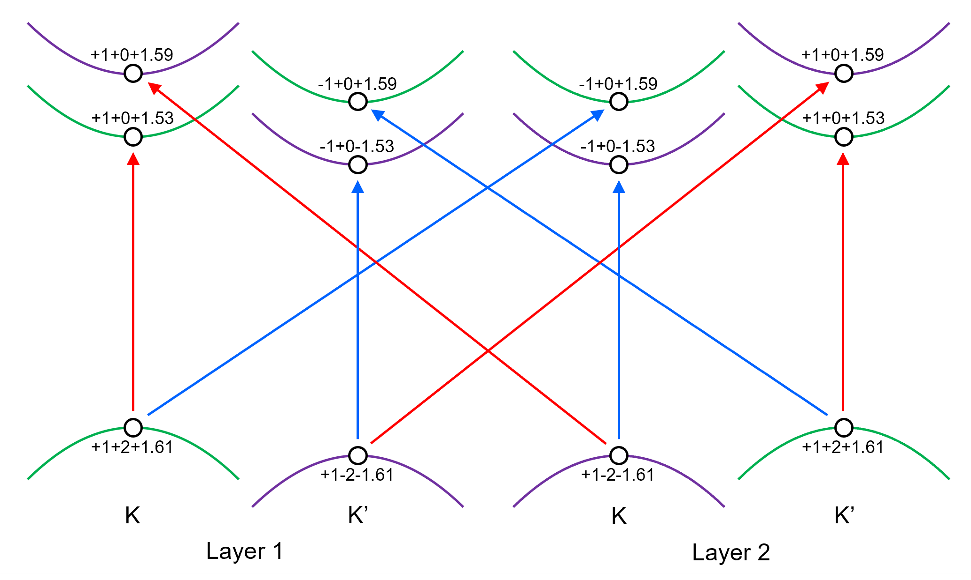
Figure S12 | Estimation of the g-factors for the conduction and valence bands in bilayer MoS₂. The three numbers shown at each band represent the contributions from spin, orbital angular momentum, and Berry curvature, respectively. Red and blue arrows indicate optical transitions with right-handed and left-handed circular polarization, respectively.
Section III. Theoretical Simulations for Excitons in Bilayer MoS₂
This section presents our theoretical framework for describing excitons in bilayer MoS₂ under an applied electric field. We begin by introducing the basis states used to construct the excitonic wavefunctions, followed by the evaluation of Coulomb interaction matrix elements. We then compute the zeroth-order exciton states and incorporate the effects of hybridization between them. Finally, we calculate the complex dielectric function of bilayer MoS₂ and simulate the reflectance contrast map for direct comparison with experimental observations.

1. Bloch states in bilayer MoS₂
1.1. Bloch states in the K valley
Our exciton theory is formulated based on Bloch states at the K and K’ valleys of bilayer MoS₂. Since we do not consider the effects of a magnetic field, the K and K' valleys remain degenerate, and it is sufficient to focus on the K valley; all Bloch states in our theory are taken from this valley. In bilayer MoS₂, these Bloch states are predominantly either spin-up or spin-down, and states with opposite spins do not hybridize.
In a simplified picture, the bilayer can be reviewed as two weakly coupled monolayers, allowing each Bloch state to be labeled by its layer index (L1, L2) and spin index ($↑$, $↓$). This yields four conduction bands ($C_{L1,↑}$, $C_{L1,↓}$, $C_{L2,↑}$, $C_{L2,↓}$) and four valence bands ($V_{L1,↑}$, $V_{L1,↓}$, $V_{L2,↑}$, $V_{L2,↓}$) as illustrated in Fig. S6. When interlayer coupling is included, this labeling remains valid for the valence bands because (1) their charge densities remain largely confined to individual layers, and (2) the two valence bands of the same spin are well separated in energy and thus do not strongly hybridize.
In contrast, complications arise for the conduction bands: those with the same spin in different layers are nearly degenerate—separated by only a few meV—and can strongly hybridize at finite momentum. Nevertheless, a layer-based labeling can still be employed for the conduction bands if an appropriate basis is chosen to disentangle the interlayer mixing. In this section, we describe our treatment of both valence and conduction bands to maintain a consistent, layer-localized descriptions.

1.2. Density distribution of the valence bands
We calculate the Bloch states of the valence bands by using the Quantum Espresso package⁵ within the framework of density functional theory (DFT). Our DFT calculations model free-standing bilayer MoS₂, with interlayer spacing fixed at 0.614 nm to match the experimentally measured distance⁶. The Bloch states are obtained using a supercell method, where L denotes the vertical length of the supercell and $G_{z}$ represents the z-component of the reciprocal lattice vectors of the superlattice used in the DFT calculation.
Once the Bloch states are obtained, their z-dependent charge density—averaged over the x-y plane—is computed as:
$ρ_{μ}\left(z\right)=\int{d{r^{'}}_{ }}ψ_{μ}^{*}\left(r^{'}\right)ψ_{μ}\left(r^{'}\right)δ\left(z-z^{'}\right)$ (18)
Here, $ψ_{μ}(r')$ is the wavefunction of $μ$-th Bloch state at the K point. In the supercell model, the system is periodic in the z-direction due to repeated slabs. This modifies Eq. (18) to:
$ρ_{μ}\left(z\right)=\int{d{r^{'}}_{ }}ψ_{μ}^{*}\left(r^{'}\right)ψ_{μ}\left(r^{'}\right)\sum_{m}{δ\left(z-z'-mL\right)}$
$=\int{d{r^{'}}_{ }}ψ_{μ}^{*}(r')ψ_{μ}(r')\frac{1}{L}\sum_{G_{z}}{e^{iG_{z}(z-z^{'})}}$ (19)
using the following identity with m covering all integers:
$\sum_{m}{δ\left(z-z_{e}-mL\right)}=\frac{1}{L}\sum_{G_{z}}{e^{{iG}_{z}(z-z_{e})}}$ (20)
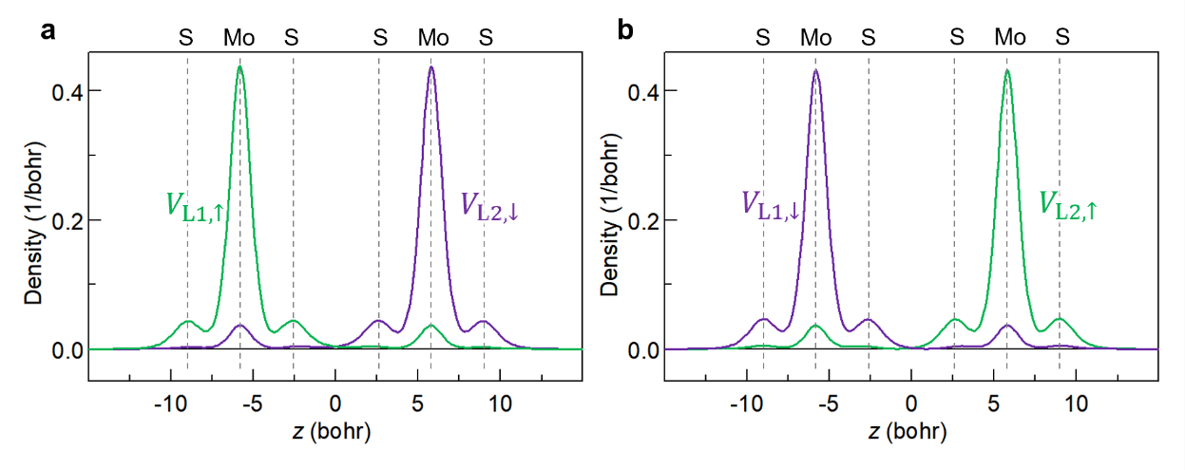
Figure S13 | a,b, The z-dependent in-plane-averaged densities of four valence-band states ($V_{L1,↑}$, $V_{L1,↓}$, $V_{L2,↑}$, $V_{L2,↓}$) at the K point of bilayer MoS₂.

Fig. S13 shows the z-dependent, in-plane-averaged particle densities of the four valence-band states at the K point of bilayer MoS₂. Similar results are expected for states slightly away from the K point, as interlayer mixing between same-spin valence bands from different layers remains weak due to their large energy separation. The four valence-band states exhibit nearly identical charge distributions, which can be attributed to two key factors. First, the degenerate valence bands from different layers are related by inversion symmetry. Second, although spin-orbit coupling lifts the spin degeneracy within each layer, the spatial and spin components of the wavefunctions remain nearly decoupled, resulting in similar spatial distributions for the spin-split bands.
Fig. S13 shows that the density distributions of $V_{L1,↑}$ and $V_{L2,↓}$ are mirror images of each other, and $V_{L1,↓}$ and $V_{L2,↑}$ are also mirror images of each other. Since $V_{L1,↑}$ and $V_{L1,↓}$ have nearly identical density distributions, we can drop the spin subscript and simply label the density distributions as $ρ_{V_{L1}}\left(z\right)$ and $ρ_{V_{L2}}\left(z\right)$. At zero electric field, these distributions satisfy the approximate mirror relation $ρ_{V_{L1}}\left(z\right)≈ρ_{V_{L2}}\left(-z\right)$.
The results show that the hole density is primarily localized within individual layers, yet a non-negligible portion extends into the opposite layer—consistent with previous findings⁷. As we will show later, the application of a vertical electric field substantially enhances interlayer hole hopping, playing a crucial role in brightening the interlayer exciton.

1.3. Expressing bilayer valence-band states in terms of monolayer-like states
This bilayer density distribution can be constructed from the monolayer one, as illustrated in Fig. S14.
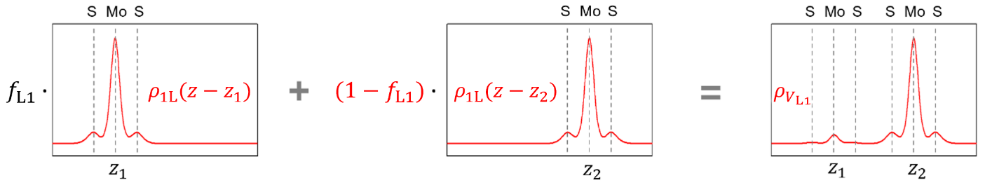
Figure S14 | Schematic illustration of constructing the bilayer valence density distribution from a linear combination of two monolayer density distributions.

For an isolated monolayer MoS₂, the two valence bands exhibit nearly the same density profiles, which we denote as $ρ_{1L}\left(z\right)$, with the origin centered at the middle of the layer. In the bilayer system, we can treat it as two monolayers centered at z₁ and z₂, each contributing a shifted density: $ρ_{1L}\left(z-z_{1}\right)$ and $ρ_{1L}\left(z-z_{2}\right)$, respectively. The density profiles of the $V_{L1}$ and $V_{L2}$ bands in the bilayer can be approximated as:
$\left\{\begin{matrix}ρ_{V_{L1}}\left(z\right)=f_{L1} ρ_{1L}\left(z-z_{1}\right)+(1-f_{L1})ρ_{1L}\left(z-z_{2}\right) \\ ρ_{V_{L2}}\left(z\right)=(1-f_{L2})ρ_{1L}\left(z-z_{1}\right)+f_{L2}ρ_{1L}\left(z-z_{2}\right)\end{matrix}\right.$ (21)
Here, $f_{L1}$ and $1-f_{L1}$ represent the fractions of the $V_{L1}$ charge density residing in L1 and L2, respectively; similarly, $f_{L2}$ and $1-f_{L2}$ correspond to the fractions of the $V_{L2}$ density in L2 and L1, respectively.
At zero electric field, both $f_{L1}$ and $f_{L2}$ are approximately 92.3%, leading to nearly mirror-symmetric distributions $ρ_{V_{L1}}\left(z\right)≈ρ_{V_{L2}}\left(-z\right)$, as shown in Fig. S13. However, the application of an electric field induces interlayer charge transfer and distort the symmetry. The values of $f_{L1}$ and $f_{L2}$ evolve differently under the field, and consequently, ${ρ_{V}}_{L1}\left(z\right)$ and ${ρ_{V}}_{L2}^{ }\left(z\right)$ are no longer mirror images. Moreover, the field dependence of $f_{L1}$ ($f_{L2}$) differs between spin-up and spin-down valence bands, leading to spin-resolve components $f_{L1,↑}$, $f_{L1,↓}$, $f_{L2,↑}$, and $f_{L2,↓}$.
Based on these charge distributions, the corresponding valence-band states can be expressed as linear combinations of monolayer-like states. For the spin-up bands, the Bloch states take the form:
$\left\{\begin{matrix}u_{V_{L1,↑},k}^{ }=\sqrt{f_{L1,↑}}{\tilde{u}}_{V_{L1,↑},k}^{ }+e^{iϕ_{1}}\sqrt{1-f_{L1,↑}}{\tilde{u}}_{V_{L2,↑},k}^{ } \\ u_{V_{L2,↑},k}^{ }=\sqrt{f_{L2,↑}}{\tilde{u}}_{V_{L2,↑},k}^{ }+e^{iϕ_{2}}\sqrt{1-f_{L1,↑}}{\tilde{u}}_{V_{L1,↑},k}^{ } \end{matrix}\right.$ (22)
Here, ${\tilde{u}}_{V_{L1,↑},k}^{ }$ and ${\tilde{u}}_{V_{L2,↑},k}^{ }$ are monolayer-like basis states localized in L1 and L2, respectively. The coefficients $f_{L1,↑}$ and $f_{L2,↑}$ are defined in Eq. (21), but specific to spin-up bands. The phases $e^{iϕ_{1}}$ and $e^{iϕ_{2}}$ are determined from DFT calculations. Analogous expression applies for the spin-down valence-band states.

1.4. Bloch states of the conduction bands
The conduction-band Bloch states at the K point are computed using the same DFT-based approach as for the valence bands. At the K point, conduction bands originating from different layers transform according to distinct irreducible representations of the three-fold rotational symmetry. This symmetry forbids interlayer hybridization, ensuring that the states remain localized within individual layers. Using Quantum ESPRESSO, we calculate the charge densities of the four conduction-band states at the K point in bilayer MoS₂. As shown in Figs. S15a and S15b, these states—regardless of layer or spin—exhibit nearly identical charge distributions that are strongly confined to individual layers. This confirms that the layer index of each conduction-band state is well defined at the K point.
However, when the Bloch states wave vector deviates from the K point by a k-vector, the three-fold rotational symmetry is broken, allowing interlayer mixing. This effect is particularly significant for the two conduction bands with the same spin from different layers, which are nearly degenerate (within a few meV) and can strongly hybridize. Figs. S15c-S15f present the in-plane averaged charge densities of the DFT-calculated conduction-band states at various k values away from the K point. The results indicate pronounced interlayer mixing at finite k, with a noticeable crossover from L1 to L2 near $k=0.05 (2π/a_{L})$.
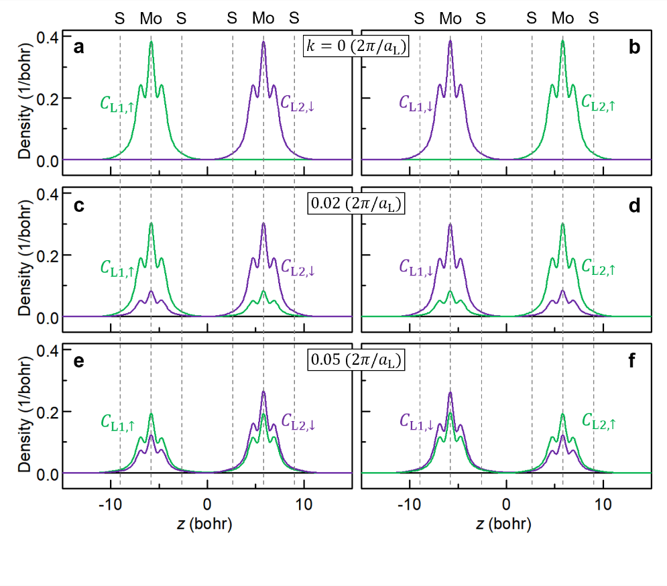
Figure S15 | In-plane averaged density distribution of the DFT-computed Bloch states in the conduction band of bilayer MoS₂ at k = 0 (a-b), k = 0.02 (c-d), and k = 0.05 (e-f) with k expressed in units of $2π/a_{L}$, where $a_{L}$ is the in-plane lattice constant of bilayer MoS₂.

While one could still use these mixed-layer Bloch states as a basis for solving the exciton problem, the resulting exciton eigenstates would eventually manifest as intralayer and interlayer excitons with only weak interlayer mixing. However, working with these delocalized states necessitates the inclusion of additional interlayer coupling terms in the Bethe-Salpeter equation, complicating the calculations and obscuring the physical interpretation. To simplify the analysis and retain physical clarity, it is more practical to adopt a layer-localized basis from the outset.
To this end, we construct new monolayer-like basis states at each k-point by disentangling the interlayer mixing. Taking the spin-up conduction bands as an example, we denote the original DFT-obtained bilayer Bloch states as $u_{C_{L1,↑},k}^{ }$ and $u_{C_{L2,↑},k}^{ }$ and define the new basis states as linear combinations:
$\left\{\begin{aligned}{\tilde{u}}_{C_{L1,↑},k}^{ }=c_{11}\left(k\right)u_{C_{L1,↑},k}^{ }+c_{21}\left(k\right)u_{C_{L2,↑},k}^{ } \\ {\tilde{u}}_{C_{L2,↑},k}^{ }=c_{12}\left(k\right)u_{C_{L1,↑},k}^{ }+c_{22}\left(k\right)u_{C_{L2,↑},k}^{ }\end{aligned}\right.$ (23)
The four $c$ coefficients are k-dependent. These new basis states remain layer-localized even at finite $k$, just like in the monolayer case.
At $k=0$, the original bilayer states closely resemble the monolayer-like states due to strong layer localization, as seen in Figs. S15a and S15b. We then apply $k∙p$ theory to express the monolayer-like states at finite k as:
${\tilde{u}}_{C_{L1,↑},k}^{ }\left(r\right)=e^{ik∙r_{ }}\left[a_{l}\left(k\right)u_{C_{L1,↑},k=0}^{ }\left(r\right)+b_{l}\left(k\right)u_{V_{L1,↑},k=0}^{ }\left(r\right)\right]$ (24)
where $l$ = L1, L2, and $a_{l}$, $b_{l}$ satisfy the eigenvalue equation⁸:
$\left(\begin{matrix}E_{C_{l,↑}} & {a_{L}t}_{l}∙k \\ {a_{L}t}_{l}^{*}∙k & E_{V_{l,↑}}\end{matrix}\right)\left(\begin{matrix}a_{l} \\ b_{l}\end{matrix}\right)=E_{C_{l,↑},k}^{ }\left(\begin{matrix}a_{l} \\ b_{l}\end{matrix}\right)$ (25)
Here, $E_{C_{l,↑}}$ ($E_{V_{l,↑}}$) denotes the energy at the K point of the $C_{l,↑}$ ($V_{l,↑}$) band; $a_{L}$ is the in-plane lattice constant of MoS₂; $t_{l}=ℏP_{l}/m_{0}a_{L}$; $P_{l}$ is the momentum matrix element between the $C_{l,↑}$ and $V_{l,↑}$ bands; $m_{0}$ is the mass of a free electron. We take ${|t}_{l}|$ = 1.137 eV according to DFT calculations⁷, which give similar values for $l$ = L1, L2 in MoS₂. Solving Eq. (25) gives:
$\left(\begin{matrix}a_{l} \\ b_{l}\end{matrix}\right)≈{\left[1+\frac{{{\left|t_{l}\right|}^{2}(ka_{L})}^{2}}{{\left(E_{C_{l,↑}}-E_{V_{l,↑}}\right)}^{2}}\right]}^{-\frac{1}{2}}\left(\begin{matrix}1 \\ {a_{L}t}_{l}^{*}∙k/\left(E_{C_{l,↑}}-E_{V_{l,↑}}\right)\end{matrix}\right)$ (26)
Since $a_{l}$ depends only on the magnitude of $k$, we simplify $a_{l}\left(k\right)$ into $a_{l}\left(k\right)$. With the $\tilde{u}$ and $u$ basis provided by DFT and $k∙p$ theory respectively, the expansion coefficients in Eq. (23) can be approximated to leading order as:
$\left\{\begin{aligned}c_{11}\left(k\right)≈a_{1}\left(k\right)\left\langle u_{C_{L1,↑},k}^{ } | e^{ik∙r_{ }} | u_{C_{L1,↑},k=0}^{ }\right\rangle \\ c_{21}\left(k\right)≈a_{1}\left(k\right)\left\langle u_{C_{L2,↑},k}^{ } | e^{ik∙r_{ }} | u_{C_{L1,↑},k=0}^{ }\right\rangle \\ c_{12}\left(k\right)≈a_{2}\left(k\right)\left\langle u_{C_{L1,↑},k}^{ } | e^{ik∙r_{ }} | u_{C_{L2,↑},k=0}^{ }\right\rangle \\ c_{22}\left(k\right)≈a_{2}\left(k\right)\left\langle u_{C_{L2,↑},k}^{ } | e^{ik∙r_{ }} | u_{C_{L2,↑},k=0}^{ }\right\rangle \end{aligned}\right.$ (27)
In our theory, exciton states are constructed using the monolayer-like $\tilde{u}$ basis functions for the conduction bands. While these functions are not exact eigenstates of the bilayer Hamiltonian, their expectation values yield slight shifts in energies and effective masses, which can be corrected through our fitting procedure. In addition, they modify the off-diagonal elements of the exciton Hamiltonian—an effect we explicitly include in our analysis of the hybridization between intralayer and interlayer excitons.
Using the charge density distributions of the monolayer-like conduction and valence bands (Figs. S13 and S15), we estimate the electric dipole moment of an interlayer electron–hole pair in bilayer MoS₂ to be 0.575 e₀·nm, assuming an interlayer separation of 0.614 nm. This value closely matches the experimentally extracted dipole moment of 0.60 e₀·nm, obtained from the Stark shift of the interlayer exciton using a BN dielectric constant of 3.0.

2. Excitons and their Coulomb-interaction matrix elements
After discussing the Bloch states of the conduction and valence bands of bilayer MoS₂ in the previous section, we now use them to construct the exciton states and evaluate the relevant matrix elements of the electron–hole Coulomb interaction.

2.1. Constructing excitons from the Bloch states
Our theory here only considers the excitons with zero center-of-mass momentum residing at the K valley of bilayer MoS₂. Our theory encounters 24 excitonic states, including the intralayer A exciton 1s - 4s states ($A_{1s}^{0}-A_{4s}^{0}$) and 2p state ($A_{2p}^{0}$), the interlayer A exciton 1s - 4s states ($A_{1s}^{I}-A_{4s}^{I}$) and 2p state ($A_{2p}^{I}$), the intra- and interlayer B exciton 1s states ($B_{1s}^{0}$, $B_{1s}^{I}$), each with spin-up and spin-down configurations. Each of these excitons can be expressed as a linear combination of the Bloch states as:
$\left.\left|ψ_{n}^{i}\right.\right\rangle =\sum_{k}{F_{n}^{i}\left(k\right)\left.\left|{\tilde{u}}_{C_{i},k}^{ };u_{V_{i},k}^{ }\right.\right\rangle }$ (28)
Here, the index $i$ denotes the exciton type ($A_{ }^{0},B^{0}, A^{I}, B^{I}$); $n$ denotes the Rydberg state (1s, 2s, 3s, 4s, 2p, …); ${\tilde{u}}_{C_{i},k}^{ }$ and $u_{V_{i},k}^{ }$ denote the conduction and valence Bloch states associated with the i-th exciton with wave vector $k$ measured from the K point; $F_{n}^{i}$ denotes the expansion coefficient, which is real-valued and depends only on the magnitude of $k$ for the s-like excitons but exhibits a complex phase for the p-like states.

2.2. Direct electron-hole Coulomb interaction
To solve for the exciton eigenstates, we consider the electron-hole coulomb interaction ($\hat{V}$), which consists of both the direct interaction ($\hat{W}$) and exchange interaction (${\hat{V}}_{ex}$). The matrix elements of direct Coulomb interaction are given by⁹:
$W_{ii}(k,k^{'})=\left\langle {\tilde{u}}_{C_{i},k}^{ };u_{V_{i},k}^{ } | \hat{W} | {\tilde{u}}_{C_{i},k^{'}}^{ };u_{V_{i},k^{'}}^{ }\right\rangle$
$=\frac{1}{Ω}\sum_{G,G^{'}}{\frac{-e^{2}}{{ε_{0}|G+k^{'}-k|}^{ }{|G^{'}+k^{'}-k| }^{ }}} ε_{GG^{'}}^{-1}M_{C_{i}C_{i}}^{G}\left(k,k^{'}\right)M_{V_{i}V_{i}}^{G^{'}*}(k,k^{'})$ (29)
where
$\left\{\begin{matrix}M_{C_{i}C_{i}}^{G}\left(k,k^{'}\right)=\left\langle {\tilde{u}}_{C_{i},k}^{ } | e^{i\left(G+k-k^{'}\right)∙r} | {\tilde{u}}_{C_{i},k'}^{ }\right\rangle \\ M_{V_{i}V_{i}}^{G^{'}}\left(k,k^{'}\right)=\left\langle u_{V_{i},k}^{ } | e^{iG^{'}+k-k^{'}∙r} | u_{V_{i},k'}^{ }\right\rangle \end{matrix}\right.$ (30)
Here,$ε_{GG^{'}}^{ }$ represents the dielectric function of bilayer MoS₂, accounting for the screening effects of all valence charges; $G$ and $G'$ denote the reciprocal lattice vectors of bilayer MoS₂ in our DFT supercell model, where $G={(G}_{||},G_{z})$ includes both in-plane ($G_{||}$) and out-of-plane ($G_{z}$) components. $Ω$ is the volume of the slab in the supercell used for the DFT calculation.
For simplicity, we approximate the non-local dielectric function $ε_{GG^{'}}^{ }$ by $κδ_{G{G^{'}}^{ }}^{ }$, where $κ=4.16$ is used as an effective dielectric constant of the BN-encapsulated bilayer MoS₂ sample. Under this approximation, the matrix elements of $\hat{W}$ simplify to:
$W_{ii}(k,k^{'})=\frac{1}{Ω}\sum_{G}{\frac{{-e}^{2}}{κε_{0}{{\left|G+k^{'}-k\right|}^{2}}^{ }}} M_{C_{i}C_{i}}^{G}\left(k,k^{'}\right)M_{V_{i}V_{i}}^{G*}(k,k^{'})$ (31)
Further simplifying, we neglect the short-range interaction contributed from the $G_{||}≠0$ terms, which are negligible the excitons considered. Afterward, we express it in real space as
$W_{ii}\left(k,k^{'}\right)=\int{dr_{e}dr_{h}}{\tilde{u}}_{C_{i},k}^{*}\left(r_{e}\right)u_{V_{i},k}^{*}\left(r_{h}\right)\frac{-e^{2}}{4πκε_{0} \left|r_{e}-r_{h}\right|}{\tilde{u}}_{C_{i},k^{'}}^{ }\left(r_{e}\right)u_{V_{i},k^{'}}^{ }\left(r_{h}\right)$ (32)
By performing a 2D Fourier transform in the in-plane coordinates, it can be written as
$W_{ii}\left(k,k^{'}\right)=\sum_{q}{\frac{-e^{2}}{2A{κε_{0}\left|q\right|}^{ }}}\int{dr_{e}dr_{h}}{\tilde{u}}_{C_{i},k}^{*}\left(r_{e}\right)u_{V_{i},k}^{*}\left(r_{h}\right){e^{-q\left|z_{e}-z_{h}\right|}e}^{iq∙\left(ρ_{e}-ρ_{h}\right)}{\tilde{u}}_{C_{i},k^{'}}^{ }\left(r_{e}\right)u_{V_{i},k^{'}}^{ }\left(r_{h}\right)$ (33)
Due to the conservation of momentum, only the terms with $q= k-k^{'}$ can be finite and this reduces it into:
$W_{ii}\left(k,k^{'}\right)=\frac{-e^{2}}{2A{κε_{0}|k-k^{'}|}^{ }}\int{dz_{e}dz_{h}}e^{-|k-k^{'}||z_{e}-z_{h}|}{ζ_{kk^{'}}^{C_{i}}\left(z_{e}\right)}_{ }ζ_{kk^{'}}^{V_{i}}\left(z_{h}\right)$ (34)
with
$\left\{\begin{matrix}{ζ_{kk'}^{C_{i}}\left(z_{e}\right)}_{ }=\frac{1}{L_{c}}\sum_{G_{z}}{\int{dρdz{ \tilde{u}}_{C_{i},k}^{*}(ρ,z){e^{{iG}_{z}(z-z_{e})}e}^{i(k^{'}-k)∙ρ}}{\tilde{u}}_{C_{i},k^{'}}^{ }(ρ,z)} \\ ζ_{kk'}^{V_{i}}\left(z_{h}\right)=\frac{1}{L_{c}}\sum_{G_{z}}{\int{dρdz{ u}_{V_{i},k}^{*}(ρ,z){e^{{iG}_{z}(z-z_{h})}e}^{i(k^{'}-k)∙ρ}}u_{V_{i},k^{'}}^{ }(ρ,z)}\end{matrix}\right.$ (35)
Here, $ρ_{e}$ and $z_{e}$ ($ρ_{h}$ and $z_{h}$) are the in-plane and out-of-plane coordinates for the electron (hole), respectively.
For the exciton states considered in bilayer MoS₂, the momentum range of $k$ and $k'$ is small, remaining within 5% of the Brillouin zone. Within this narrow range, ${ζ_{kk'}^{C_{i}}\left(z_{e}\right)}_{ }$and $ζ_{kk'}^{V_{i}}\left(z_{h}\right)$ exhibit weak dependence on $k$ and $k'$. This allows us to approximate
$\left\{\begin{matrix}{ζ_{kk'}^{C_{i}}\left(z_{e}\right)}_{ }≈ζ_{0,0}^{C_{i}}\left(z_{e}\right)B_{kk'}^{C_{i}}=ρ_{C_{i}}\left(z_{e}\right)B_{kk'}^{C_{i}} \\ ζ_{kk'}^{V_{i}}\left(z_{h}\right)≈ζ_{0,0}^{V_{i}}\left(z_{h}\right)B_{kk'}^{V_{i}}=ρ_{V_{i}}\left(z_{h}\right)B_{kk'}^{V_{i}}\end{matrix}\right.$ (36)
Here, $ζ_{0,0}^{C_{i}}\left(z_{e}\right)$ and $ζ_{0,0}^{V_{i}}\left(z_{h}\right)$ represent the in-plane-averaged electron and hole density distributions ($ρ$) in the K valley, respectively. $B_{kk'}^{C_{i}}$ and $B_{kk'}^{V_{i}}$ denote the Berry-curvature factor¹⁰. Applying this approximation, we obtain
$W_{ii}\left(k,k^{'}\right)≈W_{ii}\left(k-k^{'}\right)=\frac{-e^{2}S_{kk'}^{i}}{2A{κε_{0} |k-k^{'}|}^{ }}\int{dz_{e}dz_{h}}e^{-|k-k^{'}||z_{e}-z_{h}|}{ρ_{C_{i}}\left(z_{e}\right)}_{ }ρ_{V_{i}}\left(z_{h}\right)$ (37)
where $S_{kk'}^{i}=B_{kk'}^{C_{i}} B_{kk'}^{V_{i}}$ is the excitonic Berry-curvature factor which can be approximately written as¹¹
$S_{kk^{'}}^{i}=1+{}_{0}\left[±i\left(k×k'\right)-{\left|k-k'\right|}^{2}/2\right]/2$ (38)
${}_{0}$ for monolayer MoS₂ encapsulated by BN is found to be larger than 10$Å^{2}$. Here, we choose ${}_{0}$ to be an empirical parameter and the best fit to our experimental results for the energies of the Rydberg series for the $A^{0} and A^{I}$ excitons is 15$Å^{2}$.

2.3. Electron-hole exchange Coulomb interaction
Next, we consider the electron-hole exchange interaction term⁹ ${\hat{V}}_{ex}$. ${\hat{V}}_{ex}$ is insensitive to the variation of k within the momentum range of the exciton state$.$ Thus, we can approximate the matrix element of ${\hat{V}}_{ex}$ by its value at $k^{'}=k=0.$ This is equivalent to approximate the exchange interaction as a contact potential. With this approximation, the matrix element of ${\hat{V}}_{ex}$ becomes
$V_{ii}^{ex}\left(k,k^{'}\right)=\left\langle {\tilde{u}}_{C_{i},k}^{ };u_{V_{i},k}^{ } | {\hat{V}}_{ex} | {\tilde{u}}_{C_{i},k^{'}}^{ };u_{V_{i},k^{'}}^{ }\right\rangle ≈\left\langle {\tilde{u}}_{C_{i},k=0}^{ };u_{V_{i},k=0}^{ } | {\hat{V}}_{ex} | {\tilde{u}}_{C_{i},k^{'}=0}^{ };u_{V_{i},k^{'}=0}^{ }\right\rangle =f_{i}λ_{ i}/A$ (39)
Here $A$ is the sample area. $λ_{i}$ represents the electron-hole exchange coupling strength in a monolayer. We adopt $λ_{i}$= 58.4 $meV∙{nm}^{2}$ for the $A^{0}$ exciton and $λ_{i}$= 59.0 $meV∙{nm}^{2}$ for the $B^{0}$ exciton in monolayer MoS₂, obtained from ab initio calculations using Quantum Espresso package. $f_{i}$ denotes the fraction of the hole’s distribution residing in the same layer as the electron in band $C_{i}$.

2.4. Field-dependent matrix elements of direct Coulomb interaction
In Eq. (37), we obtain a general expression of the matrix element $W_{ii}\left(k,k^{'}\right)$ of the direct electron-hole Coulomb interaction of the i-th exciton between the electron and hole Bloch states at $k$ and $k^{'}$. Under an electric field, the valence Bloch states will change substantially, resulting in a field-dependent matrix element. As an illustration, let’s consider the spin-up $A^{0}$ exciton ($A_{↑}^{0}$) which resides primarily in L1. By substituting the expression of ${ρ_{V}}_{L1}\left(z\right)$ in Eq. (21) into Eq. (37), we obtain the matrix element between the Bloch states for the $A^{0}$ exciton:
$W_{A_{↑}^{0}A_{↑}^{0}}\left(k,k^{'}\right)≈\frac{-e^{2}}{2A{κε_{0} |k-k^{'}|}^{ }}\int{dz_{e}dz_{h}}e^{-|k-k^{'}||z_{e}-z_{h}|}{ρ_{C_{L1}}\left(z_{e}\right)}_{ }\left[f_{L1,↑} ρ_{1L}\left(z_{h}-z_{1}\right)+(1-f_{L1,↑})ρ_{1L}\left(z_{h}-z_{2}\right)\right]$ (40)
By defining
$\left\{\begin{matrix}W^{0}\left(k-k^{'}\right)=\frac{-e^{2}}{2A{κε_{0} |k-k^{'}|}^{ }}\int{dz_{e}dz_{h}}e^{-|k-k^{'}||z_{e}-z_{h}|}{ρ_{C_{L1}}\left(z_{e}\right)}_{ }ρ_{1L}\left(z_{h}-z_{1}\right) \\ W^{I}\left(k-k^{'}\right)=\frac{-e^{2}}{2A{κε_{0} |k-k^{'}|}^{ }}\int{dz_{e}dz_{h}}e^{-|k-k^{'}||z_{e}-z_{h}|}{ρ_{C_{L1}}\left(z_{e}\right)}_{ }ρ_{1L}\left(z_{h}-z_{2}\right)\end{matrix}\right.$ (41)
We can rewrite it as:
$W_{A_{↑}^{0}A_{↑}^{0}}\left(k,k^{'}\right)≈f_{L1,↑}W^{0}\left(k-k^{'}\right)+(1-f_{L1,↑})W^{I}\left(k-k^{'}\right)$ (42)
For the spin-up $B^{0}$ exciton ($B_{↑}^{0}$), $W_{B_{↑}^{0}B_{↑}^{0}}\left(k,k^{'}\right)≈W_{A_{↑}^{0}A_{↑}^{0}}\left(k,k^{'}\right)$, because $B_{↑}^{0}$ and $A_{↑}^{0}$ have nearly the same density distribution.
A similar approach can be used to obtain the matrix element for $A_{↑}^{I}$ and $B_{↑}^{I}$ excitons as:
$W_{A_{↑}^{I}A_{↑}^{I}}\left(k,k^{'}\right)≈W_{B_{↑}^{I}B_{↑}^{I}}\left(k,k^{'}\right)≈f_{L1,↑}W^{I}\left(k-k^{'}\right)+(1-f_{L1,↑})W^{0}\left(k-k^{'}\right)$ (43)
The corresponding matrix elements for the spin-down excitons ($A_{↓}^{0}$, $B_{↓}^{0}$, $A_{↓}^{I}$, $B_{↓}^{I}$) can be obtained simply by flipping the spin subscript from $↑$ to $↓$.
Next, we model $W^{0}\left(k-k^{'}\right)$ and $W^{I}\left(k-k^{'}\right)$, which represent the intralayer and interlayer electron-hole interaction potentials, respectively. For the intralayer potential $W^{0}$ in BN-encapsulated bilayer MoS₂, we approximate it using the Keldysh form with a fitting parameter $r_{0}^{ }$:
$W^{0}\left(k-k^{'}\right)=\frac{-e^{2}}{2A{κε_{0} |k-k^{'}|}^{ }}\frac{1}{1+r_{0}^{ }|k-k^{'}|}$ (44)
For the interlayer potential $W^{I}$, the standard Keldysh form fails to capture the experimentally observed $A_{ }^{I}$ Rydberg series, which differ from their intralayer counterparts. This discrepancy stems from the spatial separation between the electron and hole residing in different layers, which introduces a damping effect not captured by the conventional Keldysh model. To address this, we adopt a modified potential that incorporates an exponential damping:
$W^{I}\left(k-k^{'}\right)=\frac{-e^{2}}{2A{κε_{0} |k-k^{'}|}^{ }}\frac{{ e}^{-d|k-k^{'}|}}{1+r_{I}^{ }|k-k^{'}|}$ (45)
Here d = 0.614 nm is the interlayer spacing of bilayer MoS₂, and $r_{I}^{ }$ is a fitting parameter.
Substituting the expressions for $W^{0}$ and $W^{I}$ into Eqs. (42) and (43) for $W_{A_{↑}^{0}A_{↑}^{0}}$ and $W_{A_{↑}^{I}A_{↑}^{I}}$, we compute the Rydberg energies of the $A_{ }^{0}$ and $A_{ }^{I}$ excitons at zero field. Using the best-fit parameters $r_{0}^{ }$ = 1.16 nm and $r_{I}^{ }$ = 1.53 nm, we achieve excellent agreement with the experimentally observed Rydberg series of both $A_{ }^{0}$ and $A_{ }^{I}$ excitons.

3. Calculations of the exciton eigenstates and eigen energies in bilayer MoS₂
3.1. The exciton Hamiltonian
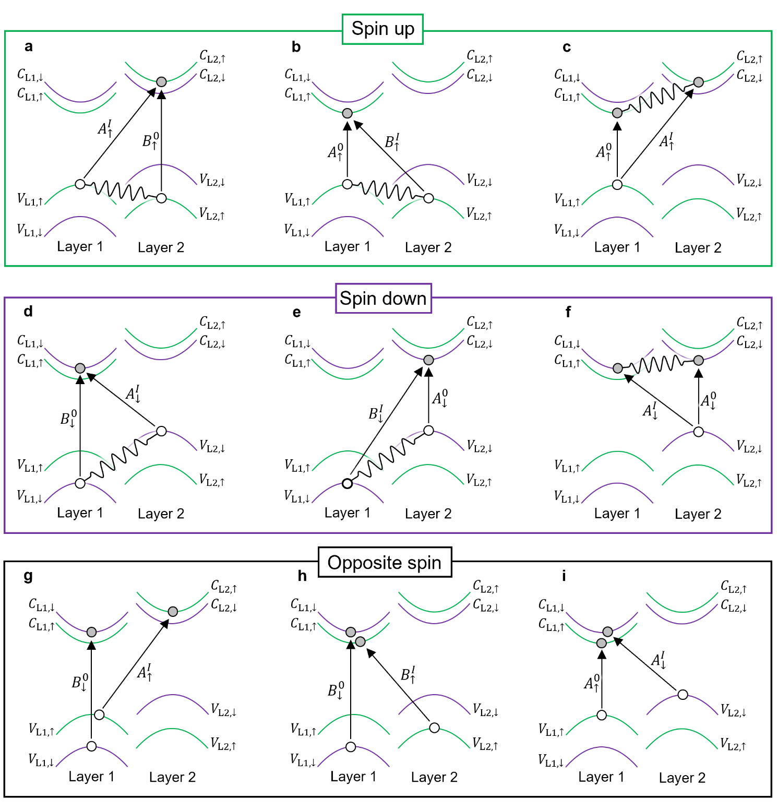
Figure S16 | Schematics of coupling between intralayer and interlayer excitons in the K valley of bilayer MoS₂. a-c, Coupling between excitons involving spin-up bands. d-f, Coupling between excitons involving spin-down bands. g-i, Coupling between excitons involving opposite-spin bands.
For our bilayer MoS₂ model, we consider four conduction bands ($C_{L1,↑}$, $C_{L1,↓}$, $C_{L2,↑}$, $C_{L2,↓}$) and four valence bands ($V_{L1,↑}$, $V_{L1,↓}$, $V_{L2,↑}$, $V_{L2,↓}$). Optical transition occurs predominantly between bands with the same spin indices, resulting in four intralayer transitions ($V_{L1,↑}→C_{L1,↑}$;$V_{L1,↓}→C_{L1,↓}$;$V_{L2,↓}→C_{L2,↓}$;$V_{L2,↑}→C_{L2,↑}$) and four interlayer transitions (${V_{L1,↑}→C}_{L2,↑}$;$V_{L1,↓}→C_{L2,↓}$;$V_{L2,↓}→C_{L1,↓}$;$V_{L2,↑}→C_{L1,↑}$). These transitions give rise to eight types of excitons: four intralayer excitons ($A_{↑}^{0}$,$B_{↓}^{0}$,$A_{↓}^{0}$,$B_{↑}^{0}$) and four interlayer excitons ($A_{↑}^{I}$,$B_{↓}^{I}$,$A_{↓}^{I}$,$B_{↑}^{I}$). Their interactions can be classified into three categories, as illustrated in Fig. S16:
(1) Interactions among $A_{↑}^{I}$,$B_{↑}^{0}$,$A_{↑}^{0}$, and$B_{↑}^{I}$, all involving transitions between spin-up bands (Figs. S16a-S16c). For simplicity, we refer to these as “spin-up” excitons, although the excitons themselves carry no net spin.
(2) Interactions among $A_{↓}^{I}$,$B_{↓}^{0}$,$A_{↓}^{0}$, and$B_{↓}^{I}$, all involving transitions between spin-down bands (Figs. S16d-S16f). We similarly refer to these as “spin-down” excitons.
(3) Interactions between spin-up and spin-down exciton states. Figs. S16g-S16i illustrate three representative cases where spin-up and spin-down excitons become nearly degenerate in energy and hybridize in the presence of an applied electric field.
In principle, the full excitonic Hamiltonian is represented by an 8 × 8 matrix constructed in the basis of all eight exciton types. However, since the coupling between spin-up and spin-down excitons is relatively weak, we begin by considering two decoupled 4 × 4 Hamiltonians – each describing interactions among excitons with the same spin configuration. The approximation already captures the main features of our experimental data, except for the weak hybridization observed between the $A_{1s}^{0}$ and $A_{1s}^{I}$ lines. To simplify the discussion, we first neglect opposite-spin coupling and focus on same-spin interactions; opposite-spin coupling effects will be incorporated later to account for finer features.
In the following, we explicitly consider the four spin-up excitons ($A_{↑}^{I}$,$B_{↑}^{0}$,$A_{↑}^{0}$,$B_{↑}^{I}$), labelled by the index i. The Schrödinger question for these excitons, equivalent to the Bathe-Salpeter equation, is:
$\left(\begin{matrix}E_{C_{L2,↑}}\left(k\right)-E_{V_{L1,↑}}\left(k\right) & 0 & 0 & 0 \\ 0 & E_{C_{L2,↑}}\left(k\right)-E_{V_{L2,↑}}\left(k\right) & 0 & 0 \\ 0 & 0 & E_{C_{L1,↑}}\left(k\right)-E_{V_{L1,↑}}\left(k\right) & 0 \\ 0 & 0 & 0 & E_{C_{L1,↑}}\left(k\right)-E_{V_{L2,↑}}\left(k\right)\end{matrix}\right)\left(\begin{matrix}F_{A_{↑}^{I}}^{ }\left(k\right) \\ F_{B_{↑}^{0}}^{ }\left(k\right) \\ F_{A_{↑}^{0}}^{ }\left(k\right) \\ F_{B_{↑}^{I}}^{ }\left(k\right)\end{matrix}\right)$
$+\sum_{k^{'}}{\left(\begin{matrix}V_{11}\left(k,k'\right) & V_{12}\left(k,k'\right) & ∆H & 0 \\ V_{12}^{*} \left(k,k'\right) & V_{22}\left(k,k'\right) & 0 & 0 \\ ∆H^{*} & 0 & V_{33}\left(k,k'\right) & V_{34}\left(k,k'\right) \\ 0 & 0 & V_{34}^{*}\left(k,k'\right) & V_{44}\left(k,k'\right)\end{matrix}\right)}\left(\begin{matrix}F_{A_{↑}^{I}}^{ }\left(k^{'}\right) \\ F_{B_{↑}^{0}}^{ }\left(k^{'}\right) \\ F_{A_{↑}^{0}}^{ }\left(k^{'}\right) \\ F_{B_{↑}^{I}}^{ }\left(k^{'}\right)\end{matrix}\right)=E_{X}\left(\begin{matrix}F_{A_{↑}^{I}}^{ }\left(k\right) \\ F_{B_{↑}^{0}}^{ }\left(k\right) \\ F_{A_{↑}^{0}}^{ }\left(k\right) \\ F_{B_{↑}^{I}}^{ }\left(k\right)\end{matrix}\right)$ (46)
Here, $E_{X}$ is the photon energy needed to generate the eigenstate. The same formalism can be applied to the spin-down excitons ($A_{↓}^{I}$,$B_{↓}^{0}$,$A_{↓}^{0}$,$B_{↓}^{I}$) by flipping the spin index in the state labels.
The first term on the left-hand side represents the interband transition energies, while the second term accounts for hybridization. The $V_{ij}$ matrix elements take the form:
$V_{ij}\left(k,k^{'}\right)=\left\langle {\tilde{u}}_{C_{i},k}^{ };u_{V_{i},k}^{ } | \hat{W}+{\hat{V}}_{ex} | {\tilde{u}}_{C_{j},k^{'}}^{ };u_{V_{j},k^{'}}^{ }\right\rangle ≡W_{ij}\left(k,k^{'}\right)+V_{ij}^{ex}\left(k,k'\right)$ (47)
Here, $\hat{W}$ and ${\hat{V}}_{ex}$ represent the direct and exchange Coulomb interaction operators, respectively. The indices i and j refer to the four types of excitons: $A_{↑}^{I}$,$B_{↑}^{0}$,$A_{↑}^{0}$, and$B_{↑}^{I}$. The functions $u_{V_{i},k}^{ }$ represent the valence-band Bloch states in bilayer MoS₂, while ${\tilde{u}}_{C_{i},k}^{ }$ refer to the monolayer-like conduction-band basis states, as introduced in Section III.1.4.
Among the off-diagonal coupling terms, $V_{12}$ describes hybridization between $A_{↑}^{I}$ and $B_{↑}^{0}$, and $V_{34}$ describes hybridization between $A_{↑}^{0}$ and $B_{↑}^{I}$. The term $∆H$, which couples $A_{↑}^{I}$ and $A_{↑}^{0}$, originates from the choice of monolayer-like conduction-band basis states discussed in Section III.1.4. Other coupling terms ($V_{14}$, $V_{13}$, $V_{23}$, $V_{34}$) are neglected as they contribute negligibly to the excitonic behavior observed in our experiments.

3.2. The zeroth-order approximation
In the zero-order approximation, we only need to consider the diagonal elements in the second term in Eq. (46) and this will give four sets of eigenstates, corresponding to the Rydberg series of the $A_{↑}^{I}$,$B_{↑}^{0}$,$A_{↑}^{0}$,$B_{↑}^{I}$ excitons. Eq. (46) will be reduced into the following Bathe-Salpeter equation:
$\left[E_{C_{i}}\left(k\right)-E_{V_{i}}\left(k\right)\right]F_{n}^{i}\left(k\right)+\sum_{k^{'}}{\left[W_{ii}\left(k,k^{'}\right)+V_{ex,ii}\left(k,k^{'}\right)\right]F_{n}^{i}\left(k'\right)}=E_{n}^{i}F_{n}^{i}\left(k\right)$ (48)
Here, $n$ denotes the Rydberg states (1s, 2s, …). We solve Eq. (48) with two approximations as listed below:
(1) We approximate each band by an isotropic parabolic expression with an effective electron or hole mass. Table S7 shows the effective mass (in unit of the free-electron mass) of each band.
 | $C_{L1,↓}$, $C_{L2,↑}$ | $C_{L1,↑}$, $C_{L2,↓}$ | $V_{L1,↑}$, $V_{L2,↓}$ | $V_{L1,↓}$, $V_{L2,↑}$
Effective mass ($m_{0}$) | 0.63 | 0.65 | 0.62 | 0.66
Table S7 | Effective carrier masses (in units of the free-electron mass) used in our calculations for bilayer MoS₂. From left to right, the columns correspond to conduction and valence bands ordered from higher to lower energy. These values agree well with the range reported in ref. 13.

(2) We approximate $W_{ii}$ and $V_{ex,ii}$ by Eqs. (37-39) to simplify Eq. (48) into:
$\left[E_{C_{i}}\left(k\right)-E_{V_{i}}\left(k\right)\right]F_{n}^{i}\left(k\right)+\sum_{k^{'}}{\left[W_{ii}\left(k-k^{'}\right)+λ_{ i}/A\right]F_{n}^{i}\left(k'\right)}=E_{n}^{i}F_{n}^{i}\left(k\right)$ (49)
When we compute the summation over $k^{'}$, we only include a $k^{'}$ range similar to the size of the Brillouin zone.
The Fourier transform of $F_{n}^{i}\left(k\right)$ in Eq. (48) is the envelope function $F_{n}^{i}\left(r\right)$ for the i-th exciton, which can be calculated by the Rayleigh-Ritz variational method as described in ref. 14. In this method, we expand $F_{n}^{i}\left(r\right)$ in terms of the Slater-type orbitals (STOs), which are defined as¹²
$f_{ν,m}\left(r\right)=S_{ν}^{m}r^{\left|m\right|}e^{-α_{ν}r}e^{imϕ}$ (50)
Here, $ν$ is an integer index that labels different radial functions with exponents $α_{ν}$. m is the magnetic quantum number. Our calculation includes the $m=0, ±1$ basis functions for the s-like and p-like states, respectively. $S_{ν}^{m}$ are the normalization constants; $α_{ν}$ are the variational variables to minimize the energies of the ground and excited exciton states while keeping them orthogonal to each other. With this variational method, we obtain the eigen energies and wavefunctions of the Rydberg series of four excitons ($A_{↑}^{0}$,$B_{↑}^{0}$,$A_{↑}^{I}$,$B_{↑}^{I}$). In this work, we only use the results of the 1s – 4s and 2p states.

3.3. Results in the zeroth-order approximation at zero electric field
We have solved Eq. (49) using the variational method, employing the trial wavefunction $F_{n}^{i}\left(r\right)$ as a linear combination of the basis functions $f_{ν,m}\left(r\right)$ defined in Eq. (50). Our calculations include basis functions with $m=0$ and $m=1$, corresponding to s-like and p-like states, respectively. For each value of $m$, we use 20 basis functions with $ν=1-20$. This number is sufficient, as increasing to 25 only improves the eigen energies by about 1 μeV.
We adopt the effective mass shown in Table S7 and apply the best-fit parameters $r_{0}=1.078$ nm, $r_{I}^{ }=1.50$ nm, and $κ=4.1$, all within physically reasonable range. Using these, we obtain the binding energies of the 1s – 4s and 2p – 4p states of the $A^{0}$, $B^{0}$, $A^{I}$, $B^{I}$ excitons, as listed in Table S8. These results agree well with experiment. For example, the $A_{1s}^{0}-A_{2s}^{0}$ separation (131.2 meV) matches the experimental value well within 1 meV. Similarly, the $A_{1s}^{I}-A_{2s}^{I}$ (76.4 meV) and $A_{1s}^{I}-A_{3s}^{I}$ (98.0 meV) separations agree with the experimental values within 2 meV. This agreement is expected to improve with the inclusion of hybridization effect later.
Using a DFT-computed conduction band splitting of 2.0 meV, we find an $A_{1s}^{0}-A_{1s}^{I}$ separation of 68.8 meV, in good agreement with the experimental value of 69.0 $±$ 0.1 meV. Our calculated $A_{1s}^{I}$-$A_{2p}^{I}$separation is 56.8 meV (at zero field), which also agrees well with the experimental value of $56.4±1.0 meV$ (at finite field), assuming this separation remains unaffected by the electric field. We will address minor discrepancies in other features by incorporating hybridization effects later.
 | $$1s$$ | $$2s$$ | $$3s$$ | $$4s$$ | $$2p_{-}$$ | $$2p_{+}$$ | $$3p_{-}$$ | $$3p_{+}$$
$$A_{ }^{0}$$ | 186.5 | 55.3 | 25.7 | 14.2 | 81.2 | 74.5 | 33.7 | 31.9
$$B_{ }^{0}$$ | 187.4 | 55.8 | 26.0 | 14.4 | 82.2 | 75.2 | 34.1 | 32.3
$$A_{ }^{I}$$ | 119.8 | 43.4 | 21.8 | 12.5 | 63.0 | 59.4 | 28.7 | 27.6
$$B_{ }^{I}$$ | 121.3 | 44.6 | 22.5 | 12.8 | 64.8 | 60.9 | 29.7 | 28.5
Table S8 | Calculated binding energies (in units of meV) of different Rydberg states for the A, B intralayer and interlayer excitons.
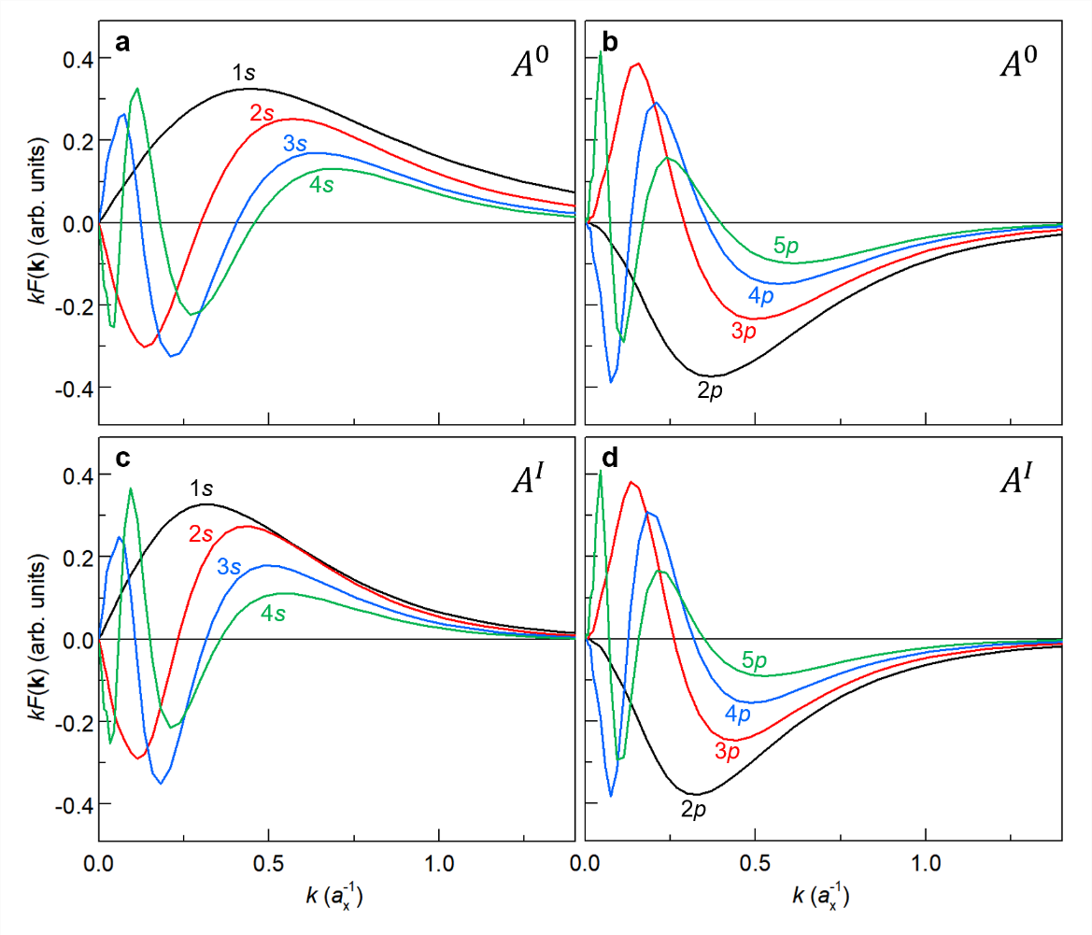
Figure S17 | The calculated value of $kF_{n}^{A^{0}}(k)$ as a function of $k$ for: a, $A_{1s}^{0}-A_{4s}^{0}$ states; b, $A_{2p}^{0}-A_{5p}^{0}$ states; c, $A_{1s}^{I}-A_{4s}^{I}$ states; d, $A_{2p}^{I}-A_{5p}^{I}$ states. Here, $k$ is expressed in units of $a_{X}^{-1}$, where $a_{X}$ is the effective Bohr radius of the $A_{ }^{0}$ exciton. The effective Bohr radius is given by $a_{X}=κa_{B}/μ_{X}$, with $κ$ denoting the dielectric constant of the medium, $a_{B}$ the conventional Bohr radius, and $μ_{X}$ the exciton reduced mass.

Solving Eq. (49) also yields the eigenstates of the $A^{0}$, $B^{0}$, $A^{I}$, $B^{I}$ excitons. Fig. S17 presents the calculated value of $kF_{n}^{A^{0}}(k)$ as a function of $k$ for various Rydberg states of the $A_{ }^{0}$ and $A_{ }^{I}$ excitons. As we will discuss later, $kF_{n}^{A^{0}}(k)$, which represents the amplitude weighted by the radial length, is crucial for determining both the oscillator strength and the hybridization strength of the exciton states.

4. Zeroth-order exciton states at finite electric fields
4.1 Band energies at finite electric fields
We have computed the band structure of bilayer MoS₂ under an external electric field ($F_{ext}$) using self-consistent DFT calculations. The screened electric filed $F_{scr}$ is approximately given by $F_{scr}=F_{ext}/κ_{1}$, where $κ_{1}$ represents an effective dielectric constant for bilayer MoS₂. The $κ_{1}$ value is determined by comparing self-consistent DFT calculations, which account for charge redistribution under the applied field, with non-self-consistent DFT calculations, which keep the charge distribution fixed.
Fig. S18 illustrates our method for determining $κ_{1}$. In Fig. S18a, we show the energies of interlayer transitions from $V_{L1,↑}$ to $C_{L2,↑}$ and from $V_{L2,↓}$ to $C_{L1,↓}$, calculated using both the non-self-consistent DFT method (black symbols) and the self-consistent DFT method (blue symbols). The much weaker energy shift observed in the self-consistent method compared to the non-self-consistent method indicates a strong screening effect of the valence charges in bilayer MoS₂. Fig. S18b presents the same results as Fig. S18a but reduce the field scale in the self-consistent method by a factor of 6.8. With this rescaling, the two sets of results align, allowing us to determine the effective dielectric constant $κ_{1}$ to be 6.8.
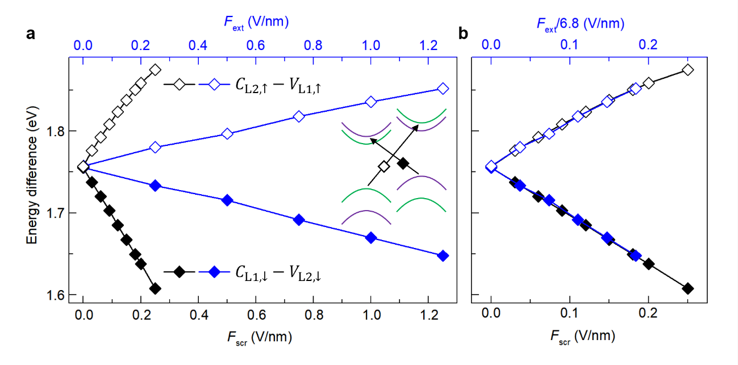
Figure S18 | a, Plot two results as a function of external electric field to show their difference. b, Results after scaling the external field by a factor.
Fig. S19 displays the calculated energies of the four conduction bands ($C_{L1,↑}$, $C_{L1,↓}$, $C_{L2,↑}$, $C_{L2,↓}$) and the four valence bands ($V_{L1,↑}$, $V_{L1,↓}$, $V_{L2,↑}$, $V_{L2,↓}$) in bilayer MoS₂ as a function of the screened electric field $F_{scr}$. An anti-crossing occurs between $V_{L1,↑}$ and $V_{L2,↑}$ near $F_{scr}=0.225$ V/nm, due to interlayer coupling when their energies become nearly degenerate. In this regime, the two bands hybridize with nearly equal weight, leading to pronounced level repulsion. Away from degeneracy, weaker mixing persists, giving rise to mild level repulsion.
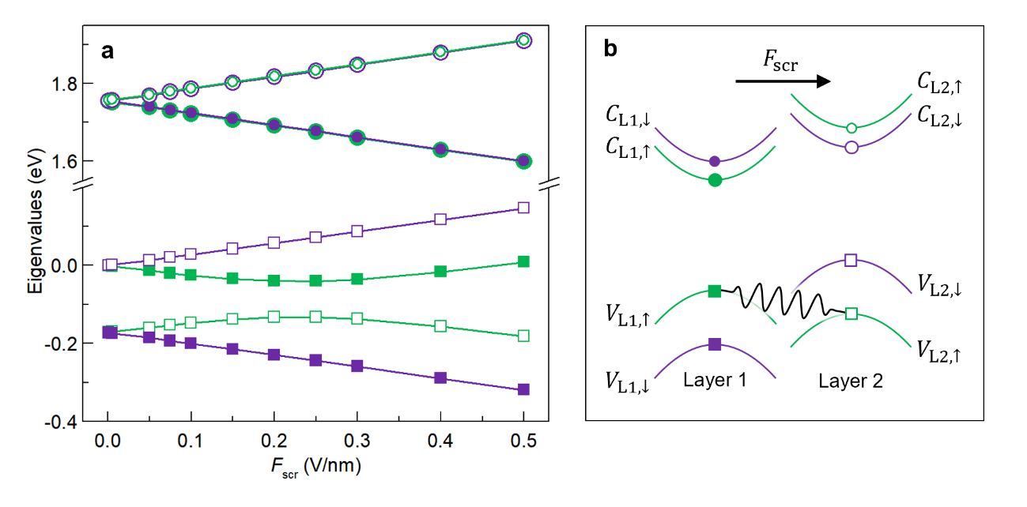
Figure S19 | a, Calculated energies of the $C_{L1,↑}$, $C_{L1,↓}$, $C_{L2,↑}$, $C_{L2,↓}$ conduction bands and the $V_{L1,↑}$, $V_{L1,↓}$, $V_{L2,↑}$, $V_{L2,↓}$ valence bands in bilayer MoS₂ as a function of the screened electric field $F_{scr}$. b, Schematic band structure of the two layers under an electric field.

The mixing between the $V_{L1,↑}$ and $V_{L2,↑}$ bands lead to significant changes in certain interband transitions. Figs. S20a and S20b show the field-dependent energies of four interband transitions, with consistent color and symbols labelling between panels a and b. Transitions between spin-down bands remain largely unaffected, as the two spin-down valence bands are well separated at positive fields. In contrast, the intralayer $V_{L1,↑}-C_{L1,↑}$ and interlayer $V_{L2,↑}-C_{L1,↑}$ transitions between spin-up bands exhibit anti-crossing behavior due to the $V_{L1,↑}-V_{L2,↑}$ band mixing. Similarly, Figs. S20c and S20d present four additional interband transitions. Among them, only the intralayer $V_{L2,↑}-C_{L2,↑}$ and interlayer $V_{L1,↑}-C_{L2,↑}$ transitions between spin-up bands display anti-crossing behavior, while transitions between spin-down bands remain nearly unaffected. Note that some transitions appear degenerate at zero field because excitonic effects are not included in this analysis.
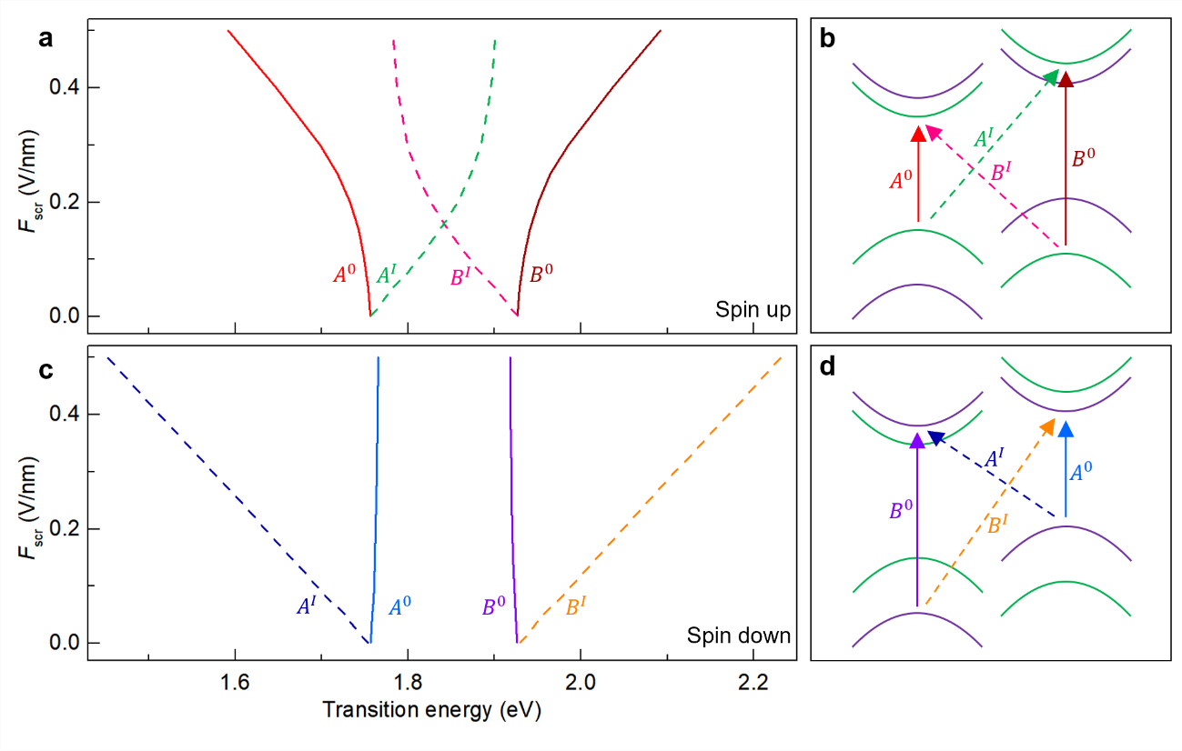
Figure S20 | a,b, Field-dependent energies of four interband transitions in bilayer MoS₂, with consistent color and symbol labelling between panels (a) and (b). c,d, Similar plots for four additional interband transitions. Excitonic effects are not included in this analysis.

4.2. Hole distribution at finite electric fields
When an external field is applied across bilayer MoS₂, the electron distribution in the conduction bands remains largely unchanged. In contrast, the holes in the valence bands become exhibit significant layer-polarization. Fig. S21a presents the schematic band structure at zero electric field, where the spin-up (green) and spin-down (purple) valence bands from the two layers are degenerate. Upon applying a finite electric field, this layer degeneracy is lifted, resulting in a splitting of the spin-up and spin-down bands. As the electric field increases, the spin-up (green) valence bands from the two layers (green curves) move closer and eventually intersect near a critical field strength of ${F_{scr}}_{ }=0.225 V/nm$, as indicated by the green dashed lines in Fig. S21b. This intersection, together with interlayer coupling, gives rise to an anti-crossing behavior, after which the two valence bands effectively exchange character, as shown in the high-field band structure in Fig. S21c. Figs. S21d-S21g illustrate the schematic band structure and corresponding in-plane-averaged hole distribution at zero electric field, as calculated by DFT. Each valence band exhibits a highly localized hole density in one layer (majority layer), with only a small fraction in the other (minority layer).
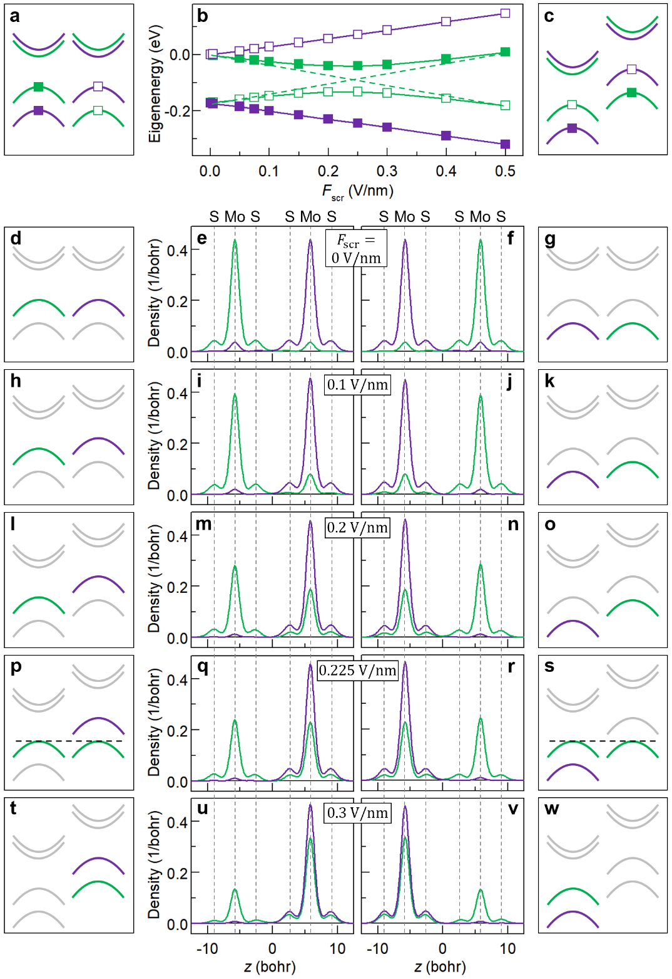
Figure S21 | a, Schematic K-valley band structure of bilayer MoS₂ at zero field. b, DFT-calculated band energies under various screened electric fields ($F_{scr}=0-0.3$ V/nm). The green dashed lines indicate the interaction between two spin-up valence band, leading to an anti-crossing behavior. c, Schematic band structure at high field, illustrating the exchange of character between the two spin-up valence bands from different layers. Solid and open green (purple) symbols on the bands and energy curves help track the evolution of spin-up (spin-down) states across different electric fields. d-w, Schematic valence bands and their corresponding in-plane-averaged hole distribution at $F_{scr}=0$ V/nm (d-g), 0.1 V/nm (h-k), 0.2 V/nm (l-o), 0.225 V/nm (p-s), and 0.3 V/nm (t-w). All hole distributions are computed using DFT. The schematic band structure highlights the exchange of character between the spin-up valence bands from the two layers as $F_{scr}$ exceeds 0.225 V/nm.
As the electric field increases, the hole density in the spin-up band gradually transfers from the majority to the minority layer, thereby reducing the layer polarization, as shown by the green curves in Figs. S21h-S21o. In contrast, holes in the spin-down band transfer from the minority to the majority layer, resulting in enhanced layer polarization, as shown by the purple curves in Figs. S21h-S21o. At the critical field ${F_{scr}}_{ }=0.225$ V/nm, the spin-up band exhibits nearly equal hole populations in both layers. Beyond this point, the originally minority layer becomes more populated than the originally majority layer, effectively reversing the direction of layer polarization. This transition corresponds to the anti-crossing behavior observed in Figs. S21a-S21c, where the spin-up valence bands switch character at high field.
To quantify this behavior, Fig. S22 plots the amplitude of the hole density in the original minority layer as a function of $F_{scr}$, for both the spin-up and spin-down valence bands. This amplitude effectively represents the layer-resolved hole distribution, as the shape of the z-dependent charge profiles remains nearly unchanged across different fields. Fig. S22 shows the hole density increases with the field for the spin-up band, but decreases for the spin-down band.
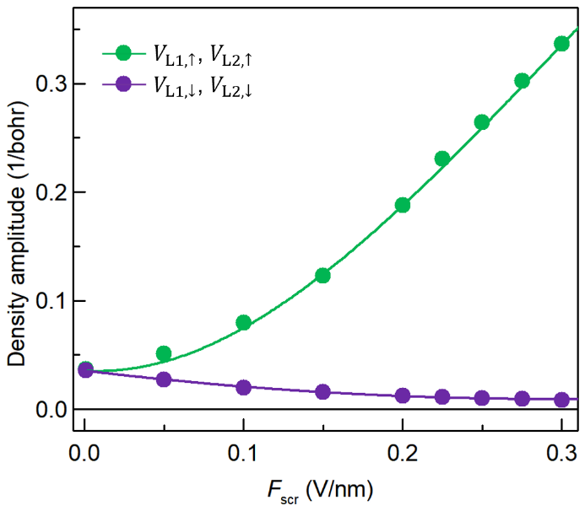
Figure S22 | Amplitude of the hole density at the peak position of the z-dependent density profiles (from Fig. S21) in the original minority layer, plotted as a function of screened electric field $F_{scr}$, for the spin-up $V_{L1,↑}$ and $V_{L2,↑}$ bands (green) and spin-down $V_{L1,↓}$ and $V_{L2,↓}$ bands (purple). Solid lines represent polynomial fits to the calculated data.

To calculate the zeroth-order exciton states, we use the valence band Bloch states illustrated above, together with the conduction band states, as the basis functions. We then solve Eq. (49) using the matrix elements defined in Eqs. (42) and (43) to obtain the exciton eigen energies and eigen states. Following the naming convention at zero electric field, we still label the resulting excitons as intralayer $A^{0}$, $B^{0}$ excitons and interlayer $A^{I}$, $B^{I}$ excitons. These labels remain approximately valid across most of the electric field range explored in our experiment, which slightly exceeds the critical field ${F_{scr}}_{ }=0.225$ V/nm. Although we use the term “intralayer” and “interlayer”, it is important to note that the hole wavefunctions are actually distributed across both layers, with a field-dependent density imbalance between them.

4.3. Exciton energies at finite electric fields
After obtaining the Bloch states at finite electric fields from DFT, we proceed to calculate the zeroth-order exciton states under the same field conditions. This calculation is based on the zeroth-order Bethe-Salpeter equation given in Eq. (49), using the $W_{ii}\left(k,k^{'}\right)$ matrix elements defined in Eqs. (42) and (43), which incorporate the field-dependent hole distribution between the two layers. Solving Eq. (49) yields the eigen energies and eigen states of the spin-up excitons $A_{↑}^{I}$,$B_{↑}^{0}$,$A_{↑}^{0}$, and$B_{↑}^{I}$, as well as the corresponding spin-down excitons $A_{↓}^{I}$,$B_{↓}^{0}$,$A_{↓}^{0}$, and $B_{↓}^{I}$.
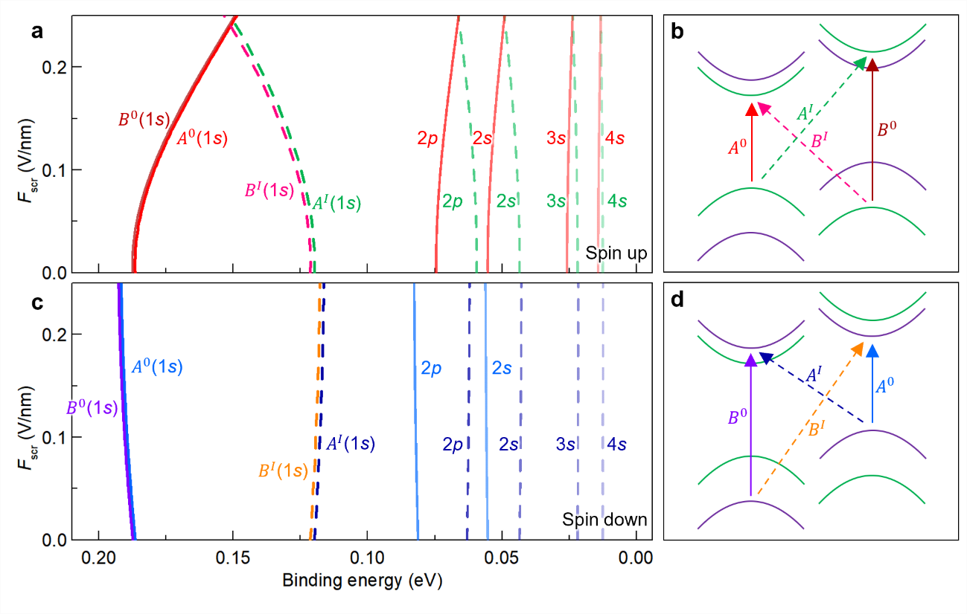
Figure S23 | a, Calculated binding energies of various spin-up excitons as a function of screened electric field. b, Corresponding excitonic transitions, with color and line style matching those in (a). c,d, Similar plots as (a-b), but for spin-down excitons. All results are zeroth-order calculations, excluding hybridization effects between different exciton states.

Figs. S23a and S23b present the binding energies of these zeroth-order exciton states for both spin-up and spin-down configurations, using consistent colors and line styles that correspond to the band-to-band transitions shown in Fig. S20. By combining the binding energies from Fig. S23 with the band-to-band transition energies in Fig. S20, we obtain the exciton generation energies, which are plotted in Fig. S24 using the same labeling convention.
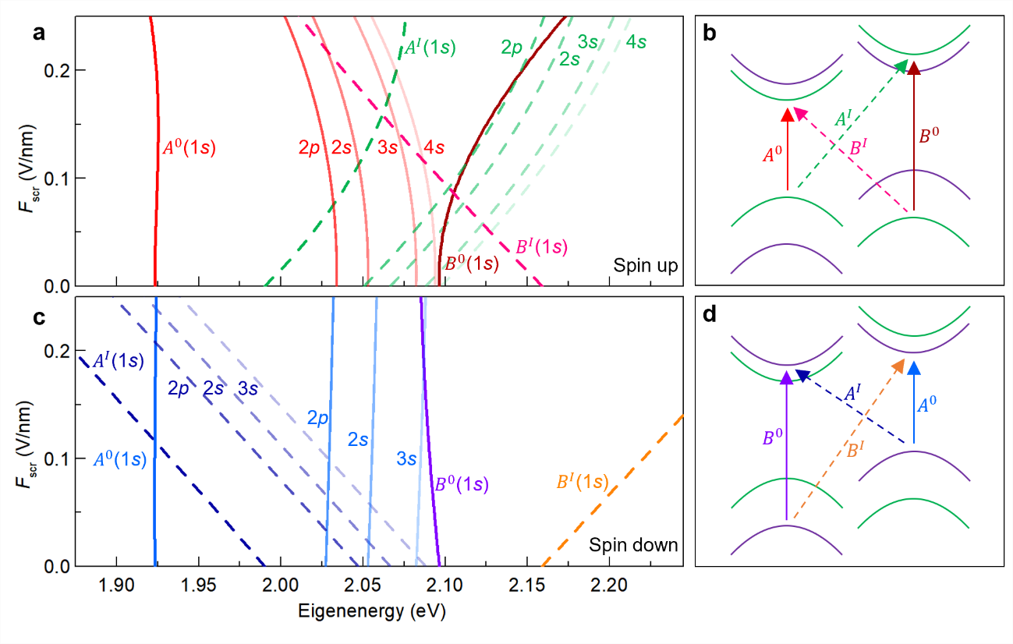
Figure S24 | a, Calculated eigen energies of various spin-up exciton states in bilayer MoS₂ under finite electric fields. b, Corresponding excitonic transitions, with color and line style matching those in (a). c-d, Similar plots as (a-b), but for spin-down excitons. All results are zeroth-order calculations, excluding hybridization effects between different exciton states.

Together, Figs. S20, S23 and S24 provide valuable insights into the behavior of excitons under electric fields. Let’s first examine the $A_{ }^{0}$ excitons. In Fig. S20, the band-to-band transition energy of $A_{↑}^{0}$ exhibits a pronounced redshift with increasing field due to the anti-crossing behavior of the valence bands, resulting in a substantial splitting between the $A_{↑}^{0}$ and $A_{↓}^{0}$ transition energies. In Fig. S23, the binding energy of 1s state $A_{1s, ↑}^{0}$ decreases with increasing field, as the hole component shifts from the majority to minority layer, gradually evolving from an intralayer to an interlayer exciton. In contrast, the binding energy of $A_{1s,↓}^{0}$ increases slightly, as the hole component shifts from the minority to majority layer, as illustrated in Fig. S21. When combining the binding energies and band-to-band energies, the resulting exciton generation energies of $A_{1s,↑}^{0}$ and $A_{1s,↓}^{0}$ become nearly degenerate.
The situation differs for the higher Rydberg states, such as the 2s-4s and 2p states. Because their binding energies are much smaller, the field-induced changes in binding energies are relatively minor. As a result, their generation energies are dominated by the band-to-band transition energies. Consequently, these Rydberg excitons inherit the large energy splitting between the $A_{↑}^{0}$ and $A_{↓}^{0}$ transitions shown in Fig. S20.
Next, we consider the $B_{ }^{0}$ excitons. As shown in Fig. S23, the binding energy of $B_{1s, ↑}^{0}$ decreases with increasing electric field, while that of $B_{1s,↓}^{0}$ increases slightly, mirroring the behavior observed in the $A_{1s}^{0}$ excitons. However, in Fig. S20, unlike the redshifting $A_{↑}^{0}$ transition, the $B_{↑}^{0}$ band-to-band transition energy exhibits a blueshift with increasing field, also driven by the anti-crossing behavior of the valence bands. As a result, when combing the exciton binding energies and the band-to-band transition energies, the exciton generation energy of $B_{↑}^{0}$ shows an enhanced blueshift, as shown in Fig. S24.
In contrast, the $B_{↑}^{0}$ exciton energy shows a small but noticeable redshift. This redshift arises not only from the increasing exciton binding (Fig. S23), but also from the slight redshift of the band-to-band transition energy, which results from mild level repulsion between the two well-separated spin-down valence bands (Fig. S20). Overall, while the $A_{↑}^{0}$ and $A_{↓}^{0}$ excitons remain nearly degenerate under electric fields, the $B_{↑}^{0}$ and $B_{↓}^{0}$ excitons exhibit a pronounced energy splitting.
Fig. S24 also reveals a distinct difference in the Stark shifts of the spin-up and spin-down interlayer excitons. While the spin-down interlayer Rydberg excitons exhibit linear Stark shifts—typical of conventional interlayer excitons—their spin-up counterparts show nonlinear Stark shifts. This deviation from linearity arises from the anti-crossing behavior of the two spin-up valence bands.

5. Hybridization between same-spin excitons
In the previous section, we calculated the zeroth-order excitonic states by retaining only the diagonal blocks $V_{ii}\left(k,k'\right)$ of the Coulomb interaction matrix in the exciton Hamiltonian (Eq. (46)). These excitonic states are built upon field-dependent Bloch states, which already incorporate the field-induced interlayer hole transfer. In this section, we go beyond the zeroth-order approximation by including selected off-diagonal blocks $V_{ij}\left(k,k'\right)$ of the Coulomb interaction matrix, thereby capturing the hybridization between different zeroth-order exciton states.
Although these hybridization effects are relatively weak, the zeroth-order states remain good approximations of the true eigenstates. However, when the energies of two zeroth-order excitons become nearly degenerate, even weak coupling (on the order of a few meV) can significantly modify both the exciton energy and their oscillator strengths. We find that such hybridization is the key mechanism responsible for brightening the otherwise dark 2p states of the ​$A_{ }^{0}$ and $A_{ }^{I}$ excitons.

5.1. Six coupling terms between same-spin excitons
The Hamiltonian in Eq. (46) describes spin-up excitons. To account for hybridization, we include the following three coupling terms:
(1) $V_{12}\left(k,k'\right)$ that accounts for the coupling between $A_{↑}^{I}$ and $B_{↑}^{0}$ (illustrated by Fig. S16a)
(2) $V_{34}\left(k,k'\right)$ that accounts for the coupling between $A_{↑}^{0}$ and $B_{↑}^{I}$ (illustrated by Fig. S16b)
(3) $V_{13}\left(k,k'\right)$ that accounts for the coupling between $A_{↑}^{I}$ and $A_{↑}^{0}$ (illustrated by Fig. S16c)
The corresponding Hamiltonian for spin-down excitons is obtained by flipping all spin indices in Eq. (46). Similarly, we include the following three coupling terms:
(4) $V_{12}\left(k,k'\right)$ that accounts for the coupling between $A_{↓}^{I}$ and $B_{↓}^{0}$ (illustrated by Fig. S16d)
(5) $V_{34}\left(k,k'\right)$ that accounts for the coupling between $A_{↓}^{0}$ and $B_{↓}^{I}$ (illustrated by Fig. S16e)
(6) $V_{13}\left(k,k'\right)$ that accounts for the coupling between $A_{↓}^{I}$ and $A_{↓}^{0}$ (illustrated by Fig. S16f)
Since all six couplings involve interlayer excitons, where the electron and hole are predominantly confined to different layers, we neglect the electron-hole exchange interaction ${\hat{V}}_{ex}$, as it is short-ranged in nature. This simplification allows us to reduce the interaction matrix elements introduced in Eq. (47) to:
$V_{ij}\left(k,k^{'}\right)=\left\langle {\tilde{u}}_{C_{i},k}^{ };u_{V_{i},k}^{ } | \hat{W}+{\hat{V}}_{ex} | {\tilde{u}}_{C_{j},k^{'}}^{ };u_{V_{j},k^{'}}^{ }\right\rangle =W_{ij}\left(k,k^{'}\right)$ (51)
This expression gives the Coulomb matrix elements between Bloch states. For our calculation, however, we need the matrix elements between two zeroth-order exciton states. Representing these exciton states as $ψ_{n}^{i}$ and $ψ_{n^{'}}^{j}$, the relevant matrix elements are:
$\left\langle ψ_{n}^{i} | \hat{W} | ψ_{n^{'}}^{j}\right\rangle =\sum_{k,k^{'}}{F_{n}^{i}\left(k\right)}W_{ij}\left(k,k'\right)F_{n^{'}}^{j}\left(k'\right)$ (52)
The expansion coefficients are given by $F_{n}^{i}\left(k\right)=f_{n}^{i}\left(k\right)$ for s-like states, and $F_{n}^{i}\left(k\right)=f_{n}^{i}\left(k\right)e^{iφ_{ }}$for p-like states, where $φ$ is the azimuthal angle of the $k$ vector.
In the following, we evaluate the $\hat{W}$ matrix elements for the six coupling terms illustrated by Figs. S16a-S16f. We begin with the spin-up excitons (Figs. S16a-S16c), and then obtain the corresponding results for spin-down excitons (Figs. S16d-S16f) by flipping the spin indices in the Bloch functions.

5.2. The $A_{↑}^{I}-B_{↑}^{0}$ coupling term (Fig. S16a)
We first evaluate the Coulomb matrix elements $\hat{W}$ between the $B_{↑}^{0}$ and $A_{↑}^{I}$ excitons, corresponding to the diagram in Fig. S16a and the $V_{12}$ term in Eq. (45). Since all coefficients $F_{n}^{i}\left(k\right)$ in Eq. (52) have been obtained from the zeroth-order solution, the remaining task is to compute $W_{ij}\left(k,k'\right)$. Adapting Eq. (33), we express $W_{ij}\left(k,k^{'}\right)$ as:
$W_{ij}\left(k,k^{'}\right)=\sum_{q}{\frac{e^{2}}{2A{κε_{0}\left|q\right|}^{ }}}\int{dr_{e}dr_{h}}{\tilde{u}}_{C_{i},k}^{*}\left(r_{e}\right)u_{V_{i},k}^{*}\left(r_{h}\right){e^{-q\left|z_{e}-z_{h}\right|}e}^{iq∙\left(ρ_{e}-ρ_{h}\right)}{\tilde{u}}_{C_{j},k^{'}}^{ }\left(r_{e}\right)u_{V_{j},k^{'}}^{ }\left(r_{h}\right)$ (53)
Following the method used in Eqs. (34) and (35), we define
$\left\{\begin{matrix}{ζ_{kk'}^{C_{i}C_{j}}\left(z_{e}\right)}_{ }=\frac{1}{L_{c}}\sum_{G_{z}}{\int{dρdz{ \tilde{u}}_{C_{i},k}^{*}(ρ,z){e^{{iG}_{z}(z-z_{e})}e}^{i(k'-k)∙ρ}}{\tilde{u}}_{C_{j},k'}^{ }(ρ,z)} \\ ζ_{kk'}^{V_{i}V_{j}}\left(z_{h}\right)=\frac{1}{L_{c}}\sum_{G_{z}}{\int{dρdz{ u}_{V_{i},k}^{*}(ρ,z){e^{{iG}_{z}(z-z_{h})}e}^{i(k'-k)∙ρ}}u_{V_{j},k'}^{ }(ρ,z)}\end{matrix}\right.$ (54)
These definitions allow us to write:
$W_{ij}\left(k,k^{'}\right)=\frac{-e^{2}}{2A{κε_{0}|k-k^{'}|}^{ }}\int{dz_{e}dz_{h}}e^{-|k-k^{'}||z_{e}-z_{h}|}{ζ_{kk^{'}}^{C_{i}C_{j}}\left(z_{e}\right)}_{ }ζ_{kk^{'}}^{V_{i}V_{j}}\left(z_{h}\right)$ (55)
For the $V_{12}$ term, $C_{i}$ is the same as $C_{j}$, while $V_{i}$ and $V_{j}$ different. We can adapt Eq. (36) to approximate $ζ_{kk^{'}}^{C_{i}C_{j}}\left(z_{e}\right)≈ρ_{C_{i}}\left(z_{e}\right)$, using the density profile shown in Fig. S15. This yields:
$W_{ij}\left(k,k^{'}\right)≈\frac{-e^{2}}{2A{κε_{0}|k-k^{'}|}^{ }}\int{dz_{e}dz_{h}}e^{-|k-k^{'}||z_{e}-z_{h}|}{ρ_{C_{i}}\left(z_{e}\right)}_{ }ζ_{kk^{'}}^{V_{i}V_{j}}\left(z_{h}\right)$ (56)
Despite this simplification, evaluating Eq. (56) remains computationally expensive due to its dependence on a dense grid over $k$, $k'$, $z_{e}$, and $z_{h}$ (six variables in total). To mitigate this, we employ $k∙p$ perturbation theory near the K point to derive an analytical form for the valence Bloch states¹⁵. This enables variable separation in the integrant, reducing the original 6D integration into a product of three lower-dimensional integrals.
In the $k∙p$ theory, the valence Bloch states near the K point can be approximated as:
$u_{V_{l,↑},k}^{ }≈e^{ik∙ρ_{ }}\left[α_{l}\left(k\right)u_{V_{l,↑},k=0}^{ }+β_{l}\left(k\right){\tilde{u}}_{C_{l,↑},k=0}^{ }\right]$ (57)
Here $l$ = L1, L2 denotes the layer, and the coefficients $α_{l}$, $β_{l}$ satisfy⁷:
$\left(\begin{matrix}E_{V_{l,↑}} & {a_{L}t}_{l}∙k \\ {a_{L}t}_{l}^{*}∙k & E_{C_{l,↑}}\end{matrix}\right)\left(\begin{matrix}α_{l} \\ β_{l}\end{matrix}\right)=E_{V_{l,↑},k}^{ }\left(\begin{matrix}α_{l} \\ β_{l}\end{matrix}\right)$ (58)
Here, $E_{V_{l,↑}}$ ($E_{C_{l,↑}}$) denotes the energy at the K point of the $V_{l,↑}$ ($C_{l,↑}$) band; $a_{L}$ is the in-plane lattice constant of MoS₂; $t_{l}=ℏP_{l}/m_{0}a_{L}$, where $P_{l}$ denotes the momentum matrix element between the $V_{l,↑}$ and $C_{l,↑}$ band and $m_{0}$ is the mass of a free electron. We take ${|t}_{l}|=1.137eV$ according to DFT calculations⁷, which give similar values for $l$ = L1, L2 in MoS₂. Solving Eq. (58) gives:
$\left(\begin{matrix}α_{l} \\ β_{l}\end{matrix}\right)≈{\left[1+\frac{{{\left|t_{l}\right|}^{2}(ka_{L})}^{2}}{{\left(E_{C_{l,↑}}-E_{V_{l,↑}}\right)}^{2}}\right]}^{-\frac{1}{2}}\left(\begin{matrix}1 \\ {-a_{L}t}_{l}^{*}∙k/\left(E_{C_{l,↑}}-E_{V_{l,↑}}\right)\end{matrix}\right)$ (59)
Since $α_{l}$ depends only on the magnitude of $k$, we simplify $α_{l}\left(k\right)$ into $α_{l}\left(k\right)$. Using this solution, we express the matrix element between $B_{↑}^{0}$ and $A_{↑}^{I}$ exciton states as:
${\tilde{W}}_{n,n'}^{B_{↑}^{0}A_{↑}^{I}}=\left\langle ψ_{n}^{B_{↑}^{0}} | \hat{W} | ψ_{n'}^{A_{↑}^{I}}\right\rangle$
$=\sum_{k,k^{'}}{F_{n}^{B_{↑}^{0}}\left(k\right)}\left\langle {\tilde{u}}_{C_{L2,↑},k}^{ };u_{V_{L2,↑},k}^{ } | \hat{W} | {\tilde{u}}_{C_{L2,↑},k'}^{ };u_{V_{L1,↑},k'}^{ }\right\rangle F_{n^{'}}^{A_{↑}^{I}}\left(k^{'}\right)$
$=\sum_{k,k^{'}}{{F_{n}^{B_{↑}^{0}}\left(k\right)}_{ }^{ }F_{n^{'}}^{A_{↑}^{I}}\left(k^{'}\right)}\frac{{-e}^{2}}{2A{κ ε_{0}\left|q\right|}^{ }}\int{dz_{e}dz_{h}}ζ_{k,k^{'}}^{21↑}\left(z_{h}\right){e^{-q\left|z_{e}-z_{h}\right|}}^{ }ρ_{C_{L2,↑}}^{ }\left(z_{e}\right)$ (60)
where
$ζ_{k,k^{'}}^{21↑}\left(z_{h}\right)=\int{dρ_{h}}u_{V_{L2,↑},k}^{*}\left(r_{h}\right)u_{V_{L1,↑},k'}^{ }\left(r_{h}\right)e^{iq∙ρ_{h}}$ (61)
Using Eqs. (57) and (59) and retaining the dominant term, we approximate:
$ζ_{k,k^{'}}^{21↑}\left(z_{h}\right)≈α_{2}\left(k\right)α_{1}\left(k'\right)\int{dρ_{h}}u_{V_{L2,↑},k=0}^{*}\left(r_{h}\right)u_{V_{L1,↑},k^{'}=0}^{ }\left(r_{h}\right)$ (62)
At $k=k^{'}=0$, $α_{2}=α_{1}=1$, so:
$ζ_{0,0}^{21↑}\left(z_{h}\right)=\int{dρ_{h}}u_{V_{L2,↑},k=0}^{*}\left(r_{h}\right)u_{V_{L1,↑},k^{'}=0}^{ }\left(r_{h}\right)$ (63)
Thus,
$ζ_{k,k^{'}}^{21↑}\left(z_{h}\right)≈α_{2}\left(k\right)α_{1}\left(k'\right)ζ_{0,0}^{21}\left(z_{h}\right)$ (64)
Substituting into Eq. (60) and converting the $k$ and $k^{'}$ summations to integrals:
${\tilde{W}}_{n,n'}^{B_{↑}^{0}A_{↑}^{I}}≈\int_{0}^{∞}{\frac{kdk}{2π}}{F_{n}^{B_{↑}^{0}}\left(k\right)}_{ }^{ }\int_{0}^{∞}{\frac{k'dk'}{2π}}{\overline{W}}_{B_{↑}^{0}A_{↑}^{I}}\left(k,k'\right)F_{n^{'}}^{A_{↑}^{I}}(k')$ (65)
Here, ${\overline{W}}_{B_{↑}^{0}A_{↑}^{I}}\left(k,k'\right)$ is the angularly averaged value of ${\overline{W}}_{B_{↑}^{0}A_{↑}^{I}}\left(k,k'\right)$:
${\overline{W}}_{B_{↑}^{0}A_{↑}^{I}}\left(k,k'\right)=α_{2}^{ }\left(k\right)α_{1}\left(k'\right)\int{dz_{e}d{z_{h}ρ_{C_{L2,↑}}^{ }\left(z_{e}\right)ζ_{0,0}^{21↑}\left(z_{h}\right)\int{\frac{dφ_{ }}{2π}\frac{-e^{2}}{2Aκε_{0}q}}}^{ }e^{-q|z_{e}-z_{h}|} }$ (66)
where $φ=φ_{k}-φ_{k^{'}}$ is the difference between the polar angles of $k$ and $k'$, and $q=\left|k-k'\right|=\sqrt{k^{2}+k^{'2}-2kk'cosφ}$.
By choosing appropriate phase conventions, the Bloch states can be made predominantly read-valued, ensuring that $ζ_{0,0}^{21↑}$ is essentially real. Fig. S25 presents the $ζ_{0,0}^{21↑}\left(z_{h}\right)$ profiles calculated using DFT under various screened electric fields. Fig. S26 further displays its field-dependent amplitude, which increases from 0.125 at zero field to a maximum of approximately 0.23 near $F_{scr}=0.225$ V/nm. Based on these results, the $\hat{W}$ matrix elements between $B_{↑}^{0}$ and $A_{↑}^{I}$ excitons can be evaluated using Eqs. (65) and (66).
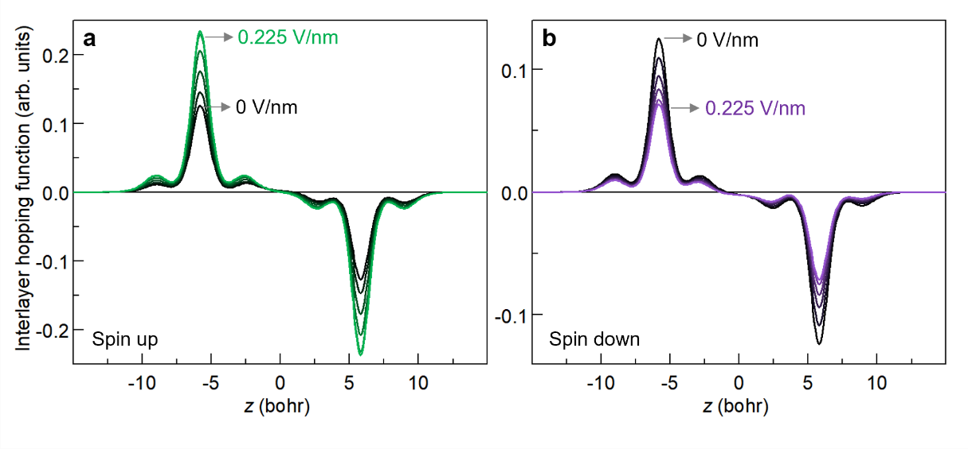
Figure S25 | a, The $ζ_{0,0}^{21↑}\left(z_{h}\right)$ profile for spin-up states of bilayer MoS₂ calculated via DFT under various screened electric fields from $F_{scr}$ = 0 to 0.225 V/nm. Darker color represents lower electric field. b, Similar plots for the $ζ_{0,0}^{21↓}\left(z_{h}\right)$ profile for spin-down states.
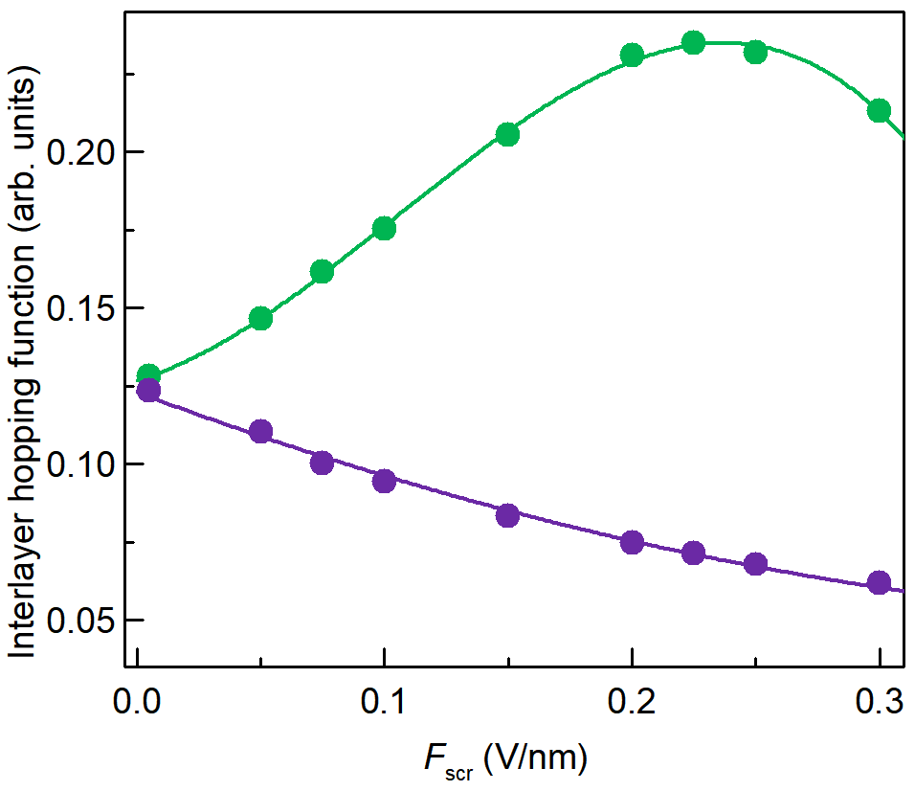
Figure S26 | The maximum values of the $ζ_{0,0}^{21↑}\left(z_{h}\right)$ profile (green) and the $ζ_{0,0}^{21↓}\left(z_{h}\right)$ profile (purple) under various screened electric fields.

5.3. The $A_{↑}^{0}-B_{↑}^{I}$ coupling term (Fig. S16b)
The $A_{↑}^{0}-B_{↑}^{I}$ coupling term corresponds to the diagram in Fig. S16b and the $V_{34}$ term in Eq. (46). Having obtained the $A_{↑}^{I}-B_{↑}^{0}$ coupling term in the previous section, we can derive the matrix elements of $\hat{W}$ between the $B_{↑}^{I}$ and $A_{↑}^{0}$ excitons by simply exchanging the roles of the A and B excitons and their associated Bloch states. The corresponding matrix elements of $\hat{W}$ are given by:
${\tilde{W}}_{n,n'}^{B_{↑}^{I}A_{↑}^{0}}=\left\langle ψ_{n}^{B_{↑}^{I}} | \hat{W} | ψ_{n'}^{A_{↑}^{0}}\right\rangle ≈\int_{0}^{∞}{\frac{kdk}{2π}}{F_{n}^{B_{↑}^{I}}\left(k\right)}_{ }^{ }\int_{0}^{∞}{\frac{k^{'}dk^{'}}{2π}}{\overline{W}}_{B_{↑}^{I}A_{↑}^{0}}\left(k,k'\right)F_{n^{'}}^{A_{↑}^{0}}(k')$ (67)
Here, ${\overline{W}}_{B_{↑}^{I}A_{↑}^{0}}\left(k,k'\right)$ is obtained by swapping the layer indices in $ζ_{k,k^{'}}^{21↑}$ from Eqs. (61-64) and (66). Notably, $ζ_{0,0}^{12↑}$ is the complex conjugate of $ζ_{0,0}^{21↑}$; however, since $ζ_{0,0}^{21↑}$ is predominantly real, the two quantities are effectively identical.

5.4. The $A_{↑}^{0}-A_{↑}^{I}$ coupling term (Fig. S16c)
The coupling between $A_{↑}^{0}$ and $A_{↑}^{I}$ corresponds to the diagram shown in Fig. S16c. In contrast to the $A_{↑}^{0}-B_{↑}^{I}$ and $A_{↑}^{I}-B_{↑}^{0}$ coupling terms discussed in the previous sections, which originate from interlayer hole hopping, this term arises from interlayer electron hopping.
As discussed in Section III.1.4, the DFT-calculated same-spin conduction bands from different layers exhibit strong interlayer mixing at finite $k$, due to their nearly degenerate energy levels. To avoid complications from this mixing, we adopt a monolayer-like conduction-band basis, as defined in Eq. (23). However, because these basis states are not exact eigenstates of the bilayer Hamiltonian, they introduce off-diagonal terms $∆H$ and $∆H^{*}$ in Eq. (46), which couple the zeroth-order $A_{↑}^{0}$ and $A_{↑}^{I}$ exciton states.
Using the expansion given in Eq. (28), the matrix element of $∆H$ between two zeroth-order $A_{↑}^{0}$ and $A_{↑}^{I}$ Rydberg excitons is given by:
${∆H}_{n,n^{'}}^{A_{↑}^{0}A_{↑}^{I}}=\left\langle ψ_{n }^{A_{↑}^{0} } | ∆H | ψ_{n^{'} }^{A_{↑}^{I} }\right\rangle$
$=\sum_{kk'}{F_{n}^{A_{↑}^{0}}\left(k\right)}F_{n'}^{A_{↑}^{I}}\left(k'\right)\left\langle {\tilde{u}}_{C_{L1,↑},k}^{ };u_{V_{L1,↑},k}^{ } | H | {\tilde{u}}_{C_{L2,↑},k'}^{ };u_{V_{L1,↑},k'}^{ }\right\rangle$ (68)
Here, $H$ denotes the single-particle DFT Hamiltonian for bilayer MoS₂. If all Bloch functions $u$ were exact eigen states of H, the matrix element in Eq. (68) would vanish, implying no coupling. However, while the valence-band states $u_{V_{L1,↑}}^{ }$ are eigen states, the conduction-band states ${\tilde{u}}_{C_{L1,↑}}^{ }$ and ${\tilde{u}}_{C_{L2,↑}}^{ }$ in our monolayer-like basis are not. This mismatch gives rise to a finite coupling.

Using the definitions in Eq. (23), we obtain:
$\left\langle {\tilde{u}}_{C_{L1,↑},k}^{ };u_{V_{L1,↑},k}^{ } | H | {\tilde{u}}_{C_{L2,↑},k^{'}}^{ };u_{V_{L1,↑},k^{'}}^{ }\right\rangle$
$=\left\langle {\tilde{u}}_{C_{L1,↑},k}^{ } | H | {\tilde{u}}_{C_{L2,↑},k}^{ }\right\rangle δ_{kk^{'}}$
$=\left\langle c_{11}\left(k\right)u_{C_{L1,↑},k}^{ }+c_{21}\left(k\right)u_{C_{L2,↑},k}^{ } | H | c_{12}\left(k'\right)u_{C_{L1,↑},k}^{ }+c_{22}\left(k\right)u_{C_{L2,↑},k}^{ }\right\rangle δ_{kk^{'}}$
$=\left(c_{11}^{*}\left(k\right)c_{12}\left(k\right)E_{C_{L1,↑}}^{ }(k)+c_{21}^{*}\left(k\right)c_{22}\left(k\right)E_{C_{L2,↑}}^{ }(k)\right)δ_{kk^{'}}$ (69)
Substituting Eq. (68) into Eq. (69), we obtain the final expression for the matrix element:
${∆H}_{n,n^{'}}^{A_{↑}^{0}A_{↑}^{I}}=\sum_{k}{F_{n}^{A_{↑}^{0}}\left(k\right)}F_{n'}^{A_{↑}^{I}}\left(k\right)\left(c_{11}^{*}\left(k\right)c_{12}\left(k\right)E_{C_{L1,↑}}^{ }(k)+c_{21}^{*}\left(k\right)c_{22}\left(k\right)E_{C_{L2,↑}}^{ }(k)\right)$ (70)

5.5. Coupling terms between spin-down excitons (Figs. S16d-S16f)
Having analyzed the coupling terms between spin-up excitons, as illustrated in Figs. S16a-S16c, we now turn to the corresponding coupling terms for spin-down excitons, shown in Figs. S16d-S16f. The $A_{↓}^{I}-B_{↓}^{0}$ coupling term (Fig. S16d) can be derived by following the same procedure as in Section III.5.2, with all layer indices L1 and L2 exchanged and spin flipped. Similarly, the $B_{↓}^{I}-A_{↓}^{0}$ coupling term (Fig. S16e) follows directly from the expression in Section III.5.3, again with the layer indices swapped and spin reversed. The $A_{↓}^{I}-A_{↓}^{0}$ coupling term (Fig. S16f) can likewise be obtained using the same method as in Section III.5.4, with the same exchange of layers and spin flip.
Although the $A_{↓}^{I}-B_{↓}^{0}$ and $B_{↓}^{I}-A_{↓}^{0}$ coupling terms share the same formal expressions as their spin-up counterparts ($A_{↑}^{I}-B_{↑}^{0}$ and $B_{↑}^{I}-A_{↑}^{0}$), their quantitative behavior differs markedly. Fig. S25 shows the $ζ_{0,0}^{21↑}\left(z_{h}\right)$ and $ζ_{0,0}^{21↓}\left(z_{h}\right)$ profiles of the spin-up and spin-down valence-band states, calculated using DFT under various screened electric fields. Fig. S26 further displays the field dependence of their amplitudes. At zero field, both $ζ_{0,0}^{21↑}$ and $ζ_{0,0}^{21↓}$ have an amplitude of 0.125, since the two valence bands with opposite spins are related by inversion plus time-reversal symmetry. As the electric field increases, inversion symmetry is broken, resulting in distinct behaviors for the two bands with opposite spin. Specifically, the $ζ_{0,0}^{21↑}$ amplitude increases, reaching a maximum of 0.23 near $F_{scr}=0.225$ V/nm. In contrast, the $ζ_{0,0}^{21↓}$ amplitude decreases monotonically, reaching 0.062 near $F_{scr}=0.3$ V/nm, the highest field considered in our calculation. Consequently, the coupling strength for spin-up excitons increases with the field, whereas that of spin-down excitons decreases.

5.6. Calculated coupling strengths between same-spin excitons
We have calculated the coupling terms ${\tilde{W}}_{n,n'}^{B_{ }^{0}A_{ }^{I}}$, ${\tilde{W}}_{n,n'}^{B_{ }^{I}A_{ }^{0}}$, and ${∆H}_{n,n^{'}}^{A_{ }^{0}A_{ }^{I}}$ for both spin-up and spin-down excitons, based on their respective expressions in Eqs. (65), (67) and (70), and following the procedures outlined in Section III.5.5. These calculations employ the zeroth-order exciton envelop functions $F_{n}^{i}\left(k\right)$, the DFT-derived screened Coulomb interactions ${\overline{W}}_{ij}$ as exemplified in Eq. (66), and the DFT-computed c coefficients defined in Eq. (27) and used in Eq. (70).
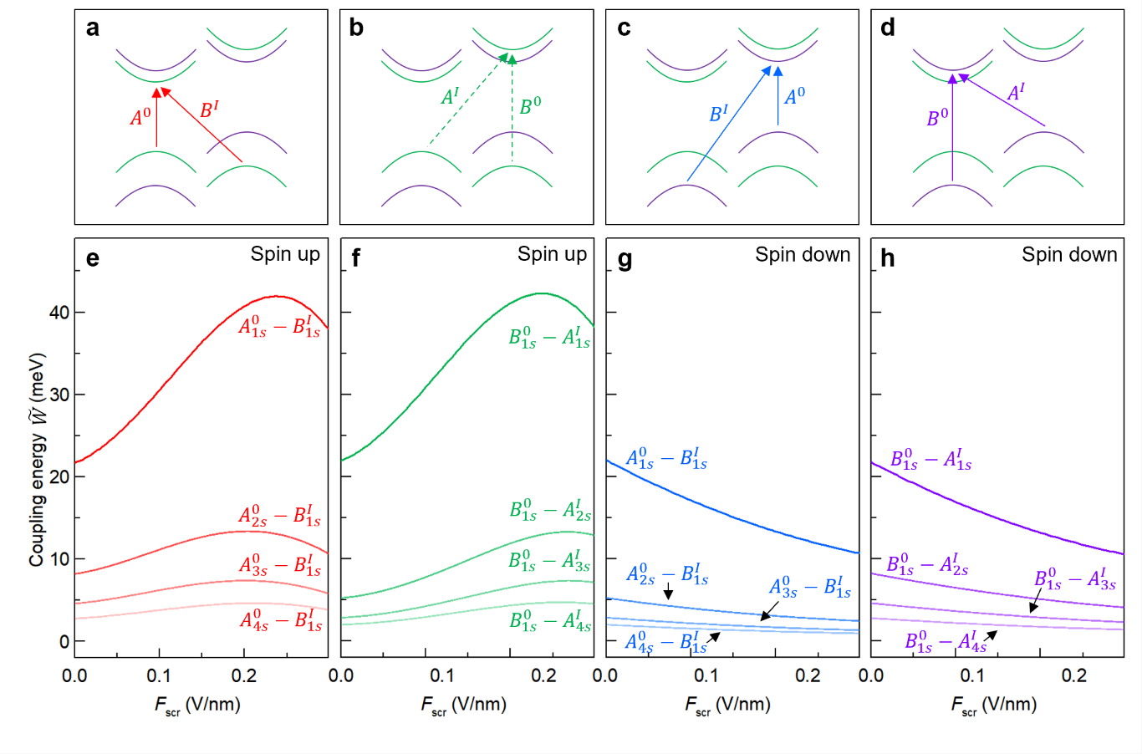
Figure S27 | a,b, Schematic illustration of the spin-up excitons considered in our calculations. c,d, Schematic illustration of the spin-down excitons. e,f Calculated field-dependent values of ${\tilde{W}}_{n,n'}^{B_{ }^{I}A_{ }^{0}}$ and ${\tilde{W}}_{n,n'}^{B_{ }^{0}A_{ }^{I}}$ for spin-up excitons at various Rydberg states. g,h, Same as e,f, but for spin-down excitons.

Fig. S27 displays the calculated ${\tilde{W}}_{n,n'}^{B_{ }^{0}A_{ }^{I}}$ and ${\tilde{W}}_{n,n'}^{B_{ }^{I}A_{ }^{0}}$ for both the spin-up and spin-down excitons across different s-like Rydberg states under various screened electric field. For spin-up excitons, the coupling energies increases with increasing field, whereas for spin-down excitons, they decrease—consistent with the field-dependent behavior of $ζ_{0,0}^{21↑}$ and $ζ_{0,0}^{21↓}$ shown in Fig. S26. The $B_{1s}^{0}$ exciton exhibit significant hybridization with multiple s-like$A^{I}$ Rydberg excitons in both spin-up and spin-down configurations. Likewise, multiple $A_{ }^{0}$ Rydberg states hybridize significantly with the $B_{1s}^{I}$ Rydberg excitons. Our simulations include 1s-4s states for both $A_{ }^{0}$ and $A^{I}$ excitons.
Fig. S28 presents the calculated ${∆H}_{n,n^{'}}^{A_{ }^{0}A_{ }^{I}}$ between s-like and p-like Rydberg states under various screened electric field, again for both spin-up and spin-down excitons. The s-like $A^{0}$ and $A^{I}$ excitons do not hybridize because they belong to different irreducible representations of the three-fold rotation symmetry. However, their s-like and p-like Rydberg states share the same symmetry and can hybridize. This s-p hybridization is the key mechanism responsible for brightening the 2p states of $A^{I}$ exciton in our experiment.
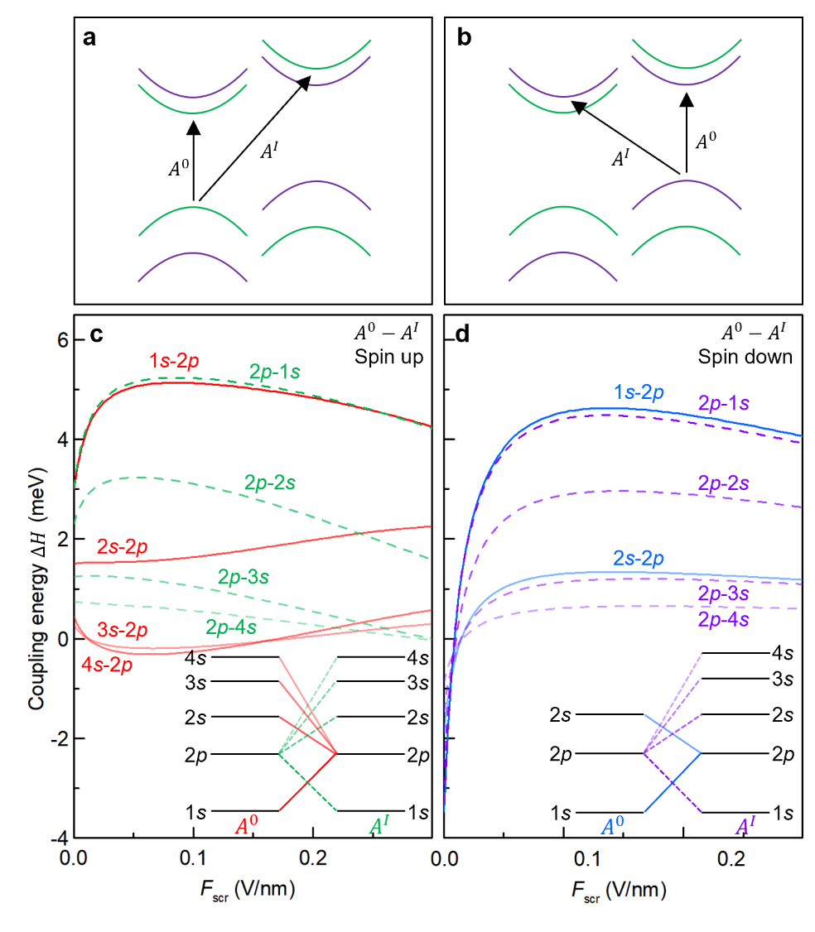
Figure S28 | a, Schematic illustration of the spin-up excitons considered in our calculations. b, Schematic illustration of the corresponding spin-down excitons. c, Calculated field-dependent values of ${∆H}_{n,n^{'}}^{A_{ }^{0}A_{ }^{I}}$ for spin-up excitons across various Rydberg states. d, Same as c, but for spin-down excitons. Insets in c and d illustrate the coupling between different Rydberg states involved in the calculation.

5.7. Hybridization between same-spin intralayer and interlayer excitons
After obtaining the various coupling energies ${\tilde{W}}_{n,n'}^{B_{ }^{I}A_{ }^{0}}$, ${\tilde{W}}_{n,n'}^{B_{ }^{0}A_{ }^{I}}$, and ${∆H}_{n,n^{'}}^{A_{ }^{0}A_{ }^{I}}$, in this section we will set up the Hamiltonian with off-diagonal coupling terms for the intralayer and interlayer exciton, and afterward solving it to obtain the eigen states and eigen energies. To explain our experimental findings, we need to consider three sets of coupled exciton states. We will show their Hamiltonian and solution separately.

5.7.1. Hybridization between $A_{↑}^{0}$, $A_{↑}^{I}$, and $B_{↑}^{0}$ excitons
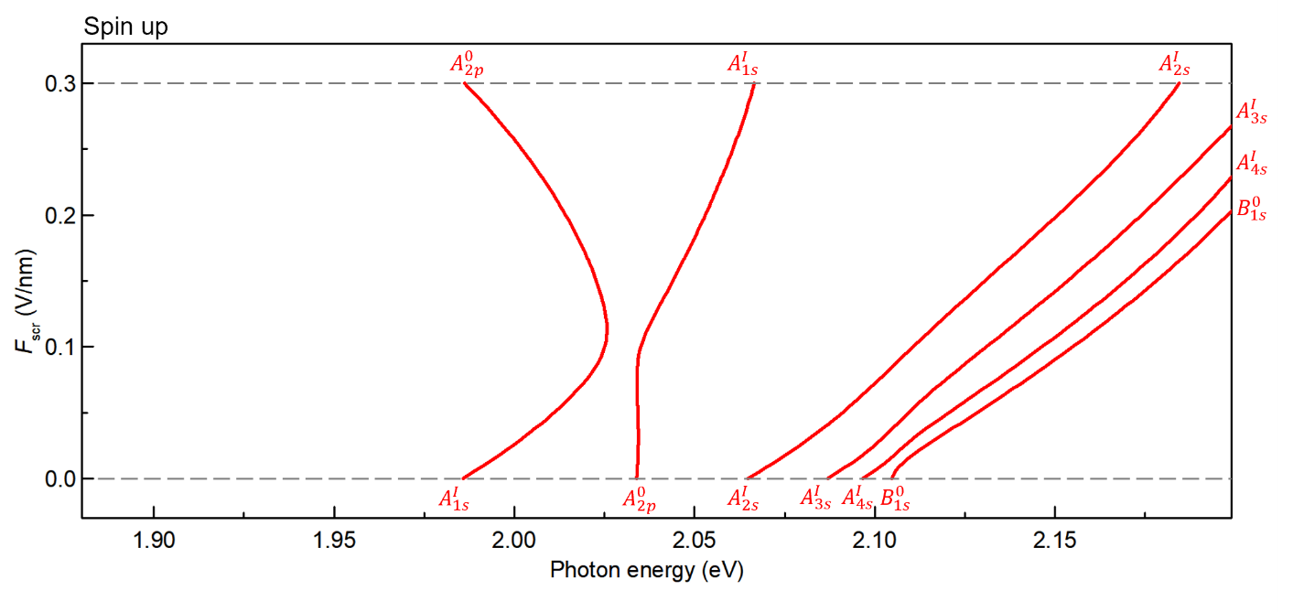
Figure S29 | Calculated energies of hybridized states between $A_{2p}^{0}$, $A_{ns}^{I} (n=1-4)$, and $B_{1s}^{0}$ spin-up excitons at various screened electric field.

The first set of coupled exciton states comprises six zeroth-order states $B_{1s,↑}^{0}$, $A_{1s,↑}^{I}-A_{4s,↑}^{I}$, and $A_{2p,↑}^{0}$ excitons, identified based on the anticipated range and intersections of their field-dependent energy levels. The hybridized exciton state is expressed as a linear combination:
$\left.\left|Ψ\right.\right\rangle =C_{ }^{B_{1s,↑}^{0}} \left.\left|B_{1s,↑}^{0}\right.\right\rangle +C_{ }^{A_{1s,↑}^{I}} \left.\left|A_{1s,↑}^{I}\right.\right\rangle +C_{ }^{A_{2s,↑}^{I}} \left.\left|A_{2s,↑}^{I}\right.\right\rangle +C_{ }^{A_{3s,↑}^{I}} \left.\left|A_{3s,↑}^{I}\right.\right\rangle +C_{ }^{A_{4s,↑}^{I}} \left.\left|A_{4s,↑}^{I}\right.\right\rangle +C_{ }^{A_{2p,↑}^{0}} \left.\left|A_{2p,↑}^{0}\right.\right\rangle$ (71)
Here, each $C$ represents the expansion coefficient corresponding to its respective zeroth-order exciton basis state. The coefficients are obtained by solving the following matrix equation:
$\left(\begin{matrix}E_{ }^{B_{1s,↑}^{0}} & {\tilde{W}}_{1s,1s}^{B_{↑}^{0}A_{↑}^{I}} & {\tilde{W}}_{1s,2s}^{B_{↑}^{0}A_{↑}^{I}} & {\tilde{W}}_{1s,3s}^{B_{↑}^{0}A_{↑}^{I}} & {\tilde{W}}_{1s,4s}^{B_{↑}^{0}A_{↑}^{I}} & 0 \\ {\tilde{W}}_{1s,1s}^{B_{↑}^{0}A_{↑}^{I}} & E_{ }^{A_{1s,↑}^{I}} & 0 & 0 & 0 & {∆H}_{1s,2p}^{A_{↑}^{I}A_{↑}^{0}} \\ {\tilde{W}}_{1s,2s}^{B_{↑}^{0}A_{↑}^{I}} & 0 & E_{ }^{A_{2s,↑}^{I}} & 0 & 0 & {∆H}_{2s,2p}^{A_{↑}^{I}A_{↑}^{0}} \\ {\tilde{W}}_{1s,3s}^{B_{↑}^{0}A_{↑}^{I}} & 0 & 0 & E_{ }^{A_{3s,↑}^{I}} & 0 & {∆H}_{3s,2p}^{A_{↑}^{I}A_{↑}^{0}} \\ {\tilde{W}}_{1s,4s}^{B_{↑}^{0}A_{↑}^{I}} & 0 & 0 & 0 & E_{ }^{A_{4s,↑}^{I}} & {∆H}_{4s,2p}^{A_{↑}^{I}A_{↑}^{0}} \\ 0 & {∆H}_{1s,2p}^{A_{↑}^{I}A_{↑}^{0}} & {∆H}_{2s,2p}^{A_{↑}^{I}A_{↑}^{0}} & {∆H}_{3s,2p}^{A_{↑}^{I}A_{↑}^{0}} & {∆H}_{4s,2p}^{A_{↑}^{I}A_{↑}^{0}} & E_{ }^{A_{2p,↑}^{0}}\end{matrix}\right)\left(\begin{matrix}C_{ }^{B_{1s,↑}^{0}} \\ C_{ }^{A_{1s,↑}^{I}} \\ \begin{matrix}C_{ }^{A_{2s,↑}^{I}} \\ C_{ }^{A_{3s,↑}^{I}} \\ C_{ }^{A_{4s,↑}^{I}}\end{matrix} \\ \begin{matrix}C_{ }^{A_{2p,↑}^{0}}\end{matrix}\end{matrix}\right)=E\left(\begin{matrix}C_{ }^{B_{1s,↑}^{0}} \\ C_{ }^{A_{1s,↑}^{I}} \\ \begin{matrix}C_{ }^{A_{2s,↑}^{I}} \\ C_{ }^{A_{3s,↑}^{I}} \\ C_{ }^{A_{4s,↑}^{I}}\end{matrix} \\ \begin{matrix}C_{ }^{A_{2p,↑}^{0}}\end{matrix}\end{matrix}\right)$ (72)
In this matrix, the diagonal elements represent the energies of the uncoupled exciton states (as determined from Eq. (49)), while the off-diagonal matrix terms denote coupling elements, which are calculated in Section III.5.6. Solving this equation yield six field-dependent hybridized exciton states, whose eigen energies are plotted in Fig. S29.

5.7.2. Hybridization between $A_{↑}^{0}$, $A_{↑}^{I}$, and $B_{↑}^{I}$ excitons
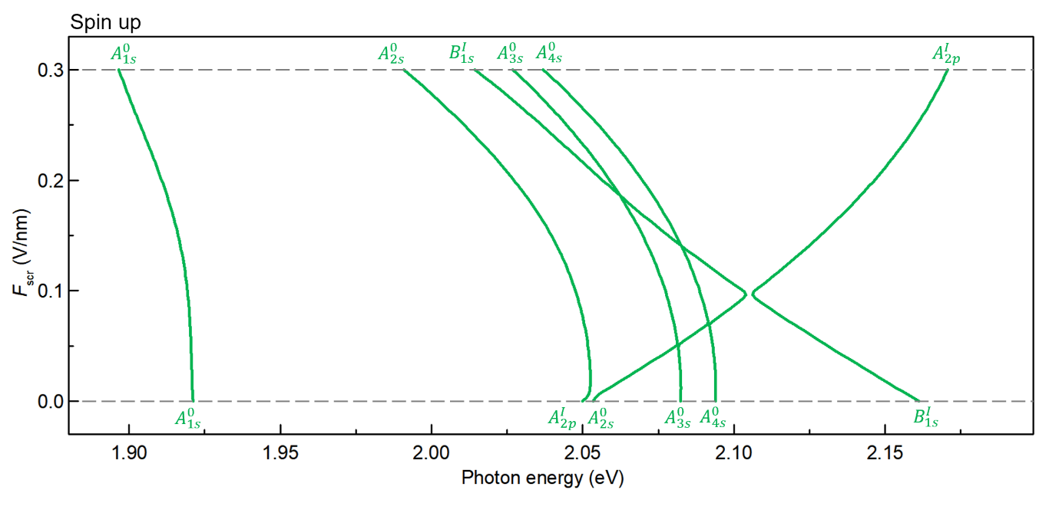
Figure S30 | Calculated energies of hybridized states between $A_{2p}^{I}$, $A_{ns}^{0}(n=1-4)$, and $B_{1s}^{I}$ spin-up excitons at various screened electric field.

The second set of coupled exciton states consists of six zeroth-order states $B_{1s,↑}^{I}$, $A_{1s,↑}^{0}-A_{4s,↑}^{0}$, and $A_{2p,↑}^{I}$ excitons, selected based on the anticipated range and intersection of their field-dependent energy levels. The hybridized exciton state is expressed as a linear combination:
$\left.\left|Ψ\right.\right\rangle =C_{ }^{B_{1s,↑}^{I}} \left.\left|B_{1s,↑}^{I}\right.\right\rangle +C_{ }^{A_{1s,↑}^{0}} \left.\left|A_{1s,↑}^{0}\right.\right\rangle +C_{ }^{A_{2s,↑}^{0}} \left.\left|A_{2s,↑}^{0}\right.\right\rangle +C_{ }^{A_{3s,↑}^{0}} \left.\left|A_{3s,↑}^{0}\right.\right\rangle +C_{ }^{A_{4s,↑}^{0}} \left.\left|A_{4s,↑}^{0}\right.\right\rangle +C_{ }^{A_{2p,↑}^{I}} \left.\left|A_{2p,↑}^{I}\right.\right\rangle$ (73)
Each coefficient $C$ represents the amplitude of the corresponding zeroth-order exciton in the hybridized states. The coefficients are obtained by solving the following matrix eigenvalue equation:
$\left(\begin{matrix}E_{ }^{B_{1s,↑}^{I}} & {\tilde{W}}_{1s,1s}^{B_{↑}^{I}A_{↑}^{0}} & {\tilde{W}}_{1s,2s}^{B_{↑}^{I}A_{↑}^{0}} & {\tilde{W}}_{1s,3s}^{B_{↑}^{I}A_{↑}^{0}} & {\tilde{W}}_{1s,4s}^{B_{↑}^{I}A_{↑}^{0}} & 0 \\ {\tilde{W}}_{1s,1s}^{B_{↑}^{I}A_{↑}^{0}} & E_{ }^{A_{1s,↑}^{0}} & 0 & 0 & 0 & {∆H}_{1s,2p}^{A_{↑}^{0}A_{↑}^{I}} \\ {\tilde{W}}_{1s,2s}^{B_{↑}^{I}A_{↑}^{0}} & 0 & E_{ }^{A_{2s,↑}^{0}} & 0 & 0 & {∆H}_{2s,2p}^{A_{↑}^{0}A_{↑}^{I}} \\ {\tilde{W}}_{1s,3s}^{B_{↑}^{I}A_{↑}^{0}} & 0 & 0 & E_{ }^{A_{3s,↑}^{0}} & 0 & {∆H}_{3s,2p}^{A_{↑}^{0}A_{↑}^{I}} \\ {\tilde{W}}_{1s,4s}^{B_{↑}^{I}A_{↑}^{0}} & 0 & 0 & 0 & E_{ }^{A_{4s,↑}^{0}} & {∆H}_{4s,2p}^{A_{↑}^{0}A_{↑}^{I}} \\ 0 & {∆H}_{1s,2p}^{A_{↑}^{0}A_{↑}^{I}} & {∆H}_{2s,2p}^{A_{↑}^{0}A_{↑}^{I}} & {∆H}_{3s,2p}^{A_{↑}^{0}A_{↑}^{I}} & {∆H}_{4s,2p}^{A_{↑}^{0}A_{↑}^{I}} & E_{ }^{A_{2p,↑}^{I}}\end{matrix}\right)\left(\begin{matrix}C_{ }^{B_{1s,↑}^{I}} \\ C_{ }^{A_{1s,↑}^{0}} \\ \begin{matrix}C_{ }^{A_{2s,↑}^{0}} \\ C_{ }^{A_{3s,↑}^{0}} \\ C_{ }^{A_{4s,↑}^{0}}\end{matrix} \\ C_{ }^{A_{2p,↑}^{I}}\end{matrix}\right)=E\left(\begin{matrix}C_{ }^{B_{1s,↑}^{I}} \\ C_{ }^{A_{1s,↑}^{0}} \\ \begin{matrix}C_{ }^{A_{2s,↑}^{0}} \\ C_{ }^{A_{3s,↑}^{0}} \\ C_{ }^{A_{4s,↑}^{0}}\end{matrix} \\ C_{ }^{A_{2p,↑}^{I}}\end{matrix}\right)$ (74)
Here, the diagonal terms correspond to the field-dependent energies of the uncoupled exciton states (obtained from Eq. (49)), while the off-diagonal terms represent the coupling elements, which are calculated in Section III.5.6. Solving this equation yields six field-dependent hybridized exciton states, whose eigen energies are displayed in Fig. S30.

5.7.3. Hybridization between spin-down excitons
The third set of coupled exciton states includes five zeroth-order states: $B_{1s,↓}^{0}$, $A_{1s,↓}^{I}-A_{3s,↓}^{I}$, and $A_{2p,↓}^{I}$. These states are selected based on the anticipated range and intersections of their field-dependent energy levels. They are related to the first set by flipping the spin.
The hybridized exciton state is expressed as a linear combination:
$\left.\left|Ψ\right.\right\rangle =C_{ }^{B_{1s,↓}^{0}} \left.\left|B_{1s,↓}^{0}\right.\right\rangle +\sum_{n=1}^{3}{C_{ }^{A_{ns,↓}^{I}} \left.\left|A_{ns,↓}^{I}\right.\right\rangle }+C_{ }^{A_{2p,↓}^{0}} \left.\left|A_{2p,↓}^{0}\right.\right\rangle$ (75)
The expansion coefficients $C$ are determined by solving the matrix eigenvalue equation:
$\left(\begin{matrix}E_{1s}^{B_{↓}^{0}} & {\tilde{W}}_{1s,1s}^{B_{↓}^{0}A_{↓}^{I}} & {\tilde{W}}_{1s,2s}^{B_{↓}^{0}A_{↓}^{I}} & {\tilde{W}}_{1s,3s}^{B_{↓}^{0}A_{↓}^{I}} & 0 \\ {\tilde{W}}_{1s,1s}^{B_{↓}^{0}A_{↓}^{I}} & E_{1s}^{A_{↓}^{I}} & 0 & 0 & ∆H_{2p,1s}^{A_{↓}^{0}A_{↓}^{I}} \\ {\tilde{W}}_{1s,2s}^{B_{↓}^{0}A_{↓}^{I}} & 0 & E_{2s}^{A_{↓}^{I}} & 0 & ∆H_{2p,2s}^{A_{↓}^{0}A_{↓}^{I}} \\ {\tilde{W}}_{1s,3s}^{B_{↓}^{0}A_{↓}^{I}} & 0 & 0 & E_{3s}^{A_{↓}^{I}} & ∆H_{2p,3s}^{A_{↓}^{0}A_{↓}^{I}} \\ 0 & ∆H_{2p,1s}^{A_{↓}^{0}A_{↓}^{I}} & ∆H_{2p,2s}^{A_{↓}^{0}A_{↓}^{I}} & ∆H_{2p,3s}^{A_{↓}^{0}A_{↓}^{I}} & E_{2p}^{A_{↓}^{0}}\end{matrix}\right)\left(\begin{matrix}C_{ }^{B_{1s,↓}^{0}} \\ \begin{matrix}C_{ }^{A_{1s,↓}^{I}} \\ C_{ }^{A_{2s,↓}^{I}}\end{matrix} \\ \begin{matrix}C_{ }^{A_{3s,↓}^{I}} \\ C_{ }^{A_{2p,↓}^{0}}\end{matrix}\end{matrix}\right)=E\left(\begin{matrix}C_{ }^{B_{1s,↓}^{0}} \\ \begin{matrix}C_{ }^{A_{1s,↓}^{I}} \\ C_{ }^{A_{2s,↓}^{I}}\end{matrix} \\ \begin{matrix}C_{ }^{A_{3s,↓}^{I}} \\ C_{ }^{A_{2p,↓}^{0}}\end{matrix}\end{matrix}\right)$ (76)
The fourth set of coupled exciton states also includes five excitons: $A_{1s,↓}^{0}-A_{3s,↓}^{0}$, $A_{2p,↓}^{0}$, and $B_{1s,↓}^{I}$. They are related to the second set by flipping the spin.
$\left.\left|Ψ\right.\right\rangle =\sum_{n=1}^{3}{C_{ }^{A_{ns,↓}^{0}} \left.\left|A_{ns,↓}^{0}\right.\right\rangle }+C_{ }^{A_{2p,↓}^{I}} \left.\left|A_{2p,↓}^{I}\right.\right\rangle +C_{ }^{B_{1s,↓}^{I}} \left.\left|B_{1s,↓}^{I}\right.\right\rangle$ (77)
$\left(\begin{matrix}E_{1s}^{A_{↓}^{0}} & ∆H_{2p,4s}^{A_{↓}^{0}A_{↓}^{I}} & 0 & ∆H_{1s,2p}^{A_{↓}^{0}A_{↓}^{I}} & {\tilde{W}}_{1s,1s}^{A_{↓}^{0}B_{↓}^{I}} \\ ∆H_{2p,4s}^{A_{↓}^{0}A_{↓}^{I}} & E_{2s}^{A_{↓}^{0}} & 0 & ∆H_{2s,2p}^{A_{↓}^{0}A_{↓}^{I}} & {\tilde{W}}_{2s,1s}^{A_{↓}^{0}B_{↓}^{I}} \\ 0 & 0 & E_{3s}^{A_{↓}^{0}} & ∆H_{3s,2p}^{A_{↓}^{0}A_{↓}^{I}} & {\tilde{W}}_{3s,1s}^{A_{↓}^{0}B_{↓}^{I}} \\ ∆H_{1s,2p}^{A_{↓}^{0}A_{↓}^{I}} & ∆H_{2s,2p}^{A_{↓}^{0}A_{↓}^{I}} & ∆H_{3s,2p}^{A_{↓}^{0}A_{↓}^{I}} & E_{2p}^{A_{↓}^{I}} & 0 \\ {\tilde{W}}_{1s,1s}^{A_{↓}^{0}B_{↓}^{I}} & {\tilde{W}}_{2s,1s}^{A_{↓}^{0}B_{↓}^{I}} & {\tilde{W}}_{3s,1s}^{A_{↓}^{0}B_{↓}^{I}} & 0 & E_{1s}^{B_{↓}^{I}}\end{matrix}\right)\left(\begin{matrix}\begin{matrix}C_{ }^{A_{1s,↓}^{0}} \\ C_{ }^{A_{2s,↓}^{0}} \\ C_{ }^{A_{3s,↓}^{0}} \\ C_{ }^{A_{2p,↓}^{I}} \\ C_{ }^{B_{1s,↓}^{I}}\end{matrix}\end{matrix}\right)=E\left(\begin{matrix}\begin{matrix}C_{ }^{A_{1s,↓}^{0}} \\ C_{ }^{A_{2s,↓}^{0}} \\ C_{ }^{A_{3s,↓}^{0}} \\ C_{ }^{A_{2p,↓}^{I}} \\ C_{ }^{B_{1s,↓}^{I}}\end{matrix}\end{matrix}\right)$ (78)
Here, the diagonal elements represent the field-dependent energies of the uncoupled exciton states, obtained from Eq. (48), while the off-diagonal terms represent the coupling elements. All coupling elements are calculated in Section 5.6. Solving Eqs. (76) and (78) yields ten hybridized spin-down exciton states, whose eigen energies are displayed in Fig. S31.
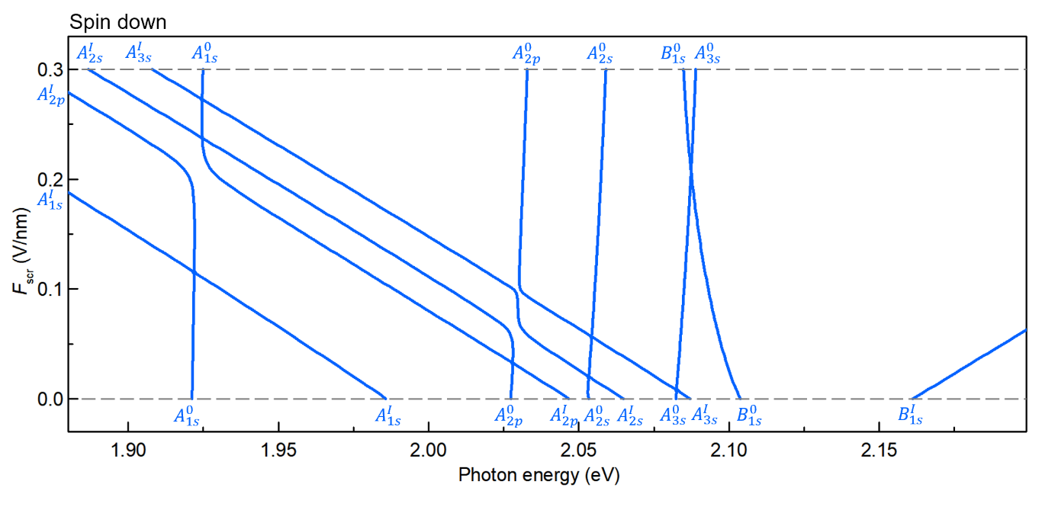
Figure S31 | Calculated energies of hybridized states between $B_{↓}^{0}$, $A_{↓}^{I}$, $A_{↓}^{0}$, and $B_{↓}^{I}$ excitons spin-down excitons at various screened electric field.

Fig. S32 presents the calculated energies of all 22 hybridized exciton states, combining the results from Fig. S29 (first set with spin-up excitons, red), S30 (second set with spin-up excitons, green) and Fig. S31 (third and fourth sets with spin-down excitons, blue).
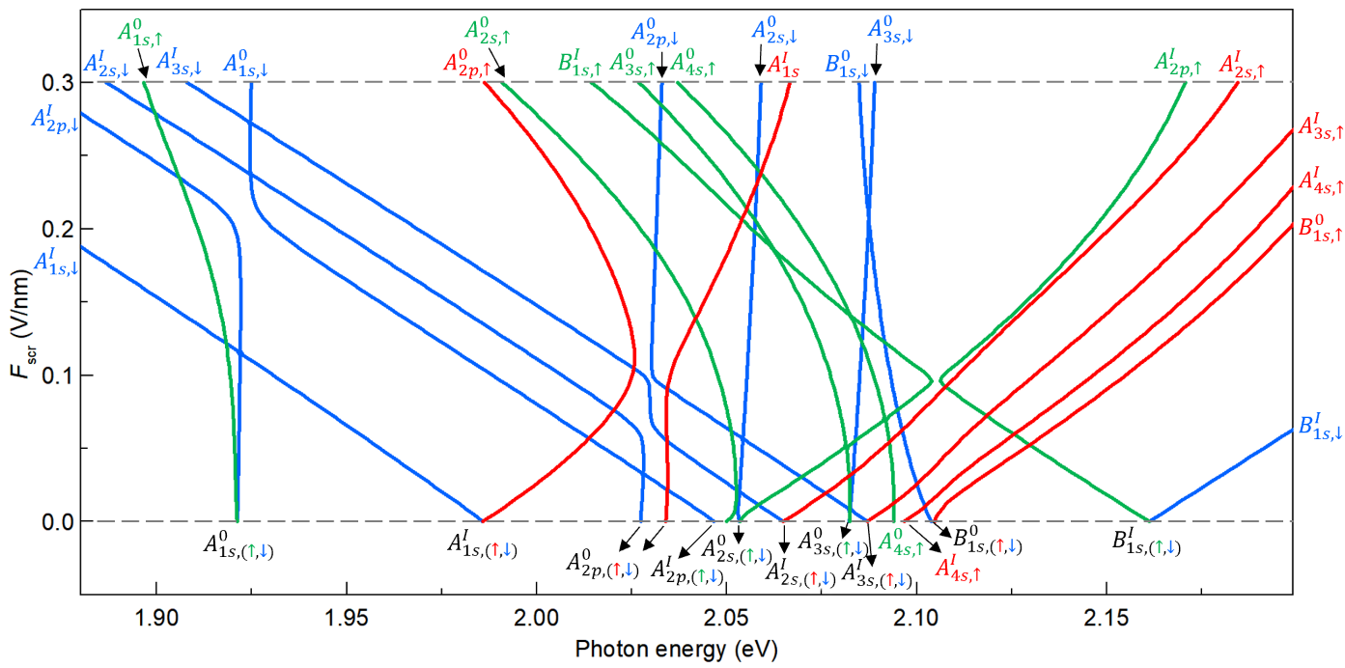
Figure S32 | Calculated energies of all hybridized same-spin exciton states at various screened electric field.

6. Hybridization between opposite-spin excitons
Until now, we have only considered coupling between excitons with the same spin configuration, which arises from both direct and exchange interactions. While this model captures most experimental features, it does not account for the coupling observed between the $A_{1s}^{0}$ and $A_{1s}^{I}$ lines in our data. This is because such coupling involves excitons with opposite spin configurations. In this section, we analyze the hybridization between opposite-spin excitons.

6.1. Coupling terms between opposite-spin excitons
Fig. S16g-S16i illustrates three representative cases of coupling between opposite-spin excitons. Such couplings arise from the electron-hole exchange effect, since direct Coulomb interactions conserve spin. The exchange interaction between two electron-hole pairs is modified from the expression $V_{ii}^{ex}$ given in Eq. (39), with the following expression¹⁶
$V_{ij}^{ex}\left(k,k^{'}\right)=\sqrt{f_{i}f_{j}}\sum_{G≠0}{\frac{e^{2}}{AL{ε_{0}{\left|G\right|}^{2}}^{ }}}M_{C_{i}V_{i}}^{G}\left(k\right)M_{C_{j}V_{j}}^{G*}\left(k^{'}\right)$ (79)
where
$M_{C_{i}V_{i}}^{G}\left(k\right)=\int{dr}{\tilde{u}}_{C_{i},k}^{*}\left(r\right)e^{iG∙r}{\tilde{u}}_{V_{i},k}^{ }\left(r\right)=\sum_{G'}{Z_{C_{i},k}^{*}}(G+G^{'})Z_{V_{i},k}^{ }(G^{'})$ (80)
Here, ${\tilde{u}}_{C_{i},k}^{ }$ and ${\tilde{u}}_{V_{i},k}^{ }$ are monolayer-like conduction-band and valence-band basis states defined in Section III.1.3-4, and the Z-functions denote their plane-wave expansion coefficients. $f_{i}{ (f}_{j})$ denotes the fraction of the hole’s distribution residing in the same layer as the electron in band $C_{i} (C_{j})$, as defined in Section III.1.3. The Bloch states are obtained using a supercell method, where L denotes the vertical length of the supercell and $G$ is a 3D reciprocal lattice vector of the supercell.
For two s-like excitons, their envelope functions are localized near $k=0$ (within 5% of the Brillouin zone), allowing us to approximate Eq. (80) by its value at $k=0$ due to its slow variation with $k$. Hence, the exchange interaction term $V_{ij}^{ex}\left(k,k^{'}\right)$ can be approximated by its value at $k=k^{'}=0$. In contrast, for coupling between an s-like and a p-like exciton, the p-like exciton vanishes at $k=0$. As a result, $V_{ij}^{ex}\left(k,k^{'}\right)$ yields a negligible exchange matrix element (less than 10 μV) after integration over the envelope functions. These terms are therefore excluded from our calculations.
Among all the first-order matrix elements between opposite-spin excitons, only those for $A_{s↑}^{0}-B_{1s↓}^{0}$ and $A_{s↑}^{I}-B_{1s↓}^{I}$ coupling (and their spin-flip counterparts) have appreciable magnitude, while the rest are negligible (less than 10 μeV). As discussed above, in these cases, the exchange interaction $V_{ij}^{ex}\left(k,k^{'}\right)$ can be approximated by $V_{ij}^{ex}\left(0,0\right)$, which is evaluated by using DFT-calculated Bloch states. Applying the expansion in Eq. (28), we obtain:
$\left\{\begin{aligned}{\tilde{V}}_{n,n'}^{A_{↑}^{0}B_{↓}^{0}}=\left\langle ψ_{n}^{A_{↑}^{0}} | {\hat{V}}_{ex} | ψ_{n'}^{B_{↓}^{0}}\right\rangle =V_{A_{↑}^{0}B_{↓}^{0}}^{ex}\left(0,0\right)\int_{0}^{∞}{\frac{kdk}{2π}}{F_{n}^{A_{↑}^{0}}\left(k\right)}_{ }^{ }\int_{0}^{∞}{\frac{k^{'}dk^{'}}{2π}}F_{n^{'}}^{B_{↓}^{0}}\left(k^{'}\right) \\ {\tilde{V}}_{n,n'}^{A_{↑}^{I}B_{↓}^{I}}=\left\langle ψ_{n}^{A_{↑}^{I}} | {\hat{V}}_{ex} | ψ_{n'}^{B_{↓}^{I}}\right\rangle =V_{A_{↑}^{I}B_{↓}^{I}}^{ex}\left(0,0\right)\int_{0}^{∞}{\frac{kdk}{2π}}{F_{n}^{A_{↑}^{I}}\left(k\right)}_{ }^{ }\int_{0}^{∞}{\frac{k^{'}dk^{'}}{2π}}F_{n^{'}}^{B_{↓}^{I}}\left(k^{'}\right)\end{aligned}\right.$ (81)
Fig. S33 shows the calculated results of these matrix elements for different Rydberg states and electric field strengths. For completeness, the figure also includes the matrix elements for the spin-flip counterparts of these excitons. These couplings are symmetric at zero field but diverge as the electric field increases.
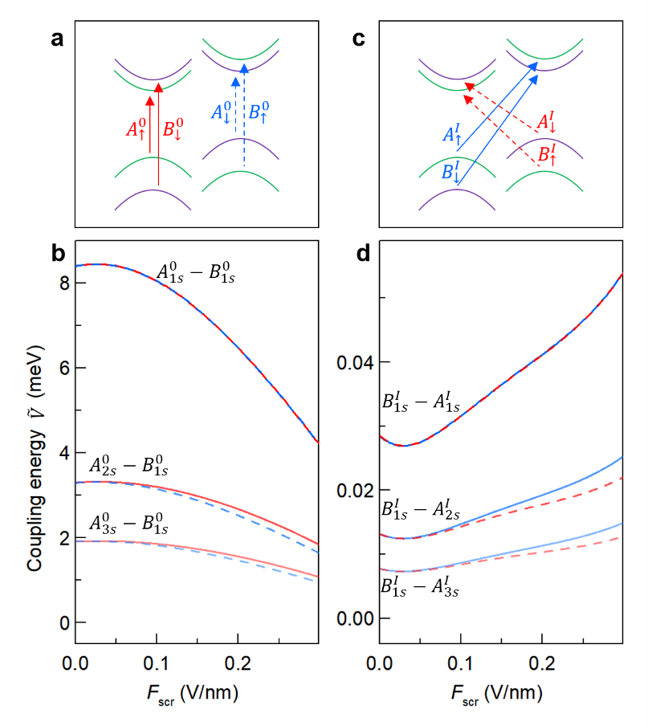
Figure S33 | a, Schematic illustration of the $A_{s↑}^{0}-B_{1s↓}^{0}$ coupling (red) and their spin-flip counterparts (blue). b, Calculated field-dependent coupling energies ${\tilde{V}}_{ns,1s}^{A_{ }^{0}B_{ }^{0}}$ for the exciton configurations shown in panel a, with color matching. c,d, Same as panels a,b, but for the $A_{s↑}^{I}-B_{1s↓}^{I}$ coupling (red) and their spin-flip counterparts (blue).

6.2. Hybridization between opposite-spin excitons
To incorporate the coupling between opposite-spin excitons, we expand the basis states to include both spin-up and spin-down configurations. In our calculations, we construct two distinct sets of basis states, which are related by spin inversion and do not couple to each other.
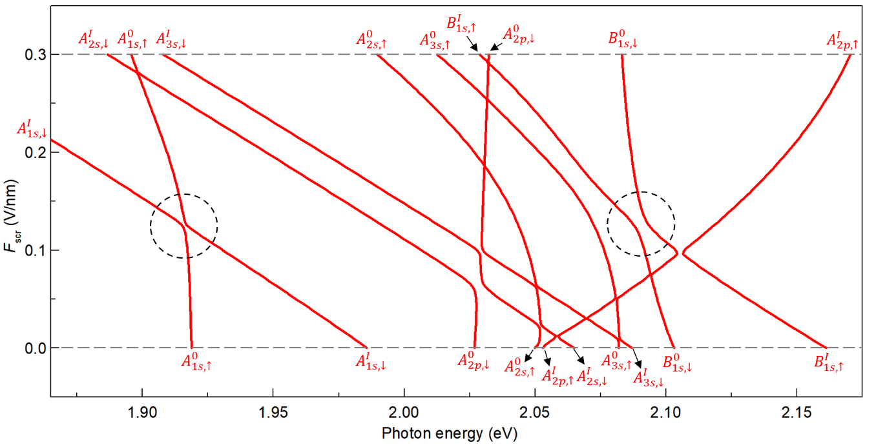
Figure S34 | Calculated energies of hybridized excitons on the first set of basis states, incorporating coupling between opposite-spin excitons, as a function of screened electric field. Dashed circles indicate anti-crossing behavior arising from hybridization between opposite-spin excitons.

The first set includes five spin-down excitons: $B_{1s,↓}^{0}$, $A_{1s,↓}^{I}-A_{3s,↓}^{I}$, and $A_{2p,↓}^{I}$; and five spin-up excitons: $A_{1s,↑}^{0}-A_{3s,↑}^{0}$, $A_{2p,↑}^{0}$, and $B_{1s,↑}^{I}$. A hybridized exciton in this basis is expressed as a linear combination of these states:
$\left.\left|Ψ_{1}\right.\right\rangle =C_{ }^{B_{1s,↓}^{0}} \left.\left|B_{1s,↓}^{0}\right.\right\rangle +\sum_{n=1}^{3}{C_{ }^{A_{ns,↓}^{I}} }\left.\left|A_{ns,↓}^{I}\right.\right\rangle +C_{ }^{A_{2p,↓}^{0}} \left.\left|A_{2p,↓}^{0}\right.\right\rangle +\sum_{n=1}^{3}{C_{ }^{A_{ns,↑}^{0}} \left.\left|A_{ns,↑}^{0}\right.\right\rangle }+C_{ }^{A_{2p,↑}^{I}} \left.\left|A_{2p,↑}^{I}\right.\right\rangle +C_{ }^{B_{1s,↑}^{I}} \left.\left|B_{1s,↑}^{I}\right.\right\rangle$ (82)
Here, each C denotes an expansion coefficient associated with the corresponding basis state. The eigenvalue equation for this system takes the form of a 10 × 10 matrix:
$\left(\begin{matrix}E_{ }^{B_{1s,↓}^{0}} & {\tilde{W}}_{1s,1s}^{B_{↓}^{0}A_{↓}^{I}} & {\tilde{W}}_{1s,2s}^{B_{↓}^{0}A_{↓}^{I}} & {\tilde{W}}_{1s,3s}^{B_{↓}^{0}A_{↓}^{I}} & 0 & {\tilde{V}}_{1s,1s}^{B_{↓}^{0}A_{↑}^{0}} & {\tilde{V}}_{1s,2s}^{B_{↓}^{0}A_{↑}^{0}} & {\tilde{V}}_{1s,3s}^{B_{↓}^{0}A_{↑}^{0}} & 0 & 0 \\ {\tilde{W}}_{1s,1s}^{B_{↓}^{0}A_{↓}^{I}} & E_{ }^{A_{1s,↓}^{I}} & 0 & 0 & ∆H_{2p,1s}^{A_{↓}^{0}A_{↓}^{I}} & 0 & 0 & 0 & 0 & {\tilde{V}}_{1s,1s}^{A_{↓}^{I}B_{↑}^{I}} \\ {\tilde{W}}_{1s,2s}^{B_{↓}^{0}A_{↓}^{I}} & 0 & E_{ }^{A_{2s,↓}^{I}} & 0 & ∆H_{2p,2s}^{A_{↓}^{0}A_{↓}^{I}} & 0 & 0 & 0 & 0 & {\tilde{V}}_{2s,1s}^{A_{↓}^{I}B_{↑}^{I}} \\ {\tilde{W}}_{1s,3s}^{B_{↓}^{0}A_{↓}^{I}} & 0 & 0 & E_{ }^{A_{3s,↓}^{I}} & ∆H_{2p,3s}^{A_{↓}^{0}A_{↓}^{I}} & 0 & 0 & 0 & 0 & {\tilde{V}}_{3s,1s}^{A_{↓}^{I}B_{↑}^{I}} \\ 0 & ∆H_{2p,1s}^{A_{↓}^{0}A_{↓}^{I}} & ∆H_{2p,2s}^{A_{↓}^{0}A_{↓}^{I}} & ∆H_{2p,3s}^{A_{↓}^{0}A_{↓}^{I}} & E_{ }^{A_{2p,↓}^{0}} & 0 & 0 & 0 & 0 & 0 \\ {\tilde{V}}_{1s,1s}^{B_{↓}^{0}A_{↑}^{0}} & 0 & 0 & 0 & 0 & E_{ }^{A_{1s,↑}^{0}} & 0 & 0 & ∆H_{1s,2p}^{A_{↑}^{0}A_{↑}^{I}} & {\tilde{W}}_{1s,1s}^{A_{↑}^{0}B_{↑}^{I}} \\ {\tilde{V}}_{1s,2s}^{B_{↓}^{0}A_{↑}^{0}} & 0 & 0 & 0 & 0 & 0 & E_{ }^{A_{2s,↑}^{0}} & 0 & ∆H_{2s,2p}^{A_{↑}^{0}A_{↑}^{I}} & {\tilde{W}}_{2s,1s}^{A_{↑}^{0}B_{↑}^{I}} \\ {\tilde{V}}_{1s,2s}^{B_{↓}^{0}A_{↑}^{0}} & 0 & 0 & 0 & 0 & 0 & 0 & E_{ }^{A_{3s,↑}^{0}} & ∆H_{3s,2p}^{A_{↑}^{0}A_{↑}^{I}} & {\tilde{W}}_{3s,1s}^{A_{↑}^{0}B_{↑}^{I}} \\ 0 & 0 & 0 & 0 & 0 & ∆H_{1s,2p}^{A_{↑}^{0}A_{↑}^{I}} & ∆H_{2s,2p}^{A_{↑}^{0}A_{↑}^{I}} & ∆H_{3s,2p}^{A_{↑}^{0}A_{↑}^{I}} & E_{ }^{A_{2p,↑}^{I}} & 0 \\ 0 & {\tilde{V}}_{1s,1s}^{A_{↓}^{I}B_{↑}^{I}} & {\tilde{V}}_{2s,1s}^{A_{↓}^{I}B_{↑}^{I}} & {\tilde{V}}_{3s,1s}^{A_{↓}^{I}B_{↑}^{I}} & 0 & {\tilde{W}}_{1s,1s}^{A_{↑}^{0}B_{↑}^{I}} & {\tilde{W}}_{2s,1s}^{A_{↑}^{0}B_{↑}^{I}} & {\tilde{W}}_{3s,1s}^{A_{↑}^{0}B_{↑}^{I}} & 0 & E_{ }^{B_{1s,↑}^{I}}\end{matrix}\right)\left(\begin{matrix}C_{ }^{B_{1s,↓}^{0}} \\ \begin{matrix}C_{ }^{A_{1s,↓}^{I}} \\ C_{ }^{A_{2s,↓}^{I}}\end{matrix} \\ \begin{matrix}C_{ }^{A_{3s,↓}^{I}} \\ C_{ }^{A_{2p,↓}^{0}} \\ C_{ }^{A_{1s,↑}^{0}} \\ C_{ }^{A_{2s,↑}^{0}} \\ C_{ }^{A_{3s,↑}^{0}} \\ C_{ }^{A_{2p,↑}^{I}} \\ C_{ }^{B_{1s,↑}^{I}}\end{matrix}\end{matrix}\right)=E\left(\begin{matrix}C_{ }^{B_{1s,↓}^{0}} \\ \begin{matrix}C_{ }^{A_{1s,↓}^{I}} \\ C_{ }^{A_{2s,↓}^{I}}\end{matrix} \\ \begin{matrix}C_{ }^{A_{3s,↓}^{I}} \\ C_{ }^{A_{2p,↓}^{0}} \\ C_{ }^{A_{1s,↑}^{0}} \\ C_{ }^{A_{2s,↑}^{0}} \\ C_{ }^{A_{3s,↑}^{0}} \\ C_{ }^{A_{2p,↑}^{I}} \\ C_{ }^{B_{1s,↑}^{I}}\end{matrix}\end{matrix}\right)$ (83)
The matrix in Eq. (83) can be conceptually divided into four 5 × 5 blocks. The first diagonal block corresponds to the spin-down exciton basis, as given in Eq. (76), while the second diagonal block corresponds to the spin-up exciton basis, obtained from the spin-flipped version of Eq. (78). The two off-diagonal blocks represent the exchange-induced coupling between opposite-spin excitons and contain the matrix elements shown in Fig. S33. Solving Eq. (83) yields ten hybridized exciton states, whose energies as functions of the applied electric field are plotted in Fig. S34.
The second set of basis states is the spin-flipped counterpart of the first set. It consists of five spin-up excitons $B_{1s,↑}^{0}$, $A_{1s,↑}^{I}-A_{3s,↑}^{I}$, $A_{2p,↑}^{I}$ and five spin-down excitons $A_{1s,↓}^{0}-A_{3s,↓}^{0}$, $A_{2p,↓}^{0}$, $B_{1s,↓}^{I}$. A hybridized exciton in this basis is expressed as the following linear combination:
$\left.{\left|Ψ\right.}_{2}\right\rangle =C_{ }^{B_{1s,↑}^{0}} \left.\left|B_{1s,↑}^{0}\right.\right\rangle +\sum_{n=1}^{3}{C_{ }^{A_{ns,↑}^{I}} \left.\left|A_{ns,↑}^{I}\right.\right\rangle }+C_{ }^{A_{2p,↑}^{0}} \left.\left|A_{2p,↑}^{0}\right.\right\rangle +\sum_{n=1}^{3}{C_{ }^{A_{ns,↓}^{0}} \left.\left|A_{ns,↓}^{0}\right.\right\rangle }+C_{ }^{A_{2p,↓}^{I}} \left.\left|A_{2p,↓}^{I}\right.\right\rangle +C_{ }^{B_{1s,↓}^{I}} \left.\left|B_{1s,↓}^{I}\right.\right\rangle$ (84)
The corresponding matrix eigenvalue equation takes the same form as Eq. (83), with the spin indices flipped:
$\left(\begin{matrix}E_{ }^{B_{1s,↑}^{0}} & {\tilde{W}}_{1s,1s}^{B_{↑}^{0}A_{↑}^{I}} & {\tilde{W}}_{1s,2s}^{B_{↑}^{0}A_{↑}^{I}} & {\tilde{W}}_{1s,3s}^{B_{↑}^{0}A_{↑}^{I}} & 0 & {\tilde{V}}_{1s,1s}^{B_{↑}^{0}A_{↓}^{0}} & {\tilde{V}}_{1s,2s}^{B_{↑}^{0}A_{↓}^{0}} & {\tilde{V}}_{1s,3s}^{B_{↑}^{0}A_{↓}^{0}} & 0 & 0 \\ {\tilde{W}}_{1s,1s}^{B_{↑}^{0}A_{↑}^{I}} & E_{ }^{A_{1s,↑}^{I}} & 0 & 0 & ∆H_{2p,1s}^{A_{↑}^{0}A_{↑}^{I}} & 0 & 0 & 0 & 0 & {\tilde{V}}_{1s,1s}^{A_{↑}^{I}B_{↓}^{I}} \\ {\tilde{W}}_{1s,2s}^{B_{↑}^{0}A_{↑}^{I}} & 0 & E_{ }^{A_{2s,↑}^{I}} & 0 & ∆H_{2p,2s}^{A_{↑}^{0}A_{↑}^{I}} & 0 & 0 & 0 & 0 & {\tilde{V}}_{2s,1s}^{A_{↑}^{I}B_{↓}^{I}} \\ {\tilde{W}}_{1s,3s}^{B_{↑}^{0}A_{↑}^{I}} & 0 & 0 & E_{ }^{A_{3s,↑}^{I}} & ∆H_{2p,3s}^{A_{↑}^{0}A_{↑}^{I}} & 0 & 0 & 0 & 0 & {\tilde{V}}_{3s,1s}^{A_{↑}^{I}B_{↓}^{I}} \\ 0 & ∆H_{2p,1s}^{A_{↑}^{0}A_{↑}^{I}} & ∆H_{2p,2s}^{A_{↑}^{0}A_{↑}^{I}} & ∆H_{2p,3s}^{A_{↑}^{0}A_{↑}^{I}} & E_{ }^{A_{2p,↑}^{0}} & 0 & 0 & 0 & 0 & 0 \\ {\tilde{V}}_{1s,1s}^{B_{↑}^{0}A_{↓}^{0}} & 0 & 0 & 0 & 0 & E_{ }^{A_{1s,↓}^{0}} & 0 & 0 & ∆H_{1s,2p}^{A_{↓}^{0}A_{↓}^{I}} & {\tilde{W}}_{1s,1s}^{A_{↓}^{0}B_{↓}^{I}} \\ {\tilde{V}}_{1s,2s}^{B_{↑}^{0}A_{↓}^{0}} & 0 & 0 & 0 & 0 & 0 & E_{ }^{A_{2s,↓}^{0}} & 0 & ∆H_{2s,2p}^{A_{↓}^{0}A_{↓}^{I}} & {\tilde{W}}_{2s,1s}^{A_{↓}^{0}B_{↓}^{I}} \\ {\tilde{V}}_{1s,2s}^{B_{↑}^{0}A_{↓}^{0}} & 0 & 0 & 0 & 0 & 0 & 0 & E_{ }^{A_{3s,↓}^{0}} & ∆H_{3s,2p}^{A_{↓}^{0}A_{↓}^{I}} & {\tilde{W}}_{3s,1s}^{A_{↓}^{0}B_{↓}^{I}} \\ 0 & 0 & 0 & 0 & 0 & ∆H_{1s,2p}^{A_{↓}^{0}A_{↓}^{I}} & ∆H_{2s,2p}^{A_{↓}^{0}A_{↓}^{I}} & ∆H_{3s,2p}^{A_{↓}^{0}A_{↓}^{I}} & E_{ }^{A_{2p,↓}^{I}} & 0 \\ 0 & {\tilde{V}}_{1s,1s}^{A_{↑}^{I}B_{↓}^{I}} & {\tilde{V}}_{2s,1s}^{A_{↑}^{I}B_{↓}^{I}} & {\tilde{V}}_{3s,1s}^{A_{↑}^{I}B_{↓}^{I}} & 0 & {\tilde{W}}_{1s,1s}^{A_{↓}^{0}B_{↓}^{I}} & {\tilde{W}}_{2s,1s}^{A_{↓}^{0}B_{↓}^{I}} & {\tilde{W}}_{3s,1s}^{A_{↓}^{0}B_{↓}^{I}} & 0 & E_{ }^{B_{1s,↓}^{I}}\end{matrix}\right)\left(\begin{matrix}C_{ }^{B_{1s,↑}^{0}} \\ \begin{matrix}C_{ }^{A_{1s,↑}^{I}} \\ C_{ }^{A_{2s,↑}^{I}}\end{matrix} \\ \begin{matrix}C_{ }^{A_{3s,↑}^{I}} \\ C_{ }^{A_{2p,↑}^{0}} \\ C_{ }^{A_{1s,↓}^{0}} \\ C_{ }^{A_{2s,↓}^{0}} \\ C_{ }^{A_{3s,↓}^{0}} \\ C_{ }^{A_{2p,↓}^{I}} \\ C_{ }^{B_{1s,↓}^{I}}\end{matrix}\end{matrix}\right)=E\left(\begin{matrix}C_{ }^{B_{1s,↑}^{0}} \\ \begin{matrix}C_{ }^{A_{1s,↑}^{I}} \\ C_{ }^{A_{2s,↑}^{I}}\end{matrix} \\ \begin{matrix}C_{ }^{A_{3s,↑}^{I}} \\ C_{ }^{A_{2p,↑}^{0}} \\ C_{ }^{A_{1s,↓}^{0}} \\ C_{ }^{A_{2s,↓}^{0}} \\ C_{ }^{A_{3s,↓}^{0}} \\ C_{ }^{A_{2p,↓}^{I}} \\ C_{ }^{B_{1s,↓}^{I}}\end{matrix}\end{matrix}\right)$ (85)
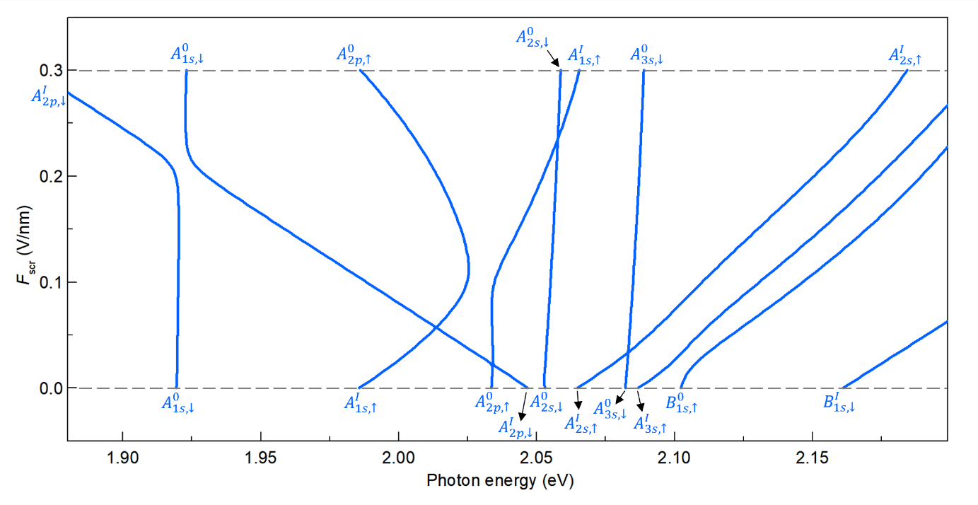
Figure S35 | Calculated energies of hybridized excitons on the second set of basis states, including coupling between opposite-spin excitons, at various screened electric field.
Solving this Eq.(85) yields another set of ten hybridized exciton states. Their energy evolution with electric field is shown in Fig. S35. These results closely resemble those obtained without the inclusion of opposite-spin couplings, as the relevant exciton states are energetically well separated and therefore exhibit negligible hybridization.
Fig. S36 presents the field-dependent energies of all 20 hybridized exciton states by combining the results from Figs. S34 (first set of hybridized excitons) and S35 (second set). These results capture all coupling mechanisms considered in our theoretical framework—namely, intra-spin couplings among spin-up and spin-down excitons, as well as inter-spin couplings between opposite-spin excitons.
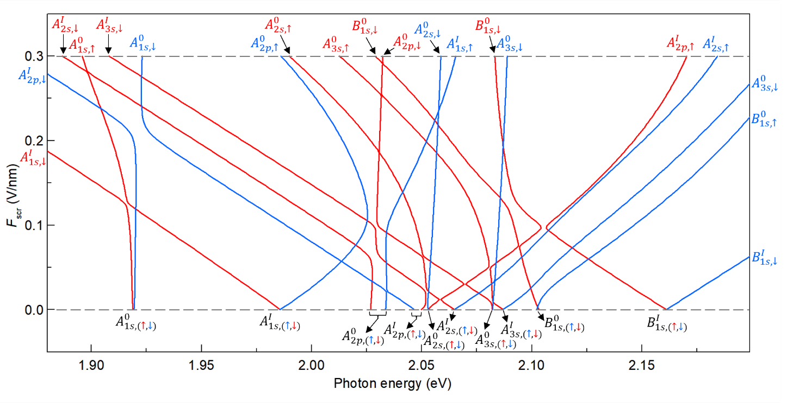
Figure S36 | Calculated energies of all 20 hybridized exciton states, combining the results from Figs. S34 (first set, red) and S35 (second set, blue).

6.3. Effective coupling strengths between opposite-spin excitons
The dashed circles in Fig. S34 highlight anti-crossing behavior arising from the $A_{s↑}^{0}-A_{s↓}^{I}$ and $B_{1s↑}^{I}-B_{1s↓}^{0}$ coupling. However, direct evaluation of the first-order matrix elements for these couplings yields negligible values (less than 10 μeV), indicating that the observed hybridizations do not originate from direct interaction.
Our analysis shows that these hybridizations arise instead from second-order coupling, mediated by intermediate exciton states¹⁷, as illustrated in Fig. S37. Using second-order perturbation theory, the effective matrix elements for the $A_{s↑}^{0}-A_{s↓}^{I}$ coupling can be written as:
$${\overset{̿}{V}}_{n,n'}^{A_{↑}^{0}A_{↓}^{I}}={\tilde{V}}_{n,n'}^{A_{↑}^{0}A_{↓}^{I}}+\frac{1}{2}\left\langle ψ_{n}^{A_{↑}^{0}} | {\hat{V}}_{ex} | ψ_{1s}^{B_{↓}^{0}}\right\rangle \left\langle ψ_{1s}^{B_{↓}^{0}} | \hat{W} | ψ_{n'}^{A_{↓}^{I}}\right\rangle \left[\frac{1}{E_{A_{n,↑}^{0}}-E_{B_{1s,↓}^{0}}}+\frac{1}{E_{A_{n',↓}^{I}}-E_{B_{1s,↓}^{0}}}\right]$$
$+\frac{1}{2}\left\langle ψ_{n}^{A_{↑}^{0}} | \hat{W} | ψ_{1s}^{B_{↑}^{I}}\right\rangle \left\langle ψ_{1s}^{B_{↑}^{I}} | {\hat{V}}_{ex} | ψ_{n'}^{A_{↓}^{I}}\right\rangle \left[\frac{1}{E_{A_{n,↑}^{0}}-E_{B_{1s,↑}^{I}}}+\frac{1}{E_{A_{n',↓}^{I}}-E_{B_{1s,↑}^{I}}}\right]≈0.6 meV$ (86)
Here, the first term represents the first-order contribution, which is negligible (less than 10 μeV); the second and third terms represent the second-order contributions mediated by the $B_{1s,↓}^{0}$ and $B_{1s,↓}^{I}$ intermediate states.
Similarly, the effective matrix element for the $B_{1s↑}^{I}-B_{1s↓}^{0}$ coupling can be written as:
${\overset{̿}{V}}_{1s,1s}^{B_{↑}^{I}B_{↓}^{0}}={\tilde{V}}_{n,n^{'}}^{B_{↑}^{I}B_{↓}^{0}}+\sum_{n}{\frac{1}{2}\left\langle ψ_{1s}^{B_{↑}^{I}} | \hat{W} | ψ_{n}^{A_{↑}^{0}}\right\rangle }\left\langle ψ_{n}^{A_{↑}^{0}} | {\hat{V}}_{ex} | ψ_{1s}^{B_{↓}^{0}}\right\rangle \left[\frac{1}{E_{B_{1s, ↑}^{I}}-E_{A_{n,↑}^{0}}}+\frac{1}{E_{B_{1s,↓}^{0}}-E_{A_{n,↑}^{0}}}\right]$
$+\sum_{n}{\frac{1}{2}\left\langle ψ_{1s}^{B_{↑}^{I}} | {\hat{V}}_{ex} | ψ_{n}^{A_{↓}^{I}}\right\rangle }\left\langle ψ_{n}^{A_{↓}^{I}} | \hat{W} | ψ_{1s}^{B_{↓}^{0}}\right\rangle \left[\frac{1}{E_{B_{1s,↑}^{I}}-E_{A_{n,↓}^{I}}}+\frac{1}{E_{B_{1s,↓}^{0}}-E_{A_{n,↓}^{I}}}\right]≈1.5 meV$ (87)
Again, the first-order contribution is negligible, and the dominant second-order terms are mediated by the $A_{n,↑}^{0}$ and $A_{n,↑}^{I}$ exciton states.
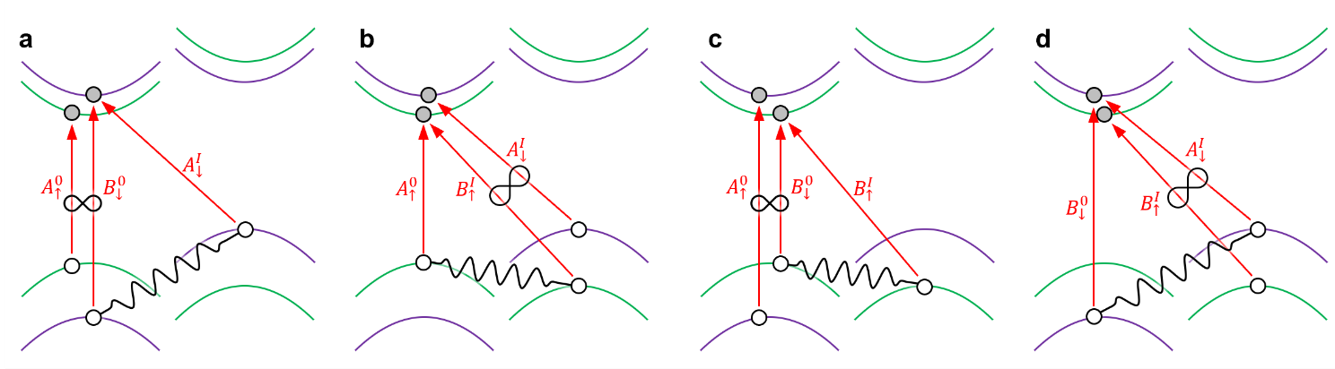
Figure S37 | a,b, Diagrams illustrating the $A_{s↑}^{0}-A_{s↓}^{I}$ coupling mediated by the $B_{1s,↓}^{0}$ (a) and $B_{1s,↓}^{I}$ states (b), respectively. c,d, Diagrams illustrating the $B_{1s↑}^{I}-B_{1s↓}^{0}$ coupling mediated by the mediated by the $A_{n,↑}^{0}$ (c) and $A_{n,↑}^{I}$ states (d), respectively.

7. Simulation of the reflectance contrast maps
After obtaining two sets of hybridized exciton states, each set having 10 states, in the previous sections, we compute their complex dielectric functions separately. Due to the high defect density in MoS₂, quantum interference between different basis exciton states is neglected, and their contributions are simply summed to yield the total dielectric function:
${ε(ℏω)}^{ }∝\sum_{μ,i}^{ }{{ _{ }\left|C_{μ}^{i}\right|}^{2}}S^{i}\left(\frac{1}{{E_{μ}}_{ }^{2 }-{\left(ℏω\right)}^{2}-iℏωΓ_{μ}}\right)+\sum_{ν,j}^{ }{{ _{ }\left|C_{ν}^{j}\right|}^{2}S^{j}}\left(\frac{1}{{E_{ν}}_{ }^{2 }-{\left(ℏω\right)}^{2}-i{ℏωΓ}_{ν}}\right)$ (88)
In this expression, the first term represents the contribution from the first set of hybridized excitons described in Eq. (82), where i indices the ten basis exciton states $μ$ and the ten hybridized eigenstates with energies $E_{μ}$. The second term corresponds to the second set of hybridized excitons described in Eq. (84), with j and $ν$ indexing the ten basis and eigenstates, respectively. $S^{i}$ and $S^{j}$ denote the oscillator strengths of the respective basis excitons. $E_{μ}$ and $E_{ν}$ ($Γ_{μ}$ and $Γ_{ν}$) are the energies (broadening parameters) of the hybridized exciton states. We adopt empirical values of $Γ_{A_{ns}^{0}}$= 15$\sqrt{n}$ meV, $Γ_{A_{2p}^{0}}=$15 meV, $Γ_{A_{ns}^{I}}$ = 12$\sqrt{n}$ meV, $Γ_{A_{2p}^{I}}=$12 meV, $Γ_{B_{1s}^{0}}$ = 40 meV, and $Γ_{B_{1s}^{I}}$ = 25 meV to have a better comparison with the observed spectral lines in experiment.
To compute the total dielectric function, we need to know the field-dependent oscillator strengths of each zeroth-order exciton states (i.e. $S^{i}$ and $S^{j}$in Eq. (88)). For convenience, we use the superscript i to denote the exciton type ($A_{↑}^{0}$, $B_{↑}^{0}$, $A_{↑}^{I}$, $B_{↑}^{I}$, $A_{↓}^{0}$, $B_{↓}^{0}$, $A_{↓}^{I}$, $B_{↓}^{I}$) and the subscript n to label the Rydberg state (1s – 3s, 2p). The oscillator strength of the n-th Rydberg state of the i-th exciton is expressed as:
$S_{n}^{i}∝{\left|\sum_{k}{F_{n}^{i}\left(k\right)}\left\langle {\tilde{u}}_{C_{i},k}^{ } | {\hat{e}}_{ }∙p | u_{V_{i},k}^{ }\right\rangle \right|}^{2}$ (89)
Here, $F_{n}^{i}\left(k\right)$ are the field-dependent expansion coefficients calculated in Section III.4; ${\tilde{u}}_{C_{i},k}^{ } (u_{V_{i},k}^{ })$ are the associated electron (hole) basis states; $\hat{e}$is the light polarization vector, and $p$ is the momentum operator.
Next, we evaluate the momentum matrix element $\left\langle {\tilde{u}}_{C_{i},k}^{ } | {\hat{e}}_{ }∙p | u_{V_{i},k}^{ }\right\rangle$. We first consider the case of $A_{↑}^{0}$, which involves the ${\tilde{u}}_{C_{L1,↑},k}^{ }$ and $u_{V_{L1,↑},k}^{ }$ states. ${\tilde{u}}_{C_{L1,↑},k}^{ }$ are monolayer-like conduction-band basis functions localized in L1. $u_{V_{L1,↑},k}^{ }$ can be expressed as a linear combination of monolayer-like Bloch states as shown in Eq. (22). Substituting the expression of $u_{V_{L1,↑},k}^{ }$ in Eq. (22) into Eq. (89), we obtain:
$$S_{n}^{A_{↑}^{0}}∝f_{L1,↑}{\left|\sum_{k}{F_{n}^{A_{↑}^{0}}\left(k\right)}\left\langle {\tilde{u}}_{C_{L1,↑},k}^{ } | {\hat{e}}_{ }∙p | u_{V_{L1,↑},k}^{ }\right\rangle \right|}^{2}$$
$≈f_{L1,↑}{\left|\sum_{k}{F_{n}^{A_{↑}^{0}}\left(k\right)}\right|}^{2}{\left|\left\langle {\tilde{u}}_{C_{L1,↑},k=0}^{ } | {\hat{e}}_{ }∙p | u_{V_{L1,↑},k=0}^{ }\right\rangle \right|}^{2}$ (90)
The momentum matrix element is approximated by its value at $k=0$ because it varies smoothly near the K point. The oscillator strength of $A_{↑}^{I}$, $B_{↑}^{0}$ and $B_{↑}^{I}$ can be derived similarly. Since all conduction (valence) bands of a given layer have nearly identical charge distribution, we use the following approximation:
${\left|\left\langle {\tilde{u}}_{C_{L1,↑},k=0}^{ } | {\hat{e}}_{ }∙p | u_{V_{L1,↑},k=0}^{ }\right\rangle \right|}^{2}≈{\left|\left\langle {\tilde{u}}_{C_{L2,↑},k=0}^{ } | {\hat{e}}_{ }∙p | u_{V_{L2,↑},k=0}^{ }\right\rangle \right|}^{2}=Q_{0}$ (91)
With this simplification, the oscillator strengths for spin-up excitons are given by:
$\left\{\begin{matrix}S_{n}^{A_{↑}^{0}}∝f_{L1,↑}{\left|\sum_{k}{F_{n}^{A_{↑}^{0}}\left(k\right)}\right|}^{2}Q_{0} \\ S_{n}^{A_{↑}^{I}}∝\left(1-f_{L1,↑}\right){\left|\sum_{k}{F_{n}^{A_{↑}^{I}}\left(k\right)}\right|}^{2}Q_{0} \\ S_{n}^{B_{↑}^{0}}∝f_{L2,↑}{\left|\sum_{k}{F_{n}^{B_{↑}^{0}}\left(k\right)}\right|}^{2}Q_{0} \\ S_{n}^{B_{↑}^{I}}∝\left(1-f_{L2,↑}\right){\left|\sum_{k}{F_{n}^{B_{↑}^{I}}\left(k\right)}\right|}^{2}Q_{0}\end{matrix}\right.$ (92)
Here, $f_{L2,↑}$ and $1-f_{L2,↑}$ represent the population fractions of the $u_{V_{L2,↑},k}^{ }$ states in L2 and L1, respectively, as discussed in Section III.1.3. The oscillator strength of spin-down excitons ($A_{↓}^{0}$, $B_{↓}^{0}$, $A_{↓}^{I}$, $B_{↓}^{I}$) follow the same form with all spin indices reversed. The same $Q_{0}$ applies to the spin-down bands.
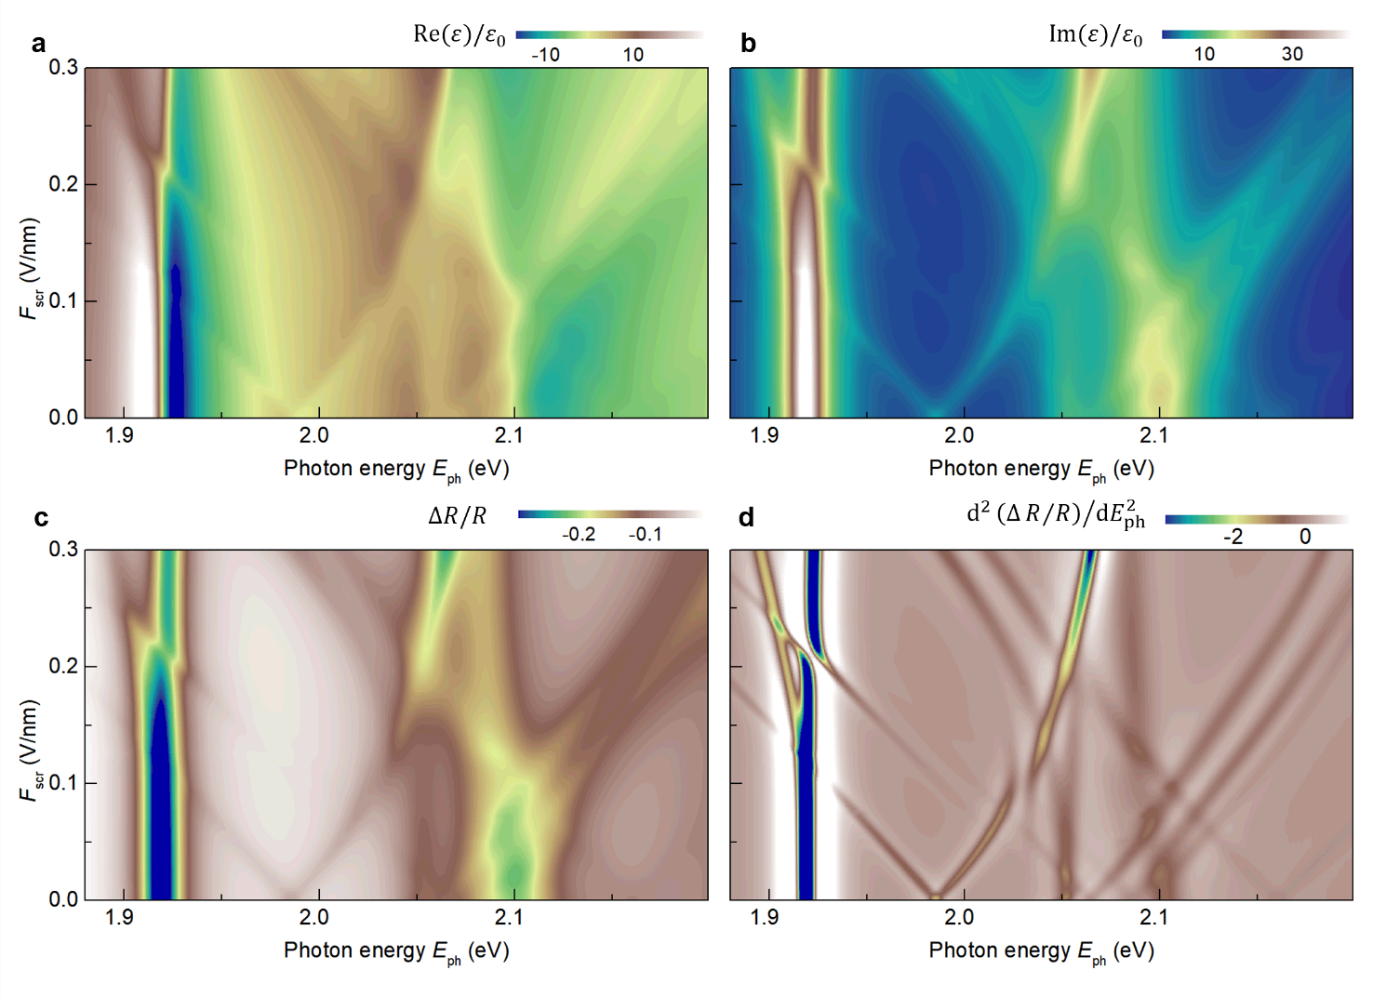
Figure S38 | a,b, Calculated real (a) and imaginary (b) parts of the dielectric function $ε(ℏω)$ for bilayer MoS₂ under various screened electric fields. c, Reflectance contrast map computed based on the results in panels a and b. d, Second-order energy derivative of the reflectance contrast map shown in panel c.

Substituting all oscillator strengths into Eq. (88), we calculate the total complex dielectric function $ε(ℏω)$ for bilayer MoS₂. Figs. S38a and S38b show the computed real and imaginary parts of $ε(ℏω)$ under various screened electric field. Finally, following the procedure described in Section I.4, we compute the reflectance contrast and its second-order energy derivative. The results are presented in Figs. S38c and S38d.

8. Summary of theory
We develop a comprehensive theoretical framework to describe excitons in bilayer MoS₂ under applied electric fields, integrating density functional theory (DFT), k·p perturbation theory, and exciton modeling. Using monolayer-like conduction-band bases and layer-polarized valence-band Bloch states, we construct 24 exciton states—including the 1s–4s and 2p Rydberg states of intra- and interlayer A excitons, and the 1s states of intra- and interlayer B excitons—and evaluate their Coulomb interaction matrix elements. Zeroth-order exciton energies and oscillator strengths are computed variationally, incorporating field-dependent valence-band mixing. We then introduce field-dependent off-diagonal couplings to capture hybridization between excitons and simulate the complex dielectric function and reflectance contrast spectra, successfully reproducing key experimental features. Our theory reveals multiple hybridization effects among intra- and inter-layer excitons, particularly the activation of dark 2p states via mixing with bright s-like states. These results establish bilayer MoS₂ as a tunable platform for exploring coupled excitonic phenomena. Our theoretical treatment introduces several innovative techniques, including:
(1) Using monolayer-like conduction-band basis for disentangling interlayer band mixing at finite momentum: In bilayer MoS₂, conduction bands of the two layers with identical spin are nearly degenerate and strongly hybridized at finite momentum, making their layer identity ambiguous. To restore physical clarity and simplify the exciton analysis, we construct a monolayer-like basis from the DFT-computed bilayer Bloch states. This basis produces conduction-band states that remain layer-polarized even in the presence of interlayer hybridization, enabling a clear and intuitive classification of intra- and inter-layer excitons. It also provides a consistent framework for evaluating field-dependent Coulomb matrix elements and for tracking the evolution of exciton character under applied electric fields.
(2) Spin-resolved field-dependent hybridization between excitons: Our theory systematically incorporates spin-resolved hybridization pathways between intra- and interlayer excitons under applied electric fields, mediated by off-diagonal Coulomb matrix elements. We identify six distinct coupling pathways among s- and p-like excitons (Fig. S16), each governed by the spin- and field-dependent modulation of conduction-band or valence-band basis states. Our model reveals that electric-field-induced interlayer hole transfer enhances the hybridization strength for spin-up excitons while suppressing it for spin-down excitons (Fig. S26), leading to pronounced spin asymmetries. These effects manifest as spin-dependent oscillator strengths and Stark shifts, in close agreement with experimental observations (Figs. S22, S25, S27 and S28). Notably, we show that the optically dark 2p excitons acquire measurable brightness via hybridization with bright s-like states—an activation mechanism that is both spin-selective and field-tunable.
(3) Modified interlayer Keldysh potential with exponential damping: To accurately describe the Coulomb interaction in spatially indirect interlayer excitons, we introduce a modified Keldysh potential that includes an exponential damping term to account for finite interlayer separation (Eq. (44)). While the conventional Keldysh model effectively captures screening in monolayer systems, it fails to reproduce the distinct binding energy trends of interlayer excitons, whose electron and hole reside in different layers. Our modified potential explicitly incorporates the 0.614 nm interlayer spacing, resulting in a softened long-range interaction that better reflects the physical separation of charges. This correction is crucial for capturing the slower decay of binding energy with increasing principal quantum number in the interlayer Rydberg series.
(4) Inter-exciton coupling from first-principles calculations: The fourth innovation of our theory is the first-principles evaluation of inter-exciton coupling elements, with no adjustable parameters aside from a single empirical term $H_{1s,1s}^{A_{↓}^{I}A_{↓}^{0}}$ used to account for defect-assisted mixing. All other hybridization terms are computed directly from DFT-derived Bloch states and exciton envelope functions obtained from an effective mass model. This fully ab initio approach allows us to quantitatively predict field- and spin-dependent exciton mixing without relying on empirical tuning.
The close agreement between our theoretical results and experimental spectra validates the rigor and predictive power of our exciton model. Beyond reproducing observed features, our theory uncovers multiple hybridization effects among exciton states, some of which remain unresolved in current experiments. These predictions offer a roadmap for future experimental investigations into the rich exciton landscape of bilayer MoS₂. Given the generality of the physical mechanisms—such as interlayer coupling, spin-selective hybridization, and field-tunable exciton mixing—our framework is readily extendable to other TMD bilayers, multilayers, and van der Waals heterostructures, providing a versatile tool for exploring complex exciton phenomena in layered materials.
Supplementary References
1. Altaiary, M. M. et al. Electrically switchable intervalley excitons with strong two phonon scattering in bilayer WSe₂. Nano Lett. 22, 1829–1835 (2022).
2. Xia, Y. et al. Superconductivity in twisted bilayer WSe₂. Nature 637, 833-838 (2025).
3. Laturia, A., Van de Put, M. L. & Vandenberghe, W. G. Dielectric properties of hexagonal boron nitride and transition metal dichalcogenides: from monolayer to bulk. npj 2D Mater. Appl. 2, 6 (2018).
4. Macleod, H. A. Thin-film optical filter. (2015).
5. Giannozzi, P. et al. Quantum Espresso: A modular and open-source software project for quantum simulations of materials. J. Phys.: Condens. Matter 21, 39550 (2009).
6. Wakabayashi, N., Smith, H. G. & Nicklow, R. M. Lattice dynamics of hexagonal MoS₂ studied by neutron scattering. Phys. Rev. B. 12, 659 (1975).
7. Gong, Z. et al. Magnetoelectric effects and valley-controlled spin quantum gates in transition metal dichalcogenide bilayers. Nat. Commun. 4, 2053 (2013).
8. Xiao, D., Liu G.-B., Feng, W., Xu, X. & Yao, W. Coupled spin and valley physics in monolayers of MoS₂ and other group-VI dichalcogenides. Phys. Rev. Lett. 108, 196802 (2012).
9. Puschnig, P. & Ambrosch-Draxl, C. Optical absorption spectra of semiconductors and insulators including electron-hole correlations: An ab initio study within the LAPW method Phys. Rev. B 66, 165105 (2002).
10. Srivastava, A. & Imamoğlu, A. Signatures of Bloch-Band Geometry on Excitons: Nonhydrogenic Spectra, Phys. Rev. Lett. 115, 166802 (2015).
11. Kim, K.-H. & Lee, H.-W. Berry curvature in monolayer MoS₂ with broken mirror symmetry. Phys. Rev. B 97, 235423 (2018).
12. Chang, Y. W. & Chang, Y.-C. Variationally optimized orbital approach to trions in two-dimensional materials. J. Chem. Phys. 155, 024110 (2021).
13. Pisoni, R. et al. Absence of interlayer tunnel coupling of K-valley electrons in bilayer MoS₂. Phys. Rev. Lett. 123, 117702 (2019).
14. Chang, Y. C., Shiau, S. & Combescot, M. Cross-over from trion-hole complex to exciton-polaron in n-doped semiconductor quantum wells. Phys. Rev. B 98, 235203 (2018).
15. Kane, E. O. Band structure of indium antimonide. J. Phys. Chem. Solids. 1, 249-261 (1957).
16. Rohlfing, M. & Louie, S. G. Electron-hole excitations and optical spectra from first principles, Phys. Rev. B 62, 4927 (2000).
17. Sponfeldner, L. et al. Capacitively and inductively coupled excitons in bilayer MoS₂. Phys. Rev. Lett. 129, 107401 (2022).

