Supplementary Materials: Appendices- Sensitivity Analysis

A. Zero Inflated Negative Binomial Analysis- Effects of the COVID-19 Pandemic on Emergency Room Visits
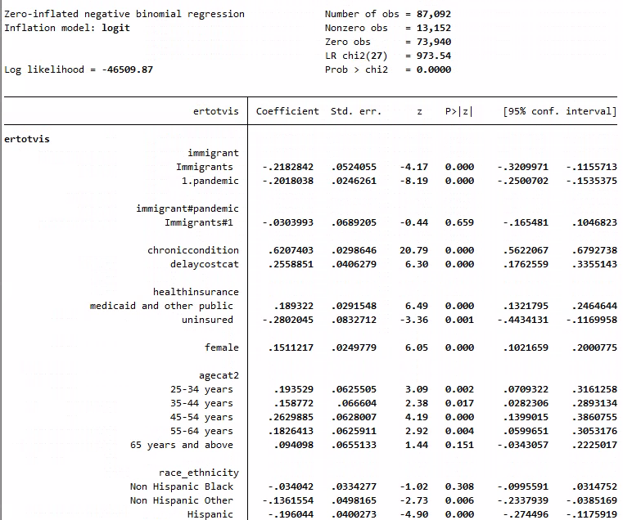
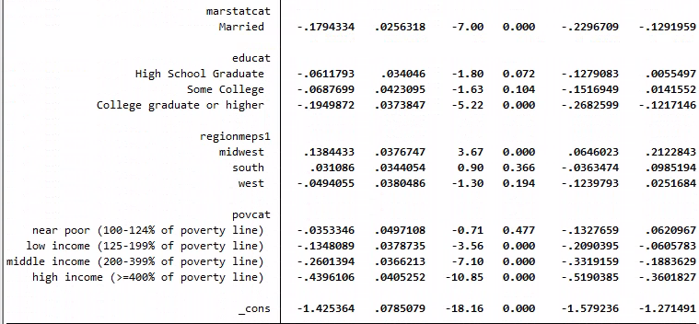
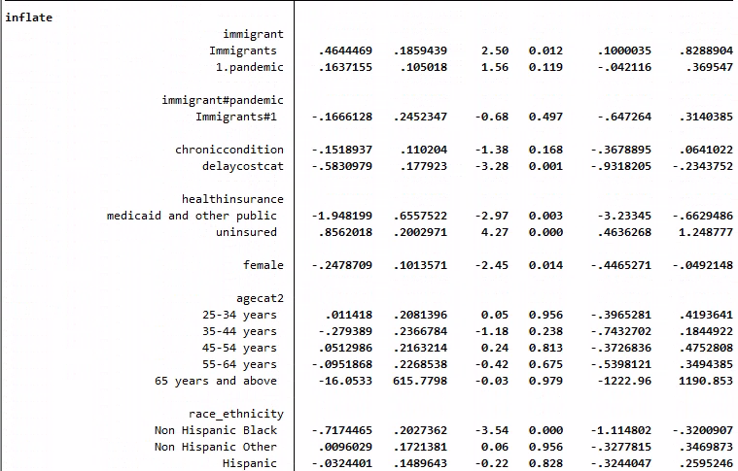
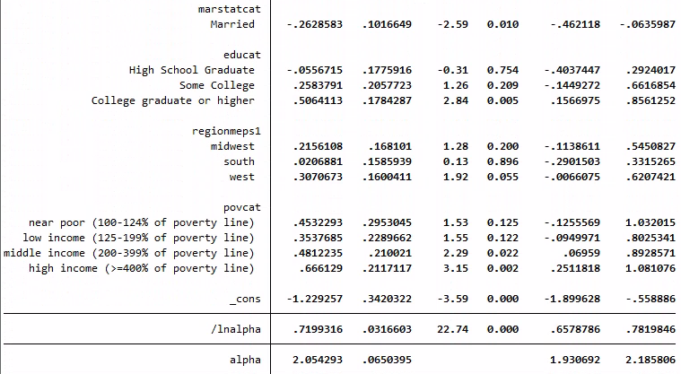

APPENDIX B

B. Zero Inflated Negative Binomial Analysis- Effects of the COVID-19 pandemic on Hospital Discharges
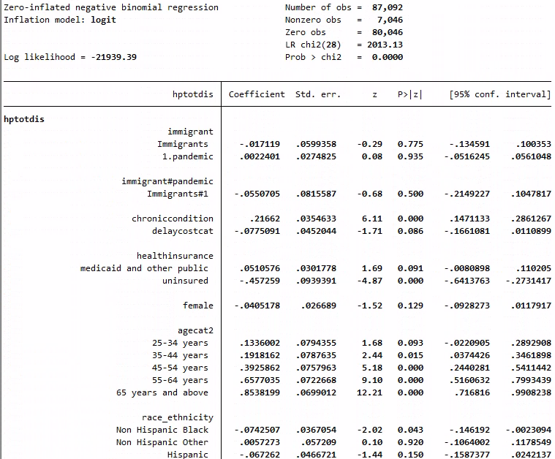
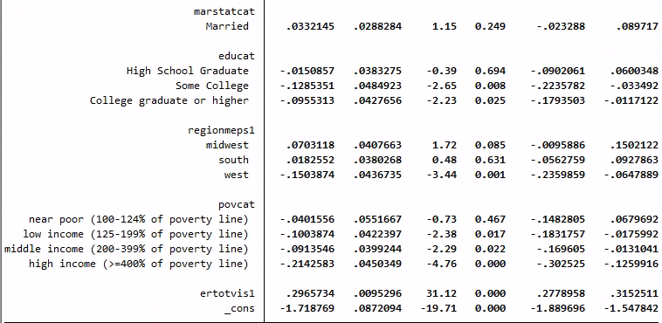
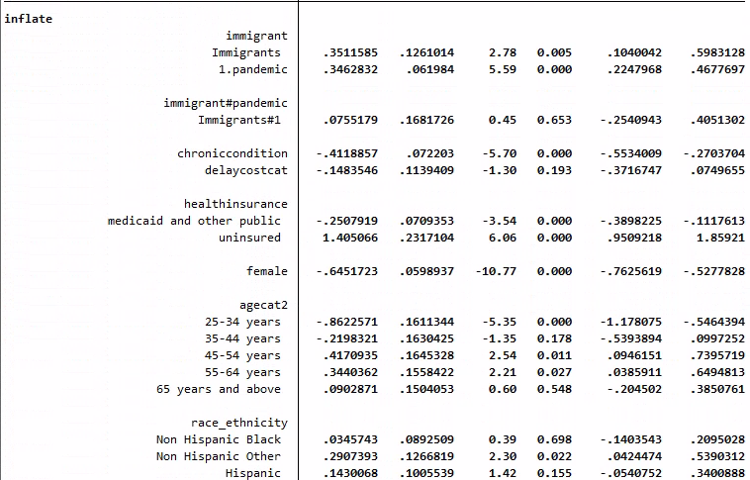
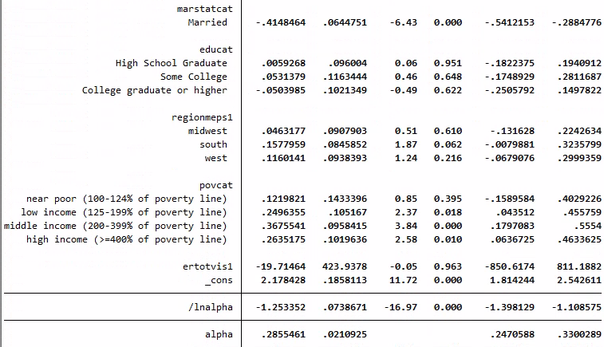

APPENDIX C

C. Ordinal Logistic Regression Analysis-Effects of the COVID-19 pandemic on Health Outcomes
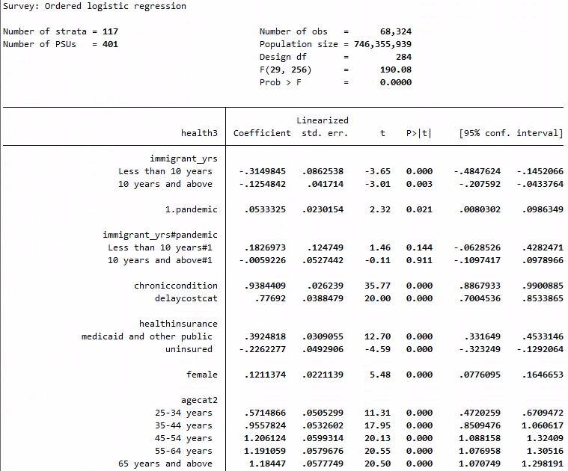
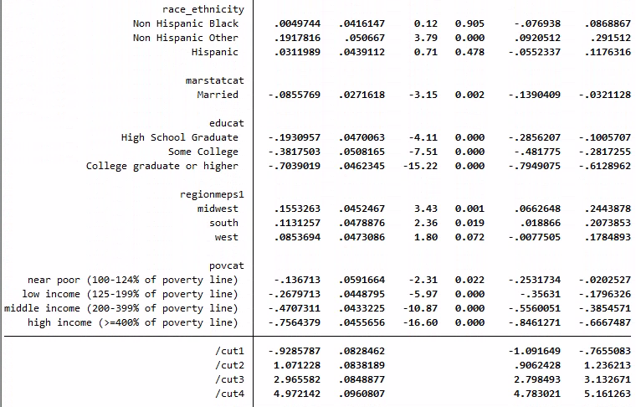

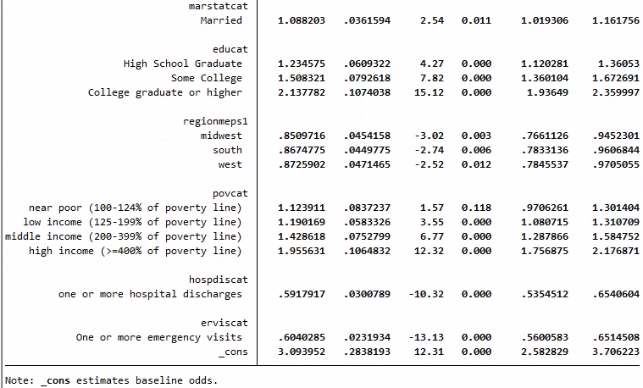

APPENDIX D

D. Logistic Regression Analysis excluding the year 2020- Effects of the COVID-19 Pandemic on Emergency Room Visits
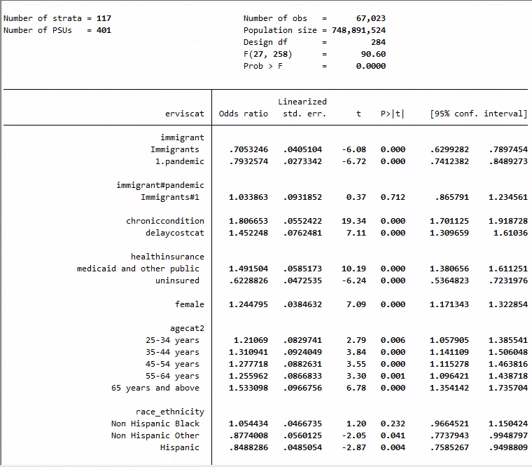
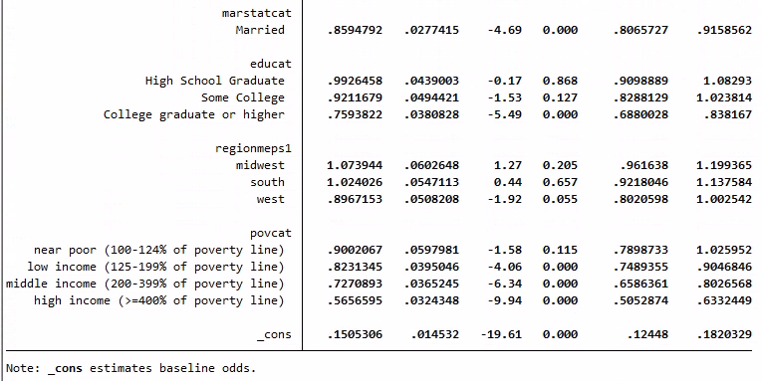
APPENDIX E

E. Logistic Regression Analysis excluding the year 2020- Effects of the Covid-19 Pandemic on Hospital Discharges
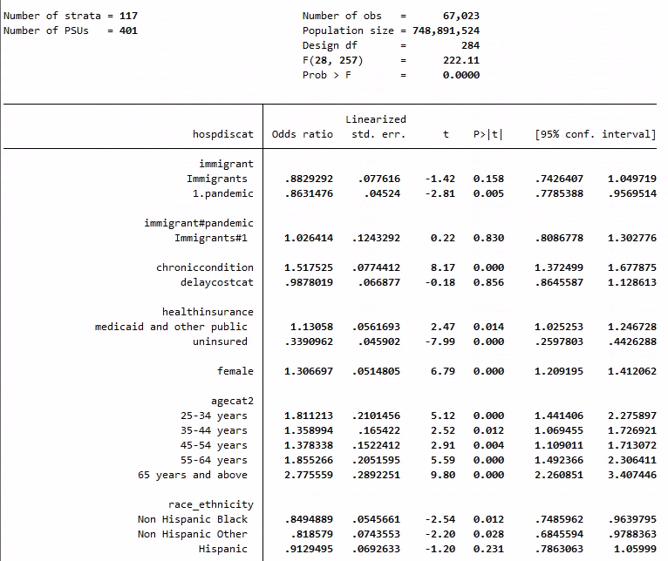
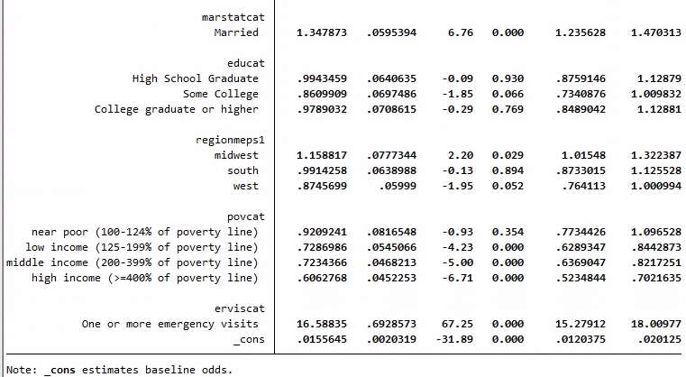
APPENDIX F

F. Logistic Regression Analysis excluding the year 2020- Effects of the COVID-19 Pandemic on Health Outcomes
