Tropical potato breeding: population structure, genetic diversity and putative regions under selection in a Brazilian tetraploid potato germplasm
Givanildo Rodrigues da Silva¹, Gustavo Nandi¹, Marcio F. R. Resende², Tiago de Souza Marçal³, Thiago Leandro Factor⁴, Fernando Angelo Piotto^{1*}

¹ Genetics Department, Luiz de Queiroz College of Agriculture, University of São Paulo, Piracicaba, São Paulo, Brazil
² Horticultural Sciences Department, University of Florida, Gainesville, Florida, USA
³ Department of Biology, University of Lavras, Lavras, Minas Gerais, Brazil
⁴ Horticulture Center, Agronomic Institute (IAC), Campinas, São Paulo, Brazil
*Corresponding author: fpiotto@usp.br

Supplementary Figures

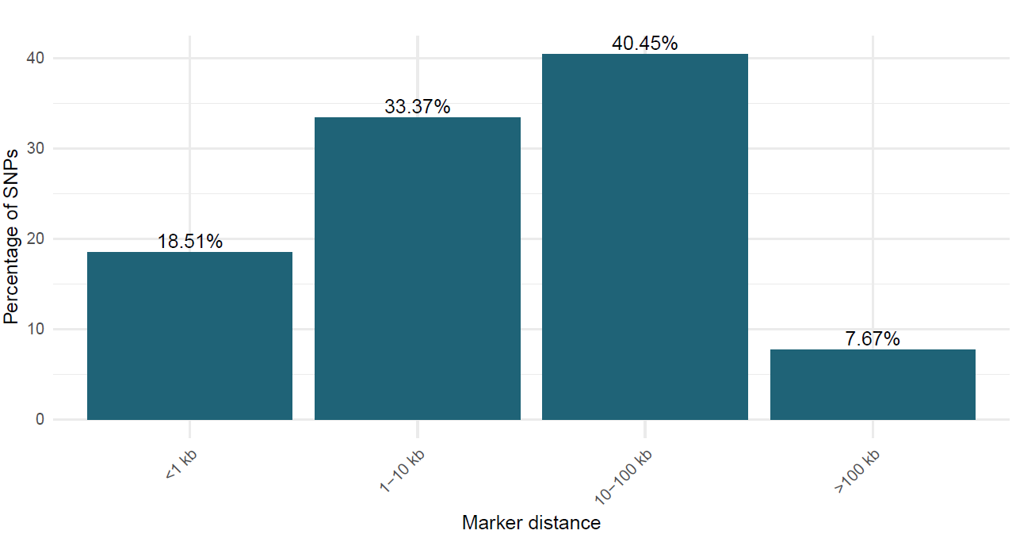
Supplementary Figure S1. Distribution of 18,481 SNPs in the LMH panel genotyping using the LGC 22K Flex-Seq platform.

Supplementary Figure S2. Sequencing quality parameters and distribution of SNPs in the LMH germplasm. Parameters extracted using the FastQC considering all samples (a), density plot of the 18,500 SNPs across 1 Mb windows in the 12 potato chromosomes (b), minor allele frequence (c), and polymorphic informative content (d).

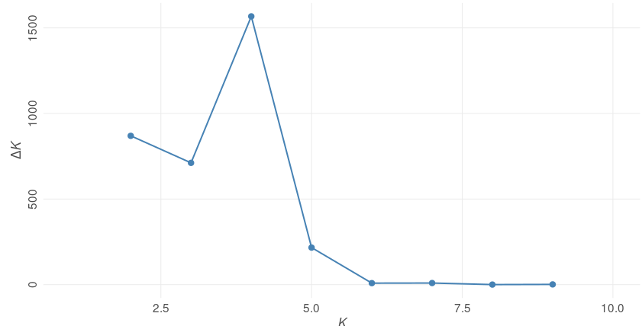Supplementary Figure S3. STRUCTURE analysis revealed three subpopulations in the LMH germplasm panel based on 18,481 SNPs using the tetraploid model. The left shows estimation of the number of populations using LnP(D) derived ΔK. The maximum ΔK determined was K= 4.

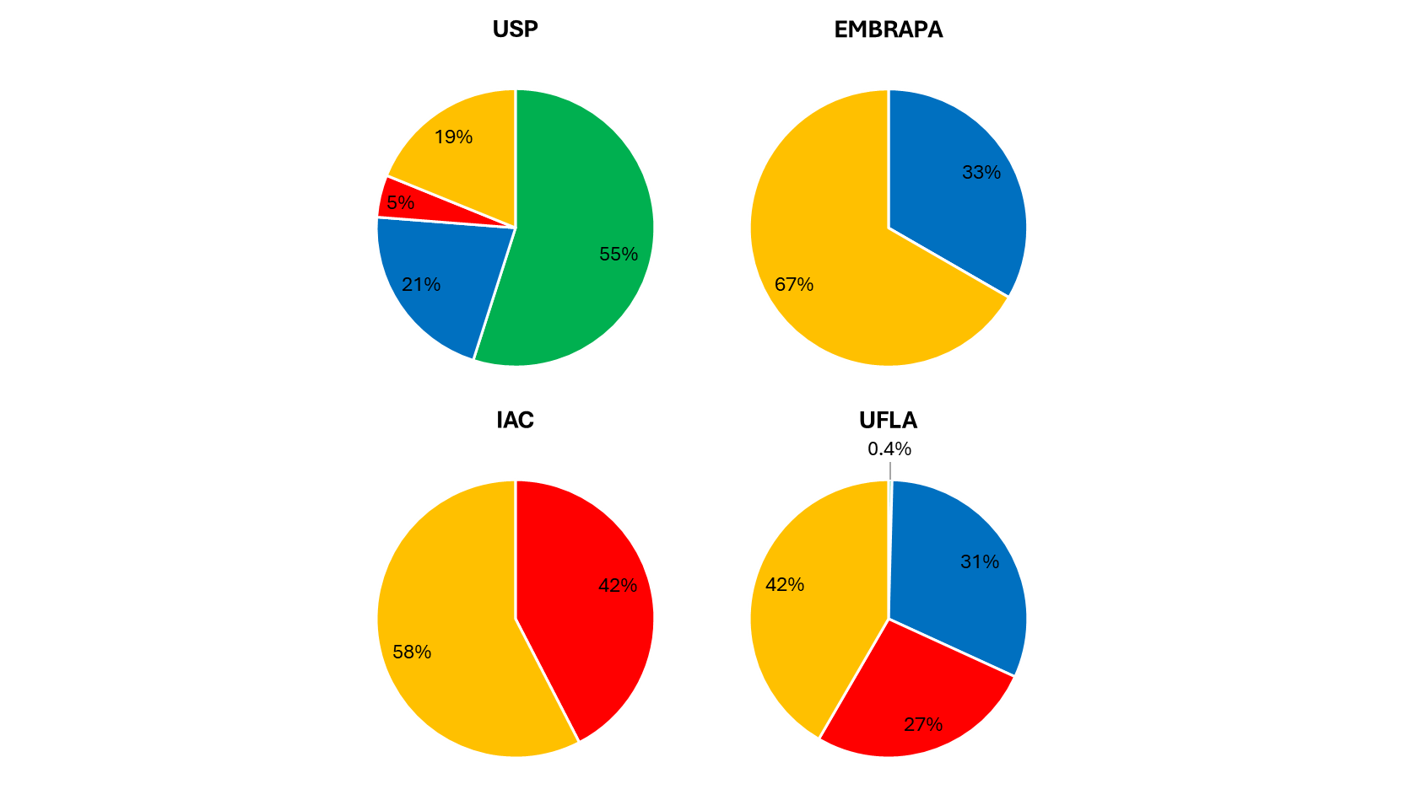
Supplementary Figure S4. The percentage of each genetic cluster across the national potato program initiatives. 403 Brazilian clones from University of São Paulo (USP, n=122), Agronomical Institute of Campinas (IAC, n=33), Brazilian Agricultural Research Corporation (EMBRAPA, n=3), and Federal University of Lavras (UFLA, n=245).

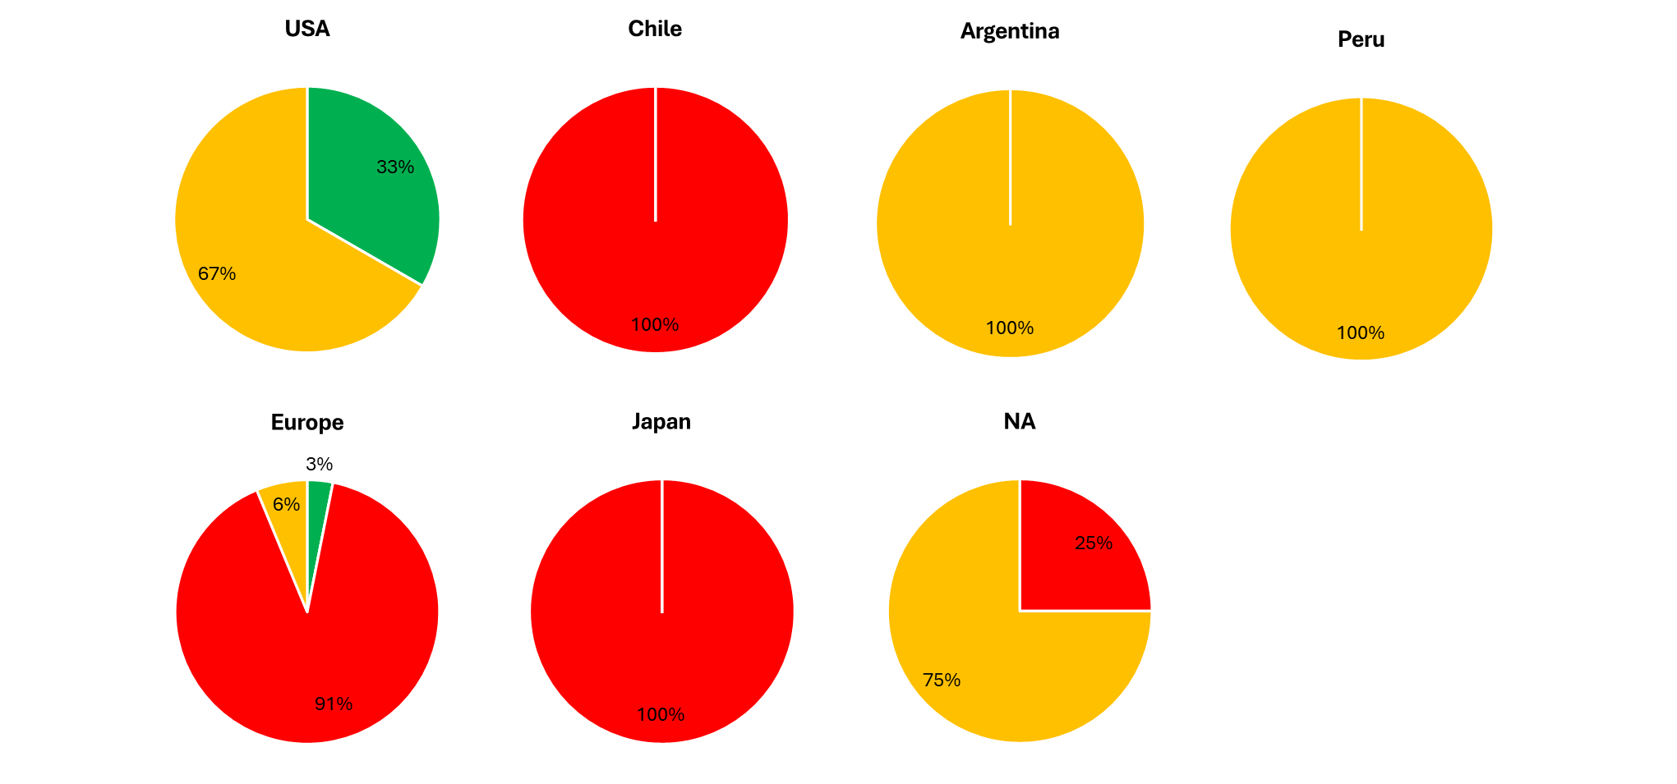
Supplementary Figure S5. The percentage of each genetic cluster across the foreign origins. 47 foreign clones from United State of America (n=3), Chile (1), Argentina (1), Peru (1), Europe (32), Japan (1), and not available (NA, 8).

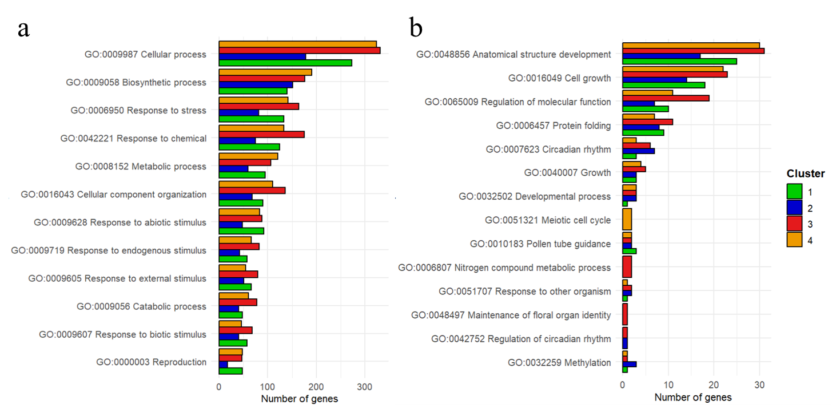
Supplementary Figure S6. Gene Ontology (GO) categories of the 1,925 genes within the regions putatively under selection. To facilitate visualization, bar plots were split by number of GO categories occurring more than 31 (a) or less than 31 times per cluster (b).

