Supplementary materials
FigureS1.(A) Age-standardized prevalence rates of COVID-19-Induced GBS in 2021 globally and by GBD regions (per 100,000 people) and percentage changes from 2020 to 2021.(B) Age-standardized YLDs rates of COVID-19-Induced GBS in 2021 globally and by GBD regions (per 100,000 people) and percentage changes from 2020 to 2021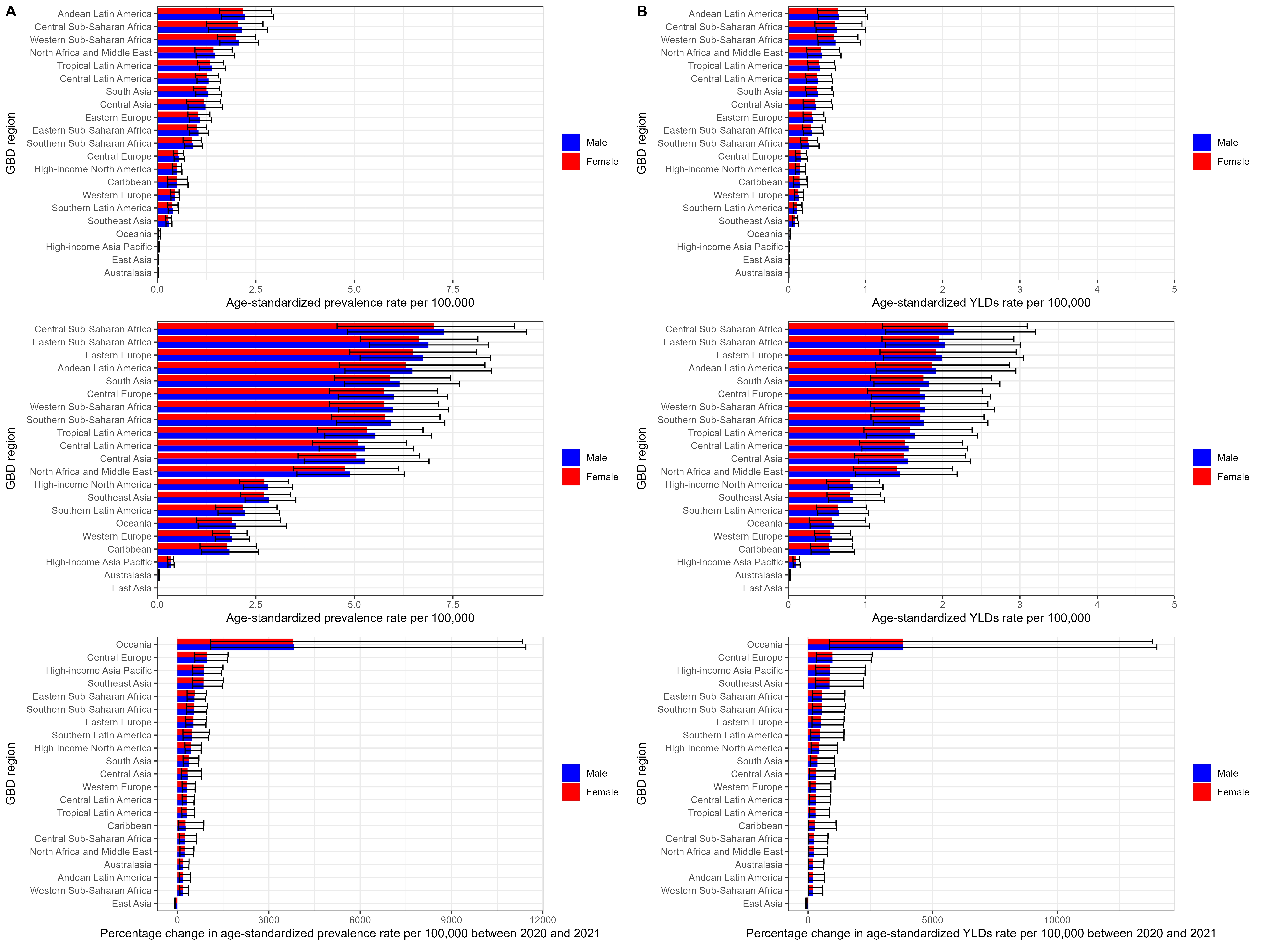
FigureS2. Age-Standardized YLDs Rates by SDI in Global Disease Burden Regions and Countries from 2020 to 2021. (A) Age-Standardized YLDs Rates by SDI in Global Disease Burden Regions from 2020 to 2021. (B) Age-Standardized YLDs Rates by SDI in Different countries.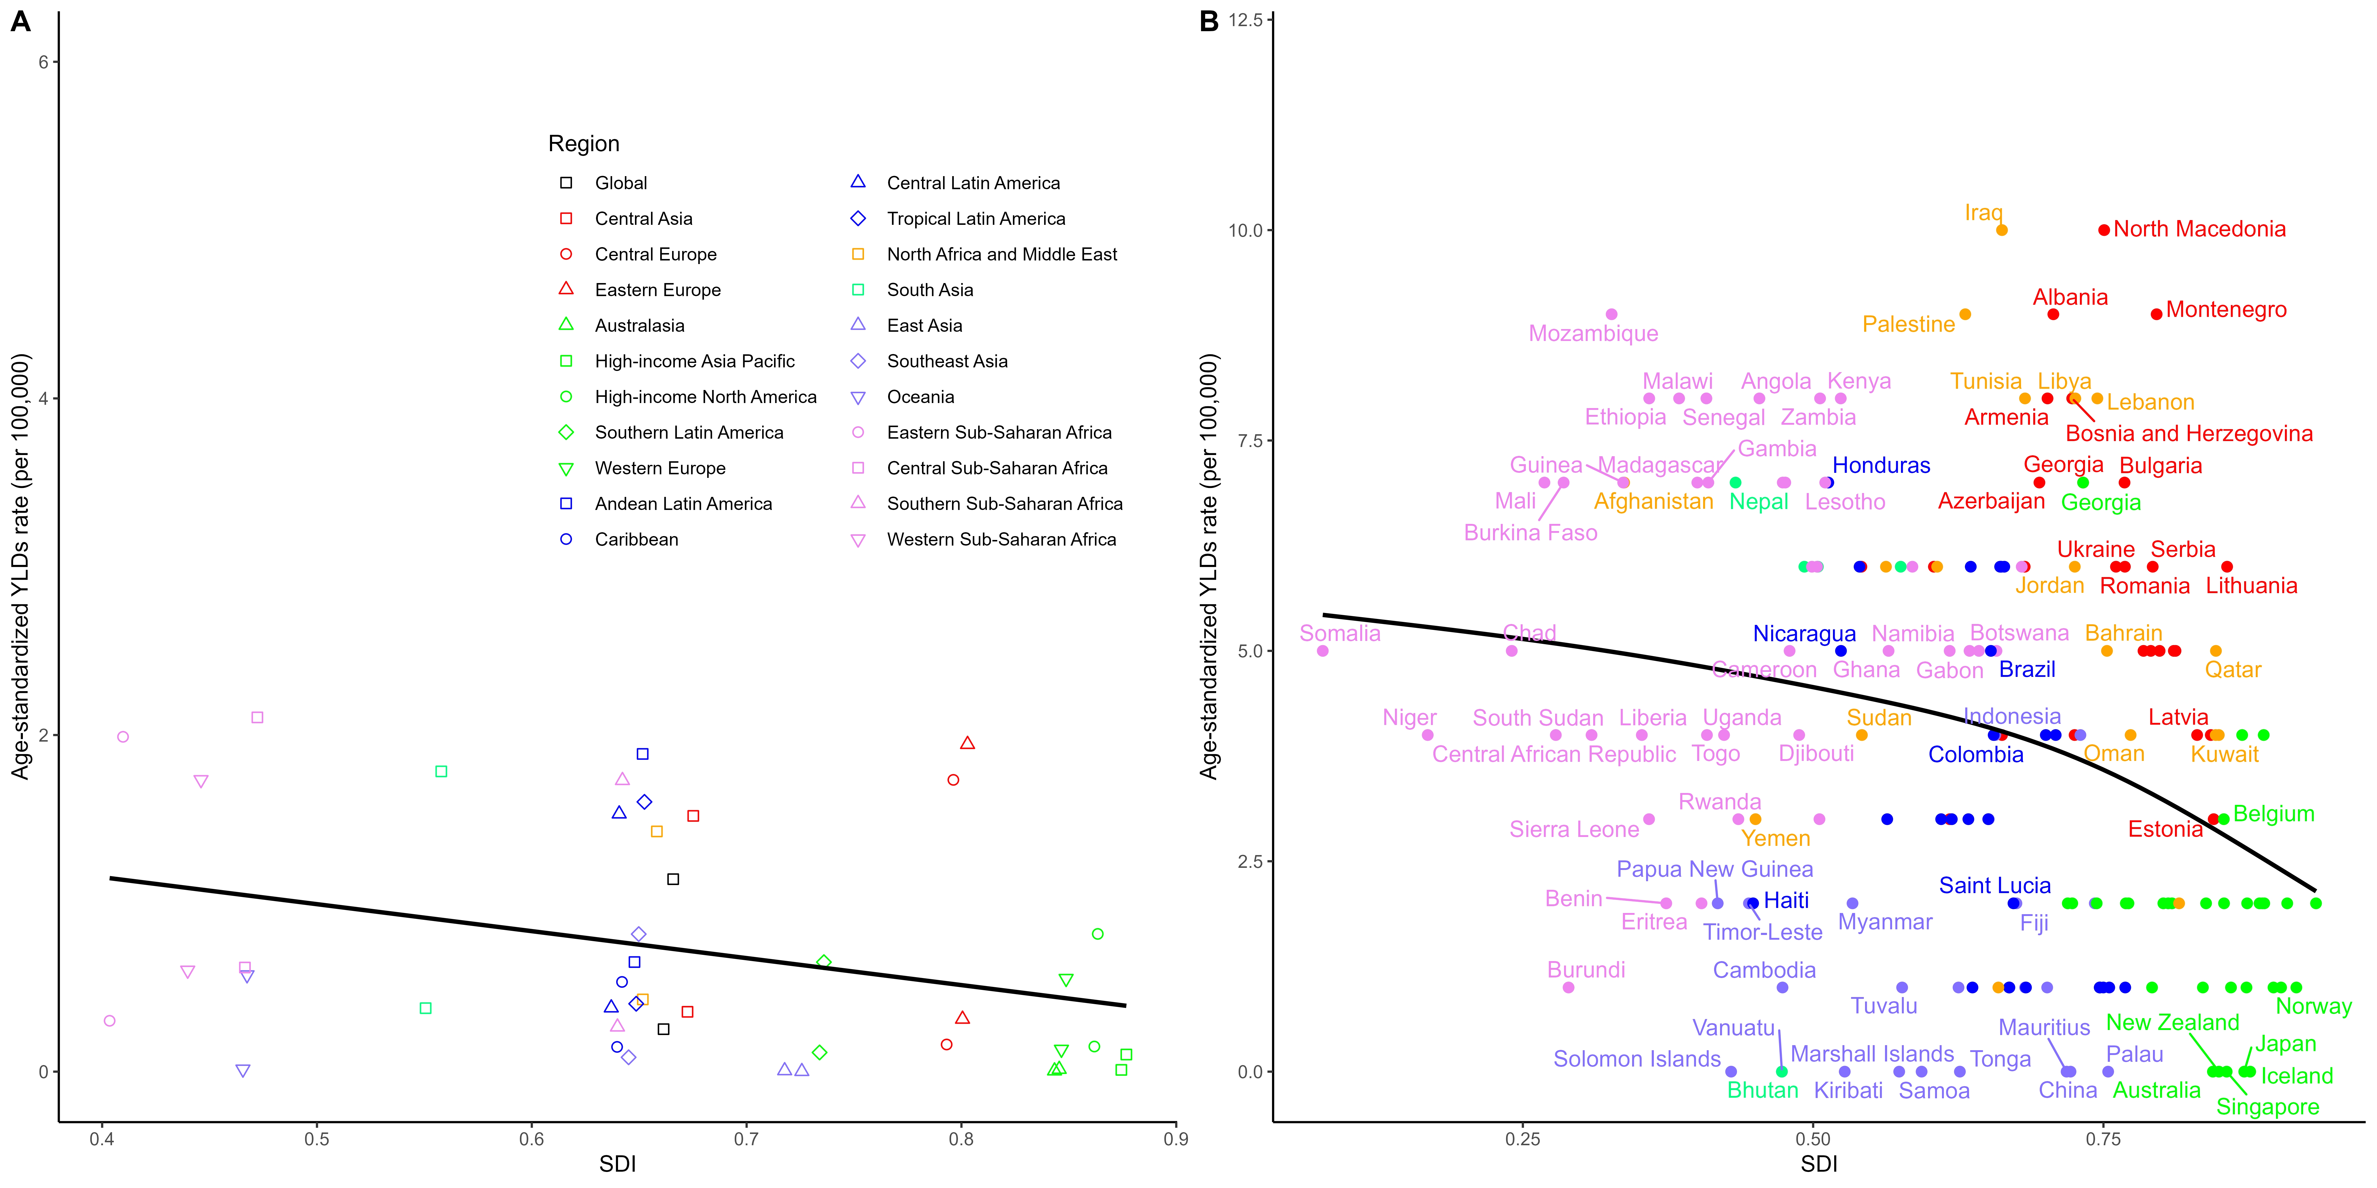
FigureS3. Frontier Analysis of Age-Standardized prevalence for COVID-19-Induced GBS Based on SDI. (A) Frontier Analysis of SDI and Age-Standardized prevalence rate from 2020 to 2021. (B) Frontier Analysis of SDI and Age-Standardized prevalence rate in Different Countries in 2021.

