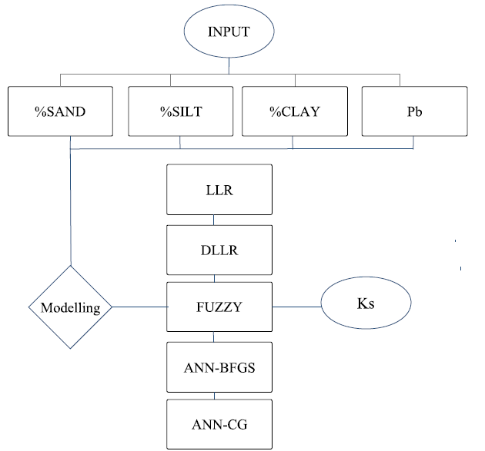
Figure 1: Flowchart for the Modelling of saturated hydraulic conductivity of soil

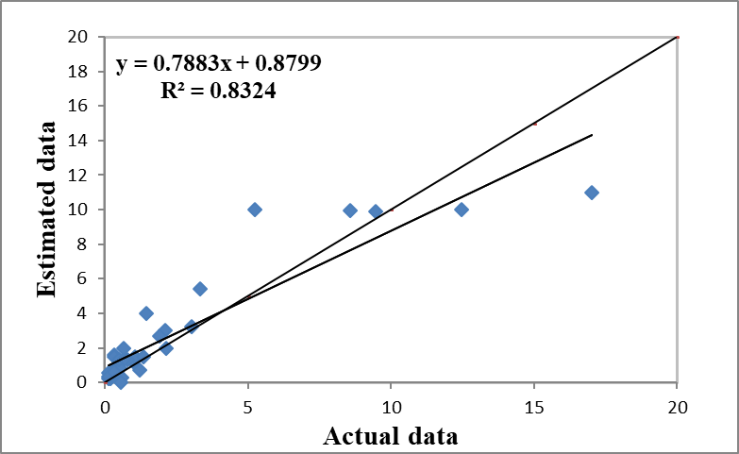(b) | 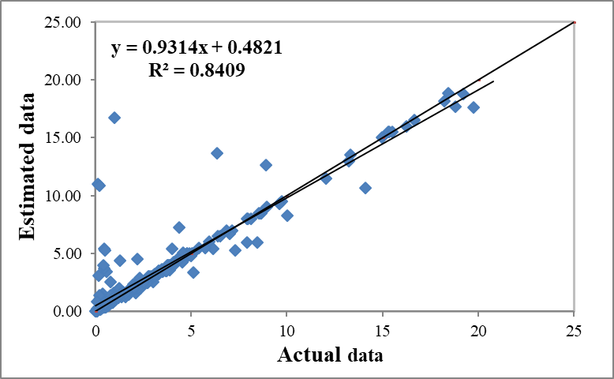(a)
Figure 1: Comparison of the fuzzy model's calculated saturated hydraulic conductivity with four inputs (a - model training) and (b - model testing).

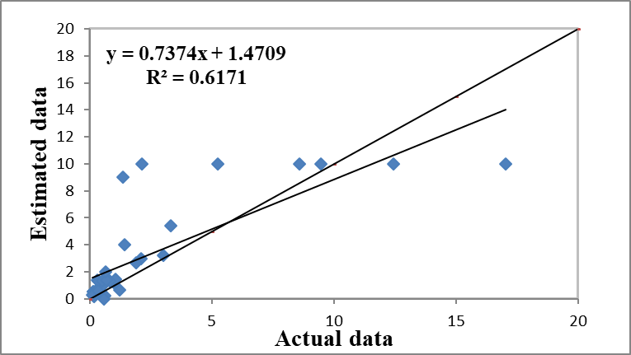 (b) |  | 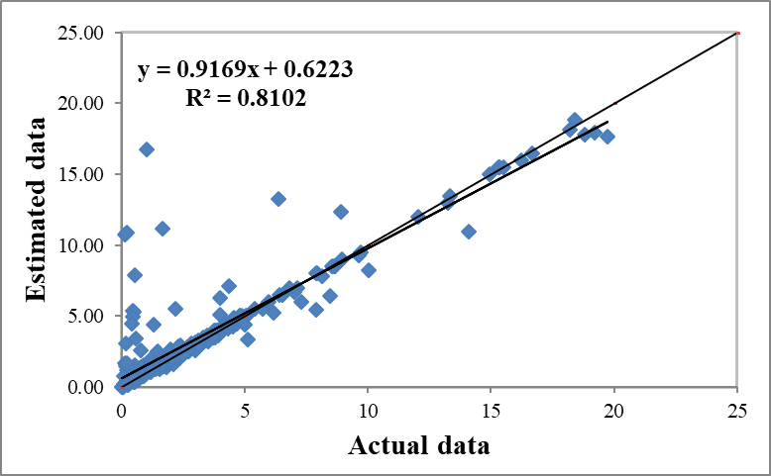 (a)
Figure 2: Comparison of the fuzzy model's calculated saturated hydraulic conductivity with three inputs (a - model training) and (b - model testing).
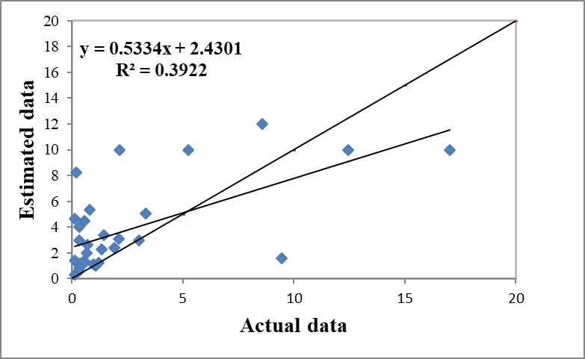(b) | 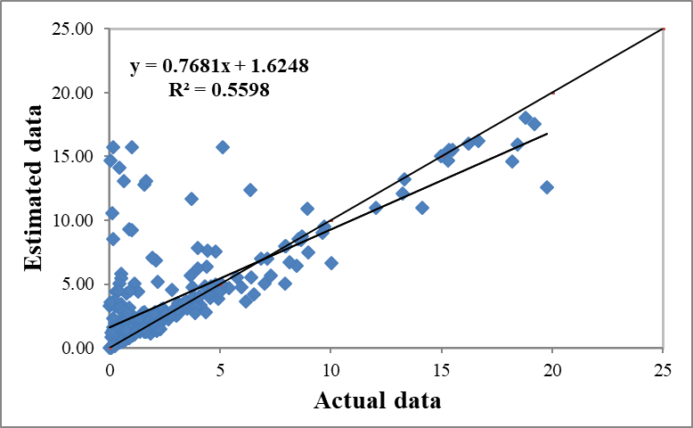(a)
Figure 3: Comparison of the fuzzy model's calculated saturated hydraulic conductivity with two inputs (a - model training) and (b - model testing).

