Supporting Information
Copolyfluorenes containing polymethine dyes in the main chain: synthesis and photophysical properties
Elena V. Zhukova, Alexander M. Mitroshin, Ksenia I. Kaskevich, Serguei A. Miltsov, Larisa S. Litvinova, Tatiana G. Chulkova, Alexander V. Yakimansky
Branch of Petersburg Nuclear Physics Institute Named by B.P. Konstantinov of National Research Centre “Kurchatov Institute” – Institute of Macromolecular Compounds, 31 Bolshoy pr. V.O., St. Petersburg, 199004 Russia

Synthesis of polymethine dyes
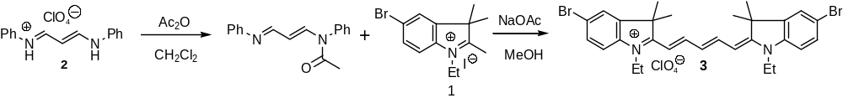

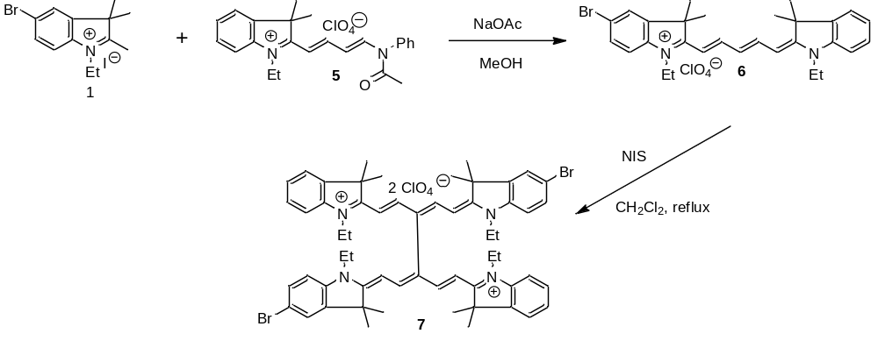

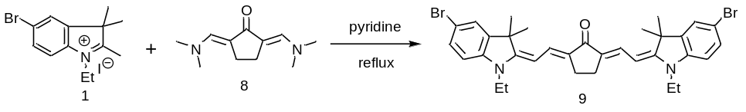
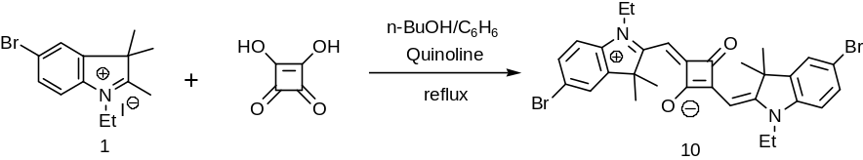

Preparation of 5-bromo-1-ethyl-2,3,3-trimethylindoleninium iodide 1¹, N-(3-anilino-2-propenylidene)aniline hydroperchlorate 2², 1-ethyl-2,3,3-trimethylindoleninium iodide 4³, 2-[4-(acetylphenylamino)-1,3-butadien-1-yl]-1-ethyl-3,3-dimethyl-3H-indolium perchlorate 5⁴ and 2,5-bis-dimethylaminomethylenecyclopentanone 8⁵ was performed according to the published protocols.

1. M. V. Reddington. Synthesis and properties of phosphonic acid containing cyanine and squaraine dyes for use as fluorescent labels. Bioconjugate Chem. 2007, 18 (6), 2178–2190.
DOI: 10.1021/bc070090y

2. D. Lloyd, H. McNab, D. R. Marshall. Diazepines. XVII. Simple preparation of 2,3-dihydro-1H-1,4-diazepinium perchlorate. Synthesis 1973, (12), 791.
DOI: 10.1055/s-1973-22305
3. J. S. Lindsey, P. A. Brown, D. A. Siesel. Visible light-harvesting in covalently-linked porphyrin-cyanine dyes. Tetrahedron. 1989, 45(15), 4845-4866.
DOI: 10.1016/s0040-4020(01)85156-5
4. S. Miltsov, M. Goikhman, A. Yakimansky, A. Misharev, M. Puyol, J. Alonso. N-Bromosuccinimide-mediated dimerization of unsymmetrical indodicarbocyanine dyes. Tetrahedron Lett. 2019, 60, 151005.
DOI: 10.1016/j.tetlet.2019.151005
5. Yu. L. Slominskii, I. D. Radchenko, S. V. Popov, A. I. Tolmachev. Polymethine dyes with hydrocarbon bridges. Enamine ketones in the chemistry of cyanine dyes. Zh. Org. Khim. 1983,
19(10), 2134-2142.

3H-Indolium, 2-[5-(1-ethyl-1,3-dihydro-5-bromo-3,3-dimethyl-2H-indol-2-ylidene)-1,3-pentadien-1-yl]-1-ethyl-5-bromo-3,3-dimethyl-, perchlorate 3

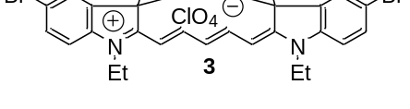

Acetic anhydride (200 mg, 2 mmol) was added dropwise to a solution of N-(3-anilino-3-propenylidene)aniline perchlorate 2 (323 mg, 1 mmol) and diisopropylethylamine (DIEA, 0.38 ml, 2 mmol) in 7 ml of CH₂Cl₂. The mixture was kept at room temperature for 3 hours and added to the solution of salt 1 (788 mg, 2 mmol) and anhydrous sodium acetate (430 mg, 5.2 mmol) in 25 ml of methanol. Methylene chloride was distilled off and the remaining methanol solution was heated at reflux for 8 hours. After reducing to 10 ml the solution was kept at -15 ⁰C overnight. The resulted crystals were washed with ether, water and ether again, and dried on air. Yield 486 mg (73%).
¹H NMR (400 MHz, DMSO-d₆) 1.26 (m, 6H), 1.68 (s, 12), 4.13 (m, 4H), 6.30 (d, J = 14 Hz, 2H), 6.58 (m, 1H), 7.36 (d, J = 8.5 Hz, 2H), 7.58 (dd, J = 8.5 Hz, J = 2 Hz, 2H), 7.92 (d, J = 2 Hz, 2H), 8.33 (m, 2H). ¹³C NMR (100 MHz, DMSO-d₆) 12.6, 27.3, 39.2, 49.6, 103.6, 113.2, 117.5, 126.3, 126.4, 131.6, 141.4, 144.1, 155.1, 172.5. HRMS (ESI⁺), m/z: 567.0991 (calcd. 567.1010 for C₂₉H₃₃Br₂N₂). UV-Vis: λ_{abs} (EtOH) = 651.5 nm (ε = 2.50∙10⁵ M⁻¹cm⁻¹). Fluor.: λ_{em} (EtOH) = 668 nm.

1-Ethyl-2-[(1E,3E,5E)-5-(1-ethyl-1,3-dihydro-5-bromo-3,3-dimethyl-2H-indol-2-ylidene)-1,3-pentadien-1-yl]-3,3-dimethyl-3H-indolium perchlorate (6)
Acetylated hemicyanine 5 (1.836 g, 4 mmol), indoleninium salt 1 (4 mmol) and anhydrous sodium acetate (400 mg, 4.82 mmol) in 30 ml of MeOH were heated at reflux for 1 hour. After evaporation to dryness in vacuo the residue was triturated with water (50 ml) filtered and dried on air. The dye was purified by column chromatography on silica (0 – 5% MeOH in CH₂Cl₂). Yield 1.86 g (79%).
¹H NMR (400 MHz, DMSO-d₆) 1.20 – 1.35 (m, 6H), 1.69 (s, 12 H), 4.03 – 4.15 (m, 2H), 4.15 – 4.27 (m, 2H), 6.24 (d, J = 13 Hz, 1H), 6.39 (d, J = 13 Hz, 1H), 6.58 (m, 1H),), 7.25 – 7.36 (m, 2H), 7.39 – 7.50 (m, 2H), 7.57 (d, J = 8 Hz, 1H) 7.67 (d, J = 8 Hz, 1H), 7.91 (s, 1H), 8.26 – 8.44 (m, 4H). ¹³C NMR (100 MHz, DMSO-d₆) 12.4, 12.8, 27.4, 27.4, 39.9, 49.2, 49.7, 102.7, 103.3, 111.8, 112.8, 116.9, 123.0, 125.7, 126.2, 129.0, 131.5, 141.6, 141.9, 141.9, 142.0, 143.9, 154.2, 155.4, 171.3, 173.9. HRMS (ESI⁺), m/z: 489.1908 [M]⁺ (calcd. 489.1905 for C₂₉H₃₄BrN₂). UV-Vis: λ_{max} (EtOH) = 647 nm.

10,10-Bis(5-bromo-1,1′-diethyl-3,3,3′,3′-tetramethylindodicarbocyanine) diiodide (7)

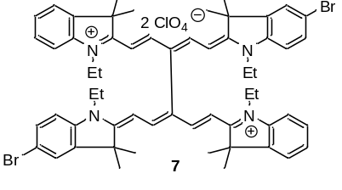

Dicarbocyanine 6 (589 mg, 1 mmol) was dissolved in CHCl₃ (30 ml), heated to reflux and NIS (337 mg, 1.5 mmol) were added in three portions during 15 min. and reflux was continued for 1 h more. After evaporation to dryness in vacuo, the residue was triturated with water (50 ml), filtered and dried on air. The product was purified by column chromatography on silica (0 – 5% MeOH in CH₂Cl₂), resulting in 432 mg (73%) of 7.
¹H NMR (400 MHz, DMSO-d₆) 0.95 – 1.15 (m, 12H), 1.81 (s, 24 H), 3.88 (m, 4H), 3.98 (m, 4H), 5.66 (d, J = 14 Hz, 2H), 5.78 (d, J = 14 Hz, 2H), 7.24 – 7.37 (m, 4H), 7.38 – 7.48 (m, 4H), 7.55 (d, J = 8 Hz, 2H), 7.71 (d, J = 8 Hz, 2H), 7.99 (s, 2H), 8.52 – 8.72 (m, 4H). ¹³C NMR (100 MHz, DMSO-d₆) 12.3, 12.6, 27.4, 27.4, 39.1, 49.6, 45.0, 100.5, 101.8, 112.0, 113.1, 117.6, 123.2, 126.1, 126.4, 127.5, 129.1, 131.6, 141.3, 141.7, 142.0, 144.0, 153.1, 154.2, 172.1, 174.2. HRMS (ESI⁺), m/z: 488.1828 [M²⁺] (calcd. 488.1827 for C₅₈H₆₆Br₂N₄/2). UV-Vis: λ_{abs} (EtOH) = 640 nm (ε = 2.16∙10⁵ M⁻¹cm⁻¹); 597 nm (ε = 1.65∙10⁵ M⁻¹cm⁻¹).

2,5-Bis-[2-(1-ethyl-1,3-dihydro-5-bromo-3,3-dimethyl-2H-indol-2-ylidene)ethylydene]-cyclopentanone 9

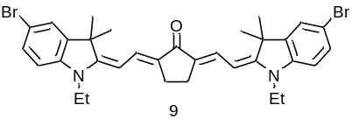
Salt 1 (788 mg, 2 mmol) и 2,5-bis-dimethylaminomethylenecyclopentanone 8 (194 mg, 1 mmol) in pyridine (10 ml) were heated to reflux for 2 h. cooling the mixture was poured in ice-water (100 ml), the precipitate formed was filtered, dried and recrystallized from MeOH. Yield: 507 mg (82%).
¹H NMR (400 MHz, DMSO-d₆) 1.16 (t, J = 7 Hz, 6H), 1.57 (s, 12), 2.68 s, 6H), 3.79 (q, J = 7 Hz, 4H), 5.42 (d, J = 13 Hz, 2H), 6.89 (d, J = 8 Hz, 2H), 7.37 (dd, J = 8 Hz, J = 1.5 Hz, 2H), 7.47 (d, J = 13 Hz, 2H), 7.56 (d, J = 1.5 Hz, 2H). ¹³C NMR (100 MHz, DMSO-d₆) 11.3, 23.5, 28.3, 37.1, 46.6, 93.8, 109.4, 112.5, 125.5, 127.5, 131.0, 132.8, 141.9, 143.1, 161.0. UV-Vis: λ_{abs(base)} (EtOH) = 540 nm. Fluor.: λ_{em(base)} (EtOH) = 638 nm. UV-Vis: λ_{abs(acid)} (EtOH) = 719 nm. Fluor.: λ_{em(acid)} (EtOH) = 747 nm.

3H-Indolium, 5-bromo-2-[[3-[(5-bromo-1-ethyl-1,3-dihydro-3,3-dimethyl-2H-indol-2-ylidene)methyl]-2-hydroxy-4-oxo-2-cyclobuten-1-ylidene]methyl]-1-ethyl-3,3-dimethyl-, inner salt 10
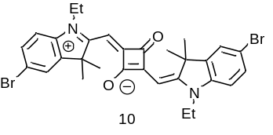
Squaric acid (114 mg, 1 mmol), salt 1 (788 mg, 2 mmol) and quinoline (516 mg, 8 mmol) in the mixture of benzene (20 ml) and n-butanol (20 ml) were kept at reflux with Dean-Stark trap for 6 h. After removal of solvents the product was recrystallized from MeOH. Yield: 480 mg (79 %).
¹H NMR (400 MHz, DMSO-d₆) 1.27 (t, J = 7 Hz, 6H), 1.70 (s, 12H), 4.12 (q, J = 7 Hz, 4H), 5.80 (s, 2H), 7.32 (d, J = 8.5 Hz, 2H), 7.55 (dd, J = 8.5 Hz, J = 1.5 Hz, 2H), 7.81 (d, J = 2 Hz, 2H). ¹³С NMR was not measured because of low solubility. UV-Vis: λ_{max} (EtOH) = 638 nm. Fluor.: λ_{em} (EtOH) = 646 nm.

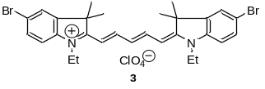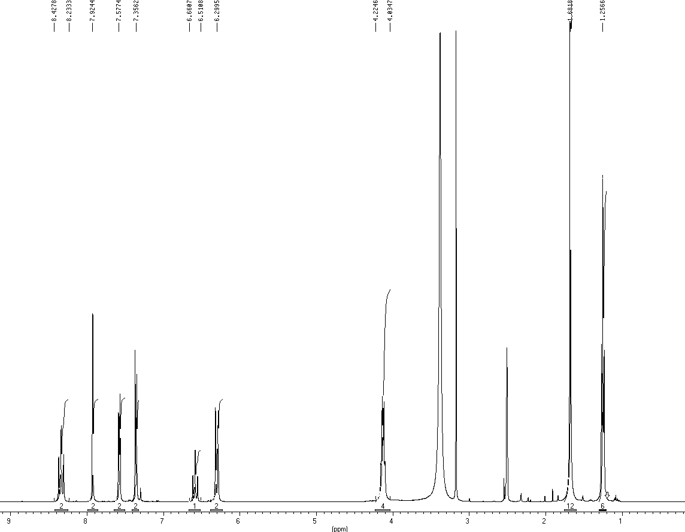
Fig. S1 The ¹H NMR (400 MHz, DMSO-d₆) spectrum of 3

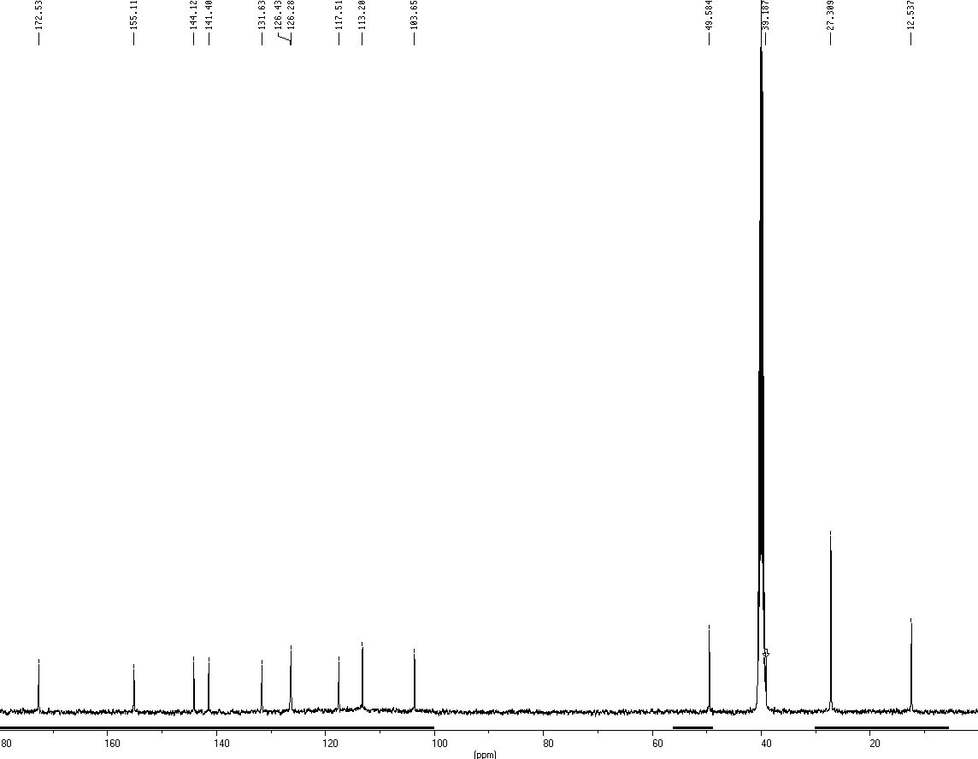
Fig. S2 The ¹³C NMR (100 MHz, DMSO-d₆) spectrum of 3
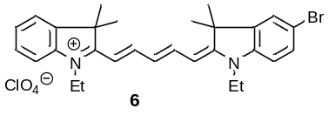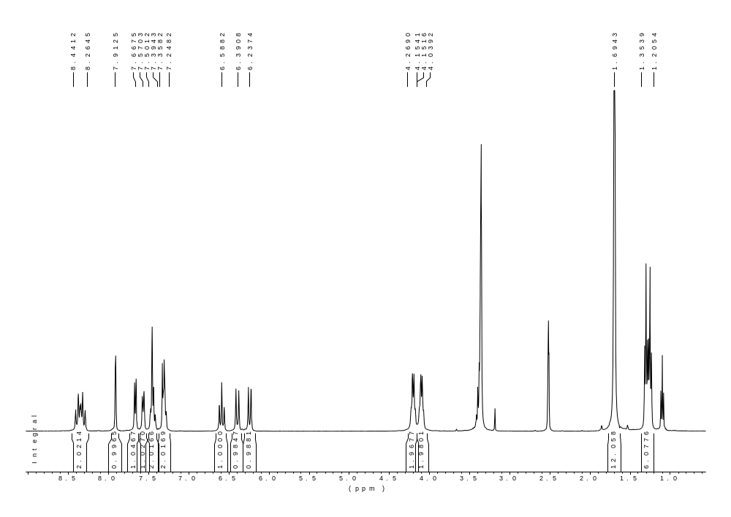
Fig. S3 The ¹H NMR (400 MHz, DMSO-d₆) spectrum of 6

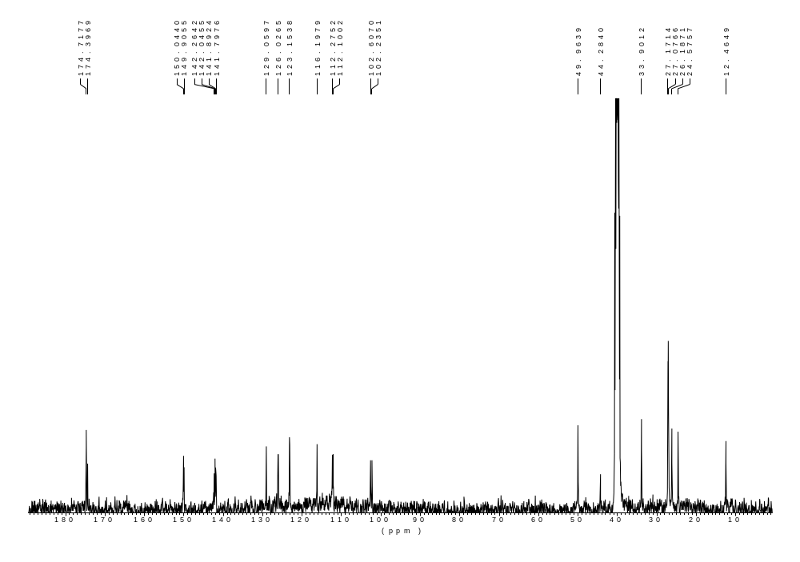
Fig. S4 The ¹³C NMR (100 MHz, DMSO-d₆) spectrum of 6

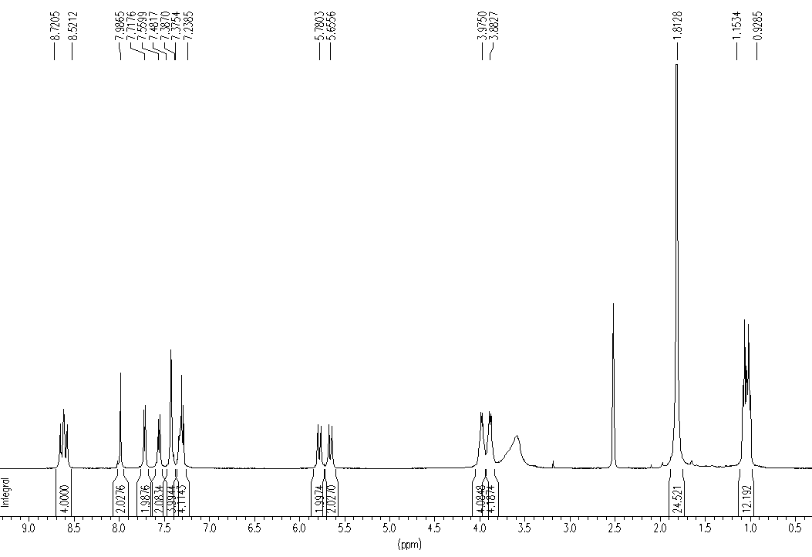

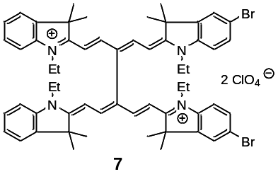

Fig. S5 The ¹H NMR (400 MHz, DMSO-d₆) spectrum of 7

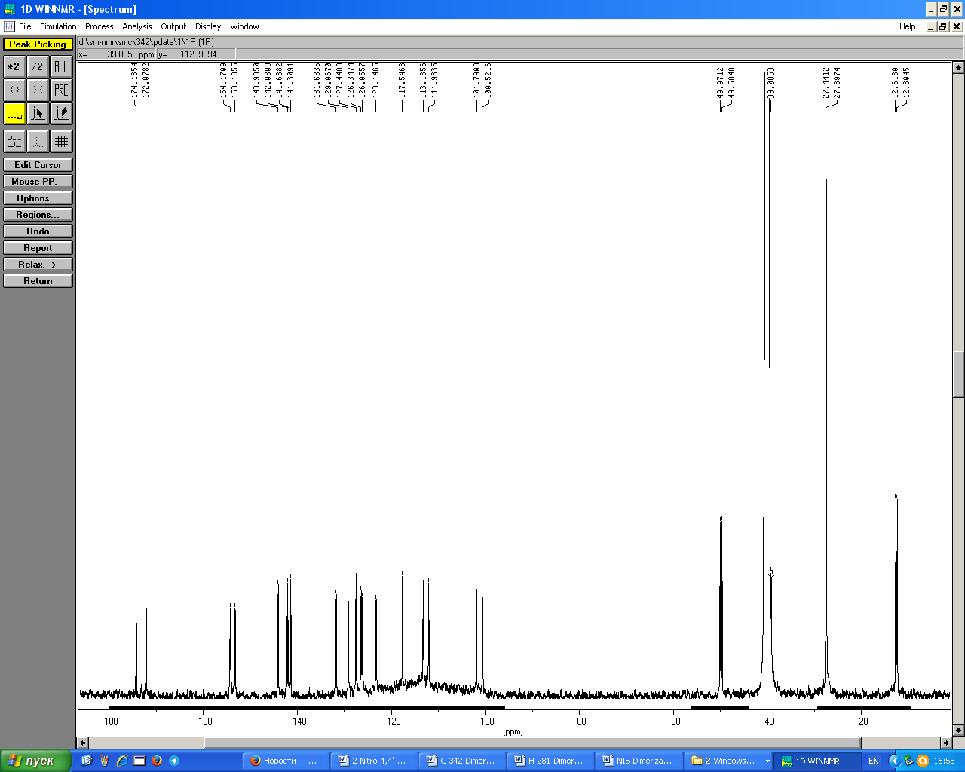
Fig. S6 The ¹³C NMR (100 MHz, DMSO-d₆) spectrum of 7
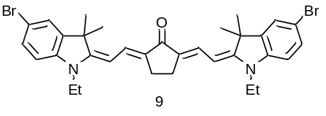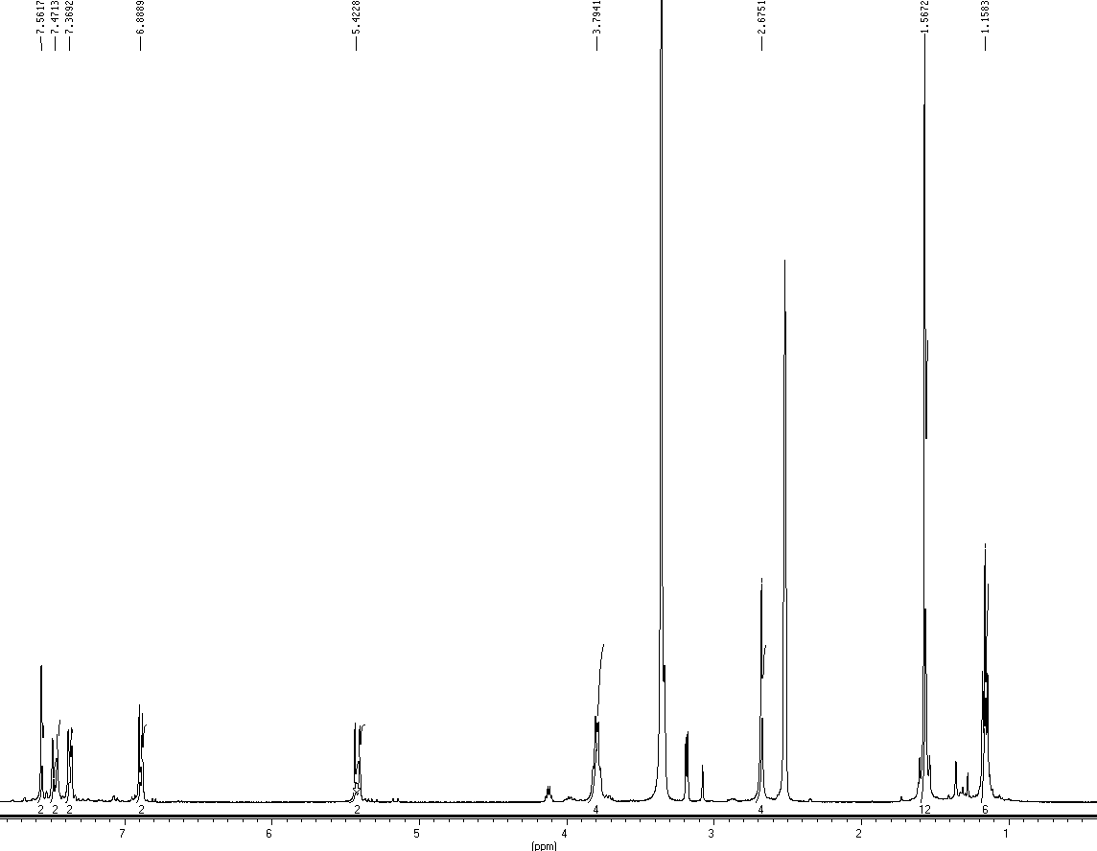
Fig. S7 The ¹H NMR (400 MHz, DMSO-d₆) spectrum of 9

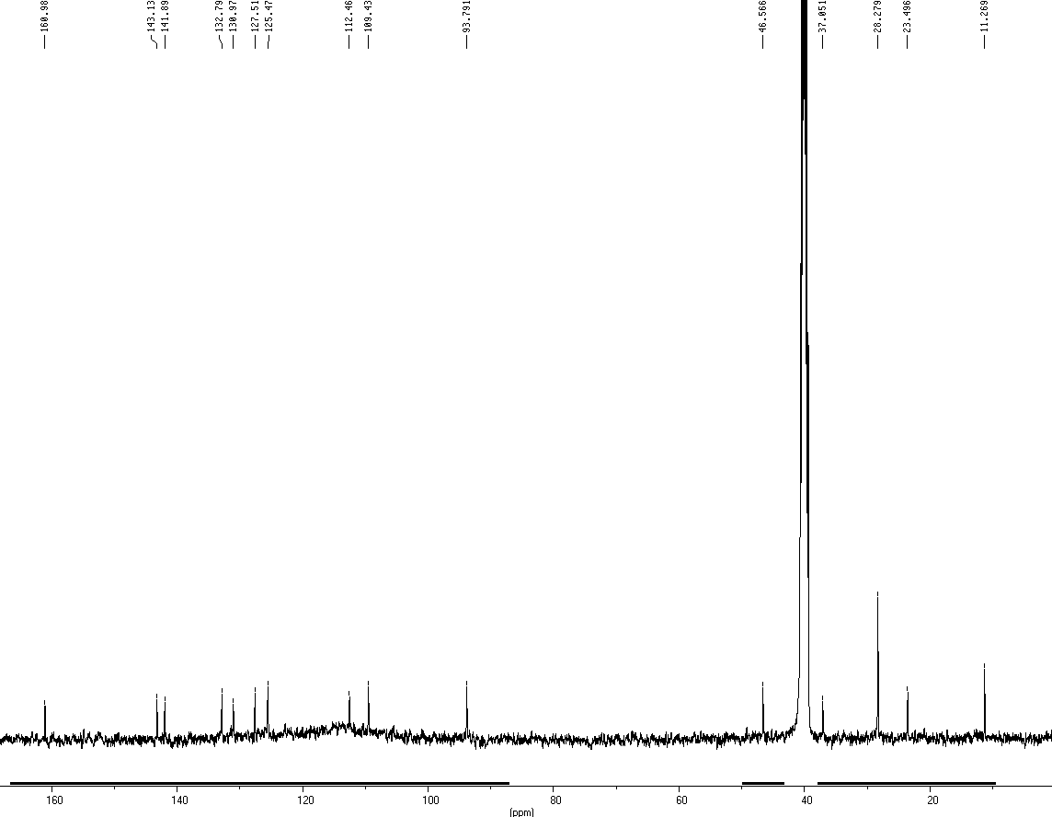
Fig. S8 The ¹³C NMR (100 MHz, DMSO-d₆) spectrum of 9

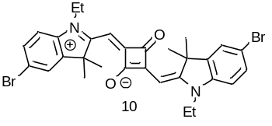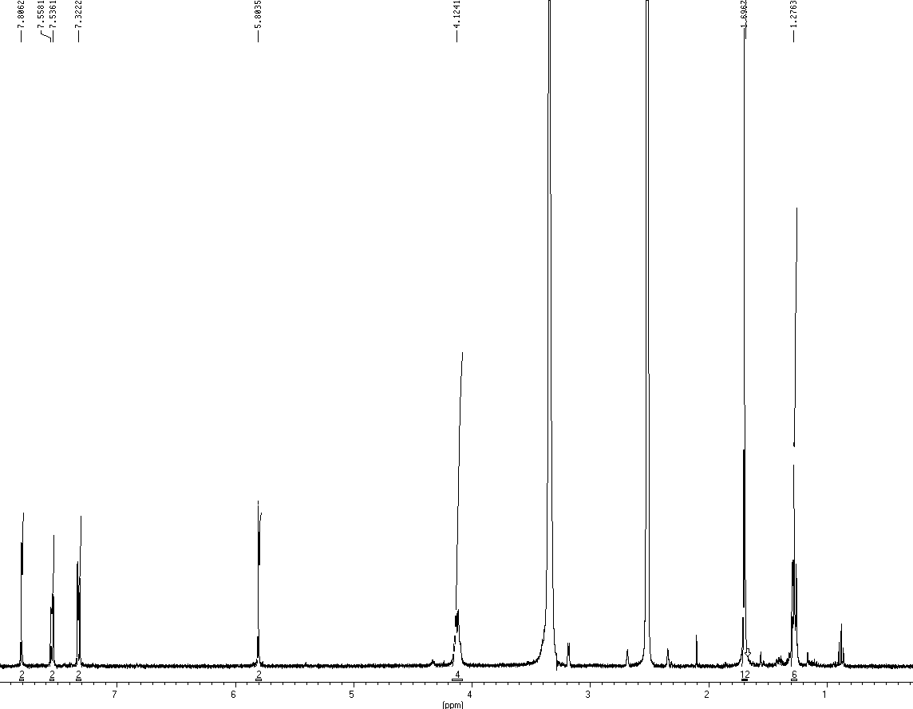
Fig. S9 The ¹H NMR (400 MHz, DMSO-d₆) spectrum of 10

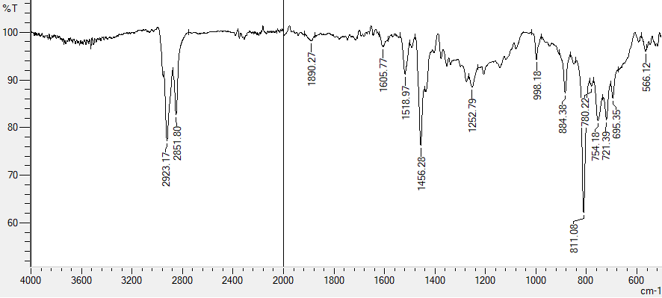
Fig. S10 The IR (ATR) spectrum of CPFPM1

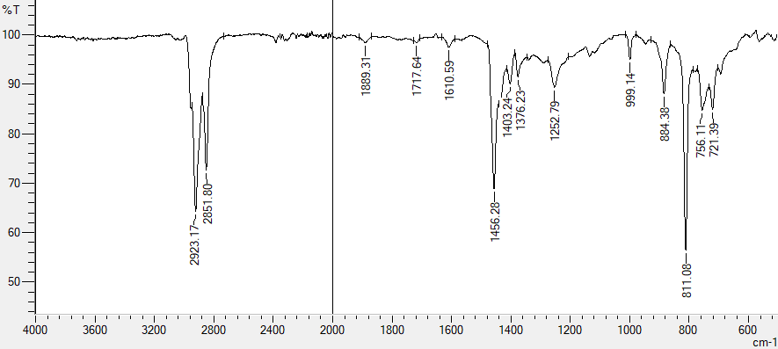
Fig. S11 The IR (ATR) spectrum of CPFPM2

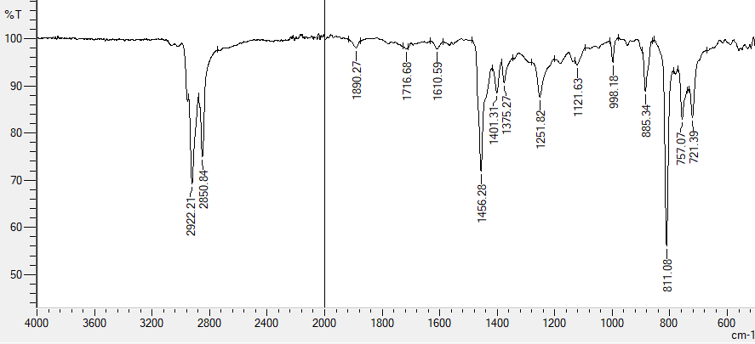
Fig. S12 The IR (ATR) spectrum of CPFPM3

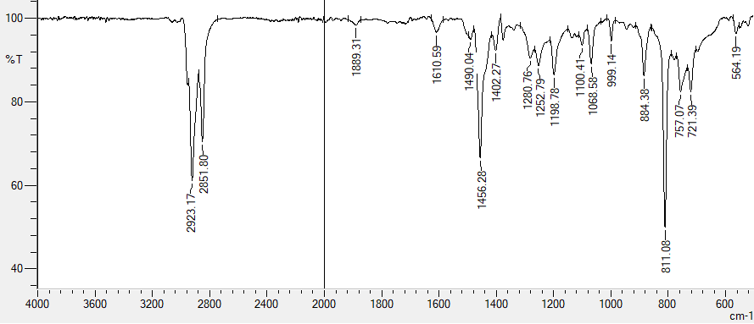
Fig. S13 The IR (ATR) spectrum of CPFPM4

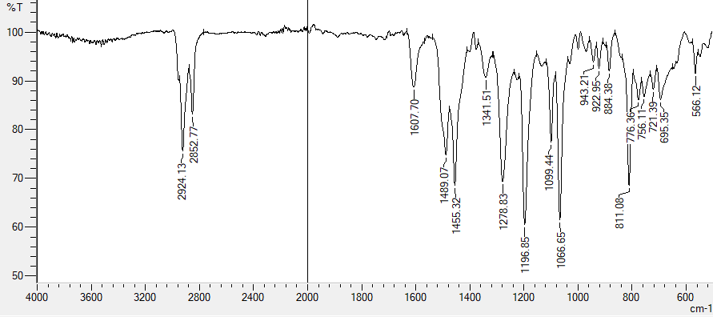
Fig. S14 The IR (ATR) spectrum of CPFPM5

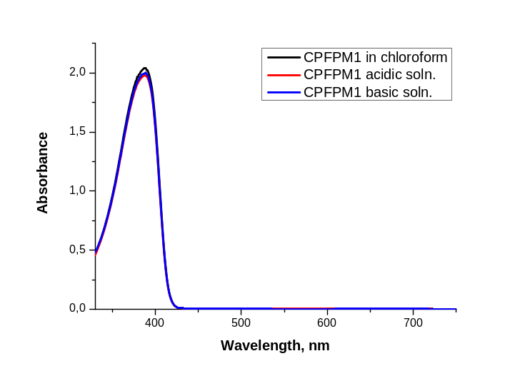
Fig. S15 The UV-Vis spectra of CPFPM1 in chloroform (black line), in chloroform with TFA (red line), in chloroform with TEA (blue line)
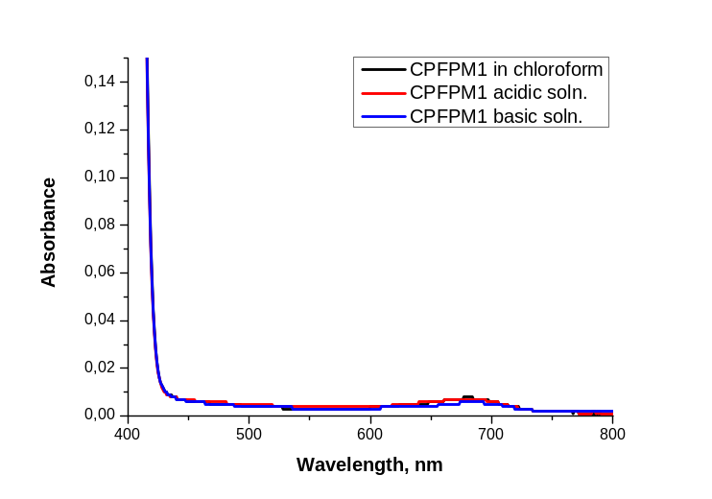
Fig. S16 The UV-Vis spectra of CPFPM1 in chloroform (black line), in chloroform with TFA (red line), in chloroform with TEA (blue line)
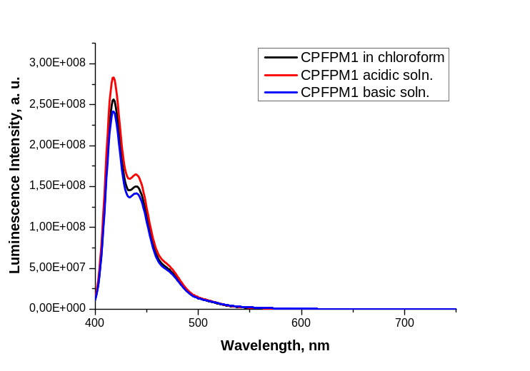
Fig. S17 The fluorescence spectra of CPFPM1 in chloroform (black line), in chloroform with TFA (red line), in chloroform with TEA (blue line)
Fig. S18 The UV-Vis absorption and fluorescence spectra of CPFPM1 in film (blue and black lines, respectively)

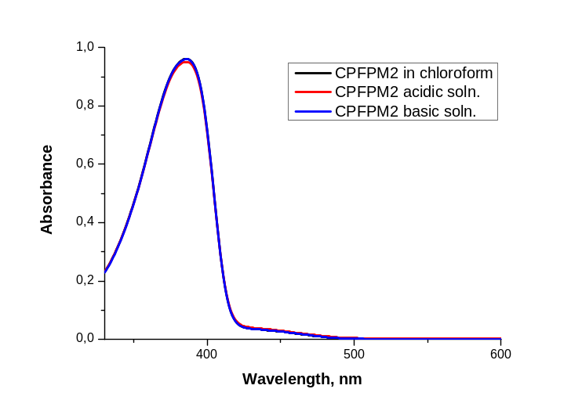
Fig. S19 The UV-Vis spectra of CPFPM2 in chloroform (black line), in chloroform with TFA (red line), in chloroform with TEA (blue line)

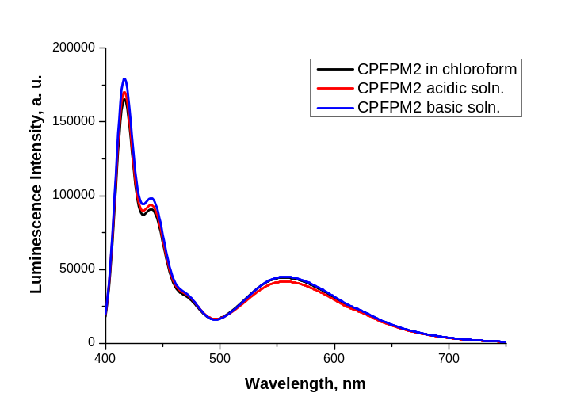
Fig. S20 The fluorescence spectra of CPFPM2 in chloroform (black line), in chloroform with TFA (red line), in chloroform with TEA (blue line)
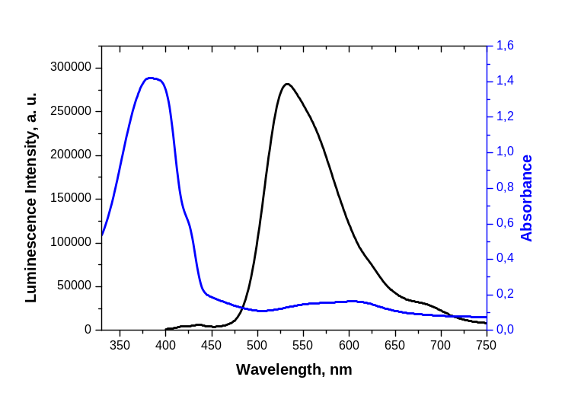
Fig. S21 The UV-Vis absorption and fluorescence spectra of CPFPM2 in film (blue and black lines, respectively)
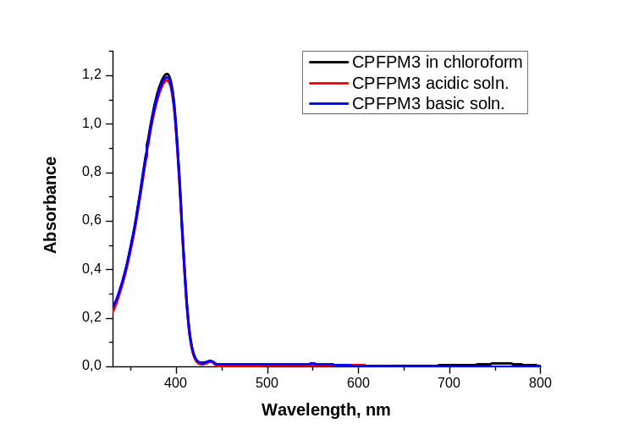
Fig. S22 The UV-Vis spectra of CPFPM3 in chloroform (black line), in chloroform with TFA (red line), in chloroform with TEA (blue line)
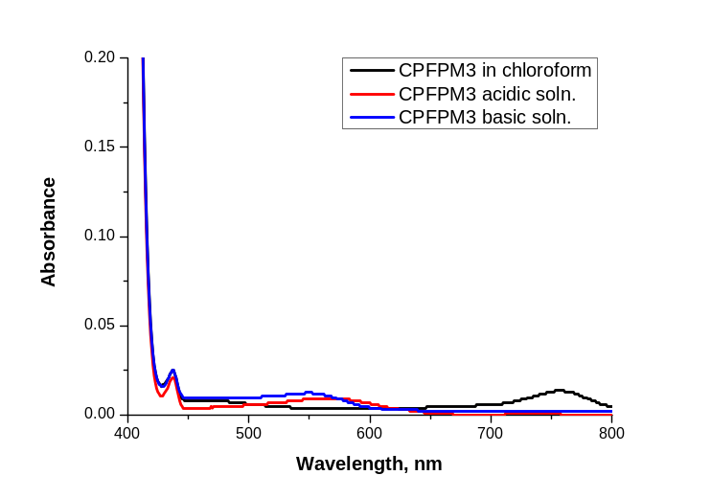
Fig. S23 The UV-Vis spectra of CPFPM3 in chloroform (black line), in chloroform with TFA (red line), in chloroform with TEA (blue line)
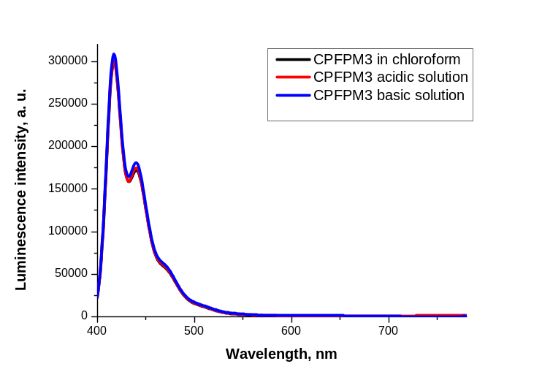
Fig. S24 The fluorescence spectra of CPFPM3 in chloroform (black line), in chloroform with TFA (red line), in chloroform with TEA (blue line)
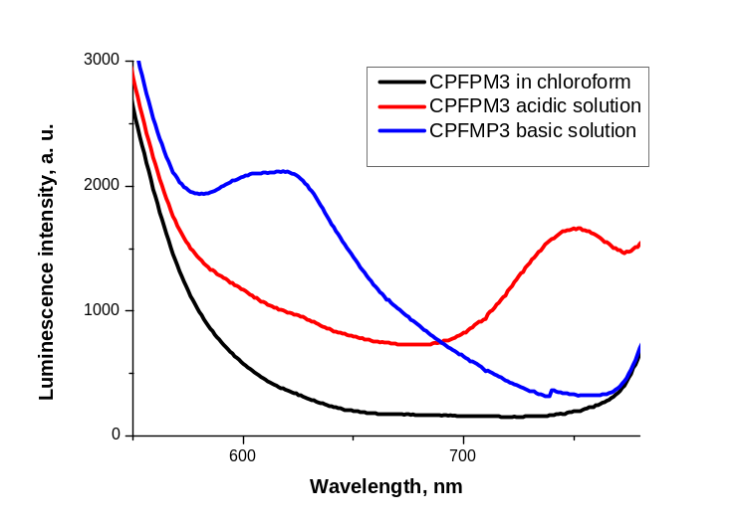
Fig. S25 The fluorescence spectra of CPFPM3 in chloroform (black line), in chloroform with TFA (red line), in chloroform with TEA (blue line)
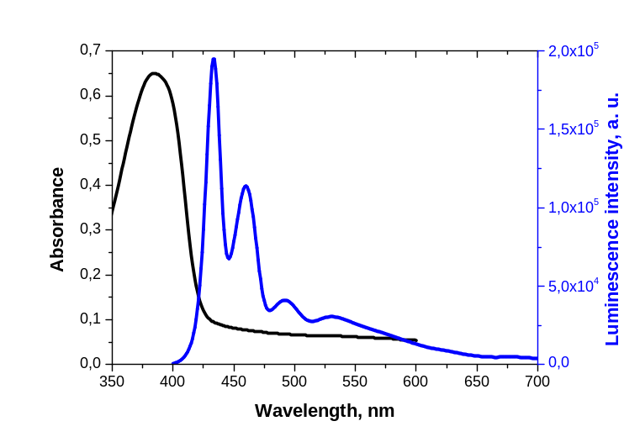
Fig. S26 The UV-Vis absorption and fluorescence spectra of CPFPM3 in film (blue and black lines, respectively)
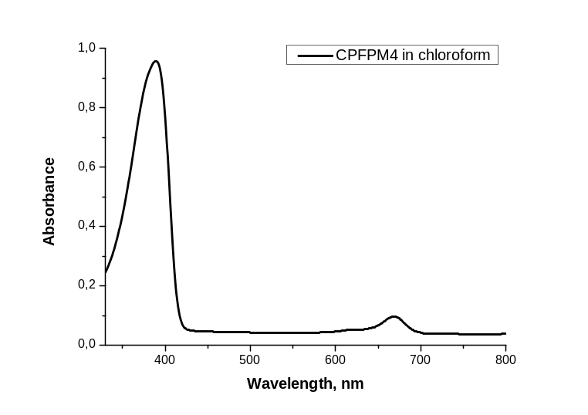
Fig. S27 The UV-Vis spectrum of CPFPM4 in chloroform
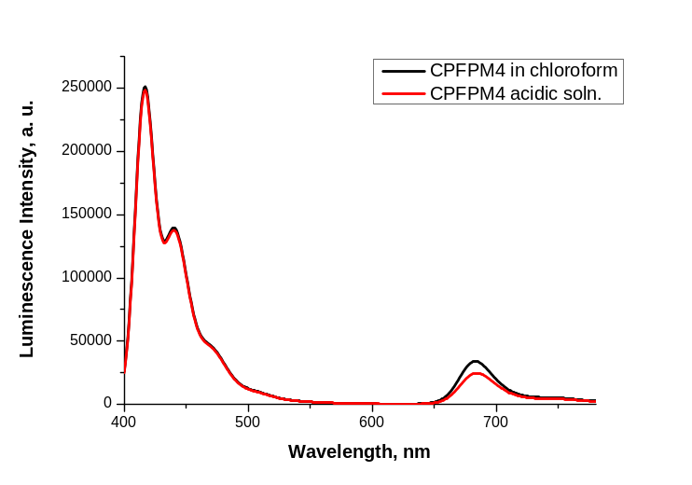
Fig. S28 The fluorescence spectrum of CPFPM4 in chloroform (black line), in chloroform with TFA (red line)
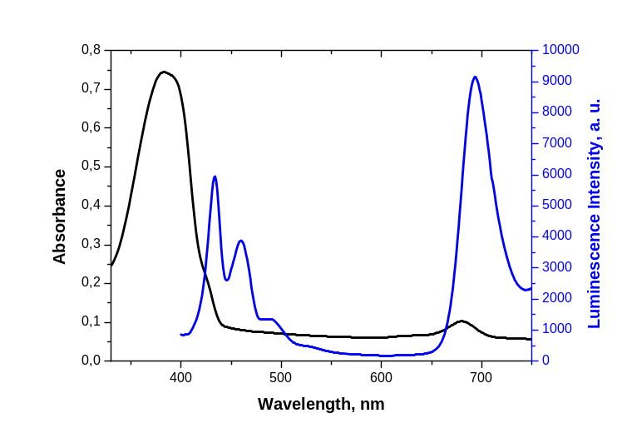
Fig. S29 The UV-Vis absorption and fluorescence spectra of CPFPM4 in film (blue and black lines, respectively)
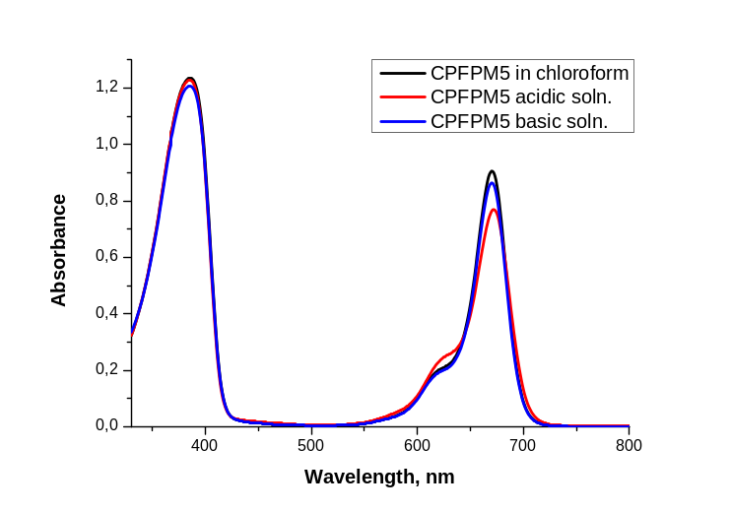
Fig. S30 The UV-Vis spectra of CPFPM5 in chloroform (black line), in chloroform with TFA (red line), in chloroform with TEA (blue line)
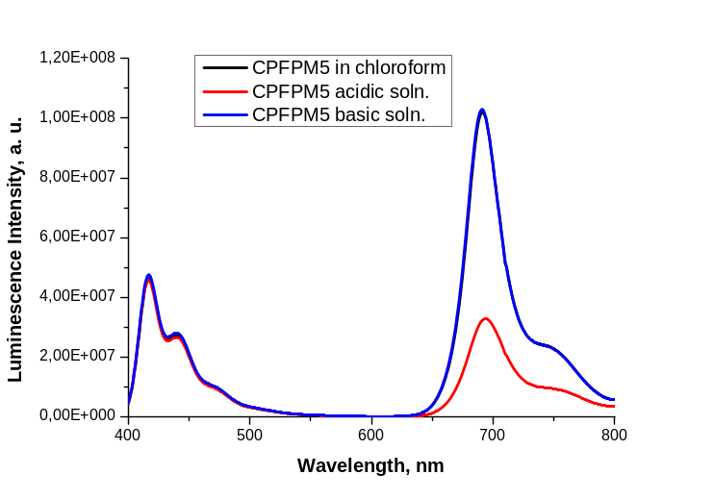
Fig. S31 The fluorescence spectra of CPFPM5 in chloroform (black line), in chloroform with TFA (red line), in chloroform with TEA (blue line)
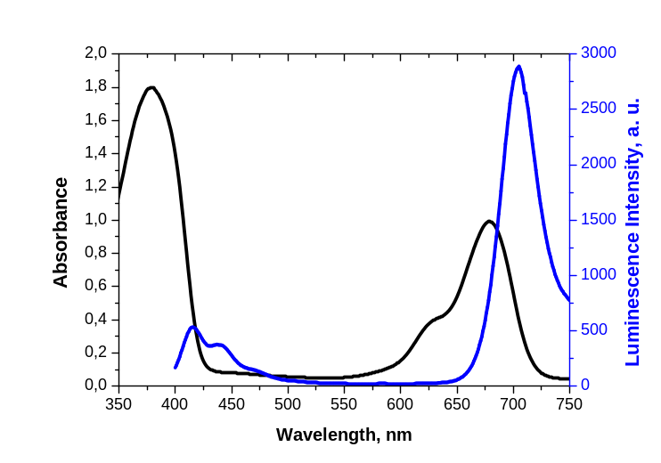
Fig. S32 The UV-Vis absorption and fluorescence spectra of CPFPM5 in film (blue and black lines, respectively)

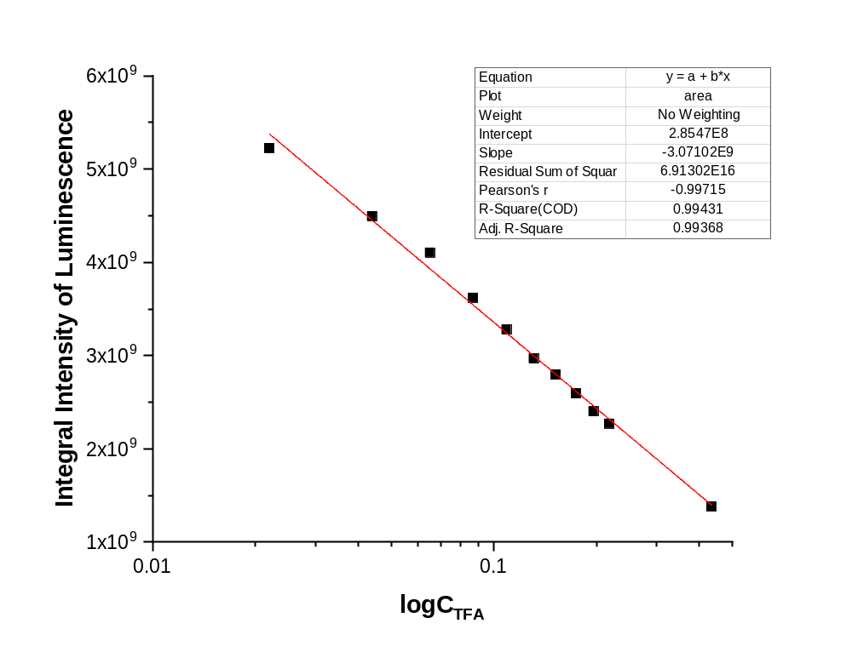
Fig. S33 Plot of of the integral intensity of the luminescence of the long-wavelength band of CPFPM2 against varying logarithm of TFA concentrations

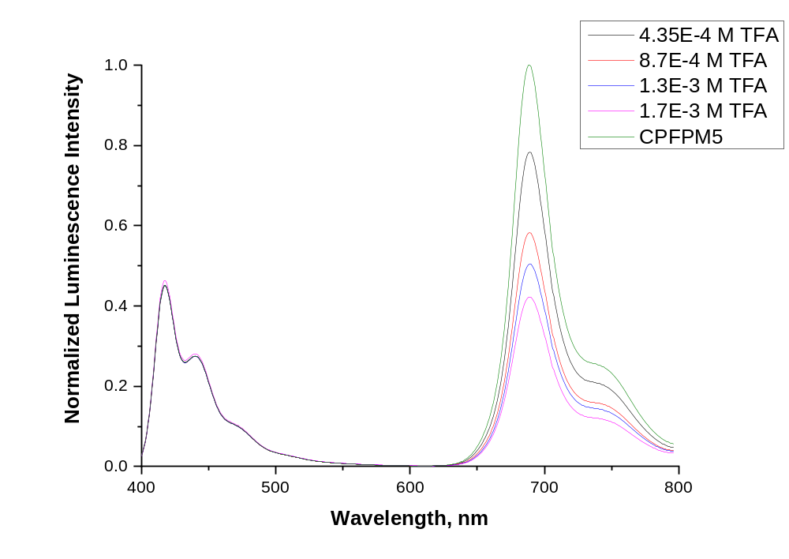
Fig. S34 Luminescence intensites of CPFPM5 in chloroform solution changed with different concentrations of TFA (C_{TFA} = 0 – 1.7⋅10⁻³ M)

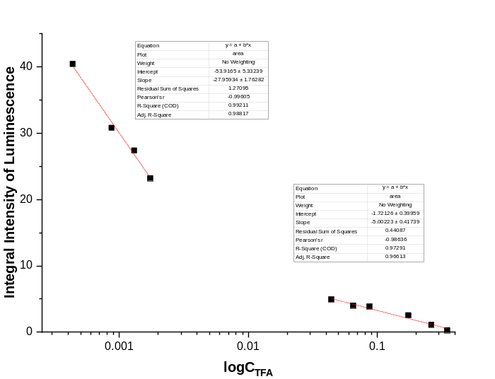
Fig. S35 Plot of of the integral intensity of the luminescence of the long-wavelength band of CPFPM5 against varying logarithm of TFA concentrations

a)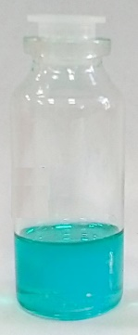 | b)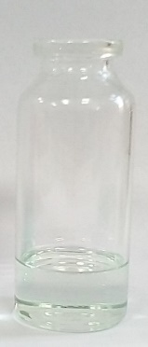
c) | d)
Fig. S36 The color of the CPFPM5 solution in chloroform (a), in chloroform with the addition of TFA (b) and luminescence of the CPFPM5 solution in chloroform (c), in chloroform with the addition of TFA (d)

