Table 1 Composition of synthesized copolyfluorenes
Polymer | PMBr₂ loading (m) | PMBr₂ | BTBr₂ loading (l) | BTBr₂ | X
CPFPM1 | 0.01 | 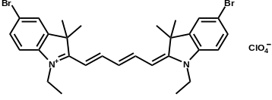 |  |  | OEt
CPFPM2 | 0.01 | 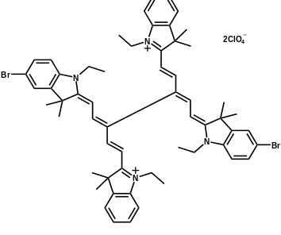 | 0.05 | 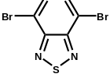 | OEt
CPFPM3 | 0.01 | 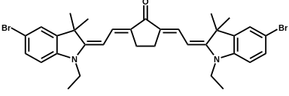 |  |  | OEt
CPFPM4 | 0.01 | 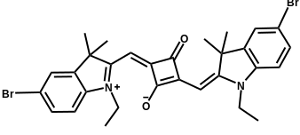 |  |  | OEt
CPFPM5 | 0.1 |  |  |  | OEt

