Qualitative Analysis and Topic Modeling Procedures

Procedure
Given that the sequencing and nature of questions can shape participants’ responses (Schwarz, 1999), each interview followed a consistent structure. It began with open-ended, low-threshold questions, such as inquiries about participants’ roles and positions within the organizational hierarchy. The subsequent questions explored their perceptions of responsibility in leadership, starting with broad, abstract inquiries (e.g., “What does responsible mean to you?”). This approach was guided by the principle that researchers should refrain from imposing predefined theories or constructs—responsible leadership, in this case—on participants (Gioia et al., 2013). By doing so, participants were encouraged to articulate their own conceptualizations and interpretations without being constrained by existing frameworks or predefined examples. Following these foundational questions, participants were asked to describe the characteristics of responsible leaders (e.g., “From your point of view, what characterizes a responsible leader?”) and the behaviors they associate with responsible leadership (e.g., “How would a responsible leader behave?”). Although the primary emphasis of the study was on responsible leadership, questions about irresponsible leadership behaviors were also incorporated. This strategy aimed to mitigate the risk of sampling only the dependent variable (Denrell, 2003). To further explore participants’ experiences, the critical incident technique (Bott & Tourish, 2016) was employed, prompting them to provide concrete examples of situations where they demonstrated responsible leadership behavior. Instead of directly questioning them about their intentions behind responsible leadership behaviors, participants were asked to reflect on the challenges or obstacles they faced in exhibiting such behaviors. This approach allowed researchers to capture participants’ perspectives on the potential gap between their intentions and actual behaviors (Hagger et al., 2022), offering deeper insights into how responsible leadership is enacted in practice.

Pre-Processing the Data
A crucial step in topic modeling is pre-processing the data to ensure that only relevant and meaningful text is analyzed. Following established best practices, extraneous information—such as background details about participants, punctuation, numbers, and symbols—was removed to enhance analytical clarity (Piepenbrink & Gaur, 2017). Additionally, sparse terms, which can introduce noise into the analysis, were identified and excluded based on a minimum document threshold, as recommended by Banks et al. (2018). Specifically, words that appeared in only one document were classified as sparse and eliminated from the dataset to streamline the model and improve its efficiency. Further refinement of the dataset involved the removal of common stop words, which provide minimal semantic value, using the quanteda package in R (Benoit et al., 2018). To prevent the model from being disproportionately influenced by frequently occurring but uninformative terms, domain-specific words such as “responsible,” “responsibility,” and “leadership” were added to the stop word list. While text normalization techniques like stemming and lemmatization are often used to standardize words, Schofield and Mimno (2016) caution that these approaches can oversimplify linguistic structures, potentially diminishing the richness of word relationships in topic modeling. To maintain the integrity of the original textual data, this study retained words in their unmodified forms. Another key decision in pre-processing was determining the appropriate n-gram representation, specifically whether to use unigrams, bigrams, or trigrams. Selecting the right n-gram structure is essential for balancing contextual depth with model complexity (Tonidandel et al., 2022). In this study, bigrams were included a priori, as participants frequently used phrases such as "role model" and "good example," which provide critical contextual meaning. Once all text was converted to lowercase, the data was transformed into a document-term matrix (DTM), which quantifies the frequency of each term (columns) across all documents (rows). As a result, the final processed text corpus comprised 27 documents, 1,138 unique terms, and 7,599 tokens, incorporating both unigrams and bigrams for a more nuanced analysis.

Estimation of the Topic Model
Structured Topic Modeling (STM) enhances traditional topic modeling by allowing for the analysis of topic correlations and the impact of covariates on both content (i.e., how topics are discussed) and prevalence (i.e., how frequently topics appear) (Roberts et al., 2014). In this study, STM was employed to determine the optimal number of topics, with models generated across a range from two to 20 topics. Following the procedure outlined by Roberts et al. (2016), spectral initialization with a fixed seed was used to ensure reproducibility in the results. To select the most appropriate number of topics, multiple evaluation metrics were considered. First, held-out likelihood assesses the model’s predictive accuracy for unseen words, with higher values indicating a well-specified model (Wallach et al., 2009). Second, the dispersion of residuals examines how closely the predicted word frequencies align with observed frequencies, where lower values suggest a better model fit (Taddy, 2012). Third, semantic coherence evaluates the interpretability of topics by measuring how often the most representative words for a given topic co-occur. Higher coherence values indicate that topics are more meaningful and easier to interpret (Mimno et al., 2011). As illustrated in Figure 1, held-out likelihood declined after four topics but stabilized at five and six, suggesting similar predictive performance between these models. Residual dispersion showed a slight increase between four and six topics, indicating a marginal decline in fit. Semantic coherence peaked at four topics, dropped slightly between four and five, and remained relatively stable from six to nine topics.
Figure 1
Comparison of solutions for topics spanning 2–20.
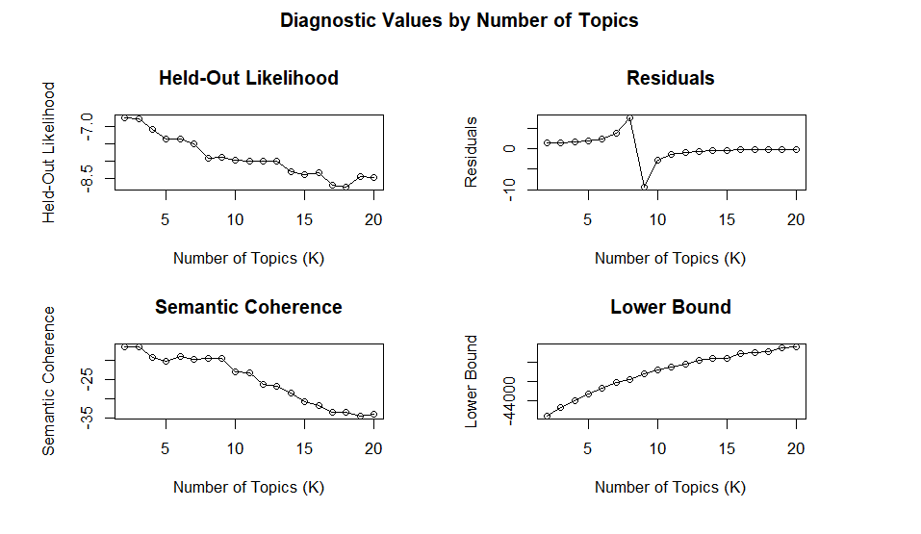
Based on these statistical indicators, the four-, five-, and six-topic models were further examined, as they demonstrated strong model fit. To refine this selection, word exclusivity, which measures how uniquely the most probable words belong to a single topic, was analyzed (Schmiedel et al., 2019). While the four-topic model exhibited the highest coherence, its lower exclusivity made topics less distinct. Conversely, the six-topic model improved exclusivity but at the cost of coherence, reducing overall interpretability. Given this trade-off, the five-topic model was selected as the optimal solution, striking a balance between coherence and distinctiveness, thereby best capturing the underlying structure of the data (see Figure 2).

Figure 2
Comparing semantic coherence and exclusivity of four-, five-, and six-topic model
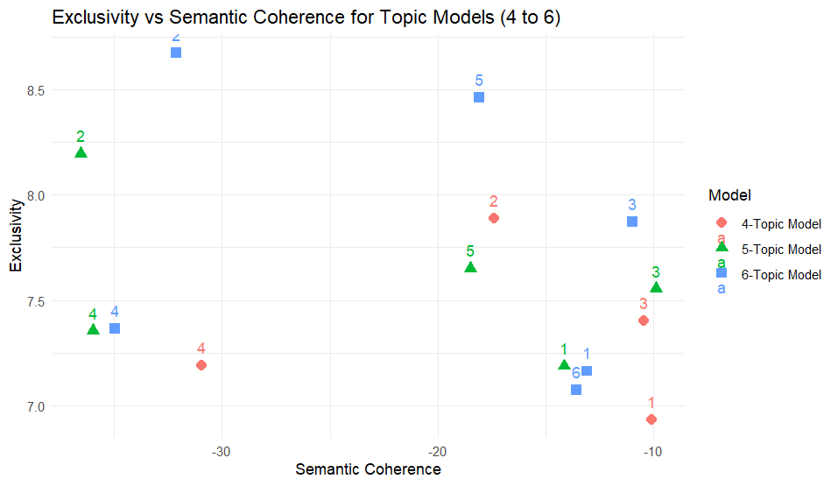

Interpretation of the Topic Model
To enhance validity and interpretability, topic modeling requires a researcher-driven inductive approach to assess the face validity of the identified topics (Schmiedel et al., 2019). In this study, established best practices in topic modeling were followed to assign topic labels, define content, and select key representative quotes that illustrate each topic (Banks et al., 2018). The process began by examining correlations between topics to assess potential conceptual overlap. As shown in Table 1, small negative correlations between topics (ranging from -0.20 to -0.29) indicated that the topics were conceptually distinct, ruling out concerns regarding dimensionality issues.
Table 1
Topic-Correlation matrix
Topic | 1 | 2 | 3 | 4 | 5
1 | 1 | -0.29 | -0.26 | -0.28 | -0.24
2 | -0.29 | 1 | -0.25 | -0.22 | -0.21
3 | -0.26 | -0.25 | 1 | -0.26 | -0.20
4 | -0.28 | -0.22 | -0.26 | 1 | -0.24
5 | -0.24 | -0.21 | -0.20 | -0.24 | 1

Additionally, an analysis of topic distribution revealed a relatively even representation, with Topic 1 appearing most frequently and Topic 5 the least, though these differences were not substantial (see Figure 3). This further reinforced the independence of the topics, strengthening their interpretability.
Figure 3
Topic proportions (i.e., percentage of data coverage) of the five-topic model.
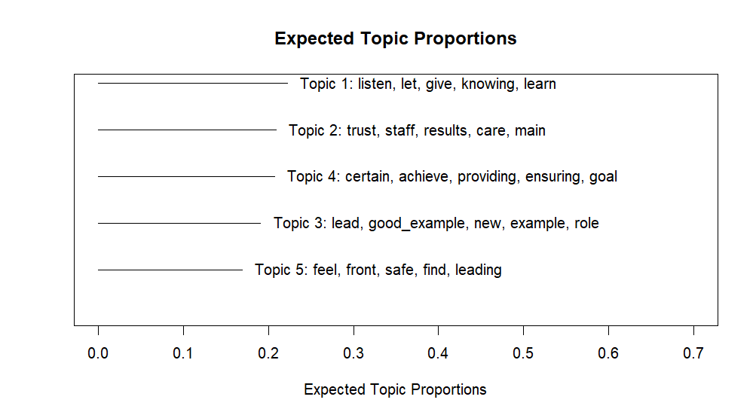
The next phase involved interpreting topic content using four key lexical metrics: highest probability, FREX, lift, and score words (Roberts et al., 2019). Through an iterative process, the research team systematically analyzed these words, refining topic labels by comparing emergent themes against the text data while also aligning them with the existing literature. During these discussions, the team addressed key conceptual questions, including: “How are these topics similar?”, “How do they differ?”, and “If they are distinct, in what way?” (for a similar approach, see Banks et al., 2018; Stock et al., 2022). The analysis concluded once the research team reached a consensus on the final topic labels and definitions, with illustrative examples selected directly from the data. To provide clear evidence of how topics were grounded in the qualitative dataset, representative quotes were extracted and summarized in Table 2, along with topic descriptions, top word lists, and example statements.

Table 2
Final five topic model with topic labels, topic descriptions, top words, and example statements
Topic Label | Description | FREX | Highest Prob | Lift | Score | Example Statements
Humility | Leaders' intention to learn from others’ inputs, and give recognition to their strengths while acknowledging personal weaknesses | listen, let, give, knowing, learn | people, make, say, leader, work | afraid, afraid_making, bit_feeling, build, choose | coworkers, price, listen, input, colleagues | It is very important to listen to the others, get their point of views. And actually make the whole team work as a unit. (P9).
Selflessness | Leaders' intention to care for their staff and prioritize collective success over personal interests by ensuring that their results are valued as much as their own. | trust, staff, results, care, main | people, care, say, work, important | dependent, factors, make_understand, perspective, physically | physically, staff, working_direction, topics, main | I would say an irresponsible leader is someone who puts themselves in front of everyone else and takes credit for others' achievements (P12).
Being a Positive Role Model | Leaders' intention to lead by example by serving as role models | lead, good_example, example, new, role | leader, people, say, employees, person | conversations_employees, delivering, divided, get_person, gm | supervisor, receptionist, good_example, opportunities, sustainability | Working as a role model, I hope. It is my top priority […]. Being a good example for my employees (P18).
Fulfilling Stakeholders' Needs | Leaders' intention to achieve goals that ensure stakeholder satisfaction and provide outcomes that align with their expectations. | certain, achieve, providing, ensuring, goal | leader, team, people, work, person | providing, achieved, achieving, achieving_goals, address | certain, providing, ensuring, satisfaction, believe | Responsible means being accountable for producing a certain result. It means you are the person who has to put actions in place to ensure that a certain result is achieved (P23).
Balancing Stakeholders' Needs | Leaders' intention to find a balance between competing demands of stakeholder to make them feel valued. | feel, front, safe, find, leading | people, work, make, employees, feel | safe, fixing, hardest, hardest_part, job_hard | fixing, safe, honest, quite_important, hardest | You want to have a balance at the end of the day. Because you could be very good and exceed in one goal, but that might be in favor or disfavor of another. If you are not able to achieve all of them, you want to balance how you can maintain money. I would say money is satisfaction, guest satisfaction, and employee satisfaction, right? It is always a balance (P22).

To further refine the thematic structure, this study categorized subcategories based on the framework proposed by Doldor et al. (2019). The analysis focused on 93% (N = 25) of the documents, where document-topic loadings exceeded 0.5, ensuring that subcategories were derived from documents with the strongest topic representation. Using the five topics as an initial framework, the research team conducted a systematic coding process, identifying semantic variations within the data. To enhance coding reliability, three independent researchers classified the identified subcategories under the five main topics. This validation process resulted in a substantial level of agreement, with a κ coefficient of 0.645 (Doldor et al., 2019; Fleiss, 1971). A comprehensive summary of the categories, subcategories, and corresponding illustrative quotes is presented in Figure 4.

Figure 4
Framework derived from the data
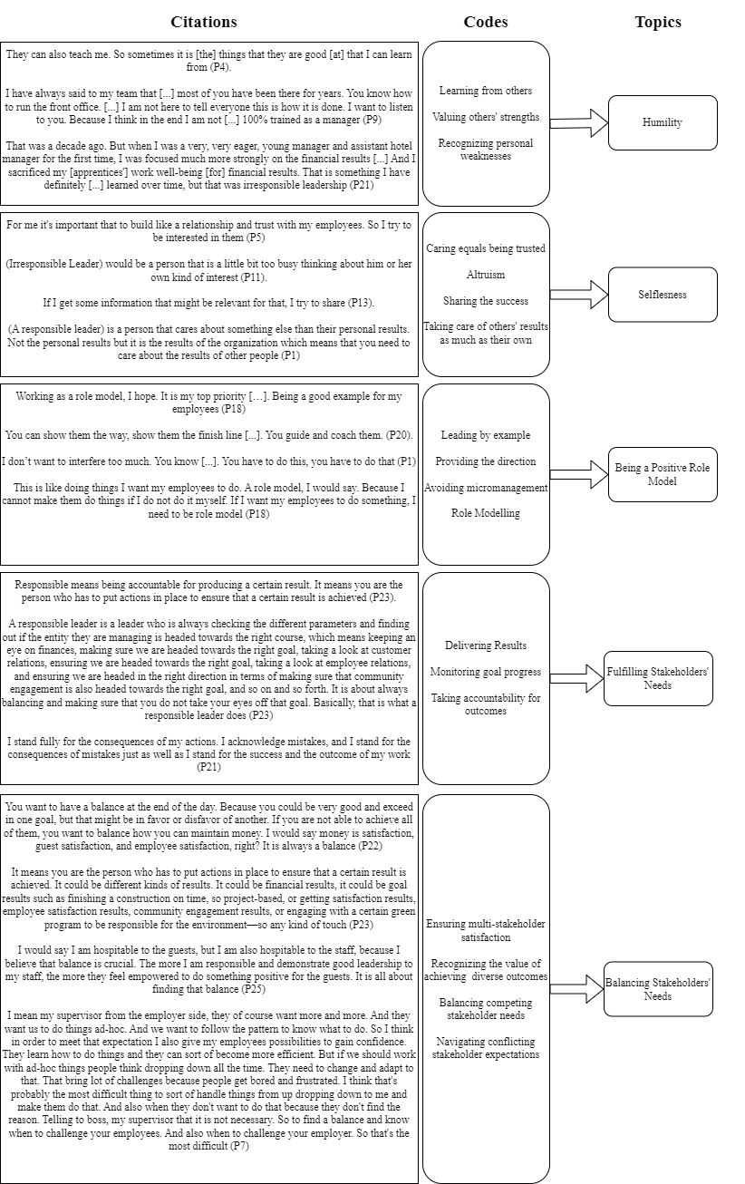

Results
Topic modeling revealed five distinct themes that align with key attributes identified in the literature review: (1) humility, (2) selflessness, (3) being a positive role model, (4) fulfilling stakeholders’ needs, and (5) balancing stakeholders’ needs. These themes were derived from the qualitative dataset and provide empirical insights into the structure of RLIs.
The first topic, humility, accounted for 22.25% of the analyzed data and captures leaders’ intentions to actively listen, learn from others, and acknowledge their own limitations. Leaders demonstrating this intention emphasize that responsible leadership requires recognizing their own weaknesses and valuing team members' strengths. This topic consists of three subcategories: learning from others, valuing others' strengths, and recognizing personal weaknesses.
The second topic, selflessness, emerged in 20.93% of the data and reflects leaders’ intentions to prioritize the needs of others over their personal interests. This topic includes caring as a foundation of trust, altruism, sharing success, and taking responsibility for others’ achievements. Leaders exhibiting selflessness demonstrate a genuine interest in their employees' well-being and emphasize collective over individual success.
The third topic, being a positive role model, represented 19.11% of the dataset and centers on leaders' intentions to lead by example and inspire others through their actions. This theme highlights an egalitarian approach to leadership that emphasizes providing direction, leading by example, avoiding micromanagement, and demonstrating role-model behaviors. Leaders who embody this intention aim to influence others through their conduct rather than relying on hierarchical authority.
The fourth topic, fulfilling stakeholders’ needs, was present in 19.11% of the data and highlights leaders' intentions to achieve specific goals that address stakeholder expectations. This theme captures a goal-oriented approach to responsibility, where leaders set clear objectives and monitor progress to ensure they meet diverse stakeholder demands. Subcategories within this topic include delivering results, monitoring progress, and taking accountability for outcomes.
The final topic, balancing stakeholders’ needs, accounted for 16.97% of the data and reflects the complexity of managing competing stakeholder demands. This theme involves leaders' intentions to navigate conflicting expectations and prioritize fairness when addressing multiple stakeholder concerns. Subcategories include ensuring multi-stakeholder satisfaction, balancing competing needs, and navigating conflicting stakeholder expectations. Unlike the previous theme, which focuses on goal achievement, this topic emphasizes the challenges of harmonizing diverse interests while maintaining equity in decision-making.

References
Banks, G. C., Woznyj, H. M., Wesslen, R. S., & Ross, R. L. (2018). A review of best practice recommendations for text analysis in R (and a user-friendly app). Journal of business and psychology, 33, 445-459.
Benoit, K., Watanabe, K., Wang, H., Nulty, P., Obeng, A., Müller, S., & Matsuo, A. (2018). quanteda: An R package for the quantitative analysis of textual data. Journal of Open Source Software, 3(30), 774-774.
Bott, G., & Tourish, D. (2016). The critical incident technique reappraised: Using critical incidents to illuminate organizational practices and build theory. Qualitative Research in Organizations and Management: An International Journal, 11(4), 276-300.
Denrell, J. (2003). Vicarious learning, undersampling of failure, and the myths of management. Organization Science, 14(3), 227-243.
Doldor, E., Wyatt, M., & Silvester, J. (2019). Statesmen or cheerleaders? Using topic modeling to examine gendered messages in narrative developmental feedback for leaders. The Leadership Quarterly, 30(5), 101308.
Fleiss, J. L. (1971). Measuring nominal scale agreement among many raters. Psychological bulletin, 76(5), 378.
Gioia, D. A., Corley, K. G., & Hamilton, A. L. (2013). Seeking qualitative rigor in inductive research: Notes on the Gioia methodology. Organizational Research Methods, 16(1), 15-31.
Hagger, M. S., Cheung, M. W.-L., Ajzen, I., & Hamilton, K. (2022). Perceived behavioral control moderating effects in the theory of planned behavior: A meta-analysis. Health Psychology, 41(2), 155.
Mimno, D., Wallach, H., Talley, E., Leenders, M., & McCallum, A. (2011). Optimizing semantic coherence in topic models. Proceedings of the 2011 conference on empirical methods in natural language processing,
Piepenbrink, A., & Gaur, A. S. (2017). Topic models as a novel approach to identify themes in content analysis. Academy of Management Proceedings,
Roberts, M. E., Stewart, B. M., & Tingley, D. (2016). Navigating the local modes of big data. Computational social science, 51(91), 1-40.
Roberts, M. E., Stewart, B. M., & Tingley, D. (2019). Stm: An R package for structural topic models. Journal of statistical software, 91, 1-40.
Roberts, M. E., Stewart, B. M., Tingley, D., Lucas, C., Leder‐Luis, J., Gadarian, S. K., Albertson, B., & Rand, D. G. (2014). Structural topic models for open‐ended survey responses. American journal of political science, 58(4), 1064-1082.
Schmiedel, T., Müller, O., & Vom Brocke, J. (2019). Topic modeling as a strategy of inquiry in organizational research: A tutorial with an application example on organizational culture. Organizational Research Methods, 22(4), 941-968.
Schofield, A., & Mimno, D. (2016). Comparing apples to apple: The effects of stemmers on topic models. Transactions of the Association for Computational Linguistics, 4, 287-300.
Schwarz, N. (1999). Self-reports: How the questions shape the answers. American psychologist, 54(2), 93.
Stock, G., Banks, G. C., Voss, E. N., Tonidandel, S., & Woznyj, H. (2022). Putting leader (follower) behavior back into transformational leadership: A theoretical and empirical course correction. The Leadership Quarterly, 101632.
Taddy, M. (2012). On estimation and selection for topic models. Artificial intelligence and statistics,
Tonidandel, S., Summerville, K. M., Gentry, W. A., & Young, S. F. (2022). Using structural topic modeling to gain insight into challenges faced by leaders. The Leadership Quarterly, 33(5), 101576.
Wallach, H. M., Murray, I., Salakhutdinov, R., & Mimno, D. (2009). Evaluation methods for topic models. Proceedings of the 26th annual international conference on machine learning,

