Supplementary Materials
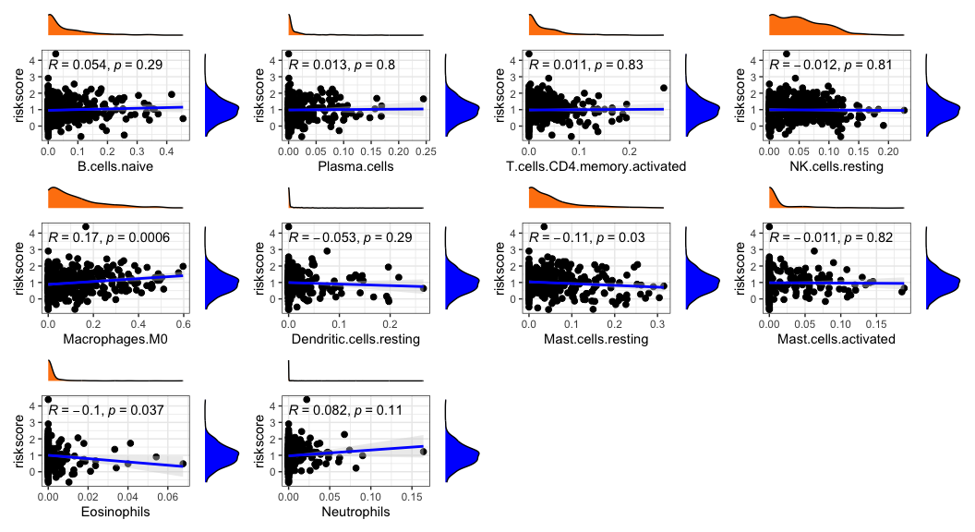
Figure S1. Association between risk score and other tumor immune infiltrating cells.
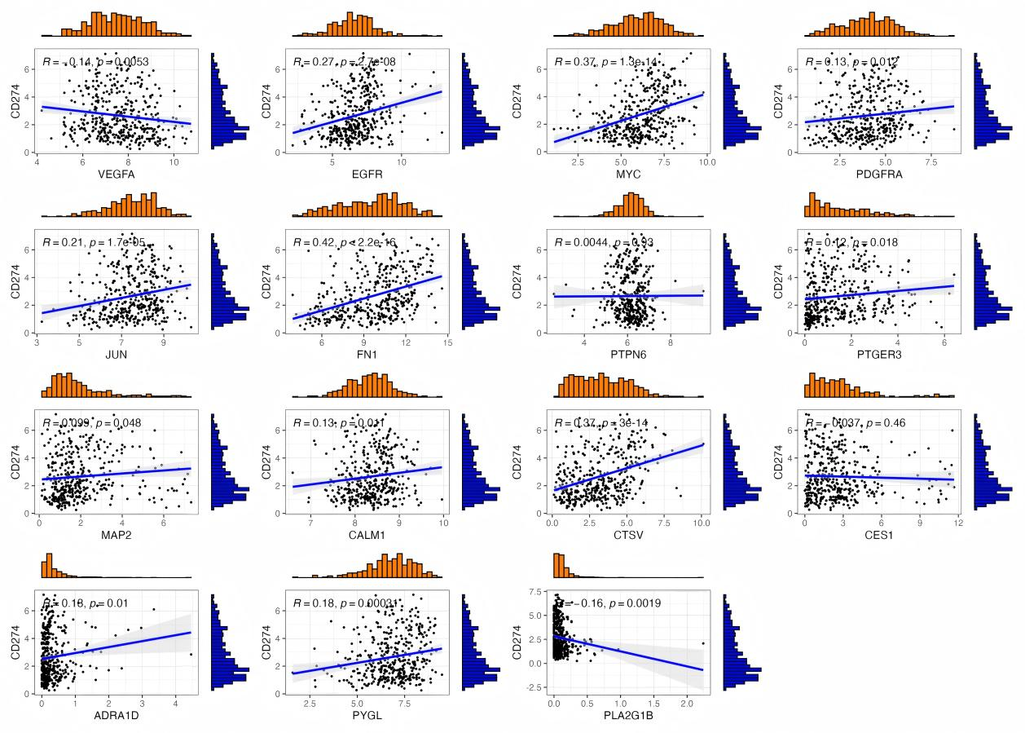
Figure S2. Correlation analysis between model genes and CD274 (PD-L1).
Figure S3. The optimal docking images between three major compounds and PLA2G1B and PYGL.
Table S1. Prognostic genes associated with overall survival in bladder cancer patients from the TCGA cohort. (See the Supplementary Materials 1 for details.)

