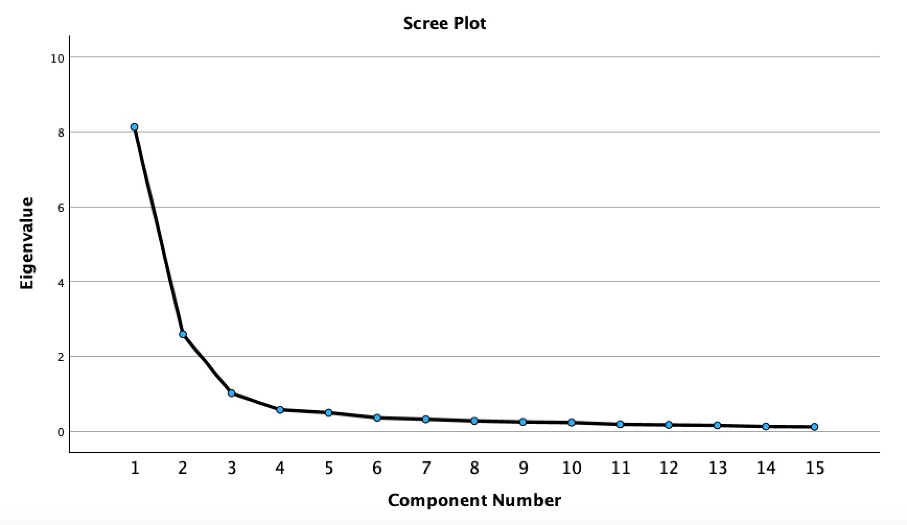
Figure 1. Scree Plot
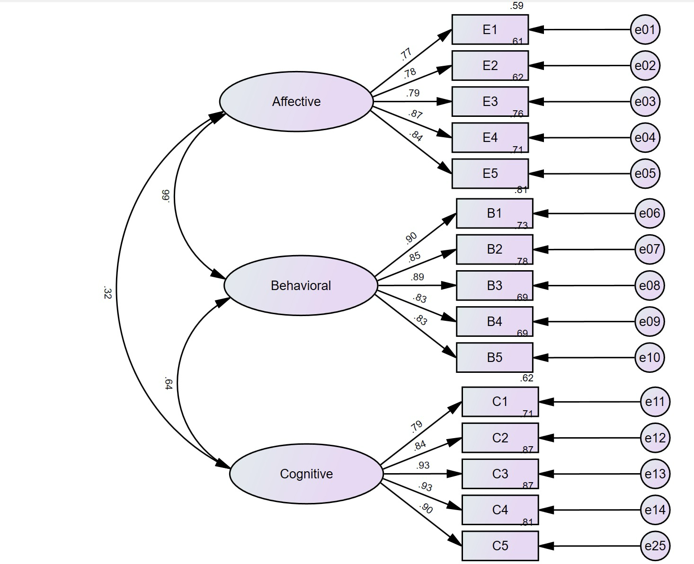
Figure 2. Three-factor Structure of Academic Tangping Scale

