Supplementary figures

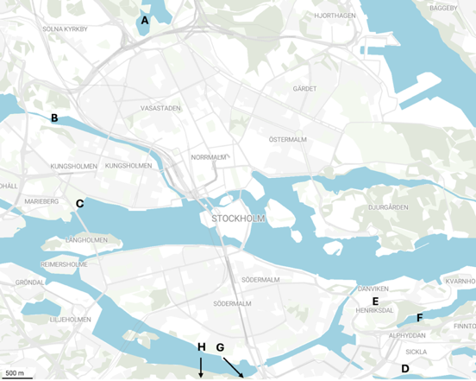

Supplementary figure 1. Map of water sampling locations in Stockholm, Sweden. Brunnsviken in Hagaparken (A), Karlbergskanalen (B), Rålambshovsparken (C), Sickla Inlet (D), Henriksdal Inlet (E), Henriksdal Outlet (F), Tyresö Fiskarholmen (G), Nynäshamn (H). A, B and C are urban freshwater sites. E, F and D are from the wastewater treatment plant. H and G are not seen on the map, these samples are from brackish water. https://app.datawrapper.de/edit/e5IV1/design

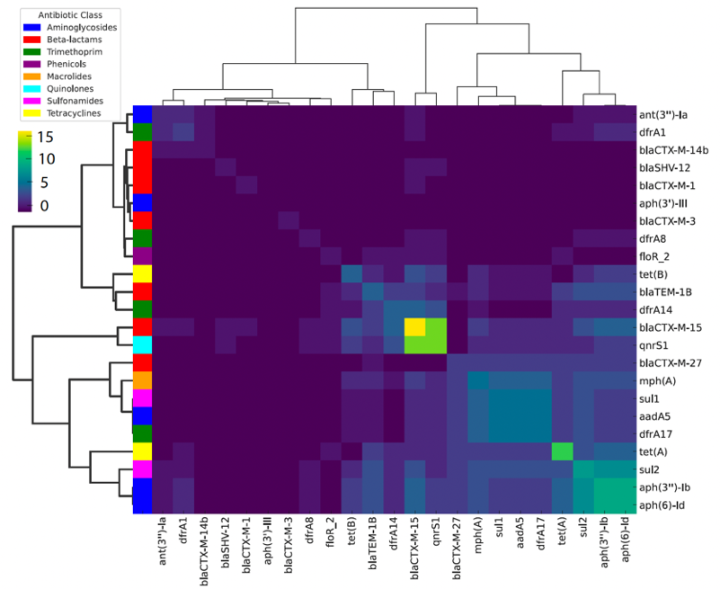
Supplementary figure 2. Co-occurrence of antibiotic resistance genes (ARGs) in the isolates from Stockholm. Clustering on the y and upper x-axis indicates the isolates involved in the analysis. Colour intensity (blue to yellow) indicates more frequent co-occurrence. The most commonly found ARG was bla_{CTX-M-15} and the co-occurrence of bla_{CTX-M-15} and qnrS1 is the most frequent. The mdf(A) ARG was removed from this analysis since it is present in all isolates. Correlation was used as the clustering method and the pheatmap R program was used to generate the heatmap.

