Design and Synthesis of Fluorophore-tagged Disparlure Enantiomers to Study Pheromone Enantiomer Discrimination in the Pheromone-Binding Proteins from the Gypsy Moth, Lymantria dispar.
Govardhana R. Pinnelli, Erika Plettner*
¹Dept. of Chemistry, Simon Fraser University, 8888 University Dr., Burnaby B. C. V5A 1S6, Canada
* Author for correspondence (plettner@sfu.ca)

Table of Contents
Synthesis of ethylene glycol linker 5 3
Synthesis of key intermediate epoxy alcohol ent-4 4
Synthesis of 6-FAM tagged (-)-disparlure ent-1a 5
Determination of enantiomeric excess of epoxy alkynes 31 and ent-31 6
Preparation of (S)-12-(benzyloxy)-2-chlorododecanal (ent-22) 6
Preparation of (7R,8S)-18-(benzyloxy)-8-chloro-2-methyloctadec-5-yn-7-ol (ent-24) 7
Preparation of (7S,8S)-8-chloro-18-hydroxy-2-methyloctadecan-7-yl benzoate (ent-27). 8
Preparation of (11R,12S)-11,12-epoxy-17-methyl-octadecan-1-ol (ent-4) 8
Preparation of 10-((2R,3S)-3-(5-methylhexyl)oxiran-2-yl)decyl 2-(2-(prop-2-yn-1-yloxy)ethoxy)acetate (ent-31) 9
General procedure for the synthesis of the compounds 36 and ent-36 10
¹H & ¹³C NMR spectra 12
HRMS spectra of 6-FAM (+)-disparlure (1a) 26
¹H & ¹³C NMR spectra 27
HRMS spectra of 6-FAM (-)-disparlure (ent-1a) 34
¹H & ¹³C NMR spectra 35
HPLC chromatograms 38
Determination of quantum yield for 6-FAM (+)-disparlure 1a in phosphate buffer (pH 8) 40
Determination of molar extinction coefficient for 6-FAM (+)-disparlure 1a 43
6-FAM (+)-disparlure 1a emission spectra. 1a bound to LdisPBP2 44
6-FAM (-)-disparlure ent-1a emission spectra. ent-1a bound to LdisPBP1 45
6-FAM (-)-disparlure ent-1a emission spectra. ent-1a bound to LdisPBP2 46
Competition of fluorescent disparlure enantiomers binding to LdisPBP1 and LdisPBP2 by disparlure enantiomers 47

Synthesis of ethylene glycol linker 5
The monopropargylation of diethylene glycol (28) was achieved using equimolar amounts of propargyl bromide (29) and NaH, which led to the propargyl ether precursor 30 with 54 % yield. The alcohol 30 was efficiently converted to the corresponding acid 5 by treating it with oxidizing agent NaOCl (sodium hypochlorite) and TEMPO (2,2,6,6-Tetramethylpiperidin-1-yl) oxidanyl) as a catalyst.
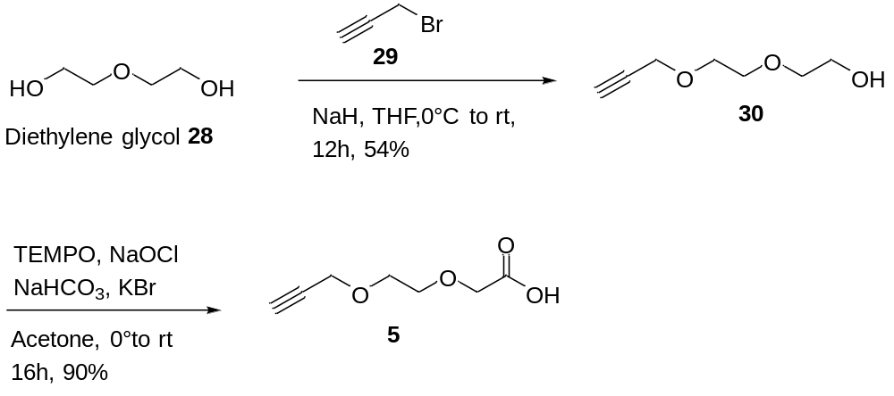
Scheme S1. Synthetic route to ethylene glycol linker 5

Synthesis of key intermediate epoxy alcohol ent-4
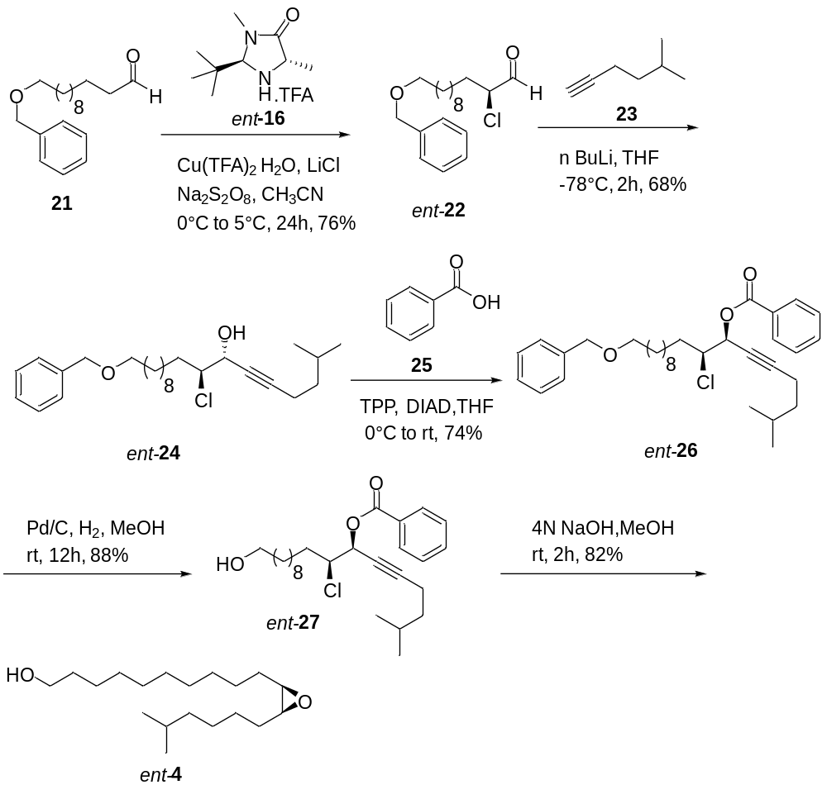
Scheme S2. Syntheis of epoxy alcohol ent-4

Synthesis of 6-FAM tagged (-)-disparlure ent-1a
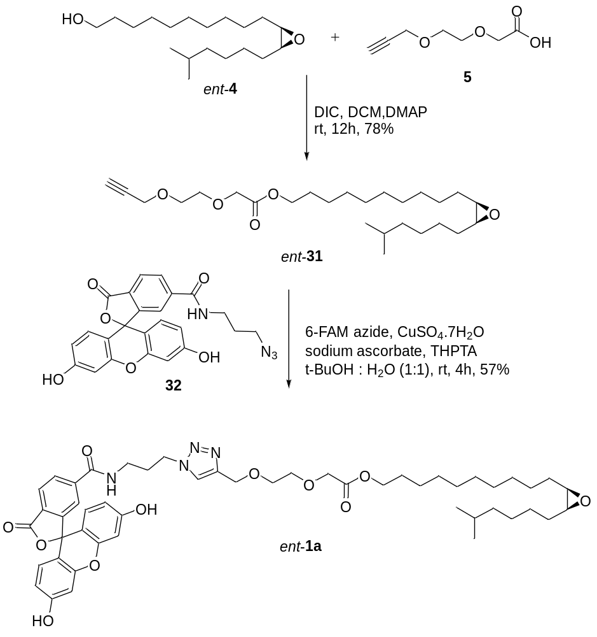
Schme S3. Synthesis of 6-FAM tagged-(-)-disparlure ent-1a

Determination of enantiomeric excess of epoxy alkynes 31 and ent-31
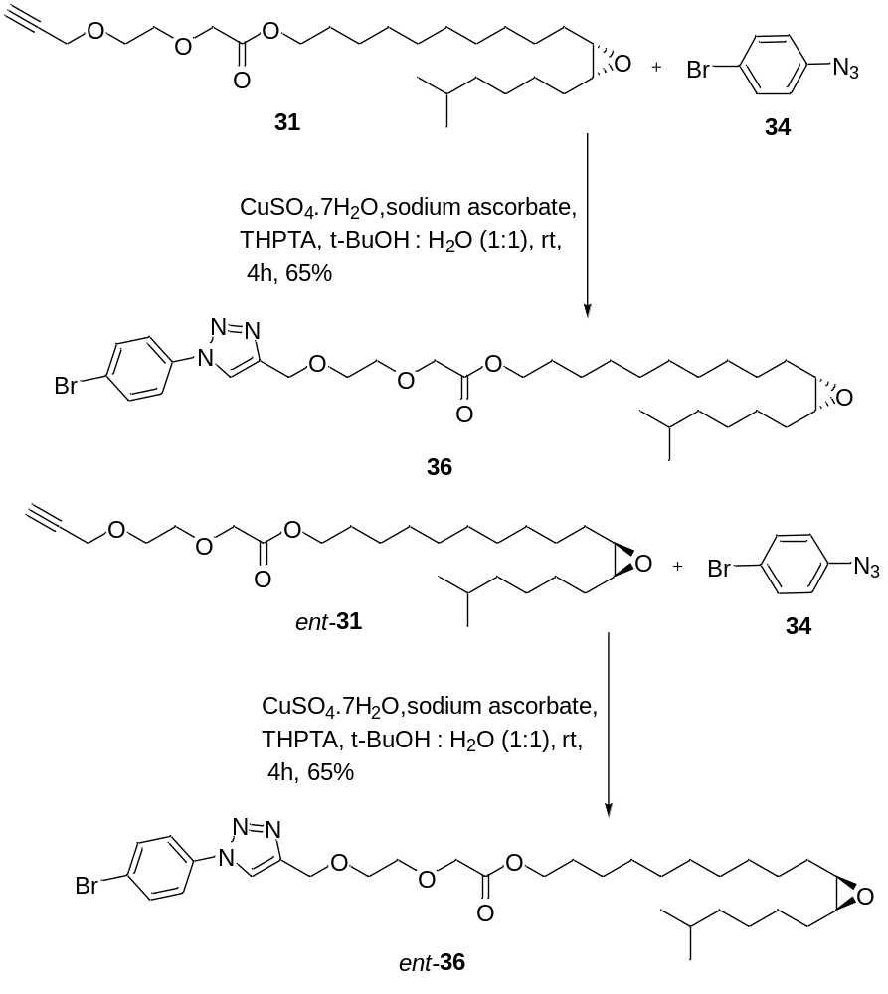
Scheme S4. Determination of enantiomeric excess of epoxy alkynes 31 and ent-31 by forming phenyltriazoles

Preparation of (S)-12-(benzyloxy)-2-chlorododecanal (ent-22)
The compound ent-22 was prepared according to the procedure described for the compound 22 in the methods and materials section. 12-(benzyloxy) dodecanal (21) (7.241 mmol), L-SOMO ent-16 (1.448 mmol), Cu(TFA)₂.H₂O (3.62 mmol), LiCl (14.48 mmol) and Na₂S₂O₈ (8.68 mmol). (Eluent: 20% EA/hexane), 1.35 g, 57%, pale yellow oil. ¹H NMR (500 MHz, CDCl₃) δ: 9.50-9.47 (d, J = 2.5 Hz, 1H), 7.36-7.32 (m, 5H), 4.51-4.50 (s, 2H), 4.17-4.13 (ddd, J = 8.1, 5.4, 2.4 Hz, 1H), 3.49-3.45 (t, J = 6.6 Hz, 3H), 2.01-1.94 (m, 1H), 1.87-1.79 (m, 1H), 1.64-1.60 (m, 2H), 1.31-1.26 (m, 12H). ¹³C NMR (500 MHz, CDCl₃) δ: 195.28, 138.63, 128.24, 127.52, 127.37, 77.20, 77.15, 76.95, 76.69, 72.77, 70.42, 63.92, 31.98, 29.69, 29.41, 29.35, 29.31, 29.18, 28.84, 26.10, 25.45. IR (neat): 2925, 2854, 1725, 1102, 1028, 735, 697 cm⁻¹. GCMS (EI) m/z calculated for C₁₉H₂₉ClO₂ [M+1]: 325.19; found: 325.30. [α ]²⁵ _{D}: - 13.28 (c 0.8, CHCl₃).

Preparation of (7R,8S)-18-(benzyloxy)-8-chloro-2-methyloctadec-5-yn-7-ol (ent-24)
The compound ent-24 was prepared according to the procedure described for the compound 24 in the methods and material section. 5-methyl-1-hexyne (23) (4.147 mmol), n-butyllithium (3.732 mmol), (S)-12-(benzyloxy)-2-chlorododecanal (ent-22) (4.147 mmol). (Eluent: 10% EA/hexane), 1.30 g, 75%, colorless oil. ¹H NMR (500 MHz, CDCl₃) δ: 7.36-7.34 (d, J = 4.4 Hz, 4H), 7.31-7.27 (dt, J = 8.8, 4.3 Hz, 1H), 4.53-4.50 (s, 2H), 4.53- 4.49 (dt, J = 9.5, 4.1 Hz, 1H), 4.04-3.98 (dt, J = 9.5, 4.1 Hz, 1H), 3.49-3.46 (t, J = 6.7 Hz, 2H), 2.52-2.36 (s, 1H), 2.27-2.21 (m, 2H), 1.91-1.74 (m, 2H), 1.74-1.65 (m, 1H), 1.67-1.58 (m, 4H), 1.34-1.24 (s, 16H), 0.91-0.89 (d, J = 6.6 Hz, 6H). ¹³C NMR (500 MHz, CDCl₃) δ: 138.59, 128.24, 127.53, 127.37, 87.74, 77.20, 76.95, 76.69, 76.60, 72.76, 70.41, 67.52, 66.20, 37.26, 33.49, 29.67, 29.46, 29.38, 29.29, 27.17, 27.00, 26.39, 26.10, 22.07, 22.01, 16.65, 16.60. IR (neat): 3404, 2926, 2854, 2238, 1275, 1100, 735, 697 cm⁻¹. GCMS (EI) m/z calculated for C₂₆H₄₁ClO₂ [M]^{+.}: 420.28; found: 421.20. [α ]²⁵ _{D}: - 9.6 (c 1.54, CHCl₃).
Preparation of (7S,8S)-18-(benzyloxy)-8-chloro-2-methyloctadec-5-yn-7-yl benzoate (ent-26)
The compound ent-26 was prepared according to the procedure described for the compound 26 in the methods and materials section. (7R,8S)-18-(benzyloxy)-8-chloro-2-methyloctadec-5-yn-7-ol (ent-24) (3.095 mmol), triphenylphosphine (6.190 mmol), benzoic acid 25 (6.190 mmol) and DIAD (6.190 mmol). (Eluent: 10% EA/hexane), 1.12 g, 69%, colorless oil. ¹H NMR (500 MHz, CDCl₃) δ: 8.11-8.08 (d, J = 7.1 Hz, 2H), 7.60-7.57 (t, J = 7.4 Hz, 1H), 7.49-7.44 (t, J = 7.8 Hz, 2H), 7.36-7.34 (d, J = 4.4 Hz, 4H), 7.31-7.27 (m, 1H), 5.78-5.74 (dt, J = 6.1, 2.0 Hz, 1H), 4.52-4.51 (s, 2H), 4.14-4.08 (ddd, J = 9.6, 6.2, 3.4 Hz, 1H), 3.49-3.46 (t, J = 6.6 Hz, 2H), 2.28-2.23 (td, J = 7.4, 2.0 Hz, 2H), 2.08-2.01 (m, 1H), 1.89-1.81 (m, 1H), 1.72-1.59 (m, 4H), 1.40-1.24 (m, 15H), 0.91-0.88 (d, J = 6.6 Hz, 6H). ¹³C NMR (500 MHz, CDCl₃) δ: 165.06, 138.64, 133.20, 129.82, 129.55, 128.33, 128.24, 127.51, 127.36, 88.46, 77.20, 77.15, 76.95, 76.69, 74.27, 72.77, 70.42, 67.70, 62.45, 37.09, 33.65, 29.69, 29.47, 29.40, 29.39, 29.31, 28.94, 27.16, 26.11, 25.97, 22.04, 16.69. IR (neat): 2926, 2854, 2245, 1727, 1263, 1095, 1068, 734, 710, 697 cm⁻¹. GCMS (EI) m/z calculated for C₃₃H₄₅ClO₃ [M]^{+.}: 524.31; found: 524.20. [α ]²⁵ _{D}: - 11.06 (c 1.38, CHCl₃).

Preparation of (7S,8S)-8-chloro-18-hydroxy-2-methyloctadecan-7-yl benzoate (ent-27).
The compound ent-27 was prepared according to the procedure described for the compound 27 in the methods and material section. (7S,8S)-18-(benzyloxy)-8-chloro-2-methyloctadec-5-yn-7-yl benzoate (ent-26) (0.9532 mmol) and 10% Pd/C (10 mol %). (Eluent: 20% EA/hexane), 0.350 g, 84%, colorless oil. ¹H NMR (500 MHz, CDCl₃) δ: 8.14-8.06 (d, J = 8.9 Hz, 2H), 7.61-7.55 (t, J = 7.3 Hz, 1H), 7.49-7.43 (t, J = 7.7 Hz, 2H), 5.33-5.27 (m, 1H), 4.09-4.03 (m, 1H), 3.68-3.61 (t, J = 6.6 Hz, 2H), 1.88-1.81 (m, 2H), 1.81-1.68 (m, 2H), 1.60-1.45 (m, 4H), 1.37-1.23 (m, 19H), 0.87-0.81 (d, J = 6.6 Hz, 6H). ¹³C NMR (500 MHz, CDCl₃) δ: 165.91, 130.07, 129.87, 129.77, 129.61, 128.36, 128.30, 75.63, 63.87, 62.90, 38.63, 34.45, 32.59, 31.32, 29.39, 29.26, 28.89, 27.84, 27.68, 27.08, 26.53, 25.70, 25.60, 25.55, 22.51, 22.48. IR (neat): 3449, 2926, 2854, 1723, 1268, 1110, 1071, 1026, 711 cm⁻¹. GCMS (EI) m/z calculated for C₂₆H₄₃ClO₃ [M]^{+.}: 438.29; found: 438.20. [α ]²⁵ _{D:} + 10.78 (c 1.52, CHCl₃).

Preparation of (11R,12S)-11,12-epoxy-17-methyl-octadecan-1-ol (ent-4)
The compound ent-4 was prepared according to the procedure described for the compound 4 in the methods and materials section. (7S, 8S)-8-chloro-18-hydroxy-2-methyloctadecan-7-yl benzoate (ent-27) (0.798 mmol) and 4N NaOH (4 mL). (Eluent: 25% EA/hexane), 0.187 g, 79%, colorless oil. ¹H NMR (500 MHz, CDCl₃) δ: 3.64-3.58 (t, J = 6.7 Hz, 2H), 2.92-2.85 (p, J = 4.1 Hz, 2H), 1.60-1.42 (m, 11H), 1.36-1.30 (m, 7H), 1.29-1.25 (m, 8H), 1.22-1.13 (m, 3H), 0.87-0.84 (d, J = 6.6 Hz, 6H). ¹³C NMR (500 MHz, CDCl₃) δ: 77.20, 76.95, 76.69, 62.89, 57.07, 38.91, 38.80, 38.74, 32.83, 32.70, 32.54, 29.44, 29.37, 29.32, 27.87, 27.72, 27.22, 26.76, 26.50, 25.79, 22.53, 22.50. IR (neat): 3410, 2925, 2855, 1367, 1267, 1095, 1058 cm⁻¹. GCMS (EI) m/z calculated for C₁₉H₃₈O₂ [M]^{+.}: 298.29; found: 298.30. [α ]²⁵ _{D}: - 5.64 (c 1.5, CHCl₃).

Preparation of 10-((2R,3S)-3-(5-methylhexyl)oxiran-2-yl)decyl 2-(2-(prop-2-yn-1-yloxy)ethoxy)acetate (ent-31)
The compound ent-31 was prepared according to the procedure described for the compound 31 in the methods and material section. 10-((2R, 3S)-3-(5-methylhexyl) oxiran-2-yl) decan-1-ol (ent-4) (0.251 mmol), 2-(2-(prop-2-yn-1-yloxy) ethoxy) acetic acid (5) (0.276 mmol), DIC (0.502 mmol) and DMAP (0.0502 mmol). (Eluent: 30% EA/hexane), 0.089 g, 81%, colorless oil. ¹H NMR (500 MHz, CDCl₃) δ: 4.21-4.19 (s, 2H), 4.15-4.13 (t, J = 3.2 Hz, 4H), 3.75-3.73 (m, 4H), 2.90-2.87 (m, 2H), 2.43-2.41 (t, J = 2.4 Hz, 1H), 1.66-1.59 (m, 3H), 1.51-1.46 (m, 6H), 1.36-1.27 (m, 16H), 1.20-1.13 (m, 3H), 0.87-0.85 (d, J = 6.6 Hz, 6H). ¹³C NMR (500 MHz, CDCl₃) δ: 170.38, 79.39, 77.20, 77.15, 76.95, 76.69, 74.54, 70.59, 69.01, 68.56, 64.90, 58.30, 57.14, 38.81, 29.43, 29.36, 29.11, 28.48, 27.80, 27.77, 27.73, 27.22, 26.76, 26.52, 25.74, 22.53, 22.52. IR (neat): 2925, 2855, 2115, 1753, 1202, 1147, 1104 1029 cm⁻¹. GCMS (EI) m/z calculated for C₂₆H₄₆O₅ [M+1]: 438.33; found: 439.30. [α ]²⁵ _{D}: + 3.66 (c 0.5, CHCl₃).
Preparation of fluorescently-tagged (-)-disparlure(ent-1a)
The compound ent-1a was prepared according to the procedure described for the compound 1a in the methods and materials section. 6-FAM azide 32 (1 mg, 0.0022 mmol), 10-((2R,3S)-3-(5-methylhexyl)oxiran-2-yl)decyl 2-(2-(prop-2-yn-1-yloxy)ethoxy)acetate (ent-31) (5 mg, 0.0114 mmol), tris(3-hydroxypropyltriazolylmethyl)amine (THPTA, 1 mg, 0.0023 mmol), sodium ascorbate (28 mg, 0.01144 mmol), and copper (II) sulfate heptahydrate (1.1 mg, 0.0057 mmol). (Eluent: 10% MeOH/DCM), 1.12 mg, 57.4%. ¹H NMR (600 MHz, CDCl₃) δ: 8.17-8.06 (m, 4H), 8.06 (s, 1H), 7.63 (s, 2H), 6.72-6.52 (m, 4H), 4.79 (s, 2H), 4.14 (d, J = 6.3 Hz, 4H), 3.80-3.76 (m, 4H), 3.40 (t, J = 6.8 Hz, 2H), 3.36 (t, J = 6.6 Hz, 2H), 2.91-2.88 (m, 2H), 1.82 (p, J = 6.7 Hz, 2H), 1.63 (dt, J = 14.3, 6.7 Hz, 4H), 1.55-1.46 (m, 7H), 1.36-1.27 (m, 17H), 0.87 (d, J = 6.6 Hz, 6H). IR (neat): 3572-3244 (O-H & N-H str), 2925-2855 (C-H str), 1771, 1750, 1691, 1625, 1590, 1524, 1456, 1439, 1250, 1213, 1148, 1104 1029 cm⁻¹. HRMS (ESI) m/z calculated for C₅₀H₆₅N₄O₁₁ [M+H]: 897.4650; found: 897.4662.

General procedure for the synthesis of the compounds 36 and ent-36
In a 2 mL reaction vial, 4-bromophenyl azide (34) (1 mg, 0.0022 mmol) and 10-((2S,3R)-3-(5-methylhexyl)oxiran-2-yl)decyl2-(2-(prop-2-yn-1-yloxy)ethoxy)acetate (31) or 10-((2R,3S)-3-(5-methylhexyl)oxiran-2-yl)decyl 2-(2-(prop-2-yn-1-yloxy)ethoxy)acetate (ent-31) or were added to the mixture of tris(3-hydroxypropyltriazolylmethyl)amine (THPTA, 1 mg, 0.0023 mmol) sodium ascorbate (28 mg, 0.01144 mmol), and copper (II) sulfate heptahydrate (1.1 mg, 0.0057 mmol) dissolved in ratio of 1:1 volume of t-BuOH and water (1 mL) at room temperature. The reaction mixture was stirred at room temperature for 1h. After this time, the t-BuOH was removed, and the resulting residue was diluted with water and dichloromethane. The aqueous layer was extracted with 10% MeOH/DCM (4×10 mL). The pooled organic layers were washed with saturated sodium chloride solution, dried over Na₂SO₄ and concentrated in vacuo. The crude residue was purified by column chromatography on neutral alumina (70% EtoAc/hexane) yielded 36 or ent-36.
10-((2S,3R)-3-(5-methylhexyl)oxiran-2-yl)decyl 2-(2-((1-(4-bromophenyl)-1H-1,2,3-triazol-4-yl)methoxy)ethoxy)acetate (36)
The compound 36 (3.9 mg, 54.1%): ¹H NMR (500 MHz, CDCl₃) δ: 8.08-8.05 (s, 1H), 7.66-7.65 (s, 4H), 4.80-4.78 (s, 2H), 4.15 (s, 2H), 4.15-4.12 (t, J = 5.7 Hz, 2H), 3.80-3.76 (td, J = 5.4, 3.5 Hz, 4H), 2.92-2.87 (m, 2H), 1.66-1.59 (m, 4H), 1.56-1.46 (m, 7H), 1.38-1.26 (m, 16H), 0.88-0.85 (d, J = 6.6 Hz, 6H). ¹³C NMR (600 MHz, CDCl₃) δ: 170.40, 136.04, 132.86, 122.32, 121.88, 120.69, 70.86, 69.87, 68.65, 65.00, 64.67, 57.21, 38.88, 29.51, 29.43, 29.18, 28.56, 27.87, 27.85, 27.81, 27.30, 26.84, 26.60, 25.81, 22.60, 22.59. IR (neat): 2924, 2856, 1753, 1635, 1590, 1456, 1439, 1200, 1148, 1104 1029 cm⁻¹.
10-((2R,3S)-3-(5-methylhexyl)oxiran-2-yl)decyl 2-(2-((1-(4-bromophenyl)-1H-1,2,3-triazol-4-yl)methoxy)ethoxy)acetate (ent-36)
The compound ent-36 (4.0 mg, 55.5%): ¹H NMR (500 MHz, CDCl₃) δ: 8.08-8.06 (s, 1H), 7.66-7.65 (s, 4H), 4.80-4.78 (s, 2H), 4.15 (s, 2H), 4.15-4.12 (t, J = 5.7 Hz, 2H), 3.80-3.76 (m, 4H), 2.92-2.87 (m, 2H), 1.65-1.59 (m, 4H), 1.55-1.46 (m, 7H), 1.38-1.26 (m, 16H), 0.88-0.85 (d, J = 6.6 Hz, 6H). ¹³C NMR (600 MHz, CDCl₃) δ: 170.40, 136.04, 132.86, 122.32, 121.88, 120.69, 70.86, 69.87, 68.65, 65.00, 64.67, 57.21, 38.88, 29.51, 29.43, 29.18, 28.56, 27.87, 27.85, 27.81, 27.30, 26.84, 26.60, 25.81, 22.60, 22.59. IR (neat): 2924, 2856, 1753, 1635, 1590, 1456, 1439, 1200, 1148, 1104 1029 cm⁻¹.

¹H & ¹³C NMR spectra
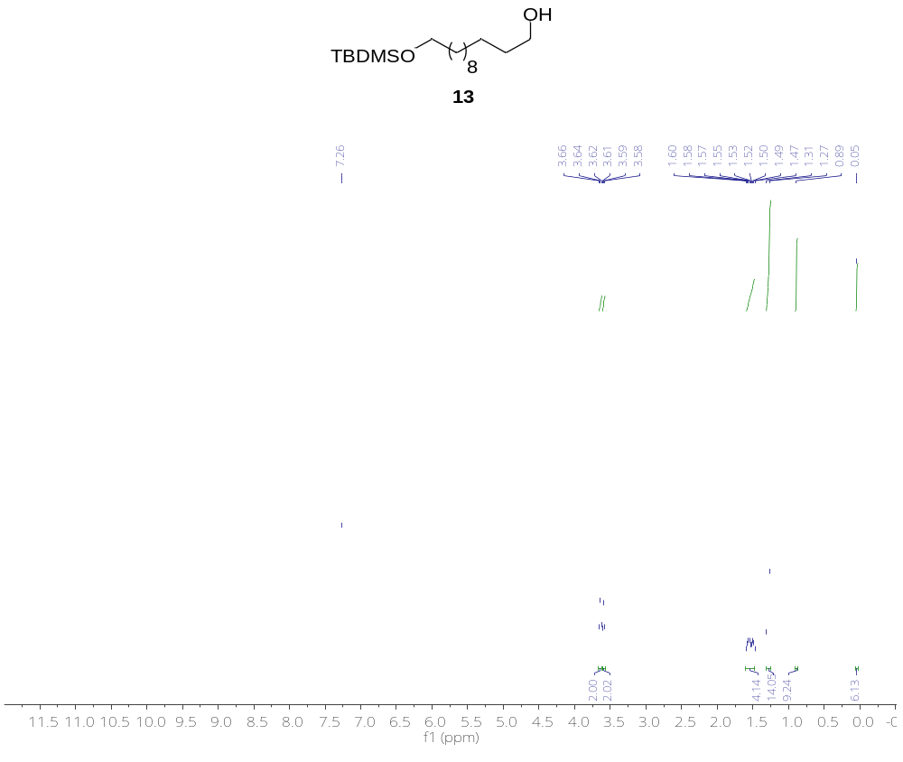
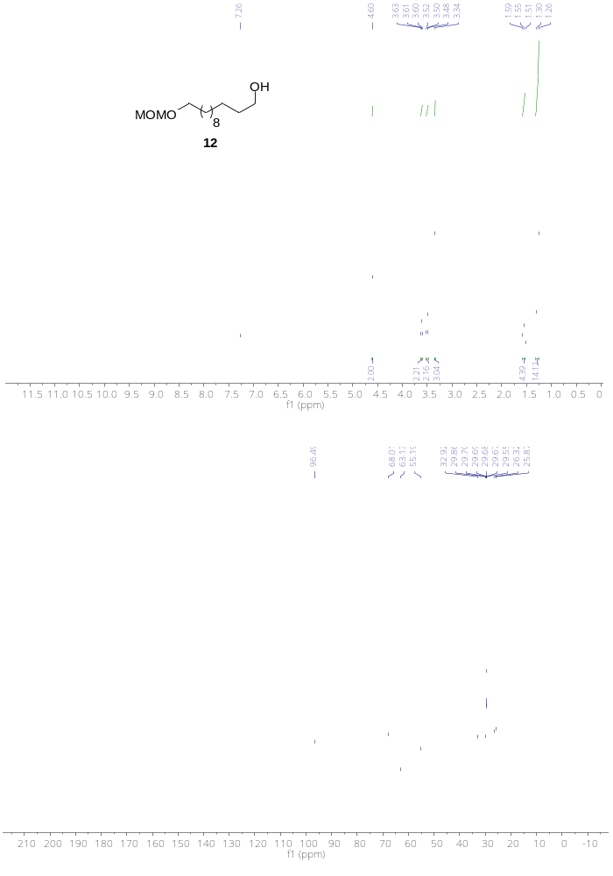
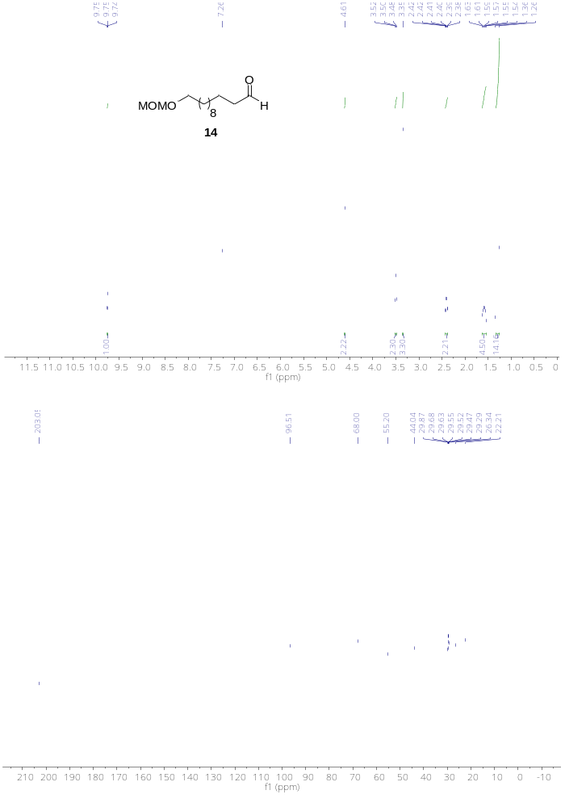
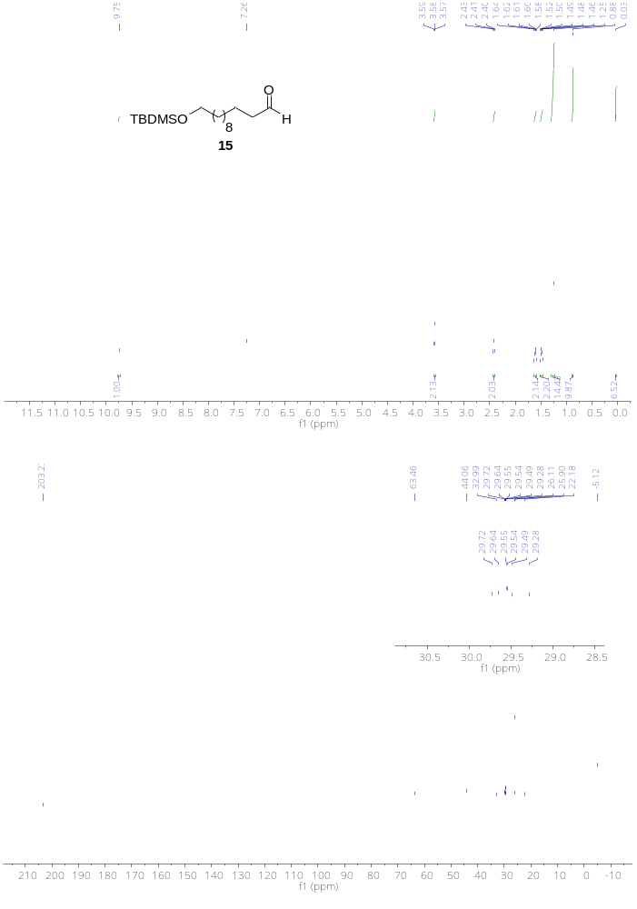
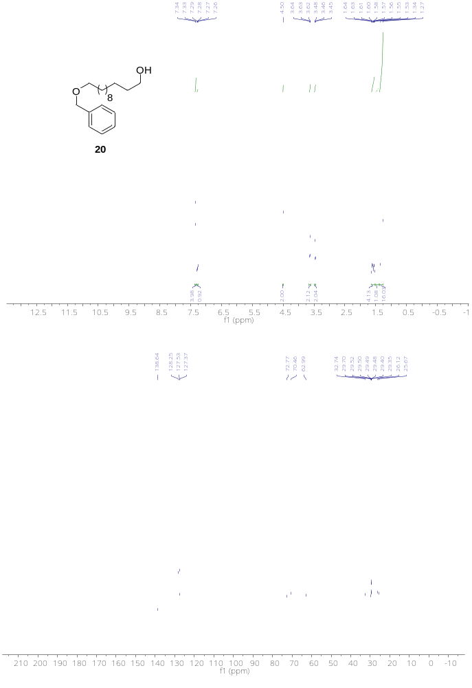
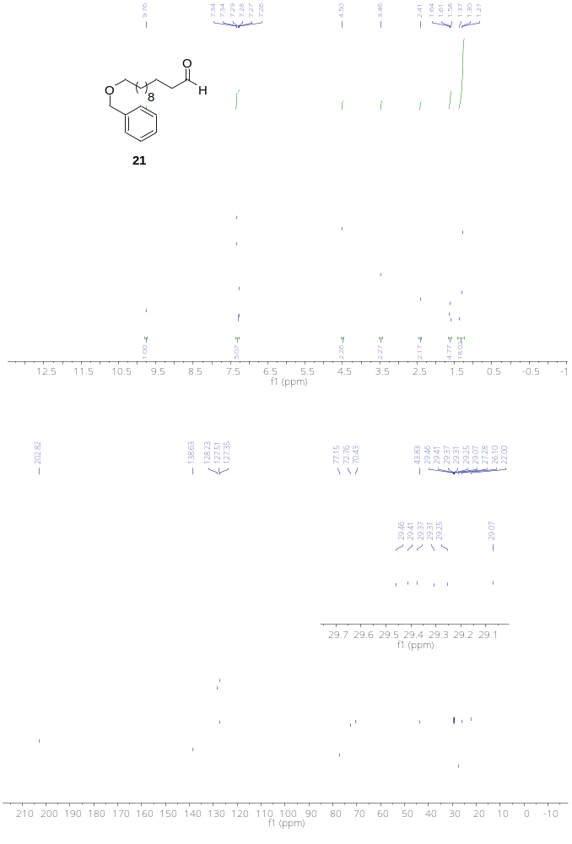
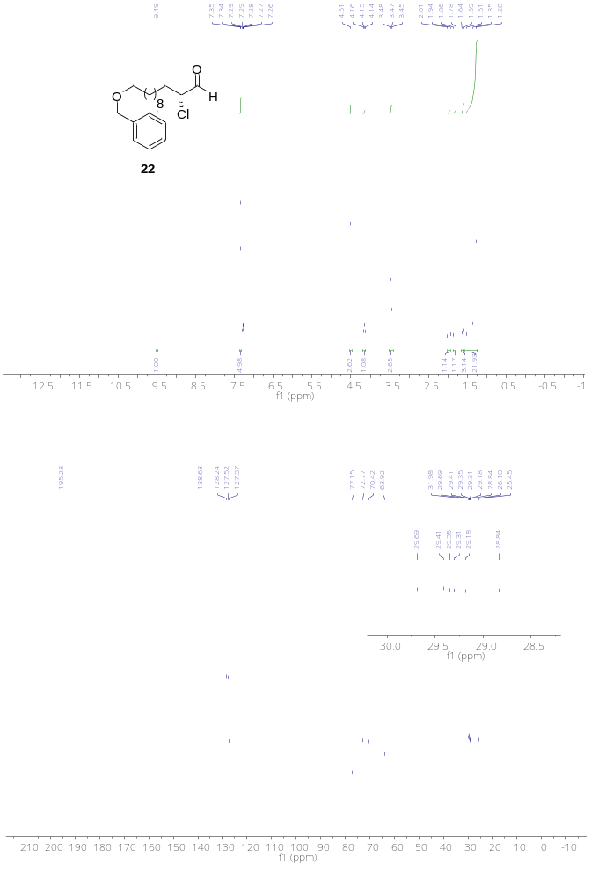
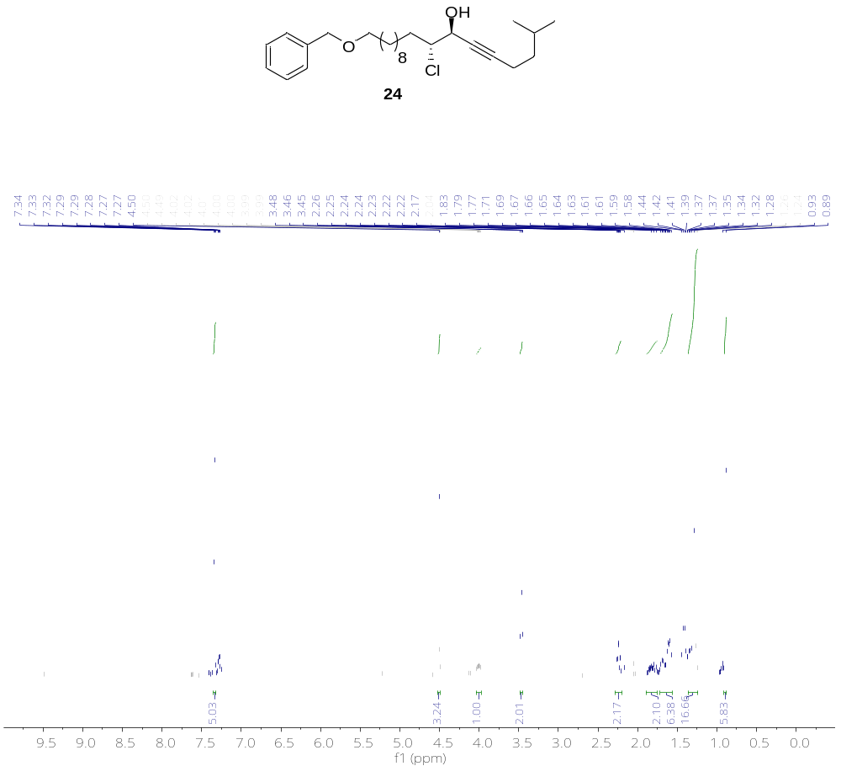
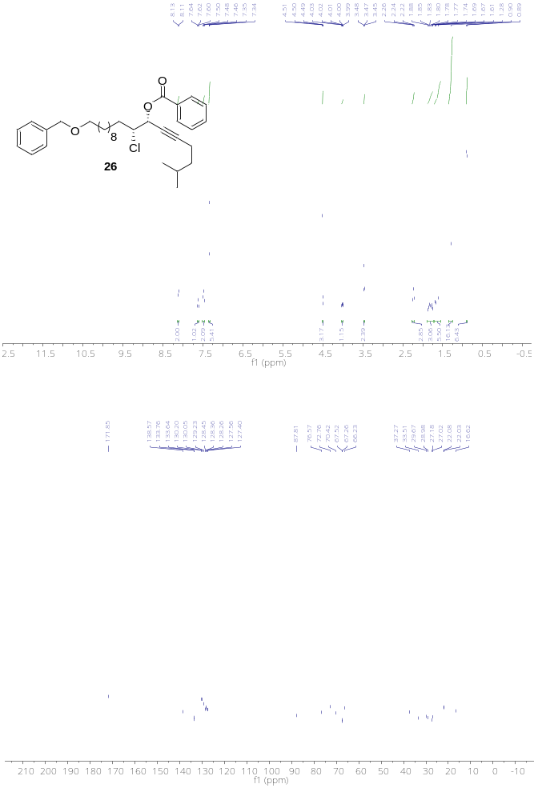
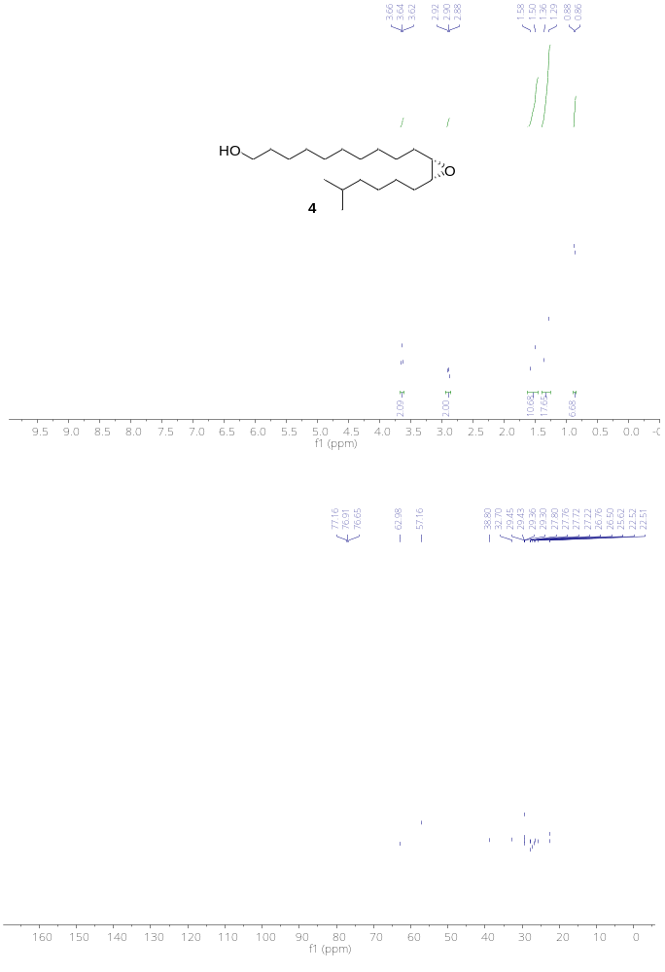
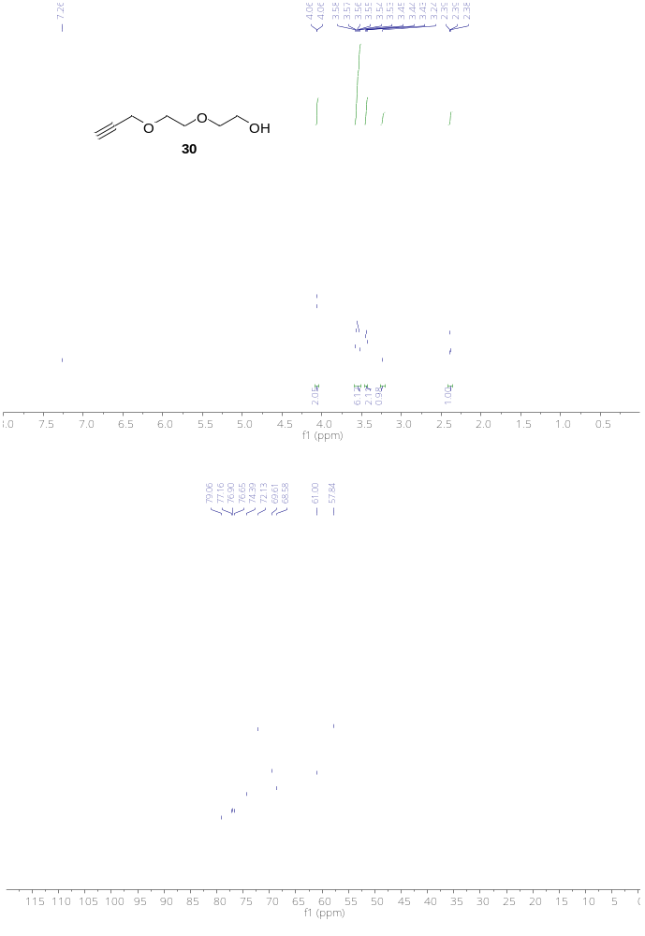

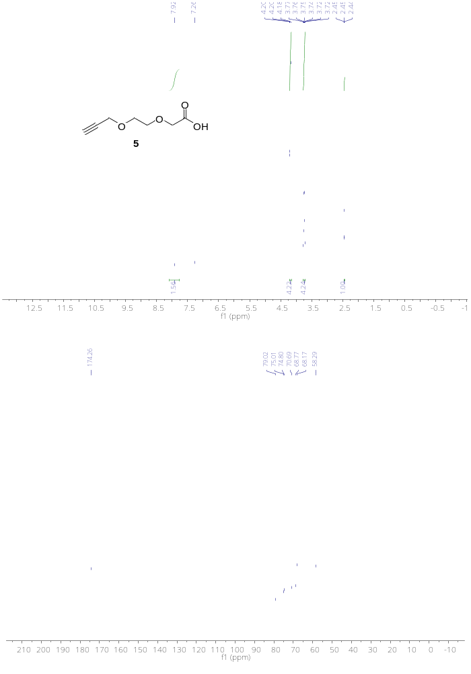

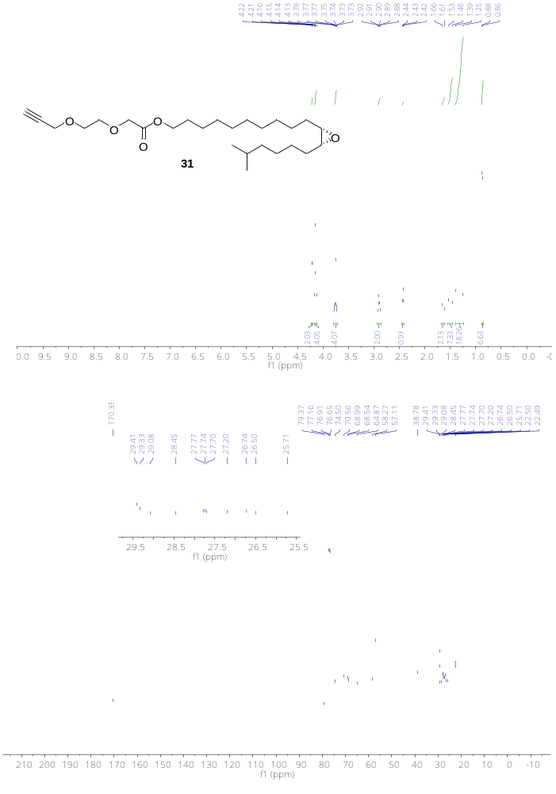

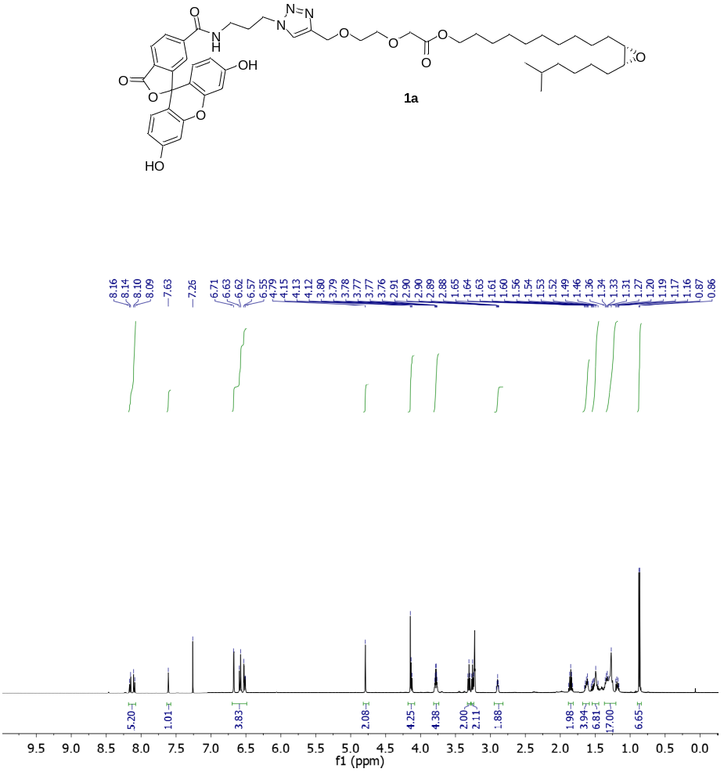

HRMS spectra of 6-FAM (+)-disparlure (1a)
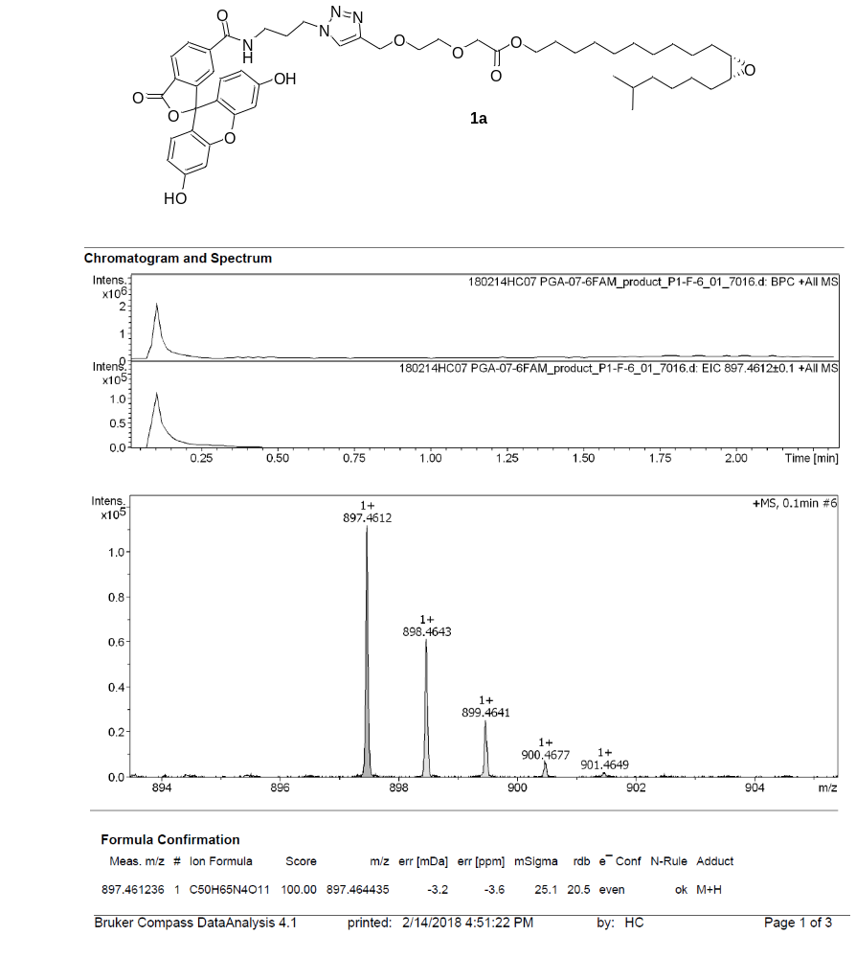
Fig. S1 HRMS spectra of 6-FAM tagged (+)-disparlure (1a)

¹H & ¹³C NMR spectra
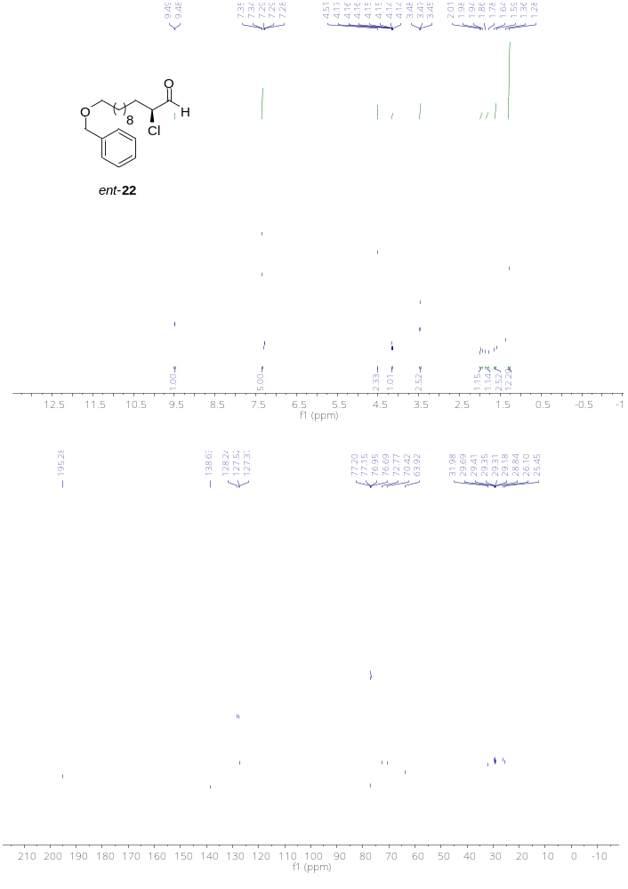
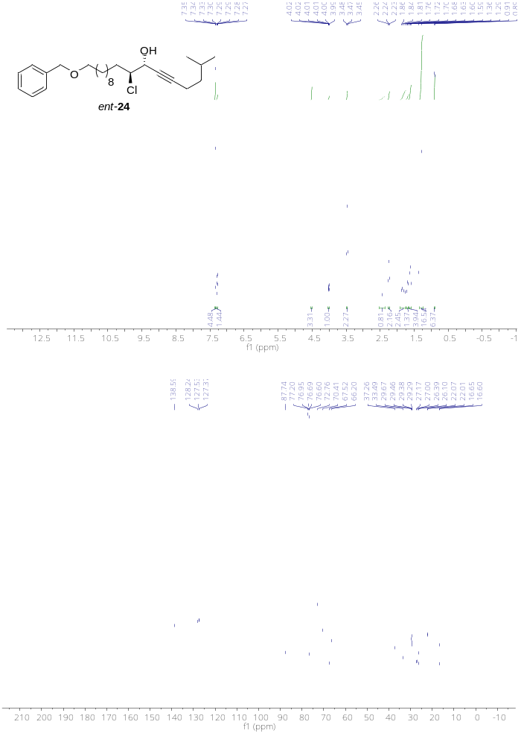

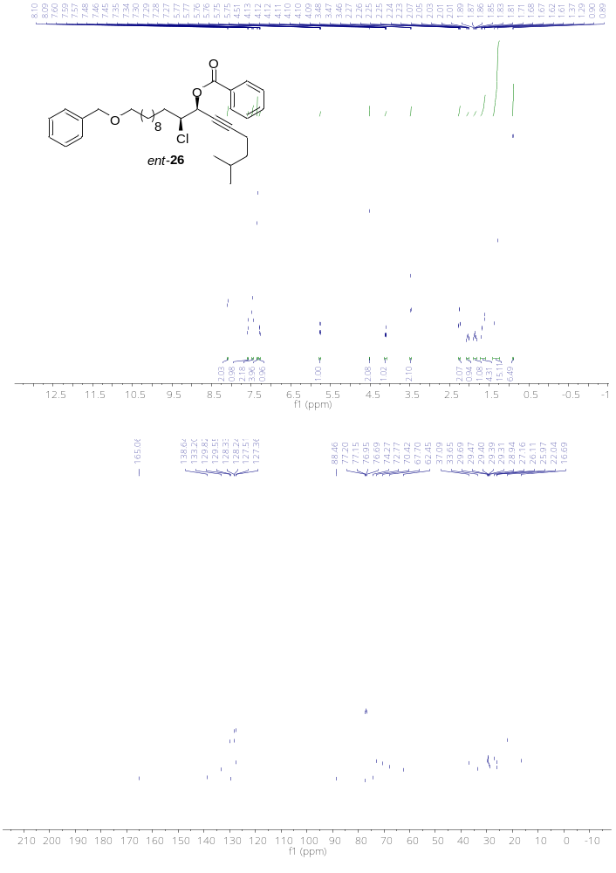

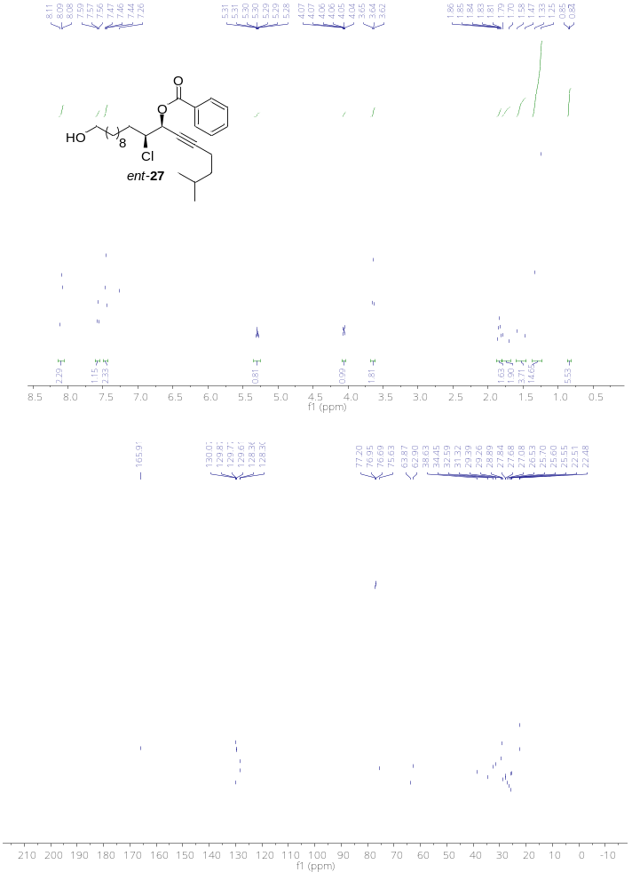
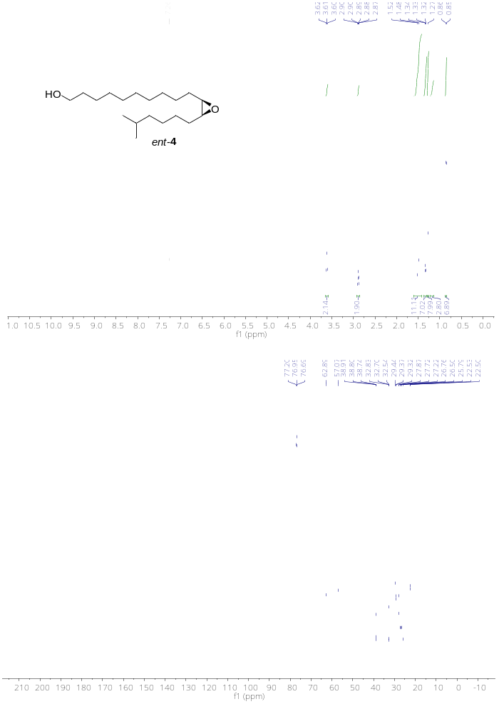
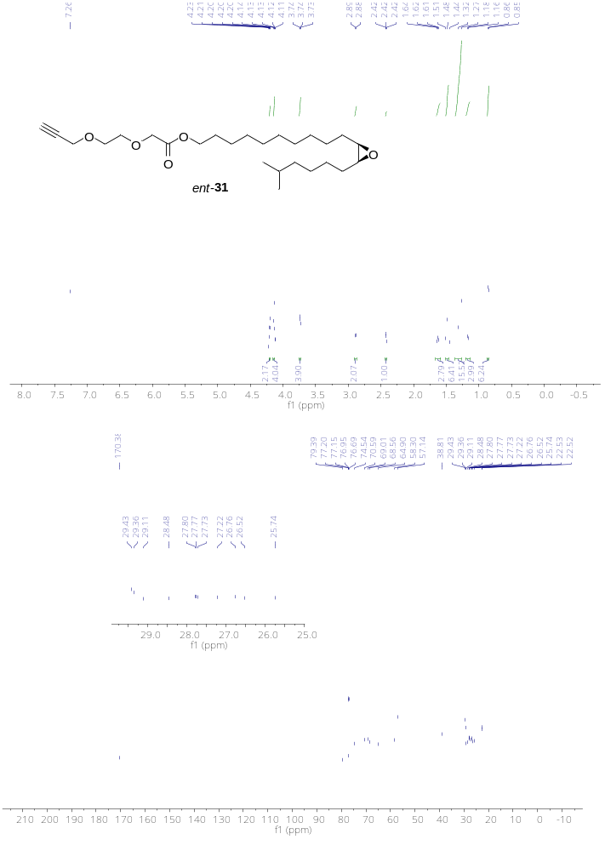
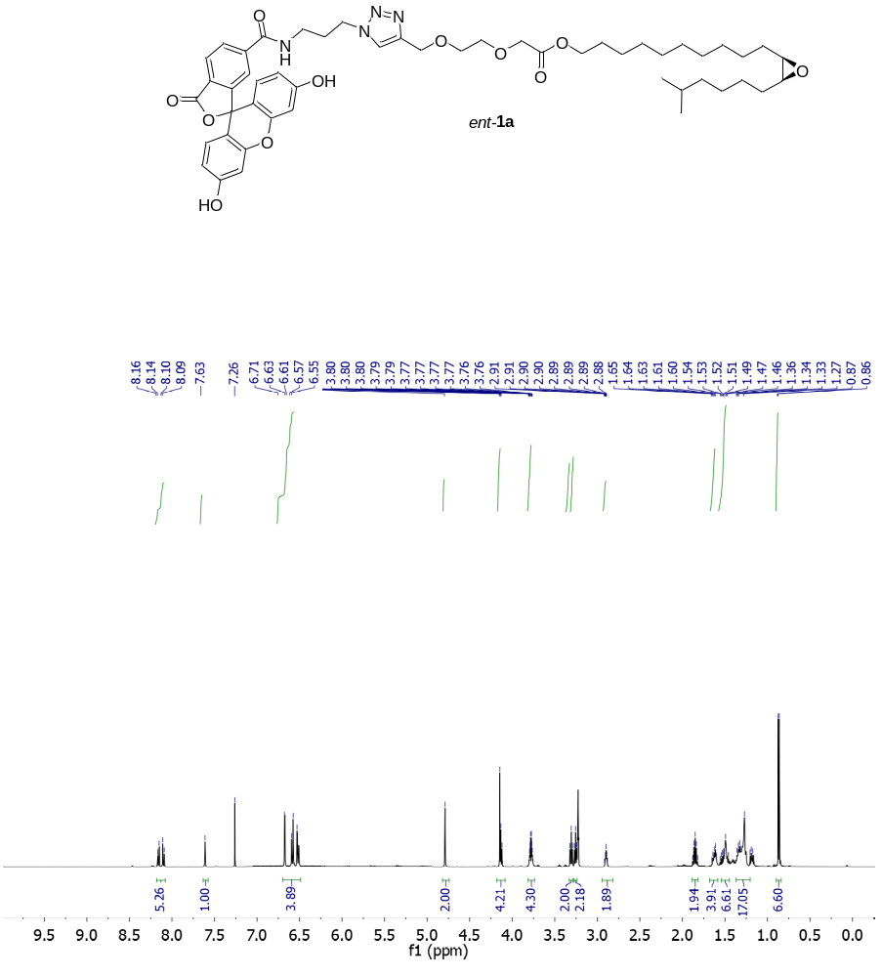

HRMS spectra of 6-FAM (-)-disparlure (ent-1a)
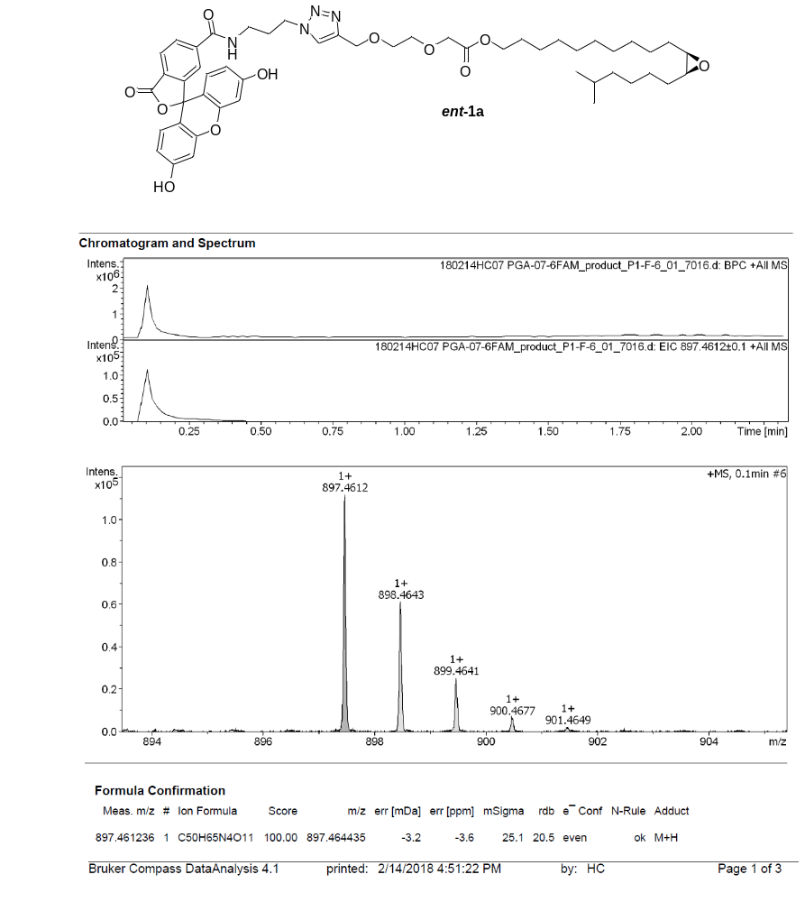
Fig. S2 HRMS spectra of 6-FAM tagged (-)-disparlure (ent-1a)

¹H & ¹³C NMR spectra
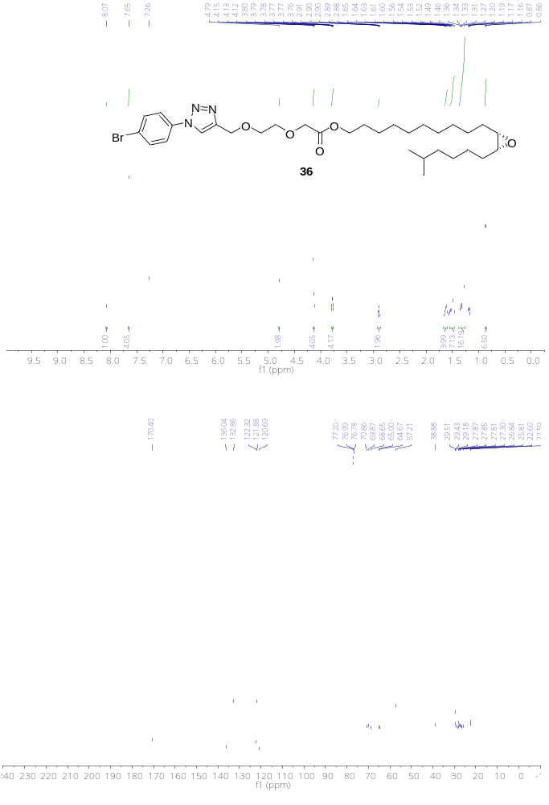
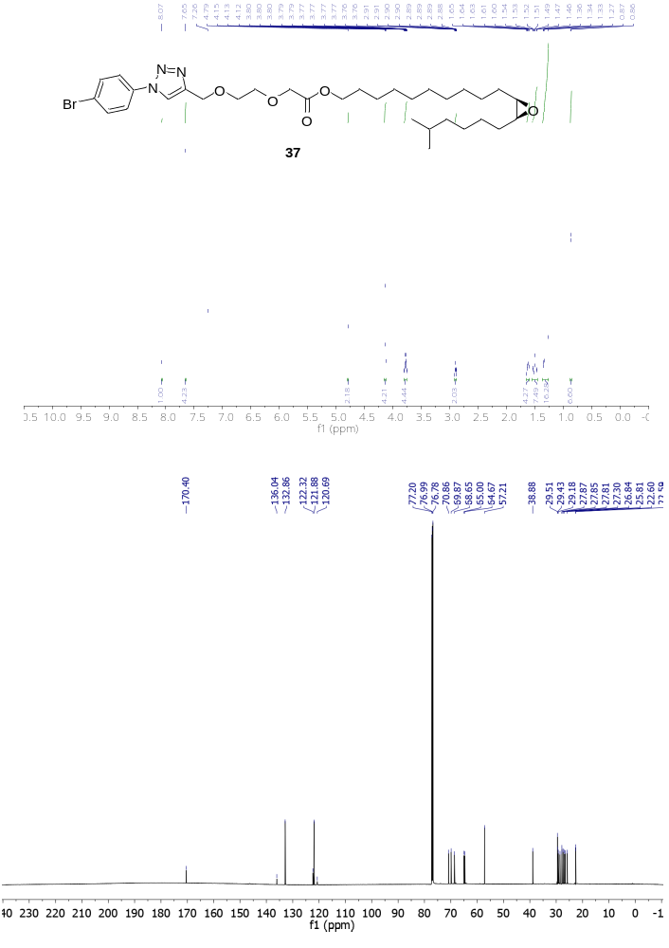

HPLC chromatograms
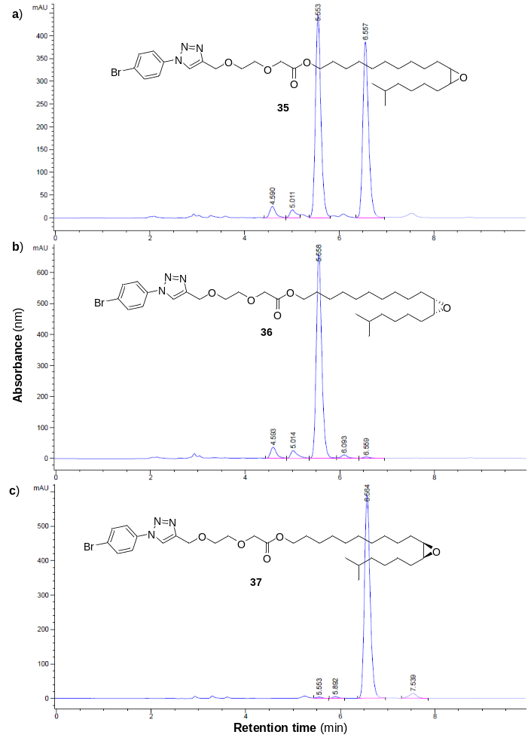
Figure S3. HPLC chromatogram showing separation of a) nearly racemic cis epoxy triazole b) (R, S)-enantiomer 42 c) (S, R)-enantiomer 43 using CHIRALPAK-D chiral HPLC column.
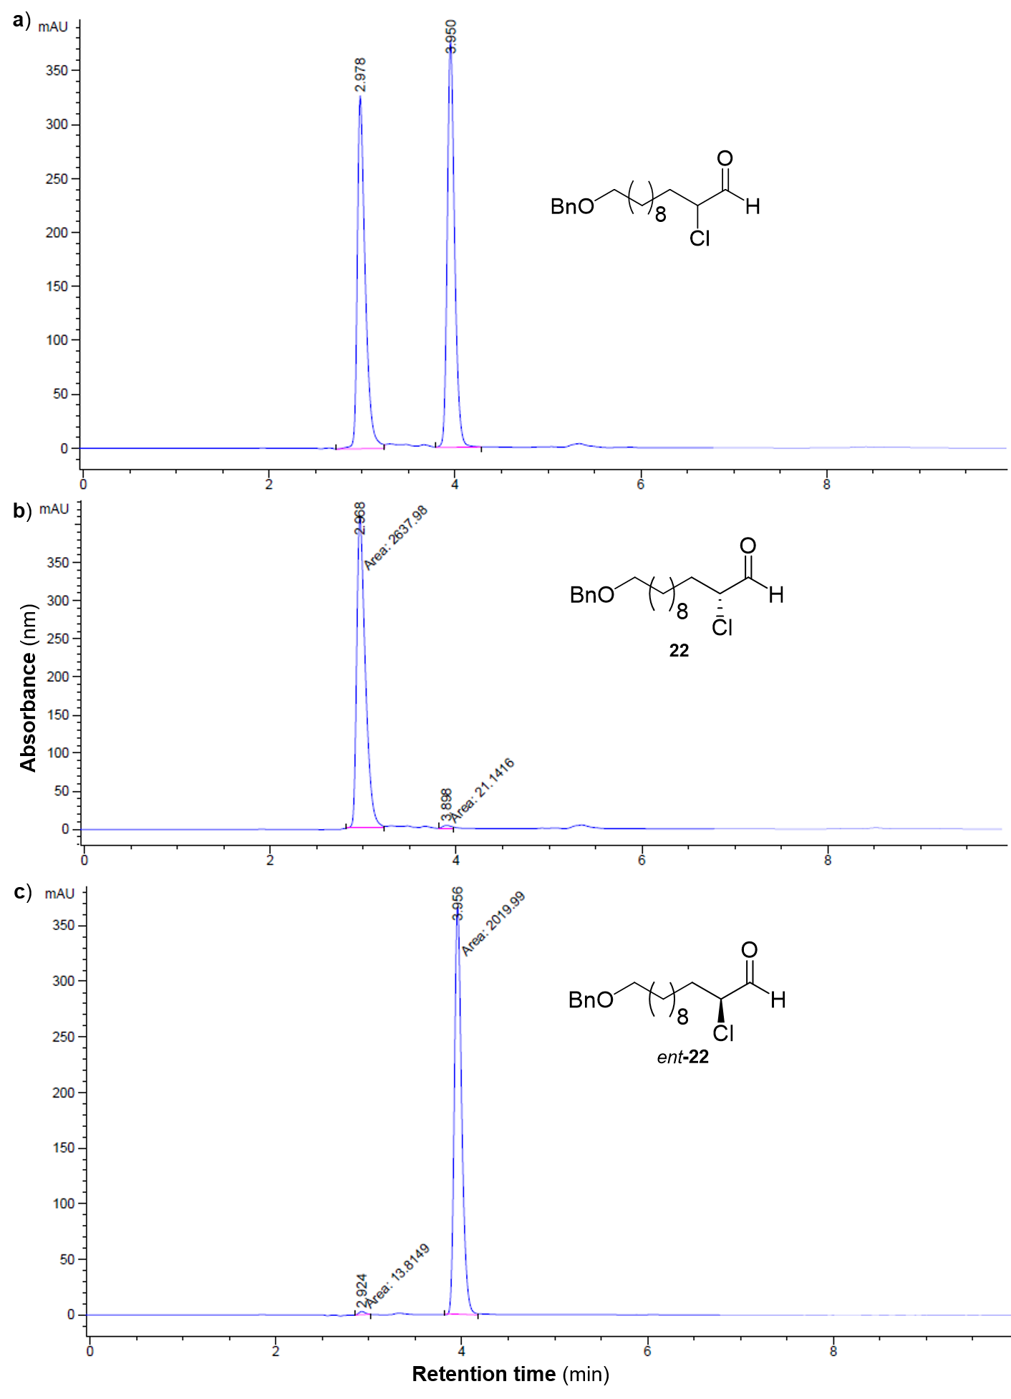
Figure S4. High-performance liquid chromatographic traces of: a) separation of nearly racemic α-chloroaldehyde by chiral HPLC column, b) & c) elution of (R) and (S)-enantiomers at 2.668 min and 3.956 min, respectively

Determination of quantum yield for 6-FAM (+)-disparlure 1a in phosphate buffer (pH 8)
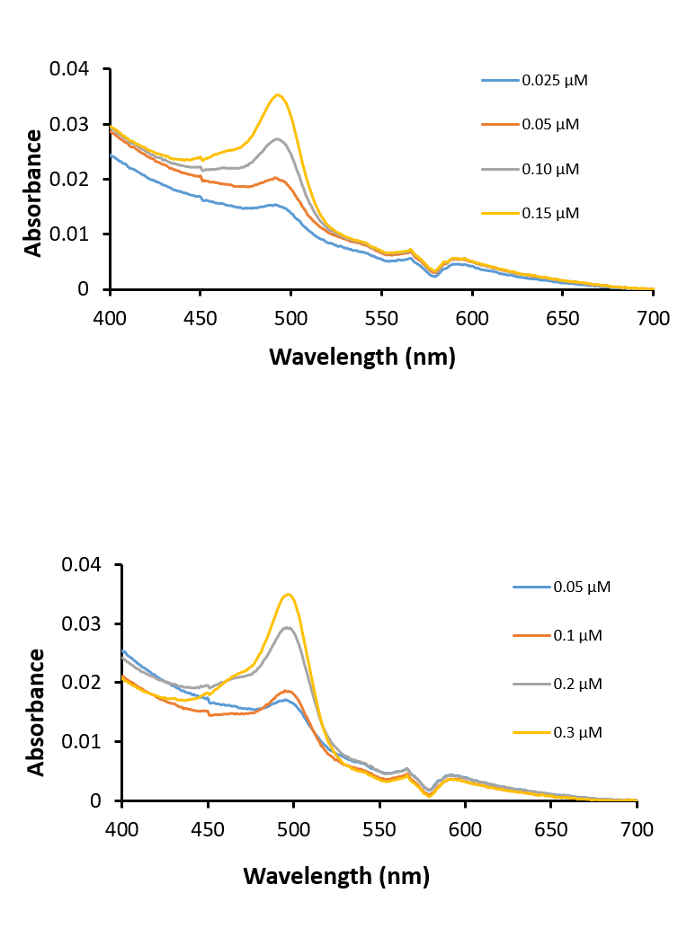
Figure S5. Absorbance specta of 6-FAM azide (top) and 6-FAM (+)-disparlure 1a (bottom) samples with varying concentartions.
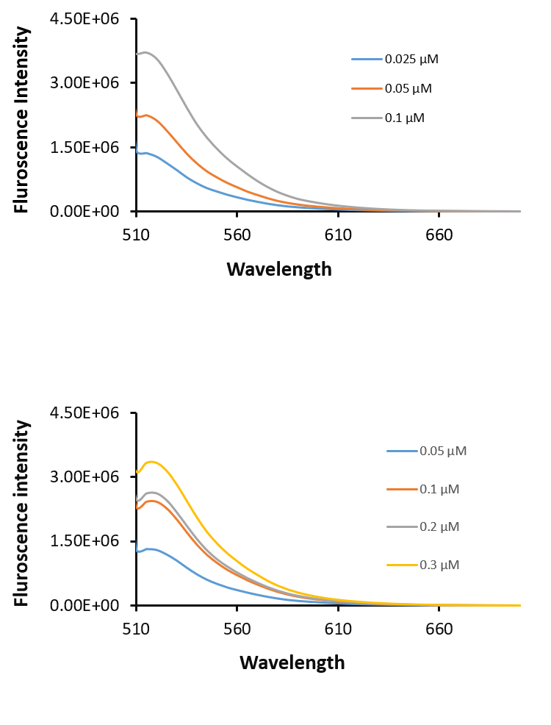
Figure S6. Fluorescence emission specta of 6-FAM azide (top) and 6-FAM (+)-disparlure 1a (bottom) samples with varying concentartions.

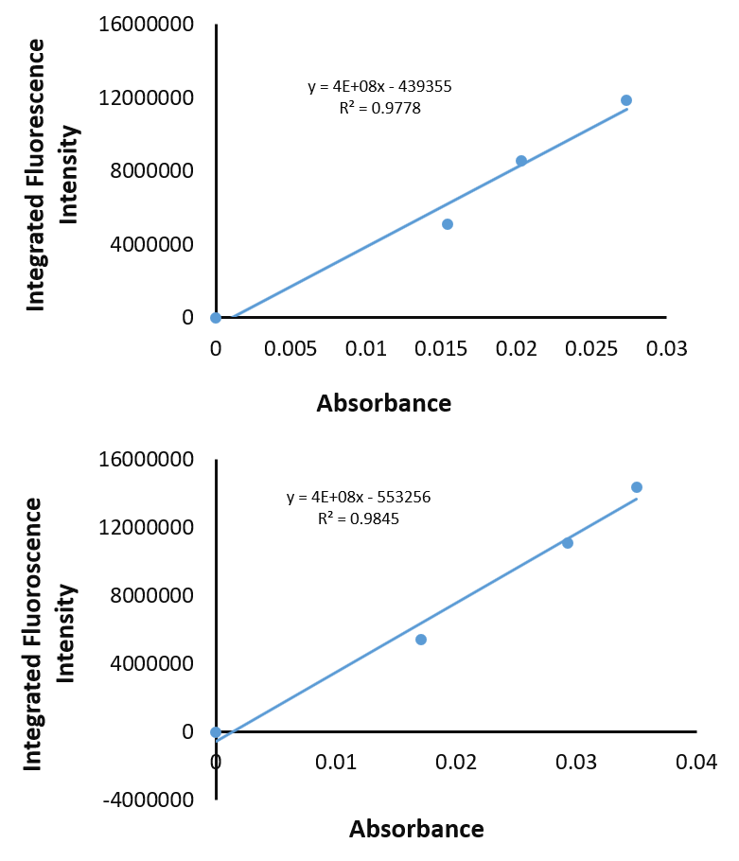
Figure S7. Plots of integrated fluorescence intensity (area) vs absorbance for 6-FAM azide (top) and 6-FAM (+)-disparlure 1a (bottom).

Determination of molar extinction coefficient for 6-FAM (+)-disparlure 1a
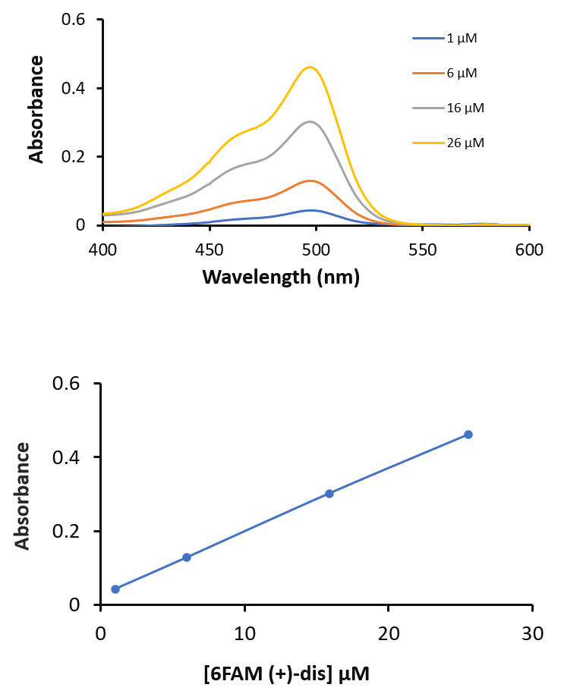
Figure S8. Absorbance specta of 6-FAM (+)-disparlure 1a with varying concentartions (top) plot of absorbance against concentartion of 6-FAM (+)-disparlure 1a.

6-FAM (+)-disparlure 1a emission spectra. 1a bound to LdisPBP2
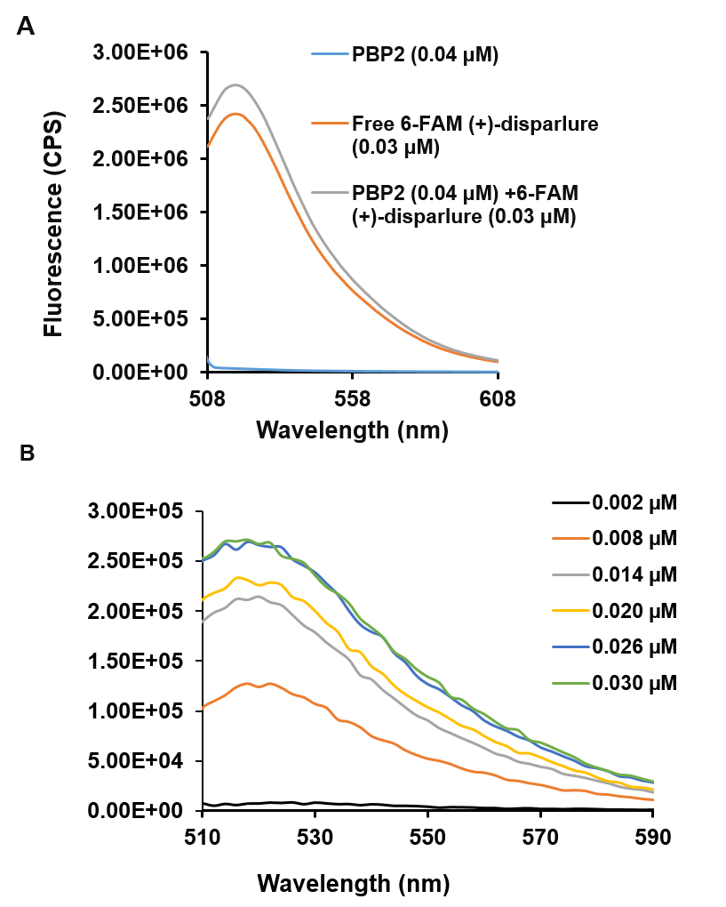
Figure S9. A) 6-FAM (+)-disparlure 1a emission spectra. 1a bound to LdisPBP2 was excited at 494 nm and its emission spectra (grey trace) was recorded. B) Fluorescence emission spectra were recorded with increasing doses of 6-FAM (+)-disparlure 1a.

6-FAM (-)-disparlure ent-1a emission spectra. ent-1a bound to LdisPBP1
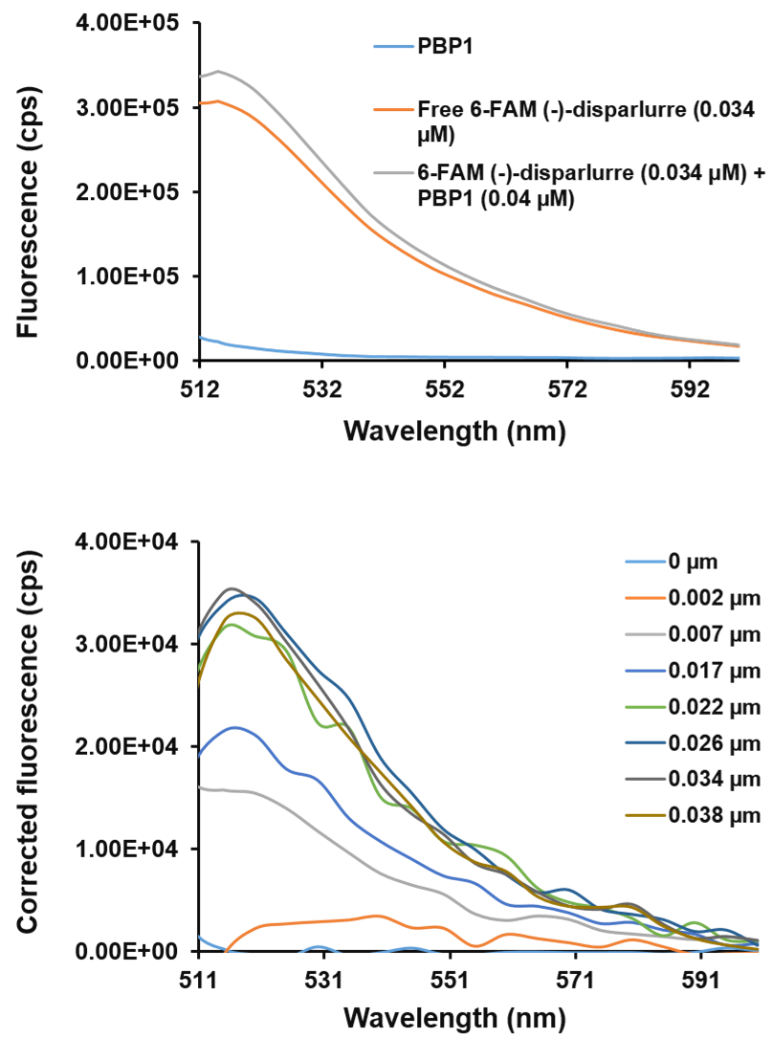
Figure S10. A) 6-FAM (-)-disparlure ent-1a emission spectra. ent-1a bound to LdisPBP1 was excited at 494 nm and its emission spectra (gray trace) was recorded. B) Fluorescence emission spectra were recorded with increasing doses of 6-FAM (-)-disparlure ent-1a.

6-FAM (-)-disparlure ent-1a emission spectra. ent-1a bound to LdisPBP2
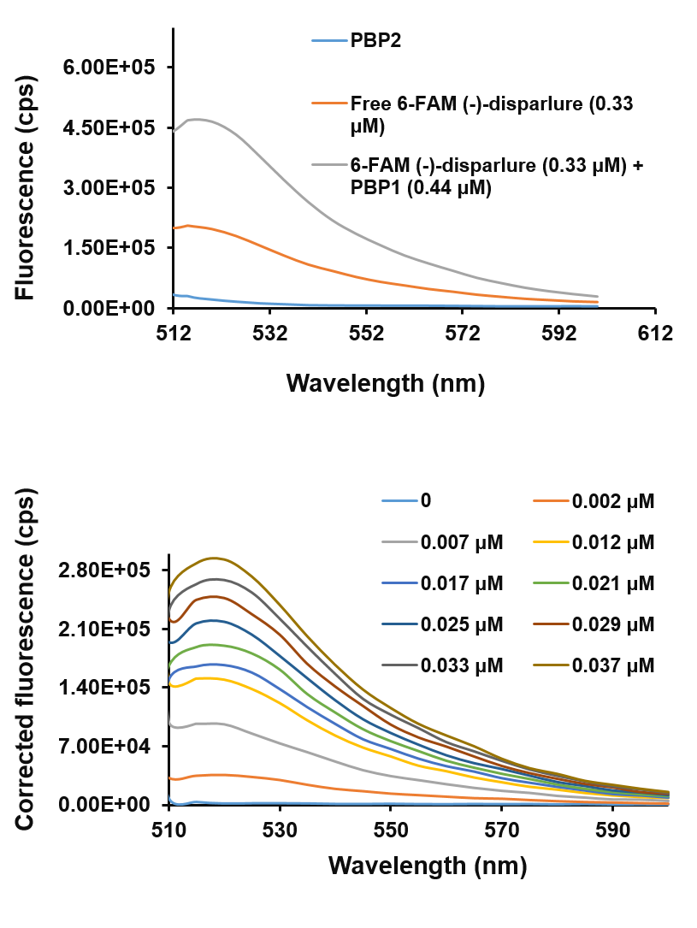
Figure S11. A) 6-FAM (-)-disparlure ent-1a emission spectra. ent-1a bound to LdisPBP2 was excited at 494 nm and its emission spectra (gray trace) was recorded. B) Fluorescence emission spectra were recorded with increasing doses of 6-FAM (-)-disparlure ent-1a.

Competition of fluorescent disparlure enantiomers binding to LdisPBP1 and LdisPBP2 by disparlure enantiomers
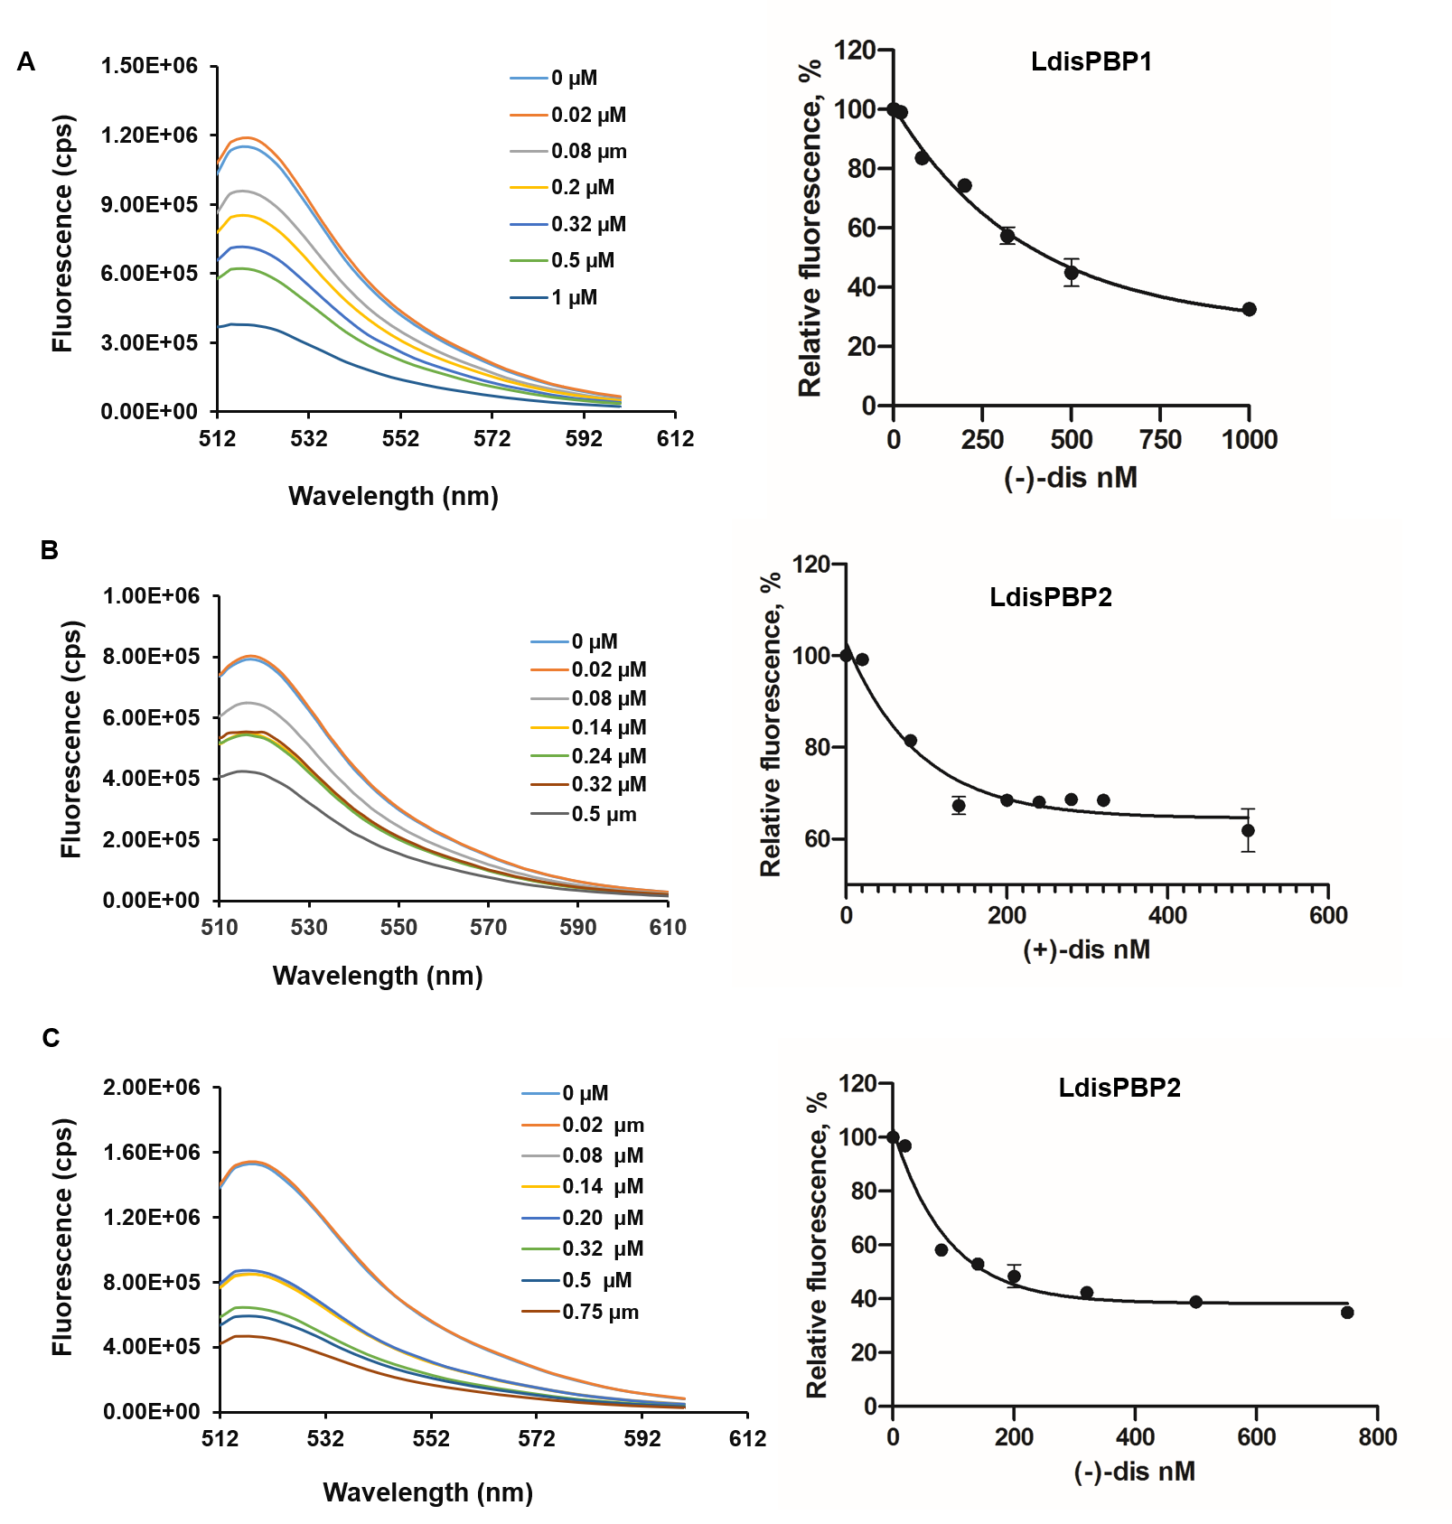
Figure S12. Competition of fluorescent disparlure enantiomers binding to LdisPBP1 and LdisPBP2 by non-fluorescent disparlure enantiomers. A) The decrease of 6-FAM (-)-disparlure/LdisPBP1 fluorescence emission intensity at maximum (520 nm) at increasing concentrations of competitor (-)-disparlure. B) & C) The decrease of 6-FAM (+)-disparlure/LdisPBP2 and 6-FAM (-)-disparlure/LdisPBP2 fluorescene intensity at increasing concentrations of (+)-disparlure and (-)-disparlure, respectively.

