S1 The variance inflation factor (VIF) of the independent variables
Climate |  | Stand |  | Soil |  | Structure diversity |  | Topography
Variables | VIF | Variables | VIF | Variables | VIF | Variables | VIF | Variables | VIF
MAT | 1.44 | Age | 1.82 | DEPTH | 1.18 | ISCD | 1.06 | Altitude | 3.25
MWMT | / | Dg | 3.12 | REF_BULK_DENSITY | 3.52 |  |  | Aspect | 1.09
MCMT | / | Density | 2.06 | OC | 2.32 |  |  | Slope | 1.29
TD | / |  |  | PH_H2O | 12.66
MAP | 1.14 |  |  | CEC_SOIL | 2.81
AHM | 29.46 |  |  | BS | 4.98
DD_0 | / |  |  | TEB | 3.01
DD5 | / |  |  | CACO3 | 5.91
DD18 | / |  |  | ESP | 1.67
NFFD | / |  |  | ECE | 2.10
PAS | 12.72
EMT | 64.73
EXT | 68.50
EREF | 15.22
CMD | 12.24
RH | 39.98

S2 The variance Pearson of the independent variables
Climate |  | Stand |  | Soil |  | Structure diversity |  | Topography
Variables | Pearson | Variables | Pearson | Variables | Pearson | Variables | Pearson | Variables | Pearson
MAT | .316** | Age | .283** | DEPTH | 0.251** | ISCD | -.225** | Altitude | -.221**
MWMT | .316** | Dg | .258** | REF_BULK_DENSITY | -0.02 |  |  | Aspect | 0.026
MCMT | .189** | Density | .362** | OC | -0.013 |  |  | Slope | -.158**
TD | 0 |  |  | PH_H2O | -0.049
MAP | .273** |  |  | CEC_SOIL | -0.01
AHM | .304** |  |  | BS | -0.027
DD_0 | -.246** |  |  | TEB | -0.012
DD5 | .308** |  |  | CACO3 | -0.042
DD18 | -.272** |  |  | ESP | 0.02
NFFD | .288** |  |  | ECE | 0.021
PAS | .292**
EMT | -.122**
EXT | .199**
EREF | .320**
CMD | .187**
RH | .245**

S3 Factor load of each measurement index in PLS-SEM
Age group | Climate |  | Stand |  |  | Soil | Structure diversity | Topography
Age group | MAP | MAT | Age | Dg | Density | DEPTH | ISCD | Altitude
Young stand | 0.9973 | 0.1328 | -0.3308 | 0.3345 | 0.3394 | 1.0000 | 1.0000 | 1.0000
Middle-age stand | 0.9811 | -0.0498 | -0.3262 | 0.3351 | 0.3432 | 1.0000 | 1.0000 | 1.0000
Near-mature stand | 0.9009 | -0.1933 | -0.3328 | 0.3349 | 0.3398 | 1.0000 | 1.0000 | 1.0000
Mature stand | 0.8563 | -0.2299 | -0.3316 | 0.3352 | 0.3387 | 1.0000 | 1.0000 | 1.0000
Over-mature stand | 0.8539 | -0.2142 | -0.3419 | 0.3281 | 0.3357 | 1.0000 | 1.0000 | 1.0000

Young forest：
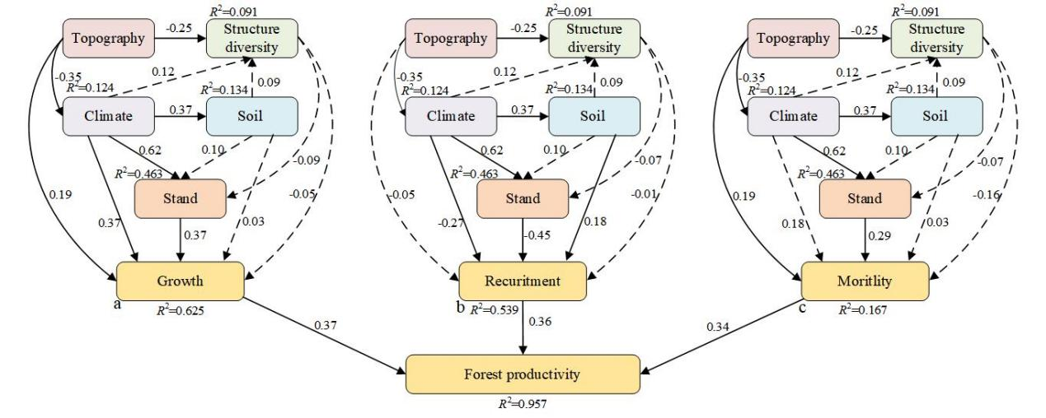
Middle-aged forest：
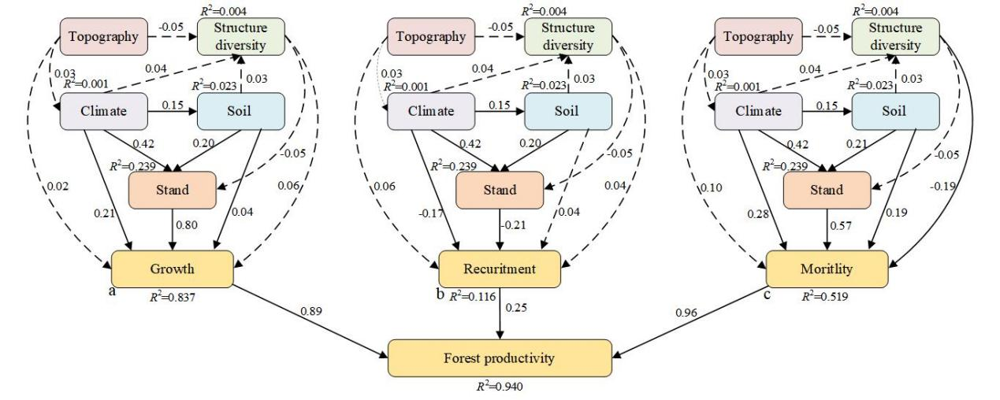

Near-aged forest：
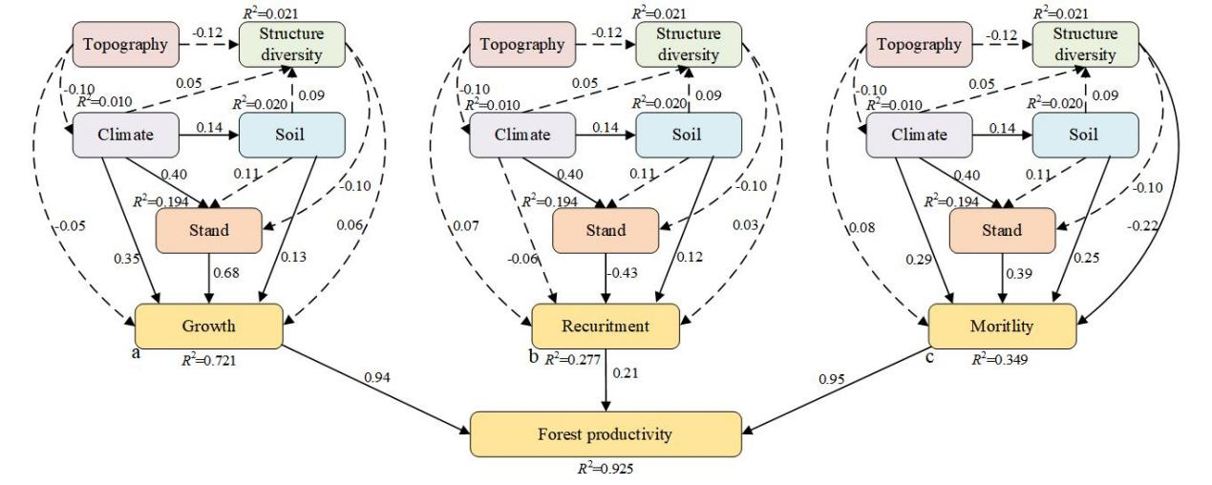
Mature forest：
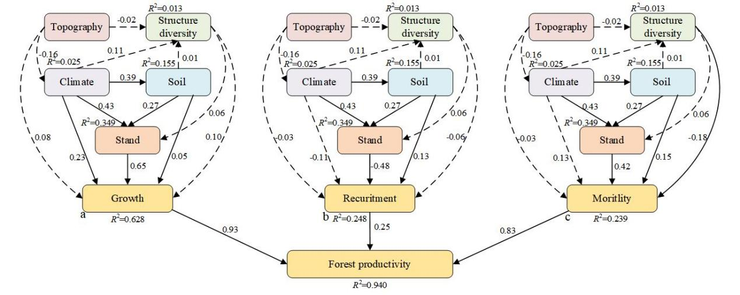
Overaged forest：
