SUPPORTING INFORMATION
Leveraging crystal defect modulation of Zirconium nano-MOF for enhanced water vapour confinement and photocatalytic behaviours
Liang Ying Ee^{* a, b}, Sean Yi Rong Chia ª, Regina Pei Woon Tan ª, Qian Ma ª

ª Department of Chemistry, College of Humanities and Sciences, National University of Singapore, 3 Science Drive 3, Singapore 117543, Singapore.
^{b} Chemical Engineering Program, Physical Science and Engineering Division, King Abdullah University of Science and Technology, Thuwal, 23955-6900, Saudi Arabia.

Contents
1. Optimization of synthesis and characterization of UiO66NH₂ 2
2. Modulator effect on bonding environments of synthesized UiO66NH₂ 11

Optimization of synthesis and characterization of UiO66NH₂

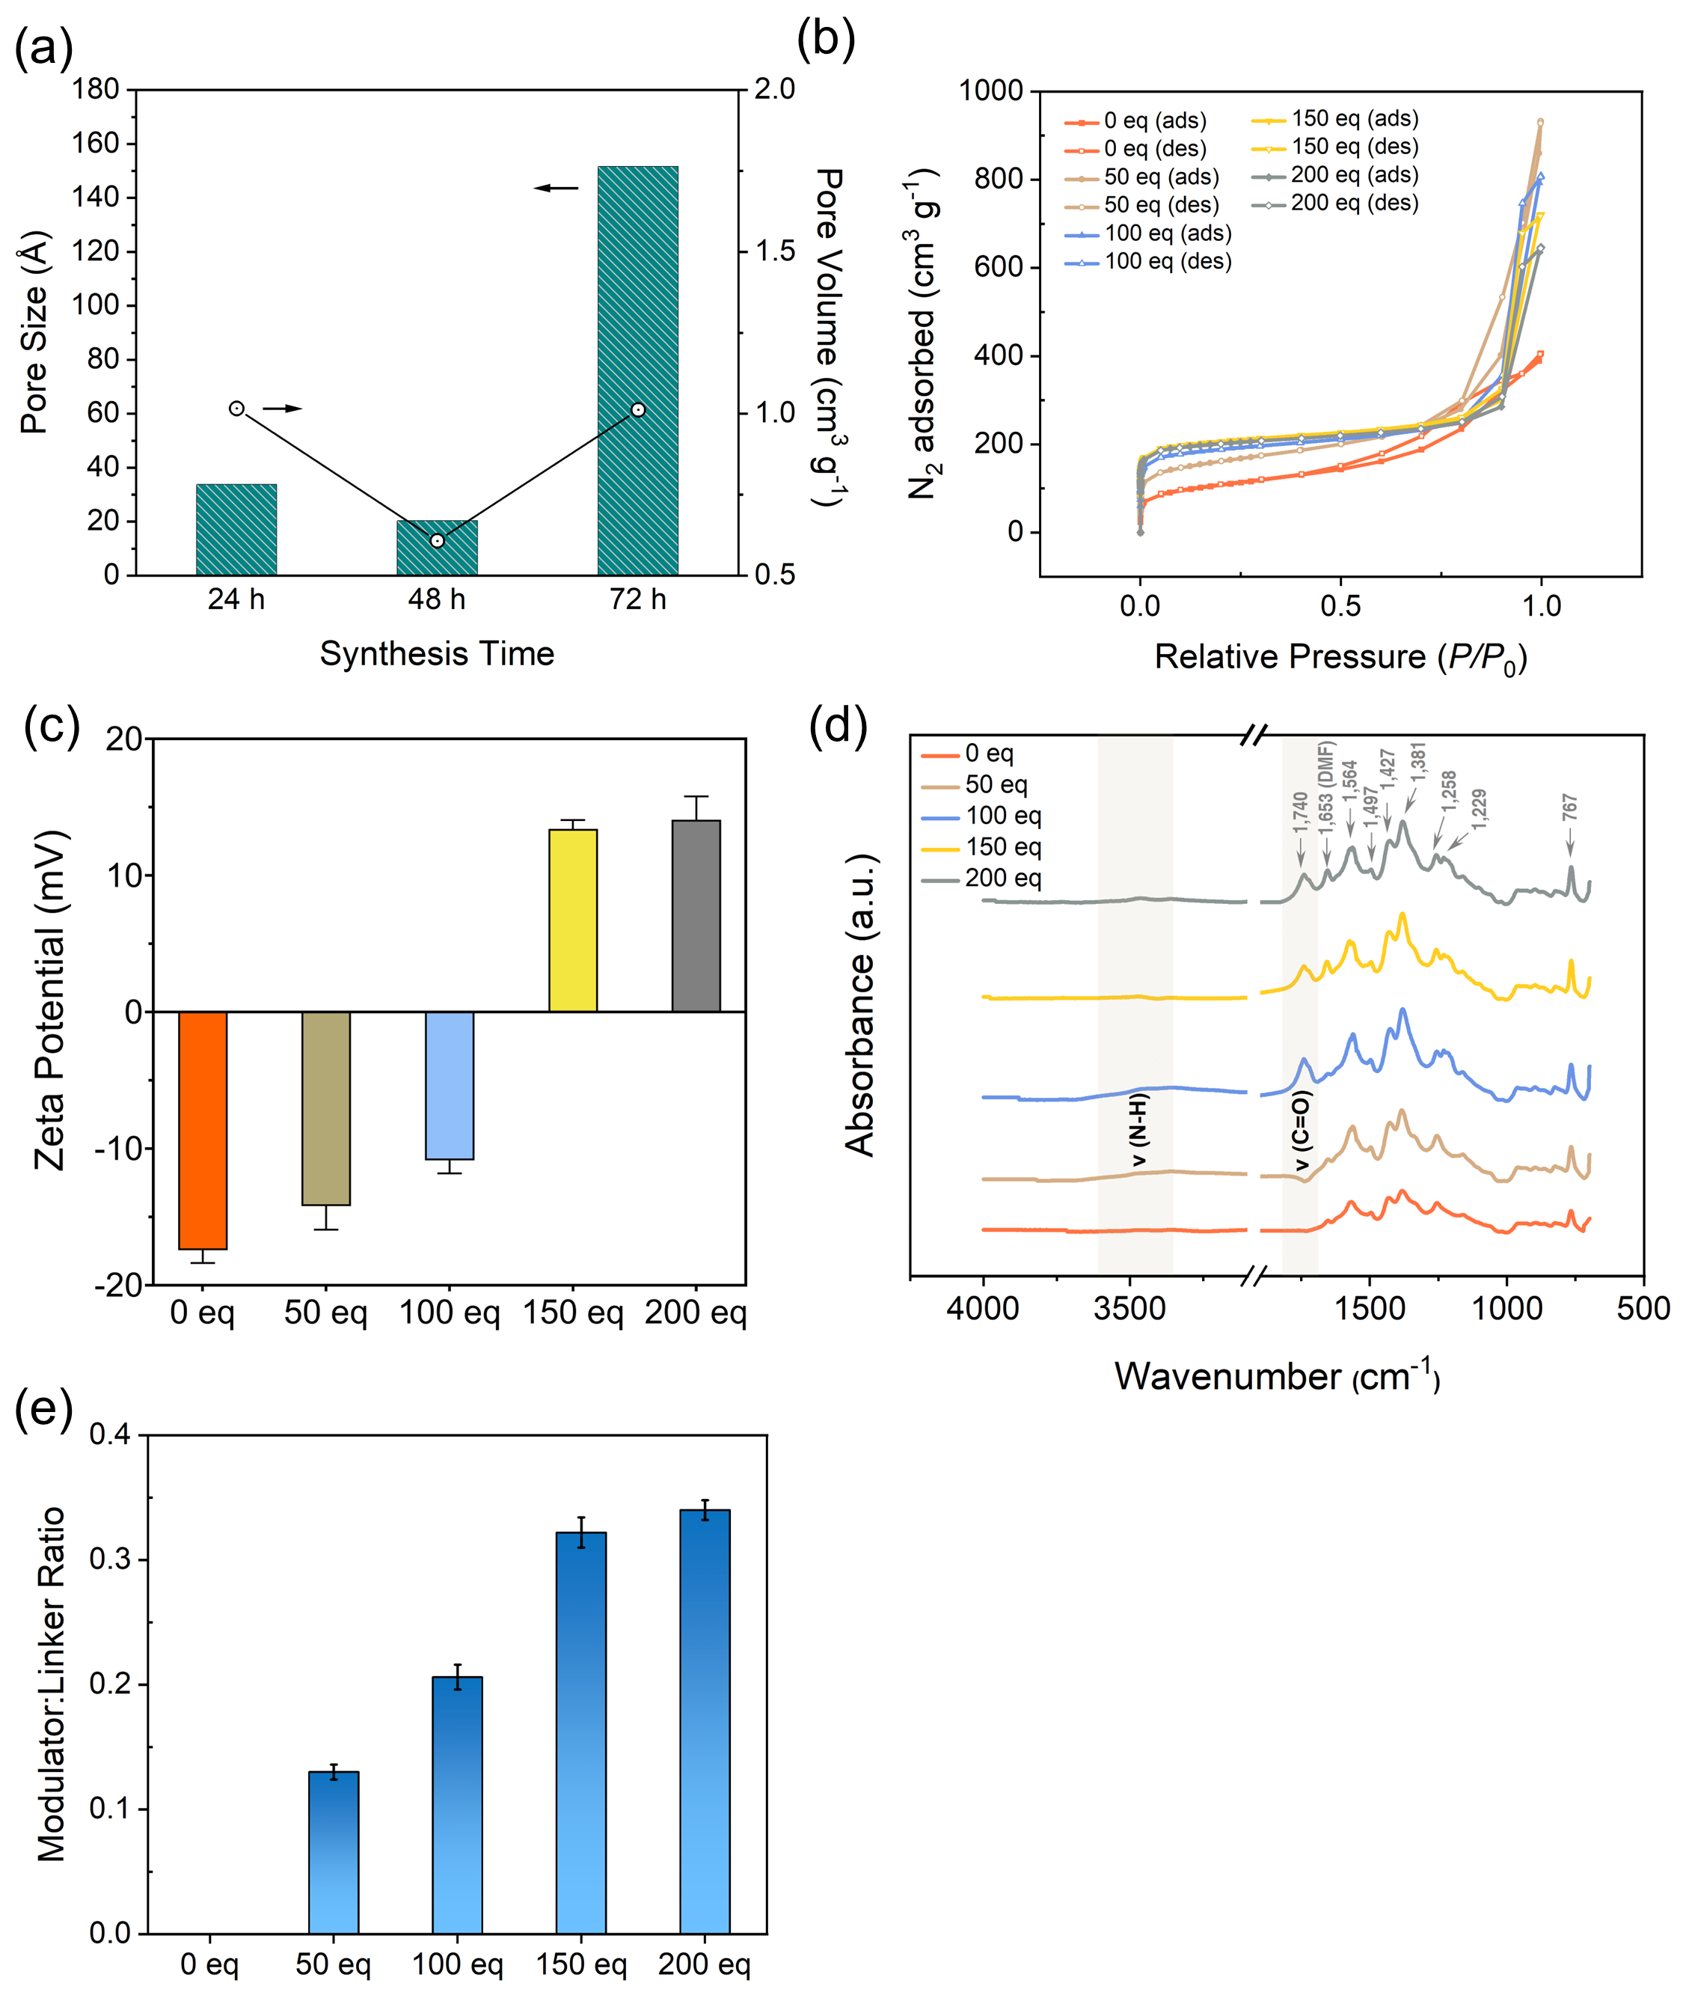
Figure S1.1. (a) BET analysis results of UiO66NH₂ crystals under different synthesis time for their pore sizes and volumes; (b) BET N₂ adsorption-desorption profile, (c) surface zeta potential, (d) ATR-FTIR spectra and (e) modulator:linker ratio calculated from ¹H qNMR of UiO66NH₂ samples.

Table S1.1. BET analysis results of UiO66NH₂ samples.
Sample | Specific Surface Area (m² g⁻¹) | Micropore Surface Area (m² g⁻¹) | Mean Pore Size (nm) | Pore Volume (cm³ g⁻¹)
UiO66NH₂_0eq | 380.7 | 103.1 | 1.9 | 0.6
UiO66NH₂_50eq | 581.2 | 228.3 | 3.3 | 1.4
UiO66NH₂_100eq | 714.5 | 351.1 | 2.8 | 1.3
UiO66NH₂_150eq | 797.1 | 308.9 | 2.8 | 1.1
UiO66NH₂_200eq | 780.0 | 284.1 | 2.6 | 1.0

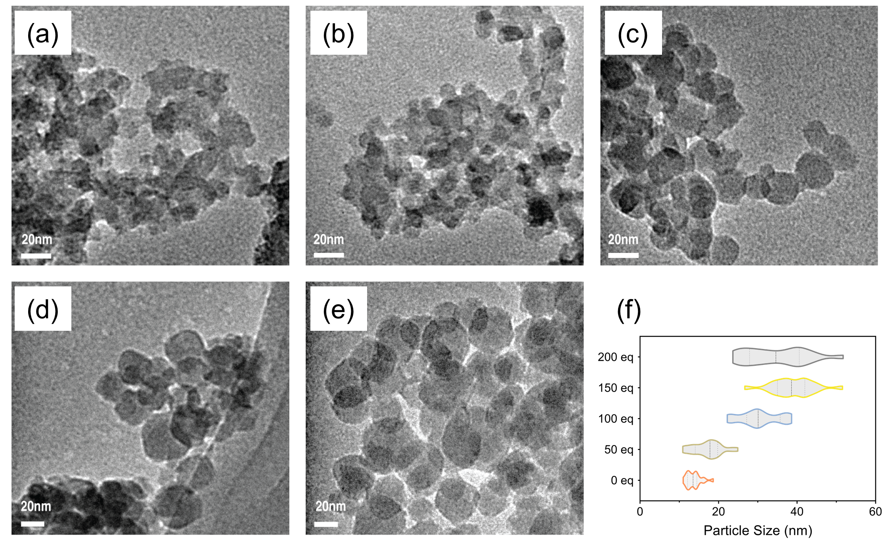
Figure S1.2. TEM micrographs of (a) UiO66NH₂_0eq, (b) UiO66NH₂_50eq, (c) UiO66NH₂_100eq, (d) UiO66NH₂_150eq and (e) UiO66NH₂_200eq; (f) Particle size distribution of UiO66NH₂ samples from TEM analysis.

Table S1.2. TEM size analysis of UiO66NH₂ samples.
Sample | Particle Size (nm)
Sample | Min | Max | Mean ª
UiO66NH₂_0eq | 11.0 | 18.7 | 13.7 ± 1.8
UiO66NH₂_50eq | 10.9 | 24.9 | 17.2 ± 3.6
UiO66NH₂_100eq | 22.2 | 38.6 | 30.5 ± 5.0
UiO66NH₂_150eq | 26.7 | 51.6 | 39.0 ± 5.3
UiO66NH₂_200eq | 23.6 | 51.7 | 34.8 ± 7.6
ª At least 20 crystals were selected for size distribution analysis.

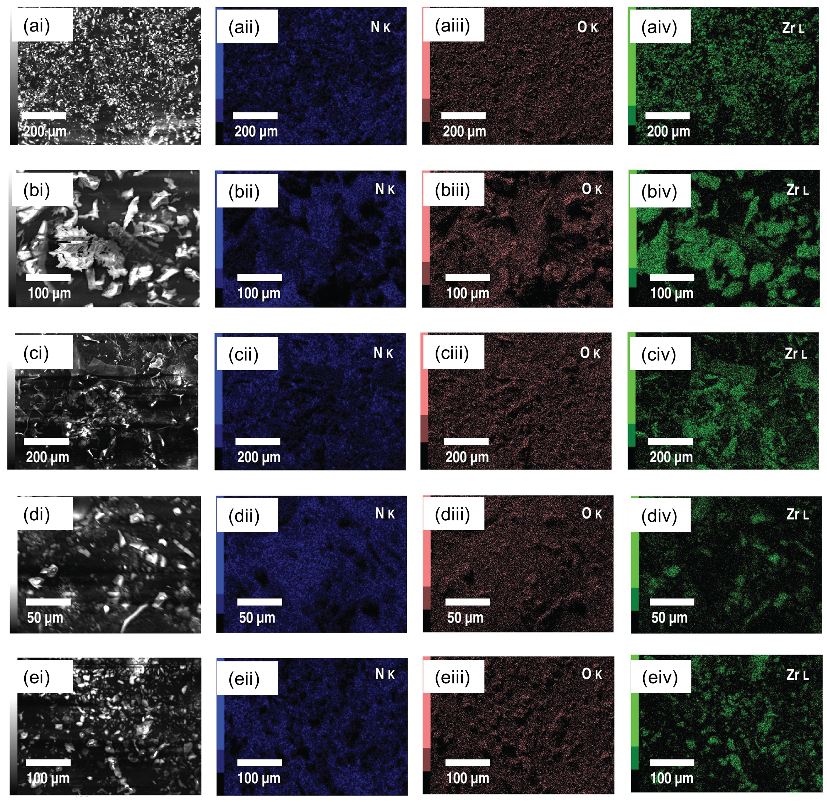
Figure S1.3. SEM-EDX micrographs of (ai) – (aiv). UiO66NH₂_0eq, (bi) – (biv). UiO66NH₂_50eq, (ci) – (civ). UiO66NH₂_100eq, (d) – (div). UiO66NH₂_150eq and (ei) – (eiv). UiO66NH₂_200eq (elements identified: nitrogen, oxygen and zirconium).

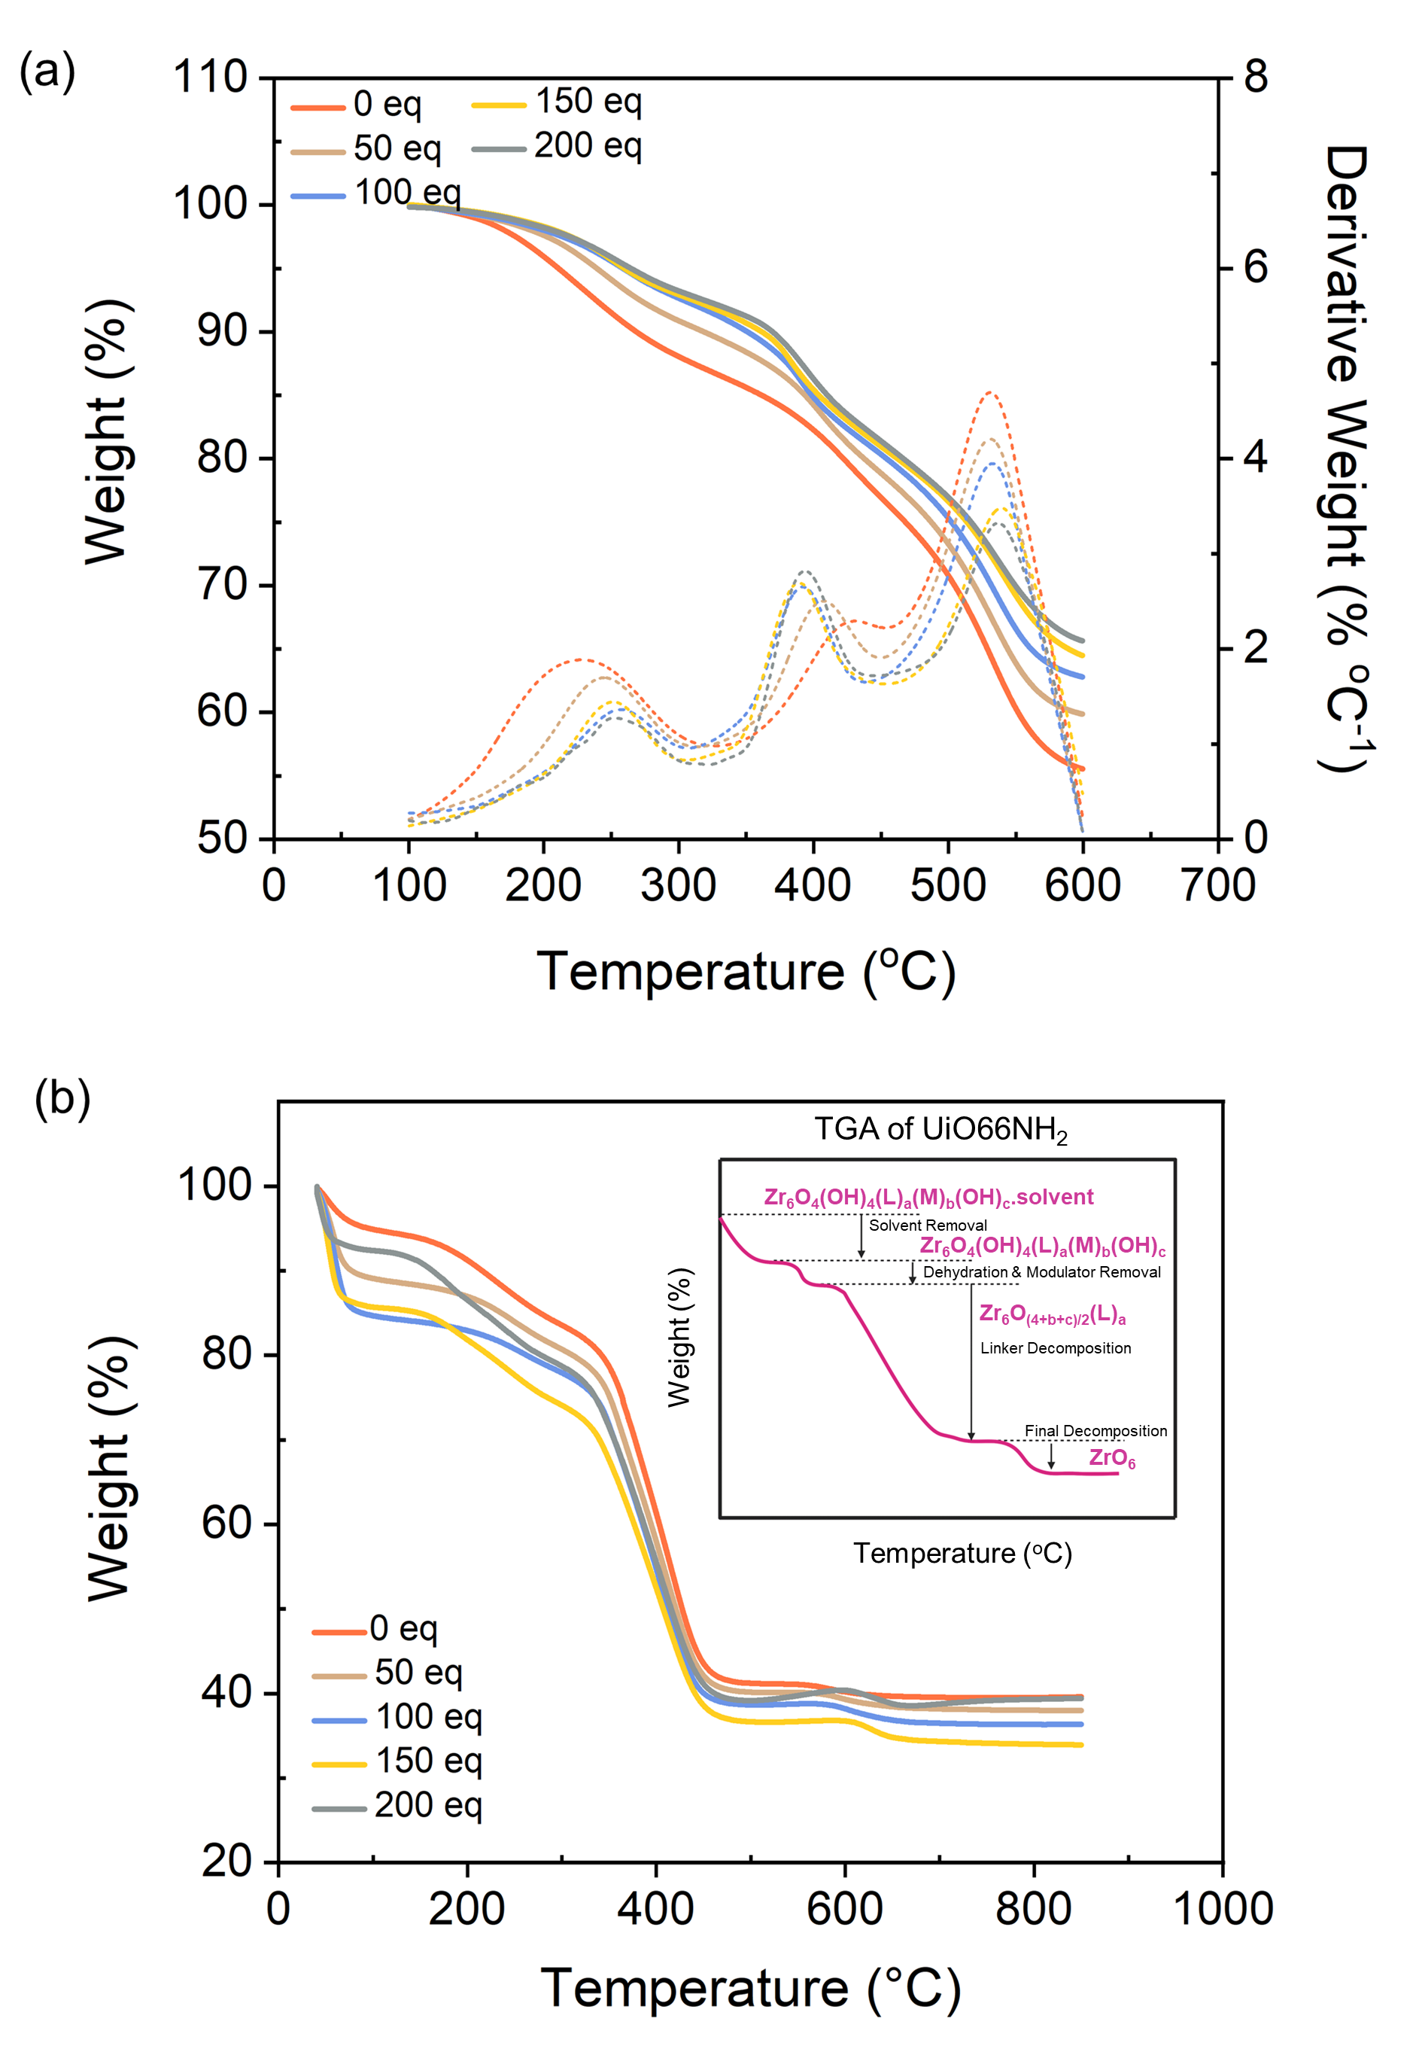
Figure S1.4. (a) TGA degradation and derivative profile, and (b) defect quantitation from TGA analysis of UiO66NH₂ samples.

Table S1.3. TGA defect analysis of UiO66NH₂ samples.
Sample | TGA Defect Analysis
Sample | Ligands/fu ª | Defects/fu ª | % Defects | Theoretical Dehydration Mass %
UiO66NH₂_0eq | 5.0 | 1.0 | 16.8 | 210.1
UiO66NH₂_50eq | 5.1 | 0.9 | 15.7 | 211.7
UiO66NH₂_100eq | 5.1 | 0.9 | 14.5 | 213.2
UiO66NH₂_150eq | 5.3 | 0.7 | 11.2 | 217.6
UiO66NH₂_200eq | 4.5 | 1.5 | 25.2 | 199.0
ª “fu” refers to formula unit of the crystal.

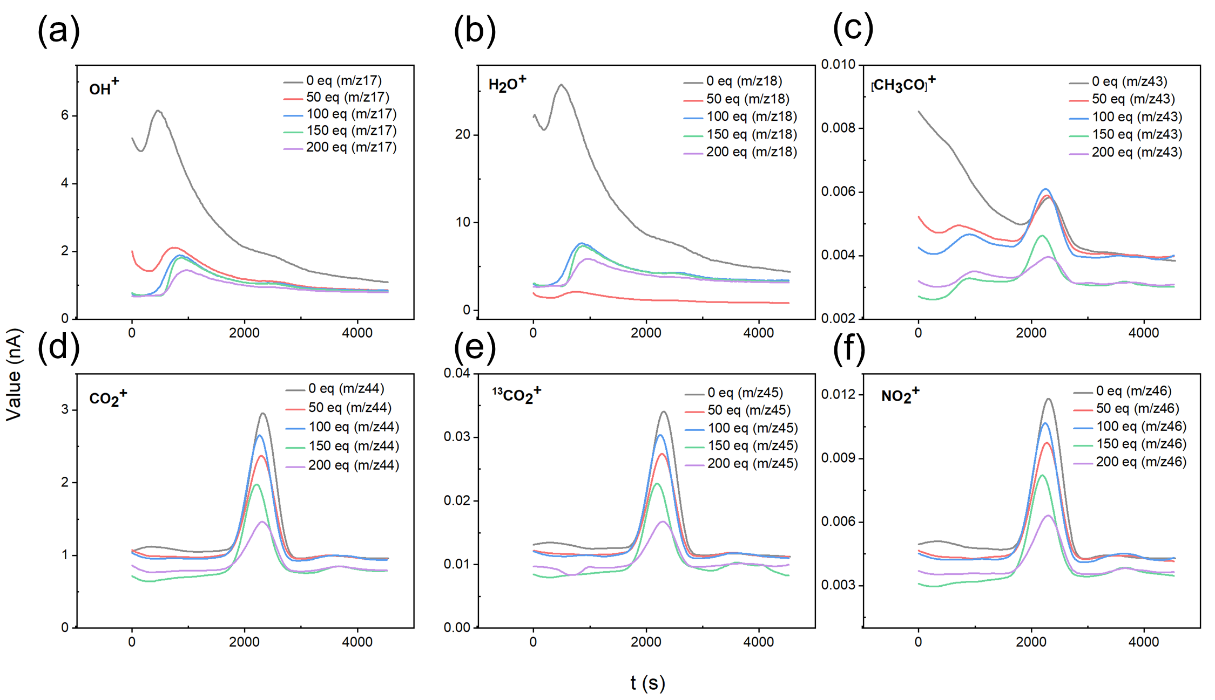
Figure S1.5. Respective TGA-MS spectra on (a) – (f) OH⁺, H₂O⁺, [CH₃CO]⁺, CO₂⁺, ¹³CO₂⁺ and NO₂⁺ of UiO66NH₂ samples.

Table S1.4. TGA-MS analysis of UiO66NH₂ samples.
Sample | Integral (nsA)
Sample | OH⁺ | H₂O⁺ | [CH₃CO]⁺ | CO₂⁺ | NO₂⁺
UiO66NH₂_0eq | 851.71 | 3664.17 | 0.55 | 1032.2 | 4.14
UiO66NH₂_50eq | 572.28 | 559.62 | 0.82 | 764.39 | 2.97
UiO66NH₂_100eq | 869.93 | 3430.03 | 0.90 | 855.25 | 3.40
UiO66NH₂_150eq | 785.01 | 3052.87 | 0.80 | 615.93 | 2.51
UiO66NH₂_200eq | 543.03 | 2119.84 | 0.42 | 375.76 | 1.67

Modulator effect on bonding environments of synthesized UiO66NH₂
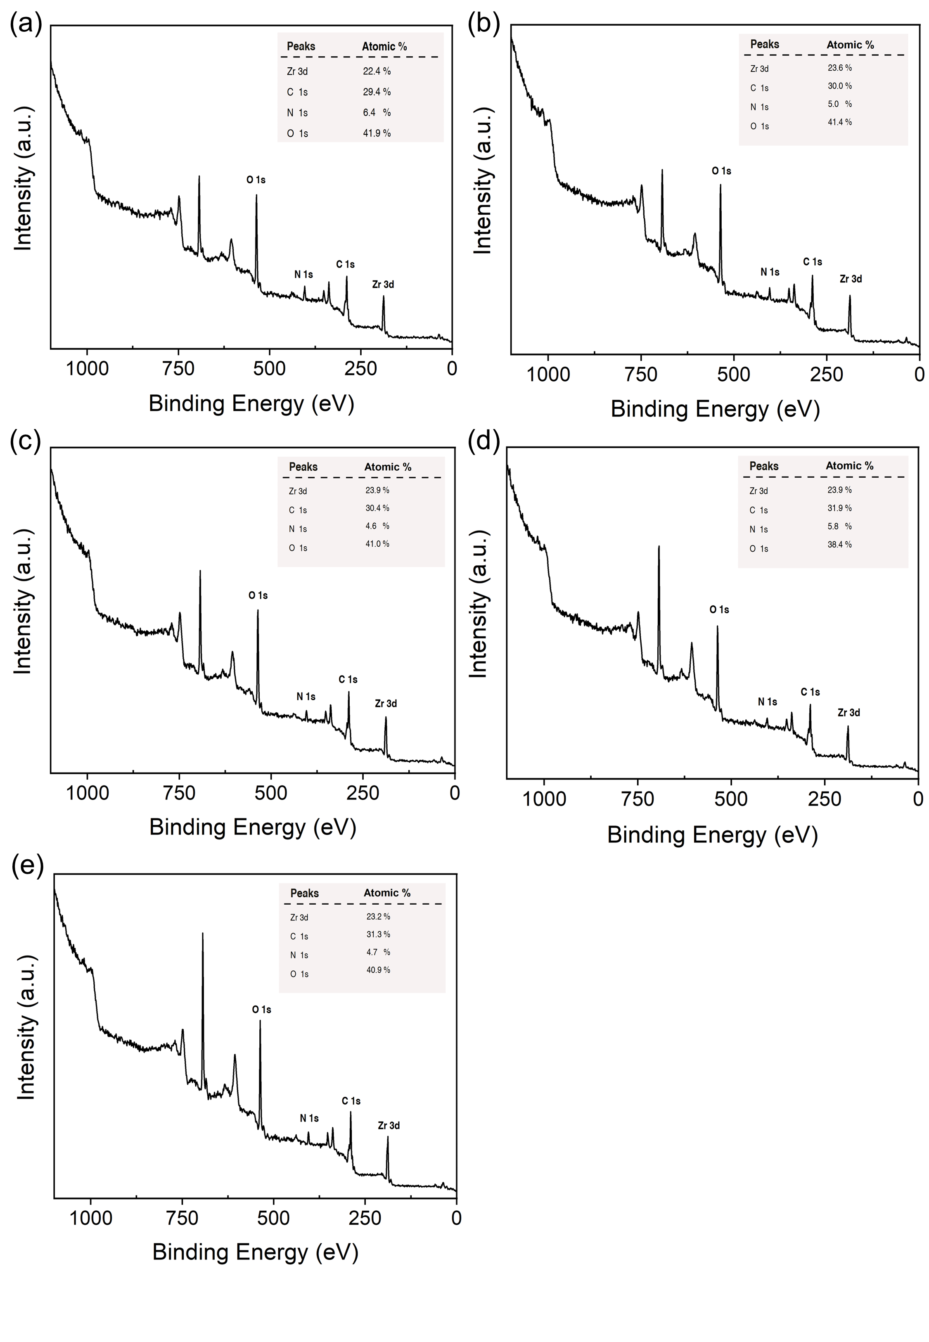
Figure S3.1. a. Survey XPS spectra of (a) UiO66NH₂_0eq, (b) UiO66NH₂_50eq, (c) UiO66NH₂_100eq, (d) UiO66NH₂_150eq, and (e) UiO66NH₂_200eq. The percentage atomic concentrations of C, N, O, and Zr are tabulated in each spectrum.

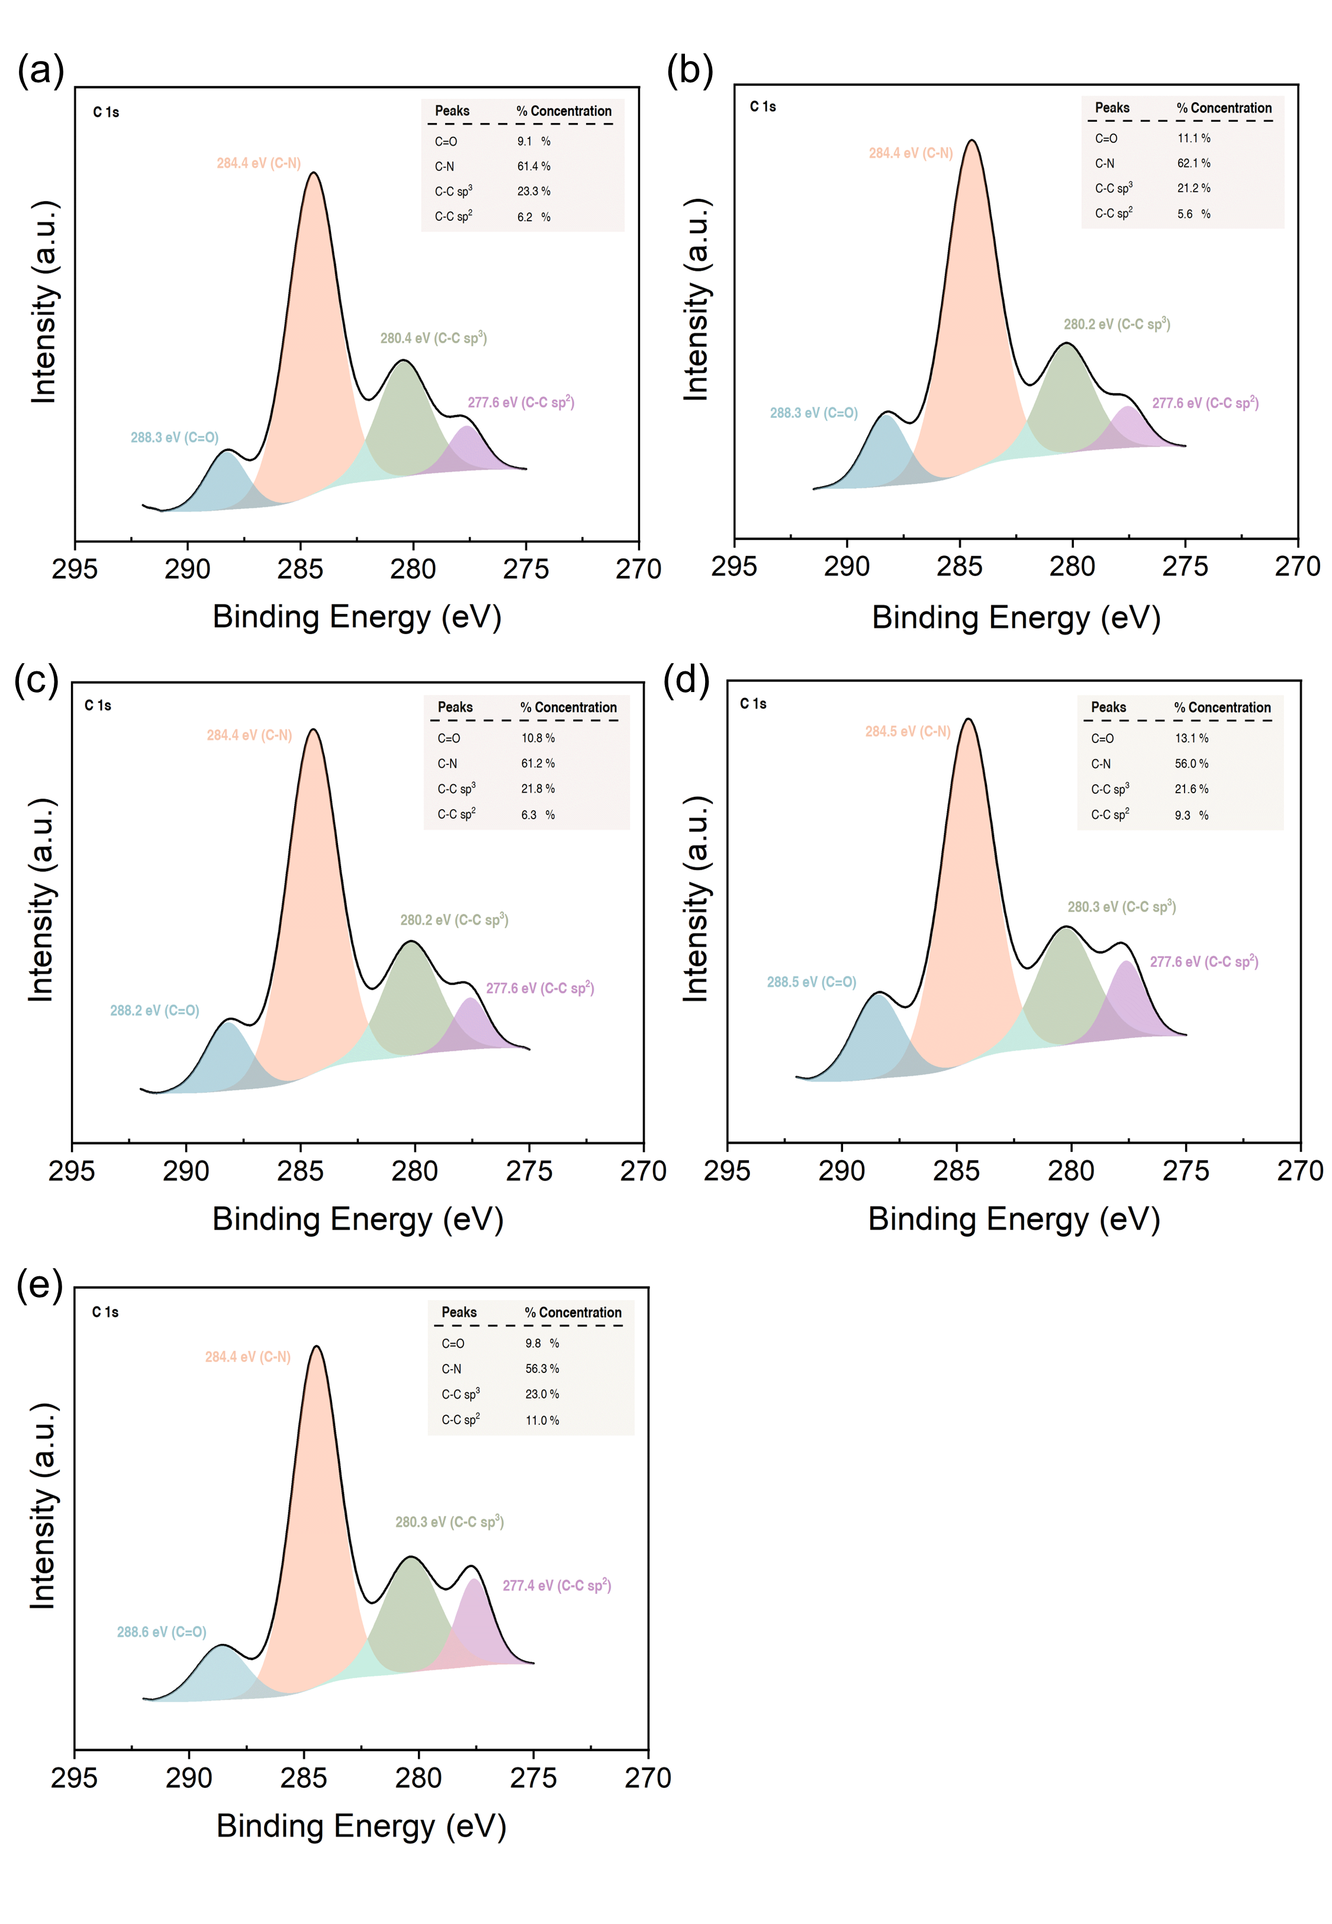
Figure S3.2. Deconvoluted high-resolution C 1s XPS spectra of (a) UiO66NH₂_0eq, (b) UiO66NH₂_50eq, (c) UiO66NH₂_100eq, (d) UiO66NH₂_150eq, and (e) UiO66NH₂_200eq. The percentage atomic concentrations of C, N, O, and Zr are tabulated in each spectrum.

