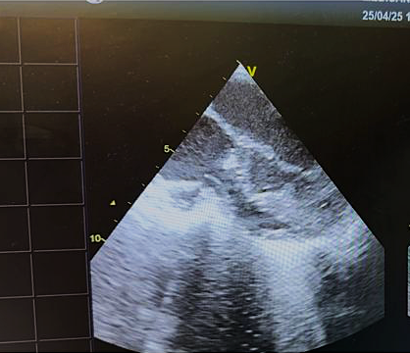
Deep subaortic stenosis
Photo 1. Transesophageal echocardiography demonstrates significant subaortic obstruction associated with marked hypertrophy of the ventricular septum
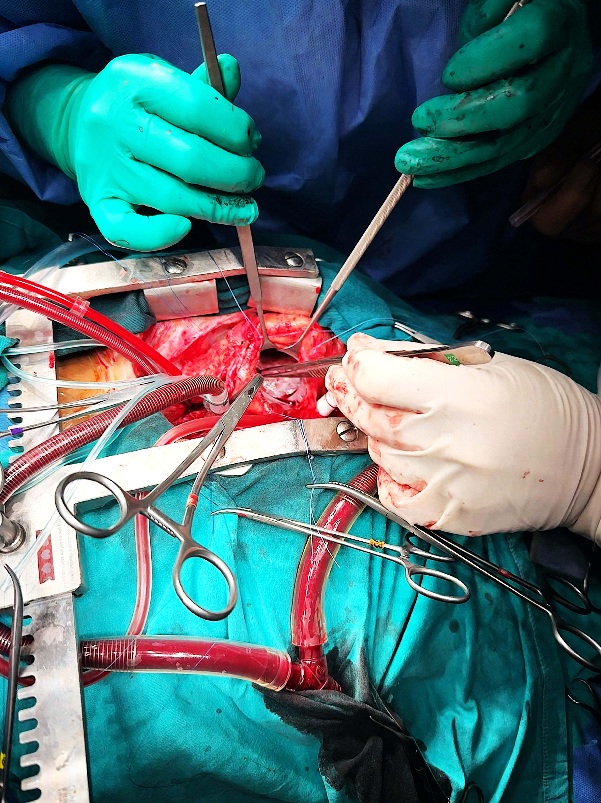
Created VSD

Photo 2. After performing septal resection via the aortotomy, an iatrogenic VSD was created to allow further exposure and resection of the deeply located obstructive myocardium.

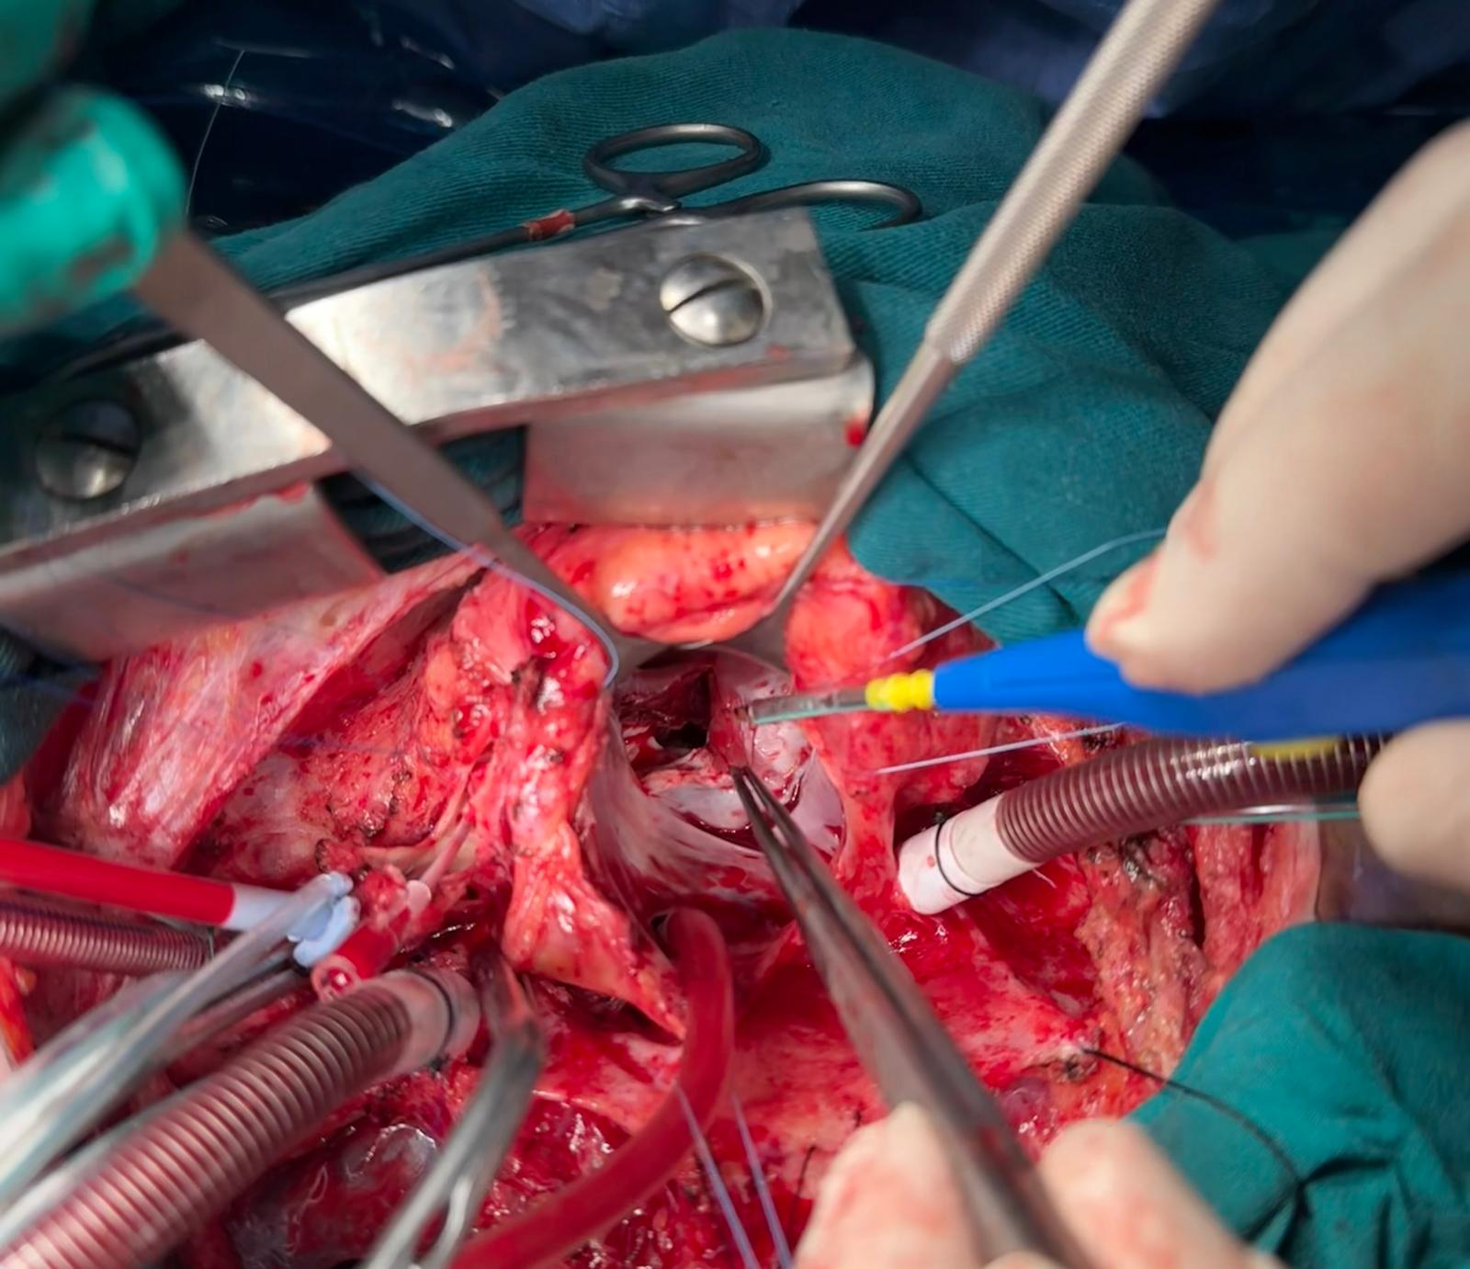
The iatrogenic VSD is being surgically enlarged
Photo 3. The iatrogenic VSD was surgically enlarged to facilitate access to deeply located obstructive septal muscle that could not be reached via the aortotomy. In the image, both the enlarged VSD and the aortotomy incision are visible.

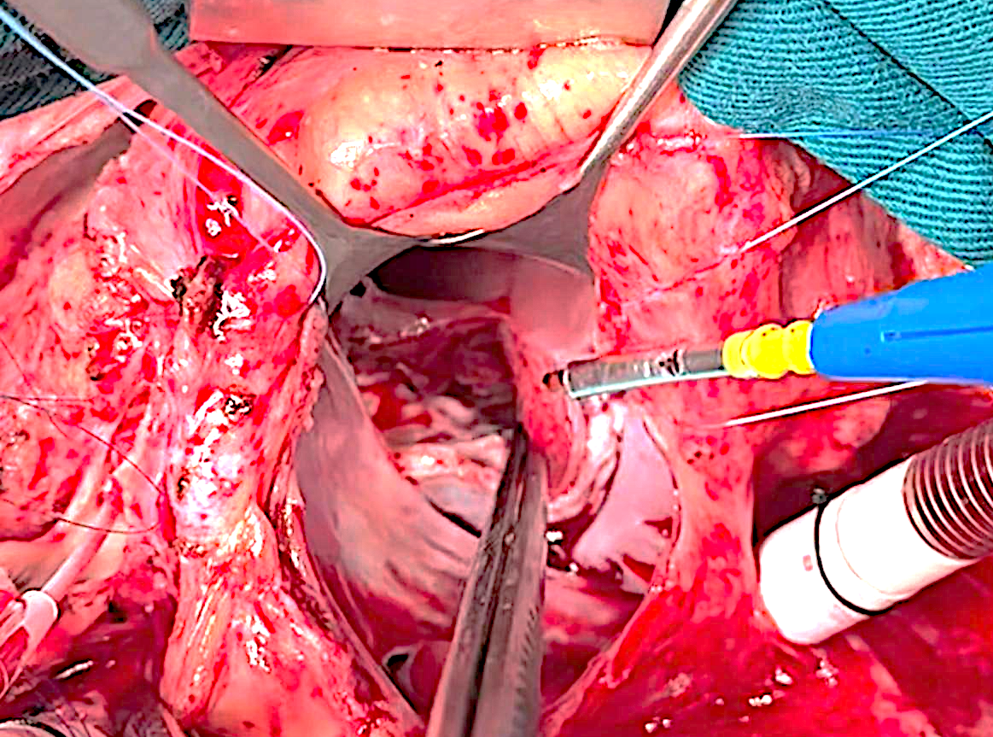
Photo 4a. The iatrogenic VSD provides access to deeper structures, enabling extensive resection of the hypertrophic septum up to the vicinity of the LV apex.

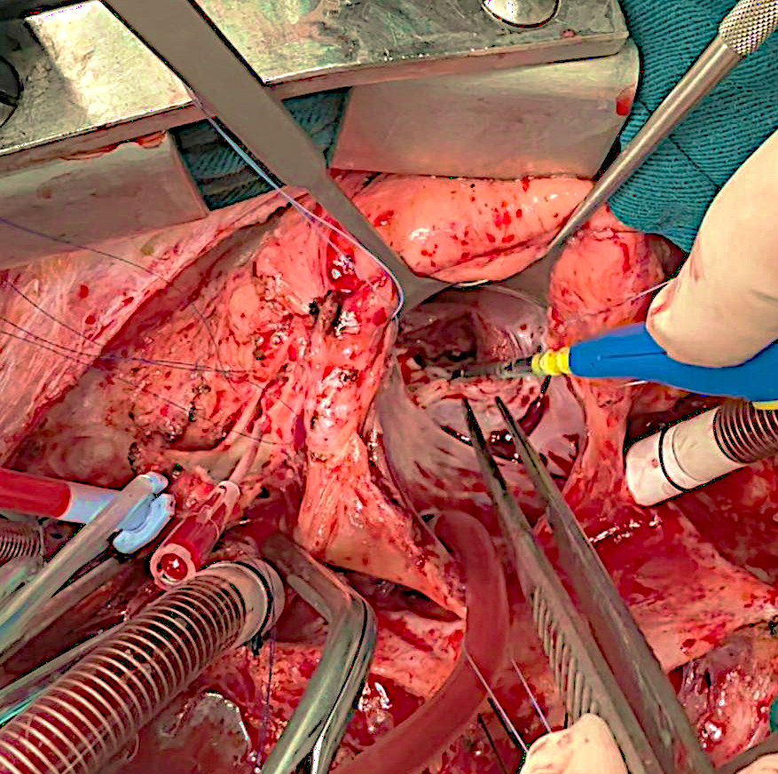
Photo 4b. The iatrogenic VSD provides access to deeper structures, enabling extensive resection of the hypertrophic septum up to the vicinity of the LV apex.

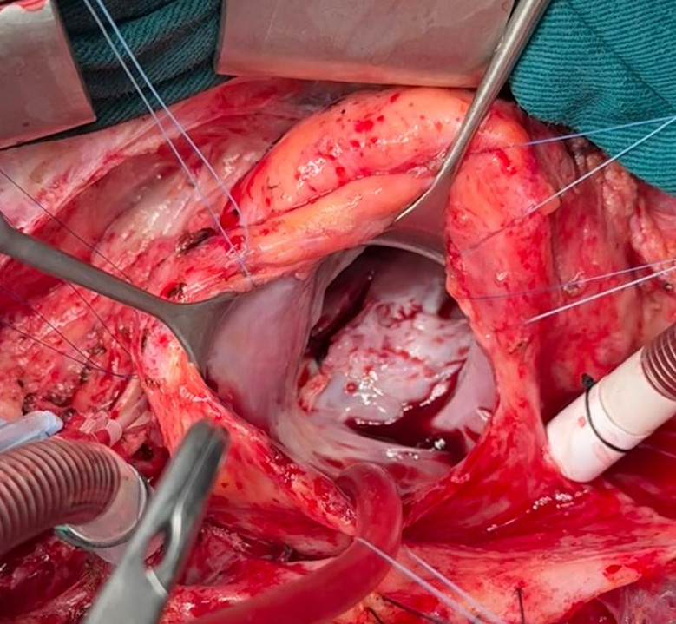
Photo 5. Following the resection of the left ventricular outflow tract obstruction, the ventricular septum was carefully inspected to ensure complete removal of hypertrophic muscle.

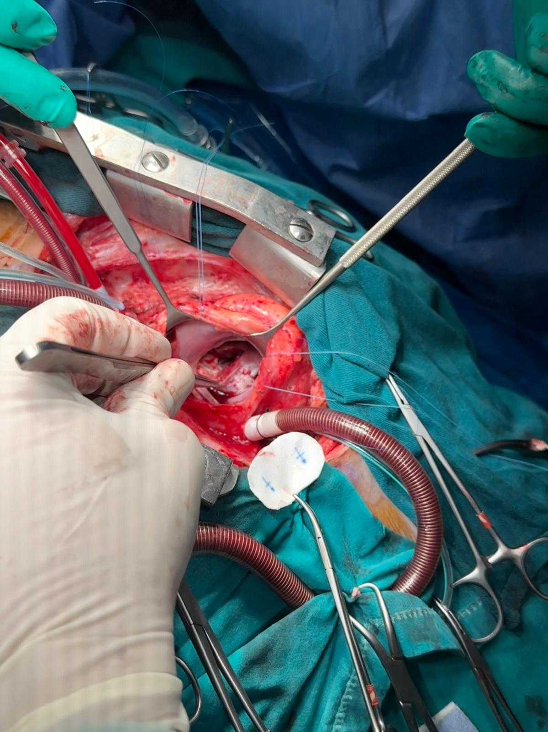

Photo 6A. The iatrogenic ventricular septal defect was closed using a Dacron patch
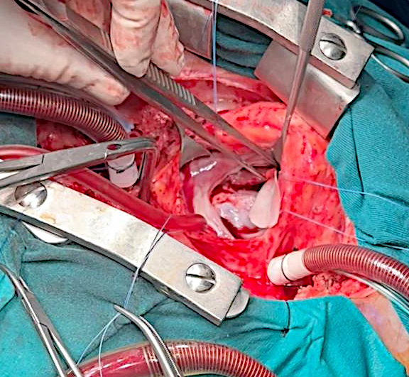

Photo 6B. The iatrogenic ventricular septal defect was closed using a Dacron patch

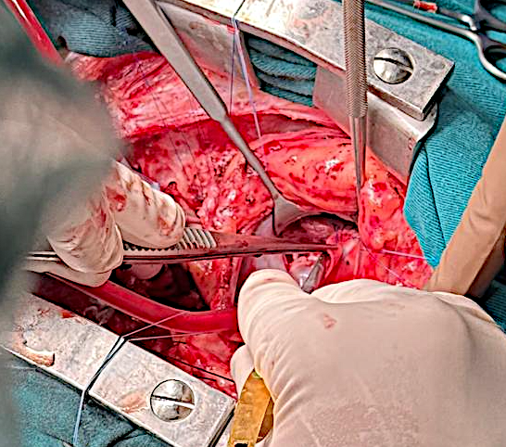
Photo 7C. The iatrogenic ventricular septal defect was closed using a Dacron patch

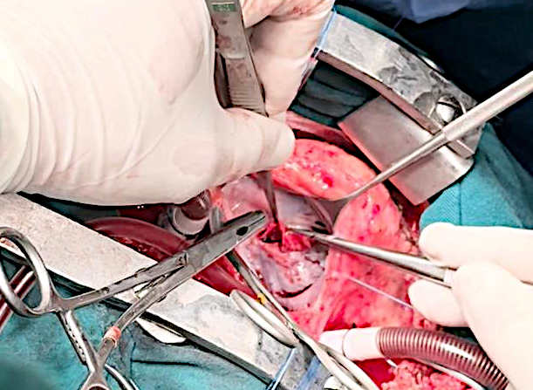
Photo 7D. The iatrogenic ventricular septal defect was closed using a Dacron patch
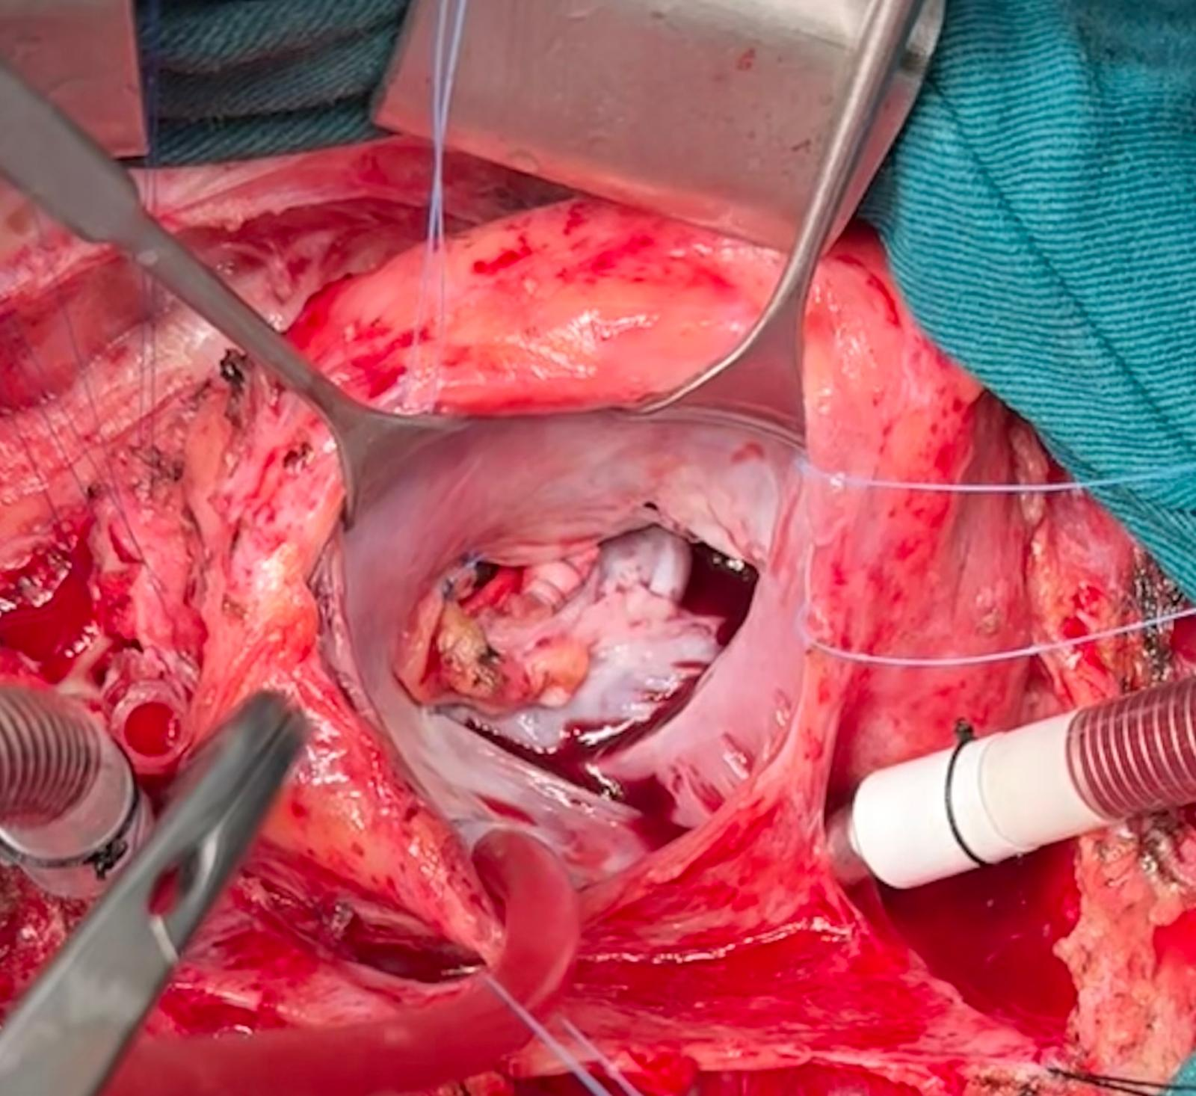
Photo 8. The surgically closed ventricular septal defect is shown, with the patch in place and reinforced by pericardial support tissue.
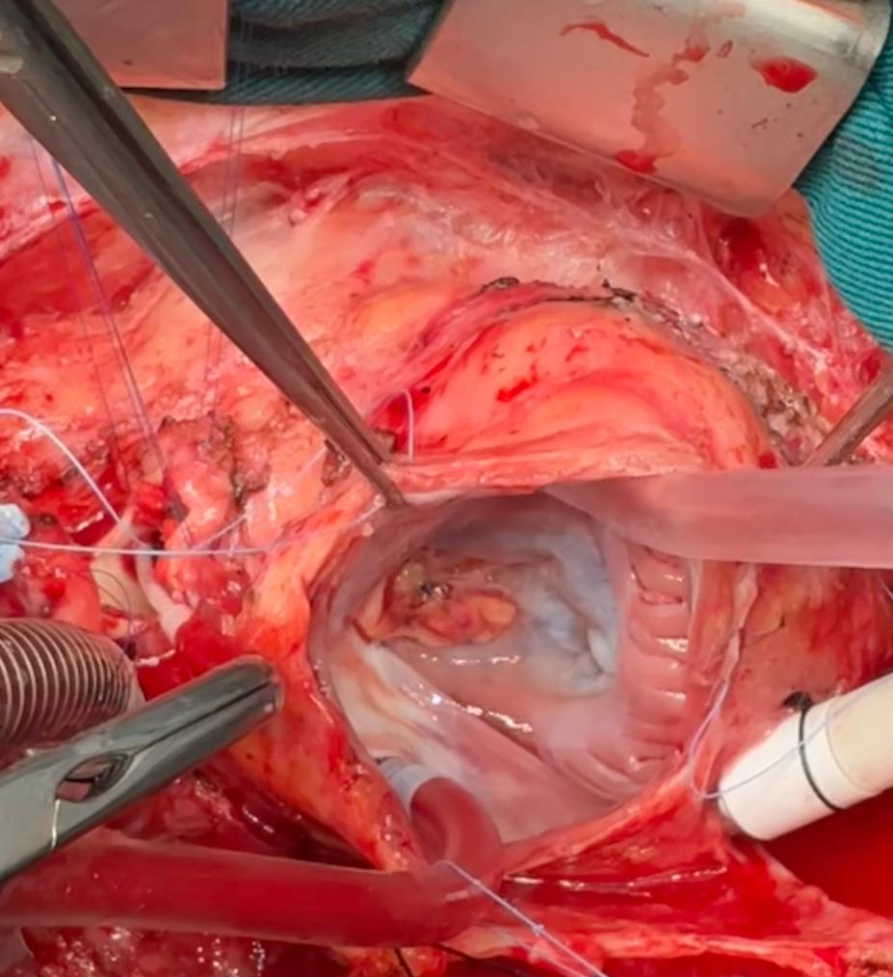

Photo 9. Saline test for the tricuspid valve
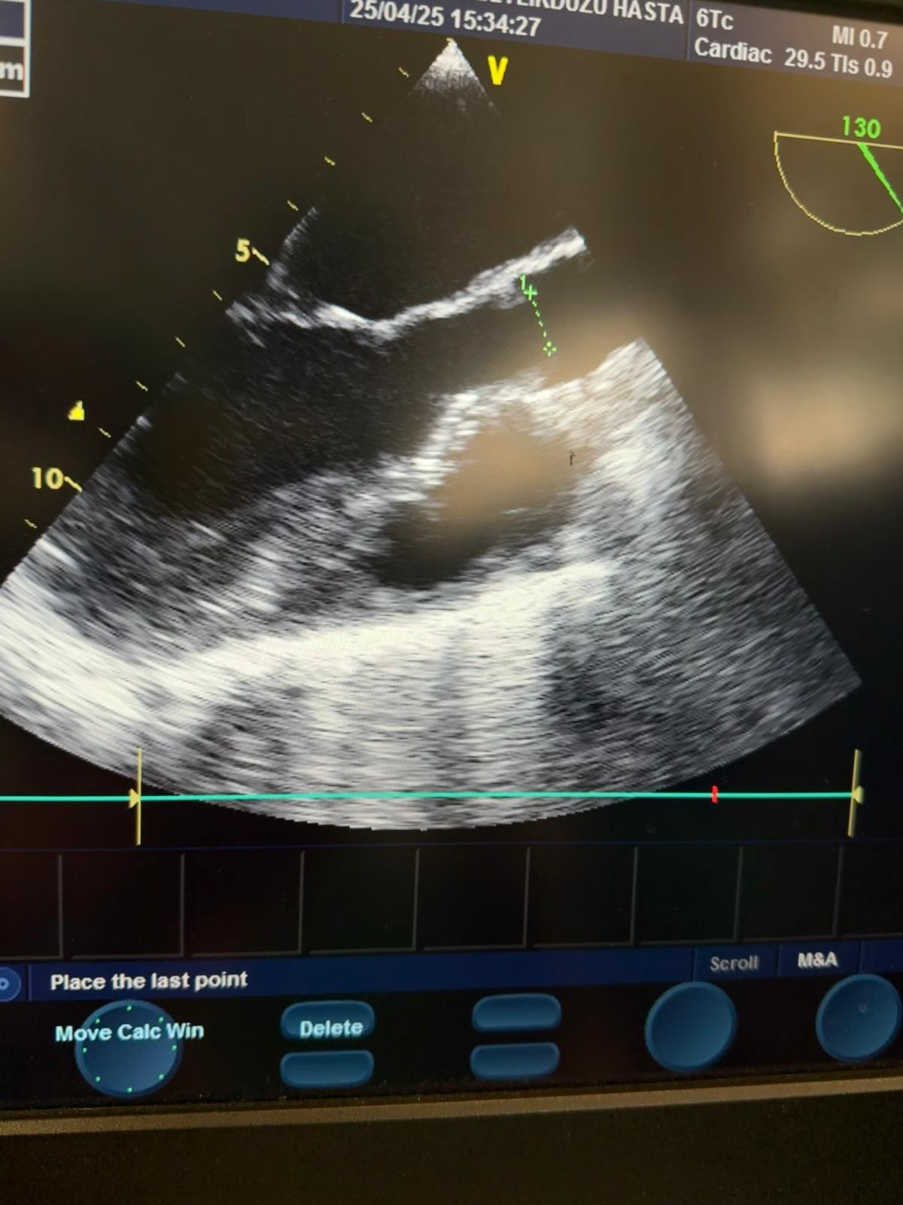
VSD patch
Photo 10. Postoperative TEE. LVOT is open, no obstruction.

