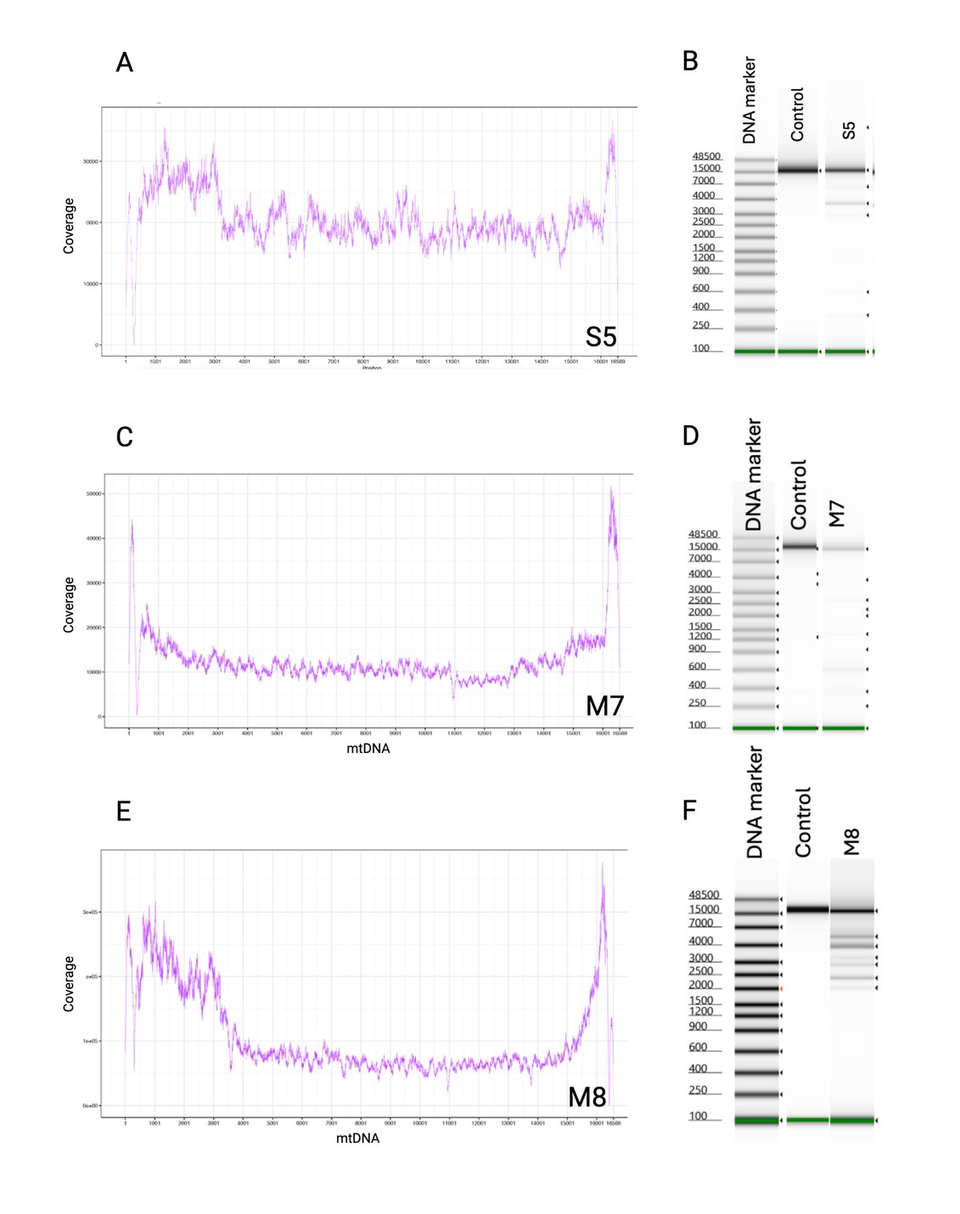
Supplementary Material S1: MMD detected by long-range PCR and NGS.
The NGS coverage profile showing the NGS read depth (y-axis) across the mtDNA position (x-axis) indicates the presence of large-scale mtDNA deletions (A,C, E). Long-range PCR gel images: The presence of single deletion band (B) and multiple deletion bands supports the detection of SLSMD and MMD by NGS.

Supplementary Material S2: Reproducibility of SNV detection by LRS
SNVs detected in M1 |  | SNVs detected in M7
M1 Replicate 1 | M1 Replicate 2 | M7 Replicate 1 | M7 Replicate 2
m.263A>G | m.263A>G | m.263A>G | m.263A>G
m.750A>G | m.750A>G | m.750A>G | m.750A>G
m.1438A>G | m.1438A>G | m.1393G>A | m.1393G>A
m.3992C>T | m.3992C>T | m.1438A>G | m.1438A>G
m.4024A>G | m.4024A>G | m.1719G>A | m.1719G>A
m.4769A>G | m.4769A>G | m.4769A>G | m.4769A>G
m.5004T>C | m.5004T>C | m.4793A>G | m.4793A>G
m.8269G>A | m.8269G>A | m.8860A>G | m.8860A>G
m.8860A>G | m.8860A>G | m.10931T>C | m.10931T>C
m.9123G>A | m.9123G>A | m.15326A>G | m.15326A>G
m.10044A>G | m.10044A>G | m.16261C>T | m.16261C>T
m.14365C>T | m.14365C>T | m.16519T>C | m.16519T>C
m.14582A>G | m.14582A>G
m.15326A>G | m.15326A>G

Supplementary Data S3: SNV Comparison for All Samples and Heteroplasmy Levels
This spreadsheet contains a comparison of all SNVs called from SR-NGS and LRS workflows described in this study. Samples are organized in tabs. “N/A” in columns with SR-NGS data denote sites where no data was available because the SNVs occurred within the primer set 2 used for LR-PCR amplification.

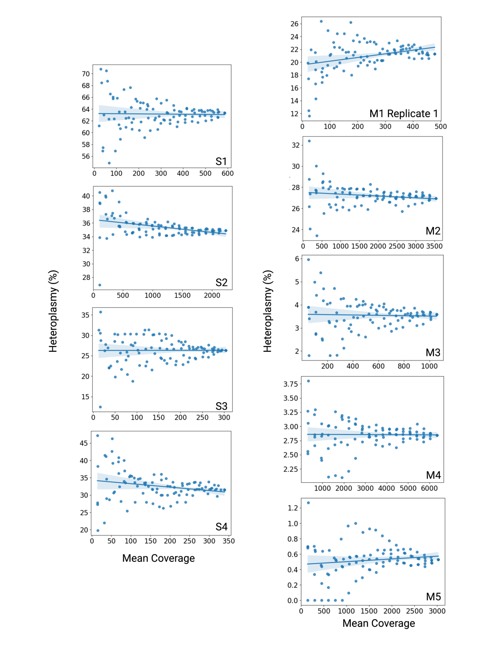Supplementary Material S4: Effects of sequencing coverage on deletion heteroplasmy quantification.
Datasets of varying mean coverage were simulated for each sample by randomly subsampling the long-read sequencing reads. Deletion heteroplasmy (y-axis) was calculated for each dataset and is plotted here against the mean coverage (x-axis).

