Supplementary Information for:
Identifying potential earthquake-prone structures from short-term array monitoring in complex normal fault systems
Francesco Scotto di Uccio, Titouan Muzellec, Antonio Scala, Grazia De Landro, Giovanni Camanni, Francesco Carotenuto, Luca Elia, Matteo Picozzi, Aldo Zollo, Claudio Strumia, Gregory C. Beroza, Gaetano Festa

Figure S1

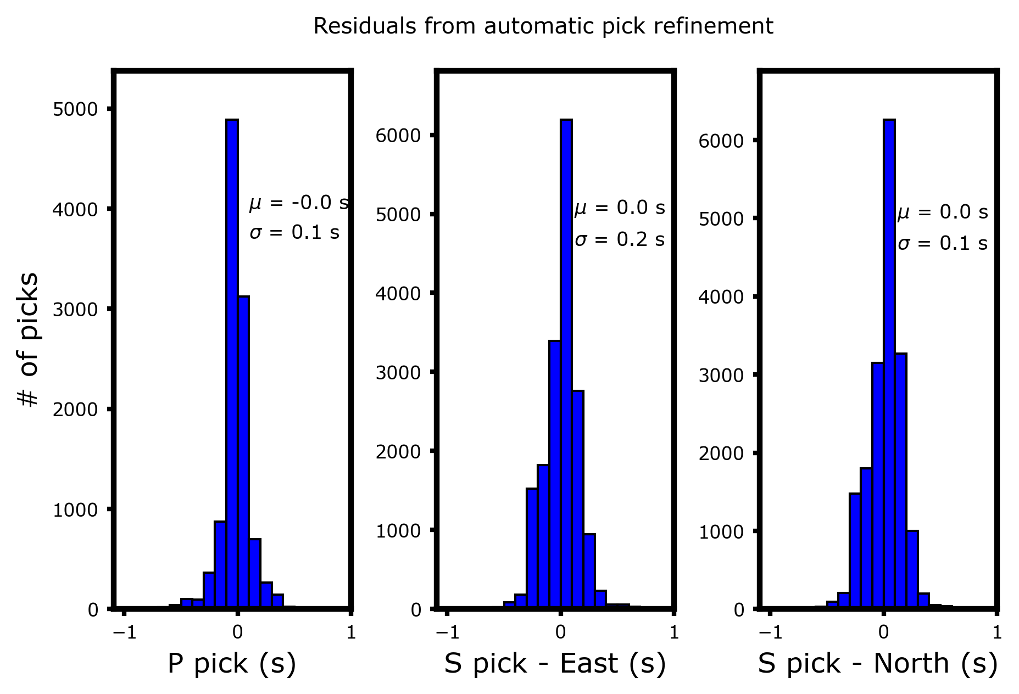
Figure S1: Results from the refinement of the automatic phase arrival times using waveform similarity and hierarchical clustering for the P and S picks. The average correction term is compatible with 0 for both phases, however small corrections can be introduced for constraining small-scale features of seismicity.

Figure S2
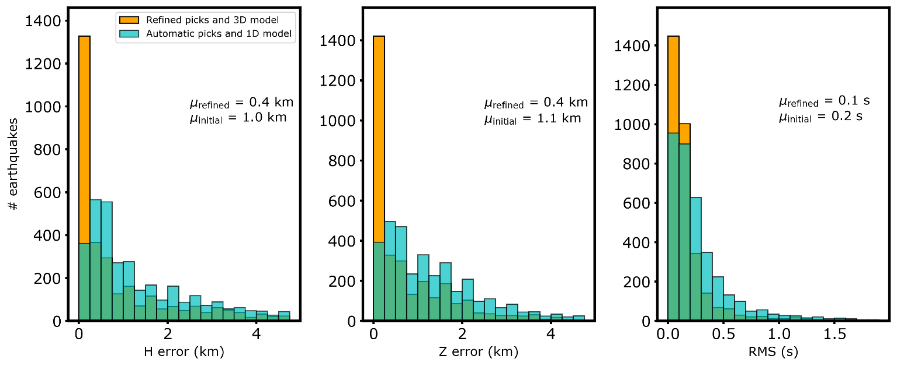
Figure S2: Histograms of location uncertainties (horizontal errors: left panel, vertical uncertainties: center panel, RMS of the arrival time residuals: right panel) for the absolute location from automatic phase arrival times and a 1D layer velocity model (cyan bars) and from refined arrival times and 3D velocity model (yellow bars). The implementation of refined arrival times and the adoption of a 3D velocity model can halve location uncertainties, achieving median spatial errors of 400m and RMS of 0.1s.

Figure S3
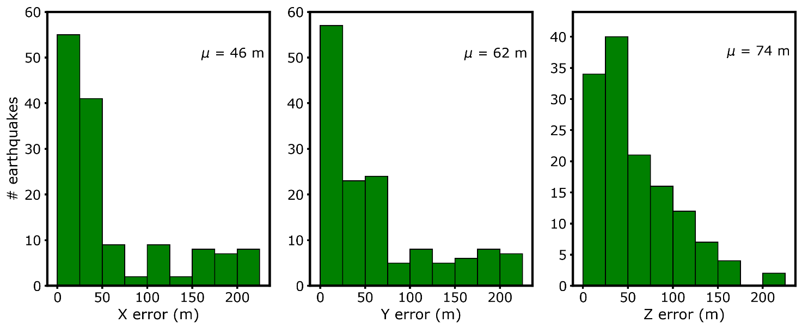
Figure S3: Histograms of spatial location uncertainties extracted from iterative SVD inversions. For this analysis, groups of 100 events within a distance of 1km in the refined 3D absolute location are selected. The resulting median uncertainties in the x,y and z directions (46m, 62m and 74 m, respectively), significantly reduce the spatial location uncertainties observed for the absolute location in the 3D model.

