EXTENDED DATA TABLES AND FIGURES

Extended Data Table 1. Baseline characteristics of patients.
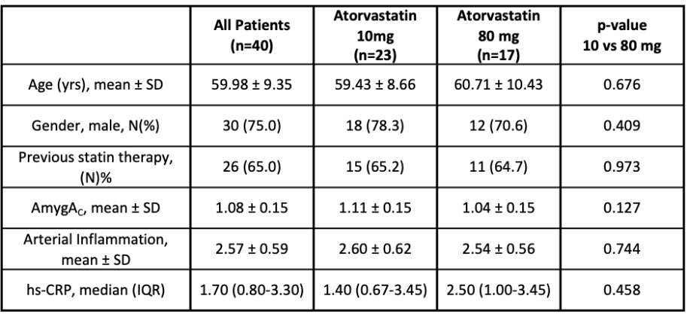

Abbreviations: AmygA_{C}: amygdala to temporal lobe activity ratio; hs-CRP: high sensitivity C-reactive protein; IQR: inter-quartile range; N=number; SD: standard deviation; yrs: years.

Extended Data Table 2. Baseline AmygA_{C} (tertiles) predicts changes in arterial inflammation after 12 weeks of statin therapy.
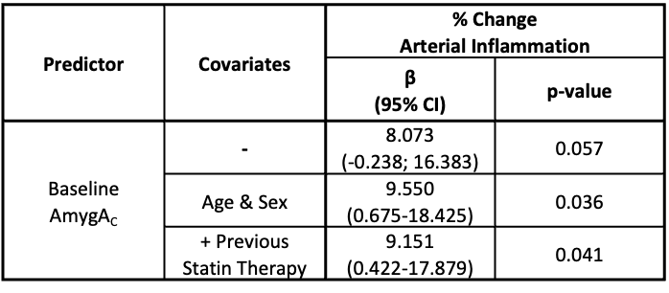

Abbreviations: β: unstandardized coefficient of the linear regression model; AmygA_{C}: amygdala to temporal lobe activity ratio.

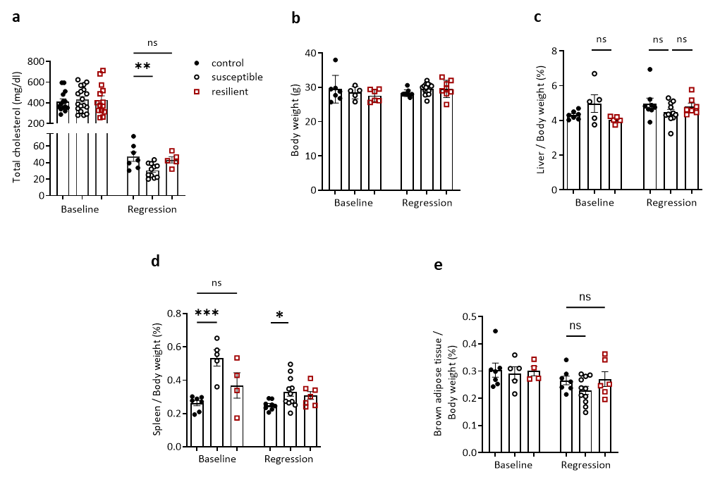

Extended Data Fig. 1. Plasma cholesterol levels and measurements of tissue weights. a. Plasma cholesterol levels. b. Weight of mice. c. d. e. Liver, spleen, and brown adipose tissues were measured at the baseline and regression harvest days. One-way ANOVA. Data are the mean ± SEM. P values adjusted for multiple comparisons. *P < 0.05, **P < 0.01, ***P < 0.001.

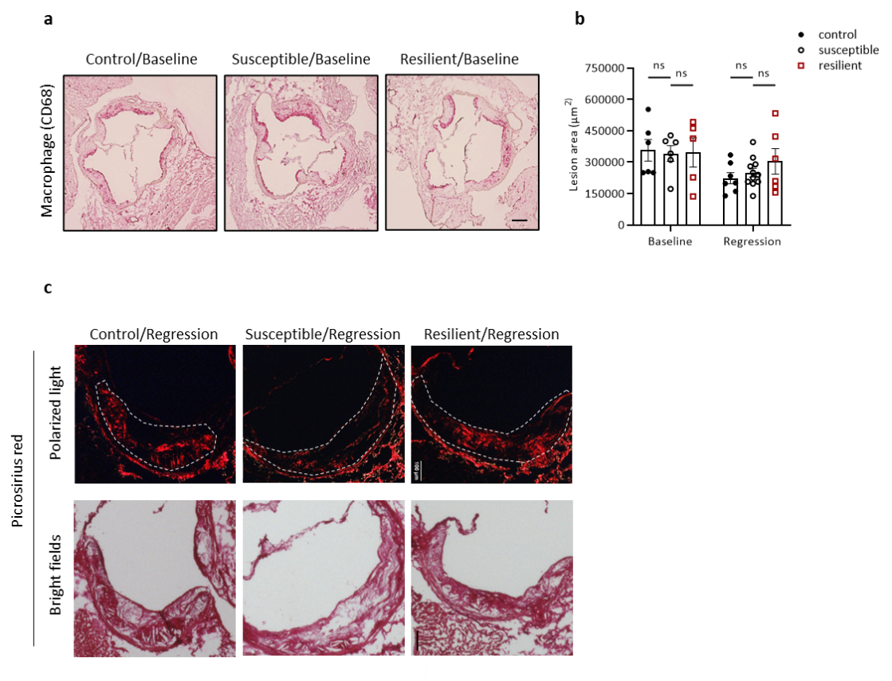

Extended Data Fig. 2. Total plaque area calculation and representative images of macrophage and collagen staining. a. Representative images of baseline CD68 staining. b. Quantification of total plaque areas. One-way ANOVA. Data are the mean ± SEM. P values adjusted for multiple comparisons. c. Representative images of picrosirius red staining to identify collagen and necrotic areas using polarized light (top panels) and bright field (bottom panels) microscopy sequentially. Scale bar: 100 μm.

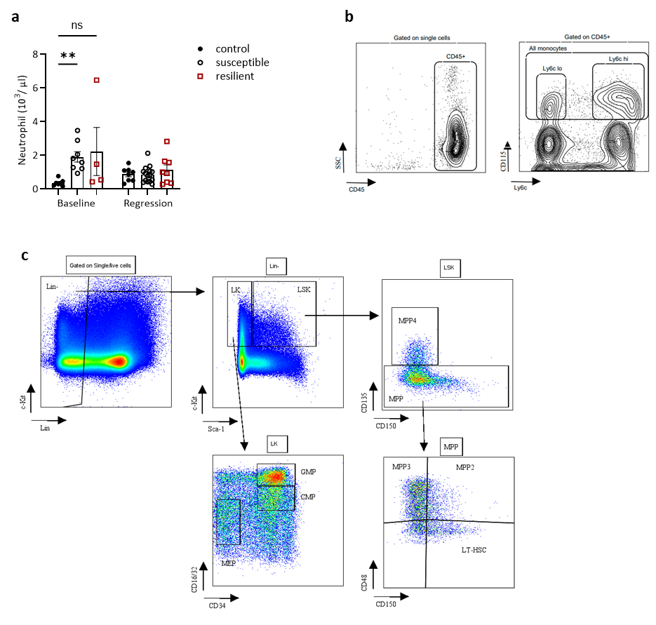

Extended Data Fig. 3. Blood neutrophil counts and flow cytometry gating strategies. a. A number of neutrophils in the circulation of CON, SUS, RES mice at baseline and after 3 weeks of regression diet. One-way ANOVA. Data are the mean ± SEM. P values adjusted for multiple comparison. b. Representative flow cytometry plots showing gating strategy for fluorescence-activated cell sorting of Ly6C^{hi} and Ly6C^{lo} monocytes, and c. GMP, CMP, and HSC populations.

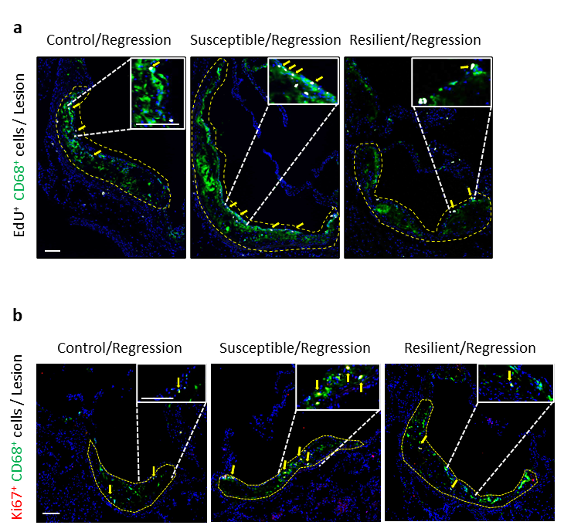

Extended Data Fig. 4. Representative images of EdU and Ki67stainings. a. Macrophages in the aortic root plaques were stained with CD68 marker (green) and labelled with EdU (white). Scale bar: 100 μm. b. Representative images of Ki67 (red) and macrophages (green) staining. Scale bar: 100 μm.

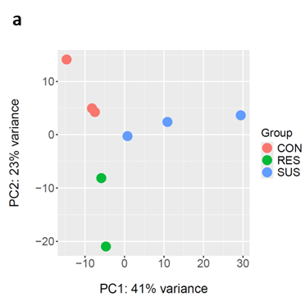

Extended Data Fig. 5. PCA plot analysis on the subset of significantly upregulated DEGs. a. Principal component analysis (PCA) plot was performed on the subset of significantly different genes (p-val < 0.05) that were upregulated in any of the performed comparisons (SUS vs CON, RES vs CON, SUS vs RES) of plaque macrophage enriched regions collected by laser capture microscopy (LCM).

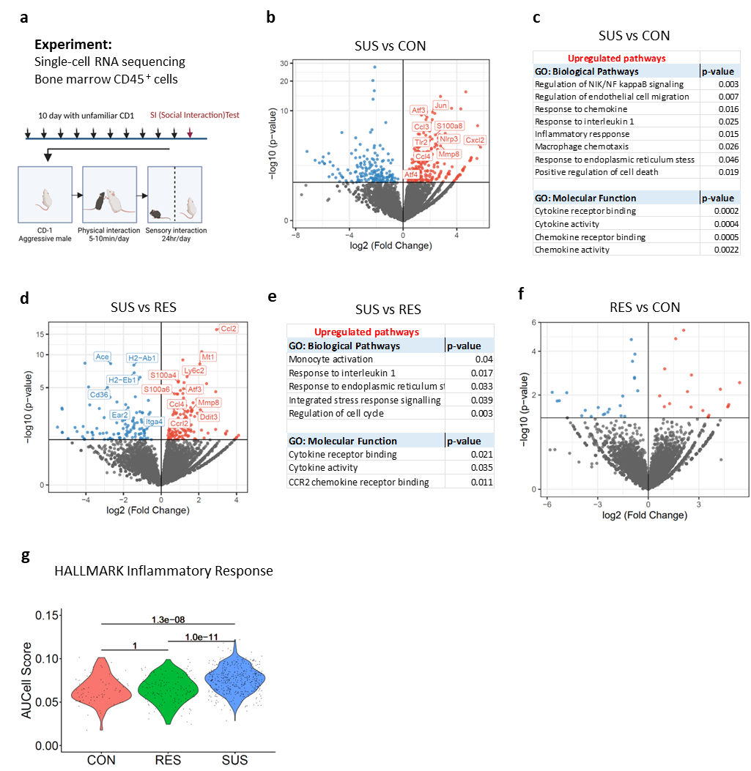

Extended Data Figure 6. CSDS shifts the bone marrow monocyte transcriptional profile towards a pro-inflammatory phenotype in stress-susceptible (SUS) mice. a. Experimental outline: After 10 days of CSDS, mice social interaction (SI) testing was performed. Bone marrow cells were collected and CD45⁺ leukocytes were sorted then single-cell RNA sequencing was performed. b. Volcano plot of significantly differentially expressed genes in monocytes of SUS vs CON mice. c. Gene ontology (GO) analysis ‘biological pathways’ and ’molecular functions’ were performed for upregulated genes in monocytes compared SUS vs CON mice using p-value cutoff of 0.05. d. Volcano plot showing significantly differentially expressed genes in monocytes of SUS and RES mice. e. Gene ontology (GO) analysis ‘biological pathways’ and ’molecular functions’ of significantly upregulated genes and KEGG pathway analysis of significantly downregulated genes in monocytes compared SUS vs RES using p-value cutoff of 0.05. f. Volcano plot showing significantly differentially expressed genes in monocytes of RES vs CON mice. g. Violin plot showing AUCell scores for the Hallmark gene set “Inflammatory response”, calculated for all monocytes in each group. Significant differences in AUCell scores across groups were identified using a Wilcoxon test. P-values were corrected for multiple testing using the Bonferroni correction.

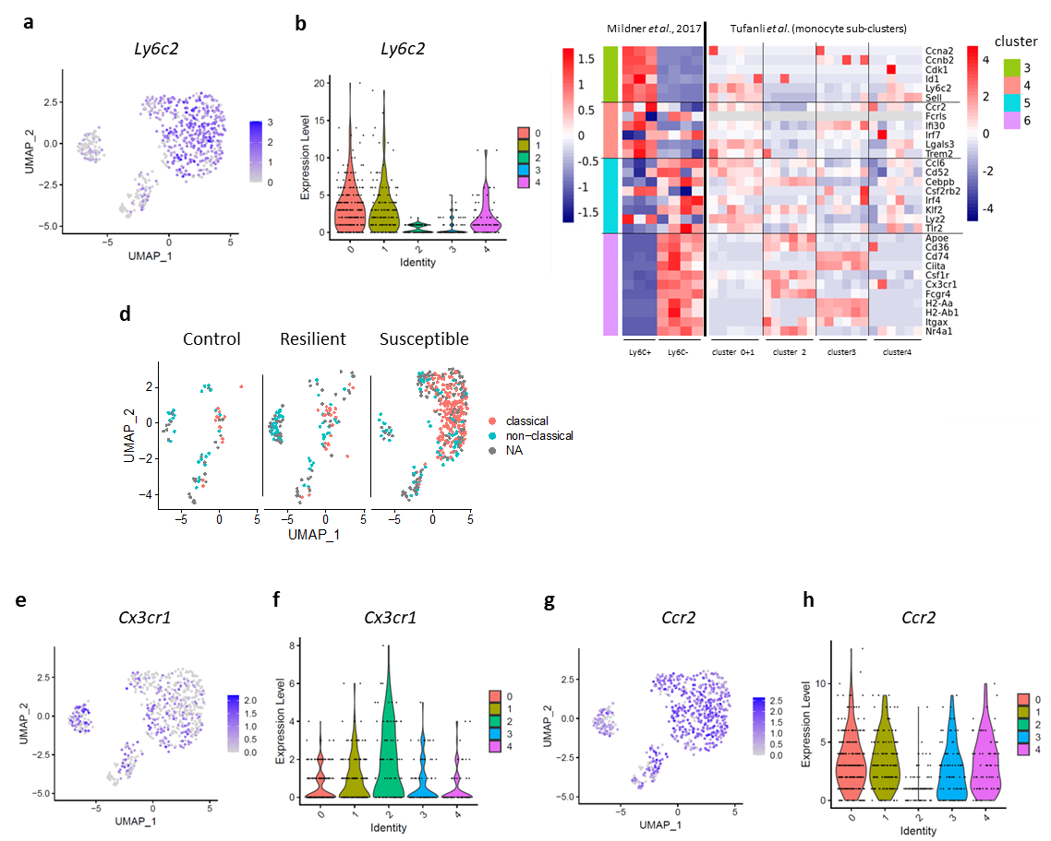

Extended Data Fig. 7. Susceptibility to CSDS drives monocytes towards a more classical phenotype, while resiliency promotes their maintenance in a more non-classical phenotype. a. Feature plot of normalized gene expression of Ly6c2 in bone marrow monocytes and b, violin plot representation of Ly6c2 expression level in each monocyte clusters. c. Comparison of differentially expressed genes in each monocyte cluster with the published data set from Mildner et.al. d. Manual annotation of classical and non-classical monocytes. Feature plot of normalized gene expression of Cx3cr1 and Ccr2 in bone marrow monocytes e. and g. respectively; violin plot representation of Cx3cr1 and Ccr2 expression level in each monocyte clusters f. and h.

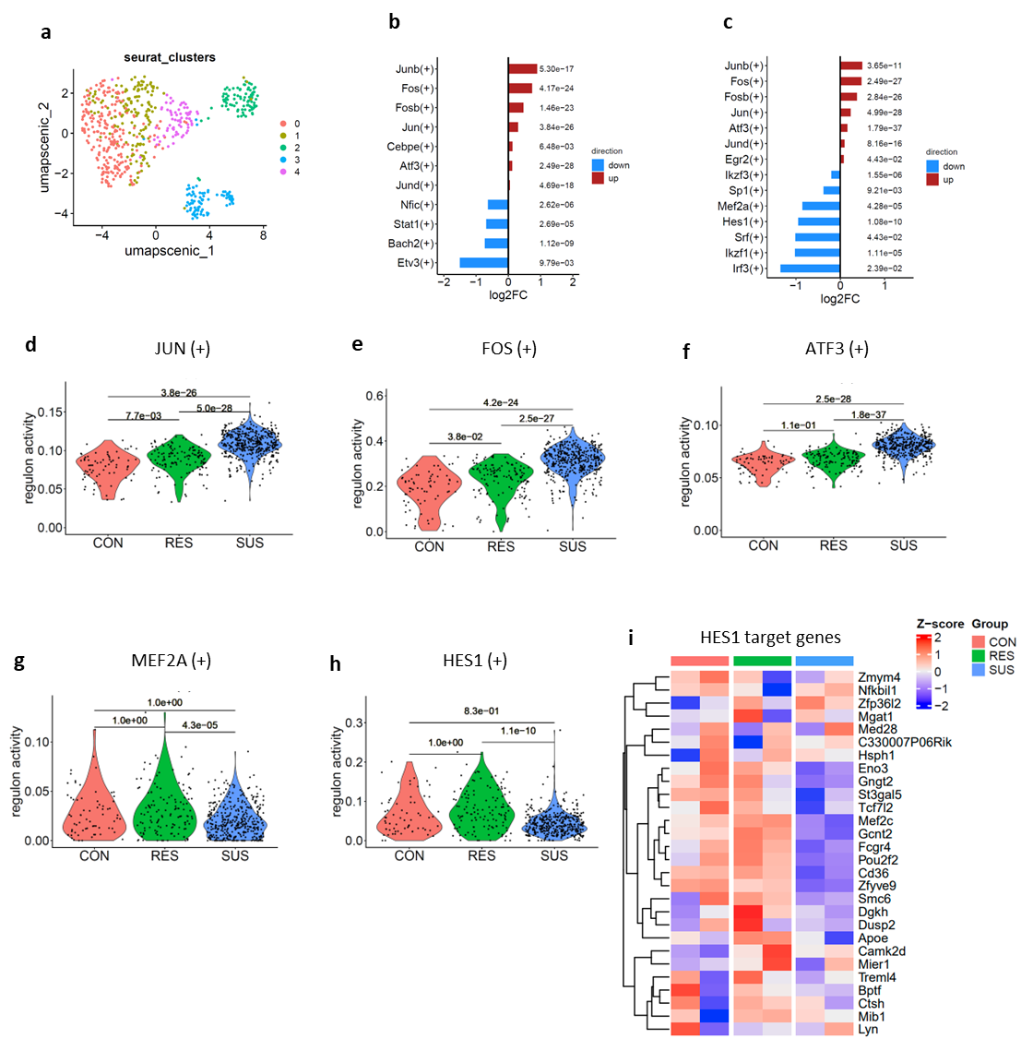

Extended Data Fig 8. CSDS differently modifies the transcription factor profile of bone marrow monocytes in susceptible and resilient groups. a. UMAP visualization of monocytes using the SCENIC regulon activity matrix, with cells colored by monocyte subtypes. b, c. Log2 fold-change of regulon activity for the regulons with significant differences in activity between SUS vs CON (b) and SUS vs RES (c). (Wilcoxon test adjusted p-value < 0.05; multiple testing correction was done using the Bonferroni method). Violin plot of regulon activity of d. Jun e. Fos f. Atf3 g. Mef2a and h. Hes1 across all monocytes in each SUS, RES and CON mice groups. A Wilcoxon test was run to compare regulon activity between groups, and p-values were corrected for multiple testing using the Bonferroni method. i. Heatmap showing Z-scores of normalized counts for Hes1 target genes, which were used to define Hes1 regulon activity in SCENIC analysis.

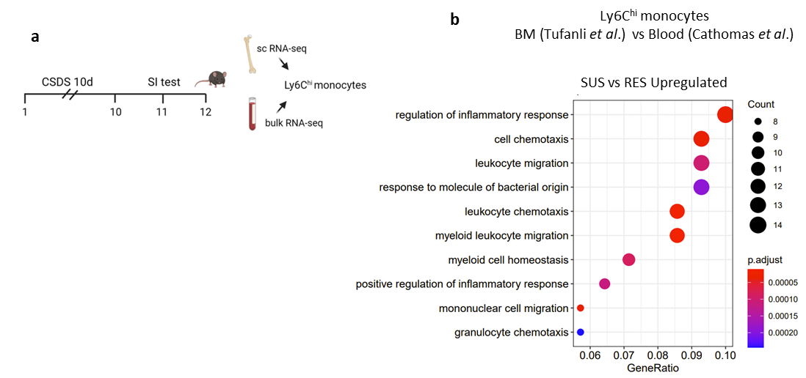

Extended Data Fig. 9. Comparisons between chronic social stress-induced changes in the transcriptomes of monocytes from BM and blood. a. Outline showing different sources of monocytes after stress exposure. b. Gene ontology (GO) terms of upregulated pathways in significantly expressed genes from Ly6C^{hi} monocytes in bone marrow data set (Tufanli et al.) and /or blood Ly6C^{hi} monocytes data set (Cathomas et al.) between SUS vs RES.

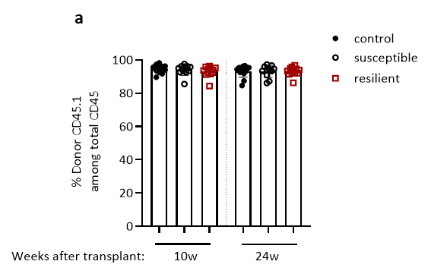

Extended Data Fig 10. Chimerism was validated using tail blood at the 10th week and at the end of the experiment.

