Unipolar and non-volatile RF switches using MoS₂ by liquid-liquid interface assembly for millimeter wave applications
SUPPLEMENTARY INFORMATION
TABLE OF CONTENTS
Supplementary Table 1: Comparison table of state of the art RF switches.
Supplementary Table 2: Comparison between the EC-LL MoS₂ memristor and the reporting RF switching technologies in state of the art.
Supplementary Figure 1: Fabrication steps of the EC-LL MoS₂ memristor devices and GSG Coplanar Waveguides.
Supplementary Figure 2: Demonstration of bipolar and unipolar symmetric switching behavior.
Supplementary Note 1: Optimizing reset Strategies for Enhanced Device Stability and Performance
Supplementary Figure 3: Undesired switching to LRS and mitigation steps.
Supplementary Figure 4: Current readouts when applying 40 ns pulses (20 ns rise + 20 ns fall).
Supplementary Figure 5: State retention after a couple days and up to weeks after zero bias RF measurements.
Supplementary Figure 6: Resistivity decreases as result of implemented IPA washing steps.
Supplementary Figure 7: Maps of the first cycle IV curve among different samples of devices.
Supplementary Figure 8: The experimental setup for the RF measurements of the EC-LL MoS₂ memristor.
Supplementary Note 2: The customized multiline TRL de-embedding kit.
Supplementary Figure 9: The characterization setup initialization through VNA calibration and test fixture de-embedding process.
Supplementary Note 3: The S-parameter measurements for several devices at both states.
Supplementary Figure 10: Lumped-Element Modeling and Switching Performance of EC-LL MoS₂ Memristors.
Supplementary Table 3: Values of the extracted equivalent circuit for memristor devices.
Supplementary Note 4: Electromagnetic simulation of Ka-band memristor-based 1-bit Reconfigurable Intelligent Surface Unit Cell RIS-UC.
Supplementary Figure 11: The RIS UC Schematic model and the performance stability according to the obtained measurement variability.
Supplementary Figure 12: The 3D radiation pattern of the beamforming capabilities offered by the proposed 24×24 RIS.
Supplementary Note 5: Test fixture design and performance characterization.
Supplementary Figure 13: Test Fixture Design and Performance: Side View, 3D Simulation, and Scattering Parameter Analysis.
Supplementary Figure 14: Setup for the DC electrical characterization of the memristor devices.
Supplementary Table 1 | Comparison table of state of the art RF switches.
Stack | Non-Volatility | Operating Voltage | Switching time | Switching energy | Endurance | Frequency Tested | IL (dB) | Isolation (dB) | R_{ON} | C_{OFF} | FOM | Area (µm²⁾ | Ref
Ti/Au-MoS₂(2 layers)-Cr/Au | Yes (2 weeks+) | 0.5-2.5 V | 40 ns | 330 pJ | 100 | 110 GHz | 0.42-0.9dB (10-110 GHz) | >18dB (10-110 GHz) | 6.45 | 4.3 fF | 5.87 THz | 4 – 25 (PL) | This Work
Au-hBN(7-8layers)-Ti/Au | Yes (10 yrs LRS) | <2 V | 120 ps (mean: 1.43 ns) | 2 pJ | 100-600 |  |  |  | >20 |  |  | 0.25 – 4 (EBL) | ¹³
Ti/Au-hBN(12-18layers)-Au | Yes (1 day +) | -3 V | <2.5ns |  | 10^3 - 10^4 | 260GHz | 0.9 dB (120GHz), 2dB (260GHz), <3dB (120GHz) | 10dB (120GHz), 25dB (120GHz), 35dB (120 GHz) | 4.5 | 5.1 fF | 4.7-6.7 THz | 0.81 – 3 (PL) | ¹⁸
Cr/Au-MoS₂(monolayer)-Cr/Au | Yes (9 months) | 1.5 V | <0.5ns | 49 pJ | N/A | 480GHz | 0.7dB (120GHz) | 25dB (120GHz) | 8 | 0.9 fF | 22 THz | 0.04 (EBL) | ⁷
Cr/Au-hBN(monolayer)-Cr/Au | Yes (3 months) | 1.5 V | <0.5ns | <680 pJ | N/A | 210GHz | 0.2dB (67GHz), 0.5dB (180GHz) | 10dB (210GHz) | 2.8 | 0.44 fF | 129 THz | 0.03 (EBL) | ¹⁷
Cr/Ag-hBN(monolayer)-Ag | Yes (10^4) | 0.5 V | 10ns | 1.2 nJ | 30 | 170GHz | 0.5dB (170GHz) | 22.5dB (170GHz) | 6.1 | 0.68 fF | 38 THz | 0.04 (EBL) | ¹⁴
Au-hBN-Au | Yes (1 month +) | ~1.5 V | <15 ns |  |  | 110 GHz | 0.2 dB (110GHz) | 15dB (110GHz) | 1.6 | 2.3 fF | 43 THz | 0.05 (EBL) | ¹⁶
Cr/Au-MoS₂-Cr/Au | Yes (5*10⁴) | ~0.5 – 1.5 V | <30 ns |  | 20-100 | 50 GHz | 0.3 dB (50GHz) | <20dB (50GHz) | 4.2 (1L)  5.3 (2L) | 6.5 fF (2L)  5.4 fF (2L) | ~11 THz | 0.25 (EBL) | ¹⁵
Cu/Nafion CBRAM | Yes (3000 s) | 0.7-2.3 set / -0.5-0.9 reset | N/A |  | 3000 | 67 GHz | 1.2 dB (67GHz) | 10 dB (67GHz) | 1.23 | 12.8 fF | 10.1 THz |  | ¹⁹
GeTe PCM |  | >4V | 60ns | 660 nJ, 330 nJ | N/A | 40GHz | 0.5dB (40GHz), 0.15dB (40GHz) | 25dB (40GHz), 12dB (40GHz) | 5, 1.1 | 13.2 fF, 6.8 fF | 11 THz (shunt) 21 THz (series) |  | ²³
SbTe PCM |  | 6-10 V | <300ns |  | 10^7 | 50GHz | 1.8dB (50GHz) | 18dB (50GHz) | 0,5 | 75 fF | 4.2 THz |  | ²²
Silicon-on-insulator SOI MOSFET |  | 2V (±1V) | N/A |  | Inf | 60GHz | 1.3dB (50GHz) | N/A |  |  | 2.5 THz |  | ²⁰
VO₂ | Yes | 1 V | 10 us (10000 ns) |  |  | 67 / 290 GHz | 0.6 dB (67 GHz) / 1.5 dB (290GHz) | 35 dB (67 GHz) / 12 dB (290GHz) |  |  |  | 820*9500 | ²¹

Supplementary Table 2 | Comparison between the EC-LL MoS₂ memristor and the reporting RF switching technologies in state of the art.
RF- Switch | Frequency (GHz) | Non-Volatility | Operating voltage (V) | Switching time | Switching energy | Static Power dissipation | R_{ON} (Ω) | C_{OFF} (fF) | Dimensions w*l | Ref.
Memristor | 110 | Yes | 0.5 - 2.5 | 40 ns | 330 pJ | None | 6.45 | 4.3 | 4 µm² | This work
PCM | 67 | Yes | 2 | ~ 100 ns | 20 nJ | None | 1 | 7 | 19 µm² | ^{27,28}
Microfluidic | 123 | Yes | 2 | ~ 1 ms | 20nJ | 0.001 mW |  |  | ≥ mm² | ^{25,26}
PIN diode | 100 | No | 0.95 | 29 ns | 5.3 mW | 50 mW | 3 – 5 | 13 – 25 | 310×280 µm² | ^{24,29}

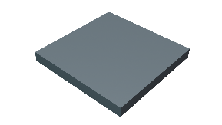 | 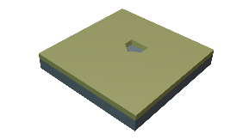 | 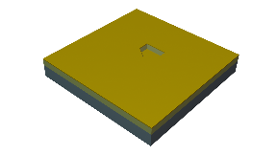 | 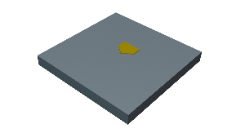
1. Clean fused silica substrate | 2. Photolithography for BE | 3. Ti/Au deposition for BE | 4. Lift-off for BE
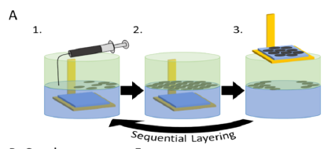 | 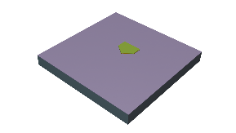 | 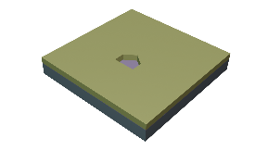 | 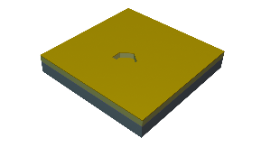
5. Deposition of MoS₂ layers |  | 6. Photolithography for TE | 7. Cr/Au deposition for TE
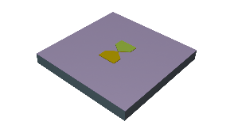 | 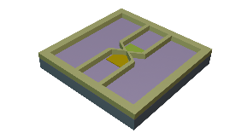 | 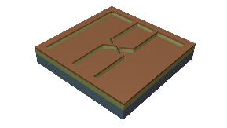 | 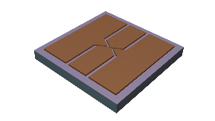
8. Lift-off for TE | 9. Photolithography for test fixture | 10. Cu deposition for test fixture | 11. Final lift-off for test fixture
Supplementary Figure 1 | Fabrication steps of the EC-LL MoS₂ memristor devices and GSG Coplanar Waveguides.

Supplementary Figure 2 | Demonstration of bipolar and unipolar symmetric switching behavior. The set and reset sweeps were applied on both polarities on different orders and displayed a symmetric characteristic.

Supplementary Note 1: Optimizing reset Strategies for Enhanced Device Stability and Performance
The 2-step reset scheme, represented in purple, was designed to approximate the compliance of a fixed power scheme, shown in green. The fixed power compliance itself is intended to limit the stimulus to the current density required for a successful reset, which ideally follows the trajectory of the orange line. By adhering to this approach, the risk of a premature set event is expected to be significantly mitigated.
In theory, an unlimited number of reset steps would allow for an exact replication of this behavior. However, such an approach would introduce excessive complexity. To strike a balance between effectiveness and practicality, a two-step scheme was adopted.
Initially, two-way I-V sweeps were performed. However, to further minimize premature set occurrences, reduce stress on the devices, and prevent both undesired state reinforcement and potential burnouts, the methodology was quickly revised in favor of a one-way sweep. Additionally, a cease-test trigger was introduced at compliance to provide further protection for the devices.
This refined approach ensures a more controlled and reliable reset process, ultimately enhancing device stability and performance.
Supplementary Figure 3 | Undesired switching to LRS and mitigation steps. (a) demonstration of a typical premature set during a reset sweep. (b) illustration of the mitigation steps that were employed using a more dynamic compliance.

Supplementary Figure 4 | Current readouts when applying 40 ns pulses (20 ns rise + 20 ns fall). a) Current readout over time when applying a 9V pulse. b) Current readout over time when applying a 7V pulse, lower pulse amplitudes were achieved, which may explain the increased amount of switching failures. 40ns is the shortest pulse allowed by the equipment and current range was set to 10 mA, which acts as a compliance.

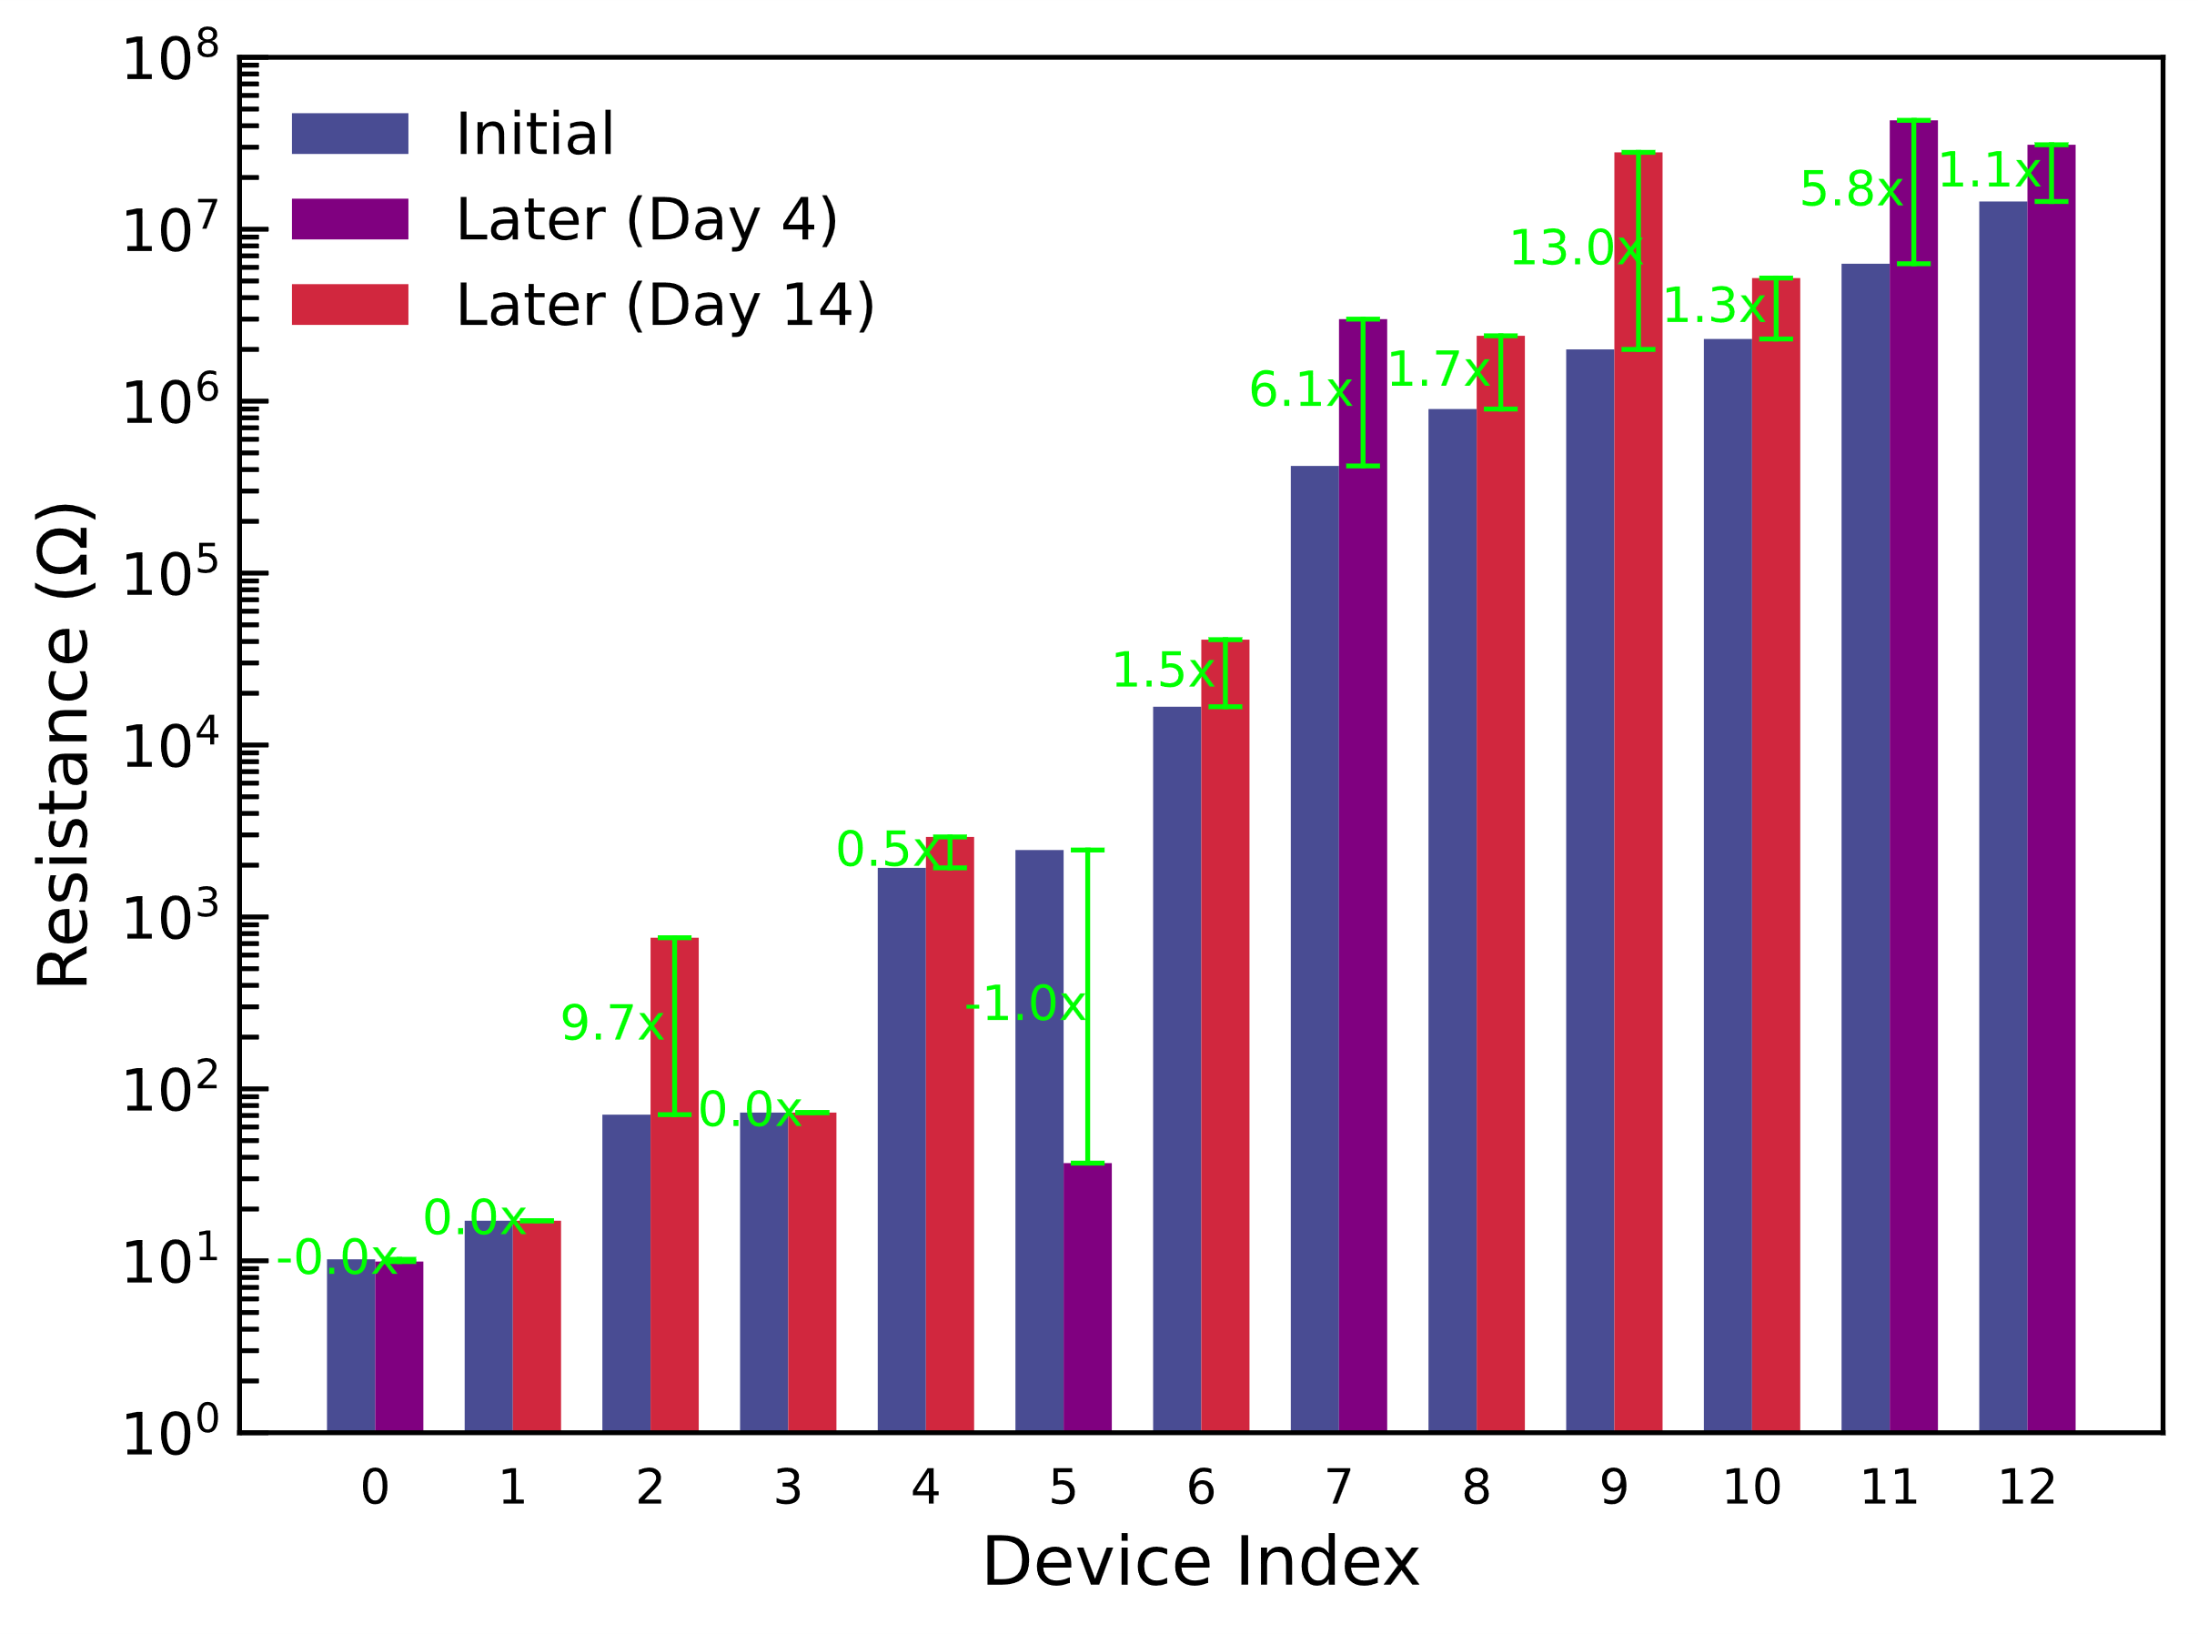
Supplementary Figure 5 | State retention after a couple days and up to weeks after zero bias RF measurements. The devices were pre-programmed before performing the zero bias RF characterization and the states of those select devices were accessed 4 days and 14 days later, showing no visible change to those on LRS state and a decay to an even higher resistance state for those on the HRS. Some intermediary states showed a greater variation.

Supplementary Figure 6 | Resistivity decreases as result of implemented IPA washing steps. a) Measured resistance of as-deposited vs washed MoS₂ layers. b) Cross-section view of as-deposited (top) vs washed (bottom) MoS₂ layers.

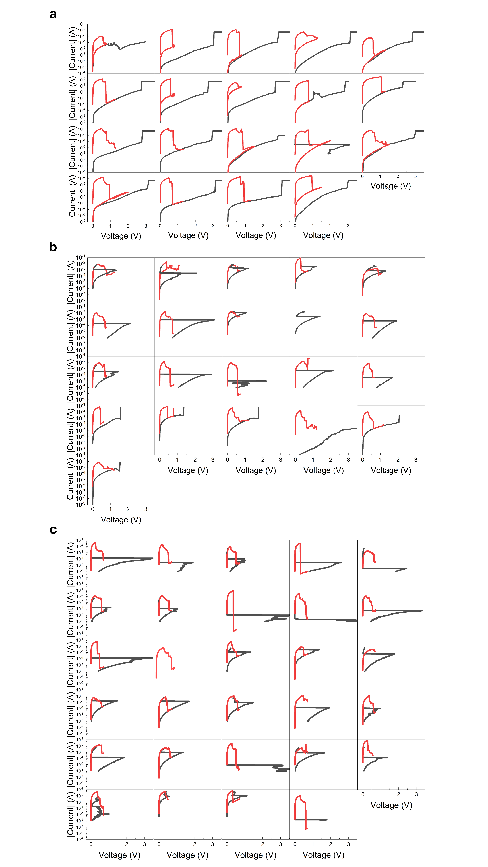
Supplementary Figure 7 | Maps of the first cycle IV curve among different samples of devices. (a) crosspoint devices (b) overlapped devices: top electrode deposited right after arrival (c) top electrode deposited about 5 months after arrival. Both voltage-controlled and current controlled sets can be observed.

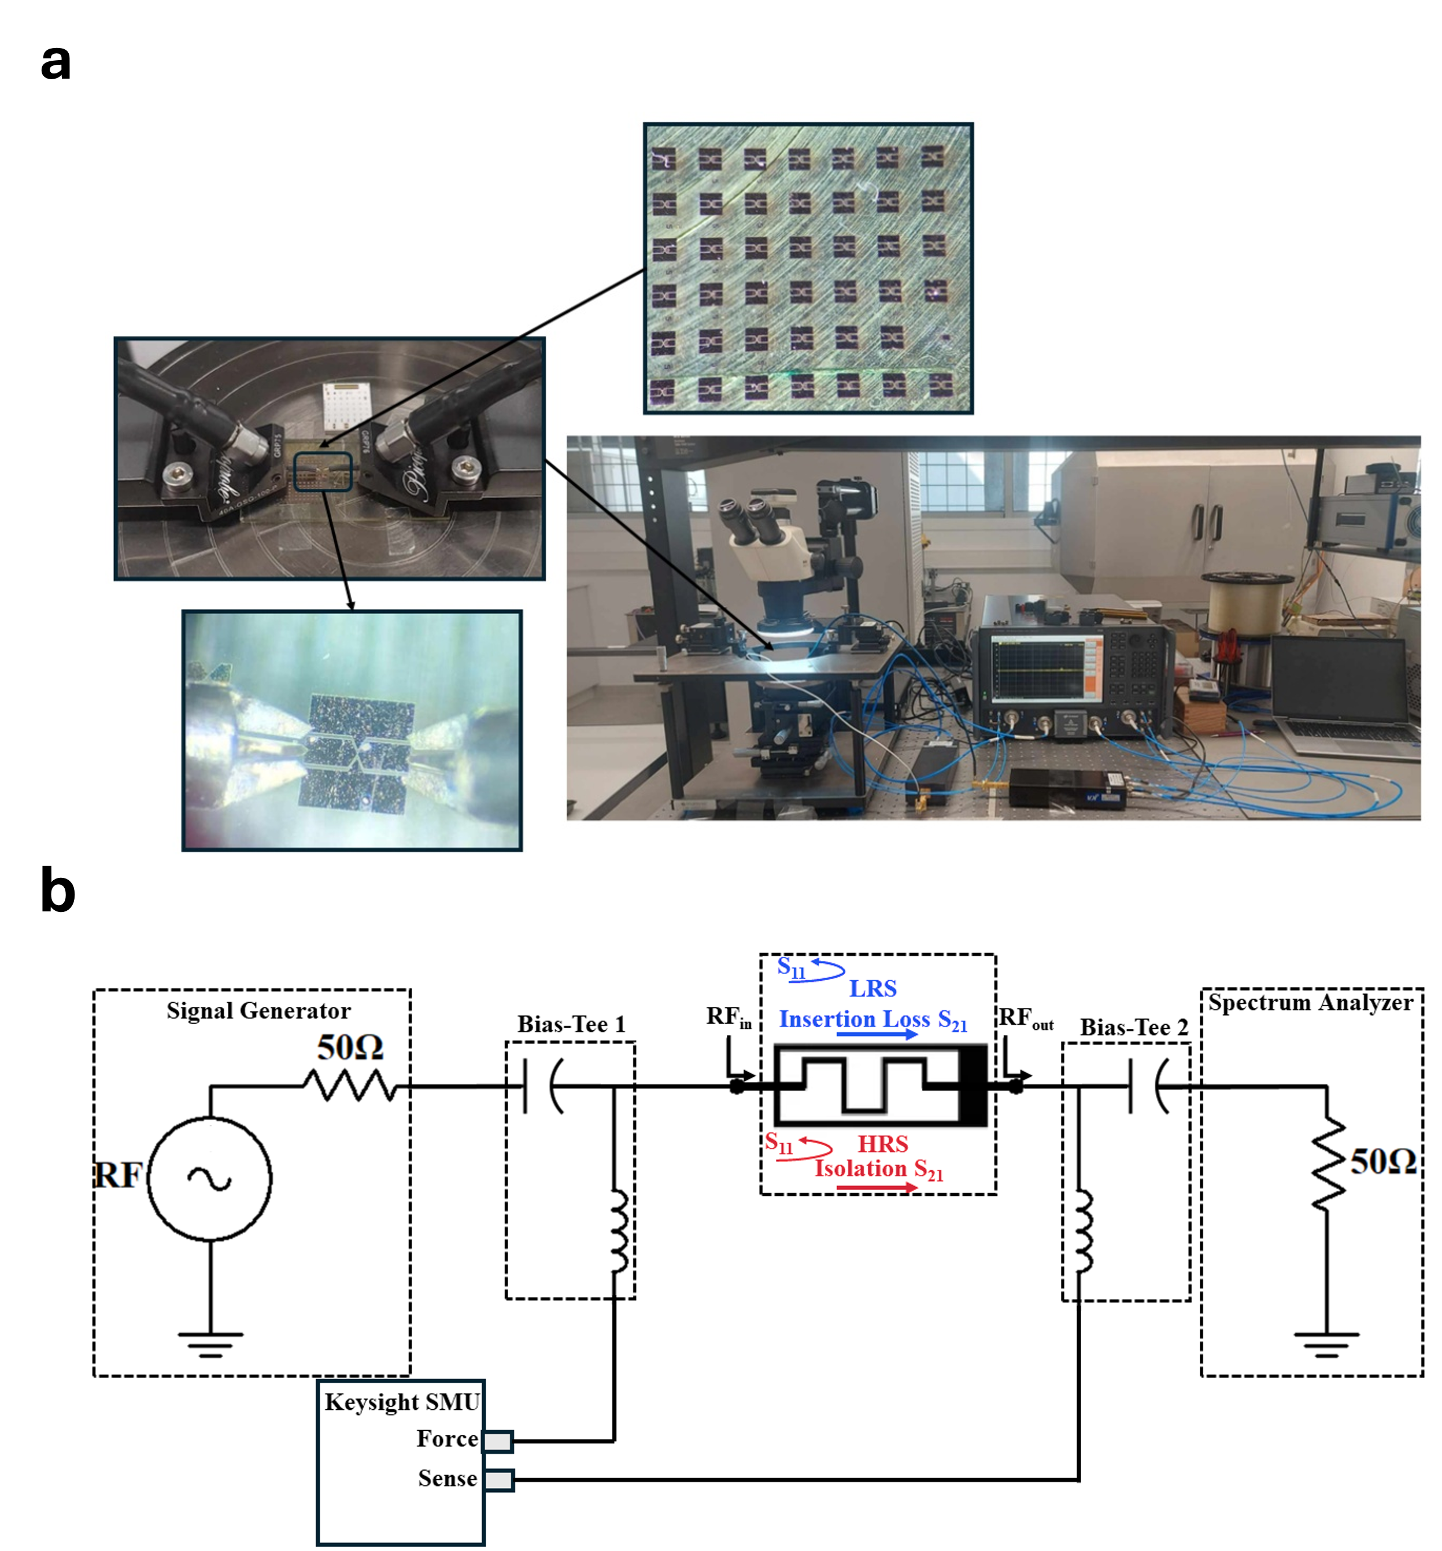
Supplementary Figure 8 | The experimental setup for the RF measurements of the EC-LL MoS₂ memristor. (a) The Keysight N5224B 10 MHz - 43.5 GHz PNA network analyzer is connected to the probe station, which is equipped with two GGB probes with GSG configuration and 100 µm pitch. The experimental setup was upgraded with two VDi WR10+ frequency extenders to perform measurements in the frequency range from 67 to 110 GHz. (b) The schematic circuit diagram of the memristor, in the LRS and HRS states, connected to the experimental measurement setup illustrating the insertion loss and isolation in the s-parameters for the LRS and HRS, respectively.

Supplementary Note 2: The customized multiline TRL de-embedding kit.

The purpose of VNA calibration is to adjust the reference planes at the probe tip by eliminating the effect of any connections between the VNA and the samples being measured (memristors embedded in the test fixture). This calibration was performed with the CS-5 calibration substrate using the SOLT (Short-Open-Load-Thru) technique. Each standard in the SOLT technique is measured, stored, and used in the algorithm calculation to adjust the measurement reference plane at the probe tips as illustrated in Supplementary Fig. 9a. As depicted in Supplementary Fig. 9b, a customized calibration kit, based on the TRL technique and the designed test fixture, was used to de-embed the test fixture from the measurements. The TRL de-embedding technique is a pre-processing approach in which the reference planes during the measurement are set to be at the two edges of the memristor, so that measurements can only be made for the memristor. This aims to eliminate the test fixture contributions to the measurements, thereby revealing the intrinsic characteristics of the memristor. The measurement reference planes were adjusted at 1.5 µm away from both edges of the manufactured memristor as illustrated in Supplementary Fig. 9c. The customized TRL de-embedding kit comprises three standards: Thru, Reflect, and Line. All standards were designed using the same substrate and test fixture structure but with different lengths. The Thru standard has the same length as the memristor embedded in the test fixture. The Reflect standard has an OPEN configuration with an offset equal to half the length of the Thru, resulting in total reflection. The optimum Line standard is designed to be λg/4 longer than the Thru standard, providing a 90-degree phase shift relative to the Thru standard at the center frequency f. The guided wavelength, λg, is calculated as λg = C × (f × sqrt(𝜀_{𝑟}))-1, where 𝑐 is the speed of light and 𝜀_{𝑟} is the substrate relative permittivity. It is worth noting that each of the Line standards has a different length, depending on the frequency band for which the de-embedding process is being carried out. The length of each Line standard is capable of supporting a bandwidth ratio of up to 8:1 between the upper and lower frequencies. Consequently, three Line standards with lengths of 2300 µm, 1048.2 µm, and 8465 µm have been designed to facilitate de-embedding over the frequency range from 10 GHz to 170 GHz, divided into three sub-bands: 10-45 GHz, 67-110 GHz, and 110-170 GHz, respectively.
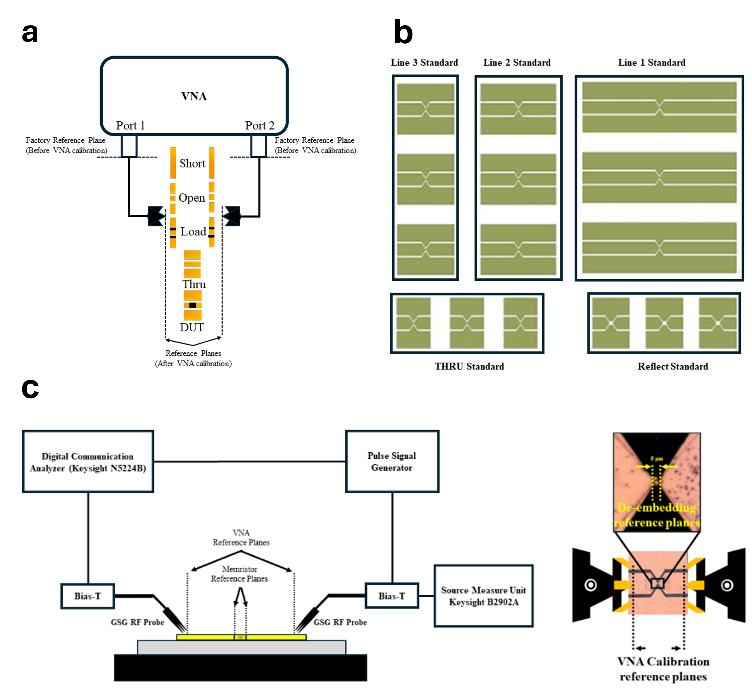
Supplementary Figure 9 | The characterization setup initialization through VNA calibration and test fixture de-embedding process. (a) VNA calibration using SOLT technique (b) The designed standards for the customized TRL de-embedding kit (c) The schematic diagram for the experimental setup and the measured samples on the (left) and the top view of the measured samples showing the position of the reference planes before and after the de-embedding process.

Supplementary Note 3: The S-parameter measurements for several devices at both states.

In order to investigate the stability of the fabricated EC-LL MoS₂ memristor, the RF performance of four devices have been characterized and analyzed. The intrinsic parameters were extracted by fitting process of the electrical circuit shown in Supplementary Fig. 10a based on the measured S-parameters of the memristors. For each device, these parameters, R_{ON} and C_{OFF}, of the memristors and the figure of merit (FOM = (2×π×R_{ON}×C_{OFF})⁻¹) were estimated. Measurements of the insertion loss (S_{21ON}), the isolation (S_{21OFF}) and reflection coefficients for both switching states are shown in Supplementary Fig. 10b-e. All the measurements were compared with the results of the simulation of the equivalent electrical circuit that was obtained for each device separately. Supplementary Table 3 summarizes the extracted values from the fitting process based on the de-embedded measurements and the calculated Figure of Merit (FOM) of the four measured devices. As shown in both Supplementary Figure 12 and Supplementary Table 3, the performance variability of the measured devices is very low and the intrinsic parameters of the memristors are very close to each other. The calculated mean values of the intrinsic parameters are 4.3 fF for the C_{OFF}, 12.8 KΩ for R_{OFF} and 6.45 Ω for R_{ON}. In addition, the average FOM was estimated to be 5.87 THz. The low performance variability demonstrates the high stability of the fabricated memristor devices with low ON-Resistance and OFF-Capacitance.
Supplementary Figure 10 | Lumped-Element Modeling and Switching Performance of EC-LL MoS₂ Memristors. (a) The equivalent lumped model for the EC-LL MoS₂ memristor in the LRS and HRS, shown in parallel combination of resistor R and capacitor C, embedded in a small section of the test fixture. On either side of the memristor, the model includes the resistor and inductor of the transmission line, R_{l} and L_{l} respectively. To account for the parasitic capacitance in the coplanar waveguide CPW, a coupling capacitor to ground C_{l}. It is worth noting that the CPW sections on both sides of the memristor are asymmetric, so, the lumped elements on each side have different values. From (b) to (e), The switching performance of the EC-LL MoS₂ memristors compared with the modelled lumped electrical circuit for four devices where the upper figure represents the LRS, and the lower figure represents the HRS.

Supplementary Table 3: Values of the extracted equivalent circuit for memristor devices.
Parameter | C_{OFF} (fF) | R_{OFF} (KΩ) | R_{ON} (Ω) | FOM (THz)
Device 1 | 4.3 | 14.1 | 6.8 | 5.44
Device 2 | 4.8 | 12.4 | 6 | 5.52
Device 3 | 3.2 | 8.9 | 7.2 | 6.9
Device 4 | 4.9 | 15.8 | 5.8 | 5.6
Mean values | 4.3 | 12.8 | 6.45 | 5.87
Best MoS₂⁷ | 0.9 |  | 8 | 22
Best hBN¹⁸ | 5.1 |  | 4.5 | 6.7

Supplementary Note 4: Electromagnetic simulation of Ka-band memristor-based 1-bit Reconfigurable Intelligent Surface Unit Cell RIS-UC.

The proposed unit cell architecture is designed at 28 GHz center frequency, with dimensions of (4.318 mm × 4.318 mm) and utilizes memristor devices as a reconfigurable technique. As shown in Supplementary Figure 13, the stacked structure of the unit cell consists of two layers: Fused silica (εr = 3.81, tan δ = 0.0004, thickness t1= 0.6mm) and Rogers RT-duroid s880LZ (εr = 2, tan δ = 0.0021, thickness t2 = 0.25mm), separated by a copper layer acting as a ground plane. Silica was chosen as the upper substrate material because of its low surface roughness. This provides suitable properties for the direct manufacturing process of memristors and ensures their good performance. The square patch is connected to the ground layer through a transmission line and a metallic via and a memristor switch. The transmission line consists of two tapered branches with a 5 µm × 5 µm space in the middle, where the memristor element will be installed. On the other hand, the square patch is connected to a radial stub through a metallic via to avoid losses in RF signal. The two metal vias are connected to bias lines printed on the lower surface of the Roger substrate. These bias lines will be connected to a digital controller to control the switching state of the memristor. Thus, the HRS and LRS modes can be achieved by setting a single digital control pin to either 'high' or 'low' voltage state to initiate either the set or reset state of the memristor. In the simulation model, the memristor element is replaced by the equivalent circuit model of the fabricated memristor in either the High Resistance State (HRS) or the Low Resistance State (LRS). The performance of the designed RIS-UC was studied based on measurements obtained from four devices in order to investigate the stability of the RIS-UC performance according to the variability of the intrinsic parameters of the memristors. Supplementary Figure 11 shows the RIS-UC performance represented by the reflection coefficient magnitude and phase. On average, the reflection coefficient of the RIS-UC is affected by approximately 0.2 dB due to the variability of the memristor parameters. The reflection phase remains constant in the LRS state and is affected by approximately 3 degrees in the HRS state of the memristor. In other words, the reflection phase difference remains almost the same between the two states, this variation does not affect the correct operation of the RIS-UC. Therefore, even with the possible variability in the fabricated memristor performance, this reflects the stability and durability of the designed RIS-UC.
Supplementary Figure 11 | The RIS UC Schematic model and the performance stability according to the obtained measurement variability. (a) The 3D model where memristor element is incorporated as a reconfigurable technique in the EM simulator, where the memristor element was replaced by its intrinsic equivalent circuit. (b) The RIS UC performance stability according to the obtained measurements variability from four fabricated memristors. (a) reflection coefficient magnitude |S₁₁| (b) reflection coefficient phase for both switching states and phase difference (|∆Φ|).

To redirect the incident EMW radiation and create the focused reflected beam to a desired observation angle, the reflection phase of all unit cells in the RIS aperture is controlled to compensate for the incident EMW phase. Therefore, the precise control of the EMW radiation and the beam steering characteristics are achievable as shown in Supplementary Fig. 12. A MATLAB script has been utilized to generate the phase distribution of the distributive cells for each desired reflection angle at frequency of 27.5 GHz. The phase distribution corresponding to each beamforming angle was applied to the RIS in the EM simulator CST by modelling the memristor in each unit cell as lumped element according to its switching state either LRS (RON) or HRS (COFF in parallel with ROFF). In this figure, the RIS array with a side length of D is illuminated by a 15 dBi horn antenna placed at a distance equal to the focal length F to simulate its performance. The F/D = 0.8 is chosen as a compromise between the illumination and the spillover losses.
Supplementary Figure 12 | The 3D radiation pattern of the beamforming capabilities offered by the proposed 24×24 RIS.

Supplementary Note 5: Test fixture design and performance characterization.
Test fixtures act as the interface between the test equipment and the DUT by providing the electrical connection between them. They secure the DUT during the measurement process and facilitate accurate and repeatable measurements. Accurate DUT characterization therefore requires high performance test fixtures with minimal reflection and insertion loss. As shown in Supplementary Fig. 13a, 13b, the test fixtures, for memristors, were designed based on the Coplanar Waveguide (CPW) structure printed on a glass substrate (ɛr = 3.81, tan θ = 0.0001 and thickness ts = 300 µm). The high flatness of the glass substrate allows both the test fixture and the memristor to be fabricated directly on its surface. The signal line has a tapered section in the middle to accommodate the fabricated memristor. The designed test fixture was simulated, optimized, and analyzed using the CST electromagnetic simulator. The S-parameters of the fabricated test fixture were measured and compared with the simulated results in Supplementary Fig. 13c, 13d. The magnitude of the reflection coefficient |S₁₁| was found to be less than -15 dB, while the magnitude of the transmission coefficient |S₂₁| exceeded -0.4 dB over the measured frequency bands. As depicted in (b), the comparison shows good agreement, indicating a successful simulation and accurate manufacturing processes.
Supplementary Figure 13 | Test Fixture Design and Performance: Side View, 3D Simulation, and Scattering Parameter Analysis. The designed test fixture (a) side view (b) 3D simulation model (c) and (d) the performance in terms of the reflection coefficient |S₁₁| and transmission coefficient |S₂₁| magnitude, respectively.

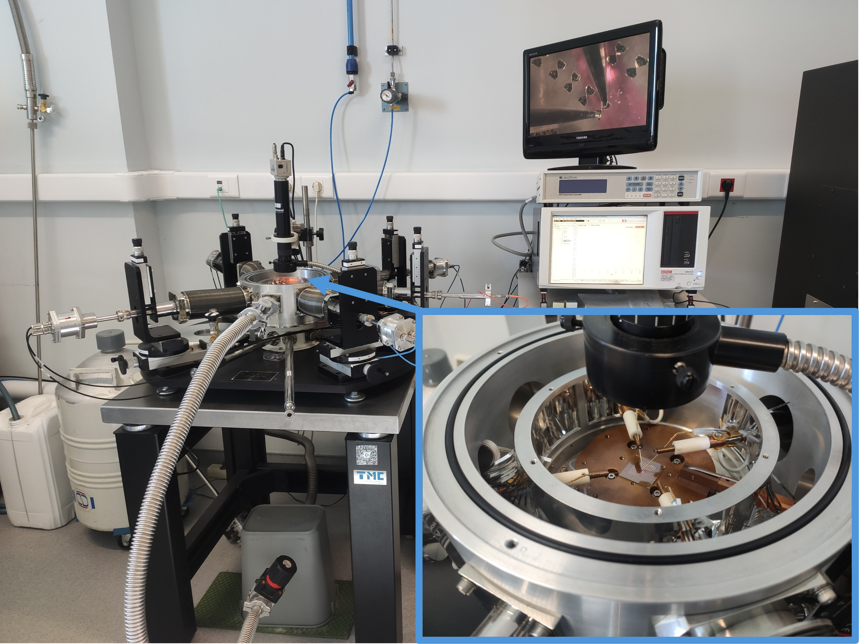
Supplementary Figure 14 | Setup for the DC electrical characterization of the memristor devices. Picture of Janis probe station on the left connected to Keithley 4200 SCS on the right, while performing IV cycling on one of these devices.

