Supplementary table S1. Performance according to evaluation metric
Class | DSC |  | IOU |  | HD95 |  | AHD
Class | Internal validation | External validation | Internal validation | External validation | Internal validation | External validation | Internal validation | External validation
Vascular structures | 0.687 (0.21) | 0.646 | 0.558 (0.02) | 0.521 | 45.5 (5.6) | 43.9 | 9.8 (2.1) | 11.8
Avascular plane | 0.659 (0.) | 0.643 | 0.518 (0.01) | 0.502 | 33.9 (2.1) | 30.0 | 6.7 (0.6) | 6.1

This table presents the performance evaluation by various metrics using both internal validation and external validation. The results are shown for different performance metrics: DSC (Dice Similarity Coefficient), IOU (Intersection Over Union), HD95 (Hausdorff Distance at 95th percentile), and AHD (Average Hausdorff Distance). Despite the high DSC for the vein class, HD95 is relatively worse. This is because DSC measures overlap between predicted and actual regions, indicating good overall segmentation accuracy. However, HD95 measures boundary accuracy, and the complex, elongated shape of veins may lead to localized boundary errors, resulting in higher HD95 values even with a high DSC.

Supplementary figure S1. The Variation of DSC by Inference Time According to Encoder-Decoder in Internal Validation
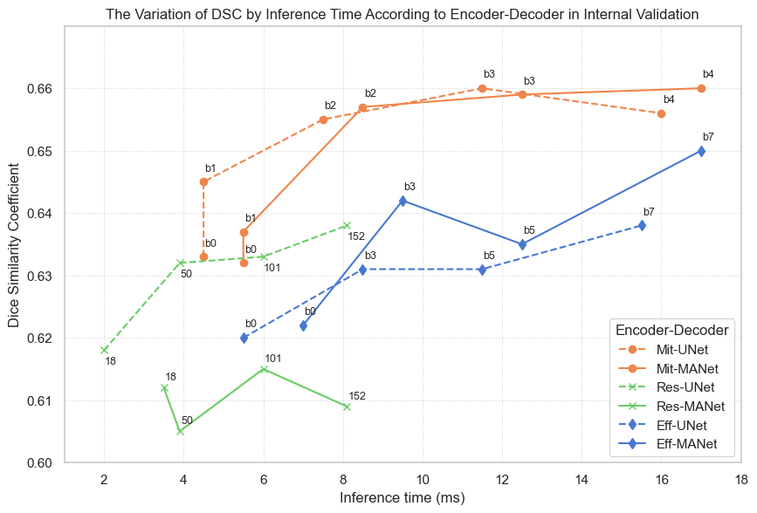
The figure demonstrates the variation of the Dice Similarity Coefficient (DSC) by inference time, measured in milliseconds, for six different Encoder-Decoder configurations used in internal validation, split 8:2 into training and validation set. The Encoder-Decoder configurations include Mix Transformer (Mit), ResNet (Res), and EfficientNet (Eff), each paired with UNet or MANet. These configurations are represented by distinct colors and marker styles to facilitate easy differentiation. The plotted lines indicate the performance trends of each configuration across different inference times. Each scatter point is labeled with the corresponding encoder size (e.g., b0, b1, b3) to illustrate how the complexity of the model impacts both the DSC and inference time.
Mit-UNet and Mit-MANet (orange lines) consistently show high DSC values with increasing model complexity, achieving the highest performance among the configurations. The Mix Transformer (Mit) architecture leverages powerful self-attention mechanisms to effectively capture complex image patterns, leading to higher DSC values. Despite increased computational complexity, these models demonstrate significant performance improvements due to their extensive parameterization and sophisticated operations. [1,2]
Eff-UNet and Eff-MANet (blue lines) display a notable upward trend in DSC, particularly with larger models (e.g., b7), highlighting EfficientNet's efficiency in balancing performance and inference time. Res-UNet and Res-MANet (green lines) show variable performance, with Res-UNet stabilizing at higher DSC values as model complexity increases.
The results emphasize that while more complex models generally achieve higher DSC values, they require longer inference times, with Mit configurations performing best in terms of DSC across various complexities.

