Supplementary Information: “Oxic microbial ferrihydrite reduction rates of Shewanella oneidensis and the potential for Fe mobilization in oxic sediments”
- Giulia Ceriotti^{1*}, Alice Bosco-Santos², Jasmine S. Berg¹
¹Institute of Earth Surface Dynamics, Faculty of Geoscience and Environment, University of Lausanne, Lausanne, Switzerland
² Institute of Earth Sciences, Faculty of Geoscience and Environment, University of Lausanne, Lausanne, Switzerland
E-mail: giulia.ceriotti@unil.ch

Measurements of Fe(II) concentrations
The addition of 1 mM of Ferrozine (FZ) rapidly creates a stable complex FZ-Fe(II) in case Fe(II) was released by biotic or abiotic processes in our incubations. The Fe(II)-FZ complex concentration can be measured by spectrophotometric methods under both anoxic and oxic conditions [1-3].
To this end, we applied a modified version of the protocol originally proposed by Arnold et al. (1990)[1]:
- A sample of 300 μL was collected from the incubations every 24 hours with sterile material, i.e., with a pipette under laminar flow or with a syringe flushed three times with filter-sterile N₂ for oxic and anoxic batches, respectively.
- The sample was transferred to a 1.5 mL Eppendorf centrifuge conical tube and centrifuged at 3000 x g for 5 minutes to precipitate suspended ferrihydrite particles.
- An aliquot of 200 μL of the supernatant was pipetted into a Greiner Microplate micro-well (96 wells, PS, F-bottom, clear), and the sample’s absorbance at 560 nm was measured using a Spark® Multimode Microplate Reader.
The absorbance measurements are translated into Fe(II) concentrations by applying the following calibration curve
$$\left\{\begin{aligned}Fe\left(II\right)\left[μM\right]=167.52ABS-7.70 if ABS≤0.34 \\ Fe\left(II\right)\left[μM\right]=69.51ABS+25.70 if ABS>0.34\end{aligned}\right.$$
The calibration curve was obtained by interpolating the absorbance measured for 4 calibration solutions with Fe(II) concentrations equal to 0, 50, 100, and 200 μM. To prepare the calibration solutions, a stock solution of 2 mM of Fe(II) was prepared by dissolving Fe-sulfate in the sterile anoxic experimental medium (10% v/v LB, deionized water, 20 mM PIPES). The stock solution is diluted into the sterile oxic medium previously enriched with 1 mM FZ to obtain the four calibration solutions. By adding the anoxic stock solution to the medium already enriched by 1 mM FZ, the Fe(II) was fast trapped by FZ, preventing Fe(II) oxidation by O₂. Since the Fe(II) is trapped by FZ, the same calibration curve is applied to oxic and anoxic incubations. The Fe(II)-FZ complex exists in a molar ratio of 1:3[4]. This means that 1 mM of FZ is sufficient to trap a maximum of ~300μM of Fe(II).

Negative controls
Fe(II) concentration measurements for S. oneidensis incubations and killed controls under oxic and anoxic conditions presented in the manuscript are here compared against the negative controls (Figure S 1). Negative and killed control results are consistent under both anoxic and oxic conditions, confirming the insignificance of abiotic ferrihydrite reduction and FZ alteration compared to microbially-mediated processes, as further discussed in the manuscript.
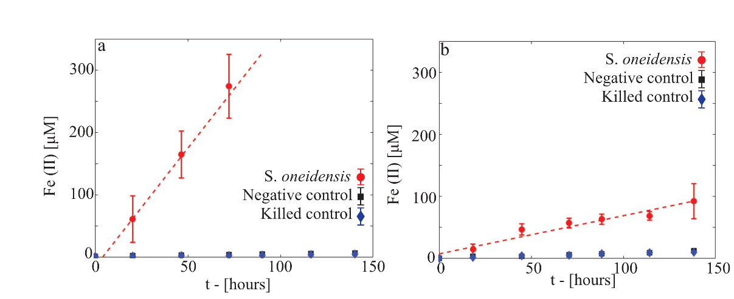
Figure S 1 - Time evolution of Fe(II) concentration in S. oneidensis incubations, killed and negative controls measured every 24 hours for 144 hours under anoxic (a) and oxic (b) conditions. A vertical bar indicates the standard deviation computed over triplicate for each experiment. Dashed lines indicate the linear interpolation of -Fe(II) concentration data.

Identification of the stationary growth phase and cell counting procedure
We characterized the temporal dynamics of S. oneidensis growth under oxic and anoxic conditions (3 replicates for each condition, Figure S 2) in the chosen experimental medium, i.e., 10% v/v LB, deionized water, 20 mM PIPES, and 2 mM ferrihydrite. For experimental setups and inoculation procedures, the reader can refer to the Methods presented in the manuscript. No FZ was added to these incubations to avoid interference with the biomass content spectrophotometric measurements.
We monitored bacterial growth for 168 hours (7 days) every 24 hours using protein concentration as a proxy and the following procedure:
- A sample of 300 μL was collected from the incubations with sterile material (with a pipette under laminar flow or with a syringe flushed 3 times with filter-sterile N₂ for oxic and anoxic batches, respectively).
- The sample was transferred in a 1.5 mL Eppendorf centrifuge conical tube and mixed with 345 μL of 0.1 M HCl for 15 minutes. This step lysed bacterial cells and freed their protein content.
- An aliquot of 150 μL was pipetted into a micro-well of a Greiner Microplate (96 wells, PS, F-bottom, clear) and mixed with 150 μL of Coomassie brilliant blue G-250.
- After 10 minutes of contact time, the sample’s absorbance at 595 nm (ABS595) was measured using a Spark® Multimode Microplate Reader.
- Protein concentration was computed through the following calibration curve obtained by applying Thermo Scientific's guidelines.
$$Protein concentration \left[\frac{μg}{mL}\right]=68.7 {ABS}_{595}-18.1$$
Oxic S. oneidensis growth attained the stationary phase after 24 hours, while, under anoxic conditions, protein concentration can be considered stable only after 48 hours. This is because of an initial lag phase, probably due to the sudden change of oxygenation conditions for the cell inoculum and the need for adaptation. The biomass during the stationary phase under oxic conditions is more abundant than under anoxic conditions, reflecting a more efficient metabolic activity in the presence of oxygen. This means that, given the same medium, imposing anoxic conditions led to a lower biomass density. We concluded that at 48 hours from the inoculation S. oneidensis growth attained the stationary phase under both anoxic and oxic conditions.
Figure S 2 – S. oneidensis growth assessment in 10 % v/v LB buffered (20 mM PIPES) medium under oxic and anoxic conditions using protein concentration as a proxy.
Cell concentrations were estimated using a cell counting procedure in a 1-mL aliquot sampled at 48 hours from inoculation before adding ferrihydrite and FZ, and fixed with 4% formaldehyde. DAPI was then added to a final concentration of 1 μg mL⁻¹. After 10 minutes of reaction time, the samples were injected into a microfluidic device with geometry reported in Figure S 3a. Samples from oxic incubation were diluted 20X to reduce cell density and facilitate the cell counting procedure. The microfluidic device was produced by casting polydimethylsiloxane polymer structure (PDMS, Sylgard 184 Silicone Elastomer mixed with 10 w/w % of curing agent; supplier: Dow Corning, Midland, MI) using a silica mold prepared with classical soft lithography. The microfluidic device, saturated with a DAPI-stained sample, was then placed on the stage of a Zeiss AxioObserver Z1 inverted microscope equipped with a Photometrics CoolSnap HQ2 camera. After 1 hour of waiting time to allow cell deposition at the bottom of the microfluidic device, DAPI-stained cells were imaged at 10 randomly chosen locations along the microfluidic channel at 20X magnification (EC Plan Neofluar 20X, N.A. 0.5 Ph2) in DAPI fluorescence mode. Images were post-processed to identify cells using an image thresholding procedure (e.g., in Figure S 3b-g) using an in-house-developed MATLAB® code (R2021b, version 9.11.0.1769968).
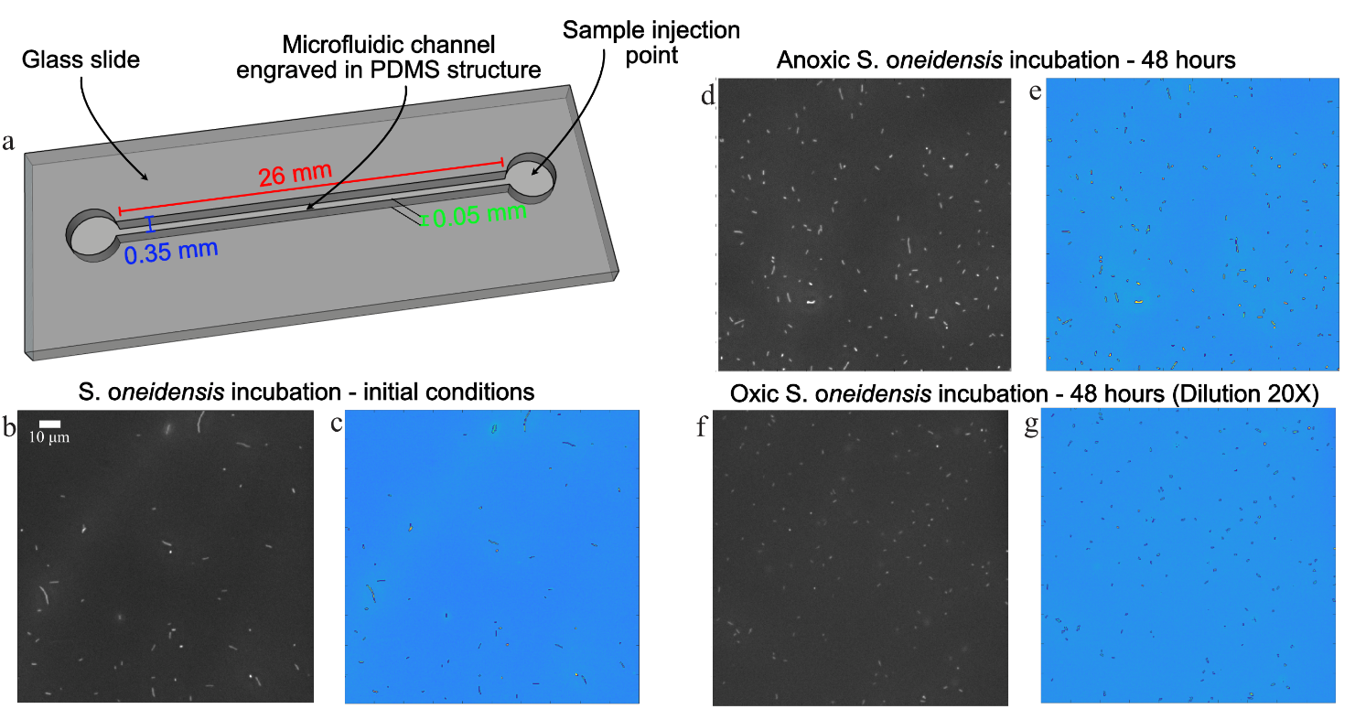
Figure S 3 – a) Outline of the microfluidic device used for cell counting procedure. Portions of raw images captured by the inverted microscope for the initial inoculum (b) and after 48 hours of incubations under anoxic (d) and oxic conditions (f). Panels c, e, and g display processed images corresponding to panels b, c, and f, respectively, with identified cells in yellow color on a light-blue background and delimited by a black perimeter.

The number of cells in every image is normalized to the corresponding imaged sample volume. The cell concentration and its uncertainty (Figure 3a, main text) were estimated by computing the mean and standard deviation from all images taken for each sample.

Mass spectrometry
At the end of the planned incubation period (i.e., 6 days), the medium was filtered through 0.22 μm syringe filters and stored frozen at −15 °C until further processing. To quantify Fe(II) via mass spectrometry, the Fe(II)–ferrozine (FZ) complex was acid-digested to eliminate matrix interference. For acid digestion, 1 ml of each Fe(II)–FZ complex sample was transferred to a Teflon vial and mixed with 5 ml of metal-free, double-distilled HNO₃ and 0.5 ml of metal-clean H₂O₂. The mixture was heated on a hot plate at 150 °C until complete evaporation to dryness. The resulting residue was then reconstituted in 10 ml of 0.05 M HNO₃. Metal concentrations were measured using an Agilent 8700 triple quadrupole ICP-MS. Fe(II) concentrations determined by mass spectrometry were quantitatively consistent with those obtained via photometric measurements of Fe(II)–FZ complex absorbance. This cross-validation (Table Table S 1) supports the reliability of using Fe(II)–FZ absorbance to monitor Fe(II) production during live bacterial incubations under oxic conditions and confirms the robustness of the results presented in this manuscript.
Table S 1 – Comparison of Fe(II) concentration estimated with the ferrozine method and measured via mass spectrometry at the end of oxic incubations (6 days or 144 hours after the addition of ferrihydrite). Concentrations are presented as mean values over the 3 incubation replicates along with their standard deviation for oxic S. Oneidensis incubations, killed, and negative controls.
Experiment | Mass Spectrometry [μM] | Ferrozine [μM]
S. oneidensis incubation | 112.1 ± 55.4 | 92.5 ± 28.2
Killed control | 10.5 ± 3.6 | 10.5 ± 1.0
Negative control | 12.6 ± 1.2 | 12.9 ± 0.7

Oxic and anoxic biomass
We moved from the data presented in Figure 3D in Ceriotti et al. (2022)[5], where the authors presented the percentage of total pore space colonized by biomass (PS_{B}) and occupied by anoxic microsites (PS_{A}) as a function of time. The latter is used here to compute the temporal dynamics of the pore space anoxic volume (V_{A}) and the associated uncertainty reported in Figure 4A of the manuscript.
The mean trend of V_{O}, i.e., the volume of pore space colonized by biomass and exposed to oxic conditions, was computed as the difference between the total pore space occupied by biomass (from PS_{B}, in Ceriotti et al. (2022)[5]) and V_{A}. The uncertainty associated with anoxic microsite volume was propagated to V_{O}. The uncertainty associated with PS_{B} was not accounted for in this work.

Uncertainty propagation
All the parameters and predictors in Eq. (1) of the manuscript were associated with a certain level of uncertainty that is propagated to the final assessment outputs, namely c_{A}, c_{B}, C_{A}, and C_{B} (Figure 4b and c). To propagate the uncertainty, we used a Monte Carlo approach with 100 000 realizations. All parameter and predictor values were randomly sampled for each realization, assuming a uniform distribution within their uncertainty intervals.

References

1. Arnold, R.G., et al., Regulation of dissimilatory Fe (III) reduction activity in Shewanella putrefaciens. Applied and Environmental Microbiology, 1990. 56(9): p. 2811-2817.
2. Royer, R.A., et al., Enhancement of hematite bioreduction by natural organic matter. Environmental science & technology, 2002. 36(13): p. 2897-2904.
3. Royer, R.A., et al., Enhancement of biological reduction of hematite by electron shuttling and Fe (II) complexation. Environmental science & technology, 2002. 36(9): p. 1939-1946.
4. Smith, G.L., et al., Complexation of ferrous ions by ferrozine, 2, 2′-bipyridine and 1, 10-phenanthroline: Implication for the quantification of iron in biological systems. Journal of Inorganic Biochemistry, 2021. 220: p. 111460.
5. Ceriotti, G., et al., Morphology and size of bacterial colonies control anoxic microenvironment formation in porous media. Environmental Science & Technology, 2022. 56(23): p. 17471-17480.

