Superalkalis as building block for efficient Lewis Base
Swapan Sinha, Subhra Das, Gourisankar Roymahapatra, Santanab Giri*
School of Applied Science and Humanities, Haldia Institute of Technology, Haldia, India 721657
* Email: santanab.giri@gmail.com, sgiri.chem@hithaldia.in
Table S1: Calculated vertical ionization energy (VIE), chemical hardness (η), electrophilicity (ω) and nucleophilicity index (N) of different N-centred molecules attached with electron-donating aliphatic groups in MP2/6-311+G(d,p) level of theory.

Sl No. | Lewis Base | I.E (eV) | η (eV) | ω (eV) | Nucleophilicity Index (N) eV  I II III IV
a | 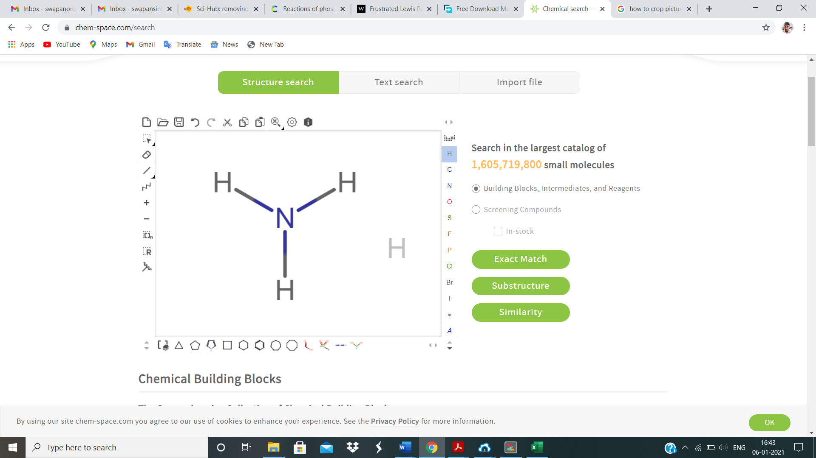 | 10.605 | 12.961 | 0.656 | 0.566 | 1.524 | 0.230 | 0.239
b | 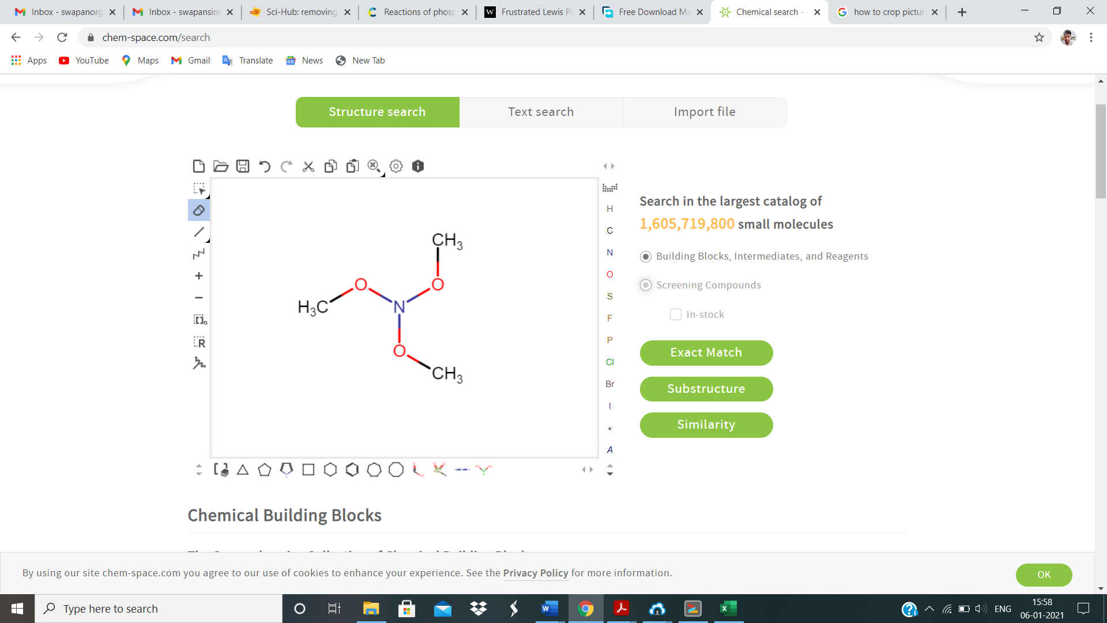 | 9.475 | 11.023 | 0.712 | 1.085 | 1.403 | 0.246 | 0.244
c | 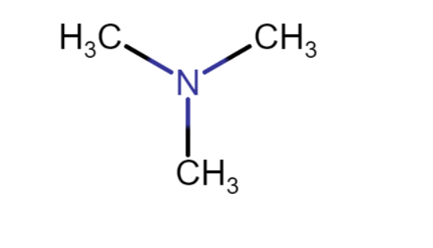 | 8.481 | 10.043 | 0.596 | 2.531 | 1.678 | 0.279 | 0.281
d | 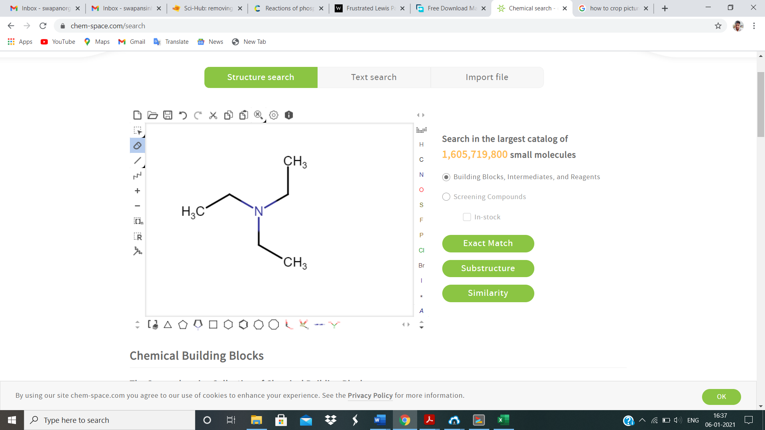 | 8.042 | 9.528 | 0.564 | 2.822 | 1.773 | 0.295 | 0.297
e | 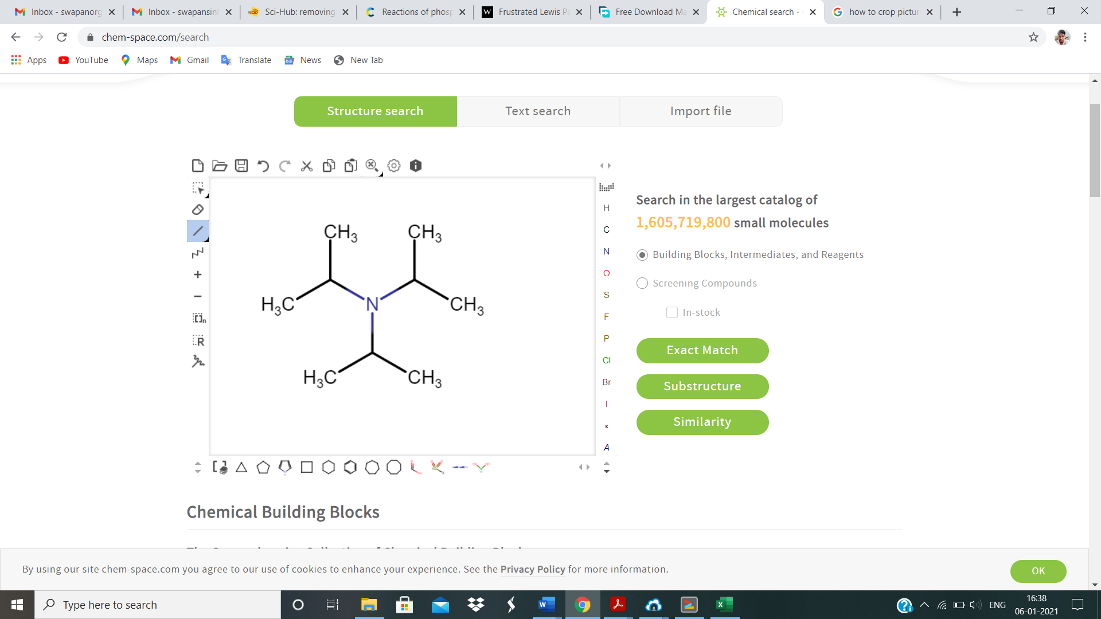 | 7.687 | 9.053 | 0.552 | 3.050 | 1.813 | 0.306 | 0.308
f | 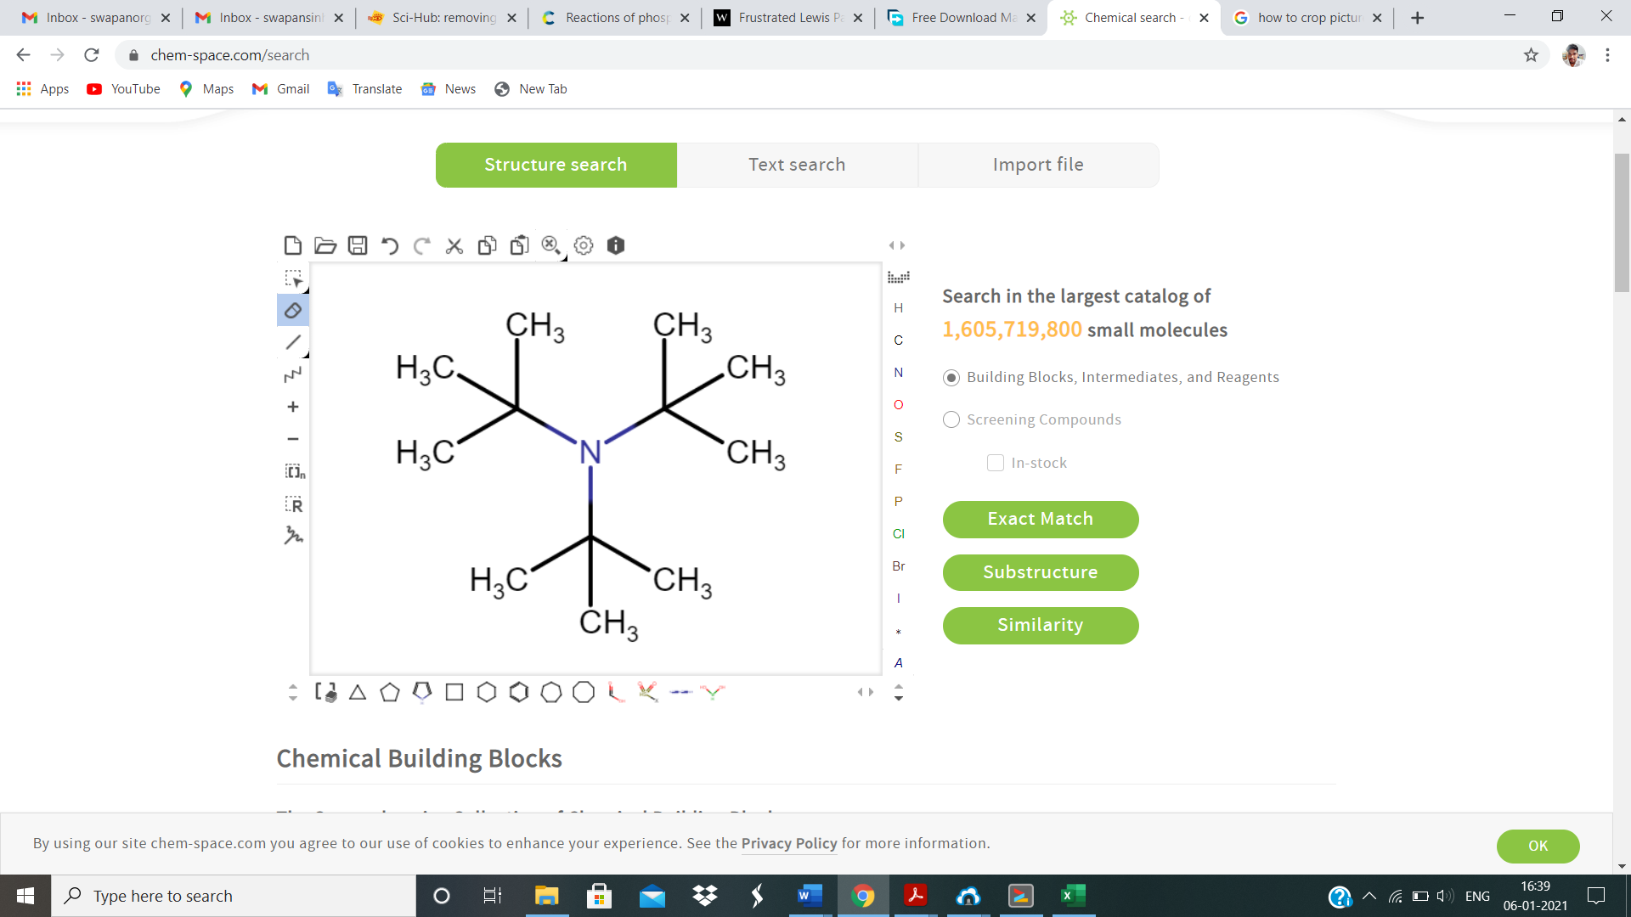 | 7.353 | 8.659 | 0.528 | 3.260 | 1.894 | 0.320 | 0.321

Table S2: calculated ionisation energy (I.E), chemical hardness (η), electrophilicity (ω), nucleophilicity index (N) of N-centred attached with electron-donating aromatic ligand in electron volt (eV) unit at MP2/6-311+G (d, p) level of theory.

Sl No. | Lewis Base | I.E (eV) | η (eV) | ω (eV) | Nucleophilicity Index (N) eV  I II III IV
g | 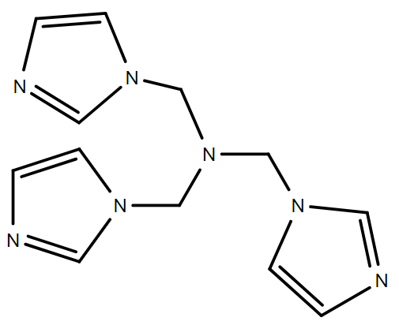 | 9.335 | 9.879 | 0.978 | 3.472 | 1.023 | 0.227 | 0.210
h | 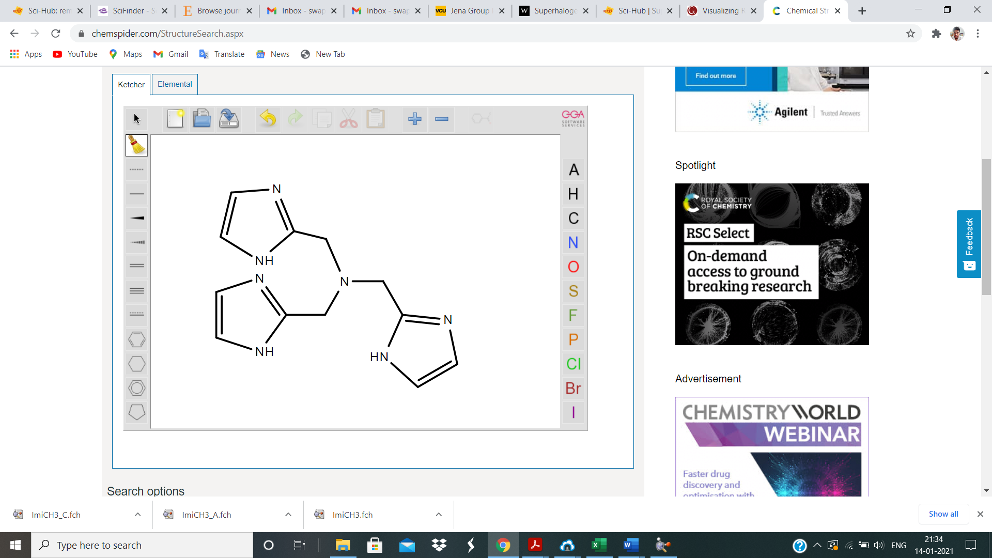 | 8.322 | 8.810 | 0.871 | 3.799 | 1.148 | 0.254 | 0.235
i | 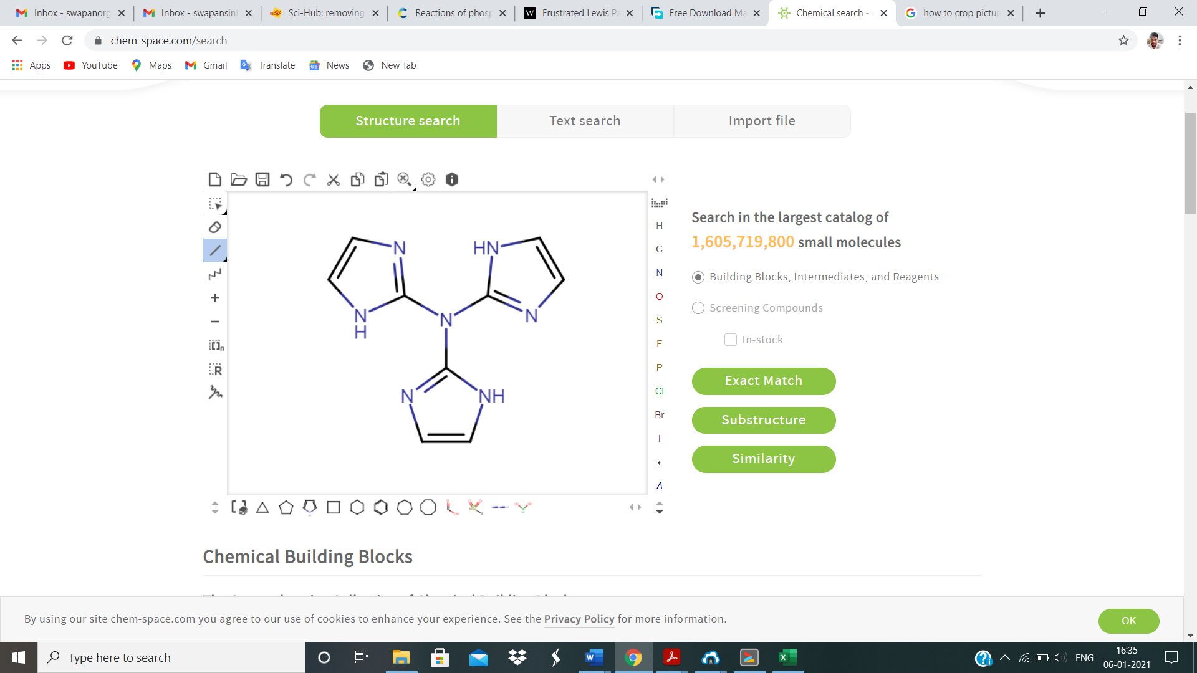 | 9.717 | 10.647 | 0.907 | 4.835 | 1.103 | 0.226 | 0.213
j | 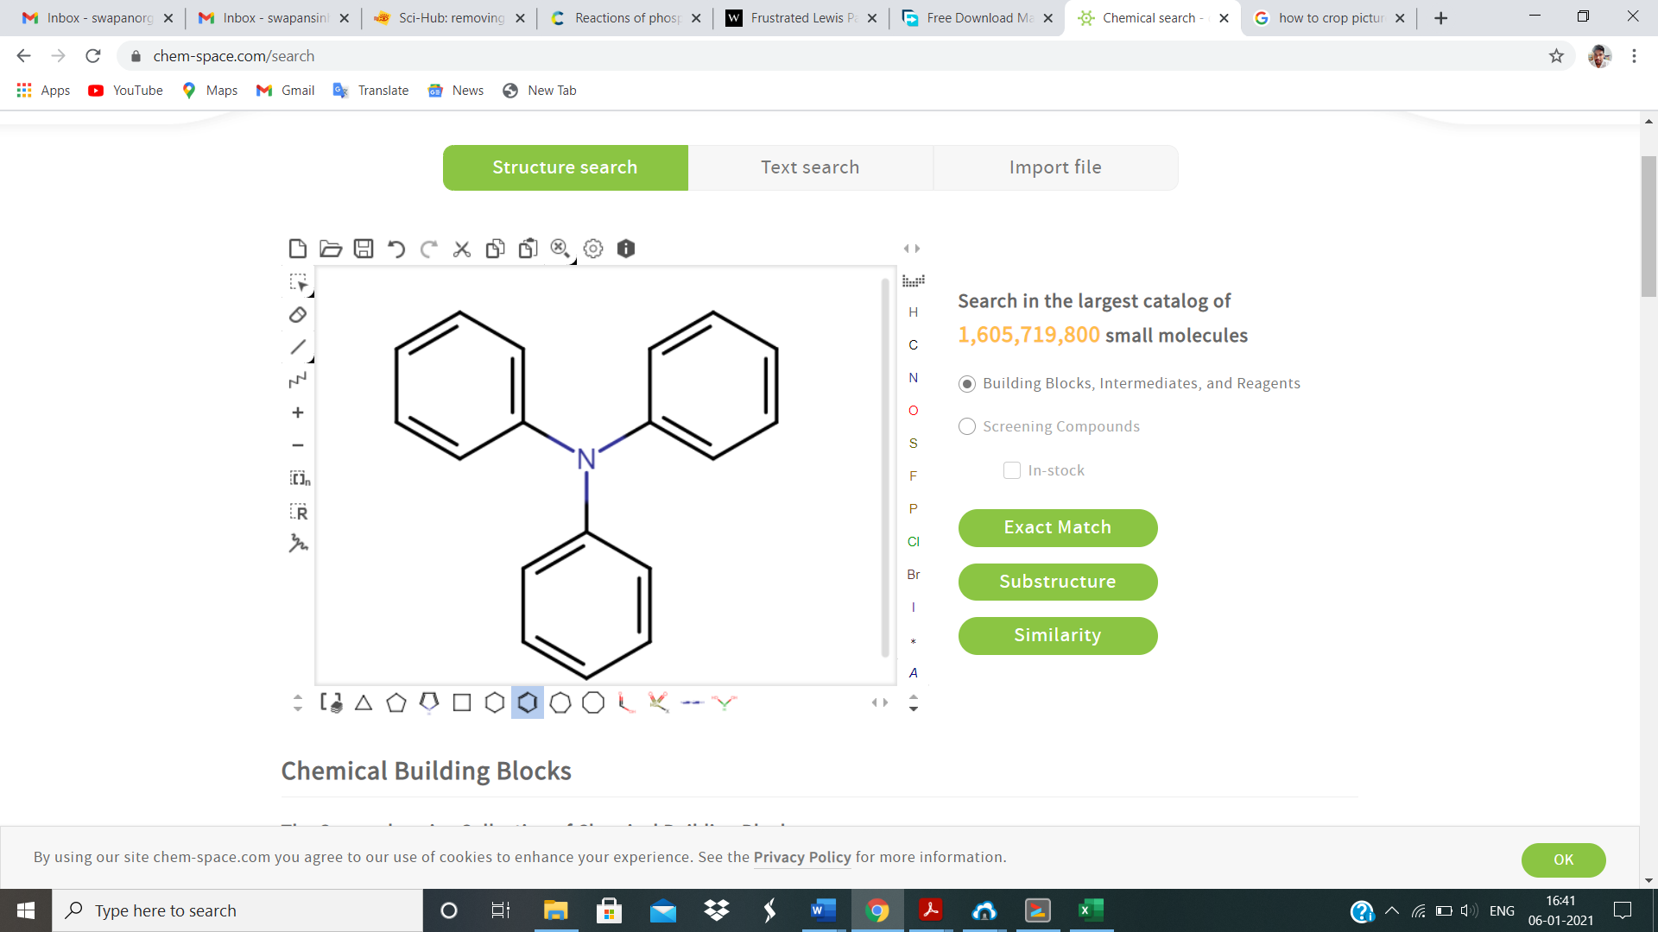 | 8.029 | 9.271 | 0.621 | 4.450 | 1.610 | 0.288 | 0.284

Table S3: calculated vertical ionisation energy (V.I.E), chemical hardness (η), electrophilicity (ω), nucleophilicity index (N) of N-centred attached with superalkalis ligand in electron volt (eV) unit at MP2/6-311+G (d, p) level of theory.
Sl.No | Lewis Base | V.I.E(eV) | η(eV) | ω(eV) | Nucleophilicity Index (N) eV  I II III IV
k | 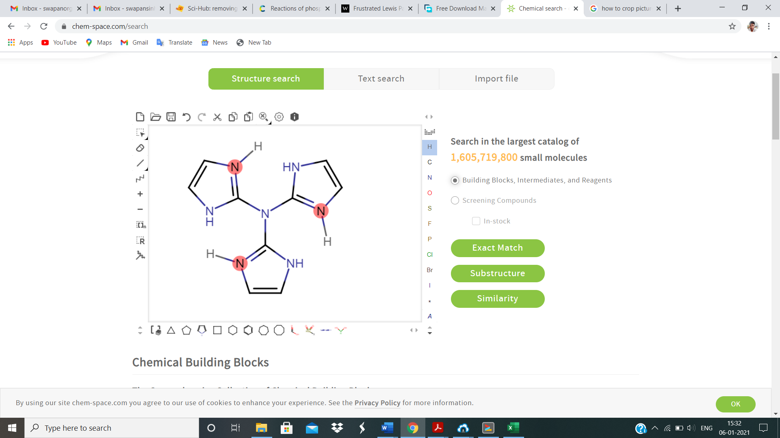 | 4.097 | 5.269 | 0.203 | 7.619 | 4.924 | 0.628 | 0.681
l | 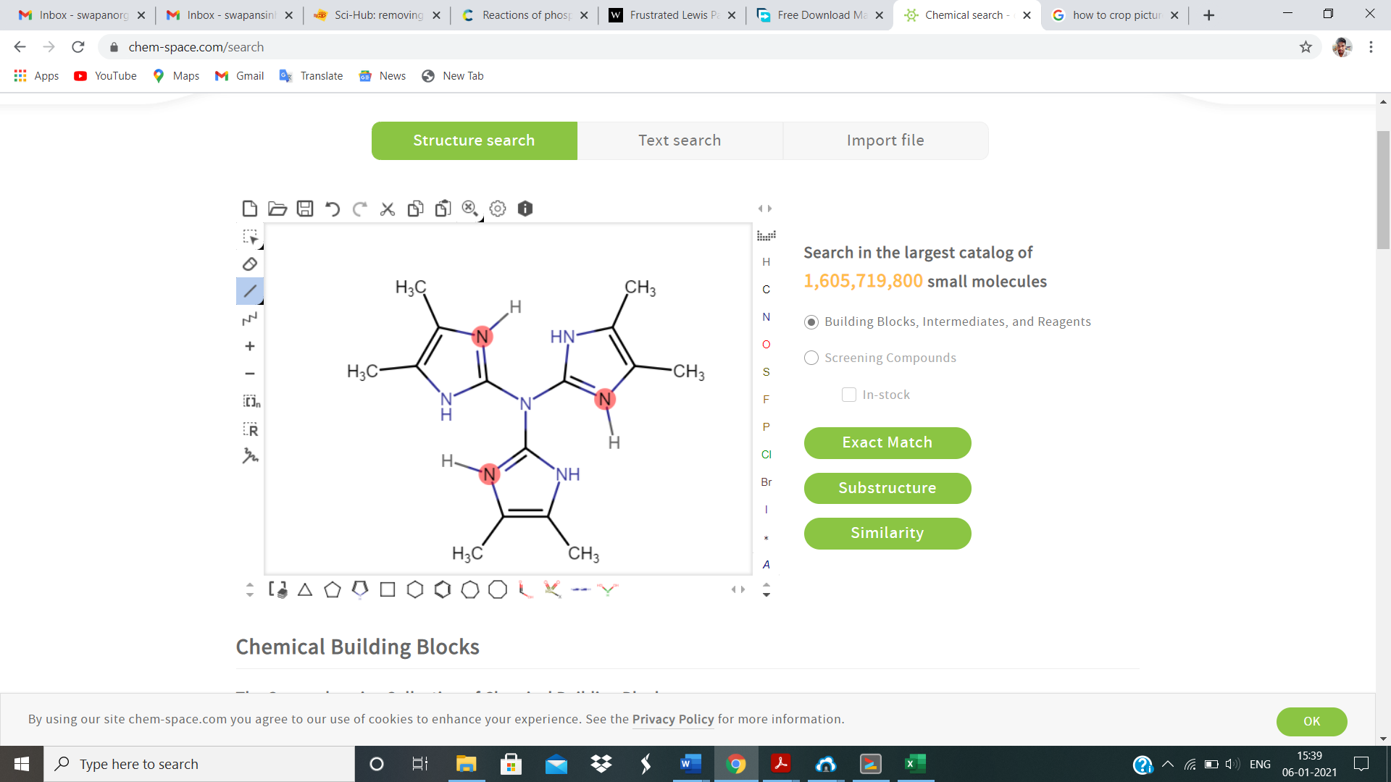 | 3.942 | 4.549 | 0.306 | 6.349 | 3.271 | 0.585 | 0.578
m | 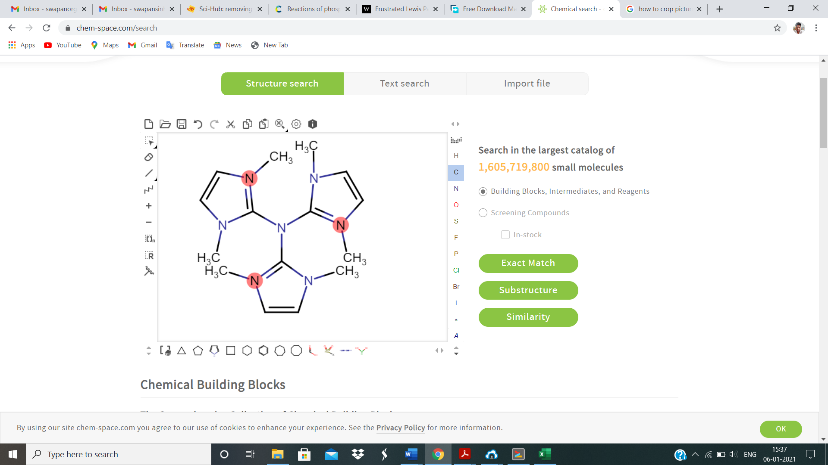 | 3.318 | 3.781 | 0.269 | 8.146 | 3.711 | 0.687 | 0.671
n | 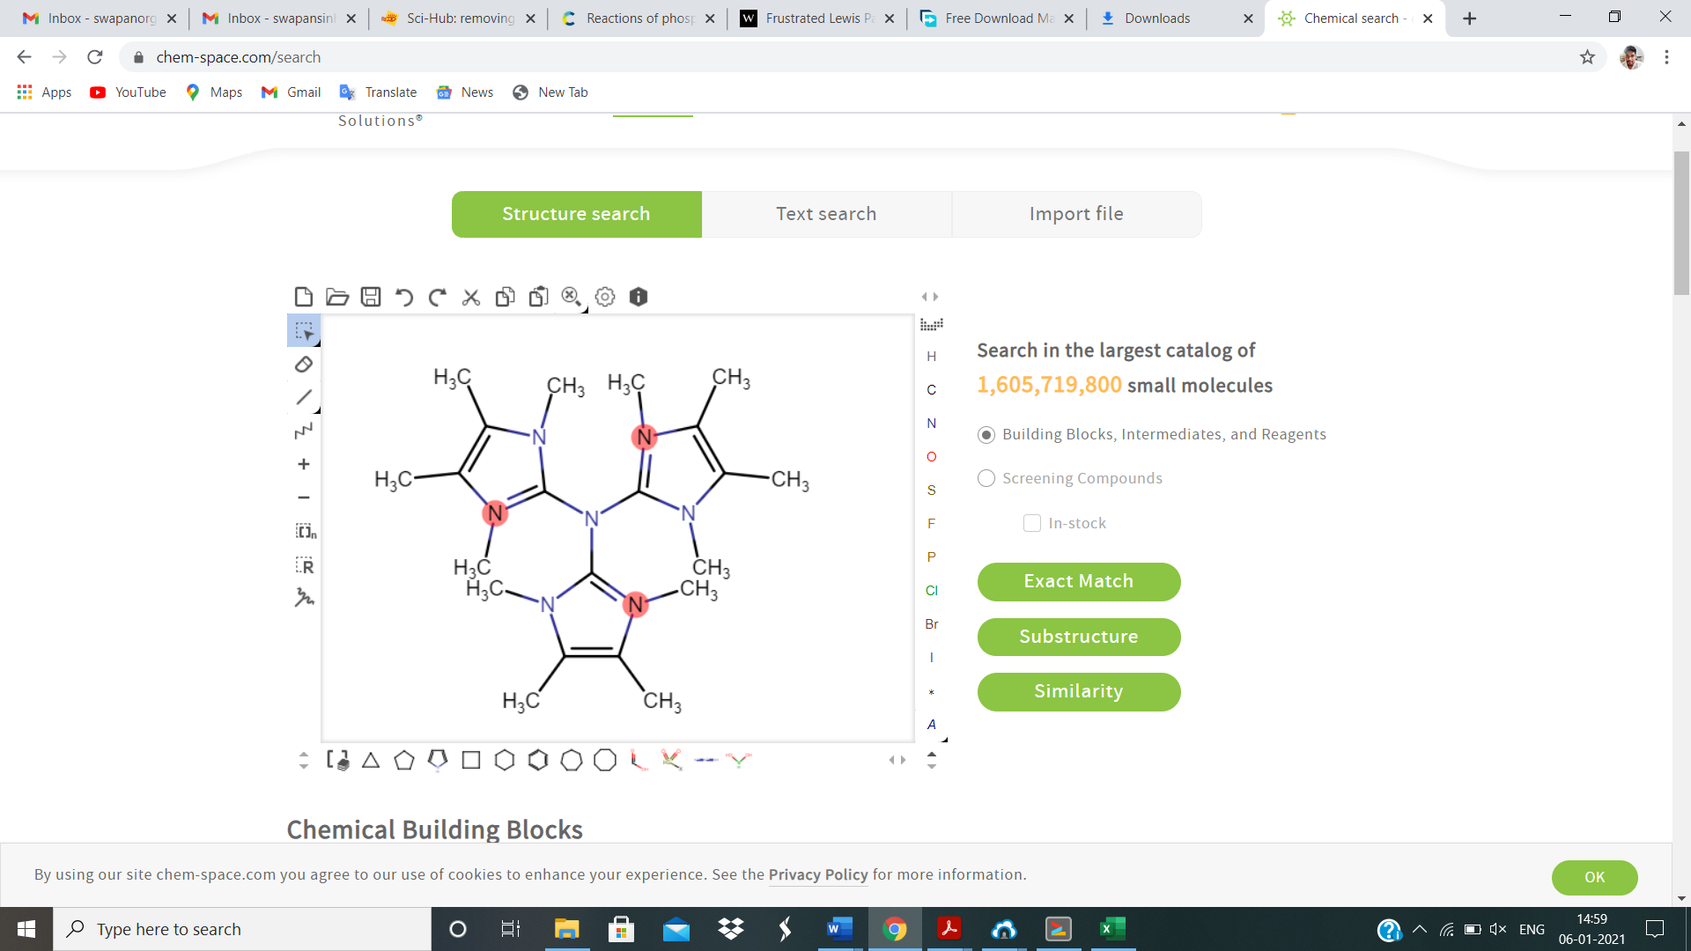 | 3.645 | 3.981 | 0.343 | 6.940 | 2.911 | 0.599 | 0.567

Table S4: Calculated Fukui function, dual descriptor (Δf), multiphilic descriptor (Δω_{k}±)) for taken systems.

Sl No | System | ƒ⁺ | ƒ⁻ | ω⁺=ω×ƒ⁺ | ω⁻=ω×ƒ⁻ | Δf | Δω_{k}±)
a | NH₃ | 0.623 | 0.827 | 0.436 | 0.579 | -0.204 | -0.143
b | N(OMe)₃ | 0 | 0.21 | 0.138 | 0 | -0.210 | -0.138
e | N(Me)₃ | 0.033 | 0.56 | 0.310 | 0.018 | -0.527 | -0.291
f | N(Et)₃ | 0.006 | 0.554 | 0.290 | 0.003 | -0.548 | -0.287
g | N(iPr)₃ | 0.003 | 0.547 | 0.275 | 0.002 | -0.544 | -0.273
h | N(tBu)₃ | 0.005 | 0.559 | 0.262 | 0.002 | -0.544 | -0.259
i | N(imidazole)₃ | -0.007 | 0.158 | 0.077 | -0.003 | -0.165 | -0.080
j | N(Ph)₃ | 0.005 | 0.26 | 0.149 | 0.003 | -0.255 | -0.146

Table S5. Cartesian coordinates of optimized geometries of (k) N(C₃N₂H₄)_{3.}

Standard orientation
---------------------------------------------------------------------
Center Atomic Atomic Coordinates (Angstroms)
Number Number Type X Y Z
---------------------------------------------------------------------
1 7 0 -0.009049 0.032944 0.011160
2 6 0 -1.473603 -0.093166 0.019974
3 6 0 -3.734145 -0.487889 0.554204
4 6 0 -3.742673 -0.234763 -0.761643
5 6 0 0.597243 1.327855 0.033860
6 6 0 1.897697 3.225705 -0.650318
7 6 0 1.444542 3.392655 0.599634
8 6 0 0.832253 -1.172077 -0.020990
9 6 0 2.364090 -2.877420 0.690626
10 6 0 2.072808 -3.020345 -0.609500
11 7 0 0.724509 2.124763 1.153298
12 7 0 1.115551 1.954925 -1.142167
13 7 0 1.423634 -1.891057 1.123676
14 7 0 1.269837 -1.930244 -1.069736
15 7 0 -2.272802 -0.138123 -1.104152
16 7 0 -2.477822 -0.193382 1.170499
17 1 0 3.115859 -3.378383 1.264019
18 1 0 2.396523 -3.837730 -1.219410
19 1 0 1.030363 -1.707130 -2.014655
20 1 0 1.166528 -1.678843 2.066470
21 1 0 0.421615 1.919760 2.084012
22 1 0 1.560023 4.287781 1.174362
23 1 0 2.627778 3.821355 -1.157351
24 1 0 1.016703 1.666852 -2.094660
25 1 0 -4.585238 -0.127105 -1.412331
26 1 0 -4.578984 -0.870359 1.087930
27 1 0 -1.919936 -0.109982 -2.039402
28 1 0 -2.217501 -0.068331 2.127889
---------------------------------------------------------------------

Table S6. Cartesian coordinates of optimized geometries of (l) N(C₅N₂H₈)₃

Standard orientation
---------------------------------------------------------------------
Center Atomic Atomic Coordinates (Angstroms)
Number Number Type X Y Z
---------------------------------------------------------------------
1 7 0 0.007998 -0.006059 -1.336767
2 6 0 0.023493 1.378874 -0.843894
3 6 0 -0.184799 3.010011 0.711922
4 6 0 -0.865847 3.410515 -0.391560
5 6 0 1.204953 -0.710764 -0.855192
6 6 0 3.414031 -0.953855 -0.426415
7 6 0 2.738723 -1.342369 0.685333
8 6 0 -1.195088 -0.689398 -0.841316
9 6 0 -2.493545 -1.698077 0.713270
10 6 0 -2.507461 -2.478346 -0.396933
11 7 0 2.492664 -0.767998 -1.557507
12 7 0 1.298777 -1.454745 0.407218
13 7 0 -0.574461 2.529419 -1.532492
14 7 0 0.628976 1.820136 0.419196
15 7 0 -1.871487 -0.396080 0.428553
16 6 0 -1.832909 4.608244 -0.434428
17 1 0 -2.599518 4.421738 -1.157101
18 1 0 -2.276988 4.743026 0.529663
19 1 0 -1.294132 5.491786 -0.705506
20 6 0 -0.273209 3.693124 2.088920
21 1 0 -1.239447 4.137454 2.205369
22 1 0 -0.119719 2.965283 2.858415
23 1 0 0.478228 4.451170 2.160373
24 6 0 -3.031556 -2.128736 2.090294
25 1 0 -2.472610 -1.639965 2.860287
26 1 0 -4.063333 -1.856607 2.170886
27 1 0 -2.932606 -3.188766 2.196086
28 6 0 -3.063541 -3.913350 -0.449471
29 1 0 -3.860862 -4.012923 0.256617
30 1 0 -3.430945 -4.117496 -1.433613
31 1 0 -2.285251 -4.606456 -0.208324
32 6 0 3.387678 -1.603108 2.057464
33 1 0 4.255910 -0.986960 2.164366
34 1 0 2.687689 -1.370796 2.832936
35 1 0 3.670322 -2.632688 2.128539
36 6 0 4.933887 -0.713537 -0.488147
37 1 0 5.146135 0.043265 -1.214015
38 1 0 5.284070 -0.395522 0.471715
39 1 0 5.427586 -1.621309 -0.765199
40 7 0 -1.895895 -1.776819 -1.535754
41 1 0 0.733791 -1.075299 1.140021
42 1 0 -2.551384 0.328329 0.315100
43 1 0 -2.581841 -1.416784 -2.167716
44 1 0 -1.391706 2.300666 -2.061935
45 1 0 0.585239 1.134993 1.146629
46 1 0 2.696503 0.053534 -2.089789
---------------------------------------------------------------------

Table S7. Cartesian coordinates of optimized geometries of (m) N(C₅N₂H₈)₃ isomer of l.

Standard orientation
---------------------------------------------------------------------
Center Atomic Atomic Coordinates (Angstroms)
Number Number Type X Y Z
---------------------------------------------------------------------
1 7 0 -0.018750 -0.006680 -0.084166
2 6 0 -1.155326 -0.828619 -0.196057
3 6 0 -3.343387 -1.195811 0.409861
4 6 0 -3.347712 -0.850026 -0.889630
5 1 0 -4.163124 -1.495389 1.042297
6 1 0 -4.170705 -0.786449 -1.583268
7 6 0 0.097590 1.364850 -0.191889
8 6 0 1.071967 3.384971 -0.486017
9 6 0 0.073185 3.549755 0.400880
10 1 0 1.759258 4.113452 -0.884000
11 1 0 -0.274619 4.452284 0.876637
12 6 0 0.902086 -1.021384 0.227864
13 6 0 2.974049 -1.528226 1.052072
14 6 0 2.897449 -2.063576 -0.178343
15 1 0 3.761539 -1.596084 1.785274
16 1 0 3.607756 -2.682943 -0.702016
17 7 0 1.729319 -1.611486 -0.789555
18 7 0 1.833115 -0.762059 1.270709
19 7 0 1.123882 2.054153 -0.859322
20 7 0 -0.496892 2.314628 0.664327
21 7 0 -2.047730 -0.546845 -1.263683
22 7 0 -2.049731 -1.063149 0.904866
23 6 0 -1.658823 -0.174652 -2.595958
24 1 0 -0.758826 0.443500 -2.561024
25 1 0 -1.477196 -1.042519 -3.243659
26 1 0 -2.454098 0.423823 -3.044852
27 6 0 -1.605277 -1.724468 2.102404
28 1 0 -2.447323 -2.224459 2.586341
29 1 0 -0.823573 -2.454165 1.839924
30 1 0 -1.172882 -1.016787 2.812862
31 6 0 1.119105 -2.317818 -1.887277
32 1 0 1.897114 -2.791545 -2.488997
33 1 0 0.397871 -3.066082 -1.525798
34 1 0 0.581551 -1.618924 -2.526439
35 6 0 1.478932 -0.250217 2.567134
36 1 0 1.082470 -1.026420 3.234529
37 1 0 2.367178 0.180240 3.034133
38 1 0 0.738786 0.544990 2.464314
39 6 0 -1.718203 2.085237 1.379289
40 1 0 -2.536631 1.815715 0.701231
41 1 0 -1.600578 1.268529 2.095799
42 1 0 -1.983377 2.994272 1.920555
43 6 0 2.179251 1.424642 -1.601611
44 1 0 2.778384 0.763498 -0.969806
45 1 0 1.770114 0.822766 -2.419831
46 1 0 2.819099 2.200813 -2.022781
---------------------------------------------------------------------
Table S8. Cartesian coordinates of optimized geometries of (n) N(C₇N₂H₁₂)_{3.}

Standard orientation:
--------------------------------------------------------------------
Center Atomic Atomic Coordinates (Angstroms)
Number Number Type X Y Z
---------------------------------------------------------------------
1 7 0 -0.080304 -0.352121 0.012773
2 6 0 -1.359777 -0.912293 0.246011
3 6 0 -3.532979 -0.500831 0.789086
4 6 0 -3.529014 -1.189031 -0.368142
5 6 0 0.087543 0.984088 0.037019
6 6 0 -0.112498 3.183406 -0.404341
7 6 0 0.950186 3.023892 0.418306
8 6 0 0.988677 -1.342850 -0.451782
9 6 0 3.098008 -1.732831 0.438237
10 6 0 3.269672 -0.957072 -0.642050
11 7 0 -0.628410 1.915234 -0.653141
12 7 0 1.054749 1.665816 0.696442
13 7 0 -2.206476 -1.363982 -0.797356
14 7 0 -2.200393 -0.214199 1.144734
15 7 0 1.718035 -1.895888 0.702125
16 6 0 -4.663009 -1.657529 -1.212707
17 1 0 -4.625936 -2.741000 -1.359924
18 1 0 -5.619228 -1.415794 -0.747589
19 1 0 -4.635919 -1.191957 -2.203954
20 6 0 -4.664674 0.021058 1.604359
21 1 0 -5.619144 -0.202104 1.126394
22 1 0 -4.682951 -0.423028 2.604918
23 1 0 -4.594097 1.107770 1.728443
24 6 0 4.111760 -2.248973 1.403243
25 1 0 3.891653 -1.901078 2.420432
26 1 0 4.124878 -3.343169 1.432507
27 1 0 5.116945 -1.916152 1.137397
28 6 0 4.523715 -0.383952 -1.210066
29 1 0 5.394534 -0.681234 -0.623091
30 1 0 4.694246 -0.714878 -2.239580
31 1 0 4.475755 0.712873 -1.227889
32 6 0 1.907341 4.014226 0.980590
33 1 0 1.719539 5.002315 0.559980
34 1 0 1.823476 4.092041 2.068969
35 1 0 2.939611 3.740105 0.744557
36 6 0 -0.695740 4.410985 -1.009796
37 1 0 -1.761065 4.503750 -0.779602
38 1 0 -0.193340 5.295869 -0.618795
39 1 0 -0.585625 4.419752 -2.098884
40 7 0 2.014719 -0.574699 -1.167395
41 6 0 -1.809372 -0.168545 2.542494
42 1 0 -2.381162 0.599932 3.066504
43 1 0 -1.958794 -1.137722 3.038440
44 1 0 -0.751213 0.086399 2.603977
45 6 0 -1.826631 -2.499385 -1.626048
46 1 0 -0.739926 -2.464690 -1.736881
47 1 0 -2.100057 -3.450956 -1.149068
48 1 0 -2.319420 -2.428869 -2.599636
49 6 0 -1.724862 1.611975 -1.548519
50 1 0 -1.541034 0.648331 -2.021824
51 1 0 -2.670927 1.548321 -1.006028
52 1 0 -1.787288 2.387242 -2.311510
53 6 0 2.004572 1.077631 1.615959
54 1 0 1.668318 0.067112 1.859261
55 1 0 2.986003 0.990103 1.148796
56 1 0 2.067438 1.690244 2.517321
57 6 0 1.283383 -3.227879 1.089580
58 1 0 1.473729 -3.970954 0.297679
59 1 0 1.786206 -3.540979 2.010451
60 1 0 0.209442 -3.200587 1.278007
61 6 0 1.868348 -0.607580 -2.610136
62 1 0 1.997442 -1.623215 -3.019470
63 1 0 0.862961 -0.267137 -2.869354
64 1 0 2.583620 0.071135 -3.086001
---------------------------------------------------------------------

