Supplementary material
Figure S1. Vaccine effectiveness among those aged ≥65 years against (a) influenza A(H1N1)pdm09 and (b) A(H3N2), by individual season and pooled (1- and 2-stage analysis) over six seasons, 2015/16–2023/24, VEBIS multicentre hospital study, Europeª
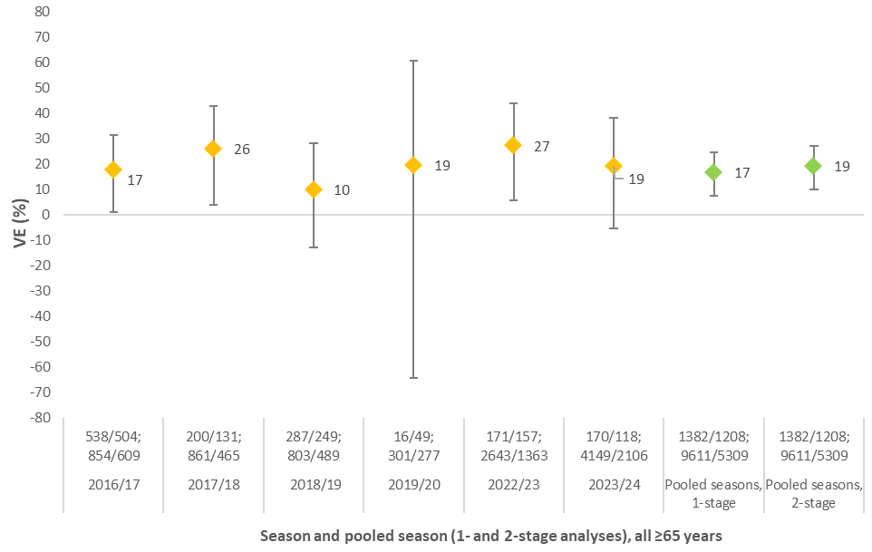
ab
a
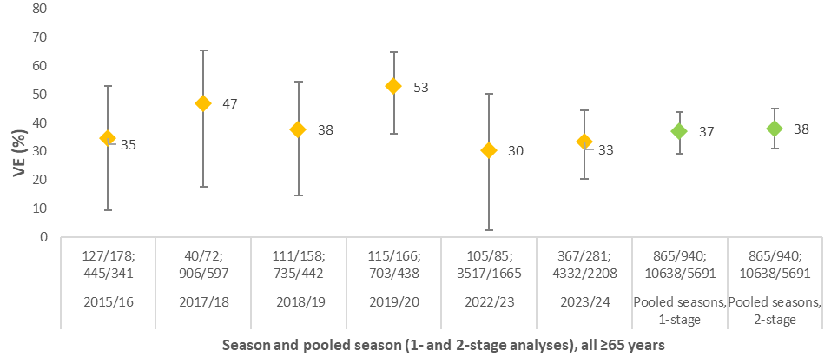
bb

ªNote: we adjusted the odds ratios for each individual season using the same variables used in the final pooled-season analysis, to have better comparison between the 1- and 2-stage pooled VE results. Some minor differences between these and previously published data for any individual season may therefore exist, due to differences in adjustment variables and analytic approaches. For each subtype, heterogeneity I²=0 for the 2-stage analysis.
Figure S2. Vaccine effectiveness among those aged ≥65 years against influenza A(H1N1)pdm09 by presence and absence of (a) heart disease, lung disease/asthma, diabetes, and kidney disease; (b) cancer, obesity, immunosuppression and liver disease, pooled over six seasons, 2015/16–2023/24, VEBIS multicentre hospital study, Europe
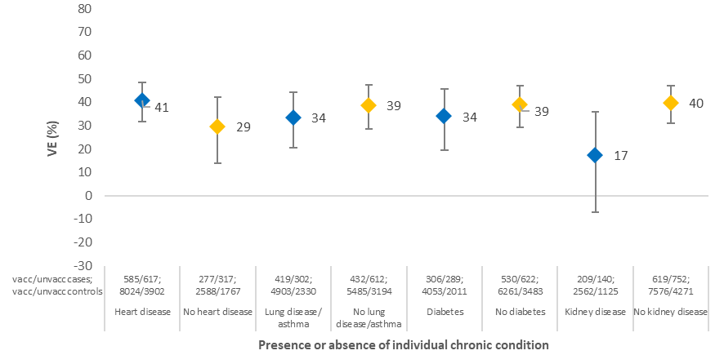
ab

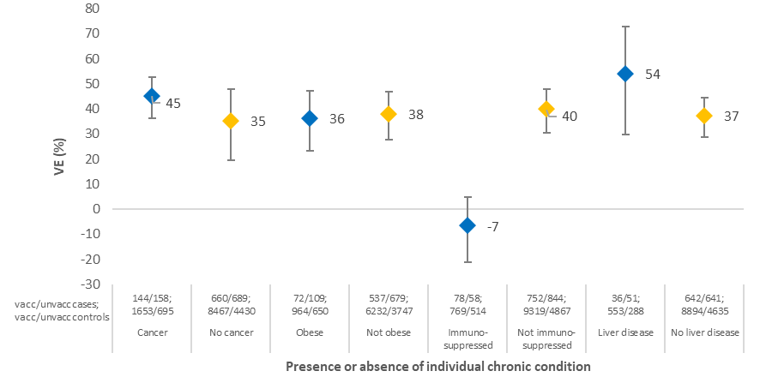
bb

Figure S3. Vaccine effectiveness among those aged ≥65 years against influenza A(H3N2) by presence and absence of (a) heart disease, lung disease/asthma, diabetes, and kidney disease; (b) cancer, obesity, immunosuppression and liver disease, pooled over six seasons, 2015/16–2023/24, VEBIS multicentre hospital study, Europe

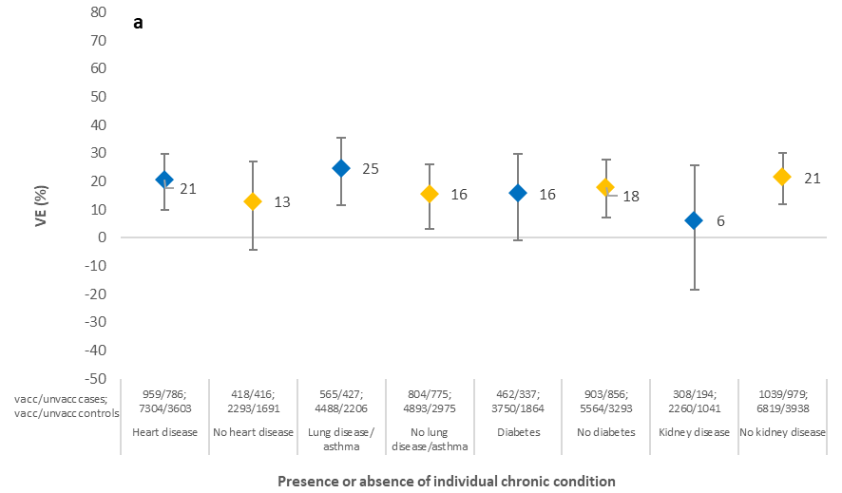

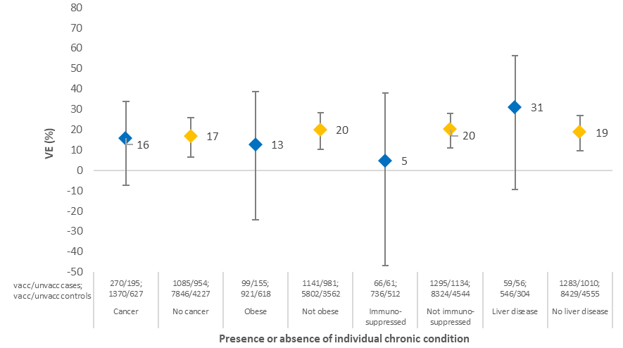
bb
Figure S4. Sensitivity analysis 1. Vaccine effectiveness among those aged ≥65 years and those with at least two chronic conditions against (a) influenza A(H1N1)pdm09 and (b) A(H3N2) by SARI case definition, 2022/23 and 2023/24, VEBIS multicentre hospital study, Europe.
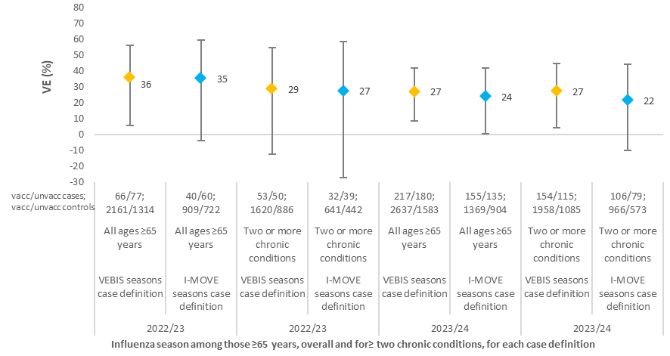
ab

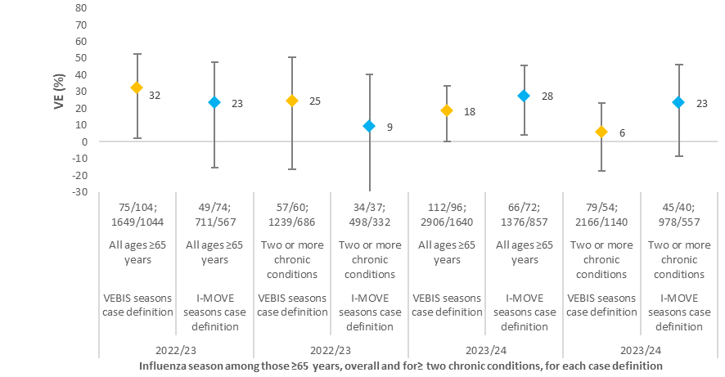
vacc/unvacc cases;
vacc/unvacc controls
bb

Figure S5. Sensitivity analysis 2. Vaccine effectiveness among those aged ≥65 years and with at least two chronic conditions against (a) influenza A(H3N2) and (b) A(H1N1)pdm09 by SARI case definition, 2022/23 and 2023/24, VEBIS multicentre hospital study, Europe.
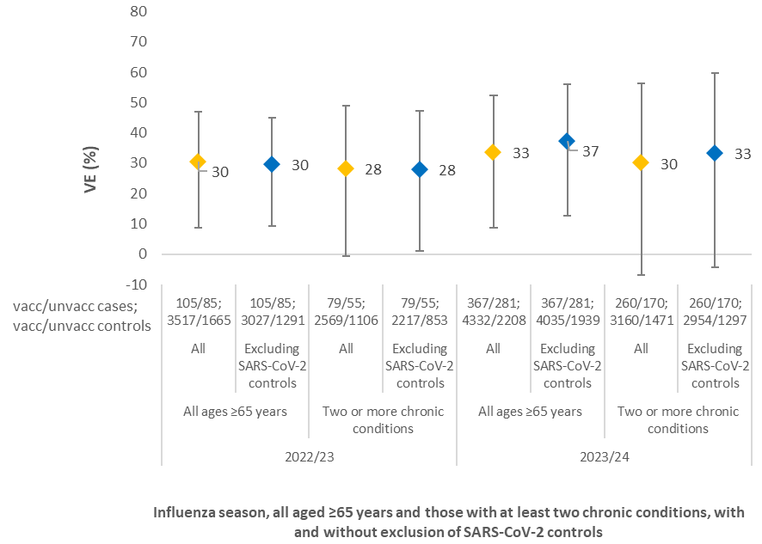
ab

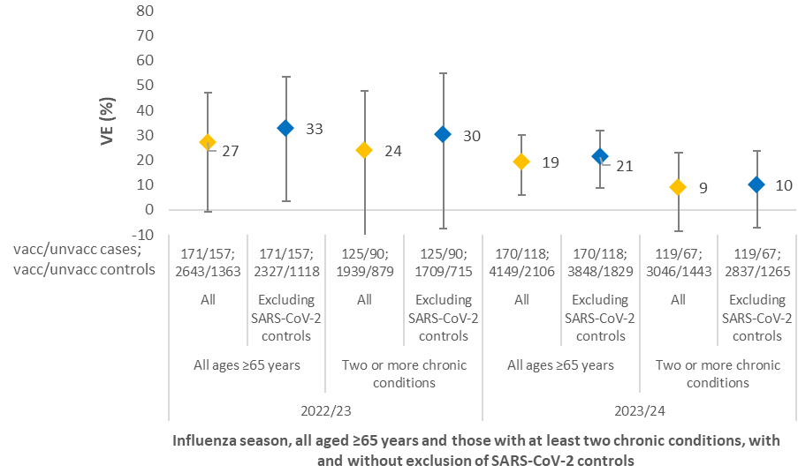
b

