Supplemental Figures
Supplemental Figure1 The flowchart of study participants.
Supplementary Figure 2 Kaplan-Meier curves for the cumulative incidence of cardiovascular disease.
Supplementary Figure 3 Kaplan-Meier curves for the cumulative incidence of heart disease.
Supplementary Figure 4 Kaplan-Meier curves for the cumulative incidence of stroke.
Supplementary Figure 5 Mediation effect of obesity between the eGDR and cardiovascular diseases.
Supplementary Figure 6 Mediation effect of obesity between estimated glucose disposal rate and heart disease.
Supplementary Figure 7 Mediation effect of obesity between estimated glucose disposal rate and stroke.
Supplementary Figure 8 Subgroup analysis of HRs(95% CIs) for CVD、Heart disease and stroke of estimated glucose disposal rate

Supplementary Figure 1 The flowchart of study participants.
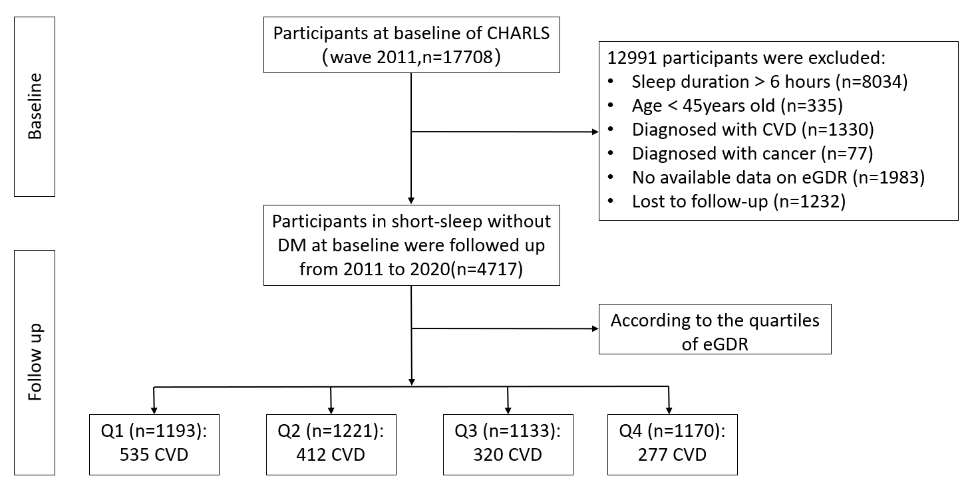

Supplementary Figure 2 Kaplan-Meier curves for the cumulative incidence of cardiovascular disease.
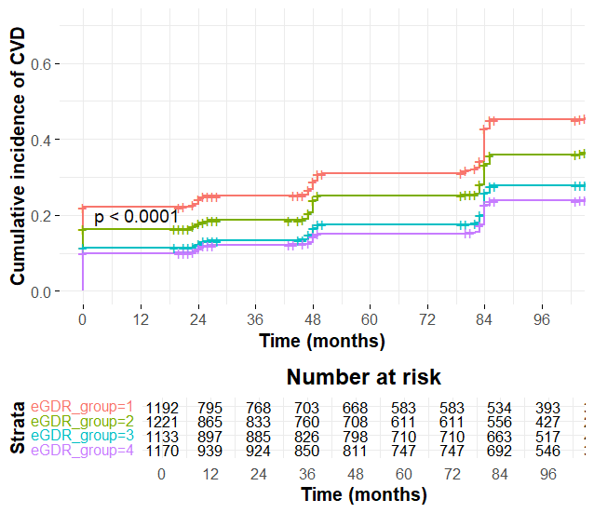

Supplementary Figure 3 Kaplan-Meier curves for the cumulative incidence of heart disease.
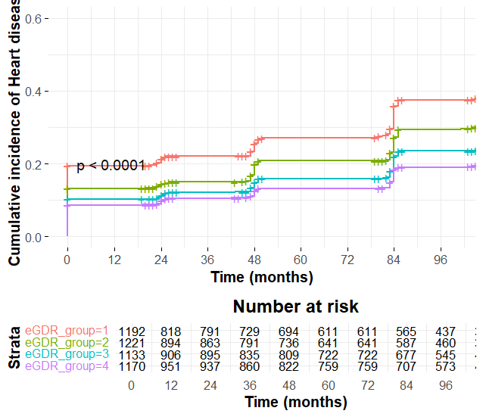

Supplementary Figure 4 Kaplan-Meier curves for the cumulative incidence of stroke.
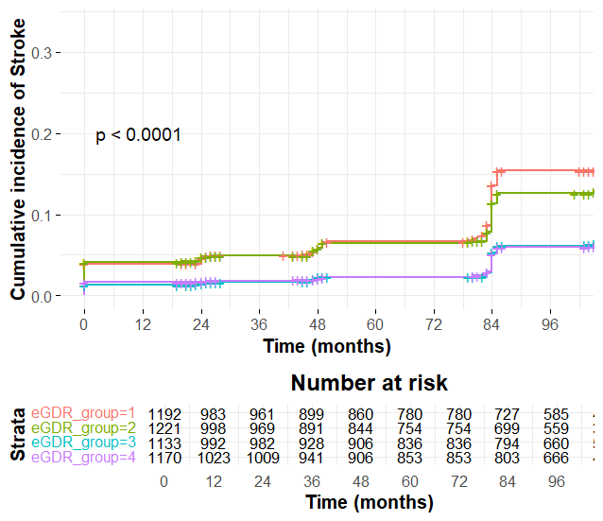

Supplementary Figure 5 Mediation effect of obesity between the eGDR and cardiovascular diseases.

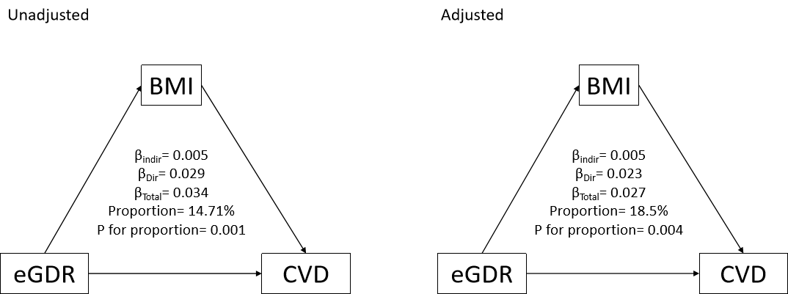

Supplementary Figure 6 Mediation effect of obesity between estimated glucose disposal rate and heart disease.

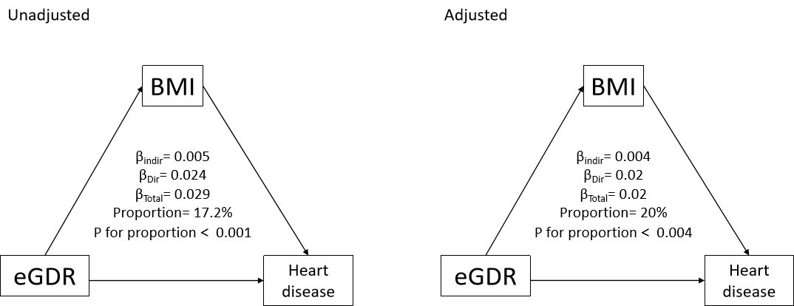

Supplementary Figure 7 Mediation effect of obesity between estimated glucose disposal rate and stroke.

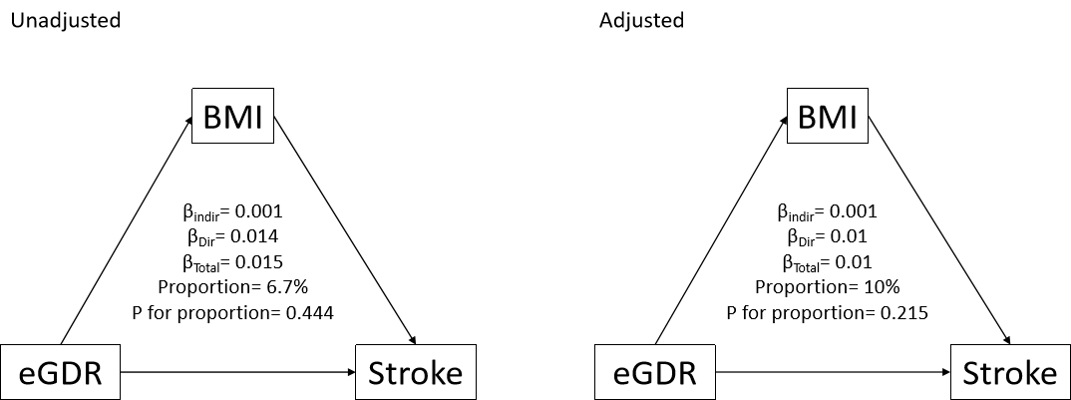
Supplementary Figure 8 Subgroup analysis of HRs(95% CIs) for CVD、Heart disease and stroke of estimated glucose disposal rate
