Visualizing cortical laminar architecture in the living human brain using next-generation ultra-high-gradient diffusion MRI

Hansol Lee^{1,2,3,¶}, Yixin Ma^{1,2,¶}, Kwok-Shing Chan^{1,2}, Eva A. Krijnen^{4,5}, Laleh Eskandarian^{1,2}, Aneri Bhatt^{1,2}, Julianna Gerold^{1,2}, Mirsad Mahmutovic⁷, Oula Puonti^{1,6}, Xiangrui Zeng^{1,2}, Lucas Jacob Deden Binder^{1,2}, Bruce Fischl^{1,2}, Boris Keil^{7,8,9}, Gabriel Ramos-Llordén^{1,2}, Eric C. Klawiter⁴, Hong-Hsi Lee^{1,2,&,*}, and Susie Y. Huang^{1,2,&,*}

¹Athinoula A. Martinos Center for Biomedical Imaging, Department of Radiology, Massachusetts General Hospital, Charlestown, MA, United States
²Harvard Medical School, Boston, MA, United States
³Department of Biomedical Engineering, Ulsan National Institute of Science and Technology, Ulsan, South Korea
⁴Department of Neurology, Massachusetts General Hospital, Harvard Medical School, Boston, MA, United States
⁵MS Center Amsterdam, Anatomy and Neurosciences, Amsterdam Neuroscience, Amsterdam UMC location VUmc, Amsterdam, The Netherlands
⁶Danish Research Centre for Magnetic Resonance, Centre for Functional and Diagnostic Imaging and Research, Copenhagen University Hospital - Amager and Hvidovre, Copenhagen, Denmark
⁷Institute of Medical Physics and Radiation Protection, TH-Mittelhessen University of Applied Sciences, Giessen, Germany
⁸LOEWE Research Cluster for Advanced Medical Physics in Imaging and Therapy (ADMIT), TH-Mittelhessen University of Applied Sciences, Giessen, Germany
⁹Department of Diagnostic and Interventional Radiology, University Hospital Marburg, Philipps University of Marburg, Marburg, Germany

¶ Hansol Lee and Yixin Ma contributed equally to this work as first authors.
& Susie Y. Huang and Hong-Hsi Lee contributed equally to this work as corresponding authors.

* Corresponding authors:
Susie Y. Huang
E-mail : susie.huang@mgh.harvard.edu (SYH)
Hong-Hsi Lee
E-mail : hlee84@mgh.harvard.edu (HHL)

Supplementary Note 1
Self-similarity-based super-resolution imaging processing

Methods
A self-similarity-based super-resolution technique was applied to enhance the spatial resolution of dMRI data (2 mm isotropic), reducing partial volume effects and enhancing anatomical detail [1-3]. This method incorporates high spatial frequency information from high-resolution (1 mm isotropic) T₁-weighted images to guide the upsampling of low-resolution diffusion-weighted images (DWIs) (S4 Fig). The algorithm defines a local 5×5×5 search window around each voxel. For a center voxel and a surrounding voxel within this window, interpolation weights are computed based on the intensity differences (1) between the 3×3×3 voxel patches centered at the two voxels in the DWI and (2) between the two voxels in the co-registered T₁-weighted image. Voxel distance is not considered in the weighting, enabling similarity-based interpolation driven purely by local signal characteristics. The T₁-weighted image was co-registered to the up-sampled b0 image and DWI space using FreeSurfer “bbregister” function and served as the anatomical reference. Initial up-sampling of the b0 image and DWI to 1 mm isotropic resolution was performed using nearest-neighbor interpolation via the “mrgrid” function in MRtrix3. To progressively refine patch matching, a hyperparameter h was decreased over six iterations (e.g., 16, 8, 4, 2, 1). Data fidelity was maintained throughout the process by enforcing a consistency constraint: after each iteration, the down-sampled version of the high-resolution estimates was required to match the original low-resolution DWI. This iterative correction ensured preservation of diffusion contrast and stable convergence. The super-resolution algorithm was implemented in-house as the “mrsupres” function (https://github.com/yixinma9/super_resolution), fully compatible with the MRtrix3 framework. To support efficient processing of large-scale datasets, key computational steps, including patch-based similarity computation, image updating, and data consistency enforcement, were parallelized using multi-threading.

Discussion
This study demonstrated the substantial advantages of applying a self-similarity-based super-resolution technique to dMRI data, enhancing the capabilities of biophysical dMRI modeling by leveraging the high-resolution details from T₁-weighted anatomical images. By upsampling the lower resolution dMRI data, we effectively generated high-resolution SANDI metrics that revealed finer structural details and substantially reduced partial volume effects. Compared to traditional interpolation methods like trilinear, B-spline, and cubic approaches, this technique significantly improves SNR and minimizes artifacts near tissue boundaries [2]. In the maps of the intra-soma signal fraction f_{is}, this improvement was particularly noticeable in complex structural regions and along brain boundaries, where tissue contacts cerebrospinal fluid. Future research integrating sophisticated image processing techniques with high-resolution dMRI acquisitions, leveraging the ultra-high-performance gradient system of Connectome 2.0 to achieve sub-millimeter resolution, holds the potential to advance microstructural analyses and detailed characterization of cellular architecture.

Supplementary Note 2
Noise propagation analysis of the SANDI model fitting using the Connectome 2.0 protocol with varying soma diffusivity D_{is}

Methods
The randomly distributed parameters were simulated for the SANDI fitting with an SNR of 50 in the presence of Rician noise. A total of 1500 signals were generated from the randomly distributed parameters: intra-soma signal fraction f_{is} between 0.1 and 0.5, intra-neurite signal fraction f_{in} between 0.1 and 0.5, extracellular signal fraction f_{ec} = 1 – f_{is} − f_{in}, soma radius R_{s} between 5 and 12 μm, intra-neurite diffusivity D_{in} ​between 1 and 3 μm²/ms, and extracellular diffusivity D_{ec} ​between 1 and 3 μm²/ms, with the three different soma diffusivity D_{is} values of 1, 2, and 3 μm²/ms. These simulated signals were then fitted using the SANDI model for the Connectome 2.0 ($δ$ = 6 ms and $∆$ = 13 ms) protocol, incorporating two soma diffusivity D_{is} values, 2 μm²/ms and 3 μm²/ms, to evaluate the robustness of the parameter estimation considering variations in D_{is} values. The accuracy and precision of the model fitting were assessed by comparing the fitted parameters with their ground-truth values.

Results
The SANDI model fitting reliably estimated microstructural parameters, specifically f_{is}, f_{in}, f_{ec}, and D_{ec}, with high accuracy and precision under varying parameter distributions and soma diffusivity D_{is} used for diffusion signal generation and SANDI fitting (S5 Fig). The intra-soma signal fraction f_{is} was overestimated for lower ground truth values when the soma diffusivity D_{is} used for signal generation was 1 or 2 μm²/ms, and the soma diffusivity D_{is} used for SANDI fitting was 3 μm²/ms (indicated by red arrows). Improved estimation of intra-soma signal fraction f_{is} and extracellular signal fraction f_{ec} was observed when the soma diffusivity D_{is} used for SANDI fitting was 2 μm²/ms. The precision of the intra-neurite signal fraction f_{in} was the highest among the fitted parameters. The fitted soma radius R_{s} showed a slight positive correlation with the ground truth values; however, it was consistently overestimated for smaller radii and underestimated for larger radii exceeding 9 μm. The fitted intra-neurite diffusivity D_{in} showed no apparent variation across the range of ground truth values.

Discussion
The noise propagation analysis of the SANDI model fitting demonstrated robust performance under varying parameter distributions for Connectome 2.0 protocols, effectively estimating key microstructural parameters such as the intra-soma signal fraction f_{is}, the intra-neurite signal fraction f_{in}, the extracellular signal fraction f_{ec}, and extracellular diffusivity D_{ec}. The model's reliability was evident under different assumptions for soma diffusivity D_{is}. Our analysis revealed that using soma diffusivity D_{is} = 3 μm²/ms in the fitting process led to an overestimation of intra-soma signal fraction f_{is}, particularly when the true soma diffusivity D_{is} values were lower (1 or 2 μm²/ms). In contrast, fixing soma diffusivity D_{is} at 2 μm²/ms yielded improved estimation accuracy for intra-soma signal fraction f_{is} and extracellular signal fraction f_{ec}. These results emphasize the sensitivity of the SANDI model to various soma diffusivity D_{is} values. The choice of soma diffusivity D_{is} = 2 μm²/ms represents an optimal compromise within the biological range of 1-3 μm²/ms, resulting in more reliable parameter estimation across varying tissue conditions. This choice is further supported by previous studies, including Ianuş, et al., 2022, which used D_{is} = 2 μm²/ms in mouse in vivo applications of the SANDI model [4]. Additionally, while the model showed the highest precision in estimating f_{in} among all parameters, the estimation of soma radius Rs exhibited systematic biases, overestimating smaller radii and underestimating those exceeding 9 μm, suggesting potential limitations in radius estimation that warrant careful interpretation.

References
1. Manjón JV, Coupé P, Buades A, Collins DL, Robles M. MRI superresolution using self‐similarity and image priors. International journal of biomedical imaging. 2010;2010(1):425891.
2. Coupé P, Manjón JV, Chamberland M, Descoteaux M, Hiba B. Collaborative patch-based super-resolution for diffusion-weighted images. NeuroImage. 2013;83:245-61.
3. Lee HH, Lin YC, Lemberskiy G, Ades-aron B, Baete S, Boada FE, et al. SUper-REsolution TRACTography (SURE-TRACT) pipeline using self-similarity between diffusional and anatomical images. Proc of ISMRM Montreal. 2019;27:167.
4. Ianus A, Carvalho J, Fernandes FF, Cruz R, Chavarrias C, Palombo M, et al. Soma and Neurite Density MRI (SANDI) of the in-vivo mouse brain and comparison with the Allen Brain Atlas. Neuroimage. 2022;254:119135. Epub 20220323. doi: 10.1016/j.neuroimage.2022.119135. PubMed PMID: 35339686.

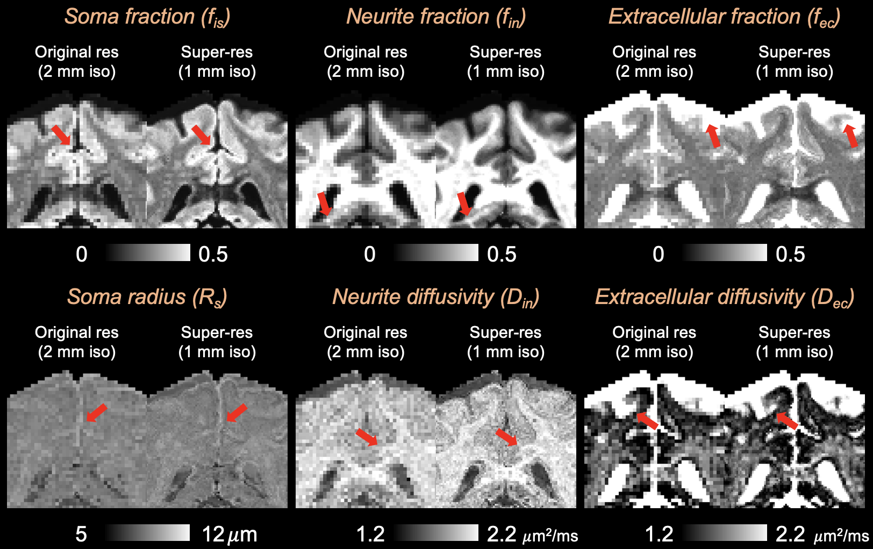
Supplementary Figure 1. SANDI-derived microstructural metrics maps at original resolution (left, 2 mm isotropic) and super-resolution (right, 1 mm isotropic). The super-resolution images are derived from self-similarity-based super-resolution image processing. Red arrows indicate regions with enhanced visibility of microstructural details on the super-resolution images.

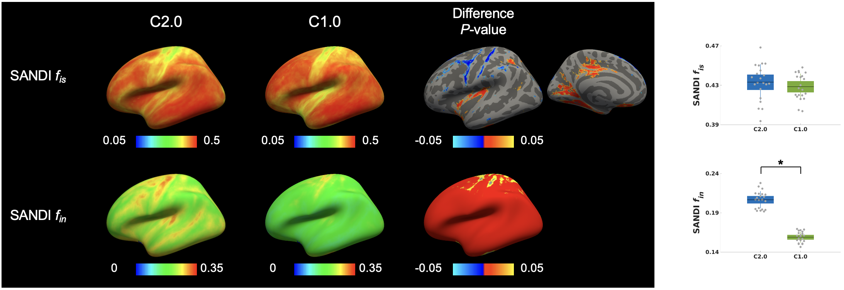 Supplementary Figure 2. SANDI-derived microstructural metrics on Connectome 2.0 (C2.0) and Connectome 1.0 (C1.0) scanners. Left: Cortical maps of the intra-soma signal fraction f_{is} and intra-neurite signal fraction f_{in} derived from SANDI, averaged across 21 individuals. The third column shows the vertex-wise differences in these metrics between Connectome 2.0 and Connectome 1.0, with associated P-values indicating regions with statistically significant differences. Right: Boxplots summarizing intra-soma signal fraction f_{is} and intra-neurite signal fraction f_{in} from data of 21 individuals, with statistically significant differences (∗: FDR-P<0.05) between Connectome 2.0 and Connectome 1.0 scanners. The box represents the 1.96 standard error of the mean (95% confidence interval), and the line represents the 1 standard deviation.
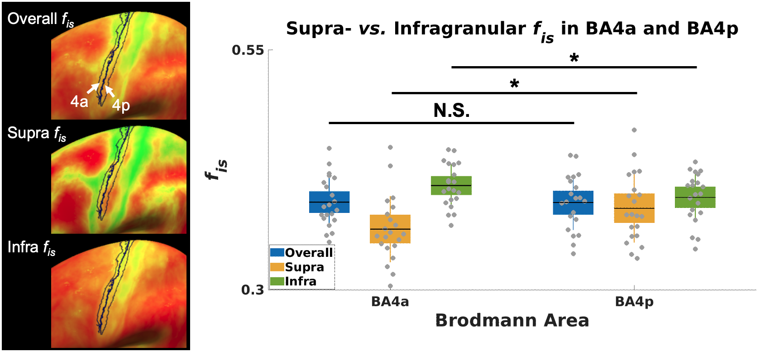
Supplementary Figure 3. Laminar-specific intra-soma signal fraction f_{is} distinguishing adjacent motor subregions BA4a and BA4p. Left: Surface maps of overall, supragranular, and infragranular intra-soma signal fraction f_{is}; black contours outlining BA4a and BA4p boundaries. Right: Boxplots of intra-soma signal fraction f_{is} across overall, supragranular, and infragranular layers for each Brodmann area, with statistically significant differences (∗: FDR-P<0.05). The box represents the 1.96 standard error of the mean (95% confidence interval), and the line represents the 1 standard deviation.

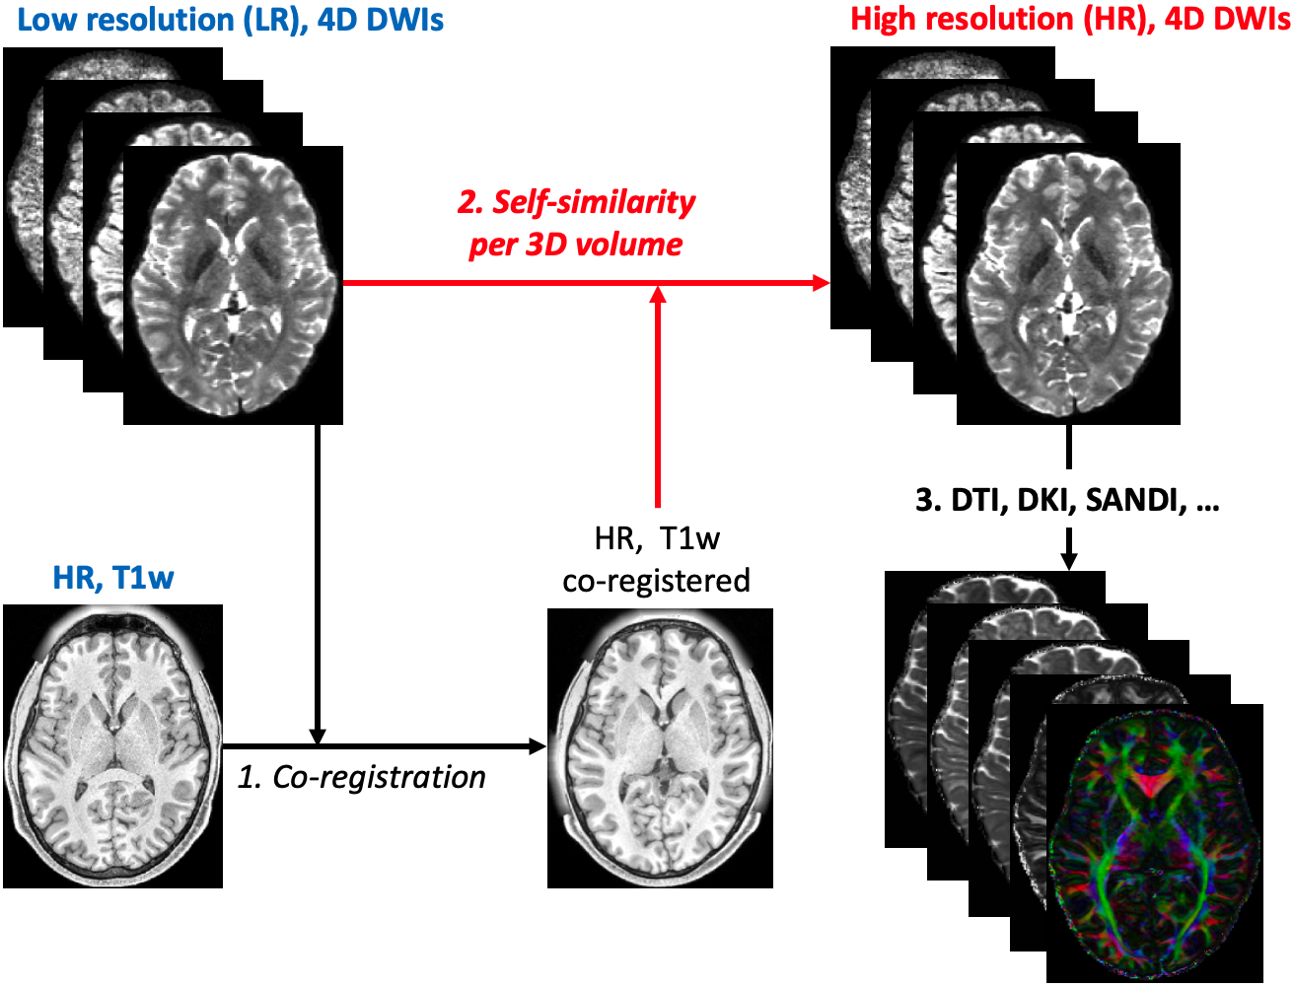
Supplementary Figure 4. Overview of the self-similarity-based super-resolution pipeline for diffusion MRI. Low-resolution (LR) 4D diffusion-weighted images (DWIs) and b0 images were interpolated to increase the matrix size by a factor of two. Then, a high-resolution (HR) T₁-weighted anatomical image was co-registered to the interpolated b0 images (Step 1). The co-registered T₁-weighted image provided high spatial frequency information to guide patch-based self-similarity weighting within each 3D DWI volume (Step 2). The super-resolution algorithm iteratively reconstructs high-resolution (HR) 4D DWIs by transferring structural detail from the anatomical image and local signal similarities in the diffusion data, yielding sharper contrasts and reduced partial volume effects. After that, we can fit any biophysical model to the HR 4D DWIs (Step 3).
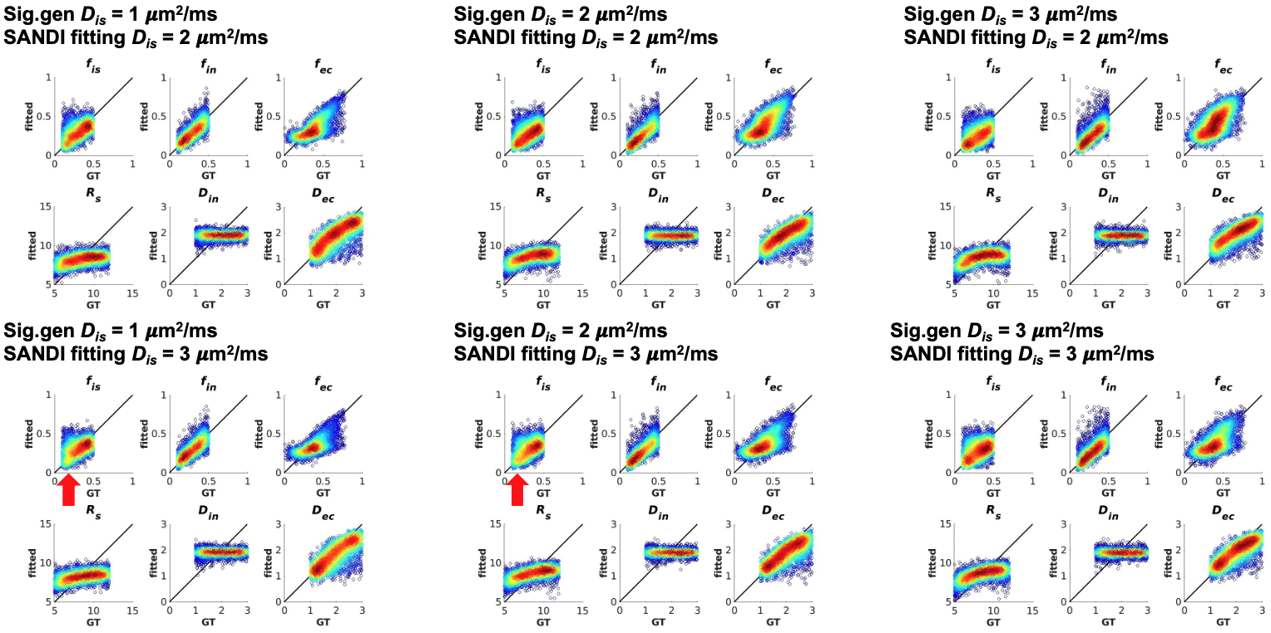
Supplementary Figure 5. Noise propagation analysis in the SANDI model fitting with varying soma diffusivity (D_{is}). GT denotes ground truth values, while fitted values are derived from the SANDI fitting process.

