SUPPLEMENTARY MATERIAL 1 - GHBMC head model modifications
BACKGROUND AND MOTIVATION
Preliminary results from a recent combined computational and experimental study of head-neck inverted drops highlighted some limitations of the GHBMC M50-HN response to HFI (Mongiardini et al. 2024). High peak impact forces and excessive head bouncing, relative to the experiments, occurred in the simulations and were consistent with observations from similar HFI simulations (Darweesh 2022). These model limitations obscured detailed analysis of the head-neck mechanics immediately following impact, and may confound simulation-based investigations of HFI and CFD.

Discussions with the GHBMC developers revealed several issues with the head-neck model that may have contributed towards the unrealistic head impact response. Therefore, an in-house model validation pilot study was performed to improve the biofidelity of the GHBMC M50-HN response to HFI.

METHODS
Inverted drop HFI simulation setup
A previously validated modified version of GHBMC M50-HN head-neck model was used as the baseline model to simulate inverted drop HFI experiments. To replicate the conditions of prior HFI experiments (Nightingale et al. 1996), the neck flesh, all musculature, tendons, hyoid bone and mandible, and all attachments were removed from the original GHBMC head-neck model, and the model was rotated so that T1 was 25° relative to the horizontal plane. Model pre-positioning was performed to produce a head-neck posture with horizontal Frankfort Plane and 30 mm head eccentricity, ensuring that the model response was validated for the HFI with a pre-impact head-forward posture.

The inferior portion of the T1 vertebra was rigidly connected to a simplified geometrical representation of an instrumented overhead drop carriage (16 kg effective torso mass (Nightingale et al. 1996)) typically used in inverted drop test of head-neck assemblies. To simulate a typical drop rail, this simplified carriage assembly was constrained to vertical translation only. A rigid surface modelled the impact plate of the drop-tower, with an assigned coefficient of friction as measured from experimental friction tests between human skin and an aluminium plate (μ = 0.52). HFI was simulated by assigning an initial velocity of 2 m/s to the head-neck model, with the head positioned closely above the impact plate. Loads acting on the impact surface and drop carriage were extracted from the simulations at 100 kHz.

Model modifications analysis
Iterative modifications were made to the model’s scalp and the skull to better match the response to existing experimental HFI data (Fig S - 1). After each modification, an HFI simulation was performed and the impact surface and drop carriage load cell outputs were compared with corresponding HFI experimental data.

HFI was firstly simulated for the unmodified GHBMC M50-HN model to obtain baseline data for comparison. Next, the material properties of the GHBMC scalp flesh were replaced with those used in the Total Human Model for Safety (THUMS) (Iwamoto et al. 2002). In Model Iteration #3, erroneously duplicated inner and outer shell elements of the skull cortical bone were deleted, and the elastic modulus of the cortical bone solid elements was reduced from 15 GPa to 10 GPa.
Table S - 1: Iteration number for the modified head-neck models
Model # | Modifications
1 | Unmodified GHBMC M50-HN
2 | GHBMC M50-HN with THUMS scalp material properties
3 | Model 2 w/ shell elements deleted, cortical elements moduli set to 10 GPa

RESULTS
Modifying the scalp material reduced head bouncing upon initial impact compared to the original GHBMC model (Fig S - 1). Although some residual bouncing remained, the modified head model re-established contact with the bottom plate sooner than the original, decreasing unloading of the partially loaded neck assembly and reducing the phase offset between the initial peak load and the subsequent major impact. Additionally, removing the inner and outer shell elements of the skull’s cortical bone, combined with lowering the elastic modulus of its solid elements, improved agreement between the simulated first peak load at the base of the neck (i.e., vertical force measured between T1 and the carriageway load cell) and experimental data. These modifications also reduced the time offset (T_{bounce}​) between the first simulated peak and the subsequent peak following head rebound.

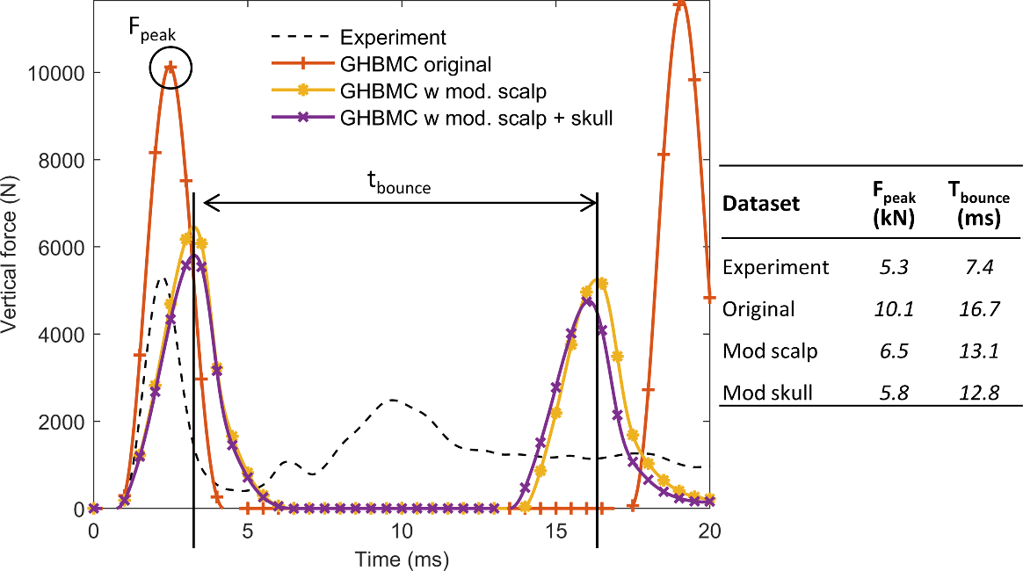
Fig S - 1: Experimental and simulated vertical head impact load during the early phase of the drop test. The modified skull replicates the experimental initial peak load more closely than the original model and also reduces the gap to the second peak load created by the initial bouncing.

DISCUSSION AND CONCLUSION
The iterative modifications to the GHBMC M50-HN head-neck model significantly improved its biofidelity in simulating inverted drop HFI. Specifically, replacing the scalp material properties, removing redundant cortical bone shell elements, and reducing the elastic modulus of solid cortical bone elements led to reduced head bouncing, improved alignment with experimental force profiles, and minimized discrepancies in impact load timing. These refinements enhanced the accuracy of the model’s early impact response, reducing phase offsets and improving force transmission characteristics at the base of the neck. Despite these improvements, residual head rebound remains a limitation, potentially affecting post-impact neck loading dynamics. Further refinements to the model’s soft tissue material properties and damping characteristics may be necessary to fully capture the complex skull and scalp mechanics during HFI.

