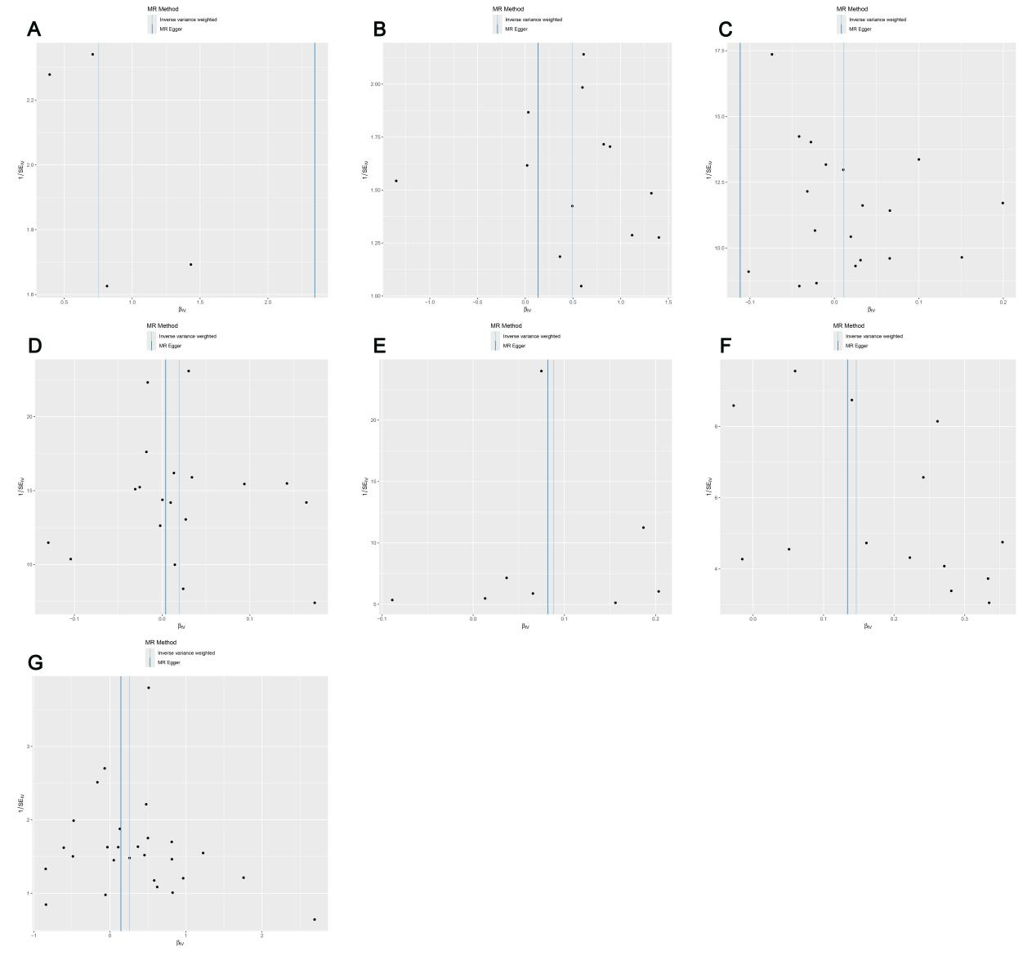
Supplementary Figure S1.Funnel plots visually display the overall heterogeneity of MR estimates for all results:(A)heterogeneity analysis for Funnelplot for Lactobacillus B salivarius on GCST005841;(B)heterogeneity analysis for Funnelplot for Lactobacillus B salivarius on GCST006909;(C)heterogeneity analysis for GCST005841 on Lactobacillus B salivarius;(D)heterogeneity analysis for GCST006909 on Lactobacillus B salivarius;(E)heterogeneity analysis for CD62L- plasmacytoid DC on GCST005841;(F)heterogeneity analysis for CD62L- plasmacytoid DC on GCST006909;(G)heterogeneity analysis for CD62L- plasmacytoid DC on Lactobacillus B salivariu

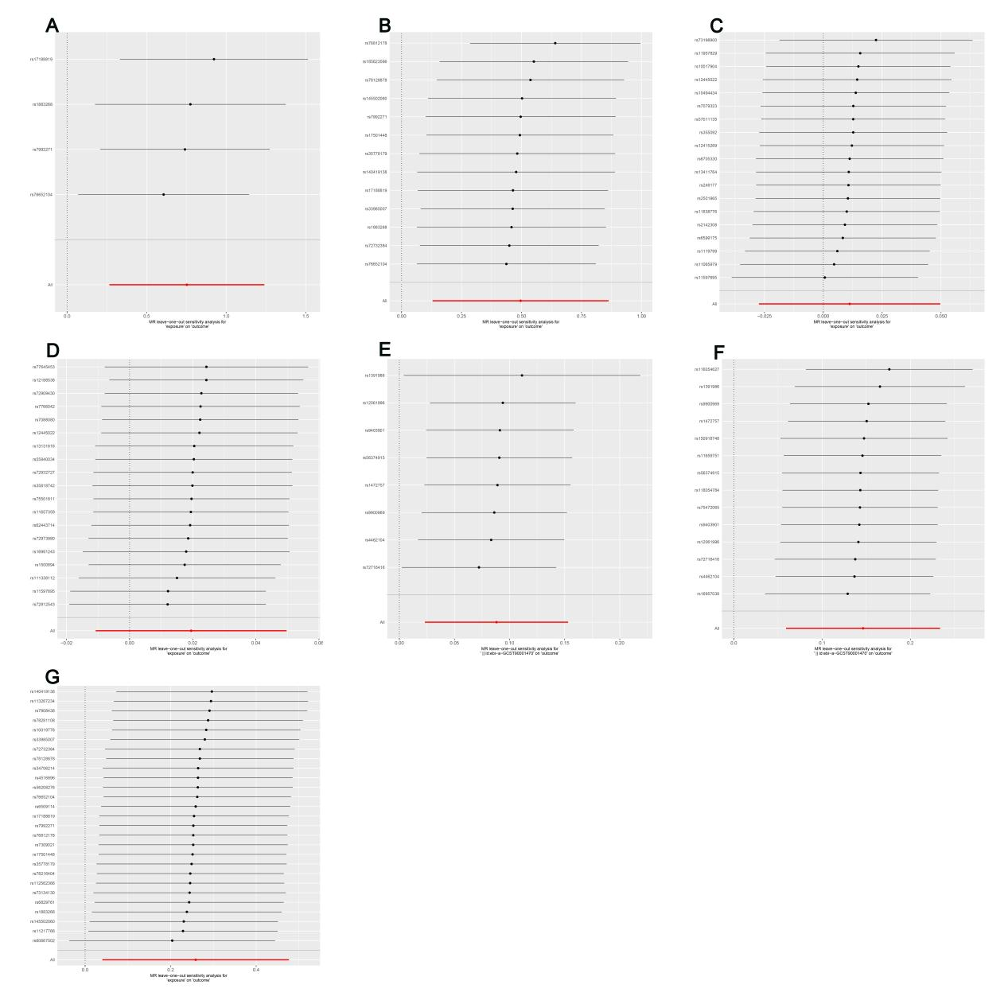
Supplementary Figure S2 Leave-one-out analysis visually displays the overall robustness of MR estimates for all results:(A)Leave-one-out analysis for Lactobacillus B salivarius on GCST005841;(B)Leave-one-out analysis for Lactobacillus B salivarius on GCST006909;(C)Leave-one-out analysis for GCST005841 on Lactobacillus B salivarius;(D)Leave-one-out analysis for GCST006909 on Lactobacillus B salivarius;(E)Leave-one-out analysis for CD62L⁻ plasmacytoid DC on GCST005841;(F)Leave-one-out analysis for CD62L⁻ plasmacytoid DC on GCST006909;(G)Leave-one-out analysis for CD62L⁻ plasmacytoid DC on Lactobacillus B salivarius.

