Supplementary figures and table
Fig. S1 The concentration of different Al form under different soil profile depths at seeding stage

Fig. S2 Total Al concentration under different soil profile depths at seeding stage

Fig. S3 Proportion of active Al under different soil profile depths at seeding stage

Fig. S4 Plant height under different phosphate fertilizer treatments alleviating the effects of acidic soil on Al toxicity at flowering stage

Fig. S5 pH at different soil profile depths on Al toxicity at the flowering stage

Fig. S6 Total Al concentration under different soil profile depths at flowering stage

Fig. S7 Different Al form (a) Al³⁺, (b) Al(OH)₂⁺, Al(OH)²⁺, (c) Al(OH)₃⁰, and (d) Al-HA at flowering stage on B. napus

Fig. S8 Proportion of active on different Al form (Al³⁺, Al(OH)₂⁺, Al(OH)²⁺, Al(OH)₃⁰, and Al-HA) at flowering stage on B. napus

Fig. S9 Available copper (Cu), iron (Fe), Manganese (Mn), and Zinc (Zn) concentrations under phosphate fertilizer treatments in acidic soil at flowering stage

Fig. S10 The LEfSe Multi-level Species Difference Discriminant Analysis on alleviating Al toxicity in acidic soil through phosphorus fertilizer application

Table S1 Assignment of absorption peaks in Fourier-transform infrared spectroscopy (FTIR) spectrum in root to Al toxicity

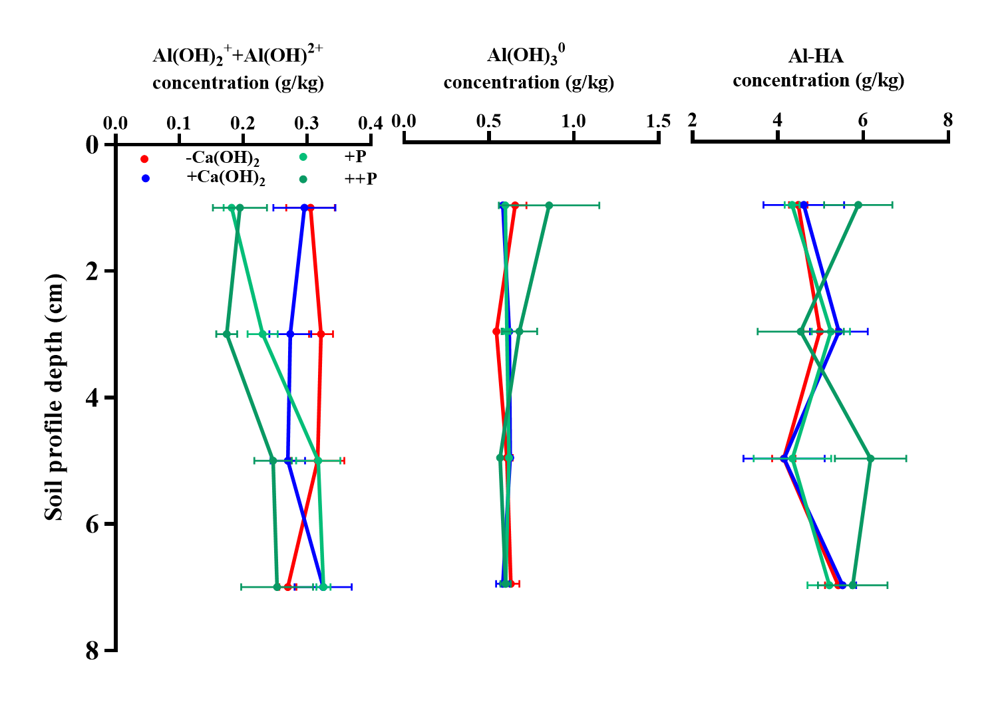
Figure S1
Figure S2
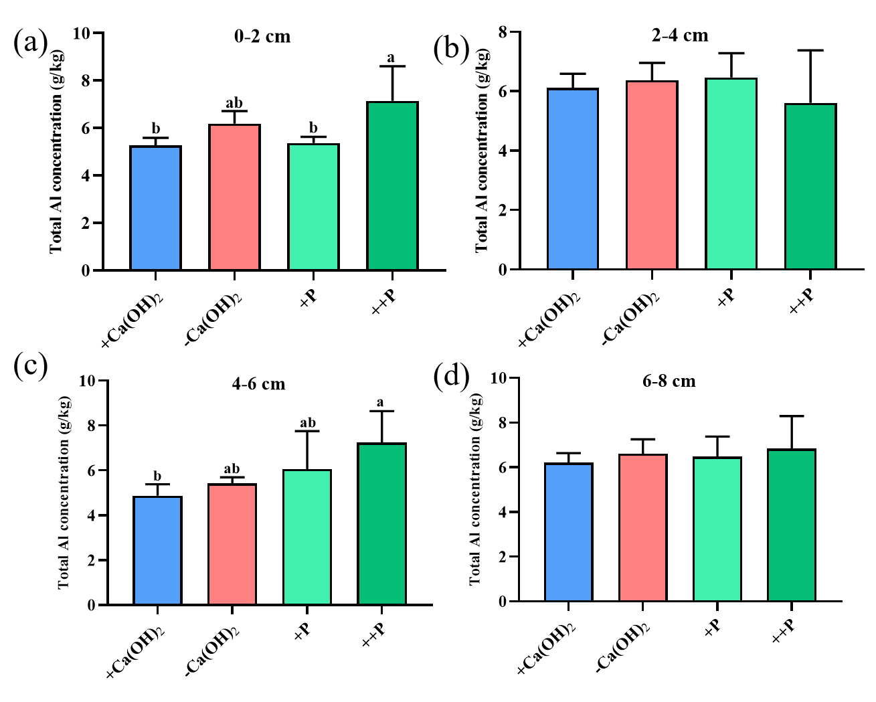
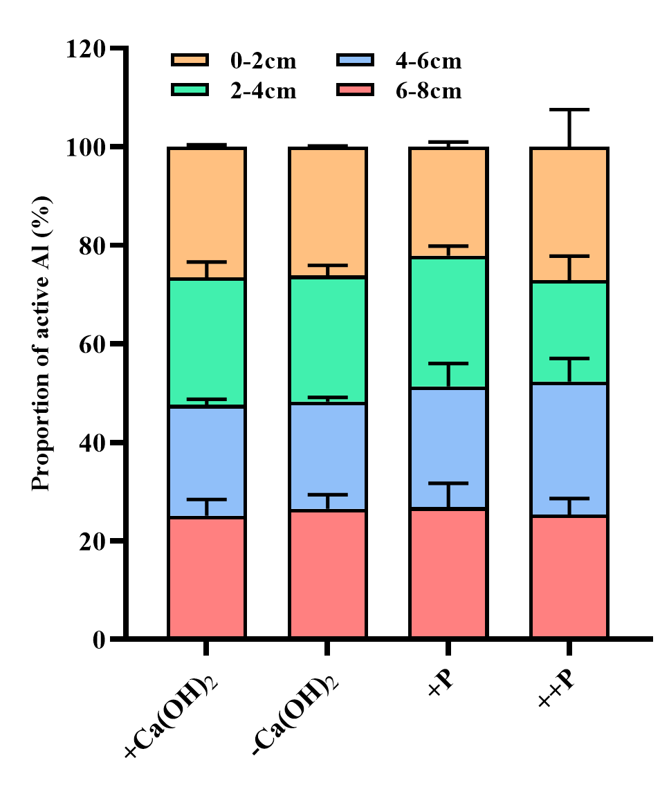
Figure S3
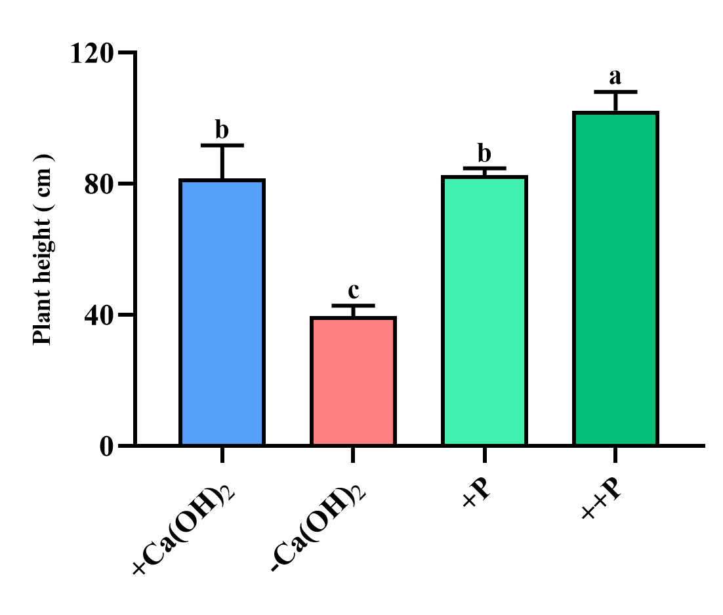
Figure S4
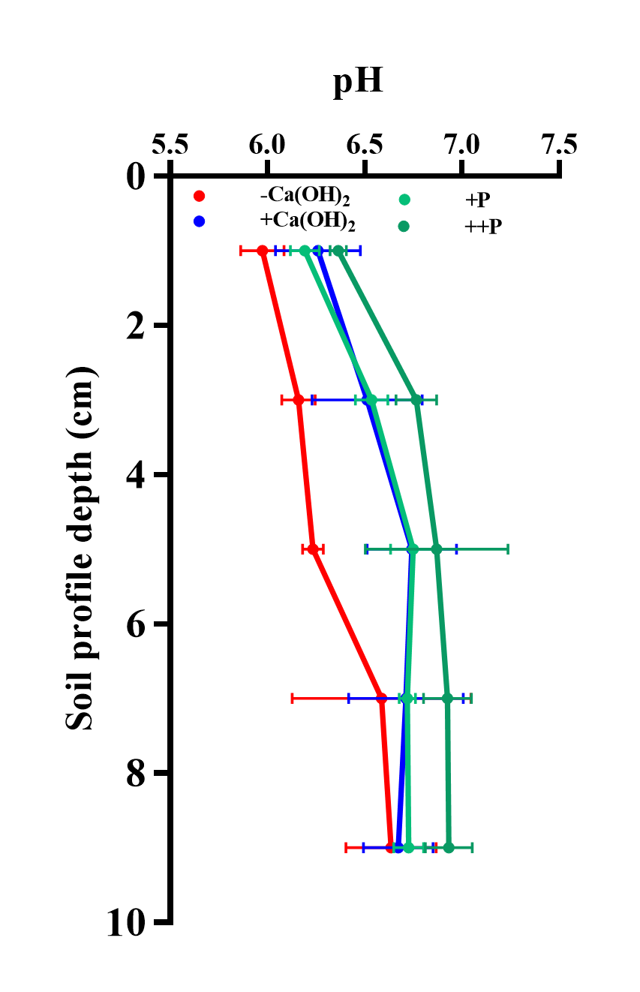
Figure S5
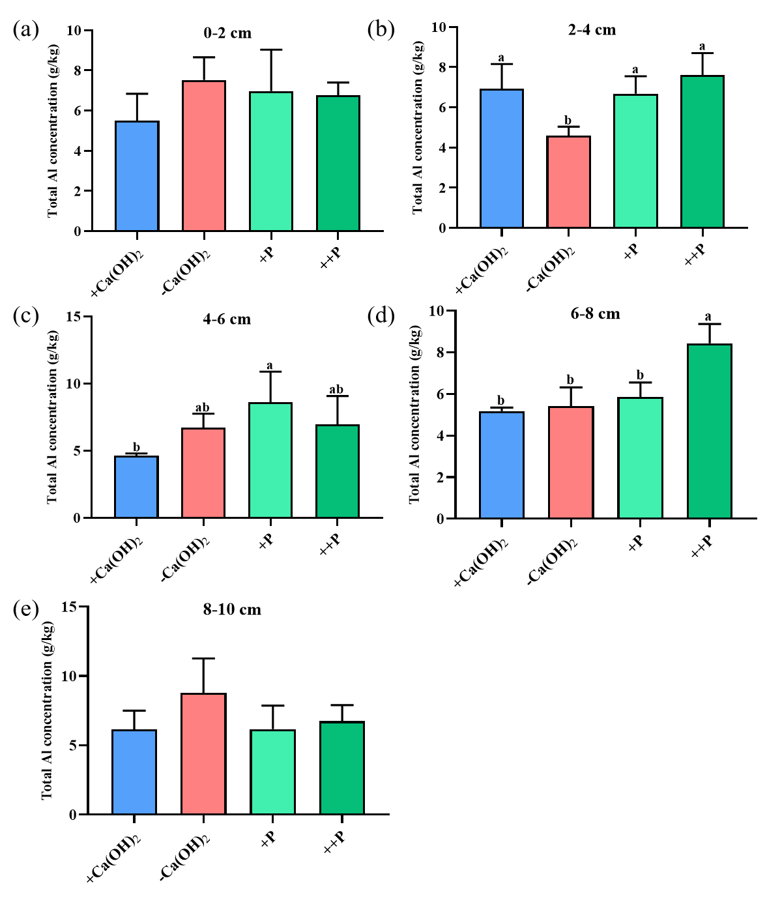
Figure S6
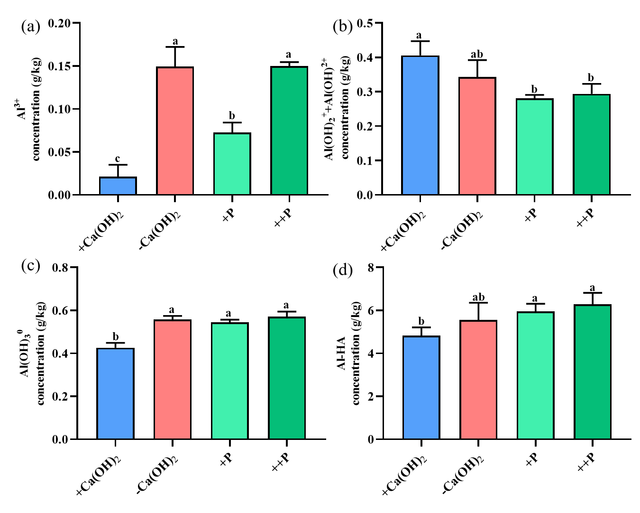
Figure S7
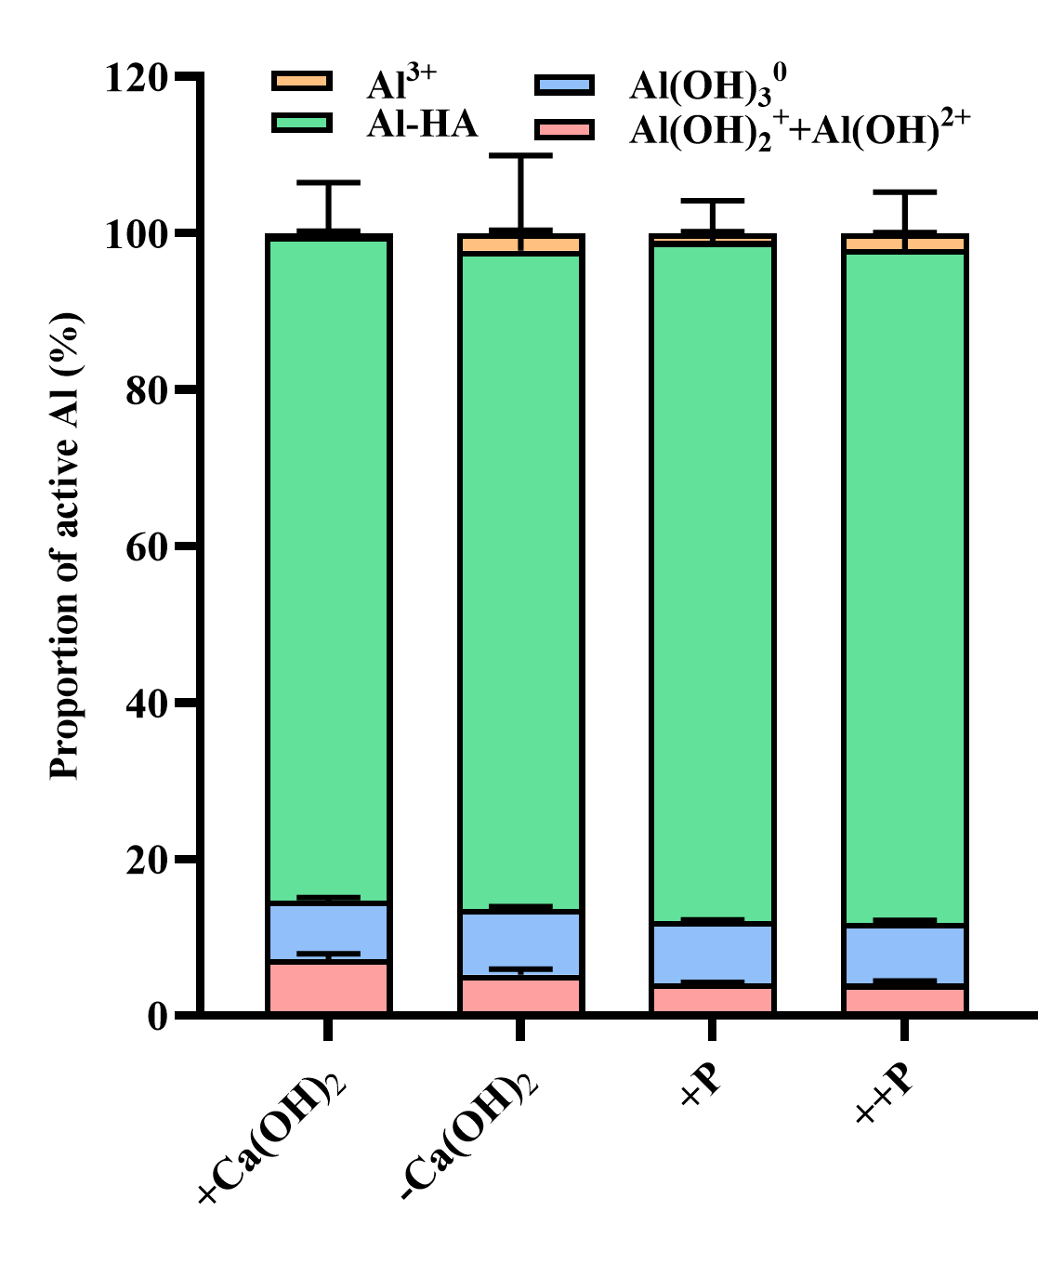
Figure S8
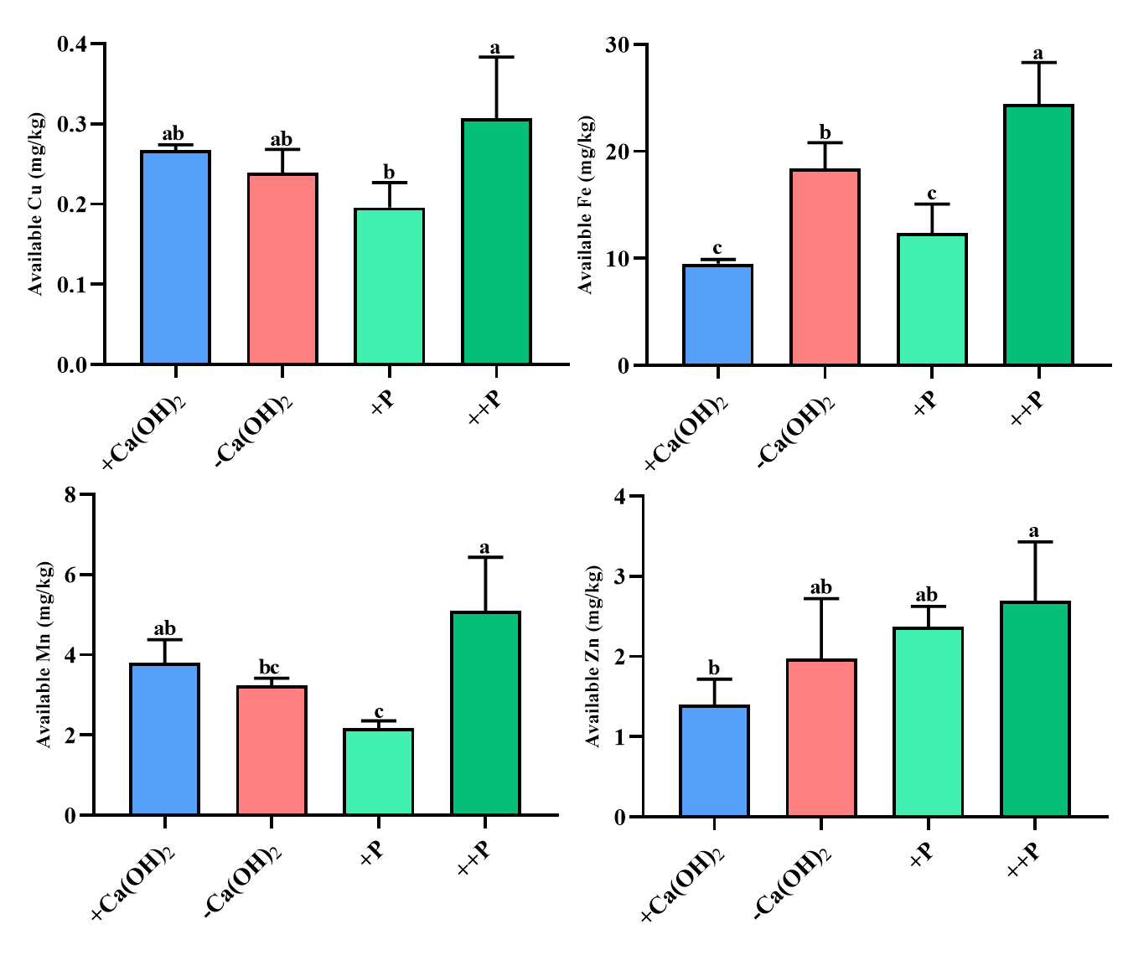
Figure S9
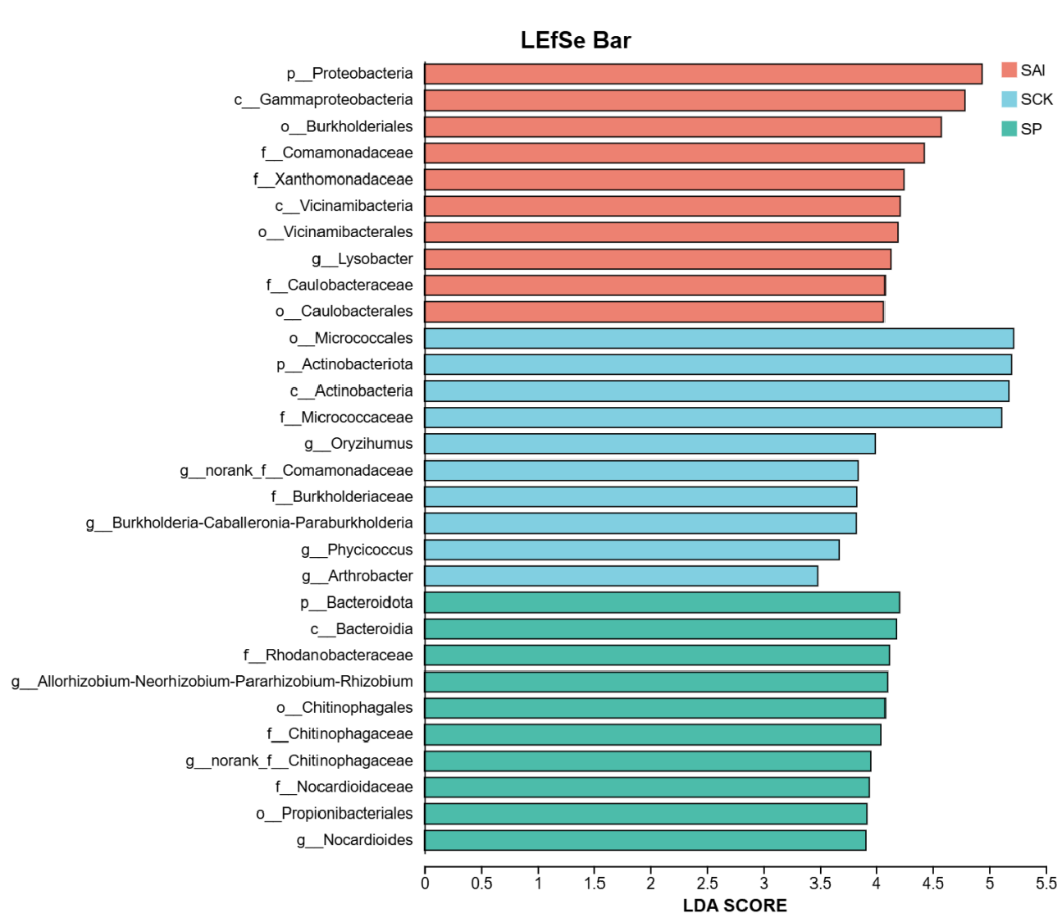
Figure S10
Table S1
Wavenumber(cm⁻¹) | Functional group | Major component
3369 | O-H, N-H stretching | Protein, cellulose, hemicellulose
2935 | Saturated C-H stretching | Protein, cellulose, pectin
2364 | C≡N, P-H stretching | Cyanide
1735 | C=O stretching from-COOR | Pectin
1637 | C=C stretching | Olefin
1510 | N-H deformation | Amide Ⅱ of pectin
1425 | C-N stretching | Amide Ⅱ of pectin
1035 | -CH deformation or C-C, C-O stretching | Carbohydrate chain from cellulose

