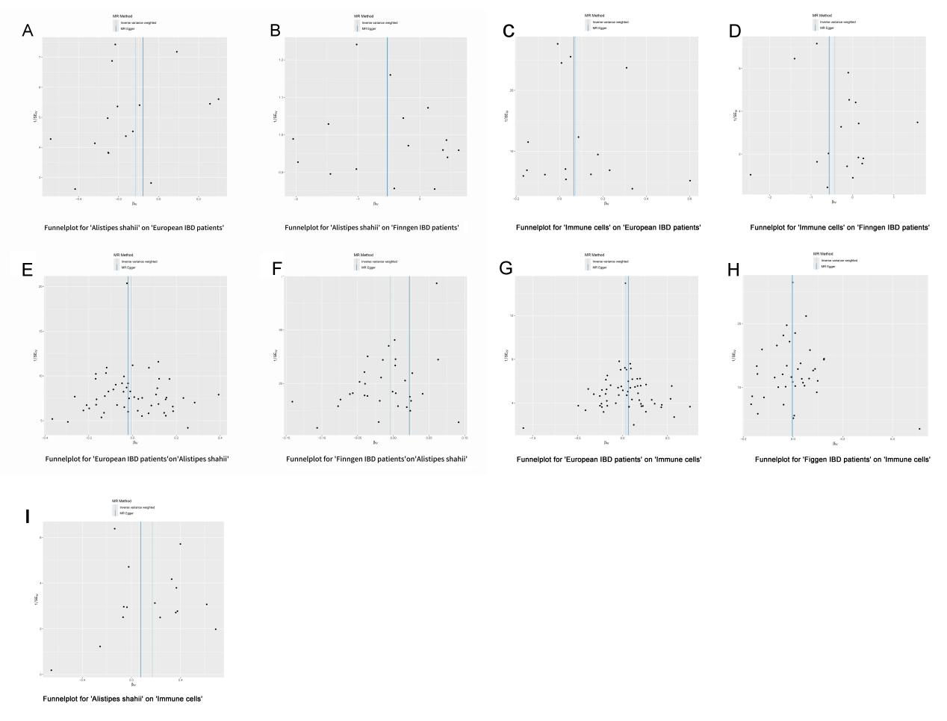
Supplementary Figure S1.Funnel plots visually display the overall heterogeneity of MR estimates for all results: (A) heterogeneity analysis for Alistipes shahii on European IBD patients; (B) heterogeneity analysis for Alistipes shahii on Finngen IBD patients; (C) heterogeneity analysis for HLA DR on monocyte on European IBD patients; (D) heterogeneity analysis for HLA DR on monocyte on Finngen IBD patients; (E) heterogeneity analysis for European IBD patients on Alistipes shahii; (F) heterogeneity analysis for Finngen IBD patients on Alistipes shahii; (G) heterogeneity analysis for European IBD patients on HLA DR on monocyte; (H) heterogeneity analysis for Finngen IBD patients on HLA DR on monocyte; (I) heterogeneity analysis for Alistipes shahii on HLA DR on monocyte.
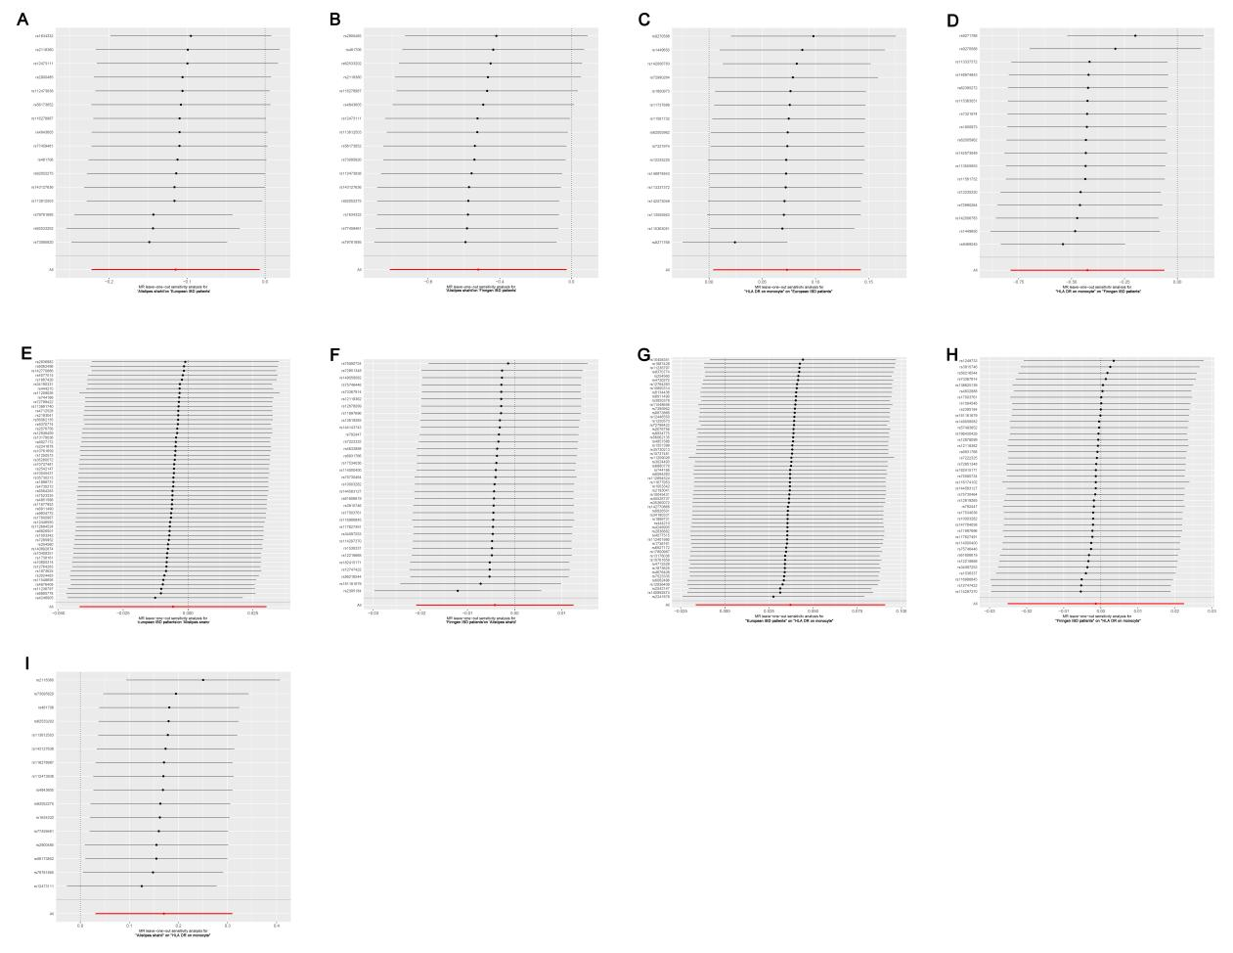
Supplementary Figure S2:Leave-one-out analysis of the effect of individual SNPs of MR analysis results: (A) Leave-one-out analysis for Alistipes shahii on European IBD patients; (B) Leave-one-out analysis for Alistipes shahii on Finngen IBD patients; (C) Leave-one-out analysis for HLA DR on monocyte on European IBD patients; (D) Leave-one-out analysis for HLA DR on monocyte on Finngen IBD patients; (E) Leave-one-out analysis for European IBD patients on Alistipes shahii; (F) Leave-one-out analysis for Finngen IBD patients on Alistipes shahii; (G) Leave-one-out analysis for European IBD patients on HLA DR on monocyte; (H) Leave-one-out analysis for Finngen IBD patients on HLA DR on monocyte; (I) Leave-one-out analysis for Alistipes shahii on HLA DR on monocyte.

