Supplementary Information

Seasonal freshwater contribution to the estuary using a two-component mixing model
In an estuarine setting, the source of freshwater can vary from rainwater, groundwater, and river water from the catchment. These freshwater sources have unique δ¹⁸O values, although the salinity of these sources is minimal. Previously reported δ¹⁸O values of the NEM from this region are -10‰ and -2‰ for the Premonsoon and -5‰ for the SWM (Lekshmy et al. 2015; Rahul and Ghosh 2019). These values are close (-1.8 to -5‰) to the river water composition measured at a seasonal interval in the region (Hameed et al. 2015). Using these δ¹⁸O values as freshwater end members, and measured average δ¹⁸O of estuarine waters, the relative contribution of freshwater can be ascertained using the mass balance equation.

$Fsw×δ^{18}Osw+Frw×δ^{18}Orw=δ^{18}Oew$ (1)
$Fsw+Frw=100$ (2)
Percentage (%) = [δ¹⁸O_{ew} − δ¹⁸O_{sw}]/ [δ¹⁸O_{rw} − δ¹⁸O_{sw}] (3)
where sw, rw, and ew refer to seawater, rainwater, and estuarine water, respectively, and F indicates the flux parameter.

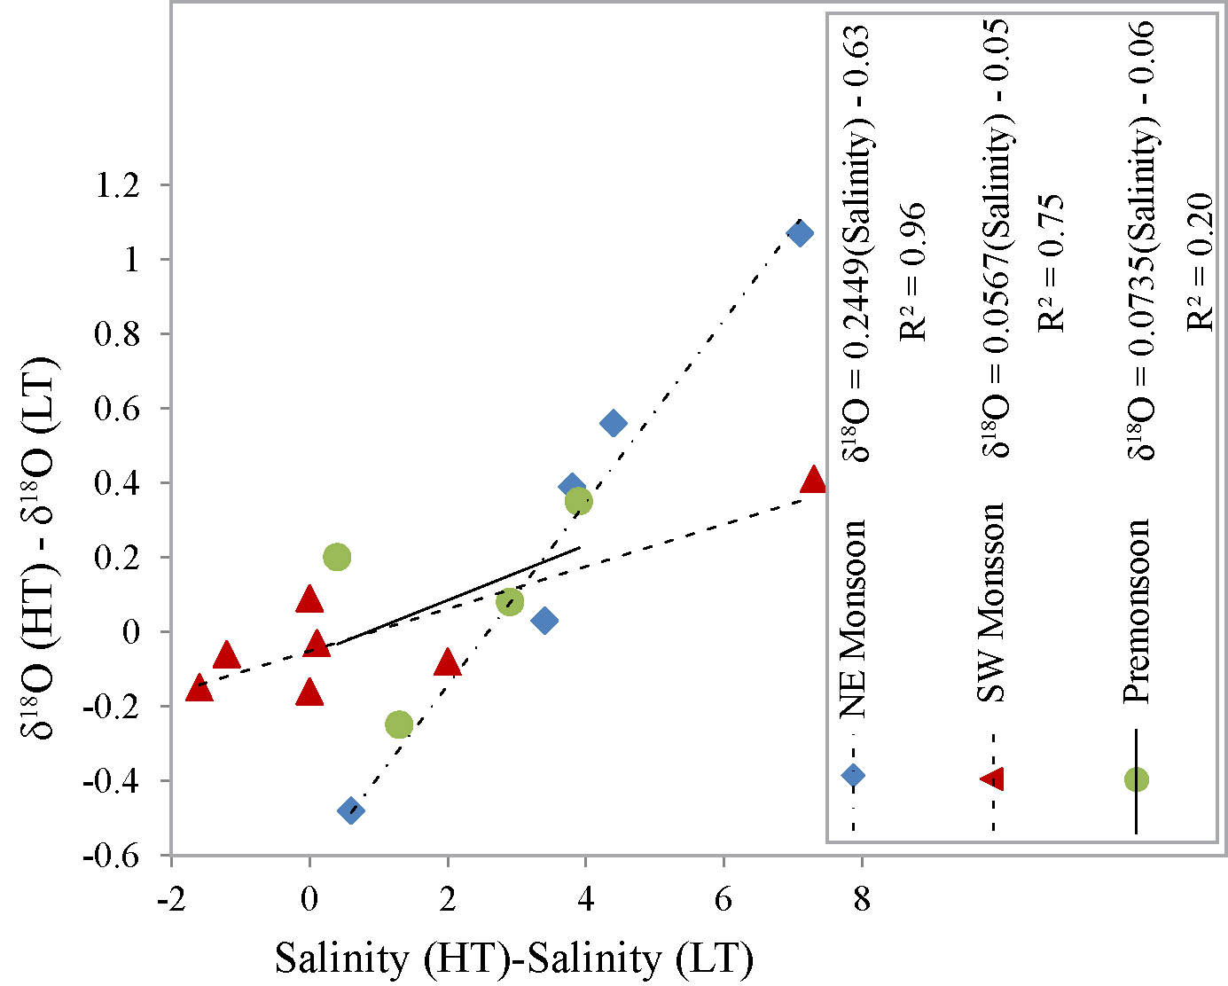
Figure S1: Difference in δ¹⁸O of water samples collected during high tide (HT) and low tide
(LT) on the same day as that for the salinity in the same water samples. A reasonably strong positive correlation between these two parameters indicates that the Cochin backwater is well mixed vertically during both monsoon and non-monsoon periods.

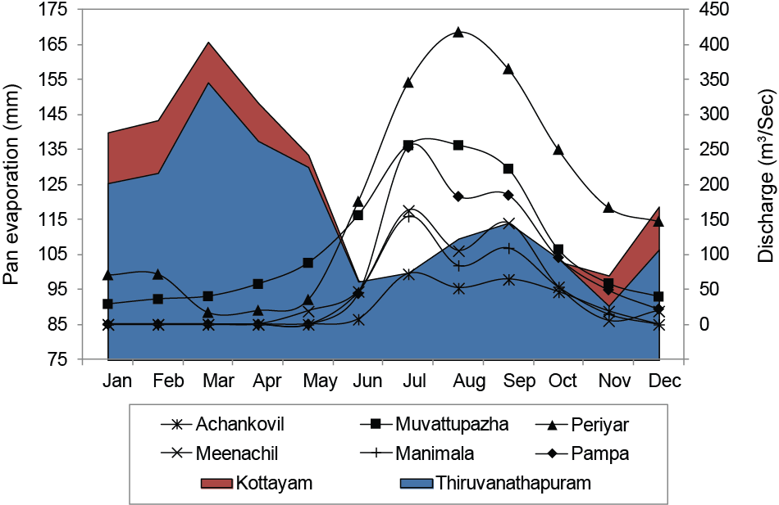
Figure S2: Pan-evaporation and daily climatological river discharges of the seven rivers at CE. Discharge data sourced from Central Water Commission, Government of India (2000–2016).

Table S1
River | Slope | SE_{slope} | Intercept | SE_{intercept} | R² | N | SE of regression | F-test overall | Degrees of freedom (n-k) | Regression SS | Residual SS
Cochin backwaters (Present Study)
High Tide | 0.13 | 0.02 | -3.35 | 0.23 | 0.73 | 22 | 0.7 | 57.8 | 21 | 28.41 | 10.32
Low Tide | 0.11 | 0.02 | -3.1 | 0.25 | 0.58 | 20 | 0.72 | 25.97 | 19 | 13.54 | 9.9
Average | 0.13 | 0.02 | -3.32 | 0.22 | 0.7 | 22 | 0.69 | 48.94 | 21 | 23.31 | 10
Hooghly (Ghosh et al., 2013)
High Tide | 0.26 | 0.06 | -7.42 | 0.55 | 0.63 | 13 | 1.03 | 20.05 | 12 | 21.47 | 12.84
Low Tide | 0.25 | 0.07 | -7.40 | 0.56 | 0.52 | 14 | 1.13 | 14.03 | 13 | 18.01 | 16.69
Average | 0.24 | 0.06 | -7.32 | 0.53 | 0.52 | 15 | 1.11 | 15.39 | 14 | 19.01 | 17.30
Hooghly (Samanta et al., 2018)
Average | 0.26 | 0.01 | -7.25 | 0.13 | 0.85 | 73 | 0.83 | 402.99 | 72 | 279.82 | 49.99
Mandovi-Zuari (Ghosh et al., 2021)
Average | 0.08 | 0.02 | -2.13 | 0.30 | 0.84 | 7 | 0.35 | 30.84 | 6 | 3.86 | 0.75

