Supplementary Information

Preparation, properties and mechanism of anionic and cationic CNCs/WPU composite films
Ya-Yu Li, Yan-Ru Bai, Xin-Qian Zhang, Xin Liu, Zhen Dai, Hong-Ji Chen, Zun-Qi Liu, Ming-Guo Ma

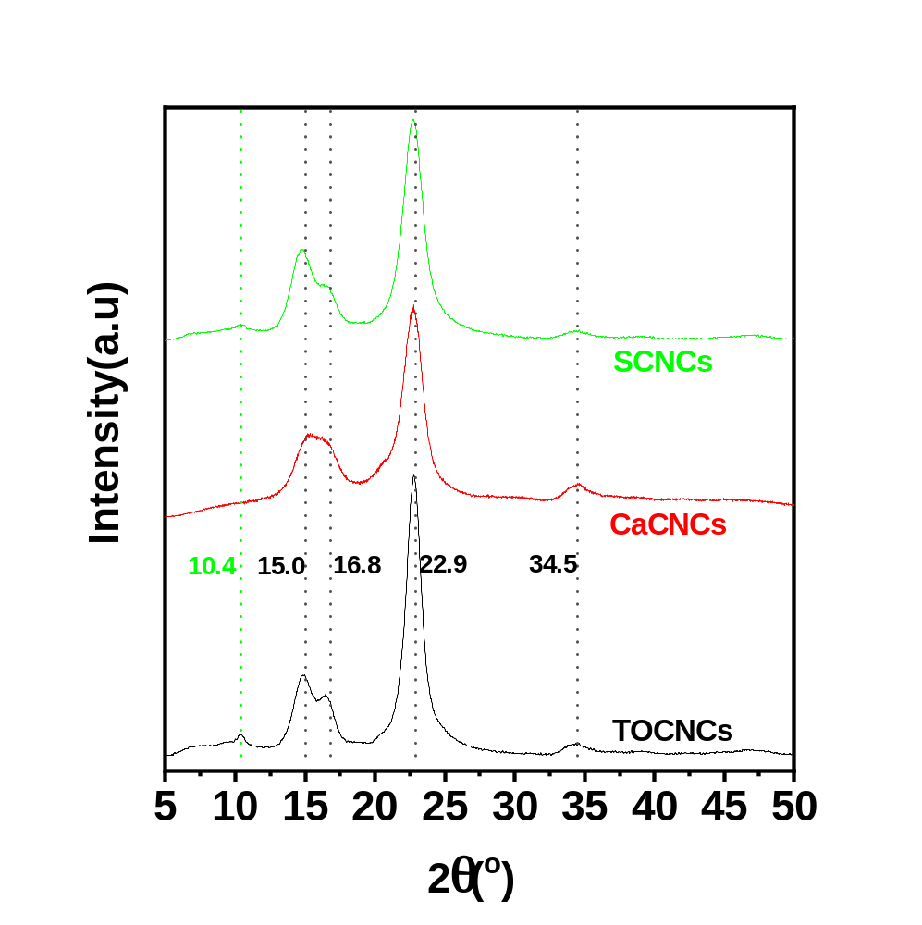
Fig. s1 XRD patterns of three kinds of CNCs: TOCNCs, CaCNCs, and SCNCs.

Fig. s1 shows the XRD patterns of three kinds of CNCs: TOCNCs, CaCNCs, and SCNCs. These three CNCs all appeared diffraction peaks at 15.0 º, 16.8 º and 22.9 º. This verified these three CNCs all reserved the cellulose I crystallinity. The small diffraction peak at 10.4 º may come from a few impurities or test deviation of equipment.

