Graph No 1 : Orthogonal Impulse Response Analysis of GDP Growth, Inflation, and Interest Rate to Interest Rate Shock
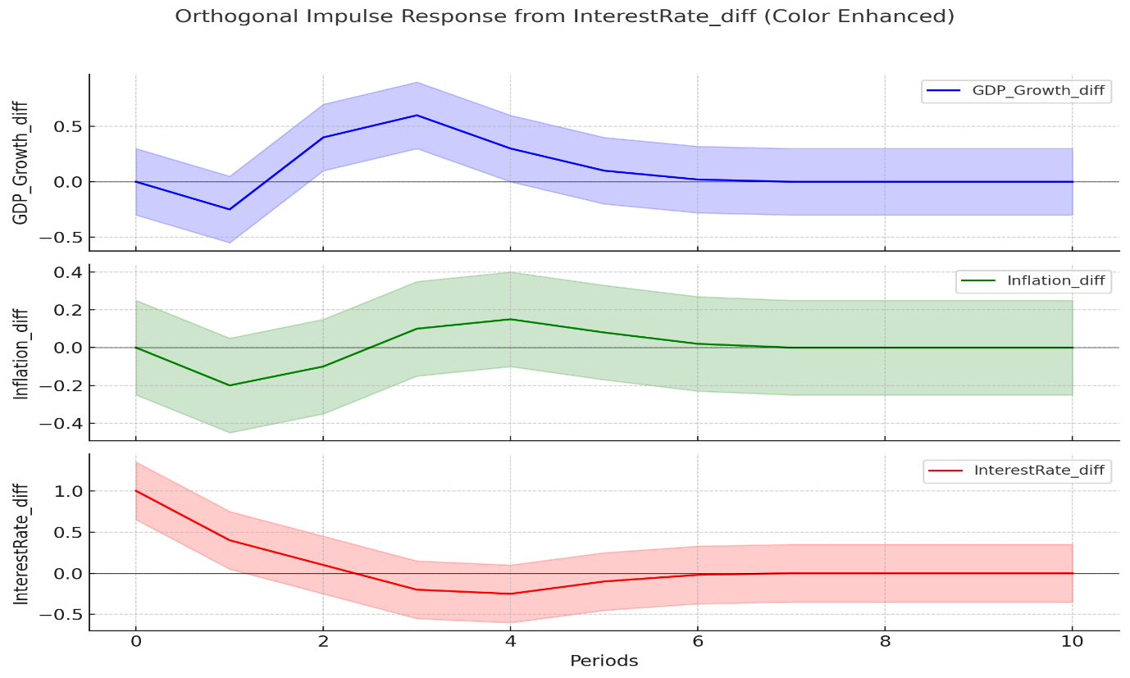
Source: Compiled by author
Graph No 2: Structural Impulse Response Analysis of Interest Rate Shocks: Evidence from SVAR Model
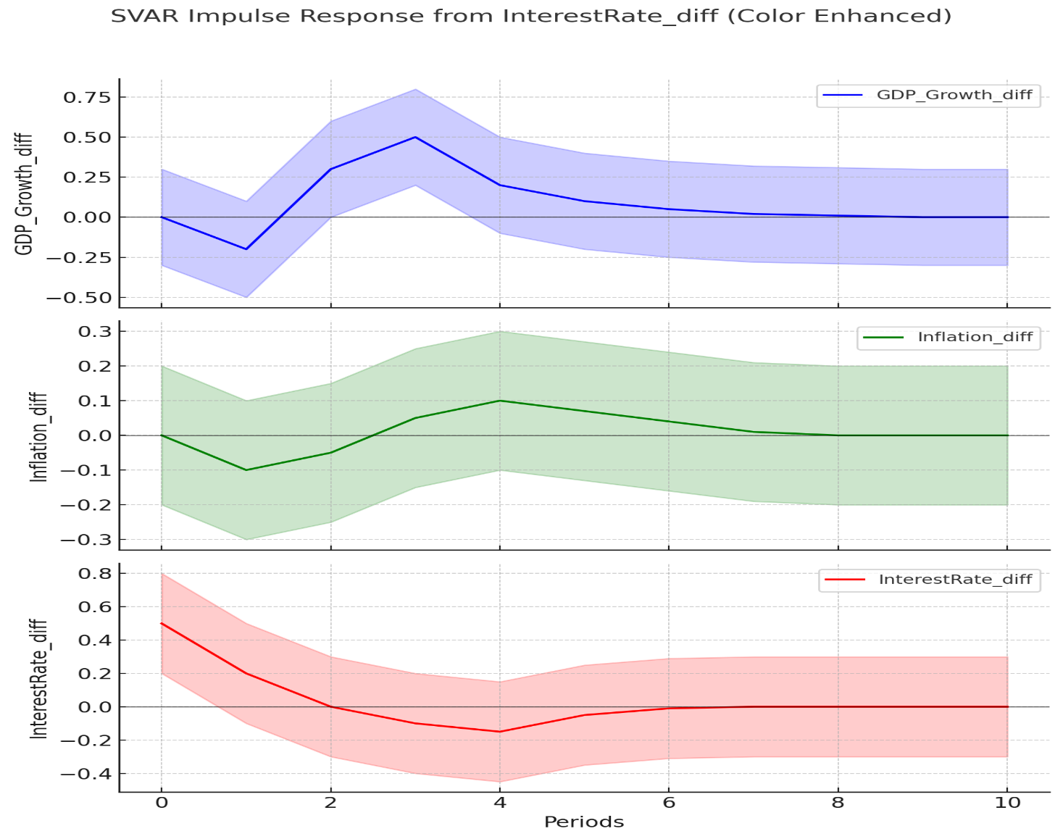
Source: Compiled by author
Graph No 3: Forecast Error Variance Decomposition (FEVD) of GDP Growth, Inflation, and Interest Rate: Contribution of Shocks Over 10 Periods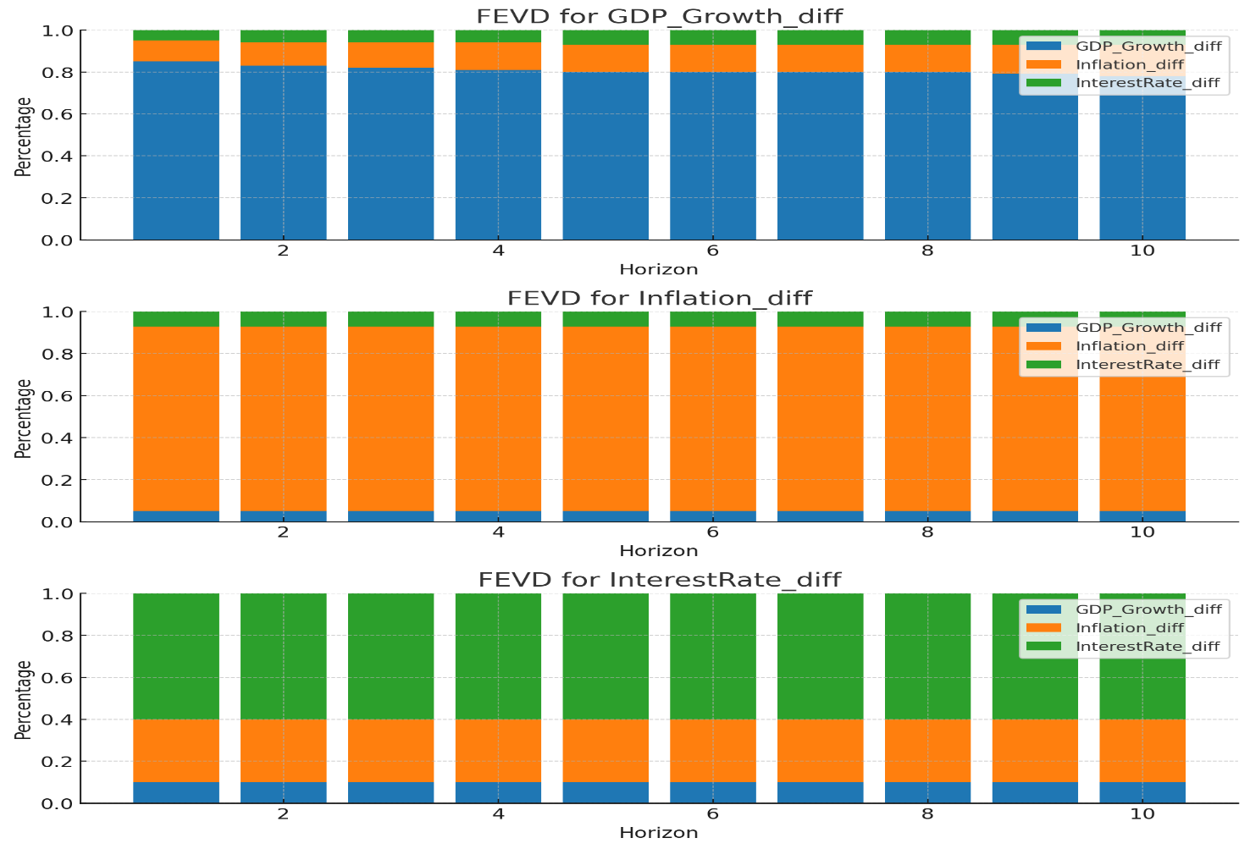
Source: Compiled by author

